## **Mastering DevOps on Microsoft Power Platform**

**Write the first review**

**By**[**Uroš Kastelic**](https://learning.oreilly.com/search/?query=author%3A%22Uroš%20Kastelic%22&sort=relevance&highlight=true)**,**[**József Zoltán Vadkerti**](https://learning.oreilly.com/search/?query=author%3A%22József%20Zoltán%20Vadkerti%22&sort=relevance&highlight=true)

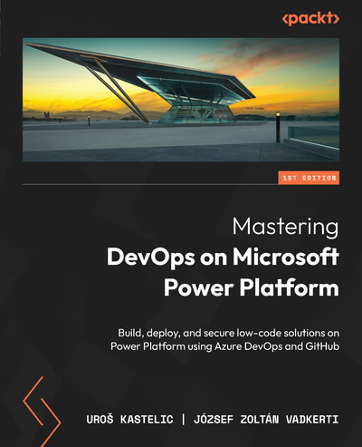

[**Start**](https://learning.oreilly.com/library/view/mastering-devops-on/9781835880845/B22208_FM.xhtml)

Schedule learning reminder

**TIME TO COMPLETE:**12h 42m

**LEVEL:**Beginner to intermediate

**SKILLS:**[**DevOps**](https://learning.oreilly.com/search/topics/devops)

**PUBLISHED BY:**[**Packt Publishing**](https://learning.oreilly.com/publisher/dd0773f2-2d09-4827-9191-33477b14398c)

**PUBLICATION DATE:**September 2024

**PRINT LENGTH:**444 pages

Mastering DevOps on Microsoft Power Platform provides developers and professionals with the tools and knowledge needed to build, deploy, and maintain robust enterprise solutions using the Power Platform. By exploring ALM and DevSecOps practices intertwined with Power Platform capabilities, you will enhance your ability to efficiently deliver secure solutions.

**What this Book will help me do**

* Gain expertise in setting up ALM practices for Microsoft Power Platform.
* Learn how to automate CI/CD pipelines using Azure DevOps and GitHub.
* Understand how to implement security measures using DevSecOps practices.
* Explore advanced integration techniques for Power Platform with Azure services.
* Master the use of AI tools like GitHub Copilot in your development workflows.

**Author(s)**

Uroš Kastelic and József Zoltán Vadkerti are Microsoft Technology Specialists with broad expertise in Power Platform and DevOps for enterprise applications. They bring a wealth of real-world experience and a practical approach to teaching advanced topics in their fields.

**Who is it for?**

This book is perfect for DevOps engineers, cloud architects, site reliability engineers, or low-code developers looking to excel in enhancing the DevSecOps capabilities of Power Platform. A basic understanding of Power Platform and software development processes is recommended to fully benefit from this book.

# Contributors

# About the authors

****Uroš Kastelic**** is a technology specialist in low-code/no-code at Microsoft, where he helps large enterprise customers implement and adopt Microsoft Power Platform. He holds a Master of Science (M.Sc.) degree in computer and information science. Prior to joining Microsoft, he worked as a software developer on various projects. He joined Microsoft in 2014 and has worked in different roles. For the last five years, he has been helping organizations with their application modernization projects and the implementation of DevOps practices, supported by Microsoft Azure services. He is a Microsoft Certified Trainer and an Expert with many certifications in Microsoft Azure and Power Platform technology, as well as being actively engaged in various tech communities.

*I would like to extend my gratitude to my parents, who taught me to always reach for the stars. I would also like to thank Microsoft for helping me to grow professionally and personally. Thank you, the Packt team and technical reviewers, for the support throughout the writing process and making this book possible.*

****József Zoltán Vadkerti**** is a senior technology specialist at Microsoft with a computer science (MSC) degree from the Karlsruhe Institute of Technology. He has almost 20 years of experience in software development. Since 2015, he has been working in different roles for Microsoft, with a focus on application development and innovation. He has deep technical knowledge of Microsoft Azure, cloud-native architecture, serverless, DevOps practices, applied AI, and Microsoft Platform. He is a Project Management Professional (PMP®), Microsoft Certified Trainer, Azure Solution Architect Expert, and DevOps Engineer Expert. Today, he is one of the most experienced Power Platform professionals at Microsoft in the CEE and MEA region. József currently resides in Budapest with his wife and three boys.

*I extend my deepest gratitude to my family, my wife, and my three heroes, who inspired me to undertake the writing of this book. I would also like to thank my employer, Microsoft, for fostering an environment where I could “learn it all” and empowering me to share this knowledge widely so that, together, we all achieve more.*

# About the reviewers

****Ralph Rivas****is a seasoned professional with over two decades of experience delivering quality software and solutions, currently with Sogeti, part of Capgemini, where he works in the corporate Applications and Cloud Technologies group, focused specifically on Power Platform and the M365 ecosystem, actively promoting and growing technologies and features to help customers make the most of their digital modernization journey. More recently, he has also been part of the global technology team, promoting and advancing low-code and Gen AI platform initiatives aligned with Microsoft and the industry.

As an MS MVP for BizApps, he is a frequent speaker at many community events as well as being the Chicago UG leader and cofounder of the M365 Chicago Community Days event.

****Praveen Gujar**** is a distinguished product leader having a transformative impact on digital advertising, ML/AI, and cloud technologies, honed at LinkedIn, Twitter, and Amazon Web Services. Renowned for building large-scale enterprise products and driving business growth, Praveen transitioned from a hands-on engineer to a strategic technology leader. At LinkedIn, he spearheaded AI/ML-powered products, co-founded the DataHub and Business Manager platforms, and enhanced advertiser trust through AI models. Additionally, he leads LinkedIn’s Associate Product Manager intern program and mentors emerging tech professionals. Praveen’s career is marked by innovation, strategic vision, and a commitment to mentorship.

****Osazee Odigie****currently works as a senior consultant at Deloitte, UK, where he is actively involved in delivering cloud transformation and business application development projects. He has worked in the technology space for more than six years as a platform engineer and Power Platform developer. A strong advocate of ****Infrastructure as Code**** (****IaC****) and open source applications, he specializes in building IaC accelerators for Microsoft Business Applications development. He volunteers for the Microsoft Power Platform Connectors open-source project and has developed two premium connectors published by Microsoft.

# Table of Contents

## [Preface](https://learning.oreilly.com/library/view/mastering-devops-on/9781835880845/B22208_Preface_eBook.xhtml" \l "_idTextAnchor004)

## [Part 1: Understanding DevOps on Microsoft Power Platform](https://learning.oreilly.com/library/view/mastering-devops-on/9781835880845/B22208_Part1.xhtml" \l "_idTextAnchor013)

## [1](https://learning.oreilly.com/library/view/mastering-devops-on/9781835880845/B22208_01.xhtml" \l "_idTextAnchor014)

## [Mastering DevOps and ALM for Efficient Software Development](https://learning.oreilly.com/library/view/mastering-devops-on/9781835880845/B22208_01.xhtml" \l "_idTextAnchor015)

### [SDLC – what it is all about](https://learning.oreilly.com/library/view/mastering-devops-on/9781835880845/B22208_01.xhtml" \l "_idTextAnchor017)

### [Phases](https://learning.oreilly.com/library/view/mastering-devops-on/9781835880845/B22208_01.xhtml" \l "_idTextAnchor018)

### [Methodologies](https://learning.oreilly.com/library/view/mastering-devops-on/9781835880845/B22208_01.xhtml" \l "_idTextAnchor020)

### [Agile, Scrum, and Lean](https://learning.oreilly.com/library/view/mastering-devops-on/9781835880845/B22208_01.xhtml" \l "_idTextAnchor021)

### [The Agile manifesto](https://learning.oreilly.com/library/view/mastering-devops-on/9781835880845/B22208_01.xhtml" \l "_idTextAnchor022)

### [Lean management](https://learning.oreilly.com/library/view/mastering-devops-on/9781835880845/B22208_01.xhtml" \l "_idTextAnchor023)

### [Scrum](https://learning.oreilly.com/library/view/mastering-devops-on/9781835880845/B22208_01.xhtml" \l "_idTextAnchor024)

### [What is ALM?](https://learning.oreilly.com/library/view/mastering-devops-on/9781835880845/B22208_01.xhtml" \l "_idTextAnchor025)

### [CI and CD](https://learning.oreilly.com/library/view/mastering-devops-on/9781835880845/B22208_01.xhtml" \l "_idTextAnchor026)

### [DevOps-enabled architecture patterns](https://learning.oreilly.com/library/view/mastering-devops-on/9781835880845/B22208_01.xhtml" \l "_idTextAnchor027)

### [Summary](https://learning.oreilly.com/library/view/mastering-devops-on/9781835880845/B22208_01.xhtml" \l "_idTextAnchor028)

### [Further reading](https://learning.oreilly.com/library/view/mastering-devops-on/9781835880845/B22208_01.xhtml" \l "_idTextAnchor029)

## [2](https://learning.oreilly.com/library/view/mastering-devops-on/9781835880845/B22208_02.xhtml" \l "_idTextAnchor030)

## [Getting Started with Microsoft Power Platform](https://learning.oreilly.com/library/view/mastering-devops-on/9781835880845/B22208_02.xhtml" \l "_idTextAnchor031)

### [Technical requirements](https://learning.oreilly.com/library/view/mastering-devops-on/9781835880845/B22208_02.xhtml" \l "_idTextAnchor032)

### [The rise of low-code/no-code](https://learning.oreilly.com/library/view/mastering-devops-on/9781835880845/B22208_02.xhtml" \l "_idTextAnchor033)

### [The current and the future state of LCNC development](https://learning.oreilly.com/library/view/mastering-devops-on/9781835880845/B22208_02.xhtml" \l "_idTextAnchor034)

### [Understanding the benefits of LCNC](https://learning.oreilly.com/library/view/mastering-devops-on/9781835880845/B22208_02.xhtml" \l "_idTextAnchor035)

### [Getting started with Microsoft Power Platform services](https://learning.oreilly.com/library/view/mastering-devops-on/9781835880845/B22208_02.xhtml" \l "_idTextAnchor036)

### [What is Microsoft Power Platform?](https://learning.oreilly.com/library/view/mastering-devops-on/9781835880845/B22208_02.xhtml" \l "_idTextAnchor037)

### [Setting up our first environment](https://learning.oreilly.com/library/view/mastering-devops-on/9781835880845/B22208_02.xhtml" \l "_idTextAnchor038)

### [Power Platform administration](https://learning.oreilly.com/library/view/mastering-devops-on/9781835880845/B22208_02.xhtml" \l "_idTextAnchor039)

### [The Power Platform admin center](https://learning.oreilly.com/library/view/mastering-devops-on/9781835880845/B22208_02.xhtml" \l "_idTextAnchor040)

### [Power Platform management and automation for administrators, makers, and developers](https://learning.oreilly.com/library/view/mastering-devops-on/9781835880845/B22208_02.xhtml" \l "_idTextAnchor041)

### [Admin and management connectors](https://learning.oreilly.com/library/view/mastering-devops-on/9781835880845/B22208_02.xhtml" \l "_idTextAnchor042)

### [Governance, compliance, and data privacy](https://learning.oreilly.com/library/view/mastering-devops-on/9781835880845/B22208_02.xhtml" \l "_idTextAnchor043)

### [Data residency](https://learning.oreilly.com/library/view/mastering-devops-on/9781835880845/B22208_02.xhtml" \l "_idTextAnchor044)

### [Compliance offerings](https://learning.oreilly.com/library/view/mastering-devops-on/9781835880845/B22208_02.xhtml" \l "_idTextAnchor045)

### [Data protection](https://learning.oreilly.com/library/view/mastering-devops-on/9781835880845/B22208_02.xhtml" \l "_idTextAnchor046)

### [Starting to build real-world business solutions](https://learning.oreilly.com/library/view/mastering-devops-on/9781835880845/B22208_02.xhtml" \l "_idTextAnchor047)

### [Creating solutions using templates in Power Platform](https://learning.oreilly.com/library/view/mastering-devops-on/9781835880845/B22208_02.xhtml" \l "_idTextAnchor048)

### [Enterprise templates](https://learning.oreilly.com/library/view/mastering-devops-on/9781835880845/B22208_02.xhtml" \l "_idTextAnchor049)

### [Power Platform patterns](https://learning.oreilly.com/library/view/mastering-devops-on/9781835880845/B22208_02.xhtml" \l "_idTextAnchor050)

### [Other ways for building business solutions](https://learning.oreilly.com/library/view/mastering-devops-on/9781835880845/B22208_02.xhtml" \l "_idTextAnchor051)

### [Customer stories](https://learning.oreilly.com/library/view/mastering-devops-on/9781835880845/B22208_02.xhtml" \l "_idTextAnchor052)

### [Summary](https://learning.oreilly.com/library/view/mastering-devops-on/9781835880845/B22208_02.xhtml" \l "_idTextAnchor053)

### [Further reading](https://learning.oreilly.com/library/view/mastering-devops-on/9781835880845/B22208_02.xhtml" \l "_idTextAnchor054)

## [3](https://learning.oreilly.com/library/view/mastering-devops-on/9781835880845/B22208_03.xhtml" \l "_idTextAnchor055)

## [Exploring ALM and DevOps in Microsoft Power Platform](https://learning.oreilly.com/library/view/mastering-devops-on/9781835880845/B22208_03.xhtml" \l "_idTextAnchor056)

### [Why implement ALM and DevOps in Power Platform?](https://learning.oreilly.com/library/view/mastering-devops-on/9781835880845/B22208_03.xhtml" \l "_idTextAnchor057)

### [Plan and track](https://learning.oreilly.com/library/view/mastering-devops-on/9781835880845/B22208_03.xhtml" \l "_idTextAnchor058)

### [Development](https://learning.oreilly.com/library/view/mastering-devops-on/9781835880845/B22208_03.xhtml" \l "_idTextAnchor059)

### [Build and test](https://learning.oreilly.com/library/view/mastering-devops-on/9781835880845/B22208_03.xhtml" \l "_idTextAnchor060)

### [Deploy](https://learning.oreilly.com/library/view/mastering-devops-on/9781835880845/B22208_03.xhtml" \l "_idTextAnchor061)

### [Operate](https://learning.oreilly.com/library/view/mastering-devops-on/9781835880845/B22208_03.xhtml" \l "_idTextAnchor062)

### [Monitor and learn](https://learning.oreilly.com/library/view/mastering-devops-on/9781835880845/B22208_03.xhtml" \l "_idTextAnchor063)

### [ALM and DevOps tooling](https://learning.oreilly.com/library/view/mastering-devops-on/9781835880845/B22208_03.xhtml" \l "_idTextAnchor064)

### [Application modernization with an LCNC approach](https://learning.oreilly.com/library/view/mastering-devops-on/9781835880845/B22208_03.xhtml" \l "_idTextAnchor065)

### [Application modernization options](https://learning.oreilly.com/library/view/mastering-devops-on/9781835880845/B22208_03.xhtml" \l "_idTextAnchor066)

### [Building Power Platform adoption journey](https://learning.oreilly.com/library/view/mastering-devops-on/9781835880845/B22208_03.xhtml" \l "_idTextAnchor068)

### [The Power Platform adoption maturity model](https://learning.oreilly.com/library/view/mastering-devops-on/9781835880845/B22208_03.xhtml" \l "_idTextAnchor069)

### [Ways to improve the maturity level](https://learning.oreilly.com/library/view/mastering-devops-on/9781835880845/B22208_03.xhtml" \l "_idTextAnchor070)

### [Summary](https://learning.oreilly.com/library/view/mastering-devops-on/9781835880845/B22208_03.xhtml" \l "_idTextAnchor071)

### [Further reading](https://learning.oreilly.com/library/view/mastering-devops-on/9781835880845/B22208_03.xhtml" \l "_idTextAnchor072)

## [Part 2: Implementing DevOps on Microsoft Power Platform](https://learning.oreilly.com/library/view/mastering-devops-on/9781835880845/B22208_Part2.xhtml" \l "_idTextAnchor073)

## [4](https://learning.oreilly.com/library/view/mastering-devops-on/9781835880845/B22208_04.xhtml" \l "_idTextAnchor074)

## [Understanding Power Platform Environments and Solutions](https://learning.oreilly.com/library/view/mastering-devops-on/9781835880845/B22208_04.xhtml" \l "_idTextAnchor075)

### [Technical requirements](https://learning.oreilly.com/library/view/mastering-devops-on/9781835880845/B22208_04.xhtml" \l "_idTextAnchor076)

### [What comes to a solution?](https://learning.oreilly.com/library/view/mastering-devops-on/9781835880845/B22208_04.xhtml" \l "_idTextAnchor077)

### [Versioning of solutions and packages](https://learning.oreilly.com/library/view/mastering-devops-on/9781835880845/B22208_04.xhtml" \l "_idTextAnchor078)

### [What about data – Dataverse and data modeling aspects](https://learning.oreilly.com/library/view/mastering-devops-on/9781835880845/B22208_04.xhtml" \l "_idTextAnchor080)

### [Environments, managed environments, and environment strategy](https://learning.oreilly.com/library/view/mastering-devops-on/9781835880845/B22208_04.xhtml" \l "_idTextAnchor081)

### [Managed Environments](https://learning.oreilly.com/library/view/mastering-devops-on/9781835880845/B22208_04.xhtml" \l "_idTextAnchor082)

### [Environment strategies](https://learning.oreilly.com/library/view/mastering-devops-on/9781835880845/B22208_04.xhtml" \l "_idTextAnchor083)

### [Managed pipelines – Our first CI/CD](https://learning.oreilly.com/library/view/mastering-devops-on/9781835880845/B22208_04.xhtml" \l "_idTextAnchor084)

### [Power Platform pipelines](https://learning.oreilly.com/library/view/mastering-devops-on/9781835880845/B22208_04.xhtml" \l "_idTextAnchor085)

### [Step-by-step walkthrough – creating our first CI/CD pipeline](https://learning.oreilly.com/library/view/mastering-devops-on/9781835880845/B22208_04.xhtml" \l "_idTextAnchor086)

### [Summary](https://learning.oreilly.com/library/view/mastering-devops-on/9781835880845/B22208_04.xhtml" \l "_idTextAnchor087)

### [Further reading](https://learning.oreilly.com/library/view/mastering-devops-on/9781835880845/B22208_04.xhtml" \l "_idTextAnchor088)

## [5](https://learning.oreilly.com/library/view/mastering-devops-on/9781835880845/B22208_05.xhtml" \l "_idTextAnchor089)

## [Streamlining Power Platform Development with DevOps Tooling](https://learning.oreilly.com/library/view/mastering-devops-on/9781835880845/B22208_05.xhtml" \l "_idTextAnchor090)

### [Technical requirements](https://learning.oreilly.com/library/view/mastering-devops-on/9781835880845/B22208_05.xhtml" \l "_idTextAnchor091)

### [Git – the single source of truth](https://learning.oreilly.com/library/view/mastering-devops-on/9781835880845/B22208_05.xhtml" \l "_idTextAnchor092)

### [Power Platform CLI](https://learning.oreilly.com/library/view/mastering-devops-on/9781835880845/B22208_05.xhtml" \l "_idTextAnchor093)

### [Power Platform build tools for Azure DevOps](https://learning.oreilly.com/library/view/mastering-devops-on/9781835880845/B22208_05.xhtml" \l "_idTextAnchor094)

### [GitHub Actions for Power Platform](https://learning.oreilly.com/library/view/mastering-devops-on/9781835880845/B22208_05.xhtml" \l "_idTextAnchor095)

### [Managed pipelines – source control integration with Git](https://learning.oreilly.com/library/view/mastering-devops-on/9781835880845/B22208_05.xhtml" \l "_idTextAnchor096)

### [GitHub workflows](https://learning.oreilly.com/library/view/mastering-devops-on/9781835880845/B22208_05.xhtml" \l "_idTextAnchor097)

### [Dataverse with Power Automate cloud flows](https://learning.oreilly.com/library/view/mastering-devops-on/9781835880845/B22208_05.xhtml" \l "_idTextAnchor098)

### [Copilots in Power Platform pipeline development](https://learning.oreilly.com/library/view/mastering-devops-on/9781835880845/B22208_05.xhtml" \l "_idTextAnchor100)

### [Summary](https://learning.oreilly.com/library/view/mastering-devops-on/9781835880845/B22208_05.xhtml" \l "_idTextAnchor101)

### [Further reading](https://learning.oreilly.com/library/view/mastering-devops-on/9781835880845/B22208_05.xhtml" \l "_idTextAnchor102)

## [6](https://learning.oreilly.com/library/view/mastering-devops-on/9781835880845/B22208_06.xhtml" \l "_idTextAnchor103)

## [A Deep Dive into Continuous Integration/Continuous Deployment (CI/CD) Pipelines](https://learning.oreilly.com/library/view/mastering-devops-on/9781835880845/B22208_06.xhtml" \l "_idTextAnchor104)

### [Technical requirements](https://learning.oreilly.com/library/view/mastering-devops-on/9781835880845/B22208_06.xhtml" \l "_idTextAnchor105)

### [When everything comes together](https://learning.oreilly.com/library/view/mastering-devops-on/9781835880845/B22208_06.xhtml" \l "_idTextAnchor106)

### [Branches and environments](https://learning.oreilly.com/library/view/mastering-devops-on/9781835880845/B22208_06.xhtml" \l "_idTextAnchor107)

### [The Power Platform catalog](https://learning.oreilly.com/library/view/mastering-devops-on/9781835880845/B22208_06.xhtml" \l "_idTextAnchor109)

### [Azure pipeline templates and reusable GitHub workflows](https://learning.oreilly.com/library/view/mastering-devops-on/9781835880845/B22208_06.xhtml" \l "_idTextAnchor110)

### [The ALM Accelerator for Power Platform](https://learning.oreilly.com/library/view/mastering-devops-on/9781835880845/B22208_06.xhtml" \l "_idTextAnchor111)

### [Automated testing in DevOps and Power Platform pipelines](https://learning.oreilly.com/library/view/mastering-devops-on/9781835880845/B22208_06.xhtml" \l "_idTextAnchor112)

### [Summary](https://learning.oreilly.com/library/view/mastering-devops-on/9781835880845/B22208_06.xhtml" \l "_idTextAnchor113)

### [Further reading](https://learning.oreilly.com/library/view/mastering-devops-on/9781835880845/B22208_06.xhtml" \l "_idTextAnchor114)

## [7](https://learning.oreilly.com/library/view/mastering-devops-on/9781835880845/B22208_07.xhtml" \l "_idTextAnchor115)

## [An Overview of DevSecOps in Power Platform](https://learning.oreilly.com/library/view/mastering-devops-on/9781835880845/B22208_07.xhtml" \l "_idTextAnchor116)

### [Technical requirements](https://learning.oreilly.com/library/view/mastering-devops-on/9781835880845/B22208_07.xhtml" \l "_idTextAnchor118)

### [What is DevSecOps?](https://learning.oreilly.com/library/view/mastering-devops-on/9781835880845/B22208_07.xhtml" \l "_idTextAnchor119)

### [Setup](https://learning.oreilly.com/library/view/mastering-devops-on/9781835880845/B22208_07.xhtml" \l "_idTextAnchor120)

### [Plan and Design](https://learning.oreilly.com/library/view/mastering-devops-on/9781835880845/B22208_07.xhtml" \l "_idTextAnchor121)

### [Commit (CI)](https://learning.oreilly.com/library/view/mastering-devops-on/9781835880845/B22208_07.xhtml" \l "_idTextAnchor122)

### [Deploy (CD)](https://learning.oreilly.com/library/view/mastering-devops-on/9781835880845/B22208_07.xhtml" \l "_idTextAnchor123)

### [Operate and Monitor](https://learning.oreilly.com/library/view/mastering-devops-on/9781835880845/B22208_07.xhtml" \l "_idTextAnchor124)

### [Security model of Power Platform](https://learning.oreilly.com/library/view/mastering-devops-on/9781835880845/B22208_07.xhtml" \l "_idTextAnchor125)

### [Secret scanning and static code analysis tools](https://learning.oreilly.com/library/view/mastering-devops-on/9781835880845/B22208_07.xhtml" \l "_idTextAnchor126)

### [Solution checker](https://learning.oreilly.com/library/view/mastering-devops-on/9781835880845/B22208_07.xhtml" \l "_idTextAnchor129)

### [Spinning up DevSecOps projects at scale](https://learning.oreilly.com/library/view/mastering-devops-on/9781835880845/B22208_07.xhtml" \l "_idTextAnchor130)

### [Security of DevOps processes](https://learning.oreilly.com/library/view/mastering-devops-on/9781835880845/B22208_07.xhtml" \l "_idTextAnchor131)

### [Summary](https://learning.oreilly.com/library/view/mastering-devops-on/9781835880845/B22208_07.xhtml" \l "_idTextAnchor132)

### [Further reading](https://learning.oreilly.com/library/view/mastering-devops-on/9781835880845/B22208_07.xhtml" \l "_idTextAnchor133)

## [8](https://learning.oreilly.com/library/view/mastering-devops-on/9781835880845/B22208_08.xhtml" \l "_idTextAnchor134)

## [Demonstrating ALM and DevOps Implementation](https://learning.oreilly.com/library/view/mastering-devops-on/9781835880845/B22208_08.xhtml" \l "_idTextAnchor135)

### [Technical requirements](https://learning.oreilly.com/library/view/mastering-devops-on/9781835880845/B22208_08.xhtml" \l "_idTextAnchor136)

### [Exercise – repository management and branch strategies for the applications](https://learning.oreilly.com/library/view/mastering-devops-on/9781835880845/B22208_08.xhtml" \l "_idTextAnchor138)

### [Exercise – building CD pipelines and a release train](https://learning.oreilly.com/library/view/mastering-devops-on/9781835880845/B22208_08.xhtml" \l "_idTextAnchor140)

### [Exercise – backlog management in GitHub](https://learning.oreilly.com/library/view/mastering-devops-on/9781835880845/B22208_08.xhtml" \l "_idTextAnchor142)

### [Exercise – testing solutions](https://learning.oreilly.com/library/view/mastering-devops-on/9781835880845/B22208_08.xhtml" \l "_idTextAnchor143)

### [Exercise – monitoring the applications](https://learning.oreilly.com/library/view/mastering-devops-on/9781835880845/B22208_08.xhtml" \l "_idTextAnchor144)

### [Exercise – introducing feature flags](https://learning.oreilly.com/library/view/mastering-devops-on/9781835880845/B22208_08.xhtml" \l "_idTextAnchor145)

### [Summary](https://learning.oreilly.com/library/view/mastering-devops-on/9781835880845/B22208_08.xhtml" \l "_idTextAnchor146)

### [Further reading](https://learning.oreilly.com/library/view/mastering-devops-on/9781835880845/B22208_08.xhtml" \l "_idTextAnchor147)

## [Part 3: Exploring DevOps Best Practices and the Road Ahead](https://learning.oreilly.com/library/view/mastering-devops-on/9781835880845/B22208_Part3.xhtml" \l "_idTextAnchor148)

## [9](https://learning.oreilly.com/library/view/mastering-devops-on/9781835880845/B22208_09.xhtml" \l "_idTextAnchor149)

## [Implementing the Fusion Development Approach](https://learning.oreilly.com/library/view/mastering-devops-on/9781835880845/B22208_09.xhtml" \l "_idTextAnchor150)

### [Technical requirements](https://learning.oreilly.com/library/view/mastering-devops-on/9781835880845/B22208_09.xhtml" \l "_idTextAnchor152)

### [What is the fusion development approach?](https://learning.oreilly.com/library/view/mastering-devops-on/9781835880845/B22208_09.xhtml" \l "_idTextAnchor153)

### [Common examples of the fusion development approach in Power Platform](https://learning.oreilly.com/library/view/mastering-devops-on/9781835880845/B22208_09.xhtml" \l "_idTextAnchor154)

### [Empowering collaboration with open source development practices](https://learning.oreilly.com/library/view/mastering-devops-on/9781835880845/B22208_09.xhtml" \l "_idTextAnchor155)

### [Building a catalog process](https://learning.oreilly.com/library/view/mastering-devops-on/9781835880845/B22208_09.xhtml" \l "_idTextAnchor156)

### [Additional tools for developers using Visual Studio](https://learning.oreilly.com/library/view/mastering-devops-on/9781835880845/B22208_09.xhtml" \l "_idTextAnchor159)

### [Microsoft Azure and Power Platform together](https://learning.oreilly.com/library/view/mastering-devops-on/9781835880845/B22208_09.xhtml" \l "_idTextAnchor160)

### [Application hosting services](https://learning.oreilly.com/library/view/mastering-devops-on/9781835880845/B22208_09.xhtml" \l "_idTextAnchor161)

### [Integration Services](https://learning.oreilly.com/library/view/mastering-devops-on/9781835880845/B22208_09.xhtml" \l "_idTextAnchor162)

### [Data analytics](https://learning.oreilly.com/library/view/mastering-devops-on/9781835880845/B22208_09.xhtml" \l "_idTextAnchor163)

### [AI services](https://learning.oreilly.com/library/view/mastering-devops-on/9781835880845/B22208_09.xhtml" \l "_idTextAnchor164)

### [Data storage](https://learning.oreilly.com/library/view/mastering-devops-on/9781835880845/B22208_09.xhtml" \l "_idTextAnchor165)

### [Example of an Azure and Power Platform integration scenario](https://learning.oreilly.com/library/view/mastering-devops-on/9781835880845/B22208_09.xhtml" \l "_idTextAnchor166)

### [Creating a Web API and a Power Platform custom connector with Visual Studio 2022](https://learning.oreilly.com/library/view/mastering-devops-on/9781835880845/B22208_09.xhtml" \l "_idTextAnchor167)

### [Creating a Power Platform custom connector with Azure APIM](https://learning.oreilly.com/library/view/mastering-devops-on/9781835880845/B22208_09.xhtml" \l "_idTextAnchor168)

### [Applying ALM to custom connectors](https://learning.oreilly.com/library/view/mastering-devops-on/9781835880845/B22208_09.xhtml" \l "_idTextAnchor169)

### [Summary](https://learning.oreilly.com/library/view/mastering-devops-on/9781835880845/B22208_09.xhtml" \l "_idTextAnchor170)

### [Further reading](https://learning.oreilly.com/library/view/mastering-devops-on/9781835880845/B22208_09.xhtml" \l "_idTextAnchor171)

## [10](https://learning.oreilly.com/library/view/mastering-devops-on/9781835880845/B22208_10.xhtml" \l "_idTextAnchor172)

## [Enabling Pro-Dev Extensibility in Power Platform](https://learning.oreilly.com/library/view/mastering-devops-on/9781835880845/B22208_10.xhtml" \l "_idTextAnchor173)

### [Technical requirements](https://learning.oreilly.com/library/view/mastering-devops-on/9781835880845/B22208_10.xhtml" \l "_idTextAnchor175)

### [Enabling the power of the integration – connectors](https://learning.oreilly.com/library/view/mastering-devops-on/9781835880845/B22208_10.xhtml" \l "_idTextAnchor176)

### [Connectors](https://learning.oreilly.com/library/view/mastering-devops-on/9781835880845/B22208_10.xhtml" \l "_idTextAnchor177)

### [Connection references](https://learning.oreilly.com/library/view/mastering-devops-on/9781835880845/B22208_10.xhtml" \l "_idTextAnchor178)

### [Environment variables](https://learning.oreilly.com/library/view/mastering-devops-on/9781835880845/B22208_10.xhtml" \l "_idTextAnchor179)

### [Example – Decoupling configuration from the application](https://learning.oreilly.com/library/view/mastering-devops-on/9781835880845/B22208_10.xhtml" \l "_idTextAnchor180)

### [Overview of canvas components and component libraries](https://learning.oreilly.com/library/view/mastering-devops-on/9781835880845/B22208_10.xhtml" \l "_idTextAnchor187)

### [Canvas components](https://learning.oreilly.com/library/view/mastering-devops-on/9781835880845/B22208_10.xhtml" \l "_idTextAnchor188)

### [Component libraries](https://learning.oreilly.com/library/view/mastering-devops-on/9781835880845/B22208_10.xhtml" \l "_idTextAnchor189)

### [Managing the life cycle of the component library](https://learning.oreilly.com/library/view/mastering-devops-on/9781835880845/B22208_10.xhtml" \l "_idTextAnchor192)

### [Getting to know code components](https://learning.oreilly.com/library/view/mastering-devops-on/9781835880845/B22208_10.xhtml" \l "_idTextAnchor194)

### [Code component composition](https://learning.oreilly.com/library/view/mastering-devops-on/9781835880845/B22208_10.xhtml" \l "_idTextAnchor195)

### [Creating your code component](https://learning.oreilly.com/library/view/mastering-devops-on/9781835880845/B22208_10.xhtml" \l "_idTextAnchor196)

### [ALM for code components](https://learning.oreilly.com/library/view/mastering-devops-on/9781835880845/B22208_10.xhtml" \l "_idTextAnchor201)

### [ALM for Power Pages](https://learning.oreilly.com/library/view/mastering-devops-on/9781835880845/B22208_10.xhtml" \l "_idTextAnchor202)

### [Use of the PAC CLI for Power Pages](https://learning.oreilly.com/library/view/mastering-devops-on/9781835880845/B22208_10.xhtml" \l "_idTextAnchor203)

### [Using Power Platform Build Tools with Power Pages](https://learning.oreilly.com/library/view/mastering-devops-on/9781835880845/B22208_10.xhtml" \l "_idTextAnchor204)

### [Using Power Platform pipelines with Power Pages](https://learning.oreilly.com/library/view/mastering-devops-on/9781835880845/B22208_10.xhtml" \l "_idTextAnchor205)

### [Summary](https://learning.oreilly.com/library/view/mastering-devops-on/9781835880845/B22208_10.xhtml" \l "_idTextAnchor206)

### [Further reading](https://learning.oreilly.com/library/view/mastering-devops-on/9781835880845/B22208_10.xhtml" \l "_idTextAnchor207)

## [11](https://learning.oreilly.com/library/view/mastering-devops-on/9781835880845/B22208_11.xhtml" \l "_idTextAnchor208)

## [Managing the Environment Life Cycle with Design Best Practices](https://learning.oreilly.com/library/view/mastering-devops-on/9781835880845/B22208_11.xhtml" \l "_idTextAnchor209)

### [Technical requirements](https://learning.oreilly.com/library/view/mastering-devops-on/9781835880845/B22208_11.xhtml" \l "_idTextAnchor210)

### [Building on the design best practices](https://learning.oreilly.com/library/view/mastering-devops-on/9781835880845/B22208_11.xhtml" \l "_idTextAnchor211)

### [Power Platform Well-Architected](https://learning.oreilly.com/library/view/mastering-devops-on/9781835880845/B22208_11.xhtml" \l "_idTextAnchor212)

### [Power Platform landing zones](https://learning.oreilly.com/library/view/mastering-devops-on/9781835880845/B22208_11.xhtml" \l "_idTextAnchor216)

### [Automating environment life cycle management](https://learning.oreilly.com/library/view/mastering-devops-on/9781835880845/B22208_11.xhtml" \l "_idTextAnchor218)

### [Infrastructure as code (IaC) over ClickOps](https://learning.oreilly.com/library/view/mastering-devops-on/9781835880845/B22208_11.xhtml" \l "_idTextAnchor219)

### [Power Platform management with Terraform](https://learning.oreilly.com/library/view/mastering-devops-on/9781835880845/B22208_11.xhtml" \l "_idTextAnchor220)

### [Traditional automated environment management approaches](https://learning.oreilly.com/library/view/mastering-devops-on/9781835880845/B22208_11.xhtml" \l "_idTextAnchor223)

### [DLP considerations when managing environments](https://learning.oreilly.com/library/view/mastering-devops-on/9781835880845/B22208_11.xhtml" \l "_idTextAnchor225)

### [Power Platform CoE](https://learning.oreilly.com/library/view/mastering-devops-on/9781835880845/B22208_11.xhtml" \l "_idTextAnchor226)

### [The CoE Starter Kit](https://learning.oreilly.com/library/view/mastering-devops-on/9781835880845/B22208_11.xhtml" \l "_idTextAnchor227)

### [Example of environment management](https://learning.oreilly.com/library/view/mastering-devops-on/9781835880845/B22208_11.xhtml" \l "_idTextAnchor228)

### [Summary](https://learning.oreilly.com/library/view/mastering-devops-on/9781835880845/B22208_11.xhtml" \l "_idTextAnchor229)

### [Further reading](https://learning.oreilly.com/library/view/mastering-devops-on/9781835880845/B22208_11.xhtml" \l "_idTextAnchor230)

## [12](https://learning.oreilly.com/library/view/mastering-devops-on/9781835880845/B22208_12.xhtml" \l "_idTextAnchor231)

## [Looking Ahead with Copilots, ChatOps, and AI-Infused Applications](https://learning.oreilly.com/library/view/mastering-devops-on/9781835880845/B22208_12.xhtml" \l "_idTextAnchor232)

### [Technical requirements](https://learning.oreilly.com/library/view/mastering-devops-on/9781835880845/B22208_12.xhtml" \l "_idTextAnchor233)

### [The era of AI and the rise of GPTs](https://learning.oreilly.com/library/view/mastering-devops-on/9781835880845/B22208_12.xhtml" \l "_idTextAnchor234)

### [Introduction to AI](https://learning.oreilly.com/library/view/mastering-devops-on/9781835880845/B22208_12.xhtml" \l "_idTextAnchor235)

### [GPTs](https://learning.oreilly.com/library/view/mastering-devops-on/9781835880845/B22208_12.xhtml" \l "_idTextAnchor236)

### [Responsible AI](https://learning.oreilly.com/library/view/mastering-devops-on/9781835880845/B22208_12.xhtml" \l "_idTextAnchor237)

### [Microsoft Copilots and Copilots in Power Platform](https://learning.oreilly.com/library/view/mastering-devops-on/9781835880845/B22208_12.xhtml" \l "_idTextAnchor238)

### [Copilots in Power Platform](https://learning.oreilly.com/library/view/mastering-devops-on/9781835880845/B22208_12.xhtml" \l "_idTextAnchor239)

### [Copilots’ usage from the perspective of a maker](https://learning.oreilly.com/library/view/mastering-devops-on/9781835880845/B22208_12.xhtml" \l "_idTextAnchor241)

### [Extending business solutions with AI Builder and Azure OpenAI](https://learning.oreilly.com/library/view/mastering-devops-on/9781835880845/B22208_12.xhtml" \l "_idTextAnchor242)

### [Introducing AI Builder](https://learning.oreilly.com/library/view/mastering-devops-on/9781835880845/B22208_12.xhtml" \l "_idTextAnchor243)

### [Using AI models and AI prompts](https://learning.oreilly.com/library/view/mastering-devops-on/9781835880845/B22208_12.xhtml" \l "_idTextAnchor244)

### [Introducing Azure OpenAI](https://learning.oreilly.com/library/view/mastering-devops-on/9781835880845/B22208_12.xhtml" \l "_idTextAnchor247)

### [ChatOps and Copilot Studio](https://learning.oreilly.com/library/view/mastering-devops-on/9781835880845/B22208_12.xhtml" \l "_idTextAnchor249)

### [A closer look at Copilot Studio](https://learning.oreilly.com/library/view/mastering-devops-on/9781835880845/B22208_12.xhtml" \l "_idTextAnchor250)

### [What is ChatOps](https://learning.oreilly.com/library/view/mastering-devops-on/9781835880845/B22208_12.xhtml" \l "_idTextAnchor251)

### [Integrating Microsoft Teams with GitHub and Azure DevOps](https://learning.oreilly.com/library/view/mastering-devops-on/9781835880845/B22208_12.xhtml" \l "_idTextAnchor252)

### [Building ChatOps for Power Platform with Copilot Studio](https://learning.oreilly.com/library/view/mastering-devops-on/9781835880845/B22208_12.xhtml" \l "_idTextAnchor253)

### [ALM for Copilot Studio](https://learning.oreilly.com/library/view/mastering-devops-on/9781835880845/B22208_12.xhtml" \l "_idTextAnchor255)

### [Summary](https://learning.oreilly.com/library/view/mastering-devops-on/9781835880845/B22208_12.xhtml" \l "_idTextAnchor256)

### [Further reading](https://learning.oreilly.com/library/view/mastering-devops-on/9781835880845/B22208_12.xhtml" \l "_idTextAnchor257)

## [Index](https://learning.oreilly.com/library/view/mastering-devops-on/9781835880845/B22208_Index.xhtml" \l "_idTextAnchor258)

## [Other Books You May Enjoy](https://learning.oreilly.com/library/view/mastering-devops-on/9781835880845/B22208_BM_eBook.xhtml" \l "_idTextAnchor260)

# Preface

Microsoft Power Platform is the world’s leading low-code, no-code platform – a modern application runtime on which an infinite number of business solutions can be realized. The more complex and business-critical these scenarios become, the more need there is for professional DevOps processes. This book focuses on the well-known practices of custom software development projects and the mapping of these common activities to the Microsoft Power Platform toolset. We explore every phase of the software development life cycle and the tools and capabilities that are provided by this Software-as-a-Service (SaaS) product to delve into the usual DevOps activities, such as packaging, building, deploying, testing, and releasing solutions, in detail. In addition, we take a deep dive into DevSecOps processes and introduce the security-infused development practices in Microsoft Power Platform. You’ll learn about modern DevOps tools such as Azure DevOps Services and GitHub and the different ways to implement DevOps processes for Microsoft Power Platform. With the right DevOps implementation in place, our solutions can run in highly regulated industries in a controlled and governed manner.

We strongly believe that low code is for professional developers. Microsoft Power Platform is one of the rapid application development frameworks and the only framework that provides a UI for citizen developers (makers). The platform was created for professional developers and engineering teams to reduce the go-to-market time of business applications. But, this only works if it is backed by professional DevOps processes.

As a unique approach, this book brings these two orthogonal worlds together: low-code/no-code enthusiasts who can build complex solutions on one side and professional developers who know about DevOps and Application Life Cycle Management on the other side. This knowledge is a unique opportunity for you, dear reader, to build up competencies that will give you a compelling advantage in the job market.

As a final thought, with the rise of generative AI solutions, developers’ work will change significantly and the focus will shift to prompt engineering and larger building blocks. Since AI agents can act in different roles (as developers, testers, or project managers) and can synthesize applications on their own with only provided prompts, instead of writing code lines, we craft components. These components can correspond to the building blocks offered by Power Platform. Considering the Copilots for Power Platform, a kind of new application crafting era has just begun, which can only be successful if DevOps processes are implemented in the same way as in the case of custom development projects.

# Who this book is for

This book is designed for professionals in the field of software development and IT operations who are interested in learning about ****Application Life Cycle** **Management**** (****ALM****) and DevOps processes specifically for Microsoft Power Platform. It is suitable for the following people:

* Software developers
* DevOps engineers
* Cloud architects
* Site reliability engineers
* Testers
* Low-code engineers

The book will be particularly beneficial for those who already have a basic understanding of software development processes and tools used in software development life cycles. Additionally, it is an excellent resource for professional developers who are curious about the ALM and DevOps aspects of Power Platform.

# What this book covers

*[Chapter 1](https://learning.oreilly.com/library/view/mastering-devops-on/9781835880845/B22208_01.xhtml" \l "_idTextAnchor014)*, *Mastering DevOps and ALM for Efficient Software Development*, provides an overview of the most significant breakthroughs in the software development industry, such as Agile, Lean, and DevOps, and explains state-of-the-art application development processes and patterns, and cutting-edge DevOps and ALM practices.

*[Chapter 2](https://learning.oreilly.com/library/view/mastering-devops-on/9781835880845/B22208_02.xhtml" \l "_idTextAnchor030)*, *Getting Started with Microsoft Power Platform*, starts by introducing the low-code/no-code development approach, provides an overview of Microsoft Power Platform services, and describes how the platform complies with various governance and compliance standards, making it an enterprise-ready development platform. It shows how to provision a trial environment that can be used to work along with examples provided in the book. It also dives into the tools for managing Power Platform and options for getting started building business applications.

*[Chapter 3](https://learning.oreilly.com/library/view/mastering-devops-on/9781835880845/B22208_03.xhtml" \l "_idTextAnchor055)*, *Exploring ALM and DevOps in Microsoft Power Platform*, works on building a connection between ALM and DevOps with Power Platform. It provides a brief introduction to Azure DevOps and GitHub. To help organizations understand how Power Platform can be used against an existing application portfolio, this chapter talks about app modernization options. It closes by connecting the Capability Maturity Model Index (CMMI) and the Power Platform adoption maturity model, to help organizations create a plan to increase maturity across different areas.

*[Chapter 4](https://learning.oreilly.com/library/view/mastering-devops-on/9781835880845/B22208_04.xhtml" \l "_idTextAnchor074)*, *Understanding Power Platform Environments and Solutions*, covers the fundamental building blocks of Power Platform: environments and solutions. It also discusses environment strategies, managed environments, and Power Platform pipelines. The chapter ends with a hands-on lab that guides us through building our first continuous-integration and continuous-delivery pipeline with the help of Power Platform pipelines.

*[Chapter 5](https://learning.oreilly.com/library/view/mastering-devops-on/9781835880845/B22208_05.xhtml" \l "_idTextAnchor089)*, *Streamlining Power Platform Development with DevOps Tooling*, takes one step forward and unleashes tools beyond Power Platform pipelines. It discusses Git, PAC CLI, and Azure DevOps Services pipelines with Power Platform-specific build tasks and GitHub actions to CI/CD our solutions across environments. Finally, it combines the Power Platform managed pipeline results from the previous chapter with professional DevOps tools and looks at version control integration directly from managed pipelines.

*[Chapter 6](https://learning.oreilly.com/library/view/mastering-devops-on/9781835880845/B22208_06.xhtml" \l "_idTextAnchor103)*, *A Deep Dive into Continuous Integration/Continuous Deployment (CI/CD) Pipelines*, describes advanced patterns of DevOps CI/CD processes, such as Git branching strategies, automated testing frameworks for Power Platform, and the Power Platform Catalog for package management. It walks through YAML pipelines in Azure DevOps and GitHub workflows that automatically spin up developer branches and developer environments respectively by using various PAC CLI commands, GitHub actions, and Azure DevOps build tasks. Additionally, it discusses the ALM Accelerator for Power Platform and how this solution uses pipeline templates, branching strategies, and environment management in general as reusable solutions for our projects.

*[Chapter 7](https://learning.oreilly.com/library/view/mastering-devops-on/9781835880845/B22208_07.xhtml" \l "_idTextAnchor115)*, *An Overview of DevSecOps in Power Platform*, goes through the theory of DevSecOps in software development projects and then it maps security-related activities to DevOps processes of our Power Platform projects. It delves into GitHub Advanced Security and CodeQL for static application security testing. It introduces a solution checker and showcases how to spin up DevSecOps projects at scale with Entra ID groups, service principals, and other security guardrails in place. It concludes with a surface attack and risk analysis of established processes and recommendations to manage solutions across tenants.

*[Chapter 8](https://learning.oreilly.com/library/view/mastering-devops-on/9781835880845/B22208_08.xhtml" \l "_idTextAnchor134)*, *Demonstrating ALM and DevOps Implementation*, takes a deep dive into the practical application of DevOps and ALM principles. This chapter provides hands-on exercises on a real-world example – the Kudos app from the Power Platform enterprise template public repository – from Git branching strategies to CI and CD pipelines through automated testing, backlog management, and monitoring applications in production. Finally, the chapter introduces feature flags to control feature rollouts.

*[Chapter 9](https://learning.oreilly.com/library/view/mastering-devops-on/9781835880845/B22208_09.xhtml" \l "_idTextAnchor149)*, *Implementing the Fusion Development Approach*, emphasizes the importance of building fusion teams that help organizations reach their goals. It demonstrates examples of the fusion development approach and talks about the importance of InnerSource practice. Then, it continues with possibilities around integration with Microsoft Azure cloud services. Finally, it concludes by demonstrating a common Azure and Power Platform integration scenario.

*[Chapter 10](https://learning.oreilly.com/library/view/mastering-devops-on/9781835880845/B22208_10.xhtml" \l "_idTextAnchor172)*, *Enabling Pro-Dev Extensibility in Power Platform*, continues explaining the possibilities pro-developers have when developing for Power Platform. It covers the power of connectors for integration scenarios and options around decoupling configuration from the application. It goes into reusable components and the power of custom code components. The chapter demonstrates how code components can be developed and how ALM practices can be applied to code components. The chapter ends by exploring application life cycle management for Power Pages.

*[Chapter 11](https://learning.oreilly.com/library/view/mastering-devops-on/9781835880845/B22208_11.xhtml" \l "_idTextAnchor208)*, *Managing the Environment Life Cycle* *with Design Best Practices*, builds on design best practices. It talks about Power Platform Well-Architected and Power Platform Landing Zones, explaining how they can help organizations build application workloads that follow best practices that are deployed in governed and secured environments. The chapter then transitions toward environment life cycle management and talks about automated environment management with different approaches, including infrastructure-as-code and Terraform. Finally, we conclude this chapter by looking into the Power Platform Center of Excellence and how the CoE starter kit can help organizations manage Power Platform tenants.

*[Chapter 12](https://learning.oreilly.com/library/view/mastering-devops-on/9781835880845/B22208_12.xhtml" \l "_idTextAnchor231)*, *Looking Ahead with Copilots, ChatOps, and AI-Infused Applications*, is the last chapter of this book and looks at how artificial intelligence can help organizations enrich their applications. It helps understand how various Copilots can be used to improve makers’ productivity and how AI Builder or Azure OpenAI can modernize existing business processes. We close this chapter and the book by talking about Copilot Studio and its ability to create custom copilots that can help organizations automatize DevOps processes using custom-built AI assistants.

# To get the most out of this book

You will need to have a basic understanding of the Microsoft Power Platform product family and fundamental knowledge of software development practices and the basics of IT application administration, support, and monitoring. Besides this theoretical knowledge, you will need to install the following software components to be able to execute the provided script snippets locally:

|  |  |
| --- | --- |
| ****Software covered in the book**** | ****OS requirements**** |
| Windows Subsystem for Linux | Windows |
| Bash | Linux |
| .NET Framework 4.7.2 or later | Windows |
| Windows PowerShell version 5.x | Windows |
| Dotnet 6 | Windows or Linux |
| PAC CLI | Windows or Linux |
| Visual Studio Code | Windows or Linux |

Please note that the scripts are created to run in cloud-hosted agents of Azure DevOps or GitHub and local execution is only intended for demonstration purposes.

To get the most out of the book, you will need to have Power Platform developer licenses, an Azure DevOps or GitHub organization (free plans available for public repositories are sufficient), and a Microsoft Azure tenant. A Microsoft Azure subscription is not required because we will use only Microsoft Entra ID features to connect the Power Platform world with our preferred DevOps tool. Of course, if your organization has enterprise tiers of these online services, the experience with the examples will be even more smooth and straightforward.

There are many examples in the book that have been created for both Azure DevOps Services and GitHub. The concepts stated in those chapters are the same beyond these DevOps tools and the scripts can be easily moved between these platforms. We highly recommend creating your workflows in the DevOps tool on your own flavor, so go either with Azure DevOps or GitHub for the samples in the book.

In *[Chapter 7](https://learning.oreilly.com/library/view/mastering-devops-on/9781835880845/B22208_07.xhtml" \l "_idTextAnchor115)*, it is recommended to have the GitHub Advanced Security add-on for GitHub or Azure DevOps Services. Although the CodeQL commands can be locally executed, the advanced security features of Azure DevOps and GitHub are only available with public projects and, respectively, with public repositories as well.

****If you are using the digital version of this book, we advise you to type the code yourself or access and fork the code via the GitHub repository (link available in the next section). Doing so will help you avoid any potential errors related to the copying and pasting of code.****

You can place the real-world example in *[Chapter 8](https://learning.oreilly.com/library/view/mastering-devops-on/9781835880845/B22208_08.xhtml" \l "_idTextAnchor134)* in a separate repository to introduce everything that you will learn over the course of the book in the same solution. With that, you will have an end-to-end, production-ready DevSecOps reference implementation for your organization.

## Download the example code files

You can download the example code files for this book from GitHub at <https://github.com/PacktPublishing/Mastering-DevOps-on-Microsoft-Power-Platform>. In case there’s an update to the code, it will be updated in the existing GitHub repository.

We also have other code bundles from our rich catalog of books available at <https://github.com/PacktPublishing/>. Check them out!

# Conventions used

There are a number of text conventions used throughout this book.

****Code in text****: Indicates code words in text, database table names, folder names, filenames, file extensions, pathnames, dummy URLs, user input, and Twitter handles. Here is an example: “We will change the property from ****SingleLine.Text**** to a number (****Whole.None****) by changing the highlighted property.”

A block of code is set as follows:

pac admin help

pac admin list help

When we wish to draw your attention to a particular part of a code block, the relevant lines or items are set in bold:

codeql.exe database analyze .\codeql-database-js .\codeql-pack\ javascript\codeql\javascript-queries\0.8.12\codeql-suites\ ****javascript-code-scanning.qls**** --format=csv --output=results.csv

Any command-line input or output is written as follows:

**pac solution create-settings --solution-zip .\EnvConnRef\_1\_1\_managed.zip**

****Bold****: Indicates a new term, an important word, or words that you see onscreen. For example, words in menus or dialog boxes appear in the text like this. Here is an example: “This time we select ****New**** | ****More**** | ****Environment variable****.”

*Tips or important notes*

*Appear like this.*

# Get in touch

Feedback from our readers is always welcome.

****General feedback****: If you have questions about any aspect of this book, mention the book title in the subject of your message and email us at [customercare@packtpub.com](mailto:customercare@packtpub.com).

****Errata****: Although we have taken every care to ensure the accuracy of our content, mistakes do happen. If you have found a mistake in this book, we would be grateful if you would report this to us. Please visit [www.packtpub.com/support/errata](http://www.packtpub.com/support/errata), selecting your book, clicking on the Errata Submission Form link, and entering the details.

****Piracy****: If you come across any illegal copies of our works in any form on the Internet, we would be grateful if you would provide us with the location address or website name. Please contact us at [copyright@packtpub.com](mailto:copyright@packtpub.com) with a link to the material.

****If you are interested in becoming an author****: If there is a topic that you have expertise in and you are interested in either writing or contributing to a book, please visit [authors.packtpub.com](http://authors.packtpub.com/).

# Share Your Thoughts

Once you’ve read *Mastering DevOps on Microsoft Power Platform*, we’d love to hear your thoughts! Please [click here to go straight to the Amazon review page](https://packt.link/r/1835880851) for this book and share your feedback.

Your review is important to us and the tech community and will help us make sure we’re delivering excellent quality content.

# Download a free PDF copy of this book

Thanks for purchasing this book!

Do you like to read on the go but are unable to carry your print books everywhere?

Is your eBook purchase not compatible with the device of your choice?

Don’t worry, now with every Packt book you get a DRM-free PDF version of that book at no cost.

Read anywhere, any place, on any device. Search, copy, and paste code from your favorite technical books directly into your application.

The perks don’t stop there, you can get exclusive access to discounts, newsletters, and great free content in your inbox daily

Follow these simple steps to get the benefits:

1. Scan the QR code or visit the link below



<https://packt.link/free-ebook/978-1-83588-084-5>

1. Submit your proof of purchase
2. That’s it! We’ll send your free PDF and other benefits to your email directly

# Part 1:Understanding DevOps on Microsoft Power Platform

In this section, we will establish the foundational knowledge required for modern DevOps and software development methodologies, and examine the reasons behind the rise of low-code/no-code frameworks in the past decade. We will delve into Microsoft Power Platform, outlining its extensive feature set and correlating these features with established software development life cycle methodologies. Furthermore, we will study the theory of the CMMI model and its influence on the development of the Power Platform adoption maturity model, underscoring the importance of this model in our practices.

This part has the following chapters:

* *[Chapter 1](https://learning.oreilly.com/library/view/mastering-devops-on/9781835880845/B22208_01.xhtml" \l "_idTextAnchor014)*, *Mastering DevOps and ALM for Efficient Software Development*
* *[Chapter 2](https://learning.oreilly.com/library/view/mastering-devops-on/9781835880845/B22208_02.xhtml" \l "_idTextAnchor030)*, *Getting Started with Microsoft Power Platform*
* *[Chapter 3](https://learning.oreilly.com/library/view/mastering-devops-on/9781835880845/B22208_03.xhtml" \l "_idTextAnchor055)*, *Exploring ALM and DevOps in Microsoft Power Platform*

1

Copy

# Mastering DevOps and ALM for Efficient Software Development

Software development practices and methodologies have evolved a lot since the first program was written on punch cards. Nowadays, every business process in every industry vertical runs on software and we cannot even imagine our life without applications, as they are used in almost every interaction with our world. Digital transformation has been accelerated during the pandemic and the demand to create more applications has risen to a level that cannot be fulfilled exclusively by traditional software development tools and frameworks. Today, every organization is a software development company regardless of its industry thanks to the global digital transformation.

In this chapter, we will explore ****Application Life Cycle Management**** (****ALM****) in the context of software development. We begin with an overview of ****Software Development Life Cycle****(****SDLC****), followed by a discussion of various software development methodologies. We will then delve into the concept of ALM, examining it from the perspective of the SDLC and the journey from requirement engineering through development and testing to production and maintenance. This knowledge is crucial as it equips us with the understanding needed to effectively manage and streamline the process of planning, creating, testing, and deploying an application of any kind. We will also explore the origin of the Lean concept, a philosophy that emphasizes creating value for customers and eliminating waste and that originated in the car manufacturing industry.

We will then introduce the Agile manifesto and the Scrum methodology, which are key frameworks in modern software development practices. We will further learn about DevOps-enabled architecture, including various design patterns and non-functional requirements such as testability and deployability. We will also cover ****Continuous Integration**** (****CI****) and ****Continuous Deployment**** (****CD****), two practices that automate the stages of app production. Finally, we will discuss the concepts of ****Release Trains**** and ****release cycles****, which are strategies for managing the release of new features in a coordinated and predictable manner. This knowledge will help us streamline the development processes and improve product quality.

By the end of this chapter, we will have gained familiarity with state-of-the-art application development processes, and patterns, as well as cutting-edge DevOps (bringing ****dev**** and ****ops**** teams together to continuously deliver value to our customers) and ALM practices.

In this chapter, we’re going to cover the following main topics:

* SDLC – what it is all about
* Overview of Software development methodologies
* What is ALM?
* Lean principles, the Agile manifesto, and Scrum methodology
* DevOps-enabled architecture patterns
* CI and CD

# SDLC – what it is all about

SDLC, which is sometimes also referred to as the ****software development process****, is the systematic methodology used to produce quality software cost-effectively. We can use several methodologies developed in the last few decades to develop or modify computer systems.

Originally, the concept was created in the 1960s. Its main goal was to establish a repeatable, auditable, and, at that time, sequential software development process that covered the steps from the ideation of the application to the delivery of the final solution by targeting corporate mainframes. Since then, many enhancements, innovations, and inventions have been implemented starting with the introduction of object-oriented programming languages through DevOps and DevSecOps practices to cloud-native architectures, which led to newer and newer SDLC methodologies. As a result of the continuous process improvement, most modern software development methodologies follow Agile principles nowadays.

## Phases

Regardless of the selected software development methodology, the stages (phases) of the software development process are the same:

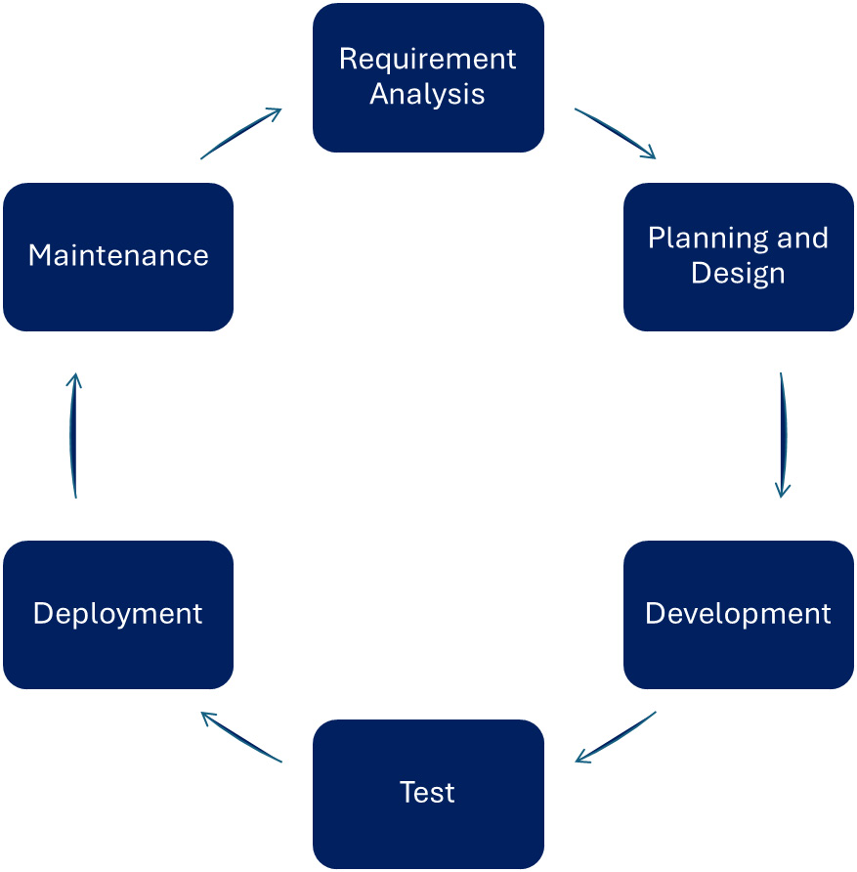

Figure 1.1 – The software development phases

Let us discover these phases:

* ****Requirement analysis**** or requirement engineering is the step in which the development team collects customer requirements and objectives. The development team works closely with customer representatives to identify the key features of the solution. In this phase, requirements are also analyzed, meaning that needs are validated and documented unambiguously. This phase also covers identifying the non-functional requirements of the system, such as performance, resource needs, or availability expectations. It is a crucial step to ensure that the final product meets the customer’s needs and expectations.
* The ****planning and design phase**** is the one in which the development team creates the project plan with cadence and key deliverables. This process usually ends with a ****Work Breakdown Structure**** (****WBS****). The development team then assigns milestones to different parts of the WBS to be able to track the progress at a higher level. A milestone frequently signifies the completion of contractual obligations, leading to financial settlements. In this phase, the team also designs software architecture and ****User Experience**** (****UX****). Wireframes for the UI and prototypes for architecture are frequently used to get more input for effort estimations. Another practice to calculate the effort and complexity of the tasks in WBS is to play so-called ****planning poker****. Team members use cards with numbers to assign values to tasks separately. At the end, poker team members reveal their cards and discuss the results until they reach a consensus.
* The ****development phase**** is essentially the coding part. The team implements the application, writes the unit tests, and debugs the code. Traditional methodologies view the development phase as solely for writing code. In contrast, Agile approaches eliminate this separation and incorporate testing and deployment earlier in the process. They do it so that they can repeat the coding-testing-deployment cycle many times in an iterative way. In addition, these modern approaches foster collaboration between development teams and client representatives by providing access to the working software at the end of every iteration.
* The ****test and quality assurance phase**** is about creating different levels of tests for the application. The development team writes and executes integration tests, system tests, end-to-end tests, performance tests, and other non-functional tests, such as resource usage or chaos tests, to validate the system against the defined requirements. In the past, there were dedicated test teams whose main duty was to provide these tests and to ensure that the software meets the customer’s requirements. When the validation passed, the software was ready to deliver to production.
* The ****deployment phase**** is the step in which the development team deploys the solution into the client’s environment. It involves not just installing the system but also configuring it and migrating data from previous solutions in some cases. Deployment can target on-premises or cloud infrastructure. Nowadays, this process is fully automated. The development team conducts user training if needed and hands over the documentation (user manuals) to the customer, too.
* The ****maintenance phase**** is about monitoring the solution in a production environment. Based on the results and customer feedback, the development team provides updates, upgrades, bug fixes, security patches, and even new features. This phase is sometimes referred to as a support period and customers pay additional fees to get those services from development teams.

*Application runtime platform*

*Low-code/no-code platforms**are**application runtime platforms**that enable professional developer teams to develop applications of any kind. Since this application development is fully identical to any other custom application development, the same SDLC methodologies can be applied to these low-code or no-code applications.*

Depending on the software development project, an organization can apply different approaches to their work, from following fixed guidelines to adapting to changing situations. However, in all scenarios, the aforementioned phases are the same. In the next section, we will learn about the most-used methodologies.

## Methodologies

As we have seen, the SDLC describes the main phases of the software development process, focusing on the question of *why*, but it does not define *what* or *how* we should implement those phases. The methodologies tell us what we should deliver and how we should work in those phases in detail.

By examining the following two distinct methodologies, we can better understand what each aims to define for software development projects:

* The Scrum framework iterates through all the phases of SDLC from requirement analysis, planning, development, testing, and deployment to maintenance every 2-4 weeks
* The waterfall methodology only goes through the SDLC phases once in a sequential way and it takes several months or sometimes even years

Some of the major methodologies include the following, in chronological order:

* Waterfall
* V-model
* XP
* Iterative and incremental development
* Agile (Scrum)

In the next sections, we will learn more about these frameworks and methodologies, and how they could be applied to low-code/no-code platforms, such as Microsoft Power Platform.

### Waterfall

This is the oldest software development process that defines the software development phases sequentially and rigorously.

It is very often criticized for its rigidity and sequential method. As we will see, all upcoming methodologies have tried to improve on this original approach in different ways, but it has also some advantages foremost in software development projects, such as writing kernel drivers or programming mission-critical applications, such as nuclear plant software. The following figure visualizes those development phases in the waterfall model that were discussed earlier in this chapter:

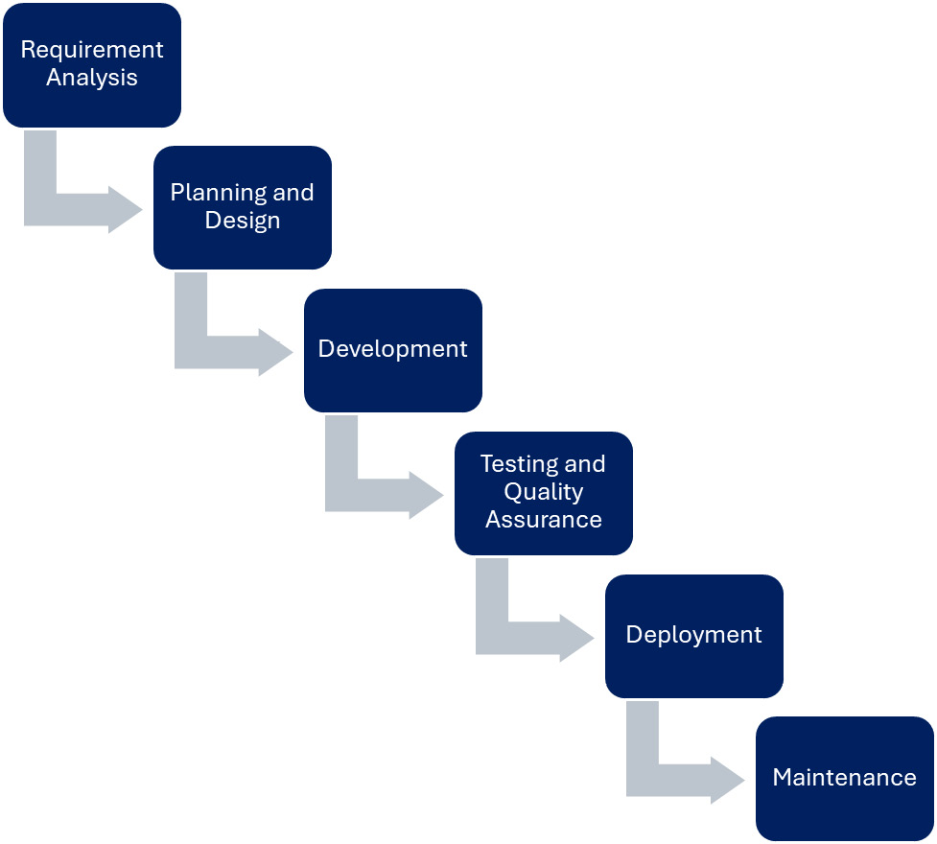

Figure 1.2 – The waterfall model

The phases, requirement analysis, planning and design, development, testing and quality assurance, deployment, and maintenance, are equivalent to the phases described earlier in this chapter. The difference is the sequential execution order of those phases.

The pros of this model are as follows:

* It is a preferred methodology for mission- or business-critical projects.
* It is preferred when *repetitive* application development is required. This occurs when projects are highly similar, such as developing kiosk applications or writing embedded software. In these cases, the requirements and customer expectations are well understood, and no changes are anticipated.
* Project milestones and deadlines are clearly defined.

The cons are as follows:

* Big upfront design cost
* Customer expectations cannot be considered after requirement analysis
* Time-to-market is huge; it is measured in years and can result in outdated deliveries
* Testing does not take place until the end of the SDLC

In spite of the aforementioned cons, even in low-code/no-code platforms, we can use this methodology to create our applications using the foundation provided by the platform.

### V-model

This model is an enhancement of the previous one to improve the time-to-market ****Key Performance Indicator**** (****KPI****) with high software quality by introducing parallel activities in the process.

The following figure shows the process in detail:

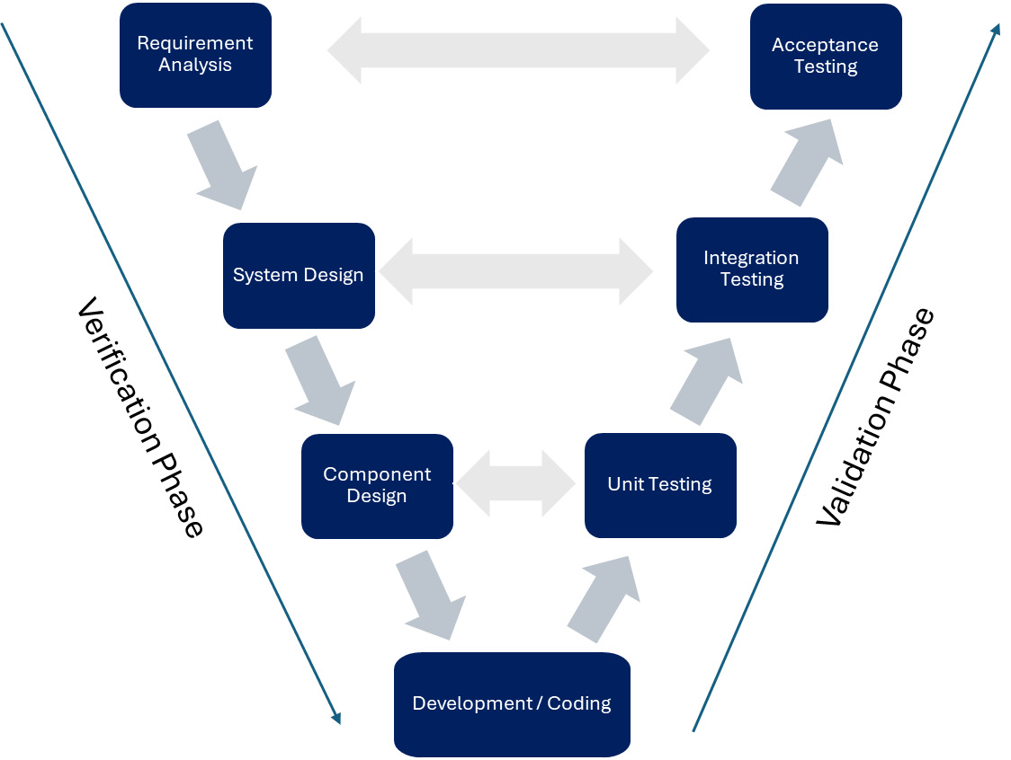

Figure 1.3 – A V-model

Everything starts with the decomposition of the requirements (the domain space) into modules or components that can be implemented separately. The V-model expects modular architecture, but not necessarily loosely coupled architectures in which those components are considered subsystems of the large system design. Low-code/no-code platforms, such as Microsoft Power Platform, provide built-in tools for testing and validation, which can help developers ensure that their applications meet the requirements and function as intended. In a low-code/no-code environment, the V-model can be realized by following a structured development process that includes requirements analysis, design, development, testing, and deployment. Each phase of the process can be completed using the tools and features provided by the low-code/no-code platform, allowing developers to build, test, and deploy their applications in a streamlined and efficient manner.

There is a corresponding V-model definition for US government institutions as part of the US Government Standard. It is more detailed and stricter than the original V-model definition to fulfill the US government’s requirements.

The pros are as follows:

* Faster time-to-market with higher overall velocity
* Built-in quality assurance

The cons are as follows:

* It is still a rigid process
* Requirement changes can hardly be managed

### Extreme programming

****Extreme Programming**** (****XP****) as a software development methodology emphasizes the need to accelerate the reaction time of the development team to customers’ changing requirements – which is expected in any software development project – by maintaining high software quality.

This methodology has become famous because of some paradigm shifts, such as introducing ****pair programming**** and strict code reviews, as well as thriving bare minimum architecture solutions, which are called ****Minimum Viable Products**** (****MVPs****). Pair programming techniques mean that two developers work together to write the same code. One developer writes the lines, while the other reviews every piece of new code on the fly. The two developers switch between these activities (who writes and who reviews) very often, but eventually, they will work on the same activity in the WBS. The MVP is the bare minimum product, which may have technical debts and architecture violations, that can already demonstrate the features requested by customers or identified by the field. MVPs are used to collect feedback from customers or contractual partners.

The goal of an MVP is to test the product’s core assumptions and to evaluate that it has a market fit, that is, that it is valuable to customers. In XP, it is common practice to keep those MVPs as they are and not to do more than expected. The main principles of XP are as follows:

* ****Customer involvement****: XP emphasizes close collaboration between the development team and the customer
* ****Frequent releases****: XP advocates for releasing working software frequently, even if it’s not feature-complete
* ****Pair programming****: XP encourages developers to work in pairs, with one person writing the code and the other reviewing it
* ****Test-driven development****: XP emphasizes creating tests before implementing business logic to ensure that the code meets the requirements
* ****CI****: XP encourages integrating code changes frequently to catch integration issues early

While it is not specifically designed for low-code/no-code platforms, many of the principles of XP can be applied to development on these platforms.

*XP and low-code/no-code platforms*

*Microsoft Power Platform supports some of these principles as the market leader in low-code/no-code platforms. Even pair programming (the co-authoring feature of PowerApps canvas applications with a YAML-based code editor), test-driven development for canvas apps, and CI are fully adapted into PowerApps.*

The pros are as follows:

* It promotes teamwork and collaboration, which can lead to more effective problem-solving and decision-making
* It emphasizes customer satisfaction, which ensures that the customer gets what they need, that is, that the product exactly meets their expectations
* It allows for flexibility and adaptability, as changes and new requirements can be incorporated into the development process as they arise
* It encourages frequent communication and feedback, which can help identify and address problems early in the development process

The cons are as follows:

* Bare minimum architectural solutions increase overall technical debt
* It can be challenging to implement in organizations with rigid hierarchies or cultures that do not value teamwork and collaboration
* It can be difficult to accurately estimate the time and resources required for each iteration, which can make project planning and management more difficult

### Iterative and incremental development

In software development, there are two equally important objectives: ****velocity**** and ****quality****. We have already seen how quality is built into the processes in the previous methodologies. However, quality means deceleration because it requires time and effort from development teams that could otherwise be spent on creating new features and requirements. That’s why the software industry has introduced the term velocity. Velocity is defined by the number of features (story points) that a team can deliver in a period. This is one of the major KPIs of almost every SDLC methodology and was one of the main drivers that created the incremental and iterative approaches.

****Iterative and incremental development**** is a software development methodology that emphasizes breaking down the development process into small, manageable chunks and delivering working software in each iteration. This approach allows for flexibility and adaptability, as changes and new requirements can be incorporated into the development process as they arise.

Low-code platforms, such as Microsoft Power Platform, can be used to support iterative and incremental development. These platforms provide building blocks that enable developers to quickly build and deploy applications without the need for extensive coding. This makes it possible to deliver working software quickly and iteratively, allowing for frequent feedback and adaptation. In an iterative and incremental development process using a low-code platform, developers can work on small, manageable chunks of functionality, building and deploying them as they go. This allows for frequent feedback from end users and enables developers to incorporate changes and new requirements into the development process as they arise. The visual development environment provided by low-code platforms makes it easy to make changes and add new functionality, allowing developers to quickly adapt to changing requirements.

The pros are as follows:

* It allows for early feedback and validation from end users, which ensures that the product exactly meets their expectations
* It enables developers to incorporate changes and new requirements into the development process as they arise, allowing for greater flexibility and adaptability
* It reduces the risk of project failure, as problems can be identified and addressed early in the development process
* It allows for the delivery of working software quickly and iteratively, providing value to end users and stakeholders early in the development process

The cons are as follows:

* It can be challenging to accurately estimate the time and resources required for each iteration, which can make project planning and management more difficult
* It requires a high level of collaboration and communication between team members
* It can be difficult to maintain a consistent vision and direction for the project, as changes and new requirements are incorporated into the development process

### Rapid application development

****Rapid Application Development**** (****RAD****) was originally developed as an alternative approach to the waterfall model and, as its name states, it is about striving for speed and velocity in the software development life cycle. It was officially introduced by James Martin in 1991. The RAD approach emphasizes the swift development of applications through iterative releases and continuous client feedback. By applying agile methodologies and rapid prototyping, RAD ensures software usability, responsiveness to user feedback, and timely delivery. The process-driven nature of RAD, with its focus on ****testing prototypes**** and making quick adjustments, enables the delivery of the expected product in a shorter timeframe.

Low-code or no-code platforms, such as Microsoft Power Platform, are ideal tools for RAD, since on top of the existing building blocks – such as software components and packages in traditional software development – developers can easily add their customizations and focus on the value creation process.

The pros are as follows:

* ****Shortened development time and higher team velocity****: The RAD approach focuses on rapid prototyping and iterative releases, which can significantly reduce the development time.
* ****Flexibility and adaptability****: The RAD approach allows for changes to be made during the development process, making it more flexible and adaptable to the changing needs of the project.
* ****Easier risk management****: By breaking down the development process into smaller, manageable chunks, issues can be identified and addressed early in the development process, reducing the likelihood of major setbacks.
* ****Less custom code and shorter testing times****: The RAD approach relies on the use of pre-built components and code generation tools, which can reduce the amount of manual coding required.
* ****Real-time user feedback****: The RAD approach allows customers to provide feedback to developers at any time since the development iterations are very fast, and they always produce working software in the end.

The cons are as follows:

* It may not be applicable to large, complex projects that require detailed planning and design. RAD relies on the reuse of software components, which can limit the flexibility and customization of the final product.
* RAD may result in a lower-quality product, as the focus on rapid development may lead to shortcuts being taken and compromises being made in the development process.
* RAD may not be suitable for projects with strict requirements for security, reliability, and performance, as the rapid development process may not allow for thorough testing and optimization.

These disadvantages are relevant to custom software development projects because the testing prototypes (MVPs) and technical debts are hard-coded into the process. Nowadays, RAD tools provide frameworks and reusable packages in public repositories to support professional developer teams to gain all the benefits of rapid development.

*RAD prosperity*

*Due to the digital transformation demand of enterprises, the world is facing traditional long development timelines and software developer shortages, which means that approximately 4 million developers will be missing from the market by 2025 according to the IDC. Low-code/no-code platforms embrace this opportunity to provide RAD tools for professional developers.*

### Agile

Agile principles emphasize flexibility, collaboration, and customer satisfaction. “*The only constant is the change”*, “*test and fail fast”*, “*individuals and collaboration over processes”*, and “*a customer-first mindset”* are the most widely heard phrases on the topic of the agile development process.

*RAD versus Agile*

*Although the RAD and agile methodologies share some similarities, there are key differences in their approach. RAD**prioritizes the development of prototypes to gather user**feedback, while agile divides the project into smaller features that are delivered incrementally through a series of sprints throughout the development cycle.*

In the software development life cycle, agile is an iterative approach that focuses on delivering working software frequently with a high level of adaptability to changing requirements. Agile development teams work closely with customers and stakeholders to prioritize features and requirements. They use techniques such as CI, automated testing, and frequent releases to ensure that the software is always in a working state.

In an agile development process using a low-code platform, developers can work closely with end users to gather feedback and incorporate changes into the development process as they arise. The visual development environment provided by low-code platforms makes it easy to make changes and add new functionality, allowing developers to quickly adapt to changing requirements.

The pros are as follows:

* Agile development allows for early feedback and validation from end users, which can help ensure that the final product meets expectations exactly
* It enables developers to incorporate changes and new requirements into the development process as they arise, allowing for greater flexibility and adaptability
* It reduces the risk of project failure since issues and risks can be recognized and targeted early in the development process
* It allows for the delivery of working software quickly and iteratively, providing value to end users and stakeholders early in the development process

The cons are as follows:

* It can be challenging to accurately estimate the time and resources required for each iteration, which can make project planning and management more difficult
* It requires a high level of collaboration and communication between team members, which can be challenging to achieve in some organizational cultures
* It can be difficult to maintain a consistent vision and direction for the project, as changes and new requirements are incorporated into the development process

One way to comprehend the concept of agile is by comparing it to another SDLC methodology, such as the V-model method. In the V-model approach, the scope of the product is predetermined, while time and resources are adjustable. Organizations using the V-method will increase the number of programmers and extend schedules to deliver the product they have planned to release. On the other hand, in the agile approach, the product’s scope is adaptable, while resources and time are fixed. Agile teams pledge to deliver software on time with their current team. The product that they deliver is a flexible combination of what they have discovered the customer wants and what they can create within the given time frame.

# Agile, Scrum, and Lean

There have been other concepts, ideas, and perceptions that have significantly influenced the software industry in the last decades. Some of the approaches have been adapted from other industries, such as the Lean management from the Toyota Production System, and others have been created by key members of the software industry. We will discuss these approaches shortly to understand how DevOps and DevSecOps have become the next major step in the software industry.

## The Agile manifesto

We have already discussed Agile as an SDLC methodology because this umbrella term can be applied directly to the software development phase as well as mapped to the entire software development organization and beyond.

The ****Agile manifesto**** was created in 2001 by a group of software developers who were looking for a better way to develop software. They came up with four core values and twelve principles that have since become the foundation of the Agile movement. The four core values of the Agile Manifesto are as follows:

* ****Individuals and interactions**** over processes and tools
* ****Working software**** over comprehensive documentation
* ****Customer collaboration**** over contract negotiation
* ****Responding to change**** over following a plan

These values and principles have been widely adopted by software development teams and have helped to improve the effectiveness and efficiency of software development processes.

Agile, as an umbrella term, is a broad concept that encompasses a variety of methodologies including Lean, Scrum, Kanban, and others.

## Lean management

Lean management, developed by Taiichi Ohno, the creator of the Toyota Production System, is a methodology that focuses on creating value for customers by optimizing resources, reducing waste (*muda* in Japanese), and continuously improving processes. Ohno’s goal was to reduce the time between car order and car delivery:

“*All we are doing is looking at the timeline from the moment a customer gives us an order to the point when we collect the cash. We are reducing that timeline by removing the nonvalue-added wastes” – Taiichi Ohno*

The principles of lean management include the following:

* ****Value****: Identify what the customer values and concentrate on delivering it to them
* ****Value stream****: Identify all the steps in the value stream for the product or service and remove any steps that do not create value
* ****Flow****: Ensure that the value-creating steps flow smoothly and continuously toward the customer
* ****Pull****: Let customer demand pull the product or service through the value stream rather than pushing it based on forecasts
* ****Perfection****: Continuously pursue improvements to identify and eliminate waste from the processes (strive for perfection)

Any type of organization can apply these principles and processes to improve efficiency, minimize costs, and improve customer satisfaction. Other industry sectors, such as accounting, have also applied lean principles. It’s no surprise that the software industry has adopted this concept, viewing itself as a software manufacturing factory and applying the analogy accordingly.

****Value stream**** and ****value stream analysis**** are the most relevant areas that provide a tool for any organization to understand, visualize, and improve their value creation processes.

The following figure represents a hypothetical software development organization and how it reacts to customer requests. ****Lead Time**** (****LT****) is the time spent between entering the stage and closing the stage, whereas ****Process Time**** (****PT****) is the time spent on real work or activity:

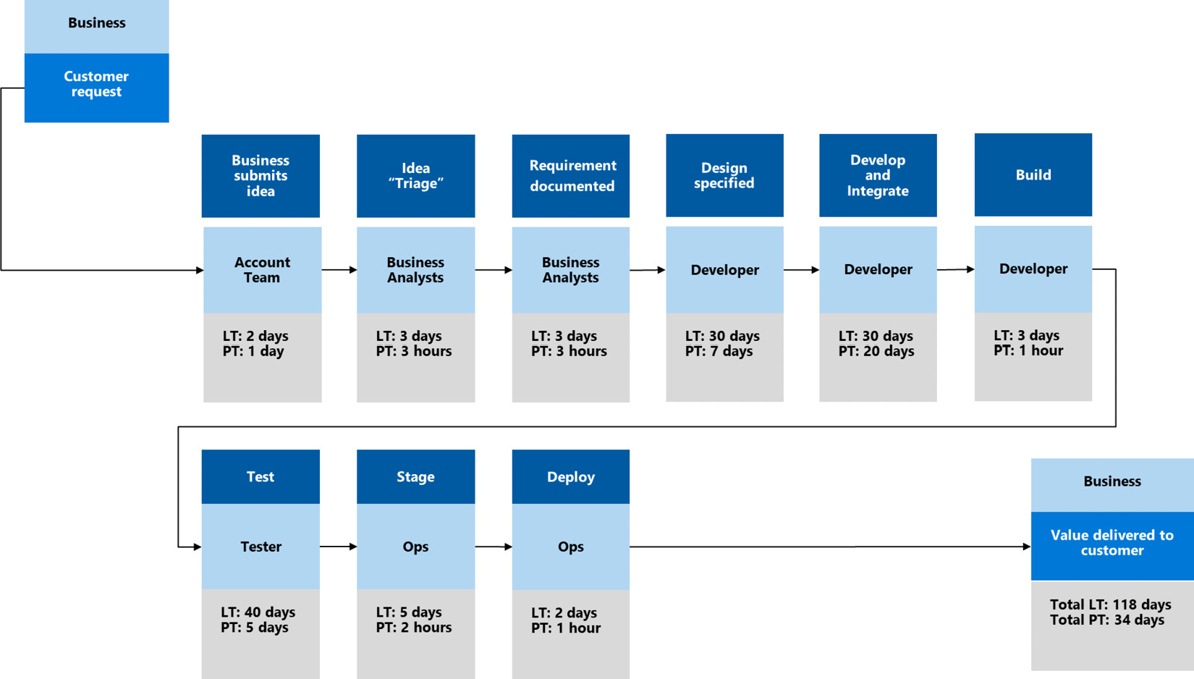

Figure 1.4 – Value stream analysis in practice

Customer requests go through different teams (accounts, business analysis, engineering, and ops) with different LTs and PTs until they reach production. This hypothetical organization can improve its efficiency by reducing the LTs spent on each phase and by accelerating the PTs.

It is obvious that low-code/no-code platforms, such as Microsoft Power Platform, can significantly decrease not just the PT but also the overall LT of any application development project. They can do this by using the pre-baked building blocks, such as front-end visuals, business logic components, and data access layers, to reduce the overall development, testing, and deployment costs of custom applications.

## Scrum

Scrum is a framework derived from the general agile principles that are often used in software development. This is one of the most widespread Agile methodologies. As we discussed earlier, Agile is an umbrella term that we can apply to SDLC methodology, project management, and organization in many ways. Scrum is a specific implementation of Agile with its own roles, events, artifacts, and rules.

Scrum is an agile framework that operates on the values of transparency, assessment, and adjustment. It uses an iterative and incremental methodology to enhance predictability and manage risks. Scrum teams deliver functional software in brief, time-bound iterations known as sprints, while constantly evaluating and adjusting their processes to improve both the product and their workflow. The following figure shows the process of incremental planning and delivery:

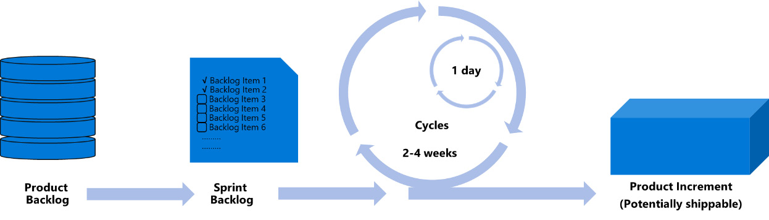

Figure 1.5 – The scrum process

Autonomous scrum teams decide which backlog items they will work on in the given sprint based on customer priorities and team velocity. Those backlog items will be moved from the product backlog to the spring backlog. A sprint usually takes 2-4 weeks and at the end of every sprint, scrum teams can deliver a potentially shippable product.

The Scrum framework defines three main roles: the ****product owner****, the ****Scrum master****, and the ****development team****. The ****product owner**** is responsible for maximizing the value of the product and representing the stakeholders (the customer). The ****Scrum master**** is responsible for promoting and supporting Scrum, orchestrating the well-known ceremonies, and encouraging everyone to abide by Scrum rules and values. The ****development team**** is a self-organizing and cross-functional team responsible for delivering a potentially shippable product at the end of each sprint.

Scrum has several ceremonies or events that are used to plan, review, and improve the process. These include ****sprint planning****, ****daily Scrum****, ****sprint review****, and ****sprint retrospective****. Sprint planning is used to plan the work for the upcoming sprint. The daily Scrum is a short daily meeting used to synchronize the work of the development team. The sprint review is scheduled at the end of the current sprint to review the backlog items completed and shift the uncompleted ones to the next sprint. The sprint retrospective is organized after the sprint review to discuss questions such as “what went well?”, “what could have been done better?”, and “how could we improve as a team?”. As a result, the team can find potential improvements and plan them for the next sprint.

Scrum framework is easily applicable to low-code/no-code platforms since these provide an ecosystem that guarantees shippable products (applications) at the end of every sprint with the roles and ceremonies defined by the framework.

# What is ALM?

There are many books and articles about ALM and, having a look at the definitions, one thing is common in all of them: ALM is broader than the SDLC and covers the entire life cycle of an application from ideation through development to discontinuity.

Per definition, ALM refers to the management of a computer program’s entire life cycle, including governance, development, maintenance, and discontinuity. It involves a wide range of activities, such as requirements management, software architecture, and project management.

The SDLC is a component of ALM that provides a detailed description of the application development phase. ALM can involve multiple iterations of the SDLC during an application’s life cycle, that is, multiple methodologies such as Agile and V-model can be applied in different phases. ALM continues after development and first release until the application is no longer used.

ALM has brought several disciplines and roles together. It includes project management, change management, requirements management, software architecture, CI, development, CD, testing, release management, and maintenance. These disciplines were managed separately in the past and organizations – before establishing ALM – were much more siloed. Internal processes were prioritized over collaboration and communication among different roles and units within the organization.

These days, ALM tools offer a standardized platform for communication and collaboration among software development teams and associated departments, such as project management, business analysis, testing, and IT ops. These tools can also streamline the process of software development and delivery through automation.

Modern integrated ALM tools, such as Azure DevOps Services, GitHub, or GitLab, support the following:

* Requirement engineering
* Project management – including planning and tracking
* Bug- and issue tracking
* Version control system
* Build – CI
* Automated testing
* Release – CD
* Monitoring applications in production and learning from usage patterns, telemetry logs, and failures

The following figure shows the main areas of ALM and how these different disciplines work together in a cyclic way:

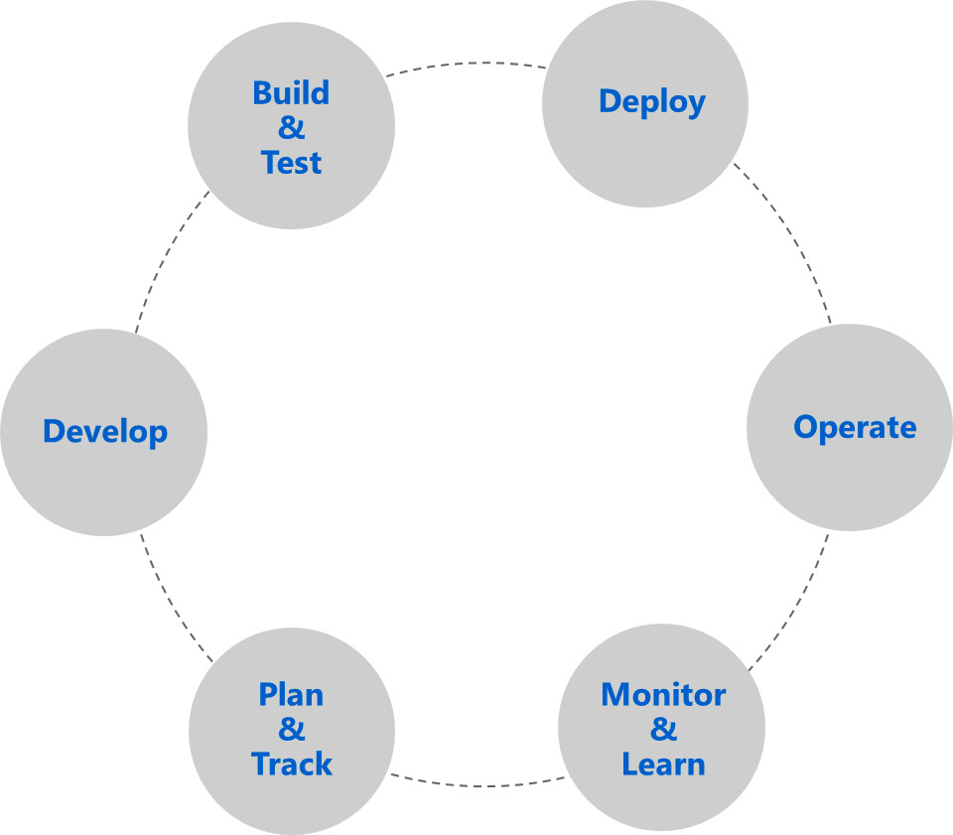

Figure 1.6 – The main areas of ALM

ALM can easily be applied to low-code/no-code platforms since they are designed to be modern application runtime platforms hosting and executing hundreds or even thousands of applications created by professional developers.

In the next chapters, we will learn how ALM disciplines can be realized in conjunction with Microsoft Power Platform.

# CI and CD

CI and CD are widely used processes and tools in modern software development and ALM practices. The CI pipeline (workflow) is for compiling the source code and generating the binaries using build agents, whereas the CD pipeline takes those binaries and deploys them, the entire solution with its configuration to different environments, like dev, test, or production.

CI is sometimes referred to as CI builds because it eventually does the official compilation of source code on dedicated build machines (sometimes they are just Docker containers). During CI builds, unit tests are also executed; those tests require no orchestration of the application and run in the millisecond range. CI is one of the greatest processes to assure software quality and to avoid the regression of our applications. In the case of large development projects, it is also very common to create ****build farms**** consisting of hundreds of build machines to generate deliverables or packages on every code change.

There are two CD terms in practice. ****Continuous delivery**** means that the application is ready to be delivered all the time, but the deployment is not automated. Typical examples for continuous delivery are to create a Docker image after compiling the code, or to create an installer to the generated binaries. ****Continuous deployment**** takes an additional step and automates the deployment process to target environments. In this book, the CD acronym refers to this latter definition. It is important to note that the CD process transfers the same version of the application throughout to different environments with quality gates established at each stage. The following figure shows a typical CD process:

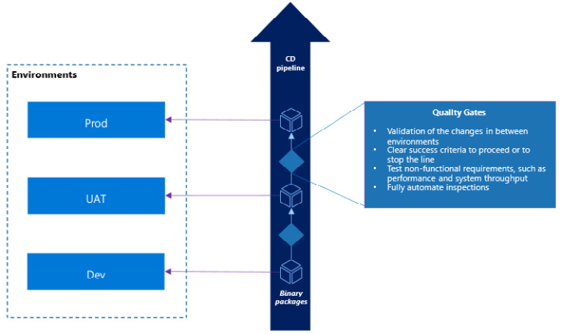

Figure 1.7 – CD with quality gates

After the successful compilation of source code during CI, the generated binary packages go through the deployment pipeline. The deployment pipeline delivers these packages to the environments (dev, UAT, and prod) in a fully automated way and validates and verifies the changes by executing automated tests.

At organizations with highly matured DevOps practices, it is usual that CD takes place very often, sometimes tens or even hundreds of times per day, to deliver parts of the solutions directly to production.

As part of the deployment process, CD workflows are usually used to implement the deployment strategy of the developed application. There are several deployment strategies that can be used to release new versions of an application:

* ****Basic deployment**** is the simplest deployment strategy, whereby the new version of the application is deployed to the production environment, replacing the old version. This approach is straightforward, but it can result in downtime and does not provide an easy way to roll back to the previous version if something goes wrong.
* ****Blue-green deployment**** involves having two identical production environments. One runs the old version of the application (blue) and one runs the new version (green). Once the new version has been tested and is ready for release, traffic is gradually shifted from the blue environment to the green environment. This approach allows for easy rollback if something goes wrong, as traffic can simply be shifted back to the blue environment.
* ****Canary deployment**** is similar to blue-green deployment, but instead of shifting all traffic at once, only a small percentage of traffic is initially directed to the new version of the application. This allows for testing the new version with real users and real traffic before fully releasing it. If everything goes well, traffic is gradually shifted to the new version until it is handling all traffic.
* ****A/B testing**** is a deployment strategy that is often used to test new features or changes to an application. It involves running two versions of the application simultaneously, with some users being directed to the old version and some to the new version.
* ****Rolling deployment**** is a strategy whereby the new version of the application is gradually rolled out to the production environment. This is done by updating a subset of servers or instances at a time, while the rest of the servers or instances continue to run the old version of the application. Once the update is complete and verified to be working correctly, the next subset of servers or instances is updated, and so on, until all servers or instances are running the new version of the application.

Modern ALM tools, such as Azure DevOps Services, GitHub, or GitLab, provide end-to-end support for CI/CD pipelines and workflows and automate everything after code has been committed to Git repositories.

In cloud-native microservice architecture using Kubernetes orchestrator to host and scale highly distributed services, a so-called ****pull**** model is widely adapted to deploy the latest version to production. This approach is called ****GitOps****. Tools such as ArgoCD or FluxCD run inside the Kubernetes cluster and when changes or commits happen in a monitored Git repository, those tools deploy the updates inside the cluster with zero downtime rollouts. In low-code or no-code platforms, this approach is just partially applicable in scenarios in which the pull model itself can be considered, such as getting configuration data from a central repository or leveraging the use of feature flags.

# DevOps-enabled architecture patterns

DevOps is one of the shift-left approaches that we have seen in the software industry. It brings operational teams (ops) close to developer teams (devs) to enable and accelerate the continuous value delivery to our customers. It means a mindset and cultural change for people; it requires processes and tools to transform an organization into a DevOps one.

“You build it, you run it” is one of the most impressive quotes that describes how developers and operations teams need to come together and form one diverse team to cover the end-to-end repetitive process from coding through deployment to operations. Ops becomes part of the team. This shift-left approach increases the overall productivity of organizations. DevOps is a paradigm shift and a cultural change at the organizational level to improve collaboration between development and operations teams, and to enhance the efficiency and quality of software production. An approach to reviving the ****day 0 company**** mindset, often called a ****startup mentality****, involves defining essential rules, processes, and safeguards that enterprise customers in regulated industries need to implement and uphold. Being agile and value-oriented at scale mean to get rid of any waste that is not part of the value creation process. DevOps also brings another benefit for enterprises, namely to maintain only one version of the developed product: the version that runs in production.

In addition, DevOps expects advanced monitoring of the software in production to not operate services blindfolded. Gathering telemetry data, traces, and callstacks in case of failure is crucial to know how the developed service or component is used. ****Application Performance Monitoring**** (****APM****) tools, such as Azure Application Insights, can be used to monitor and proactively notice performance degradation before outages happen.

DevOps teams also emphasize that solutions should create ****zero downtime deployment****-capable production environments. Orchestrators and application runtimes such as Kubernetes support this approach by design with rolling deployments.

In highly mature DevOps teams the concept of ****rolling forward**** is also widely used. Rolling forward means that if issues or errors are encountered during deployments in production, then the team produces fixes for them and rolls that version out. Rolling back to the previous version is not considered anymore.

DevOps has also defined new roles in the software development industry. One of them is the ****Directly Responsible Individual**** (****DRI****) role, which is also known as Google’s ****Sheriff**** or Facebook’s ****Designated Response Individual****. The DRI is responsible for incident management, service availability, and service health. They are the single point of contact during the sprint, both internally and externally. They communicate with customers, newspapers, and other media if outage with high or medium impact encounters. This has dramatically improved the overall customer experience. On the other hand, they also provide information to other DevOps teams internally during service incidents.

Highly mature DevOps teams and their team members can even work in different roles in every sprint. For instance, the DRI role is rotated in the team in every sprint. This leads to huge benefits for the team members: after a few sprints, everybody in the team can build up expert knowledge in every discipline (coding, testing, and operating the services).

DevOps also assumes highly automated processes. There are engineering teams at large IT companies that follow the principle of automating everything. The rule of thumb is: if we only need to do it once, we can do it manually, but if we need to repeat it even once again, we are responsible for creating the automation scripts for it.

Any architecture addresses so-called ****-ilities****, which are non-functional requirements, such as auditability, availability, compatibility, composability, configurability, accessibility, adaptability, affordability, customizability, demonstrability, deployability, durability, usability, extensibility, flexibility, interoperability, manageability, portability, predictability, recoverability, reliability, repeatability, reusability, scalability, serviceability, sociability, simplicity, testability, sustainability, traceability, reproducibility, and so on.

*Power Platform and the -ilities*

*Power Platform components**have been designed in such a way that most of these abilities are available out of the box. As Power Platform solution architects, we don’t need to care about requirements, such as auditability, availability, reusability, and so on because these are provided**by the underlying application runtime as a*****Software-as-a-Service*****(*****SaaS*****) offering.*

There are two very important ones for DevOps:

* ****Deployability**** refers to the ability to easily and reliably deploy new versions of an application to the production environment
* ****Testability**** refers to the ease with which a system or its components can be tested to ensure that they meet the specified requirements and function correctly

These two ****abilities**** make it possible for developers to change any place in the code base and to easily and reliably deploy new versions. The ideal DevOps architecture is based on loosely coupled services (not necessarily microservices) that can be deployed in different release cycles to production. The application and its components are designed to support various deployment strategies, such as basic deployment, blue-green deployment, canary deployment, A/B testing, and rolling deployment, as mentioned earlier.

The following figure shows a monolith architecture-based deployment versus a modern microservices-based approach:

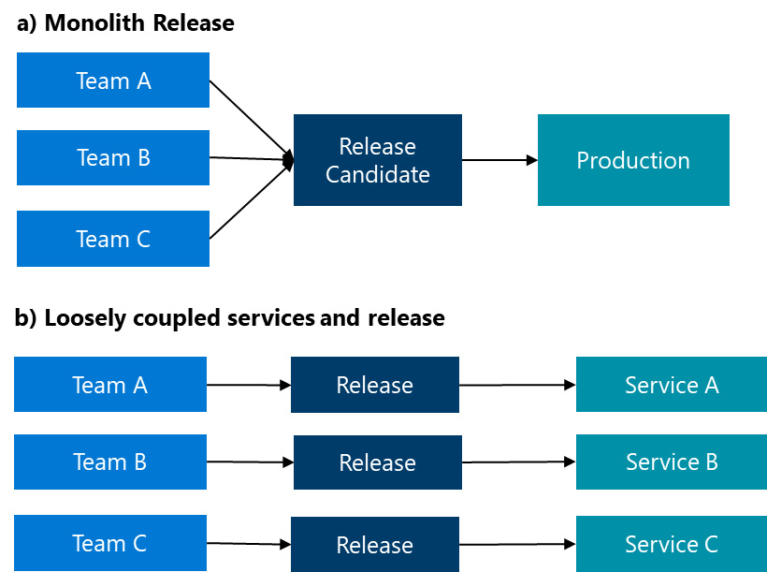

Figure 1.8 – Monolith versus loosely coupled services and release

In monoliths, although the teams work on different parts of the software, the release can happen only once together containing the changes of all services. If Service A developed by Team A breaks the release, then the changes by Team B and Team C cannot reach production either. On the other hand, if the underlying software architecture is based on loosely coupled services (e.g., OpenAPI-specified REST API endpoints), then the services developed by the different teams can be deployed to production in parallel. Deployment failures have only local impacts reducing the ****blast radius**** in production.

*ALM and DevOps*

*ALM**is a broader concept that includes all aspects of software development, while DevOps focuses specifically on the collaboration between development and operations teams to improve the efficiency of the software development process. DevOps can be seen as a part of ALM, as it helps to streamline the development, testing, and deployment of software applications.*

If large engineering organizations need to run agile at an enterprise scale based on DevOps practices, the ****Scaled Agile Framework**** (****SAFe****) provides the right structure.

SAFe is a framework of patterns and practices for implementing agile principles at an enterprise scale. It defines roles and responsibilities in detail and provides exact instructions on how to plan and manage work at such a scale through the value creation process. SAFe is designed to implement agile practices across large teams and business units and it makes it possible to gain a portfolio-level overview of those agile teams’ progress.

SAFe is based on seven core competencies of business agility, which include Lean-Agile leadership, team and technical agility, Agile product delivery, enterprise solution delivery, Lean portfolio management, organizational agility, and continuous learning culture. These competencies are designed to help organizations achieve their business goals and deliver value to their customers.

SAFe also includes the concept of an ****Agile Release Train****, which is a cross-functional team of agile teams that plans, builds, and delivers software in a synchronized cadence. In this approach, the ****Release Train**** is responsible for coordinating the deployment of new versions of the application using the deployment strategies supported by the DevOps architecture. This allows for a smooth and efficient release process, while also ensuring that the application is continuously delivered to users with high quality and reliability. SAFe can be implemented in Azure Boards in Azure DevOps Services by customizing our work item tracking experience to support features, epics, release trains, and multiple backlogs.

# Summary

In this chapter, we explored the most significant breakthroughs in the software industry, delving into various SDLC methodologies, the Agile manifesto, Lean management, the Scrum Framework, ALM, and DevOps practices. We became acquainted with the patterns and practices that define modern application development and architecture. These skills and lessons are fundamental to software development and are essential concepts that every engineer should be familiar with.

As we have concluded, modern application development adheres to DevOps principles, utilizing ALM tools and disciplines to maximize value. Modern application architecture is based on loosely coupled services or microservices and supports two crucial patterns: deployability and testability.

In the subsequent chapters, we will discover how these modern application development patterns and practices can be applied to the Microsoft Power Platform and how DevOps and ALM can be implemented for the Power Platform.

# Further reading

* Geoffrey Elliott (2004)*. Global Business Information Technology: an integrated systems approach.*Pearson Education*:*<https://www.amazon.com/Global-Business-Information-Technology-integrated/dp/0321270126>
* Everatt, G.D.; McLeod, R Jr (2007)*. “[Chapter 2](https://learning.oreilly.com/library/view/mastering-devops-on/9781835880845/B22208_02.xhtml" \l "_idTextAnchor030): The Software Development Life Cycle”. Software Testing: Testing Across the Entire Software Development Life Cycle.*John Wiley & Sons*:*[**https://dahlan.unimal.ac.id/files/ebooks/2007%20[McLeod\_R.]\_Software\_Testing\_Testing\_Across\_the\_E.pdf**](https://tinyurl.com/uw2r7c8r)
* V-Model: *US Dept of Transportation, Federal Highway Administration. Systems Engineering Guidebook for ITS*: <https://www.fhwa.dot.gov/cadiv/segb/index.cfm>
* Power Apps RAD: <https://powerapps.microsoft.com/en-us/rapid-application-development-rad/>
* ALM: DAVID CHAPPELL (2008): *WHAT IS APPLICATION LIFECYCLE MANAGEMENT?*: <https://aws.amazon.com/what-is/application-lifecycle-management/>
* Lean Management: *Taiichi Ohno: Toyota Production System:*<https://www.amazon.com/Toyota-Production-System-Beyond-Large-Scale/dp/0915299143>
* DevOps: <https://learn.microsoft.com/en-us/devops/what-is-devops>
* McKinsey & Company*: Driving business outcomes through Developer Velocity 2020:*<https://www.mckinsey.com/industries/technology-media-and-telecommunications/our-insights/developer-velocity-how-software-excellence-fuels-business-performance#/>
* DRI role: <https://www.microsoft.com/insidetrack/blog/rotating-devops-role-improves-engineering-service-quality/>
* SAFe: <https://scaledagileframework.com/agile-release-train/>

# 2

# Getting Started with Microsoft Power Platform

****Microsoft Power Platform****, which has been recognized as a leading enterprise low-code application platform for several years now, is a technology that helps organizations digitize their business processes. Throughout this chapter, we will provide you with an overview of Microsoft Power Platform and help you understand why it is beneficial for every professional software developer or business user to gain skills in this low-code/no-code application platform.

We will explore various products that are part of the Microsoft Power Platform family, such as Power Automate, Power Pages, and Copilot Studio. Familiarizing yourself with the Microsoft Power Platform family members will help you to better understand how to pick and choose the right set of services to streamline your work processes. We will create our first trial environment to test Power Platform capabilities. Then, we will move on to the Power Platform administration, discuss the standards and compliance regulations that Microsoft Power Platform adheres to, and finish with an explanation of some common real-world business solutions when using Power Apps and Power Automate.

In this chapter, we’re going to cover the following main topics:

* The rise of low-code/no-code
* Getting started with Microsoft Power Platform services
* Power Platform administration
* Governance, compliance, and data privacy
* Starting to build real-world business solutions

# Technical requirements

This chapter does not require any specific technical prerequisites. We will introduce you to the Microsoft Power Platform services and administrative configuration options, which you can follow along by using your workstation with a modern internet browser and internet connectivity.

In this chapter, we will use a set of trial Microsoft Power Platform licenses in order to create a Power Platform environment, which you can then continue to use to test Microsoft Power Platform services.

Should you already have your own Microsoft Power Platform environment, feel free to use it to follow along with the chapter, and more importantly, use it in the following chapters, which will have more hands-on exercises. We recommend creating a separate Power Platform environment for the work done in this book.

# The rise of low-code/no-code

In this section, we will take a look at the concept of ****low-code****/****no-code**** (****LCNC****) development and explore why there is a growing demand on the market to adopt this approach and its associated tools. By doing so, we will gain insights into the significance of this application development approach and where it is heading in the future.

LCNC is an application development method that allows application makers to create software applications with less or no coding and in a shorter amount of time, supported by a ****software-as-a-service**** (****SaaS****) platform that abstracts the complexities related to scaling, data management, and so on. Even though we often come across *LCNC* as a complete term, there are some differences between LC and NC.

An LC development approach will still require application makers to have at least a fundamental knowledge of software development, since some portion of the application could still use code to support a business logic or a certain function. This allows us to build software applications that are more sophisticated and complex, compared to NC applications.

In today’s era of ****artificial intelligence**** (****AI****) and AI assistants, such as Microsoft’s Copilots, which help us to be more productive with tools by only using natural language instructions, we can also get from them complete code by only providing them with a prompt in a natural language. This reduces the gap between the LC and NC development approach. However, these AI assistants are called Copilot for a reason, and this is due to the fact that users still need to understand the received suggestions to validate whether they will perform what was instructed. Our last chapter in the book will cover Microsoft’s Copilots, especially Copilots for Power Platform services, which will help us learn more about how to benefit from them.

The NC development approach focuses on the use of visual tools to visually build applications through drag and drop capabilities, allowing simple customizations, such as attribute and property configurations. Using such an approach means that we are more limited with the customizations; conversely, we do not require any prior knowledge of software development. This allows almost anyone in an organization to become an application maker. The NC approach can also be used to quickly prototype applications, which are then handed over to pro-developers or application makers with LC experience to extend the application with more complex logic.

Many platforms, including Microsoft Power Platform, combine both development approaches, thus giving an organization the possibility to choose an approach based on the project/application and the available resources.

LCNC application development approach is not something new. LCNC development platforms can trace their roots back to the 1980s. Microsoft Excel, the fourth-generation programming languages, and the rapid application development tools all played significant roles in the development of Microsoft Power Platform. ****Fourth-generation languages**** (****4GLs****) were actually designed with someone who is not strictly a software developer in mind, as the programming language is simplified and requires fewer commands to operate, compared to the other programming languages.

Even though there are many tools available on the market to enable users to build their applications and websites with the NC approach, the rich and extensive history of Microsoft tools, such as Microsoft Excel, Access, and other business productivity tools, have played an important part in creating LCNC development platforms as we know them today.

The idea behind the LCNC development approach is to offer non-developers, business analysts, and business users a platform that they could use with the knowledge that they already have. Since many users already know how to use Microsoft tools such as Microsoft Excel, Microsoft Word, and Microsoft PowerPoint, they can easily learn how to use Microsoft Power Platform, which is like a combination of these products. This allows anyone to create business applications faster, without or with little code writing. Interestingly, even the code-writing part follows the same pattern and matches the experience of formula writing in Microsoft Excel, which reinforces the theory of a connected experience across Microsoft tools.

## The current and the future state of LCNC development

With the rapid pace of work and a constant urge to digitalize their operations, many companies seek ways to do more in less time, with tools that can be used not only by traditional software developers but also by other employees. Anyone with the determination to develop new applications and digitalize and optimize business processes can become an application maker and build applications, automation workflows, and chatbots that support business operations. This idea that everyone can be a developer has fueled the adoption of LCNC tools. However, there are also other reasons why we have seen such an increase in the adoption of these tools.

Over the past five years, there has been a significant increase in interest in LC development platforms worldwide. The biggest milestone that impacted this rise and pushed organizations to accelerate their digital transformation was definitely the COVID-19 pandemic. During the global pandemic, organizations rushed to find ways to quickly adapt to changing market needs and digitalize their operations. This called for the faster development of business applications, which *increased the demand for skilled professional developers*. However, as an outcome, this led to a shortage of professional developers on the market.

In 2022, the United States Bureau of Labor Statistics predicted a 25% growth in application development and quality assurance testing demand in the next 10 years, which is much faster than the average for all occupations, as mentioned in their report. Companies can now bridge the gap of the professional developer shortage by acquiring LC developers or training their business users to become app makers.

According to Gartner, the LC development technology market will grow even further. Based on the 2022 market research, LC application platforms are projected to be the largest component of the LC development technology market in 2024, growing to reach nearly $12.3 billion in revenue.

In our discussion of LC development tools, you would be forgiven for thinking that this addresses only the area of software application development; however, we should not overlook the rising trend of interest in *hyperautomation*. This is an area that covers different technologies, including ****Robotic Process Automation**** (****RPA****) and ****Digital Process Automation**** (****DPA****), which help organizations mitigate the high demand to digitize their business operations.

Again, AI assistants, such as Microsoft Copilot, can help increase the adoption of LCNC tools. With only natural language, app makers can turn their ideas into fully functional applications.

## Understanding the benefits of LCNC

LCNC development approach offers several benefits to organizations. One of the biggest benefits is that practically anyone can be an app maker, no matter what their software developing skills are, which helps to close the pro-developer gap. Those who have no experience in software development and prefer visual experience for application development can leverage the NC approach, while others who have some software development skills or experience in writing formulas can benefit from the LC approach, where app makers can focus on the business logic for a given business application, rather than focusing on the underlying source code of the software application.

Such a development approach can help organizations to save time and money, by helping them to build custom software applications faster and more easily with fewer resources, while having their applications powered by the SaaS platform, which provides security, scalability, governance, and data management.

Lastly, we cannot ignore the fact that LCNC development tools offer great integration possibilities with first- and third-party tools, which leads to faster development of software applications with integration between different systems, applications, and services.

# Getting started with Microsoft Power Platform services

This section will describe what Microsoft Power Platform is and its basic components. We will explain how these tools empower users to create business applications, automate processes, and even gain insights into data. We will also explain how to create your own Power Platform trial account to create an environment that can be used to test the capabilities of the platform, as well as help you follow along with the following chapters.

## What is Microsoft Power Platform?

Microsoft’s approach to LCNC development is not limited to a single tool; rather, it offers a user ****a suite of tools**** that span across different focus areas, ****allowing users to use them either individually or in combination to build an end-to-end business solution****.

Microsoft Power Platform consists of five main products:

* Power Apps
* Power Automate
* Copilot Studio
* Power Pages
* Power BI

These services are all connected by a scalable cloud-based data store called Microsoft ****Dataverse****.

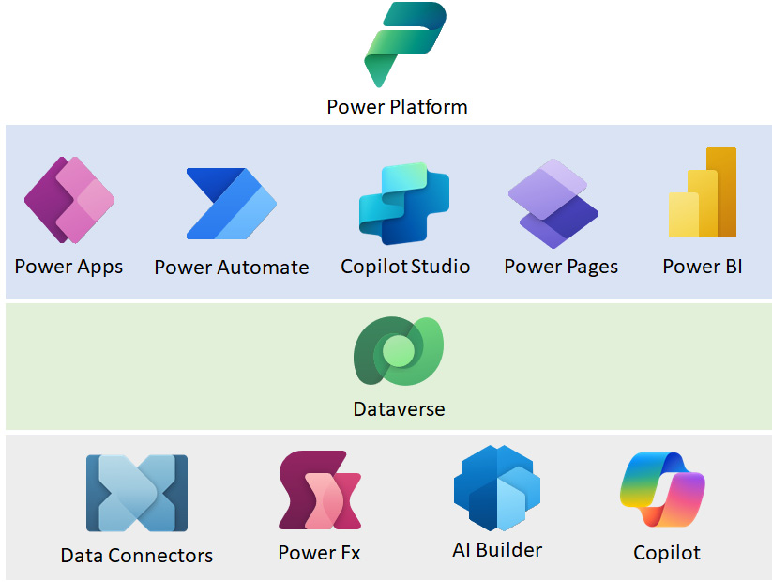

Figure 2.1 – Power Platform’s five main products and supporting services

Having a diverse range of products in the LCNC portfolio enables users to build business solutions in a flexible and modular way. These tools not only provide native integration with other Microsoft products but also empower users to build solutions more effectively.

With this, users also have the flexibility to license only the products they use, as Microsoft Power Platform services are licensed individually. Licenses can be either standalone, such as a Power Apps Premium license, or come included with another license.

As an example of having an inclusive license, some Microsoft products (such as Microsoft 365 or Dynamics 365) entitle you to use a limited set of features from selected Microsoft Power Platform services. Such an encapsulated license type is called a ****seeded license****. For example, a license for Microsoft 365 E3 or E5 includes a limited set of capabilities for Power Apps and Power Automate. To enable all Premium capabilities for Power Apps and Power Automate, a separate Premium license for these services should be purchased and used. Mostly, the licenses use a per-user subscription model; however, other variations apply.

*Important note*

*While this book doesn’t delve into the licensing details, we encourage everyone to explore the various licensing models available on the Microsoft websites, as Microsoft Power Platform licensing undergoes regular updates, making it a highly dynamic topic. Administrators and DevOps engineers should incorporate regular checks for any changes as an integral part of their responsibilities. Staying informed ensures effective management and compliance within the Power Platform ecosystem.*

*For more information about Power Platform’s capabilities**and pricing, refer to the Power Platform licensing guide, accessible on this documentation page:*<https://learn.microsoft.com/en-us/power-platform/admin/pricing-billing-skus>*.*

In October 2016, Microsoft released the generally available Power Apps and Flow (today known as Power Automate), and today, we have a very mature platform, which for five years in a row been named by Gartner as a Leader in the Gartner Magic QuadrantTM for Enterprise LC Application Platforms.

Although the platform primarily targets citizen developers, it enables you to build integration scenarios and is extensible, making it suitable even for professional developers (for example, building custom connectors through a published custom API in Azure API Management, developing code controls using the Power Apps component framework, and publishing custom models with AI Builder).

Next, let’s take a look at the Microsoft Power Platform family members.

### Power Apps

Power Apps is a product that allows users to create and run custom business applications. Applications can be rapidly developed without extensive coding, by using Visual Maker Studio and drag and drop capability. Pro-developers and app makers can create applications that connect to various data sources and integrate with many existing applications and services through connectors. Applications can be developed as a canvas application, where the focus is more on the design and custom interfaces, or a model-driven application, with the focus on the data model. An interesting aspect of canvas applications is that this type of application can be wrapped as a native mobile app package, which will resemble custom Android and iOS applications. They can be then distributed to mobile end users through Google Play Store, Apple Business Manager, Microsoft Intune, and Microsoft App Center.

### Power Automate

Power Automate is a cloud-based workflow service that helps customers address hyperautomation. It goes beyond building workflows that automate simple day-to-day repetitive tasks, all the way to automatizing very complex business processes across various services and systems. If you already use ****application programming interfaces**** (****APIs****) to access some of your backend services, then ****digital process automation**** (****DPA****) can be covered by Power Automate. If you want to automate repetitive tasks performed in a desktop application or build web automation through RPA, Power Automate is here to support you.

### Copilot Studio

Copilot Studio is a platform that builds standalone copilots. It is built on the foundations of Power Virtual Agents, a platform to build intelligent virtual agents and chatbots. Copilot Studio allows us to build custom copilots by building the topics that control the flow of conversation or keep it more dynamic, with the help of ****Large Language Models**** (****LLMs****), such as GPT. Custom copilots help users perform tasks or receive answers to questions. They can be connected to organizational data, which serves as a knowledge base, and backend systems through connectors and plugins to resolve complex tasks. Copilots can be published through different channels, such as websites, custom mobile/web applications, or any other service used for communication, such as Facebook, Slack, or Twilio.

### Power Pages

Power Pages is an enterprise-grade, scalable, and secure cloud-based service for building rich and data-driven websites. It relies extensively on Dataverse to store configurations as well as data, which is represented on websites. Even though it’s one of the youngest members of the Power Platform family, Power Pages has had quite a journey in evolving into the product that it’s known as today. It started with Microsoft’s acquisition of Adxstudio Inc., then it became Power Apps Portals, and today, we have Power Pages. Its core has stayed the same – a platform to allow users to create, host, and manage modern and visually appealing websites, with data at the center.

### Power BI

While other products from the Power Platform family are intended to automatize business processes and build business applications, Power BI is a set of tools that allow us to gain insights into data and build intelligent reports, enabling us to quickly extract the key information from the data. Dashboards and reports can be built following the same LCNC approach used for business application development. By using a drag and drop experience, we can connect various data sources and build charts and tiles that represent the extracted data.

### Power Platform’s extended ecosystem

Apart from these five core products, Power Platform products are supported by additional services and capabilities, such as Dataverse, Power Fx, Connectors, Copilots, and AI Builder. Copilots in Power Platform and AI Builder will be covered in more depth in the last chapter of this book, but we will discuss the rest in this chapter.

### Dataverse

Dataverse is a secure and scalable cloud data store that is used across Dynamics 365 and Power Platform. It allows us to create new tables that will be consumed by our business applications and apply strict security models and governance policies on them, such as permissions, column-based security, and auditing capabilities. It allows us to create views and forms over tables in Dataverse, that can then be used to rapidly build applications on top of the data model. Dataverse allows us also to build business process flows that define how data flows through its life cycle and what the business rules are that apply to a table.

### Power Fx

Power Fx is a general-purpose LC language used across Microsoft Power Platform. What started originally in Power Apps is now spread across other Power Platform services, providing a unified experience to build formulas. Power Fx is used to build custom logic in business solutions. With its spreadsheet-like formulas and resemblance to Microsoft Excel, it facilitates a rapid adoption rate. Power Fx is open source, which allows for greater transparency and community collaboration.

### Connectors

Connectors play a crucial role in the Microsoft Power Platform ecosystem. They act as an integration bridge between Power Platform and external services or data sources. Each connector comes with its own set of triggers and actions. From a licensing perspective, they are divided into standard and premium connectors, but from a technological perspective, they are divided into groups of prebuilt (connecting to first- or third-party services) and custom connectors. We will dive deeper into connectors in future chapters.

## Setting up our first environment

Now that we have a better understanding of which products are part of the Power Platform family, let’s create an environment that can be used to test these services.

As briefly mentioned in the previous section, Power Platform products are licensed separately, which is important to consider when creating a trial environment. What we recommend is to first create ****a Microsoft 365 E3**** or ****E5**** trial environment. This will give us the possibility to test out integration capabilities with Microsoft 365 or Office 365 services – for example, creating a workflow in Power Automate that uses Outlook in Office 365 to send out some emails. Alternatively, use a OneDrive for Business/SharePoint Online document library to store and manage some Excel files, which are then used in Power Apps, where the data is visually represented by forms and galleries.

### Obtaining a Microsoft 365 E3 or E5 trial account

By searching the ****Microsoft 365**** (****M365****) website for available plans and pricing, we can find several M365 plans with a free one-month trial. Examples of such plans can be found here: <https://www.microsoft.com/en-us/microsoft-365/enterprise/office-365-e3>. Since links can change, we suggest going through the available options on the M365 website, and under the ****Buy now**** button, there is a ****Try for free**** option to provision a free trial. A wizard will then guide us through the process of provisioning a trial license. First, we will need to provide our email address and sign-in details.

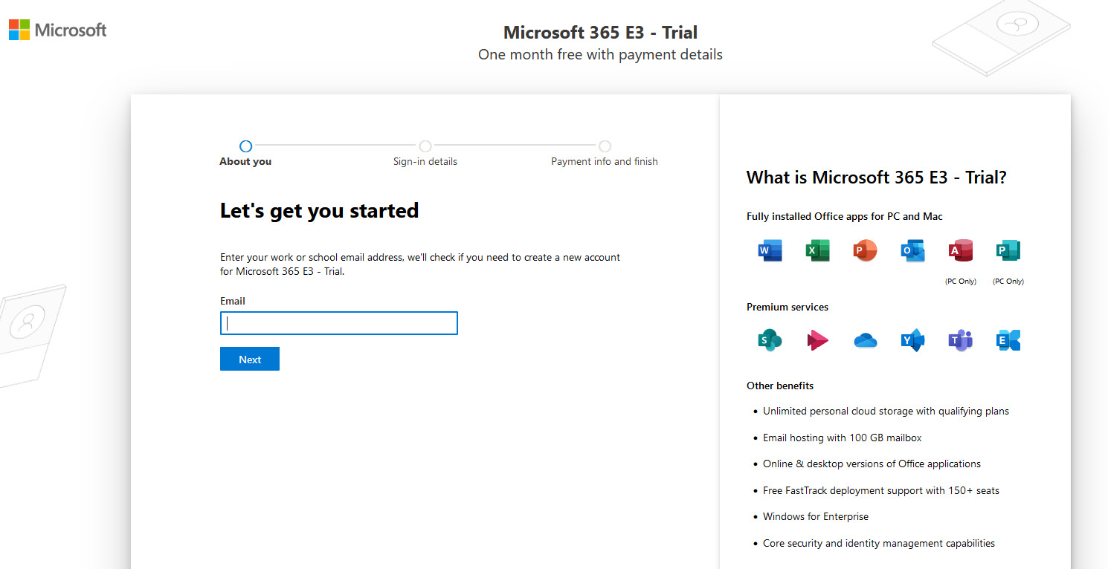

Figure 2.2 – A Microsoft 365 E3 trial account

Keep in mind that we might be required to add a credit card, for verification purposes only. We do recommend keeping the payment method added to the tenant, at least until we have completed provisioning all the required trial licenses for the new tenant, since Power Platform licenses will also require a payment method for verification purposes. Once we are done adding trial licenses of our choice to the tenant, or we want to just remove the payment method from the tenant to avoid any potential license extensions and related costs, we can remove the payment method from within the ****Microsoft 365 admin center**** ([https://admin.microsoft.com](https://admin.microsoft.com/)) with the Global Admin account. If we decide later that we want to proceed with this trial account and convert it to a more permanent test or even production environment, we can add a payment method to the account and keep on running the services in this tenant.

We can add or remove payment methods by logging in to the Microsoft 365 admin center, heading over to the ****Billing**** | ****Payment methods**** section, and adding a new payment method or selecting an existing payment method and removing it.

Now that we have created a Microsoft 365/Office 365 tenant, let’s add the Power Platform products to the tenant.

### Power Platform trial licenses

Since Power Platform products are licensed separately, trial licenses should also be obtained separately for each product we are about to test. However, if we intend to spend most of our time in Power Apps and Power Automate, there is another option –the Power Apps Developer Plan. Let’s take a closer look at both options.

#### Separate product trial licenses

Staying in the Microsoft 365 admin center, head to ****Billing**** | ****Purchase services**** and look for the Power Platform product licenses that you want to add. Most of them have a free trial that can be added to the tenant. We can use the search functionality on the right side of the ****Purchase services**** section to find products faster, such as ****Power Automate Premium****, as shown in the following screenshot.

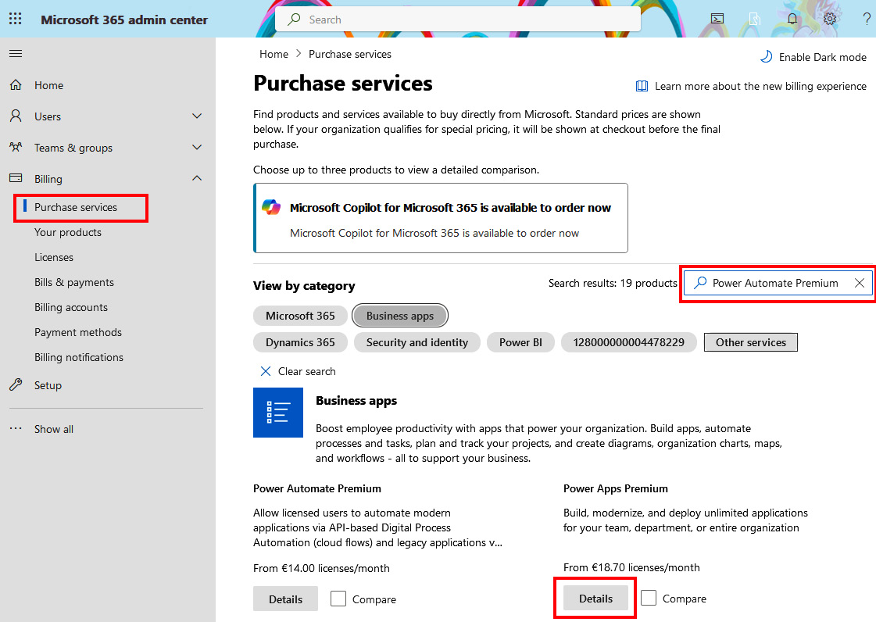

Figure 2.3 – Purchase services

Next, click on the ****Details**** button for the selected product license you wish to add, which opens a ****Product Details**** page. If the selected product allows you to add trial licenses, a ****Start free trial**** option will be visible next to the ****Buy**** button. Once you select it, you will start the process of adding licenses to the tenant. If you have kept a credit card as a payment method in the Microsoft 365 tenant from the previous step, you will be able to add trial licenses by clicking on the ****Try now**** button on the ****Check out**** screen. We can follow the same approach to add any other Power Platform product to the tenant.

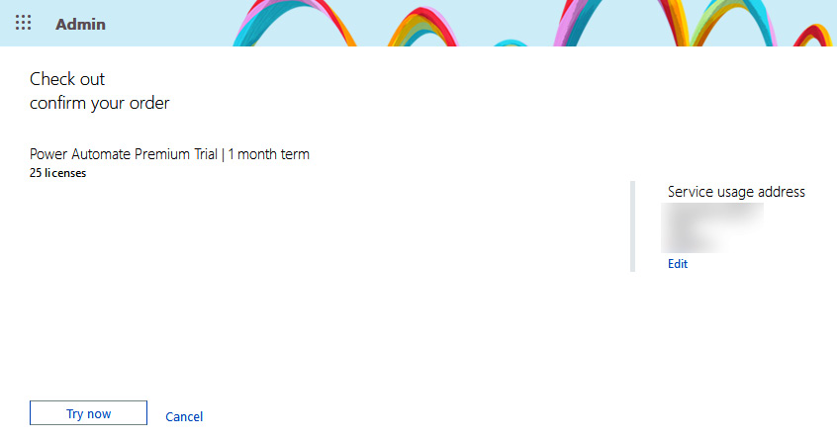

Figure 2.4 – Confirming the order of trial licenses

Trial licenses usually come in a pack of 25 user licenses, which makes it ideal for internal distribution among business users and developers to test product capabilities. The duration of a trial license is limited to 30 days. After the expiration of the trial licenses, we can purchase the required plan to continue using a product.

Some products also come with add-ons, such as the Power Automate Unattended RPA add-on. These add-ons usually rely on a standalone license, often referred to as a qualifying base license. Once we’ve added a needed qualifying base license to the tenant, such as the Power Automate Premium trial, we will be able to add a selected add-on – in this case, the Power Automate Unattended RPA add-on trial. We can search for add-ons in the ****Billing**** | ****Purchase services**** section, as we did previously, or find them under the ****Add-ons**** section on the ****Product details**** screen, as shown in the following figure:

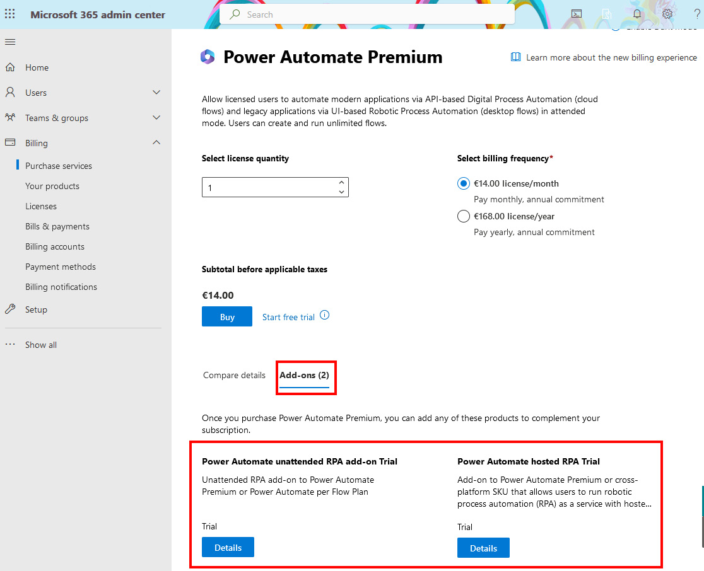

Figure 2.5 – Adding add-on trial licenses

#### The Power Apps Developer Plan

The Power Apps Developer Plan is a free developer environment that can be used to develop and test business applications. It allows you to use the premium capabilities of Power Apps and Power Automate, including the premium connectors and Dataverse. Anyone who has a Microsoft work or school account, connected to Microsoft Entra ID, can sign up for this Developer plan. We can obtain the Power Apps Developer Plan at this website: <https://powerapps.microsoft.com/en-us/developerplan/>. If a developer has a Visual Studio subscription, then the Power Apps Developer Plan can also be activated on the Visual Studio Subscriptions Dev Essentials website (<https://my.visualstudio.com/benefits>):

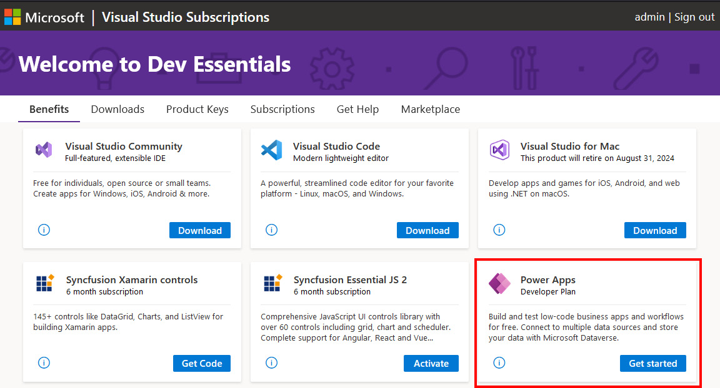

Figure 2.6 – Enabling the Power Apps Developer Plan through a Visual Studio subscription

Each user can have up to three developer environments in a Power Platform tenant. Developer environments can be created by administrators for users or by users themselves; however, administrators can also block the possibility to create such environments by users.

Compared to trial licenses, which have a 30-day duration, the Power Apps Developer Plan does not expire and will stay active as long as there is any activity with the plan. If there is inactivity for longer than 90 days, the plan will be deleted. Another important note is that trial licenses bring all the capabilities of the paid licenses, while the Power Apps Developer Plan does not have all the features/capabilities. Also, a developer environment cannot be converted to a production environment, although a trial environment can become a production environment. Developer environments also have a limit on the Dataverse capacity, with a maximum database size of 2 GB.

A developer plan is a perfect choice to test and build business solutions in Power Platform in a separate development environment. Once we are satisfied with the solution, we can follow the ****continuous integration****/****continuous deployment**** (****CI****/****CD****) pipelines to deploy the solutions to test and production environments.

# Power Platform administration

This section explores what Power Platform administrators can use to apply configuration to the Power Platform environments, manage Power Platform product features, and what can be used to understand the usage of Power Platform products throughout different environments.

As well as the Microsoft 365 admin center, where administrators can manage licenses, users, and Microsoft 365-related configuration, administrators should be aware of one more admin center that will help them manage their Power Platform tenant.

The ****Power Platform admin center**** is a unified platform for administrative tasks related to Power Platform. It can be accessed at <https://admin.powerplatform.microsoft.com/> and allows administrators to perform most of the operations related to Power Platform, such as general environment management, product feature management, and gaining analytical insights into product usage.

*Important note*

*It is important to note**that Power BI does have a separate admin center, called the Power BI admin center (available at*<https://app.powerbi.com/admin-portal>*), that enables Power BI administrators to manage their Power BI instance. The Power BI admin center is not covered in this book.*

Power Platform offers three means of interaction and management for administrators – through the Power Platform admin center, PowerShell cmdlets, and connectors – Power Platform for Admins and Power Platform for Makers.

## The Power Platform admin center

Those familiar with the Microsoft 365 admin center will find this admin center similar and easy to use. Using the Power Platform admin center, administrators have controls to manage environments, review key metrics and usage, understand and take actions relating to licenses and capacity utilization, and so on. The controls are neatly grouped into sections, placed on the left navigation menu bar in the Admin Center, providing a simple user experience.

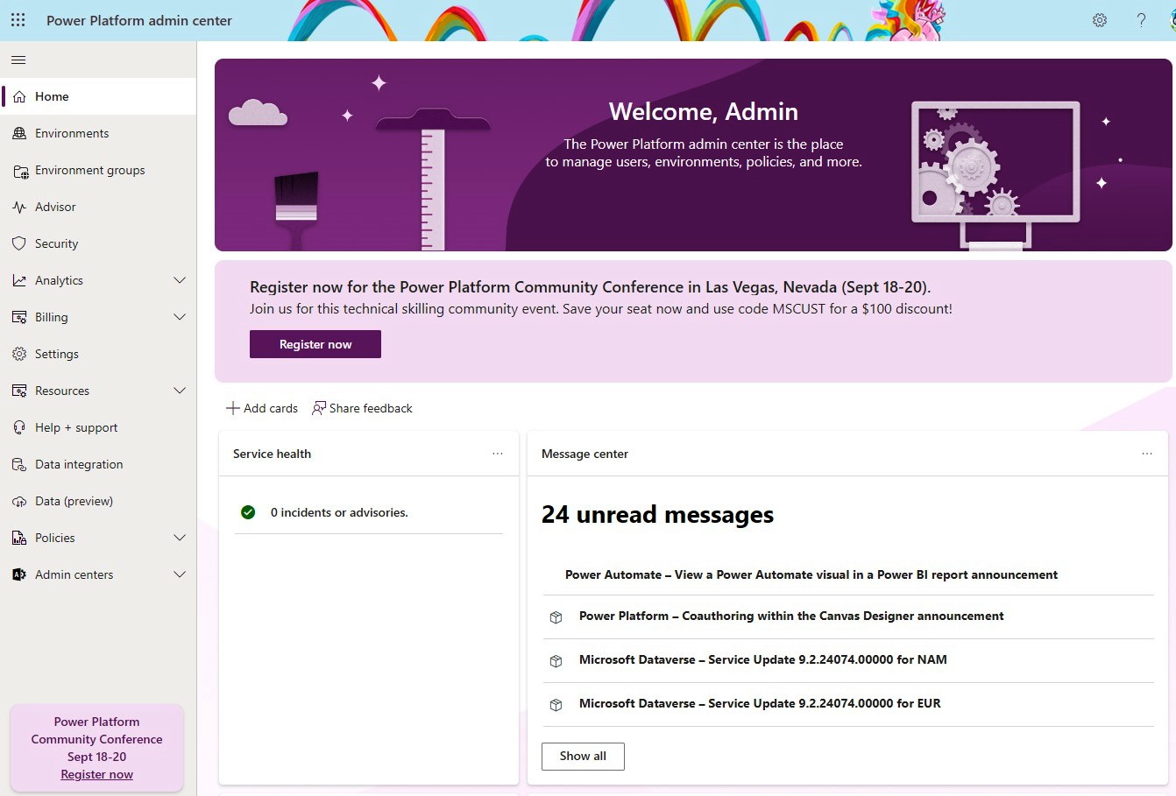

Figure 2.7 – The Power Platform Admin Center

An often overlooked capability is the ****Help + support**** functionality, which allows administrators to file a support request when Microsoft support is needed. This is also where administrators can see their previously submitted support requests, their status, and their communication history.

One of the convenient features in ****Help + support**** is a feature called ****Known issues****, which informs administrators about the current active known issues for Dynamics 365 and Power Platform products. It explains each known issue and offers a workaround. This is a convenient way to proactively inform administrators about the status of known issues on the platform. Next to that is the service health of the Power Platform. Information about this can be found on the Power Platform admin center home screen, where we can find a ****Service health**** dashboard that includes information about any incidents or advisories for Power Platform services.

****Message center**** provides information about the previous and upcoming service updates, how they might affect users, and how to prepare to minimize the potential impact. More information about service health and upcoming planned changes can be found in the Microsoft 365 admin center.

The Power Platform admin center additionally gives administrators the possibility to set up various ****policies****, from ****data loss prevention**** (****DLP****) policies to billing policies.

Tenant settings can be accessed by going to the Power Platform ****admin center**** | ****Settings****. These are tenant-wide settings that are applicable across the entire Power Platform organization. Here, you can configure settings such as tenant-level analytics, the use of unassigned AI Builder credits, and environment assignments. We will look at some of these settings later in the book, when we examine the importance of having an IT team aligned to DevOps principles. It is important to know which tenant-wide settings are available, since they can have a great impact on the user experience. An IT administrator should examine them, understand them, and have them properly configured for their organization.

Next to the tenant-wide settings, we have environment settings, which can be accessed by going to the Power Platform admin center | ****Environments**** | selecting an environment | ****Settings****. The ****Settings**** button will appear in the upper toolset options once the environment is selected. This ****Settings**** section gives you access to environmental settings, from ****Product**** and ****Features**** configuration to ****Audit and logs**** management for a selected environment:

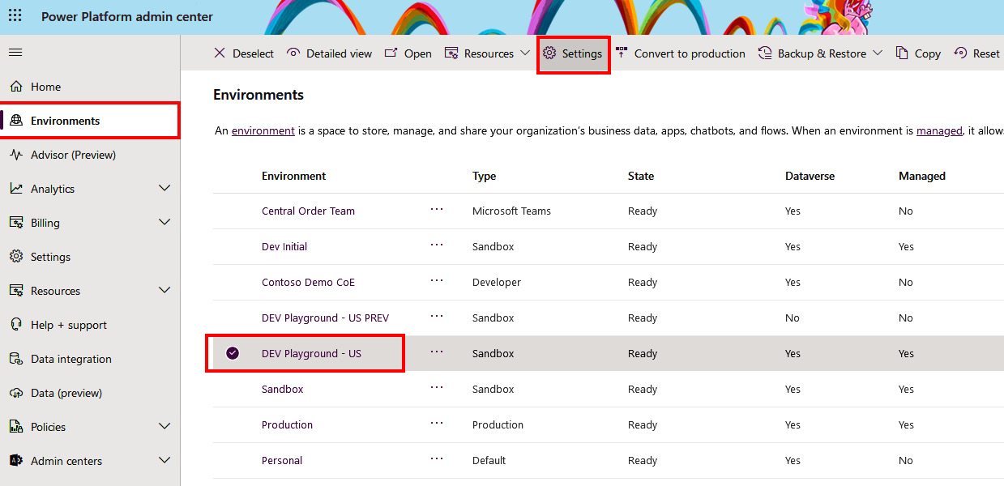

Figure 2.8 – Accessing the environment settings

****Features**** configuration allows us to enable or disable generally available features or preview features that become available inside Power Platform. For example, with the recent introduction of Generative AI, Copilot and other AI-related features are available to Power Platform users, but only if these capabilities are enabled in the ****Features****configuration. Some new features are enabled by default, and administrators can disable them here. We recommend visiting ****Message center**** (which is available on the home page of the Power Platform admin center), reading blog posts on the Microsoft Power Platform blog, or checking the Dynamics 365 and Microsoft Power Platform Release Planner to find out about new releases and upcoming features in Microsoft Power Platform:

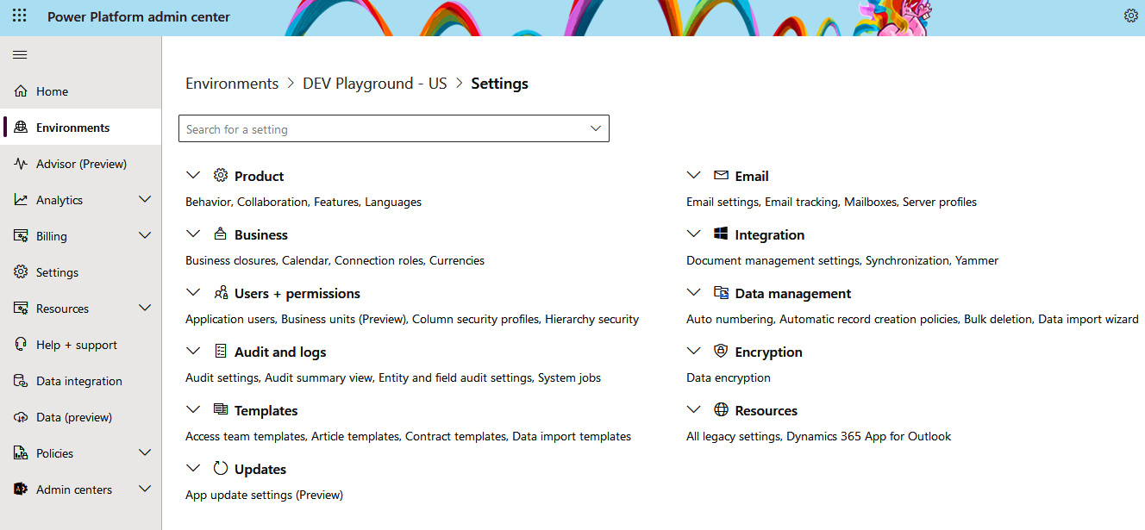

Figure 2.9 – Environments settings

## Power Platform management and automation for administrators, makers, and developers

Moving from the graphical user interface of the admin center to the ****command line interface**** (****CLI****), we can see that Power Platform offers tools with a set of commands that can be used to automatize management tasks. Depending on whether we come from an IT operations team that has the task of managing an environment, are an app maker that needs to manage an app, or a professional developer with the goal of packaging solutions and automatizing the deployment of our business solutions, everyone uses a different set of CLI tools.

### Power Platform CLI for developers

****Power Platform CLI**** (****PAC CLI****) is the preferred and most recommended CLI tool to manage Power Platform. It is intended for developers and administrators, since it offers a set of commands that support various operations related to solution packaging, the environment life cycle, code components, Dataverse environments, and so on. Administrators will find many convenient commands that can simplify administrative tasks. PAC CLI supports inner loop and outer loop development, which means that in inner loop development, a developer uses this CLI to work on a solution, and in the outer loop, a developer uses CLI tools to make sure that the produced solution can be deployed to other environments, following the ****application life cycle management**** (****ALM****) strategy.

Installation of Power Platform CLI can be done on Windows, macOS, and Linux devices. It can be done either through a ****command-line interface**** (****CLI****), such as PowerShell or Bash, or by using Power Platform Tools for VS Code. For Windows, there is also a ****.MSI**** installation package.

Addressing VS first, ****Power Platform Tools**** can be either found in the ****Extensions**** section inside VS Code or in the VS Code ****Marketplace****. You can use the search bar inside VS Code to find the extension, and then click ****Install**** button to install it. A similar approach can be taken with Marketplace. Follow the link at <https://marketplace.visualstudio.com/vscode> to enter the Marketplace for VS Code, use the search bar to find the ****Power Platform Tools**** extension, and then click ****Install****. The extension is published by Microsoft (we can see the verified publisher mark) and is free of charge. Once installed, VS Code will activate the extension, which will appear in the primary sidebar. Removing the extension is done in VS Code, following a similar approach to the installation but by pressing the ****Uninstall**** button:

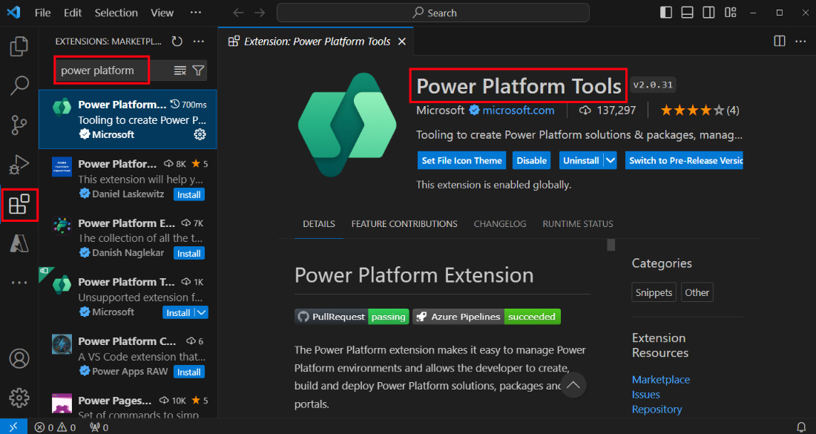

Figure 2.10 – The extension for VS Code

Next, we can also install PAC CLI by using the ****.NET tool**** (****dotnet tool****). In this case, .NET is required on the workstation (the .NET 6.0 version is currently recommended). Installation is then done by using the following command in a terminal or Command Prompt:

dotnet tool install --global Microsoft.PowerApps.CLI.Tool

The same approach applies to macOS and Linux.

Commands are currently separated into 23 groups. Each group has its own purpose, such as ****pac admin**** to work with a Power Platform admin account, ****pac data**** to work with a Dataverse organization, ****pac pcf**** to work with Power Apps component framework projects, and ****pac connector**** for connectors.

Before we can start using these commands, we need to create an authentication profile on the workstation where we plan to run commands. An authentication profile can be created with the ****pac auth create**** command, which opens a prompt for credentials:

**# more specific auth profile creation with environment info**

**pac auth create --environment xxxxxxxx-xxxx-xxxx-xxxx-xxxxxxxxxxxx --name DevInitialAuth**

In order to list all authentication profiles on a selected device, we can run the following:

pac auth list

This will return information about all authentication profiles on the workstation. We can switch back and forth between them by providing the index or name of the authorized profile:

**pac auth select --name DevInitialAuth**

Now that we have an authentication profile, we can run ****pac**** commands to execute the needed task. To understand which commands are available in PAC CLI, we can run this command:

pac help

In order to get detailed help on a specific command, we can simply add ****help**** with every command that we want to use:

pac admin help

pac admin list help

The help switch in command returns with a usage example, which is very convenient, especially if we are running a command for the first time. The following is an example of an ****admin**** command that lists all sandbox-type environments that we have in a connected Power Platform organization.

pac admin list –-type Sandbox

We will also use PAC CLI in the following chapters, where more specific examples will be provided.

### PowerShell for administrators

Next to PAC CLI, we have PowerShell commands for administrators, with a PowerShell module name, ****Microsoft.PowerApps.Administration.PowerShell****, which allows us to perform a set of actions to manage a Power Platform tenant, environments, and Power Apps and Power Automate products.

A PowerShell for administrators module can be installed by running PowerShell as an administrator and installing necessary modules, using the following commands. As a prerequisite, we should use Windows PowerShell version 5.x, and for the installation process, we should have the NuGet provider installed on our device. If the NuGet provider is not already installed, the installation process will ask us to install it before continuing with the installation of PowerShell for administrators. Administrators using PowerShell commands need to have one of the following roles to operate with the PowerShell cmdlets – Power Platform Administrator, Dynamics 365 Service Administrator, and Microsoft Entra ID Global Administrator:

**Install-Module -Name Microsoft.PowerApps.Administration.PowerShell**

Alternatively, we can set the scope to the current user if we do not have administrator permissions on the selected device:

**Install-Module -Name Microsoft.PowerApps.Administration.PowerShell -Scope CurrentUser**

We might be asked to change ****InstallationPolicy****. Confirm installation from an untrusted repository and then continue.

Updating the module can be done with the following command:

**Update-Module -Name "Microsoft.PowerApps.Administration.PowerShell"**

Once cmdlets are installed and before we start running the commands to manage Power Platform, we are required to acquire an authorization token that will be used in correlation with our executed Power Platform PowerShell commands. To obtain a token, we need to call ****Add-PowerAppsAccount****, which will provide an interactive way to sign in with our administrative account. This approach is also more convenient if our account is protected with ****Multi-Factor Authentication**** (****MFA****). If, for any reason, we need to avoid a prompt window and our account is not protected with MFA, we can use explicit credential specification using the following command. Keep in mind that it is recommended that every administrator account is secured with MFA. If we need to connect to a different endpoint, such as ****USGov**** or ****Preview****, we should add ****-Endpoint**** to the ****Add-PowerAppsAccount**** command and specify the required endpoint:

**$password = ConvertTo-SecureString "securePassword" -AsPlainText -Force**

**Add-PowerAppsAccount -Username adminuser@domain.com -Password $password**

Once we have provided our credentials and an authorization token has been obtained, we can proceed to run admin commands. If we require support on which commands are available and how to use them, we can use a simple command, ****Get-Help****, followed by the cmdlet name, as follows:

**Get-Help Get-AdminPowerApp -Detailed**

****Get-Help**** will download the most current help files for a module and present us with a response.

*Important note*

*Finding the right command for a task and an example of how to write the command can be done through*****Get-Help*****. However, as technology advances, with the use of Generative AI, we can now get answers and support with commands even faster. Now, we can ask tools such as Microsoft Copilot for help with a certain task by providing a request in a natural language.*

A list of all available commands for administrators can be found here: <https://learn.microsoft.com/en-us/power-platform/admin/powerapps-powershell#power-apps-cmdlets-for-administrators>.

### PowerShell for app makers

App makers have their own module that allows them to manage Power Apps applications, Power Automate flows, and defined connectors and permissions across flows, apps, and connectors.

The installation process is the same as for the administrator module – by running PowerShell as an administrator or by defining ****-Scope**** to ****CurrentUser****. First, we need to install the module:

**Install-Module -Name Microsoft.PowerApps.PowerShell -AllowClobber**

We might be asked to change ****InstallationPolicy****. Confirm installation from an untrusted repository and continue.

The same process as before for administrators applies here – before running any of the commands, we need to obtain an authorization token. This is done with the ****Add-PowerAppsAccount**** command, which supports an interactive mode of authentication; it also works with MFA-backed accounts:

**Update-Module -Name "Microsoft.PowerApps.PowerShell"**

A list of all available maker commands can be found here: <https://learn.microsoft.com/en-us/power-platform/admin/powerapps-powershell#cmdlet-list---maker-cmdlets>.

## Admin and management connectors

Last, but not least, is the option of using admin and management connectors, which are readily available among other 1,000+ connectors available in Power Platform.

Connectors are divided into five different groups:

* ****Power Platform for Admins****: Enables administrators to manage the environment life cycle, manage DLP policies, and create Dataverse databases in a specified environment.
* ****Power Apps for Admins****: Enables administrators to view and set various permissions and owners across Power App applications, connectors, and connections.
* ****Power Apps for Makers****: Allows app makers to publish their applications and view and manage their applications, connectors, and connections.
* ****Power Automate for Admins****: Enables administrators to manage the Power Automate Flow state, by stopping, running, or deleting the flow.
* ****Power Automate Management****: Allows app makers to view and edit flows to which they have permissions in a given environment. This connector also contains some admin-specific actions that can be used to modify flow owners or restore deleted flows.

All these connectors are standard types of connectors and work throughout Power Apps and Power Automate, across all regions. Power Platform for Admins ****version 2**** (****V2****) is available in Public Preview, and you can use the same connector within Azure Logic Apps. It does not yet offer full parity with V1, but connectors do get updated over time, so we can expect, at some point, for V2 to replace V1. Using the actions available in connectors, administrators can automatize repetitive management tasks. For example, administrators can use Power Automate to create workflows that automatize the process of creating Power Platform environments, while getting all the benefits of a Power Automate product, such as the ability to see the output of the actions for a flow’s run history.

# Governance, compliance, and data privacy

This section describes how Microsoft Power Platform is compliant with many regulations and standards, and also how it provides customers with a set of tools to make their applications compliant with the required regulations. It explains how Microsoft Power Platform follows the same approach as other Microsoft products and services, staying compliant and following Microsoft’s commitment to the customers.

Microsoft commits to its customers that it is transparent about the policies, operational practices, and technologies that are used to ensure the security, compliance, and privacy of customer data across the line of Microsoft products. Microsoft states that the data stays in the control of the customer and is transparent about where the data resides. Microsoft also explains how the data is protected at rest and secured in transit and how, ultimately, Microsoft protects customer data through its services and departments. Such a commitment is very bold and gives a level of trust to the customers. These statements are supporting Microsoft’s ****Cloud services**** that are built on four fundamental principles – ****security****, ****privacy and controls****, ****compliance****, and ****transparency****. Security is focused on protecting customers from external cyber threats. Privacy and controls allow customers to control access to their data. Compliance involves Microsoft making sure that its services meet global standards. Transparency is all about giving customers insights into policies and procedures.

Even with all the commitments that Microsoft provides to its customers, we need to understand that cloud deployments follow the shared responsibility model. This means that depending on the type of cloud service model that an organization uses, whether this is ****infrastructure as a service**** (****IaaS****), ****platform as a service**** (****PaaS****), or SaaS, different levels of responsibility fall on the shoulders of the cloud service provider and its customer.

Power Platform is an enterprise SaaS platform, which means that managing the physical data center, physical network, hosts, operating system, and network controls is in the domain of Microsoft. However, the Power Platform products that the customer uses fall under the shared responsibility model. When it comes to the shared responsibility model, organizations have to remember that they are responsible for keeping their end product secure, as well as compliant with the regulations they have to adhere to.

A good example of a shared responsibility model is how Microsoft continually monitors the threat landscape and builds Power Platform in a way that protects it against the OWASP Top 10 risks. The OWASP Top 10 is a standard awareness document for developers who are interested in web application security. While Microsoft implements controls in Power Platform in a way that protects against those risks, Microsoft also gives its customers guidance and controls that can be used in Power Platform or supported services, such as Entra ID, to further protect their Power Platform applications against threats, such as broken access control, cryptographic failures, and security misconfigurations.

Governance and compliance also relate to the area of data residency. Let’s take a look at how Microsoft handles customer data.

## Data residency

As with other Microsoft services, Power Platform services are hosted from Microsoft data centers that are dispersed across the globe and connected with a Microsoft network infrastructure, in order to minimize network latency as well as secure the transfer of the data. Power Platform customers can create environments in different geographical locations (regions) around the world, thereby bringing services and data closer to their end users. Such an approach is convenient for companies with branches around the world.

Customers can create environments in data center regions around the world, such as the United States, Europe, Asia, Australia, the United Arab Emirates, the United Kingdom, Japan, France, and Switzerland.

Sometimes, the location of an environment can play an important role in the availability of certain product features in Power Platform. Although features are gradually enabled in all data center locations, it is always good to evaluate the option of having a spare testing environment to validate preview features.

For organizations operating within the borders of the ****European Union**** (****EU****), Power Platform supports the ****EU Data Boundary****, which is a geographically defined boundary that helps customers meet their data residency requirements to limit the data residency to only EU and ****European Free Trade Association**** (****EFTA****) countries.

A good example of data residency requirements in practice is with the ****Generative AI**** (****GenAI****) features inside Microsoft Power Platform. Power Platform is utilizing Azure OpenAI service for its GenAI features, but it can happen that the Azure OpenAI service is not located in the same datacenter region as Power Platform is hosted. Organizations have a choice to allow/disallow the movement of data across regions. This means that if specific functionality is not enabled in an environment region, by allowing data movement, the data could flow to a region where a certain service is hosted.

Looking at the environments hosted in Europe region, once this data movement is enabled, and by using GenAI capabilities, the data transaction can be taken to Sweden or Switzerland regions, where corresponding services are enabled. Both countries are inside the EU Data Boundary. Other countries/regions may have other geo-region pairs for GenAI features.

With the European Union, another regulation that protects individuals and their data is ****General Data Protection Regulation**** (****GDPR****). GDPR introduced new rules for organizations that offer goods and services to people in the EU or that collect and analyze data for EU residents, no matter where you or your enterprise are located. Microsoft Power Platform offers organizations a set of services and functionalities that can be used once they receive ****Data Subject Rights**** (****DSR****) requests. ****DSR requests**** are formal requests from a data subject (individual) to a data controller (organization providing services) to act on the individual’s personal data stored in the data controller’s systems. Data subjects are allowed to ask for their data to be deleted, to have restricted processing of the data, to obtain copies of their data in the systems of the data controller, and so on. This means that Power Platform has to offer administrators the ability to find data and act on it, based on the DSR request.

When it comes to the data in Power Apps, administrators can use the Power Platform admin center or the set of CLI commands from the previous section to find and export users’ data. As an example, in Power Apps, this type of data could be a list of applications that a user has permission to use, environments that were created by the user, connections that were created by the user or used as shared connections, and so on.

*Important note*

*There is much more to write about the EU Data Boundary and GDPR and how to respond to DSR requests with the capabilities available in Power Platform, which we will not cover in full detail. To learn more about this, we recommend finding out more information at the**Microsoft Trust Center (*<https://www.microsoft.com/en-us/trust-center/product-overview>*), as well as responding to DSR requests in**Microsoft Docs (*<https://learn.microsoft.com/en-us/power-platform/admin/powerapps-privacy-dsr-guide>*).*

## Compliance offerings

Companies have to meet regulatory compliance standards with their business solutions. This is why Microsoft ensures that its products and services comply with many global, regional, industry, or US government-specific compliance regulations. Power Platform, as with other Microsoft Online Services, implements a security framework that follows industry best practices and adheres to various global standards, such as the ****International Organization of Standardization’s**** (****ISO****) standards, like ISO 27000 family of standards (ISO 27001, ISO 27017, ISO 27018, and so on) and ****Systems and Organization Control**** (****SOC****) , like SOC 1 and 2; industry-specific standards, such as HIPAA and PCI-DSS; or regional specific standards that are related to a certain country or specific region, such as GDPR for the EU.

Power Platform, as well as other Microsoft online services, are regularly audited by qualified third-party accredited assessors for compliance with global standards and regulations.

Apart from the global standards and regulations, Microsoft, through its Product Terms, previously delivered a separate document called ****Online Service Terms**** (****OST****), which explains Microsoft’s contractual commitments to customers by covering different aspects of the use of Microsoft products, including privacy and security terms in regards to the processing and security of the customer data and other types of data.

Anyone can use the Microsoft Trust Center to understand Microsoft’s products and how they comply with different security, privacy, and compliance standards and regulations.

Using the Microsoft Service Trust Portal, customers can investigate various documents related to data security and compliance, such as attestations of compliance against certain standards or regulations or other documents such as audit checks or penetration testing for Power Platform products.

## Data protection

Microsoft Power Platform comes with security strategies and processes to help secure customer data against corruption, compromise, and loss. This includes mechanisms to help protect customer data against data breaches and data loss incidents. Microsoft applies security mechanisms and protects data across different layers, from data center physical security to network security, protecting data at rest and in transit, and allowing customers to set up additional security controls that are embedded in the products, which further enhance the security level.

At the heart of Microsoft’s online services, which includes Power Platform services, tenant isolation is crucial, which is why Microsoft has put mechanisms in place that help properly ****isolate tenants**** from one another. Microsoft Entra ID plays an important role here in isolating a customer’s tenant. Once the user has authenticated, they only have access to the data within their tenant environment.

Then, there is user ****license verification****. A user can use Power Platform products and components for which they have a license. Without the license, the user won’t be able to access and operate within the service.

The main service for the data storage for Power Platform products is Microsoft Dataverse. Microsoft Dataverse, as the central data storage platform for Power Platform products, has three different storage areas. The first is to store ****data****, the second is for ****logs****, and the third is for ****files****. Dataverse implements data-at-rest and data-in-transit encryption mechanisms. For data at rest, Dataverse databases use SQL ****Transparent Data Encryption**** (****TDE****) for real-time encryption and decryption of data during a read/write operation. This mechanism is used as the data-at-rest encryption mechanism for data and log files. To store files, such as images and documents, Dataverse uses Azure Blob Storage in the backend. To protect this binary data, Azure Storage encryption is used with Azure Blob Storage. This is an automatic encryption/decryption mechanism with 256-bit AES encryption. Both solutions (SQL TDE and Azure Storage encryption) are FIPS 140-2-compliant.

For data encryption, a Microsoft-managed key is used, which is stored and managed by Microsoft. Those customers who prefer added data protection control or are required to meet certain regulatory or compliance requirements can utilize the ****customer-managed encryption key**** (****CMK****) functionality. This allows customers to provide the service with their own encryption key, which is generated and managed by their ****Hardware Security Module**** (****HSM****), which has to be one of the supported HSMs provided by Azure Key Vault. Alternatively, they can use Azure Key Vault to generate and manage the encryption key.

Data in transit is protected using industry-standard transport protocols, one of which is ****Transport Layer Security**** (****TLS****). To encrypt messages between clients and servers, and to be compliant with security policies for a secure connection, the latest TLS 1.2 is used together with a set of cryptographic algorithms, known as cipher suites. Data is protected between the client device of the user and the service itself, during communication between the Microsoft data centers, and also within the Microsoft data center, even when the Microsoft network backbone is used. This is to ensure that the data is protected from interception and to ensure transaction integrity.

After the user is authenticated and their license checked, Power Platform implements a series of controls that can further secure applications, data, or connections that are used in the applications or flows. Some examples of these controls are sharing the applications, usage of security roles in Dataverse to limit users of their data operations, and connection credentials to determine entitlements to given services.

We will cover some of these controls around governance and security in more depth in *[Chapter 11](https://learning.oreilly.com/library/view/mastering-devops-on/9781835880845/B22208_11.xhtml" \l "_idTextAnchor208)*.

# Starting to build real-world business solutions

This section demonstrates some options and template ideas that Power Platform provides to give you a headstart on building a real-world business solution. We will take a look at what templates are available in Power Platform products and what other options there are to start building applications from a previously generated design, or just an idea that is described through natural language.

## Creating solutions using templates in Power Platform

We will start with the templates. Power Platform products, such as Power Apps, Power Pages, Power Automate, and Copilot Studio, all offer predefined templates that help us start working on an idea or a business process. Power Apps has an extensive list of prebuilt app templates that can be used as a starting point. These templates can be taken, and additional customization can be done on them. Here, we can find app templates that support business scenarios, such as booking a room, submitting expense reports, submitting vacation requests, connecting end users with support professionals through a help desk assistant, and keeping projects on budget with a budget tracker. These all serve as a quick way to create business applications. App templates can be found by going to ****Start with an app template**** on the home page of the Power Apps maker portal (<https://make.powerapps.com/>). Using an approach like this helps app makers to quickly start building an application. As all these templates use data sources to store the data used in an application, one very important step will be to set up the correct data source and connect it properly with the application. Then, changing the graphical appearance of the application might be the next step that app makers take – to apply graphics that match the company logo and the appearance of the graphical design.

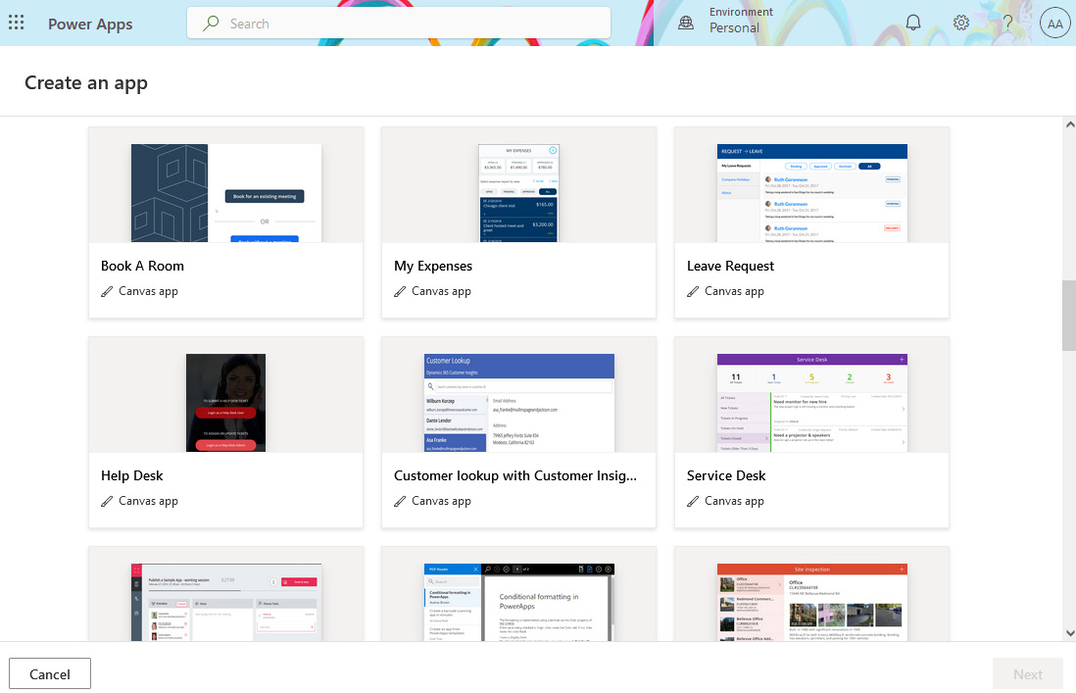

Figure 2.11 – Creating an application using app templates

App templates also offer a convenient way to learn how you can build such an application, configure controls, build business logic, and connect and integrate different components inside an application.

A similar approach can be found in Power Automate, Power Pages, and Copilot Studio. In Power Automate, you can find a set of predefined workflows that can serve as a starting point to build workflows. In Power Pages, layout templates are provided, which include graphical design and layouts for websites. Those who have a Dynamics 365 license might see additional Dynamics 365 templates, which are provided with examples such as customer self-service, partner portal, employee self-service, and community templates. In Copilot Studio, we can find templates to build custom copilots.

Whichever template you choose, there is a high chance that connection with the data source will need to be implemented, since many of these applications use and store data for their operations.

## Enterprise templates

Those who wish to start with more advanced templates should look to Enterprise templates. Microsoft came up with a set of six enterprise templates that are free to use. Enterprise templates are available on Microsoft AppSource, with documentation on the Microsoft Learn platform, where you can read more about each template scenario and how to implement it (<https://learn.microsoft.com/en-us/power-platform/enterprise-templates/overview>).

Enterprise templates cover six cases, from HR cases around an employee recognition program, onboarding buddy, and awards and recognition to IT cases, such as hardware requests and appointment booking processes.

As with the templates mentioned in the previous section, the idea of enterprise templates is to reduce the time needed to build apps around certain cases in an organization. We can use them also to learn how a specific scenario can be developed using Power Platform services.

Each of these templates comes with two applications; one is a ****canvas**** application that is intended for end users. It is a UI-rich application that either has a responsive layout or is adapted for mobile devices, so it can also be used on the go. The second application is ****model-driven**** and is intended for admins. It is a *data-intense* application, where administrators can apply admin operations to the data or the back-office team can manage all the entries in the data source.

Applications also use Dataverse as the data source, where one or more tables are created and used to store data.

On top of everything, Power Automate flows are generated, which perform some business operations based on the project.

This is a very common way to develop applications in Power Apps, with the process supported by Power Automate, while data stays in Dataverse where security roles can be applied to further protect access to the data.

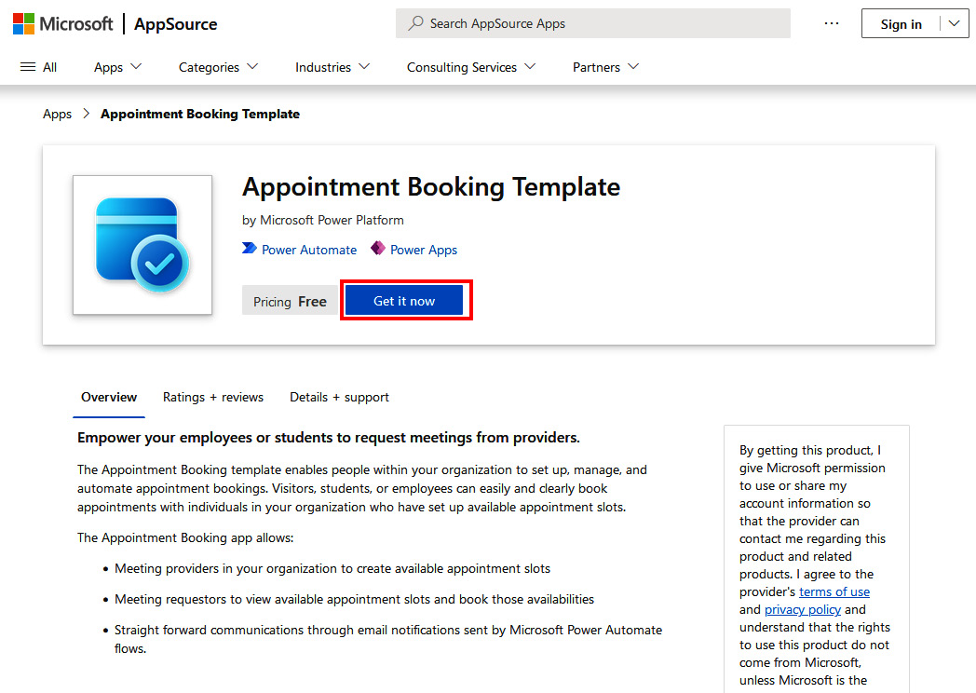

Figure 2.12 – Using Microsoft AppSource for the enterprise templates

You can install an enterprise template by going to the Microsoft AppSource, selecting the desired template, and clicking on the ****Get it now****. First, we will be asked to sign in with our account and to confirm the details of the permission before continuing with the installation. After that, we are redirected to the Power Platform admin center | ****Resources**** | ****Dynamics 365 apps****, where we select the environment in which this template will be installed. Accepting the terms will allow us to install applications. When we want to update or remove the deployed applications, we can come back to the Power Platform admin center, select the environment, and click on ****Dynamics 365 apps**** to perform the operation:

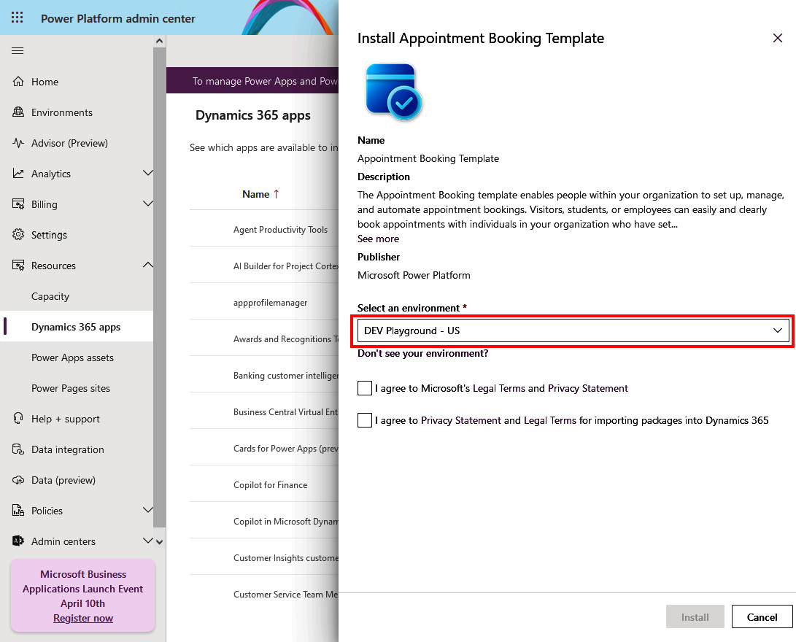

Figure 2.13 – Installing an enterprise template

## Power Platform patterns

Power Platform project development consists of phases such as project planning, designing, developing, testing, and deploying. Since developing a Power Platform project follows an agile methodology, it is an iterative and repeatable process. This approach means that once we deploy our solution, we can easily return to the initial phases of the project development, where we design and develop new versions of our application. In the next chapters, we will take a look at how we can follow the ALM of our business applications and solutions; however, it’s worth mentioning that many of the projects that are built on Power Platform follow a similar pattern. These are patterns such as approvals, asset management, and inspection applications. Microsoft has combined them and created a list of all identified Power Platform patterns, including the template solutions for each pattern and the documentation on the installation.

These patterns with templates can be found here: <https://learn.microsoft.com/en-us/power-apps/guidance/patterns/overview>.

Each pattern has its own purpose; however, from a technology perspective, it is common for them to consist of one or more Power Apps applications, central data storage, such as Dataverse, a SQL database, or SharePoint Online, and Power Automate flows to support the business process. Some patterns include Power Pages for the user frontend experience, instead of a Power Apps application.

## Other ways for building business solutions

Let us look at a few different ways to build a business solution.

### Create from conversation

Power Platform enables you to create business solutions using a natural language conversation with Copilot for Power Platform. Copilot is available on the home screen of all products, such as Power Apps, Power Automate, Power Pages, and Copilot Studio.

It is as easy to describe what kind of application we want to create, and AI will try to understand the context of our description and help build the application for us. Not only does it help us create an application but also the data schema of the tables that our application will use.

In *[Chapter 12](https://learning.oreilly.com/library/view/mastering-devops-on/9781835880845/B22208_12.xhtml" \l "_idTextAnchor231)*, we will explore Copilot for Power Platform and its capabilities in depth.

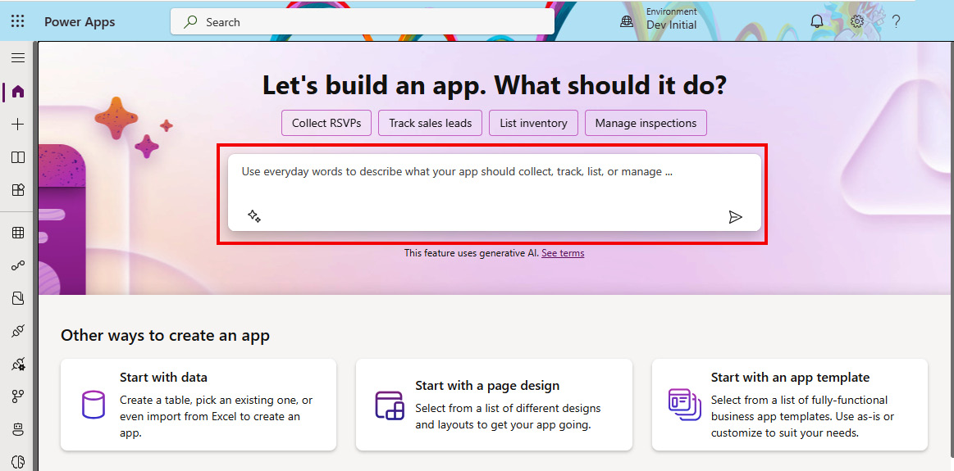

Figure 2.14 – Creating an app from a conversation

### Creating from a design (an image or Figma)

Understanding the ways that our users will interact with the data helps us build the conceptual design of our application. Conceptual designs help us to identify which tasks will be done in the app. This gives us an option to draw a simple representation of the canvas app screens or Power Pages forms. Looking at the canvas app, Power Apps allows us to take the sketch of the app screens, which we have drawn on paper, and converts that image to an application or form. This Power Apps feature turns our sketches into functional screens, with components identified from our sketches. We can also use Figma and the ****canvas app from Figma**** functionality.

****Figma**** is a collaborative web application for interface design. It allows everyone to create user interfaces and prototypes of applications. Microsoft Power Platform has an available Figma UI kit that allows us to create Power Apps applications directly from Figma:

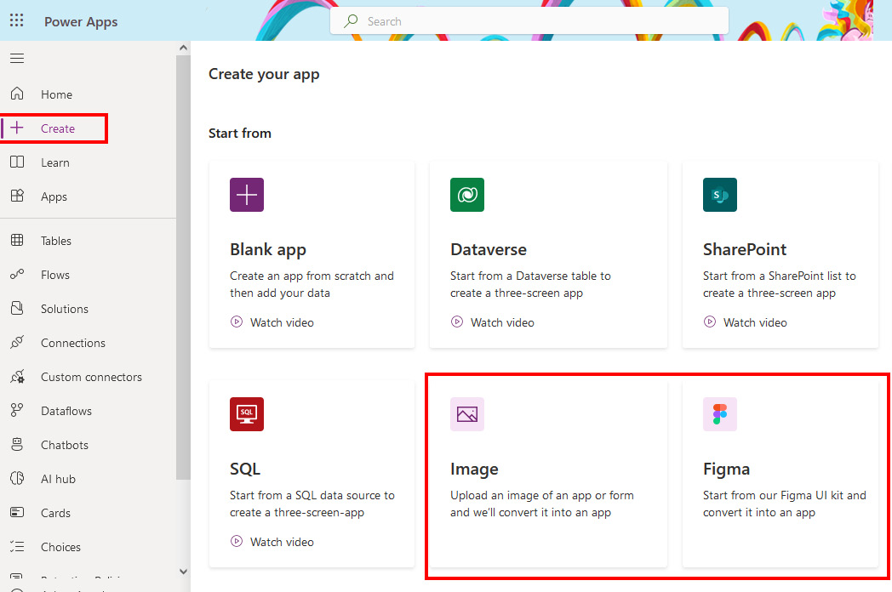

Figure 2.15 – Creating a canvas app from an image or Figma UI Kit

## Customer stories

Microsoft has on their Power Apps Customer Stories website (<https://powerapps.microsoft.com/en-us/blog/power-platform-stories/>) a consolidated list of real-life customer stories that everyone can read to understand what kind of challenges customers faced and how they solved them, by building a solution using Microsoft Power Platform.

In 2020, Microsoft claimed that 97% of Fortune 500 companies used Microsoft Power Platform in many ways. For sure, we can see that the platform is gaining popularity, which is why we believe that more and more real-life world cases will be documented and shared with the wider community, allowing people to learn from them and implement them to solve their own challenges.

Although not all customer stories are publicly available, those that are give us great insights into what made the customer decide to use the technology, and we can also read about how they implemented solutions.

# Summary

This chapter covered the rise of the LCNC development approach and how it has gained traction in recent years. We hope this chapter helped you understand why it is important to be aware of this development approach, what its benefits are, and how it is different from the classic software development approach.

We briefly explained the key family members of the Power Platform and focused on how to open your trial account. This should help you understand how to start using the platform, as the following chapters will focus on a hands-on activity, and it’s important to have a test environment prepared to follow along.

Next, we covered the tools to administer the Power Platform, from the admin center to different CLI tools, with PAC CLI being the preferred one, and various connectors that can help automate management tasks. No matter whether you are an IT administrator, DevOps engineer, or professional developer, there is a good chance that you will use one or more of these tools with Power Platform while developing or managing your solutions.

The last two sections in this chapter focused on understanding how the platform is kept secure and compliant with different standards and regulations, as well as how to make use of the various templates and patterns that are published on Microsoft public sites. This should help you gain trust in the platform and speed up your initial project, set up using the available templates (at least for the first few projects).

In the next chapter, we will use our knowledge of Power Platform and try to connect it with why ALM and DevOps are important for Power Platform projects. We will also delve into the Power Platform adoption maturity model and how it is helping organizations to assess their current maturity level and improve DevOps processes.

# Further reading

* Microsoft Power Platform Blog: <https://www.microsoft.com/en-us/power-platform/blog/>
* Dynamics 365 and Power Platform Release Planner: <https://releaseplans.microsoft.com/en-US/>
* Power Platform Admin documentation: <https://learn.microsoft.com/en-us/power-platform/admin/>
* Power Platform CLI: <https://learn.microsoft.com/en-us/power-platform/developer/cli/introduction>
* PowerShell support for Admins and Makers: <https://learn.microsoft.com/en-us/power-platform/admin/powerapps-powershell>
* Admin and Management Connectors: <https://learn.microsoft.com/en-us/connectors/powerplatformforadmins/>
* Microsoft Trust Center: <https://www.microsoft.com/en-US/trust-center>
* Microsoft Product Terms: <https://www.microsoft.com/licensing/docs/view/Product-Terms>
* Microsoft Enterprise Templates: <https://learn.microsoft.com/en-us/power-platform/enterprise-templates/>
* Power Apps Patterns: <https://learn.microsoft.com/en-us/power-apps/guidance/patterns/overview>
* Power Platform Stories: <https://powerapps.microsoft.com/en-us/blog/power-platform-stories/>

# 3

# Exploring ALM and DevOps in Microsoft Power Platform

Microsoft Power Platform allows users to create business applications in a simpler and faster way, which should be appealing to anyone no matter their development skills. Once we go beyond making personal productivity applications and start automating concrete business processes, we need to start planning how to best set up a life cycle model for managing all these newly built applications in the organizations.

Customer stories help us understand that once an organization has adopted Power Platform, the number of produced applications in the organization most likely increase heavily. Organizations should have a plan in place for how applications will be built, deployed, governed, and maintained. This is where ****Application Life Cycle Management**** (****ALM****) comes in. However, it is not all only about the developers. It is imperative that IT professionals and security engineers talk to developers and make sure that they are involved in the process of planning, creating, managing, and monitoring environments where applications are running. This is why expanding ALM with DevOps is also important for a ****Low-Code/No-Code**** (****LCNC****) development approach.

In this chapter, we will continue building on the previous chapters by explaining why ALM and DevOps should be used by LCNC projects in order to improve overall collaboration and quality assurance. After exploring how ALM can help us with building applications, we will delve into the topic of application modernization, since organizations often have many existing legacy applications that should be assessed and have their future decided on. We will close this chapter by understanding how the Power Platform adoption maturity model is connected with ALM/DevOps and application modernization, as well as why it is important to increase the maturity level in organizations.

Throughout this chapter, we will cover the following main topics:

* Why implement ALM and DevOps in Power Platform?
* Application modernization with an LCNC approach
* Building Power Platform adoption journey

# Why implement ALM and DevOps in Power Platform?

This section examines why LCNC platforms such as Microsoft Power Platform should implement ALM processes and how it will improve team collaboration, improve quality assurance, and help mitigate potential risks.

In the early stages of the adoption, we can see organizations giving Power Platform services to their ****citizen developers****. Citizen developers are individuals or employees within an organization who do not strictly hold traditional programming skills and usually come from the business unit rather than IT or development teams. They use Power Platform to build business applications mostly for themselves, to enable their personal productivity, without imposing any strict guidance on the usage.

As organizations mature, increase their awareness and knowledge around Power Platform, and start building more complex projects, they look for scalable, consistent, stable, and secure approaches for building and maintaining business applications. This is directly connected with understanding the importance of the ALM, which brings practices on how to govern, develop, and maintain applications together. Using the ALM approach for building applications can have positive implications for the development speed, reliability, and end user experience.

When talking about the ****speed of development****, we need to mention that ALM provides a framework and strives toward using the platform that allows multiple contributors to work on the application simultaneously. This is where a version control tool comes in. Since many tools nowadays, such as Azure DevOps and GitHub, offer a single platform to cover the ALM/DevOps life cycle, we can improve our speed of development by implementing automated build, test, and deployment pipelines through CI/CD pipelines. However, we can also improve delivery time by improving how we are developing our applications. Building reusable code components allows us to reuse these building blocks across projects and save time on the development. In the context of reliability, since we have a version control system in place, we have the possibility to do a rollback to the previous version, as mistakes can and will happen along the way. Having this ability increases our options to maintain system stability. The aforementioned CI/CD pipelines will help us make sure that applications are consistently deployed across different environments, which minimizes configuration drift and unexpected behavior.

Lastly, having a bug-free application plays an important role in shaping the user experience. Implementing continuous automated testing will help us discover potential issues early in the process. With automated testing, we can also look at potential performance bottlenecks. It helps us remove or optimize these issues in order to improve performance and, at the end of the day, improve the user experience.

Whenever we are considering application life cycle management in Power Platform, we concentrate on two main concepts: ****solutions**** and ****environments****. Everything that we develop throughout our project as part of the business solution, whether this would be a canvas application, flow, Dataverse table, or custom component, is represented as a ****solution component****. These solution components are added into a solution, to which we apply the ALM process, which enables the automated approach of exporting and importing of the solution to different environments. Environments act as a container that isolates the content inside our tenant and allows the separation of the target audience. The concepts of both solutions and environments will be probably well-known to IT professionals, pro developers, and DevOps engineers. This is because a similar approach is used in traditional software development, where applications are packaged in a package (solutions, in the context of Power Platform) and deployed to various target environments, such as development, test, pre-production, and production environments.

The concepts of solutions and environments will be described in depth in *[Chapter 4](https://learning.oreilly.com/library/view/mastering-devops-on/9781835880845/B22208_04.xhtml" \l "_idTextAnchor074)*. ALM in Power Platform is just one part of the story. Many people think of ALM as only being the deployment process to different environments, but the story is bigger than that. We should combine it with DevOps and also look at implementing additional steps such as building an environment management strategy, automatically packaging Power Platform resources into solutions, securing and managing environments, and, lastly, automatically deploying to different environments consistently while making sure that the produced work is properly tested. DevOps on Power Platform not only focuses on app makers and pro-developers, but also on enabling IT administrators to build strong platform and IT operations (IT ops) processes, which allow us to automate platform-specific tasks such as environment provisioning, platform management, DLP policy management, auditing, and more. Many times, business applications extend outside of Power Platform, so an IT operation team also needs to take care of the network management, for example when configuring the integration between Power Platform and Azure services or other on-premises backend systems.

As mentioned in *[Chapter 1](https://learning.oreilly.com/library/view/mastering-devops-on/9781835880845/B22208_01.xhtml" \l "_idTextAnchor014)*, ALM is a software development process that connects multiple phases of software development in a cyclical way. Now let’s take a helicopter view on what each of these phases mean in the context of Power Platform.

## Plan and track

The first thing we need to do before we jump into developing a project is to implement good preparation and planning of the project, which we can do by going through a ****requirements workshop**** process. This helps us understand the project goals and scope. It lets us start building the outcomes for this phase. This step requires good validation questions that will help us understand the goals and the project scope. Understanding the project scope will help us understand the timeline and resources available, including the budget. It will also let us potentially conduct a feasibility study to determine whether there might be some significant obstacles that we should be aware of. Once we understand the scope of the project, we can continue with capturing all the feature requests and prioritizing them using the ****four-quadrants method****:

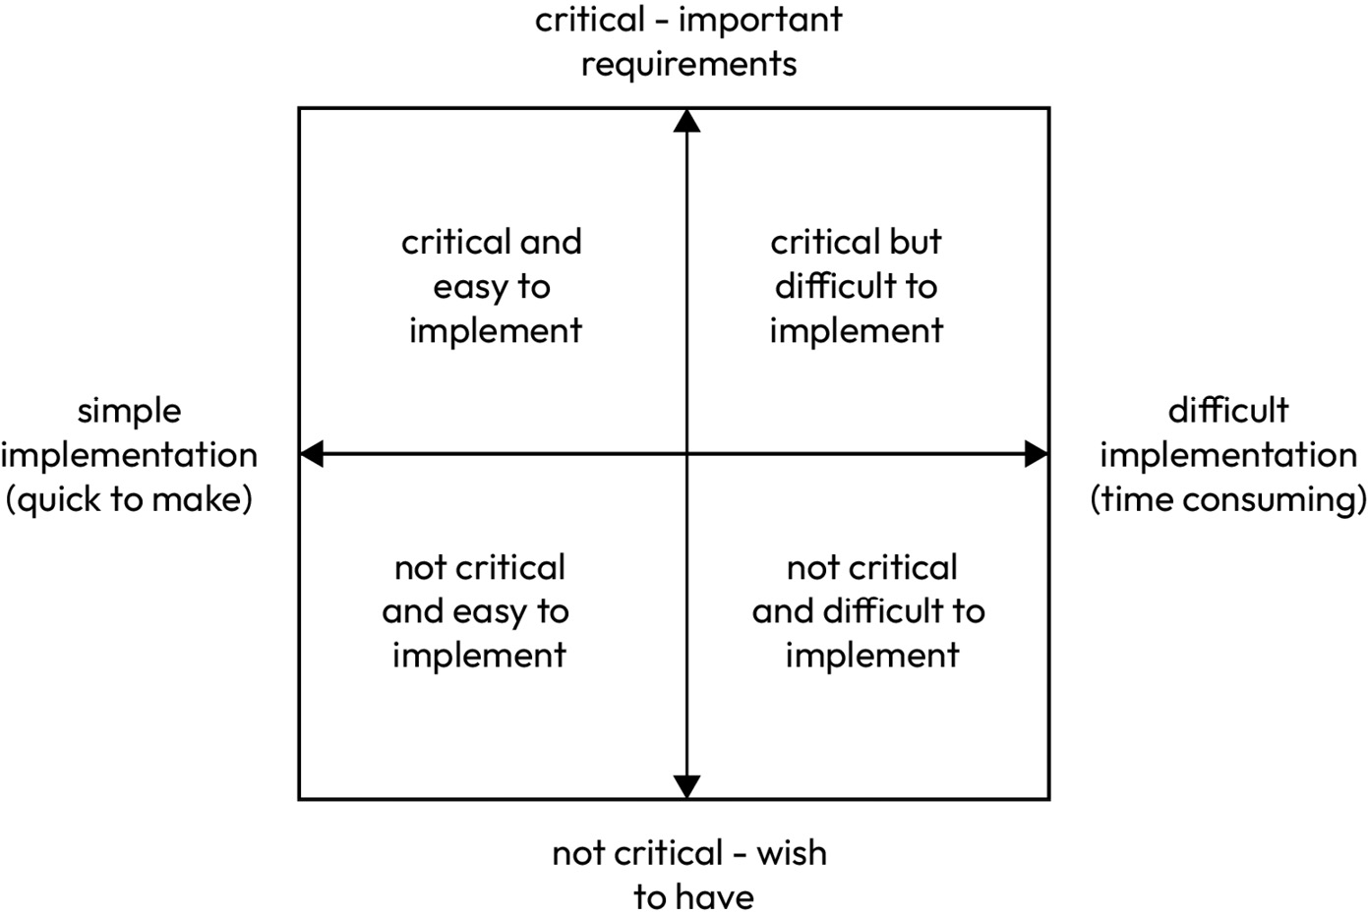

Figure 3.1 – The four-quadrant method

Next, we will identify all team members associated with the selected project and allocate them their respective roles for the project. Designated Agile methodologies, such as Scrum, already have predefined roles with their corresponding tasks, that we can reference to, when aligning roles to our team members. This will help us with assigning team members to defined tasks and user stories in the project planning tool. Using the selected project planning tool, we will align the work item types with the methodology that we will be using for the project and start creating work items, such as user stories and tasks, and map them according to the project schedule and responsible team members.

From the perspective of project planning, this is also a phase wherein we should be defining and building an environment design, defining the data strategy, and starting with the data modeling. Here, we are working on our project architectural design. Security teams should also start with threat modeling to identify any potential threats and mitigate them through adjustments in the architectural design, either physical or logical. Lastly, to address the user experience part and feature requests, we can start with the application storyboarding or wireframes.

As we can see, in the first phase of ALM, we might not even be touching Power Platform services. Instead, we will be focusing on the project planning-related activities. We can support this phase with project planning tools, such as ****Azure Boards**** (****Azure DevOps****), which has built-in project planning capabilities. It allows us to define the project through work items and to plan and track the work done as time progresses.

Here, we will also be deciding on our strategy that will influence the next phase – our branching strategy. We will also be deciding whether to use a single- or multi-repository approach.

## Development

The development phase is where app makers and pro-developers collaborate to realize the defined tasks and user stories in a sequence of sprints defined by the used methodology and project schedule. Depending on the project, this is a phase where we will be using Power Platform services to develop our business applications, flows, custom copilots, and websites. To support this phase, we will enable and connect our project with a version control system. A version control system protects development teams by having snapshots of the code over time, allowing them to revert to the previous version. It also safeguards them against potential conflicts in the code when there might be concurrent work done by offering developers a simple way to identify and resolve conflicts systematically. An example of such a system would be Azure Repos, part of Azure DevOps, or the GitHub repository.

Even though we have moved from the planning and tracking phase to the development phase, this and all subsequent phases in the life cycle have a big dependency on the first phase, as we will continue to use selected project planning tools such as Azure Boards. These tools will allow us to track the status of the work items and update them accordingly. We also use Azure Boards to collaborate with others project members by exchanging ideas and comments on the work items.

The development tasks are done in the Power Platform services and in ****Integrated Development Environments**** (****IDEs****) such as Visual Studio Code.

As an example of collaboration in Power Platform services, we can mention that Power Apps supports co-authoring in model-driven apps, and soon in canvas apps, which allows multiple makers to make changes in the application at the same time and have their changes reflected to others in real time. However, not all services enable the same level of co-authoring experience yet; thus, in order to mitigate this challenge of collaboration between code-first and citizen developers, Microsoft has introduced Power Platform Tools extensions, which we mentioned in the previous chapter.

As with DevOps, we strive to automate manual tasks. In this phase, we will start building CI/CD pipelines that will help us automate the build, test, and deploy process, which is done in the next phases of DevOps. Automated CI/CD pipelines are built in the DevOps tools, supported with tools for automating tasks in Power Platform. Examples of these are Power Platform Build Tools, ****Power Platform CLI**** (****PAC CLI****), PowerShell cmdlets.

## Build and test

Once the necessary features have been developed or bugs have been resolved and developers are ready to proceed with the next phase, they will need to initiate the sequence of tasks that will build the completed work and package it into a solution that is ready to be deployed to target environments.

One of the best practices in DevOps is to have as much as possible automated. In ****Continuous Integration**** (****CI****) pipelines, we define the tasks that are required to build and test our solution. For this task, we can use CI/CD tools, such as Azure DevOps, which has the Azure Pipelines feature built into the product itself. Alternatively, we can use GitHub Actions, which is part of the GitHub product.

The CI pipelines can be automatically triggered whenever the work gets committed to the repository. This reduces the need for human intervention to start the process.

Inside our CI pipeline, we have placed a series of tasks using Power Platform Build Tools or PAC CLI to perform necessary actions.

We cannot go forward without mentioning testing. An appropriate set of tests should be done here as well before proceeding to the next stage. Azure DevOps Pipelines or GitHub Actions enable us to automatically run tests during the CI pipelines. For example using the Solution Checker or PowerShell cmdlets for admins and developers, specifically the ****Microsoft.PowerApps.Checker.PowerShell**** module, we can integrate the solution checker functionality into the CI pipelines. Such an approach allows developers to implement static analysis checks during the build validation process and identify problematic patterns during the development process. From here on, we can use other testing tools in Power Platform, such as Power App Test Studio or Power Apps Test Engine, to build end-to-end tests in Power Apps.

As the outcome of this phase, using the tools we’ve mentioned, we have produced a build artifact. An artifact is a side effect of the build process, which in the context of Power Platform will be a packaged solution with all the components that have been added to the solution. This will be used in the next, deployment phase.

## Deploy

Now that we have an artifact as a result of the previous phase, we can focus on deploying it to the necessary environments and run additional tests there, such as integration, performance, security, and UI tests. As with the previous phase, ****Continuous Deployment**** (****CD****) aims to automatically deploy solutions to various environments, including production. With the use of DevOps tools and CD pipelines, together with Power Platform Build Tools, we can make sure that the deployment process gets automated.

An important step in this process is having the environments ready for the solution. This involves adhering to the environment strategy and following the governance guidelines defined by the organization.

With the environments ready, we can follow the agreed-upon deployment strategy. This strategy defines how we want to deliver our application to the users. Various deployment strategies exist, such as the blue-green deployment process, A/B testing, canary releases, and so on. The intention of all these deployment strategies is to bring updated applications to a set of users in a controlled way in order to be able to analyze different indicators, such as performance, user behavior, feature impact, and so on. As an example of a deployment strategy in practice, we can take a blue-green deployment strategy and, using the application sharing option, bring new features to a set of users. The process of sharing to multiple users or groups can be automatized with CLI/cmdlets.

As deployments might sometimes not go as planned, we should have our rollback strategy ready in case of any issues during the deployment or testing phase.

During this phase we can also perform any data-related activities – for example, ingesting the test data into Dataverse tables or provisioning new tables for the test environment and copying the data from the different environments using dataflows.

## Operate

The purpose of this phase is to ensure the ****availability**** of the systems and to have a stable and healthy state of the deployed solution. Since Power Platform is a SaaS solution, IT administrators do not have control over the infrastructure running the service, which is why they have to rely on Microsoft to keep the systems up and running. ****Service Level Agreements**** (****SLAs****) describe Microsoft’s commitment to uptime and connectivity. However, things happen and in order to verify the state of the service, IT administrators can verify the current state in the ****Service health**** dashboard in the Power Platform admin center. There, they can see whether there are any ongoing service degradations or future planned interruptions.

A set of tools, such as those available in the Power Platform admin center or ****Center of Excellence**** (****CoE****) Starter Kit, help us understand the state of our environments and of the deployed solutions. By connecting our applications with application performance monitoring solutions such as Azure Application Insights, we are able to collect and analyze health, performance, and usage data over the applications.

Additionally, during this phase, we can control the exposure of newly developed features and applications to our end users. Through feature flags and an agreed-upon deployment strategy, we can verify that the switches are performing and that users are able to access the features or services as designed for the specific user group.

## Monitor and learn

The last phase of the continuous DevOps life cycle is intended to make sure that the monitoring tools are in place and are providing us with the telemetry that we can use to *analyze the usage and performance* of our business application. This information helps us to learn and improve the current DevOps process. It can provide us with insights on whether we need to build better and more engaging applications.

Among other things, DevOps also focuses on the continuous delivery of features. In case we are utilizing feature flags, which allow granular control over the enablement of new functionalities to users, it is important to have a monitoring service in place to capture or gather usage information of the new features as well. This could be done by sending custom telemetry to Azure Application Insights. Azure Application Insights is an extension of Azure Monitor and was originally used to monitor applications through different environments. It allows us to understand performance and user flow, create our own queries over the logs that are stored in the log analytics, and more. By creating alerts, we can respond to exceptions or anomalies in the performance or usage. As we can see, by gathering the user telemetry, we can learn about how our application is being used and whether we are investing in building the right functionalities based on the users’ requests.

However, it’s important to note that this phase is not exclusively focused on understanding the telemetry from users. During this phase, our project and development teams need to also reflect on the work that has been done and honestly answer what is working and what is not working in the whole ALM process. Such an approach will help them to learn and grow along the way and to course-correct in case of misdirection. Learnings will be brought back to the ALM and used for the next sprints. Continuous learning and continuous improvement demonstrate a commitment to improving the process and delivering valuable products to the users. With this in mind, allowing users to provide feedback back to the development team can unlock valuable information on how to make applications even more meaningful for users.

From the tooling perspective, teams will utilize the analytics capabilities within Power Platform as well as Azure Application Insights. Teams will also use project planning tools, such as Azure Boards, to investigate the bottlenecks in the process and in the team’s performance. Through Power BI dashboards and reports, this can be represented visually and investigated.

We have already mentioned some tools that can be used to support our ALM and DevOps process flow. In the next section, we will take a closer look at the capabilities of the two tools that we will be using throughout the book for the hands-on part.

## ALM and DevOps tooling

There are many different tools available on the market for managing ALM/DevOps. Some tools are designed to cover only the CI/CD process, while others are built to cover the entire DevOps process by including tools for project planning, building, managing test scenarios, and more. From the context of productivity and integrations, it is always good to have one tool that can be used throughout the process of managing an entire application life cycle. We will look into the two most important tools that Microsoft is offering to support ALM and DevOps: Azure DevOps and GitHub Enterprise.

### Azure DevOps

Azure DevOps has a long tradition with Microsoft-oriented developers. It all started with a product known as Microsoft ****Team Foundation Server**** (****TFS****), which was released in early 2006. TFS was a collaboration tool for managing the configuration workflows of development projects. As the name suggests, it was a server product that a customer had to deploy to their on-premise environment. As the world evolved and new possibilities opened around cloud computing, Microsoft looked for ways to enable TFS as a SaaS product. This is when, in 2011, TFS was offered as a SaaS solution on the Windows Azure platform. It was named TFS. Later, it was renamed to ****Visual Studio Team Services**** (****VSTS****). In 2018, Microsoft rebranded VSTS to Azure DevOps Service, which also led to renaming TFS to Azure DevOps Server. Azure DevOps Server 2019 was the first rebranded version of the on-premise version.

As some organizations have either not yet adopted a cloud strategy or are operating in a regulated industry, Azure DevOps is still offered in two versions so that customers can decide on the variation of a product that fits them best – Azure DevOps Service or Azure DevOps Server. It can happen that the customer has a complex environment where a hybrid configuration would be required. In this case, ****build agents**** for CI/CD pipelines can be located on the on-premise servers, while still using other functionalities of the Azure DevOps service online. This is possible and a very common scenario. It solves a specific customer requirement, which is often tied to regulations, but can also be used for other technical reasons.

Azure DevOps consists of five services that support the ALM/DevOps process:

* ****Azure Boards****: Intended for project planning and work tracking, providing Kanban boards, backlogs, and team dashboards.
* ****Azure Repos****: Dedicated to offering private ****Git**** (and older ****Team Foundation Version Control**** (****TFVC****)) repositories. Allowing branching and pull request mechanisms.
* ****Azure Pipelines****: Focused on building CI/CD pipelines for any project in any language to be deployed to any platform. Consists of build agents, a component that performs actions that are defined in Azure Pipelines. Agents can be Microsoft-hosted, when using Azure DevOps Service, or self-hosted, when having an on-premise configuration with Azure DevOps Server. A combination of both, as a hybrid set-up, is also possible.
* ****Azure Test Plans****: Designed for building test scenarios to enable manual and exploratory testing.
* ****Azure Artifacts****: Intended as a package management feature that allows users to create and share NuGet, Maven, npm, Python, and Universal Package feeds from public and private sources.

Azure DevOps is very extensible. With extensions, administrators can enhance Azure DevOps capabilities. Extensions can be found and installed through Visual Studio Marketplace (<https://marketplace.visualstudio.com/azuredevops>), which holds extensions for Azure DevOps Service and Azure DevOps Server. Microsoft Power Platform Build Tools is an example of such extensions, which we will be using to support the ALM process.

Azure DevOps also supports REST API integration for automating tasks and building integrations with other systems and applications. IT administrators or DevOps engineers can also utilize Azure DevOps connector in Power Platform that will allow them to perform actions on their projects in Azure DevOps, such as creating new releases, creating new work items, or just checking the project status.

### GitHub Enterprise

GitHub was founded in 2007 with the GitHub service launched in February 2008. In June 2018, Microsoft announced its acquisition of GitHub. This acquisition also emphasizes Microsoft commitment to the open source community.

GitHub offers different pricing plans that unlock product capabilities depending on the plan. GitHub plans are designed to fit individuals, smaller teams, or even bigger organizations: there is GitHub Free for individuals or organizations, GitHub Pro for personal accounts, and GitHub Team or GitHub Enterprise for larger companies.

GitHub Enterprise is the most feature-rich option that is suitable for large-scale development projects. From a capabilities standpoint, it is similar to Azure DevOps, but there are some differences. Just like Azure DevOps, GitHub Enterprise also comes in two variations, either as a cloud service, which is called GitHub Enterprise Cloud, or as an on-premise instance called GitHub Enterprise Server. This gives customers flexibility to choose how to deploy and use the tool.

Similarly to Azure DevOps, GitHub products are designed to cover all phases of the DevOps life cycle, with features such as the following:

* ****GitHub Issues and GitHub Projects****: Intended for planning and tracking work across projects.
* ****GitHub Repository****: Dedicated to offering a private or public Git repositories, to store and collaborate across source code and files in a project. Allows branching and pull request mechanism.
* ****GitHub Actions****: Focused on providing a platform to support CI/CD for automated builds, tests, and deployment pipelines. GitHub Actions allow DevOps engineers to extend beyond CI/CD pipelines and automate other tasks around the project based on the activity in the repository. GitHub Runners are the most crucial component in running CI/CD pipelines. They perform activities that are defined in the GitHub Actions. Compared with Azure DevOps, they are similar to build agents. GitHub also provides GitHub-hosted runners, or self-hosted runners that can be deployed in an on-premise environment.
* ****GitHub Packages****: Designed for creating and managing private or public package registries. It supports commonly used package managers, such as ****npm****, NuGet, Maven, and more.

GitHub has a set of tools in its portfolio of products that are intended to enhance developer experience, improve collaboration during DevOps, and implement DevSecOps. These products are gaining in popularity and are worth mentioning:

* ****GitHub Codespaces****: Allows developers to quickly provision a secure cloud development environment , configured for a selected project. This means that it includes the necessary development tool, such as Visual Studio Code and all necessary extensions, for the developer to start working on the project faster.
* ****GitHub Copilot****: This is an AI coding assistant that helps developers with writing code by providing AI-based suggestions on code completion in real time. More about Microsoft Copilots will be covered in the final chapter of this book.
* ****GitHub Advanced Security****: Provides additional tools to further protect the security of the project. With features such as code scanning, secret scanning, and dependency review, GitHub Advanced Security enables organizations to shift-left security checks earlier in the development cycle. Code scanning allows us to find potential security vulnerabilities and coding errors in the source code. Secret scanning searches through our source code to find any secrets, such as keys and tokens, that our developers and IT engineers might have unintentionally committed into the source code. Lastly, dependency review allows us to see which dependencies are used in the project and whether any vulnerabilities have been identified for the version used in the project. GitHub Advanced Security can also be used with Azure DevOps.

As we have now looked into the DevOps life cycle phases and which tools are available for supporting DevOps life cycle, we are ready to delve into the specific modernization options. We will consider which modernization strategies are available when deciding on moving applications away from the existing technological stack toward a LCNC platform.

# Application modernization with an LCNC approach

In this section we will focus on application modernization with Power Platform. We will cover the different application modernization strategy options and how the LCNC development approach could be used as one of the options for modernizing applications.

Organizations are now, more than ever, faced with a challenge where they need to innovate at a rapid pace in order to build their competitive advantage on the market. Having a stack of legacy applications that are built on an outdated technology stack complicates the possibility of integration with modern systems. Many times, such applications present potential security threats as well due to the outdated technology and difficulty of maintaining them.

Outdated technology creates challenges with staffing as well, as it may be difficult to find developers who would be willing to continue developing in an older programming language and framework using older development tools. On the other hand, maintaining the existing legacy applications would potentially lead to a significant increase in technical debt over time.

Therefore, organizations are considering the possibilities of modernizing legacy applications. The LCNC development approach with Power Platform allows organizations to accelerate the delivery of new applications, reduce development costs, and expand the resource pool by allowing citizen developers to contribute to the process and minimize the need for extensive custom coding.

Legacy apps often do not have APIs that we can connect to. Power Platform, through Power Automate, allows organizations to implement ****Robotic Process Automation**** (****RPA****) processes that simulate user interaction with legacy applications. It allows them to insert such processes into the new modern business processes and cloud flows.

When existing applications expose APIs, we can focus on building a new frontend for our application and using custom connectors to connect to backend APIs. These are used to perform certain operations, such as database operations or functional logic. Both approaches allow us to modernize legacy applications iteratively in smaller batches, enabling functionalities as we proceed with the modernization. Such an approach of ****incrementally modernizing applications**** is also beneficial for modernizing applications that organizations rely on heavily without disrupting business operations.

Power Platform can be integrated with Microsoft Azure. This allows organizations that have already adopted Microsoft Azure cloud services to build new or extend existing applications with an LCNC development approach and simplify the adoption of Power Platform services. Since Power Platform allows integrations with many services through connectors, it is also suitable for modernizing existing applications. *[Chapter 9](https://learning.oreilly.com/library/view/mastering-devops-on/9781835880845/B22208_09.xhtml" \l "_idTextAnchor149)* will talk about the integration scenarios between Power Platform and Microsoft Azure, which will hopefully enable new ideas for app modernization.

Organizations that have adopted the fusion development approach will benefit greatly from such an approach when modernizing applications, as this approach allows pro-developers, app makers, and IT ops teams to focus on their part in the process of modernizing applications. We will also talk more about the fusion development approach in *[Chapter 9](https://learning.oreilly.com/library/view/mastering-devops-on/9781835880845/B22208_09.xhtml" \l "_idTextAnchor149)* of the book.

## Application modernization options

When deciding on a strategy for modernizing legacy applications, we should consider our options for application modernization in order to make an informed decision about the strategy. Organizations shouldn’t just take the legacy application and rewrite it using a more modern framework and language. Instead, they should also review and update the processes and used databases. Legacy applications were developed with the technology that was then available and also around the process that was suitable *at that time*. The same project could be delivered completely differently now than it was when the legacy application was developed. The technology that exists now might not have existed back then and the process that we can deliver today might be completely different from the one back then. As we are now also in the time of greater AI adoption, we should look into ways of optimizing processes and innovating with AI. Something that was previously done manually can potentially now be done completely automatically with the help of AI. This is why, when tackling the area of application modernization, we should look at modernization from the perspective of process optimization and modernization—both application and database.

### Process modernization

We should first start with ****process modernization**** in order to benefit more from the actual application modernization and database modernization process. Process modernization includes assessing existing processes in order to understand where we can improve. We can then continue with optimizing and redesigning existing business processes and aligning them to modern times using the capabilities of modern technology. The outcome of this process is a modernized and optimized process where bottlenecks were identified during the analysis process and either to some degree or completely eliminated with the help of automation. This allows us to gain operational efficiencies that lower the total cost of ownership of modernized workloads.

Power Platform has a product known as ****Power Automate Process Mining****. Power Automate Process Mining is a product that can help us discover, monitor, and improve processes. In May 2024, Microsoft’s Process Mining solution was recognized as a Leader in the 2024 Gartner® Magic Quadrant™ for Process Mining Platforms.

We should not forget to mention that a crucial part of process modernization is also the organizational culture and people, not only technology. Modernization is not only about technology; it is a mindset shift and it involves everyone in the organization being part of this change, from leadership to frontline workers. We will take a look at how the Power Platform adoption maturity model can help us with this in the next part.

### Application modernization

Application modernization is a process of updating the software application to align with the advancements in technology, matching current business needs, and improving the user experience. Nowadays, in many cases, application modernization is tied to the migration to the cloud, but it is not just that. Similar to the process modernization, it requires a holistic look at the application state, to improve user experience, make the application more secure, more reliable, compatible with the newer technology stack, and more. One of the benefits of the application modernization is the ability to accelerate innovation. Power Platform allows us to do that. Using a platform that allows quick prototyping as well as actual development of applications means that organizations will have more time to innovate. Adding DevOps or DevSecOps into the whole process, we can also improve time to market, while still keeping our applications secure.

Before jumping into modernizing applications, organizations should first run through the process of ****application rationalization****. This will help them understand what kind of applications they have in their portfolio and what to do with them. After identifying all the applications across the organization, we should perform an assessment of these applications. This will help us not only build an inventory of applications but also gain insights into each application. Such assessments can be done manually or automatically with the help of specific tools. Here, we will look at the architecture of the applications, application dependencies, infrastructure architecture, user analytics, and usage patterns, including how often the application is used and more importantly, when the last time was that application was used. Many times, customers try to modernize or migrate all applications when there might not be a need to do so since the application has not been used for many years. In such a case, retaining the data for audit purposes could be enough while retiring the application.

Once applications are assessed and inventory of apps is built, we should be deciding on the application modernization strategy.

In 2011, Gartner introduced the ****five Rs migration strategy**** that helps us segment our applications to the migration strategy. Today, we can see that more migration strategy options have appeared on the market, going beyond the five-R model. However, they more or less build on the original five Rs migration strategy, which is shown as follows:

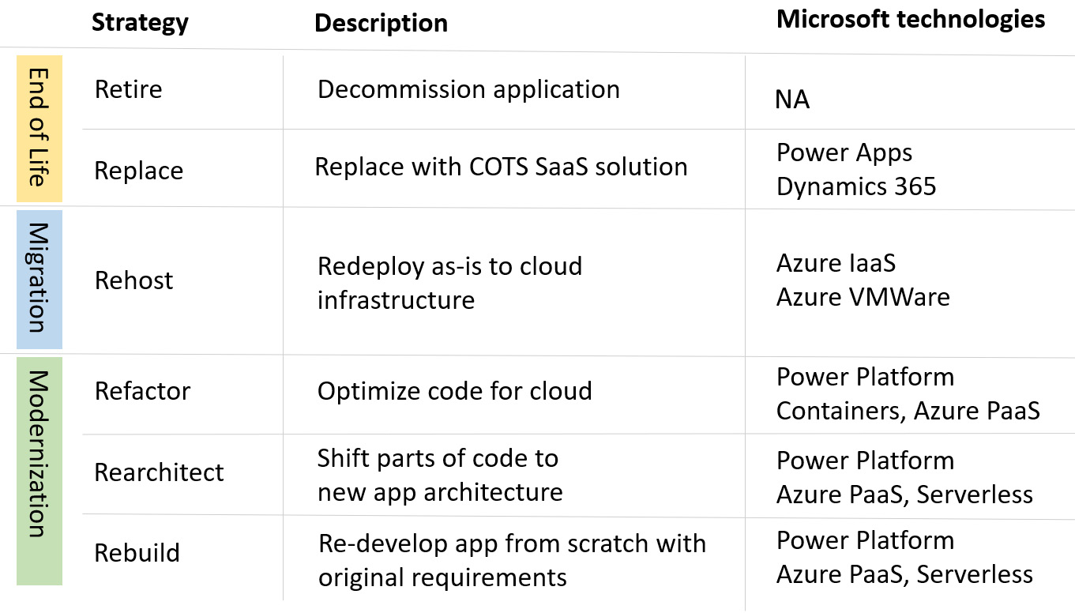

Figure 3.2 – App modernization strategy

We can see that we can segment each application into three main buckets.

* First is somehow putting an end to the existing application by either retiring it completely or replacing it with an off-the-shelf solution that is potentially built on top of Power Apps or Dynamics 365.
* Next is migration process to redeploy the application as is into the cloud infrastructure, which is usually on an IaaS workload such as virtual machines. Here, we do not do much from the perspective of Power Platform except that we are aware that the application exists on Azure IaaS and when building any new application, we might connect to the existing apps on Azure cloud more easily.
* The final bucket involves actual modernization, where parts of the code are modernized, or an entire application is built from scratch. This is the part where we come back to the project planning phase, gather all requirements, build architecture design, and start working on a new project utilizing Power Platform services. When we are done with the modernization of the application, we should have teams in place in the organization that will take care of the training and adoption to encourage users to start using the new application.

Currently, there are tools available on the market that can assess legacy applications and map them to the right migration strategy accordingly. However, using the tool is only a small percentage of the actual assessment. A larger portion of the assessment is done by conducting an analysis of the outcomes of the tool. This is to verify the outcomes and to map them with the findings of the manual assessment process, which might also include interviews with the users and administrators of the application. It could happen that tools would decide on one migration strategy based on the assessed source code or inputs that were provided to the tool. However, after conducting a thorough analysis and interviews, a different migration strategy might be selected. All these inputs will be crucial for us to decide on the migration strategy before kicking off the actual application development work.

### Database modernization

Database modernization tackles not only updating existing database systems but also how to improve the process of storing, processing, and handling an application’s data.

Usually, together with the application assessment, we also do database assessment, since they go hand in hand. Many times, the application logic is written in databases in a format of stored procedures, so when assessing and deciding on a modernization approach for applications, we should also look at this part and decide how to potentially take this logic out of the database systems and transfer it to the service that will be handling such logic. That being said, it is important to deliver database assessment as well. This will help us with the creation of the inventory of databases, tables, and their relationship. We should also look into the performance metrics and understand where the bottlenecks are.

Similar to the application modernization strategy, with database modernization, we also have to decide on different modernization strategies. They can be the same as for app modernization, only within the context of databases:

* ****Retire****: We decide to retire the database. If we are doing so, we should look into the archiving options for existing databases and the impact of decommissioning the database to other systems.
* ****Retain****: Sometimes, due to specific restrictions or requirements, we might not be able to move to newer database systems and retaining is our option. In such cases, Power Platform can support us with many connectors and on-premise data gateways through which we connect applications with the database system.
* ****Rehosting****: Without altering the data structure, we can migrate the database to a new platform. This could be a solution running on IaaS, such as SQL Server on Azure Virtual Machines, or any other open source SQL and NoSQL database solutions, such as MySQL or PostgreSQL on VMs, depending on the solution used.
* ****Refactor****: This would involve modifying or extending the existing data structure to improve the experience with the database system through performance, scalability and reliability, or anything else. Here, we aim to utilize newer technology, such as cloud database services for certain parts, while keeping the rest on the existing underlying database technology. In this case, for some parts we could be utilizing Microsoft Dataverse or switch to PaaS services, such as Azure SQL Database.
* ****Replace and rebuild****: These two options are put together here, since in favor of Power Platform services, Dataverse could be used as a database for the new application developed using the Power Platform services.

No matter which modernization strategy we select, we should work on implementing and adopting processes that will support DevOps in the organization. Application modernization is not a one-time process, but rather an iterative one. Organizations should track the progress and learnings during the modernization and improve if anything needs to be changed. This provides flexibility to the organizations to be able to change the strategy in case it is required. Having agile development teams with DevOps tools in place to work together in one central location and track the progress of the project allows us to be more effective in doing so.

However, it is not all only about the DevOps tools. Newly built applications on a platform that might be new to most of the organization would require us to work internally on increasing the adoption of the newly built applications in our organization. This is where the Power Platform adoption maturity model can help us.

# Building Power Platform adoption journey

In the previous section, we mentioned that application modernization is not a one-time process and that it will require continuous evaluation of the progress and potential improvement over time. To unlock the full potential of Power Platform, organizations should explore ways to introduce a strategy for increasing the adoption of Power Platform. This might involve empowering new app makers or providing comprehensive trainings, as well as implementing guardrails, processes, and tools that help developers work in controlled environments. This section will talk about the Power Platform adoption maturity model and emphasize its importance for organizations.

The Power Platform adoption maturity model helps organizations understand where they are on the scale of maturity and how to make sure that the adoption is aligned with business goals and KPIs while working on their digital transformation. It will be different for organizations that are more mature to build new or modernize existing legacy applications using Power Platform than for organizations that are completely new on Power Platform. Companies should understand their current maturity level and implement strategies that will help them improve, which will lead to more resilient, experienced, and adaptable organizations. Doing so could also lead to a smoother application modernization process.

## The Power Platform adoption maturity model

The intention of the Power Platform adoption maturity model is to help organizations assess their current level of maturity and use the set of best practices, patterns, and tools to guide organizations on how to improve their capabilities. Through the process of continuous improvement, organizations can continuously assess and increase their level of maturity in the areas that matter most to them.

The Power Platform adoption maturity model is closely related to the change management process, which is basically a structured approach that organizations take in order to move from the current state to the desired state by implementing a strategy for controlling this change and helping people adapt to the changes. As we have mentioned, this is also the intention of the adoption maturity model – to help define a strategy or plan for the adoption of Power Platform services. This plan should be aligned and approved by the business part of the organization since the improvement goals should be based on the business objectives.

Power Platform adoption maturity model is based on the ****Capability Maturity Model**** (****CMM****). Like the CMM, in this model, we also follow five levels of maturity that span from level 100 to level 500:

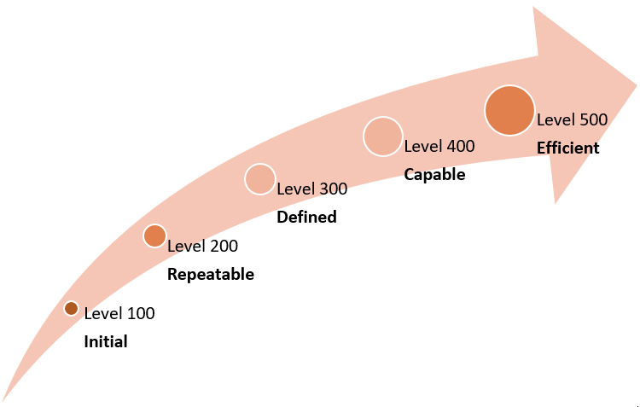

Figure 3.3 – The Power Platform adoption maturity model levels

Each level encompasses multiple disciplines that provide insights into the organization’s maturity across various domains. These disciplines are as follows:

* Strategy and vision
* Business value
* Nurture
* Admin and governance
* Support
* Automation
* Fusion teams

When looking at the ALM and DevOps, a big part of improvements can be done across the automation domain. The state of automation for organizations spans from level 100, which is where ALM processes are mostly done manually and very individually, to level 300, where deployment might still be done manually but organizations have started to use solutions, all the way to level 500, where ALM processes are implemented centrally and owned by fusion teams. Later, in *[Chapter 6](https://learning.oreilly.com/library/view/mastering-devops-on/9781835880845/B22208_06.xhtml" \l "_idTextAnchor103)*, we will also take a look at the ALM Accelerator, which helps organizations to speed up with setting up the ALM for Power Platform.

Connected with the DevOps and adoption journey is also the state of fusion teams in the organization. Maturity levels demonstrate different involvement of fusion development teams in organization. Level 100 is where fusion teams are not present, professional developers are not involved in Power Platform project development, and work is mostly done by app makers. Continuing towards the level 300, we can see that the teams are forming. Members of fusion teams understand and use version control systems and they even start implementing ALM; however, the work these teams do is still mostly scattered and not completely centralized. Proceeding to level 500, cross-real fusion teams are formed that incorporate cross-functional skills. At level 5, a common development strategy is in place, with a centralized source control system that supports collaboration across the organization. *[Chapter 9](https://learning.oreilly.com/library/view/mastering-devops-on/9781835880845/B22208_09.xhtml" \l "_idTextAnchor149)* explains more about the fusion development approach.

### The adoption maturity model across stages

The Power Platform adoption maturity model covers five levels of maturity. Ahead, we will be looking into each level through an example.

#### Level 100 – initial

In this stage, we can see that organizations might have isolated instances of successful cases developed using Power Platform. Users might find access to Power Platform on their own, usually through Microsoft 365, using their seeded licenses. They build applications on top of Office 365 services, most often using Excel or SharePoint as a data source. Since the applications are developed by individuals, individuals also maintain them, and most often, the applications are not reusable. There is no centralized strategy for governance or ALM. Users mostly work in the default environment; however, as there are no guardrails in place, users might even open new environments and use any connector. Although through these successful examples, organizations might identify potential in Power Platform, there is no strategy for going forward into organization-wide adoption and no plan for the establishment of a CoE.

To advance to the next maturity level, there is a lot to do regarding nurturing and skilling future app makers. Organizations can organize training sessions or hackathons where people learn and work together to build solutions that solve certain business problems. It is beneficial to identify app makers in the organizations that are early adopters of the technology. Through them we can promote the work and their experiences to others.

#### Level 200 – repeatable

Organizations are already moving a step ahead and are starting to discover what has been done by users across the organization. They might have implemented a CoE Starter Kit, which, among other capabilities, provides organizations with a set of tools designed to help gain insights into the adoption of Power Platform. Business applications that were developed have some documentation in place, which allows them to be repeated if needed. Organizations have built a common vision between IT and business, but new projects are still managed individually. Some policies are being put in place, including DLP policies, but there is still no environment strategy in place. App makers can form teams or communities, through which they support each other in the development process.

In order to advance to the next level, organizations can implement DLP policies in the default environment, gain access to the analytics as part of the Power Platform admin center, gain insights across tenants, improve communication with app makers, and keep on building internal training resources. The latter could be done through a centralized internal SharePoint site or other ****Learning Management System**** (****LMS****) tools.

#### Level 300 – defined

At this level, the LCNC development approach becomes part of the standard business process. Organizations have a single representative or entire team that acts as Power Platform product owners. Applications could be developed by individual users, business units, or divisions, so the innovation is happening from the bottom up or top down. There are more successful cases using Power Platform that can even be measured. The CoE team is established, which is trying to automate many of the processes such as environment creation requests. Teams are already implementing source control systems to start working on the ALM; however, the deployments are still mostly done manually. App makers understand the importance of reusability and they start building and utilizing components.

To improve the maturity level, organizations could implement an environment strategy and configure various security and governance controls in Power Platform. We should continue nurturing and promoting our app makers and teams through the successful use-cases that they have developed.

#### Level 400 – capable

Organizations at this stage are already very advanced. They have processes in place to measure the impact of Power Platform. A well-established CoE team is able to manage and monitor the Power Platform tenant. The organization already has experience with fusion teams where teams have cross-functional skills. This enables better cooperation in the development process. The ALM processes are defined and organizations use tools to centrally manage ALM and DevOps processes. Deployment pipelines are implemented and done automatically. Administrators are able to identify unused applications through analytics and take automated actions to manage environments. In the organization, a separate support team could exist that supports end users and app makers.

To proceed to the next maturity level, organizations could work more on reusability, implementing an app catalog to ensure that reusable components are reachable to provide consistency across applications. Work between the CoE team and the IT operations team could be automatized through chatbots.

#### Level 500 – Efficient

This is the most advanced stage, where Power Platform has become part of the digital transformation strategy. Organizations at this stage have standardized and automatized processes that allow rapid development of projects to support business needs. Large applications are built for use across the entire organization. When architecture for new projects is designed, it includes Power Platform services. Dashboards and reporting are implemented to support business decisions and verify the impact of Power Platform across each project. There is executive support for the usage of Power Platform in the organization. Administrative tasks are automated, utilizing automation wherever possible, including chatbots with approval processes to perform tenant management operations. Fusion teams are in place and there is a common development strategy with fully automated ALM pipelines in place. Support tasks are largely automated, including chatbots for internal support or FAQs.

## Ways to improve the maturity level

Although we have defined each level and mentioned that organizations should strive to improve the level of maturity, it often happens that disciplines in each level advance individually. This means that level improvements in organizations are not done holistically across all domains, but rather focused on specific domains.

We can come across companies that have just started with the Power Platform adoption and are in an initial stage, facing an important app modernization project , which pushes them to adapt and improve maturity level across very specific domains, in order to support the project. Companies then build their own plan and strategy around the type of level they would like to achieve per discipline and create a focus plan with a timeline that helps them aim to achieve it.

To get there faster, they can follow the Power Platform adoption best practices.

### Adoption best practices

Improving adoption maturity helps organizations to become more effective with the technology, allowing them to have processes in place that support digital transformation. To support this adoption process, Microsoft provides a set of best practices and guidance that will be helpful to anyone: those who are just starting with Power Platform adoption, those who would like to improve their adoption maturity level, and even those who are more experienced but have seen some challenges while trying to increase adoption of the services in the organization.

Adoption best practices are split into four areas and address most of the disciplines in the adoption maturity model:

* Strategy and vision
* Admin and governance
* Nurture and educate
* Support

### Power Platform Landing Zones

The ****Power Platform Landing Zones**** reference serves as a modular architecture reference guide for organizations to implement their desired Power Platform tenant state by following the design principles and critical design areas. It helps us with the Power Platform environment creation that aligns with the agreed-upon governance policies. As we have seen, the adoption maturity model highlights how the automated environment management approach differentiates organizations of different maturity levels.

### Power Platform Well-Architected

The Power Platform ****Well-Architected Framework**** (****WAF****) is a framework that brings together best practices and recommendations that help organizations of every size achieve the most optimal architecture design of the application workload in Power Platform. Organizations can make sure that by following Power Platform WAF, their environments will be ready to scale for future growth, with controls in place to ensure compliance and security of their environment and data.

We will be exploring these topics in more depth in *[Chapter 11](https://learning.oreilly.com/library/view/mastering-devops-on/9781835880845/B22208_11.xhtml" \l "_idTextAnchor208)*, where we will discuss more about IT operations. There, we will also discuss the security side of these best practices and the available tools to manage environments centrally and automatically.

# Summary

This chapter covered the *why* and *how* aspects of the usage of ALM and DevOps with Microsoft Power Platform. Understanding what ALM and DevOps bring to organizations is important since we need to show organizations that it is not an impossible mission, but something that every organization can and should implement. We learned this in this chapter. This is why it is important to learn how ALM/DevOps processes can be implemented and what tools are available, as we did in this chapter. Since it is a process of continuous learning and improvement, organizations should not worry if they might not get it completely right on the first try. Going through the iterations of improvement and adaptation of the process to get it tailored for the organization is the right approach to achieve excellence.

We touched on the app modernization topic and why it is important for organizations to review their existing legacy apps and looked into the options for the app modernization strategy. We saw that DevOps and adoption are at the heart of digital transformation and application modernization. This is why we looked at what the Power Platform adoption maturity model is and how organizations can identify at which level of maturity they are with each discipline for themselves. Most probably, they will be higher up on maturity level with some disciplines, while others may be lower, as we learned in this chapter. We also learned that it is important that the organizations create a strategy for how to improve these gaps, realize the potential of the platform, and see the return on investment in Power Platform. The next chapter will dive deeper into the solutions and environments. We will understand what these concepts represent in Power Platform, what the available types are, and what the differences between the types are. This will help us get acquainted with the managed environments and solutions, as well as how to use pipelines and start building our first CD using managed pipelines.

# Further reading

* Azure DevOps: <https://azure.microsoft.com/en-us/products/devops>
* GitHub: <https://github.com/>
* The Power Platform adoption maturity model: <https://learn.microsoft.com/en-us/power-platform/guidance/adoption/maturity-model>
* Power Platform adoption guidance: <https://learn.microsoft.com/en-us/power-platform/guidance/adoption/methodology>

# Part 2:Implementing DevOps on Microsoft Power Platform

In this part, we will explore the Microsoft Power Platform environments and solutions and their integration into DevOps-related processes. Through hands-on exercises, we will get familiar with PAC CLI, Git version control system, Azure DevOps Services pipelines, and GitHub workflows. We will also discover the latest features of Power Platform pipelines and managed environments. Additionally, we will do a deep dive into DevSecOps on Power Platform with GitHub Advanced Security features for GitHub and Azure DevOps. To conclude, we will apply our acquired knowledge to a practical example, further solidifying our understanding of these concepts.

This part has the following chapters:

* *[Chapter 4](https://learning.oreilly.com/library/view/mastering-devops-on/9781835880845/B22208_04.xhtml" \l "_idTextAnchor074)*, *Understanding Power Platform Environments and Solutions*
* *[Chapter 5](https://learning.oreilly.com/library/view/mastering-devops-on/9781835880845/B22208_05.xhtml" \l "_idTextAnchor089)*, *Streamlining Power Platform Development with DevOps Tooling*
* *[Chapter 6](https://learning.oreilly.com/library/view/mastering-devops-on/9781835880845/B22208_06.xhtml" \l "_idTextAnchor103)*, *A Deep Dive into Continuous Integration/Continuous Deployment (CI/CD) Pipelines*
* *[Chapter 7](https://learning.oreilly.com/library/view/mastering-devops-on/9781835880845/B22208_07.xhtml" \l "_idTextAnchor115)*, *An Overview of DevSecOps in Power Platform*
* *[Chapter 8](https://learning.oreilly.com/library/view/mastering-devops-on/9781835880845/B22208_08.xhtml" \l "_idTextAnchor134)*, *Demonstrating ALM and DevOps Implementation*

# 4

# Understanding Power Platform Environments and Solutions

Now that we have learned about the Power Platform products, as well as ****Application Life Cycle Management**** (****ALM****) and DevOps approaches, in the previous chapters, it is time to explore the fundamental building blocks of successful ALM by introducing the concepts of ****environments**** and ****solutions****. We will start by explaining what constitutes a solution in the Power Platform and then discuss ****Dataverse**** and data modeling within this framework. We will also cover the versioning of solutions and packages in the platform to understand how to manage different versions of solutions. We will learn about the concepts of ****Managed Environments**** and ****managed pipelines****, and we will also discover how we can use them to automate and streamline the software development process. We will conclude this section with a step-by-step guide on our first ****Continuous Integration and Continuous Deployment**** (****CI/CD****) pipeline in the Power Platform, giving us a practical understanding of how CI/CD processes work in this specific context.

By the end of this chapter, we will be able to set up a CI/CD pipeline using the built-in Power Platform pipelines, deploy solutions to different environments, and use Copilot to generate deployment notes in pipelines.

In this chapter, we’re going to cover the following main topics:

* What comes to a solution?
* Versioning of solutions and packages
* What about data – Dataverse and data modeling aspects
* Environments – Managed Environments and environment strategy
* Managed pipelines – our first CI/CD

# Technical requirements

To be able to create our first CD pipeline using Power Platform pipelines, we need to have a Power Platform subscription. We can sign up for a Power Apps Developer Plan (<https://www.microsoft.com/en-us/power-platform/products/power-apps/free>), if we already have a Microsoft Entra ID work account, or we can join the Microsoft 365 developer program (<https://developer.microsoft.com/en-us/microsoft-365/dev-program>).

In addition, we need to install the PAC CLI tool and PowerShell administrator module. See *[Chapter 2](https://learning.oreilly.com/library/view/mastering-devops-on/9781835880845/B22208_02.xhtml" \l "_idTextAnchor030)* for setup and installation information.

# What comes to a solution?

As we have learned in the previous chapters, Power Platform consists of multiple products, including Power Apps, Power Automate, Power Pages, Microsoft Copilot Studio, Dataverse, AI Builder, and so on. We often refer to the building blocks that we can create in these products as assets or solution components. An asset can be a canvas app, a connection reference, a cloud flow, a custom copilot, or even a plugin developed for Dataverse or a Dataverse Table schema definition.

****Solutions**** are the containers of the assets that build up a Power Platform application. They can contain one or more apps as well as other components such as flows, custom Copilots, Power Pages websites, site maps, entities, processes, web resources, option sets, pro-dev components, such as plugins, PCF components, and more. Some components are nested within other components; for example, a Dataverse Table contains forms, views, charts, columns, table relationships, messages, and business rules. Each of these components requires a table to exist and they cannot exist outside of a table. On the other hand, solutions need environments with Dataverse installed.

We need solutions because Power Platform solutions are the way to transport apps and components from one environment to another or to apply a set of customizations to existing apps. This is one of the key fundamentals of ALM processes in Power Platform. To implement these releases and to get ****Continuous Deployments**** (****CDs****) to work fluently, the platform defines two types of solutions:

* ****Managed solutions**** are created by exporting an unmanaged solution as a managed solution package. Once a managed solution is imported into a target environment, the components within the solution are locked and can only be modified by the publisher of the solution. This allows the publisher to control how the solution is used and updated in the target environment. Managed solutions are like generated binaries; they are immutable in the target environments.
* ****Unmanaged solutions**** are typically used in development environments where changes and customizations are made to the application. Unlike managed solutions, the components within an unmanaged solution are not locked and can be modified by anyone with the appropriate permissions. These solutions are like the source code of applications in custom development projects. Unmanaged solutions are exported as unmanaged solution packages and can be imported into other environments for further development or testing. However, it is important to note that unmanaged solutions should not be used in production environments as they can be changed by anyone who has access to the components defined within them.

Every development project starts with an unmanaged solution, which developers extend with components to realize the original customer requirements. After finalizing the development and going through the testing phase, the unmanaged solution is converted to a managed one.

We can also export solutions manually, which results in ZIP files. In the case of a managed solution, the ZIP file only contains a few files. One of them is an ****.msapp**** file. On the other hand, the ZIP files of unmanaged solutions contain a large number of JSON and XML files that describe the configuration of Power Platform assets included in the solution. We can also edit the latter ones if needed.

Considering the traditional development terms and methodologies, creating a managed solution is equal to generating binaries, so it is exactly what a ****Continuous Integration**** (****CI****) build does. Moving the managed solution through different environments corresponds to CD steps.

*Solution as starting point*

*It is highly recommended to start any customization on any Power Platform components or assets by creating a solution. We should then create any components inside the solution rather than in the corresponding editor. When we use this approach, the platform immediately appends every dependency to the Power Platform solution.*

****Solution layering**** is a feature in the Power Platform that allows us to manage the dependencies and behaviors of components within solutions. When we import a solution into an environment, the components within the solution are organized into layers based on their dependencies. Each layer represents a specific solution that has extended or changed the behavior of a component. Solution layers allow us to control how different solutions interact with each other and how changes to one solution can affect other solutions. This is particularly useful when we have multiple solutions that modify the same component, as it allows us to manage conflicts and ensure that the behavior of the component is consistent across all solutions. The following figure shows how solution layering works in practice:

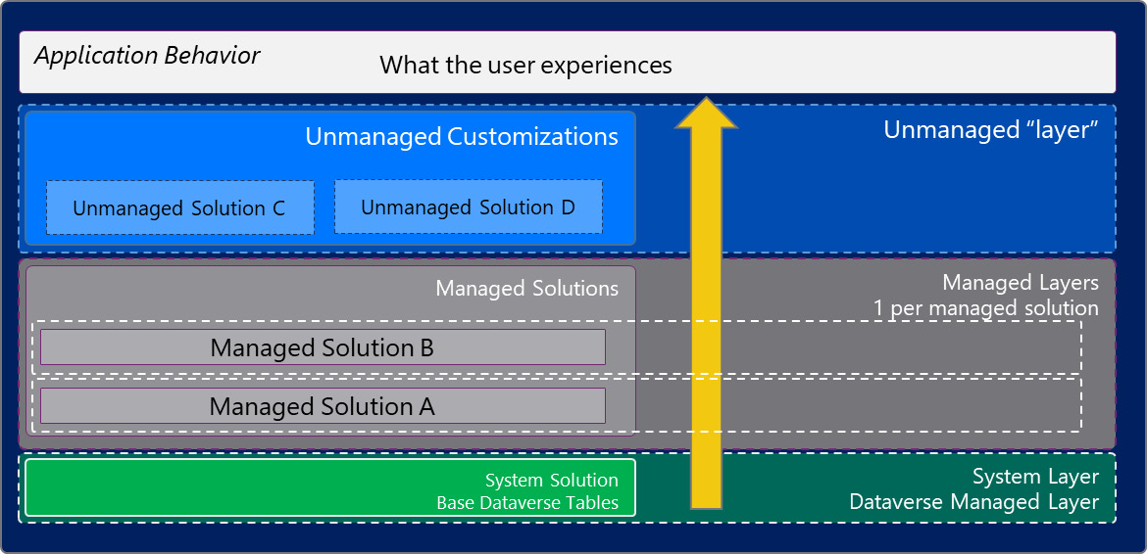

Figure 4.1 – Solution layers

On top of the ****System Solution**** and the ****System Layer****, every managed solution creates its own managed solution layer. If multiple solutions change the same underlying component (asset), then the last customization wins (*last one wins*). To avoid merge conflicts with other solutions, the best practice is using unique asset names, such as unique form and view names on common Dataverse tables. Since the automated deployment pipelines run in the background, we need to be aware of such conflicting situations too.

In order to support modern ALM and DevOps processes, in addition to having immutable binaries (solutions), we also need version numbers. ****Version numbers**** help developers and ops teams identify the software running in the production environment. Power Platform solutions provide versioning features as well, which we will discuss in the next section.

# Versioning of solutions and packages

Every solution has a version number that follows this well-known pattern:

Major.Minor.Build.Revision

Each part of the version number has a specific meaning:

* ****Major****: This number is incremented when there are significant changes to the software, such as the addition of new features or changes that are not backward compatible
* ****Minor****: This number is incremented when there are minor changes to the software, such as the addition of new functionalities or improvements to existing features that are backward compatible
* ****Build****: This number is incremented when there are changes to the software that do not affect its functionality, such as bug fixes or performance improvements
* ****Revision****: This number is incremented when there are small changes to the software, such as hotfixes or security updates

The life cycle of a Power Platform solution involves several stages, including creating, updating, upgrading, patching, and staging for upgrade. Here is an overview of when to apply each of these actions:

* ****Update****: This option substitutes our solution with the new version. The assets that are not part of the newer version will not be erased and will be still available in the environment. This option has the best performance by typically finishing in less time than the upgrade methods. We can create updates to a managed solution that are deployed to the parent-managed solution, that is, under that solution. We cannot delete components with an update.
* ****Upgrade****: Upgrades combine all patches into a new version of the solution. During the upgrade process, any components that are no longer included in the new version will be removed. The upgrade can be done immediately or staged.
* ****Staging for upgrades****: This is used to prepare the target environment before deploying the solution. Staging for an upgrade does not delete the previous version of the solution; the old and new versions are installed side-by-side. We can use this scenario if we need to do some data migration before we complete the solution upgrade.
* ****Patch****: A patch includes only the modifications made to a parent-managed solution, such as adding or modifying components and assets. Patches are useful for making minor updates like hotfixes are. When a patch is imported, it is applied on top of the parent solution. It is not possible to delete components using a patch.

The following figure shows the life cycle of Power Platform solutions, highlighting the main stages of an application:

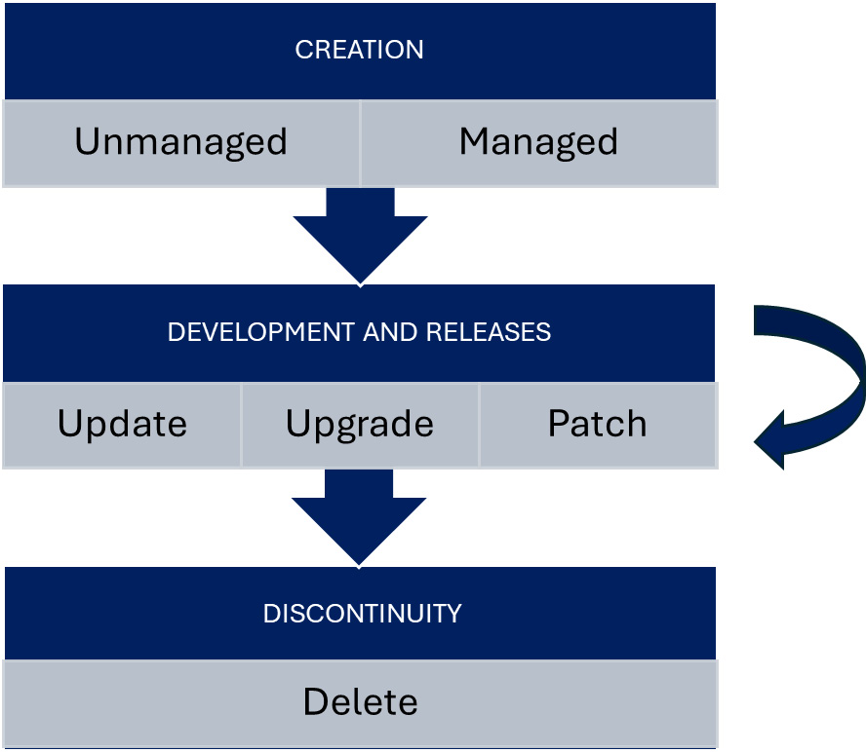

Figure 4.2 – A solution’s life cycle

Every solution starts its life cycle in the ****create**** stage. During the ****development and releases**** phase, multiple updates, upgrades, and patches are delivered in the form of managed solutions. At the end of the application’s life cycle, the managed solution is deleted, which removes every customized object from the Dataverse.

In the case of managed solutions, the ****upgrade**** action is the default option among the ****update****, ****upgrade****, ****stage for upgrade****, and ****patch**** actions, whereas unmanaged solutions can be only updated.

Power Platform solution patches are a way to update only the components of a solution that have changed instead of deploying the whole solution again. They are useful for reducing deployment time and avoiding conflicts with other solutions. Patches contain only the changes for a parent-managed solution, such as adding or editing components and assets. Typical examples of using patches include adding a new button on a canvas app or extending the column definition of a custom or system table. Patches get version number incremented by ****1**** in the ****build**** number:

{major}.{minor}.{build+1}.{version}

Only unmanaged solutions can have one or more patches that we can export as managed patches to deploy them to other environments. The solution to which the patch has been created is locked until the patches are merged and a new version of the solution is cloned. This version will get the ****{major}.{minor+1}.{build}.{version}**** version number as we can see in the following figure:

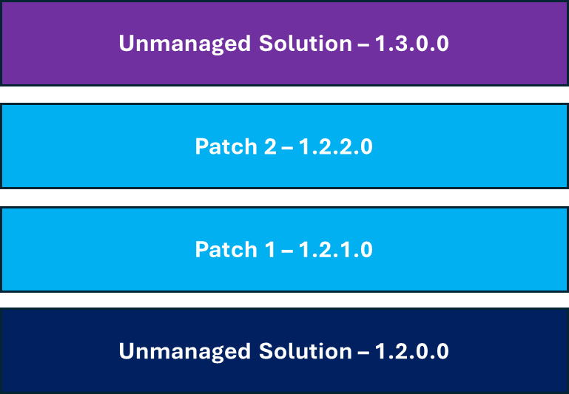

Figure 4.3 – Patches and versions

The parent solution is the unmanaged solution with version 1.2.0.0. The patches get the incremented version numbers 1.2.1.0 and 1.2.2.0, respectively. After rolling up the patches, the new version of the unmanaged solution will be 1.3.0.0.

We recommend using patches very rarely because sooner or later, we will need to roll up the patches together and release a solution update.

If our solution contains too many customizations, then we might encounter timeouts during the synchronous import. ****Solution staging**** breaks the import process into more controllable phases and executes those steps asynchronously. This option is available in the Dataverse SDK for .NET, through Web API, in the build tools of Azure DevOps and GitHub, and in the PAC CLI.

There are two advanced pro-dev tools we can use to customize the solution import and export process in depth:

* ****The SolutionPackager tool**** unpacks a managed solution file into multiple files, including XML files, for easy management by a source control system. The tool decompresses the solution file into individual files for each asset, allowing changes to be tracked in version control systems. The tool can also repackage individual files from source control into a managed solution file for deployment to other environments. PAC CLI uses ****SolutionPackager**** under the hood to unpack a solution ZIP file to a solution folder, or to pack a solution folder to a solution ZIP file. We can also configure whether the resulting ZIP file should be a managed or unmanaged solution.
* ****The Package Deployer tool**** is a powerful tool in the Power Platform that allows administrators to deploy packages on Microsoft Dataverse instances. A Package Deployer package can contain any or all of the following:
  + One or more Dataverse solution files
  + Plain text files or exported configuration data files from the Configuration Migration tool

Package Deployer is a great tool to deploy multiple solutions as one monolith package to our Power Platform environments. All we need is to create an MSBuild project file in Visual Studio 2019 or later, or with Visual Studio Code. We can then add the solutions, additional configuration files, HTML content, and even custom code to this MSBuild project. After building the package, administrators can install it in the target environment. Our custom code is executed during the import process and the HTML content is displayed for admins to get to know what exactly our package does. The Enterprise templates that we learned about in *[Chapter 2](https://learning.oreilly.com/library/view/mastering-devops-on/9781835880845/B22208_02.xhtml" \l "_idTextAnchor030)* have been created in this way too.

Now that we have learned the solution concept of Power Platform, let’s move on to Dataverse, in which these solutions (among others) are stored.

# What about data – Dataverse and data modeling aspects

We all know that applications don’t work without data. Either they use the data to change their own behavior (as for applications run on data), or they manipulate it with the well-known ****Create-Read-Update-Delete**** (****CRUD****) operations.

Microsoft Dataverse is a cloud-based data platform, a powerful database layer, the first party storage service of Microsoft Power Platform that stores not just relational data in SQL-like tables but also files, logs, and NoSQL IoT data. Under the hood, Dataverse seamlessly uses many Azure services, behaving as a ****polyglot persistence layer****. The following figure shows the high-level architecture of Dataverse and the Microsoft Azure services used:

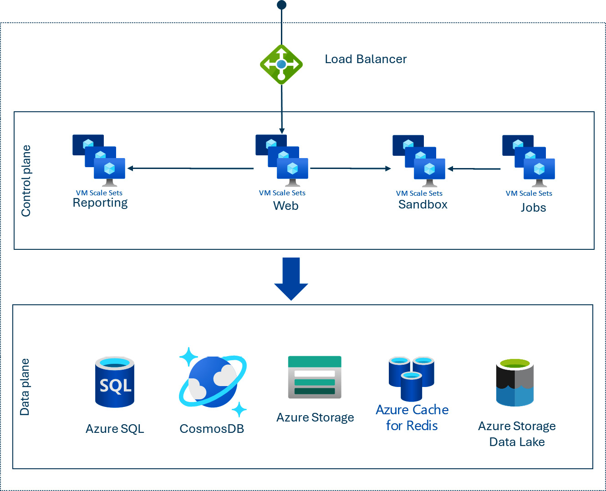

Figure 4.4 – The Dataverse polyglot concept under the hood

As we can see in the figure, an Azure Load Balancer scales requests across several compute services:

* Web for handling ****OData API**** requests
* ****Azure Jobs**** for handling asynchronous processing
* Sandbox for running customer C# code that is executed within the processing pipeline
* Reporting servers that handle paginated reports

A variety of storage services are used to persist our data in the most proficient and performant way possible. Relational data is stored in ****Azure SQL Managed Instance****, files and attachments are written to ****Azure Blob storage****, and analytical data produced by DataFlows is stored in ****Azure Data Lake Storage****. We have ****Elastic Tables**** as well, a new concept to store ****Internet of Things**** (****IoT****) data with tens of millions of records powered by ****Azure Cosmos DB****.

Dataverse manages all these Azure data services, providing 99.9% availability, enterprise scalability, backups, audit logs, and disaster-recovery management out of the box. Dataverse is also the main data storage solution behind the Dynamics 365 product family.

One of the key differentiators of the database service is the built-in security solution with a strict role-based access model, as well as row-level and column-level security configurations. Dataverse security is based on a role-based security model that protects data integrity and privacy while supporting efficient data access and collaboration. Users who can access Dataverse are Microsoft Entra ID accounts, that is, Azure AD users. Each user can be assigned to a set of pre-defined security roles that determine the types of records a user can access, the scope of data that users can manage, and the specific tasks that they can perform. This model is called row-level security and provides users with access to only the appropriate level of information that is required to do their jobs. For instance, users can view and edit the records they have created. Their supervisors can view and edit every record their directs have created. Common ****security roles**** are as follows:

* ****System Administrator****: This role has access to all data and can perform all tasks, including customizing the system
* ****System Customizer****: This role can customize the system but does not have access to all data
* ****Environment Admin****: This role has access to all resources in the environment including Dataverse
* ****Environment Maker****: This role can create new environment resources, such as apps, flows, and APIs, but cannot access data in the environment (Dataverse)
* ****Basic User****: This role has limited access to data and can perform basic tasks

Dataverse also provides ****field-level security****, which allows us to secure the data stored in individual columns. This means that we can restrict access to specific data within a record based on the user’s security role. For instance, managers can see employee records, but HR can also see the ****salary**** column within those records.

In addition, Dataverse provides ****Data Loss Prevention**** (****DLP****) capabilities to enforce policies across connectors. Policies can be defined at the tenant or environment level. We will see later that every environment can have one or zero Dataverse created. Environment-level policies are applied at the environment level and only at that level, whereas tenant-level policies are applied to the entire tenant and have precedence over environment-level ones. The management and governance of DLP involves incident alerts and reports that provide administrators with detailed information on policy matches, enabling them to monitor and protect sensitive data effectively. These reports help administrators understand the number of DLP policy and rule matches over time, filter those matches by action and location, and determine whether rule matches are trending up or down.

The ****zero trust security principle**** is based on the idea that trust is a vulnerability, and that security must be designed with the strategy of *never trust, always verify*. This means that instead of assuming that everything behind the corporate firewall is safe, the zero trust model assumes a breach and verifies each request as though it originates from an uncontrolled network. In the context of Dataverse and Power Platform, the zero trust security principle can be applied by using role-based access control, field-level security, and DLP capabilities to enforce policies and protect data. By implementing the ****least privileged strategy**** when designing security roles, we can ensure that users only have access to the resources they need to do their jobs. Additionally, we can use Microsoft Entra ID to manage user identities and access and implement ****Just-in-Time**** (****JIT****) and ****Just-Enough-Access**** (****JEA****) policies to ensure that users only have access to what they need when they need it. By following the zero trust security principle, we can minimize the risk of data breaches and protect our organization’s data while still enabling efficient data access and collaboration.

In addition to these comprehensive features, Dataverse has a common database schema. The ****Common Data Model**** (****CDM****) is a shared, standardized collection of data schemas published by Microsoft and its partners to the open source community on GitHub. It unifies data into a known form and applies structural and semantic consistency across multiple apps and deployments, making data management and app development simpler. The CDM is influenced by data schemas found in Dynamics 365 and covers a wide range of business areas. It brings, among others, common data table definitions such as ****Account****, ****Customer****, ****Product****, ****Opportunity****, ****Sale****, ****Purchase Order****, and many more to Dataverse. The CDM definitions are open and available to any service or application that wants to use them. By using the CDM, we can easily integrate with Dataverse and other services, and we can build custom applications that use the entity definitions available to us. This can save us time and effort, as we don’t have to build a new data model from scratch.

Dataverse schema definitions, such as ****Tables****, ****Columns****, ****Relationships****, ****Business rules****, ****Views****, ****Forms****, ****Dashboards****, ****Charts****, ****Messages****, ****Keys****, and ****Commands****, are part of the solution definition, which means that database-level changes are one of the assets that developers can include in their solutions. On the other hand, solutions are themselves stored in Dataverse. When we import a solution into Dataverse, its metadata and dependency configurations are imported into various system tables, such as ****Solution****, ****Solution Component Attribute Configuration****, ****Solution History****, ****Solution Component History****, and so on. After the metadata import, the underlying system flows install the solution and apply the changes.

*Data in Dataverse and Solution*

*To add data to a Dataverse table in a Power Platform solution, we can use the*****Import data*****option in the top command bar of the*****Tables*****page in Power Apps. There is (intentionally) no way to include data in a Power Platform solution. However, we can export the data and then import it into the new environment. Alternatively, we can copy our entire development environment in the Power Platform admin center, if there is nothing currently in production. Tools, such as Configuration Migration tool, Package Deployer, Power Platform DataFlow or writing code in Dataverse SDK for .NET to create entities in the target environment are the recommended tools and approaches to import data into environments.*

Dataverse instances live in environments, an additional concept to organize our applications and solutions tenant-wide. In the next section, we will learn how to consider these environments from pro-dev perspectives.

# Environments, managed environments, and environment strategy

Environments are containers of our apps, flows, connections, and other components along with security and data access management capabilities. To draw an analogy from the cloud world, we can look at environments such as Microsoft Azure subscriptions, which act as logical containers capable of hosting one or more applications. Perhaps the term *workload* is more appropriate here, as our Power Platform applications can include Power Apps, Flows, custom Copilots, Power Pages websites, and more. It is highly recommended to use solutions to deploy workloads to environments.

Microsoft Power Platform tenants can have thousands of environments. Microsoft Entra ID is the glue that provides security controls, governance, and guardrails that surround every product in Power Platform. As mentioned earlier, Power Platform runs on top of Microsoft Azure. Environments are the key concept for isolation and to define system boundaries in different geolocations. We can create environments without Dataverse, but those environments provide only very limited capabilities.

*Environments without Dataverse*

*Environments without Dataverse only support Power Apps canvas-apps and Power Automate Cloud Flows.*

If we create environments with Dataverse, we get the whole spectrum of Power Platform security features as well. It means we can assign role-based security roles to different hierarchical levels inside the environment to segment security.

In the Power Platform, a ****business unit**** represents a unit of an organization that performs one or more business functions that can be rolled up in a management hierarchy. Business units can be used to mirror the organizational structure of a company and to control data access. Each business unit has its own set of security roles that define the access rights of users within the business unit. There are built-in security roles, such as Basic User, System Administrator, and so on, and we can also create our own security roles. For instance, if we introduce a custom table that stores records for reviewing, we can create a custom security role (such as Reviewer) that allows its members to read every record from the custom table whereas, others can only see their own records. *We can add these Security roles to solutions too*.

****Teams**** are groups of users who work together and share a common set of access rights. There are two types of teams in the Power Platform: ****Owner Teams****and ****Access Teams****. Owner Teams own records and have security roles assigned to them, while Access Teams are used to grant access to records without owning them. A team can consist of users from one or multiple business units within the same organization (under the environment). A user can be assigned to one or more teams.

The relationship between business units, teams, and users is important for controlling data access and ensuring that users have the appropriate level of access to records. By setting up business units and teams correctly, administrators can ensure that users can collaborate and share information effectively while maintaining data security.

*Microsoft Entra ID and Power Platform environments*

*Due to the connection**between Microsoft Entra ID and Power Platform, it is common practice to use Microsoft Entra ID groups to grant access to Power Platform environments and the business units and teams within those environments.*

There are different types of environments:

* ****Production****: This is the default environment type for creating and running apps, flows, and other resources. It has full functionality and can be connected to any data source. Only the production environments are backed by SLAs, and all production data is backed up to the paired or secondary Azure region (geo-replication is enabled).
* ****Trial****: This is a temporary environment that can be used for testing or learning purposes. It has the same functionality as a production environment, but it expires after 30 days and cannot be extended or converted.
* ****Sandbox****: This is an isolated environment that can be used for development, testing, or training purposes. It has limited functionality and cannot be connected to production data sources. It can be reset, copied, or converted back to production as needed.
* ****Developer****: This is a special environment type that can be used by individual developers to create and test apps, flows, and other resources. It has the same functionality as a sandbox environment, but it has a lower capacity and can only be used by one user. Developer environments require no licenses and a developer can have up to three different developer environments. Administrators can allow or deny the creation of developer environments depending on the organization’s needs.

Environments are tied to a ****geographic location**** that cannot be changed after environment creation. Microsoft Power Platform guarantees that the data is held in the selected region (data residency) and the data will never be transferred to other locations.

Environments are also used to allocate ****capacity add-ons**** that we can purchase in addition to our Power Platform enrollment. Capacity add-ons are, among other things, Microsoft Copilot Studio messages, Power Pages capacity tiers, AI Builder credits, Power Automate hosted RPAs, Power Automate processes or Process Mining capacity add-ons. We can assign some or all these capacities to different environments in the Power Platform admin center.

Finally, environments can be tied to Microsoft Azure subscriptions. The ****Pay-as-You-Go**** (****PAYGO****) services of Power Platform, such as Power Apps per app meter, Power Pages Authenticated users meter, Power Pages Anonymous users meter, Dataverse Database capacity meter, Dataverse File capacity meter and Dataverse Log capacity meter, are cross-charged to existing Microsoft Azure subscriptions.

There is an even more controlled environment that we recommend using in production. Let’s learn about ****Managed Environments****.

## Managed Environments

Managed Environments is a suite of features that helps admins manage Power Platform at scale. It provides several benefits including risk assessment and threat alerts with Microsoft Defender, richer analytics with multi-year history, compliance reports, and recommendations. It also lets you audit user behavior. It also offers more control by tailoring permissions, policies, and automations to our organization’s needs, or simply activating the best out-of-the-box practice settings with a single click. The following list goes through these features in detail:

* ****Limit sharing**** allows admins to control the sharing of data and resources within their organization. Admins can block sharing with security groups and limit the number of individuals that can be shared with.
* ****Weekly usage insights**** provide analytics about our top apps, our most impactful makers, and inactive resources that we can safely clean up. These insights are delivered to our mailbox once a week.
* ****Data policies****: Data policies in Power Platform allow us to control data flows across data connectors when used within Power Apps and Power Automate. DLP policies enable admins to isolate business data from personal use data within Power Platform by classifying Power Platform connectors across business and non-business groups. We can additionally choose to block certain connectors from use.
* ****Pipelines in Power Platform**** aim to democratize ALM for Power Platform customers. Pipelines provide an easy and approachable method for all makers, admins, and developers to do ALM automation, CI, and CD workflows. We will cover this topic in the next sections.
* ****Maker welcome content**** allows admins to add a welcome message for new makers in their organization. This message can include validated resources, company-specific resources, and links to upcoming internal events to help new makers get started with Power Platform. The welcome content can be added to a Managed Environment and can include plain text or markdown.
* ****The solution checker**** tool allows us to check our solutions for best practices and common issues. It analyzes our code and customizations and provides detailed reports with information on issues and how to fix them. This helps improve the performance, maintainability, and reliability of our solutions in Managed Environments. Admins can enforce the execution of the solution checker during deployments.
* ****The IP firewall**** allows us to restrict access to our data and resources based on the IP addresses of incoming requests. This helps to prevent unauthorized access to our data and resources from outside our organization.
* ****IP cookie binding**** is a security feature that binds a user’s session cookie to their IP address. This helps prevent session hijacking attacks, where an attacker steals a user’s session cookie and uses it to impersonate them.
* ****A Customer Managed Key**** (****CMK****) allows us to use our own encryption keys to encrypt our data at rest. This gives us more control over the security of our data and helps us meet compliance requirements.
* ****Lockbox**** provides an additional layer of security for our data. It allows us to control whether Microsoft support engineers can access our data to resolve support cases. We can approve or deny each access request and all access is logged and audited for compliance.
* ****Extended backup**** allows us to retain backups of our data for a longer period. This can help us recover data in the event of accidental deletion or corruption.
* ****DLP for desktop flow**** is a feature in Power Platform that allows us to apply DLP policies to desktop flows (Robotic Process Automation flows). This helps prevent the accidental or intentional sharing of sensitive data between different systems and applications.
* ****Exporting data to Azure Application Insights**** allows us to send telemetry data from our apps and flows to Azure Application Insights. This allows us to monitor the performance and usage of our apps and flows and to diagnose and troubleshoot issues.
* ****Catalog in Power Platform**** is a central repository for our assets in the organization. It is a private marketplace through which we can share custom connectors, PAC framework controls, Power Automate flows, canvas apps, and model-driven apps, as well as various other templates, with other developers.
* ****Default environment routing**** allows us to control which environment is used as the default for new users in our organization. This helps ensure that new users are automatically added to the appropriate environment for their roles and responsibilities.
* ****Creating an app description with Copilot**** is an AI-powered feature that helps us create app descriptions. It uses natural language processing to understand our requirements and the changes we have made to provide a human-like description (change log) to our application.

*Managed Environments*

*We highly recommend using Managed Environments for production workloads. In general, every environment with environment type*****Production*****shall be a Managed Environment. Microsoft invests heavily in Managed Environments and more and more features are being released. We can follow the upcoming features in the Release Planner; see*[https://releaseplans.microsoft.com](https://releaseplans.microsoft.com/)*.*

After discussing environments, let’s explore why an ****environment strategy**** is essential to maintain and govern tens or hundreds of them at an enterprise level.

## Environment strategies

This is one of the most crucial questions that we need to decide not just on the first enrollment of our Power Platform tenant but also every time we start a new project. The environment strategy defines how environments are created, how many of them we need per workload and project, how we apply the security posture of our organization, how we establish role-based access management, and how environments are related to other products, such as Microsoft Azure subscriptions, Azure DevOps projects or GitHub Enterprise repositories.

The following are the most common strategies:

* ****Ad-hoc****: As the name suggests, there is no strategy at all. Environments are created randomly; even the default environment is used to host production workloads.
* ****Departmental****: Every department in the organization has its own environment. HR, finance, sales, operations, and all other departments have dedicated production environments, hosting and executing several solutions within them. These departmental environments can have also dev and test environments that are sometimes shared with more business units.
* ****Project-based****: Large workloads have dedicated developer, test, and production environments. Those projects get dev-test-prod environments, but the smaller solutions still live in departmental environments.
* ****Multi-tenant****: Developers work in a different tenant to create and develop Power Platform solutions. Advanced automated pipelines and workflows deploy solutions to the test and production environments of the production tenant.

The following figure shows the typical environment strategy of a department that combines departmental and project-based strategies based on project needs:

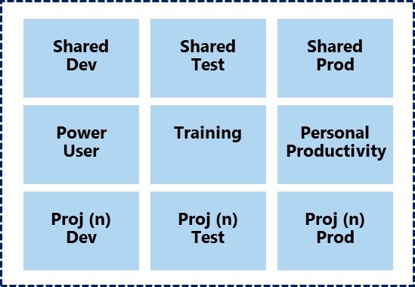

Figure 4.5 – The environment strategy of a business unit

There are shared dev, shared test, and shared prod environments for the workloads that are shared inside the business unit. Small workloads and/or the widely used applications of the department are hosted here. Complex solutions get their dedicated project-based environments with dev, test, and prod environment types (see *Proj (n) Dev* – *Proj (n) Test* and *Proj (n) Prod*, where *n* represents the number of unique projects).

There are also dedicated environments for training and for power users who experiment with new features of Power Platform. For instance, this is the only environment in which the process mining add-on is already enabled for testing purposes. Personal productivity provides a sandbox environment for business users for their own experimental use cases.

It is very important to note that this concept provides isolated environments per business unit, and that it ensures governance, compliance, and security control of those environments within the department. Other business units have no access to these environments at all.

To scale out this concept in global organizations with multiple sites across the globe, we recommend applying the following approach:

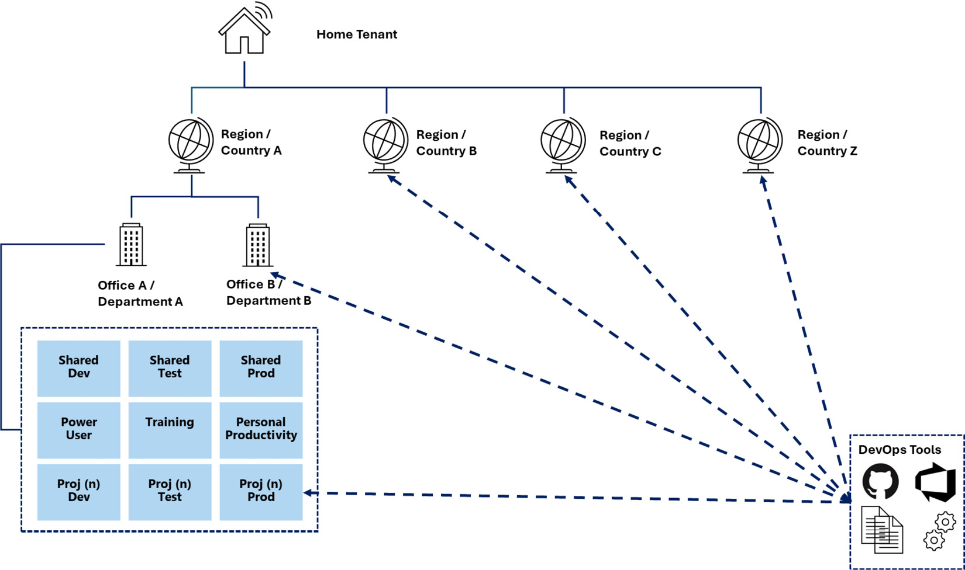

Figure 4.6 – The environment strategy of a global organization

Office A/Department A represents a business unit operating in Region/Country A under one common tenant. Every region and office (business unit or department) has the same structure with shared and dedicated environments for performance (close to the end users) and compliance reasons (data residency requirements). The development of solutions can happen in this tenant, but the concept allows us to use more tenants for development. Automation is unavoidable here. ALM and DevOps tools help us automatically create environments based on project needs and automatically deploy the solutions into different geolocations even from different tenants.

*Power Automate flows*

*Power Automate flows**with the Power Platform for Admins V2 connector provide ALM and DevOps-like capabilities inside the platform. There are activities that we can use to create environments, assign security roles, and set DLP policies. This connector also supports cross-tenant integration, a multi-tenant concept previously described as one of the environment strategies.*

Environment strategy does not only focus on environments in Power Platform, but it describes the interaction with other surrounding services. It defines whether a new Azure Subscription or only a Resource Group inside an existing Azure Subscription needs to be created for any new environment or for any new project. It also provides guidelines for ALM processes, such as *Proj (n)* shall store its artifacts (managed and unmanaged solutions) in a new ****Azure DevOps Services**** project or in that ****GitHub Enterprise**** repository. Last but not least, the strategy covers security considerations, such as creating Microsoft Entra ID security groups for administrators, makers, developers, and users during environment creation. When we fully define all these areas surrounding environment strategy, we partially address ****DevSecOps**** principles.

After getting familiar with the concept of environment strategy, let’s delve into our first Power Platform pipeline that can partially manage this approach within a department.

# Managed pipelines – Our first CI/CD

Now we have everything in place to create our first Power Platform CI/CD pipeline with the help of the built-in capabilities of the platform.

## Power Platform pipelines

Power Platform pipelines are CI/CD pipelines managed by the platform. They provide ALM features to build and deploy our solutions in a fully automated way without having deep knowledge of DevOps tools, such as Azure DevOps Services or GitHub Enterprise. Of course, we can integrate those tools into our managed pipelines to store the managed and unmanaged solutions in Git repositories as well, but it is not mandatory. The idea of the Power Platform pipelines is to democratize the build and release processes and to provide an easy-to-configure and easy-to-use experience for administrators and developers.

Platform Pipeline is a Dynamics 365 application that we need to install in one of our environments. For the built-in pipeline management, we only need to have Managed Environments; no Dynamics 365 licenses are required. It is highly recommended to create a dedicated environment for installing this application. This environment is called the ****host environment**** because it hosts the pipeline definitions, the pipeline runs with history, security settings, and deployment artifacts with history as the following figure shows:

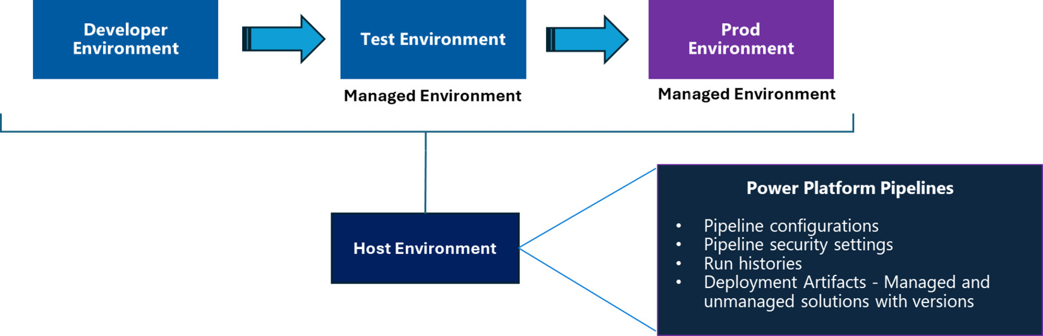

Figure 4.7 – Environments in Power Platform pipelines

Developer environments are the environments in which developers or makers create and modify solutions. Test and prod Environments represent the ****target environments**** that get the managed version of the solution deployed by our defined pipelines. Test and prod environments must be Managed Environments, whereas developer environments and the host environment can be normal ones. Every pipeline starts with a developer environment and continues with one or more chained target environments.

*Azure DevOps Services pipelines*

*Power Platform Pipeline Dynamics 365 app**uses under-the-hood Azure DevOps Services Pipelines and Azure DevOps Services Deployment Groups in a fully managed way. This is completely hidden from our eyes, and it is offered as a SaaS feature on top of Azure DevOps Services.*

As one of the premium features of Managed Environments, a Dynamics 365 app called Power Platform Pipelines brings the following Dataverse tables to the host environment:

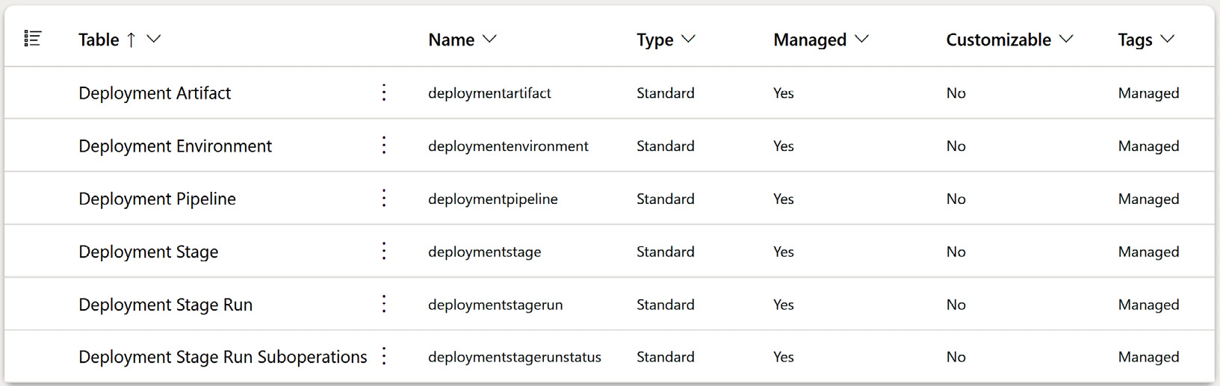

Figure 4.8 – Power Platform Pipelines’ Dataverse tables in a host environment

****Deployment Artifact****, ****Deployment Environment****, ****Deployment Pipeline****, ****Deployment Stage****, ****Deployment Stage Run****, and ****Deployment Stage Run Suboperations**** are standard Dataverse tables that we can also use to create approval flows based on different trigger conditions. The ****Deployment Artifact**** table retrospectively stores the managed and unmanaged solutions that have been created by pipelines. The maximum size of the managed and unmanaged solutions is 128 MB.

Aside from the tables, the Power Platform Pipeline introduces two additional security roles in the host environment:

* ****Deployment Pipeline Administrator****: Owners of this role can create deployment configurations in the ****Deployment Pipeline**** configuration. It is a model-driven application installed by the Power Platform Pipelines D365 app that helps administrators configure the environments, stages, and pipelines stored in the previously mentioned Dataverse tables.
* ****Deployment Pipeline User****: Owners of this role can use the pipelines created in the Deployment Pipeline Configuration app in the corresponding environments. If this user has access to the environment, and the Pipeline record from the ****Deployment Pipeline**** table is shared with them, then they are eligible to use the pipeline in any solutions in that environment.

The user (maker) experience of the ****Pipelines**** tab in the solution view looks as follows:

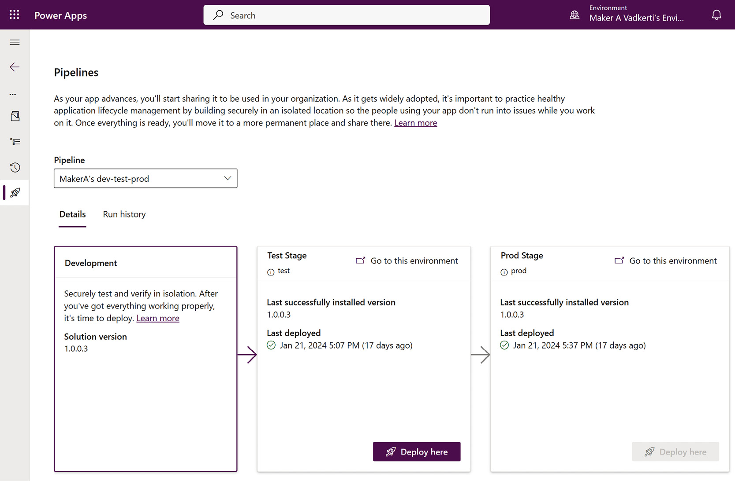

Figure 4.9 – The Pipelines user experience in Solutions

We are within a solution (editing an unmanaged solution) and when pipelines are configured, an additional ****Pipeline**** tab on the left will become visible. In our example, there is a pipeline in the drop-down box that targets two environments: first the test and then the prod. Since this user has access to more pipelines through the shared Dataverse Deployment Pipeline table’s row, the dropdown provides more choices.

To be able to execute a pipeline configured in the Deployment Pipeline Configuration tool from the source environment, the following conditions must be met:

* We need to share the pipeline record (****Read privileges****) with makers. We should use the appropriate Microsoft Entra groups to give this right to them.
* We need to have privileges to export solutions from the source environments and we need to have the appropriate rights to import solutions to target environments. The built-in ****System customizer**** and ****Environment maker**** security roles have these rights.

The pipeline will then deploy the managed solution on behalf of the user who triggered the action by default. If we would like to use service accounts instead of users, service principals are supported. In this case, the import of the solution to the target environment happens on behalf of the assigned service principal with the main security benefit that only the service principal has access to the production environment.

The real power of the deployment pipelines is that we can introduce those additional *quality gates* in our CD pipelines that we have discussed in *[Chapter 1](https://learning.oreilly.com/library/view/mastering-devops-on/9781835880845/B22208_01.xhtml" \l "_idTextAnchor014)* by building our own deployment approval logic (release approvals) before new versions of solutions hit target environments. These quality gates can vary from very simple release manager approvals to advanced automated test executions. There is the ****Pre-Deployment Step Required**** option in each ****deployment stage**** that we can use to trigger our custom logic-based approval process via Power Automate Cloud Flow. The deployment requests will be pending until they are approved. The following figure shows the ****Pre-Deployment Step Required**** and ****Pre-Export Step Required**** options in the Deployment Pipeline Configuration tool:

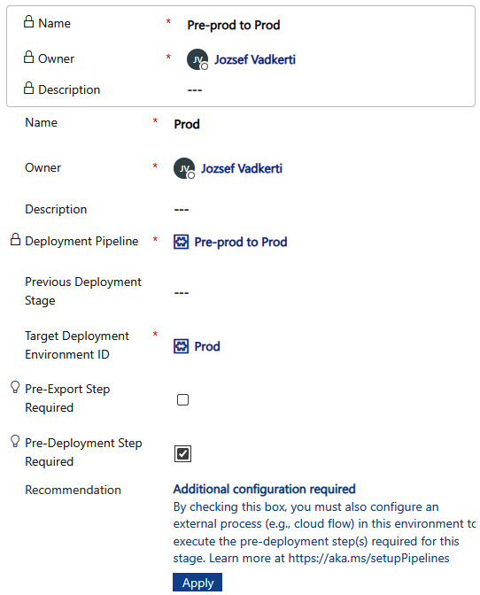

Figure 4.10 – Creating a new deployment in Deployment Pipeline Configuration tool

With the help of ****Pre-Export Step Required****, we can introduce custom validation logic that is executed before the solution is first exported from the development environment as a managed and unmanaged solution.

The cloud flows involved in the quality gates shall be created in the Host Environment and their trigger conditions are Dataverse Action. We can create multiple cloud flows reacting to the same pipeline event.

Currently, there are some limitations to using managed pipelines:

* Having multiple developers working on the same solution in dedicated developer environments requires a more careful process to avoid overwriting each other’s changes. Currently, pipelines only support a unidirectional flow from developer environments to production environments. This means that pulling the latest version of the solution and deploying it into a different developer environment requires careful and manual intervention.
* Rollback is partially supported. We can already ****redeploy**** an earlier version of the solution to the target environment in Power Platform pipelines, but we cannot roll back the entire multi-stage pipeline as one step.

## Step-by-step walkthrough – creating our first CI/CD pipeline

Let’s create our first end-to-end CI/CD pipeline using Power Platform pipelines. What we are going to do is take one of the environment templates and one of the solutions available in the GitHub repository. We will use these to set up a pipeline that will build a managed version from the unmanaged version of the solution and deploy it from a developer environment to a production environment:

1. Install the PAC CLI (assuming .NET 6.0 is installed in our environment):

****dotnet tool install --global Microsoft.PowerApps.CLI.Tool****

1. Install the PowerShell module:

****Install-Module -Name Microsoft.PowerApps.Administration.PowerShell****

1. Create an environment for hosting the managed pipelines. This environment will represent the host environment of the pipelines. We should choose the same region that our development, test, and production environments are created in:

****#Authentication – in both tools****

****Add-PowerAppsAccount****

****pac auth create****

****#Create Host Environment - Pipelinehost****

****$result=New-AdminPowerAppEnvironment -Location europe -DisplayName 'Pipelinehost' -ProvisionDatabase -EnvironmentSku Production****

1. Install the Power Platform Pipelines Dynamics 365 app. The PAC CLI provides an easy way to install Dynamics 365 apps to environments (no PowerShell cmdlet exists as of the time of writing this book):

****#Install Power Platform Pipelines to "Pipelinehost"****

****#It takes approx. 5 minutes****

****pac application install `****

****--environment $resultNewEnvironment.EnvironmentName `****

****--application-name "msdyn\_AppDeploymentAnchor"****

1. Create a developer environment:

****pac admin create `****

****--name "DevelopmentEnvironment" `****

****--currency EUR `****

****--region europe `****

****--type Sandbox****

1. Create a target environment (managed and production):

****#Create a production environment****

****$resultProductionEnvironment=New-AdminPowerAppEnvironment -DisplayName 'Production' `****

****-ProvisionDatabase `****

****-Location europe `****

****-EnvironmentSku Production****

****#Turn on Managed Environment****

****pac admin set-governance-config `****

****--environment $resultProductionEnvironment.EnvironmentName `****

****--protection-level Standard****

1. Let’s create the pipeline using the ****Deployment Pipeline Configuration tool**** in the ****Pipelinehost**** environment:
   1. Start the application.
   2. Go to ****Environments**** under ****Pipeline Setup****, open it, and click on the ****New**** button at the top.
   3. Fill out it with the data of your developer environment as the following figure shows:

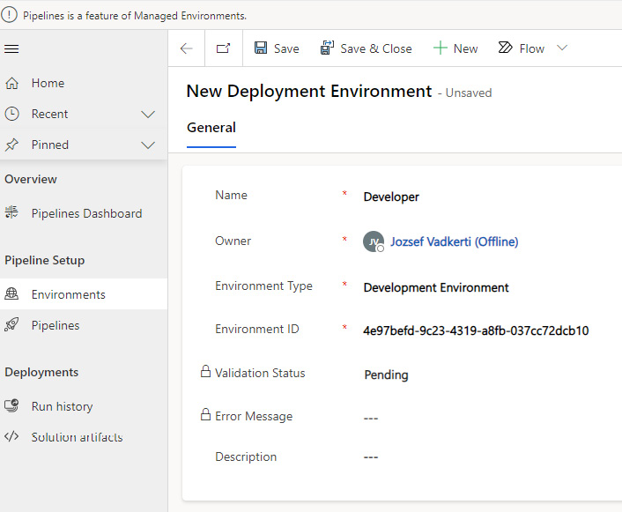

Figure 4.11 – Creating a new Deployment Environment

1. Create another ****Deployment Environment**** with the configuration data of your recently created production environment and with the ****Environment Type**** *Target Environment*, see the previous figure for details.

*Tip*

*Use the*****pac admin list*****command to get the environment IDs of your recently created environments.*

1. Go to ****Pipeline**** under ****Pipeline Setup****, open it, and click on the ****New**** button at the top. Add the ****PipelineToProd**** name and save the form to be able to configure it completely. If we would like to get AI deployment notes, then we can enable this here as well:

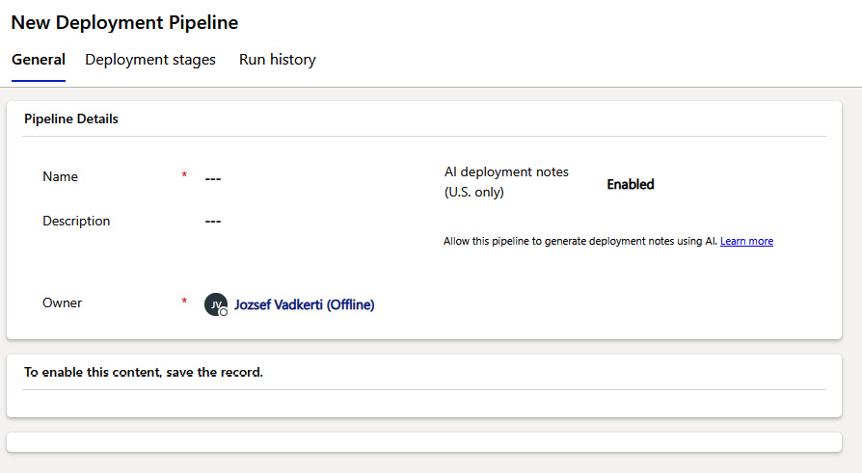

Figure 4.12 – The details of the new deployment pipeline

1. Add the developer environment (****DevelopmentEnvironment****) to the ****Linked Development Environments**** section.
2. Create a new deployment stage by clicking on the ****New Deployment Stage**** button.
3. Set the ****Name**** and ****Target Deployment Environment ID**** fields on the form.
4. Save the record.
5. Set up security:
   1. Share this new deployment pipeline Dataverse record with the users or group of users who will use this pipeline in the developer environment, that is, in ****DevelopmentEnvironment**** in our case.
   2. Add the ****System customizer**** or ****Environment maker**** built-in security roles to these members in both the ****Production**** and ****DevelopmentEnvironment**** environments.
   3. Add the ****Deployment Pipeline User**** security role to these members in the ****Pipelinehost**** environment.
6. Go to developer environment and import the ****unmanaged solution**** IT Base Pack from Power Platform Enterprise templates. You can find it at <https://github.com/microsoft/Templates-for-Power-Platform/blob/main/Solution%20Packages%20For%20Manual%20Install/IT/IT%20Base%20Pack/mpa_ITBase_managed.zip>.
7. Open the solution and look for the pipeline icon (it looks like a rocket) on the left side. Open the pipelines and select the ****PipelineToProd**** pipeline:

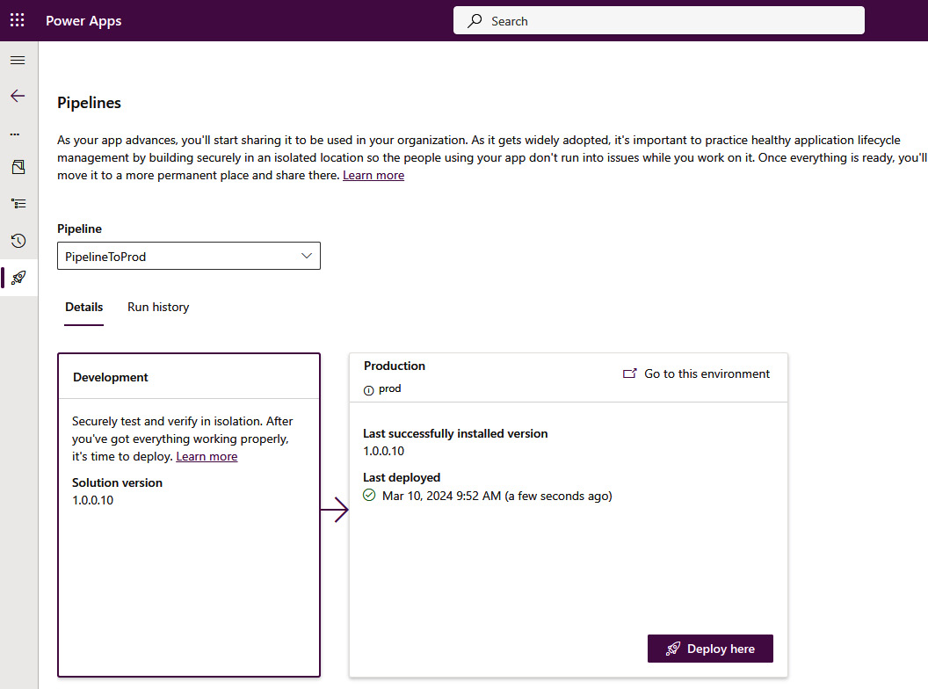

Figure 4.13 – Selecting PipelineToProd

1. Click on ****Deploy here**** or use the ****pac pipeline deploy**** command.
2. Check the deployment result in the production environment.

Congratulations, we have created our first CI/CD Power Platform pipeline.

To make this pipeline even more professional and secure, we can create a service principal and an enterprise application in ****Microsoft Entra ID**** (within ****Microsoft Azure Portal****) and assign it to the deployment stage as the following figure shows:

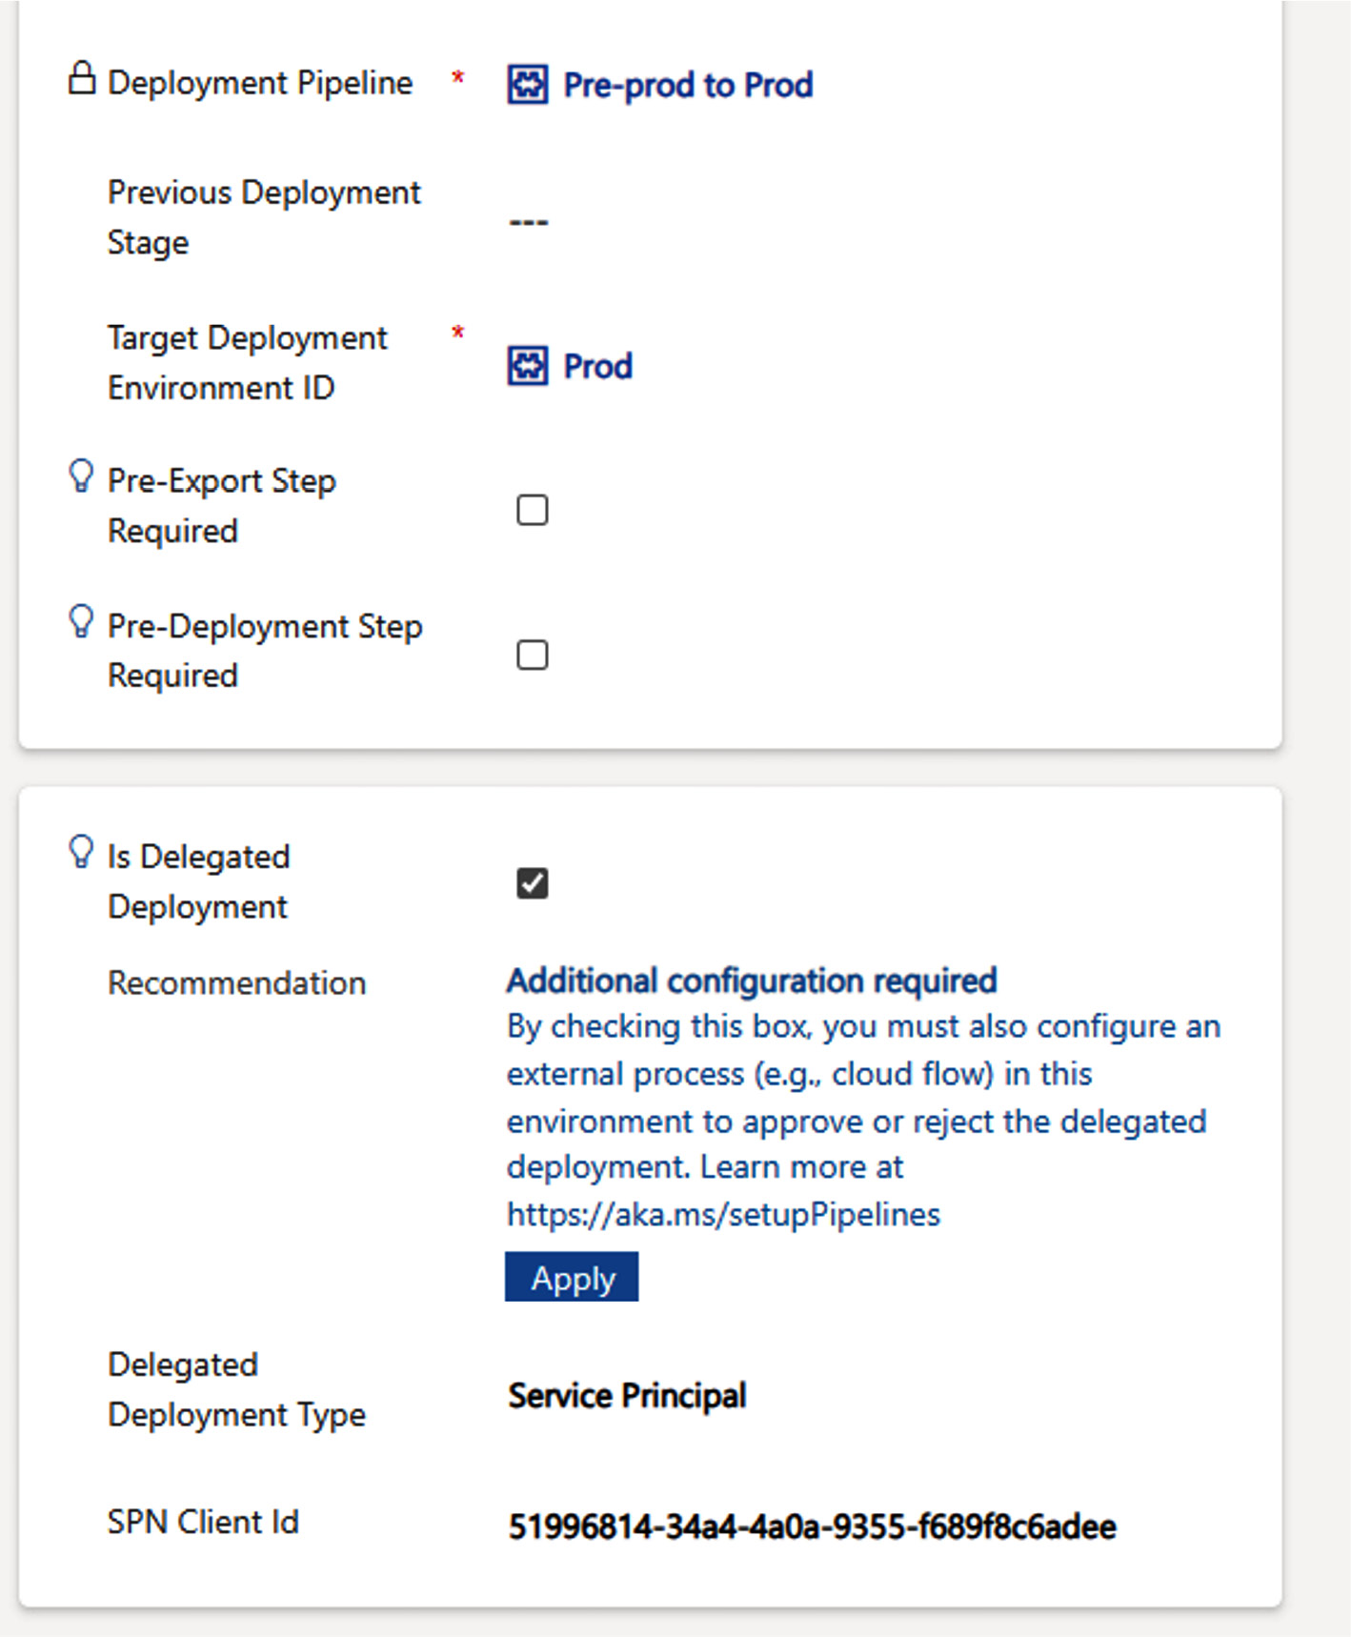

Figure 4.14 – Using the service principal in Pipeline

This is the ****delegated deployment**** process by which we assign our ****Service Principal Name**** (****SPN****) client ID to let the pipeline engine use it in the solution import phase. After creating this assignment, there is one last thing that we need to do. This is to create a delegated approval flow connecting to the Power Platform pipeline Dataverse tables by using the service principal and its client secret to approve the deployment. The next figure will show the simplest approval by reacting to the ****OnApprovalStarted**** Dataverse action, waiting five seconds, and setting the approval status to 20 (20 means approved; 30 would be the rejected state):

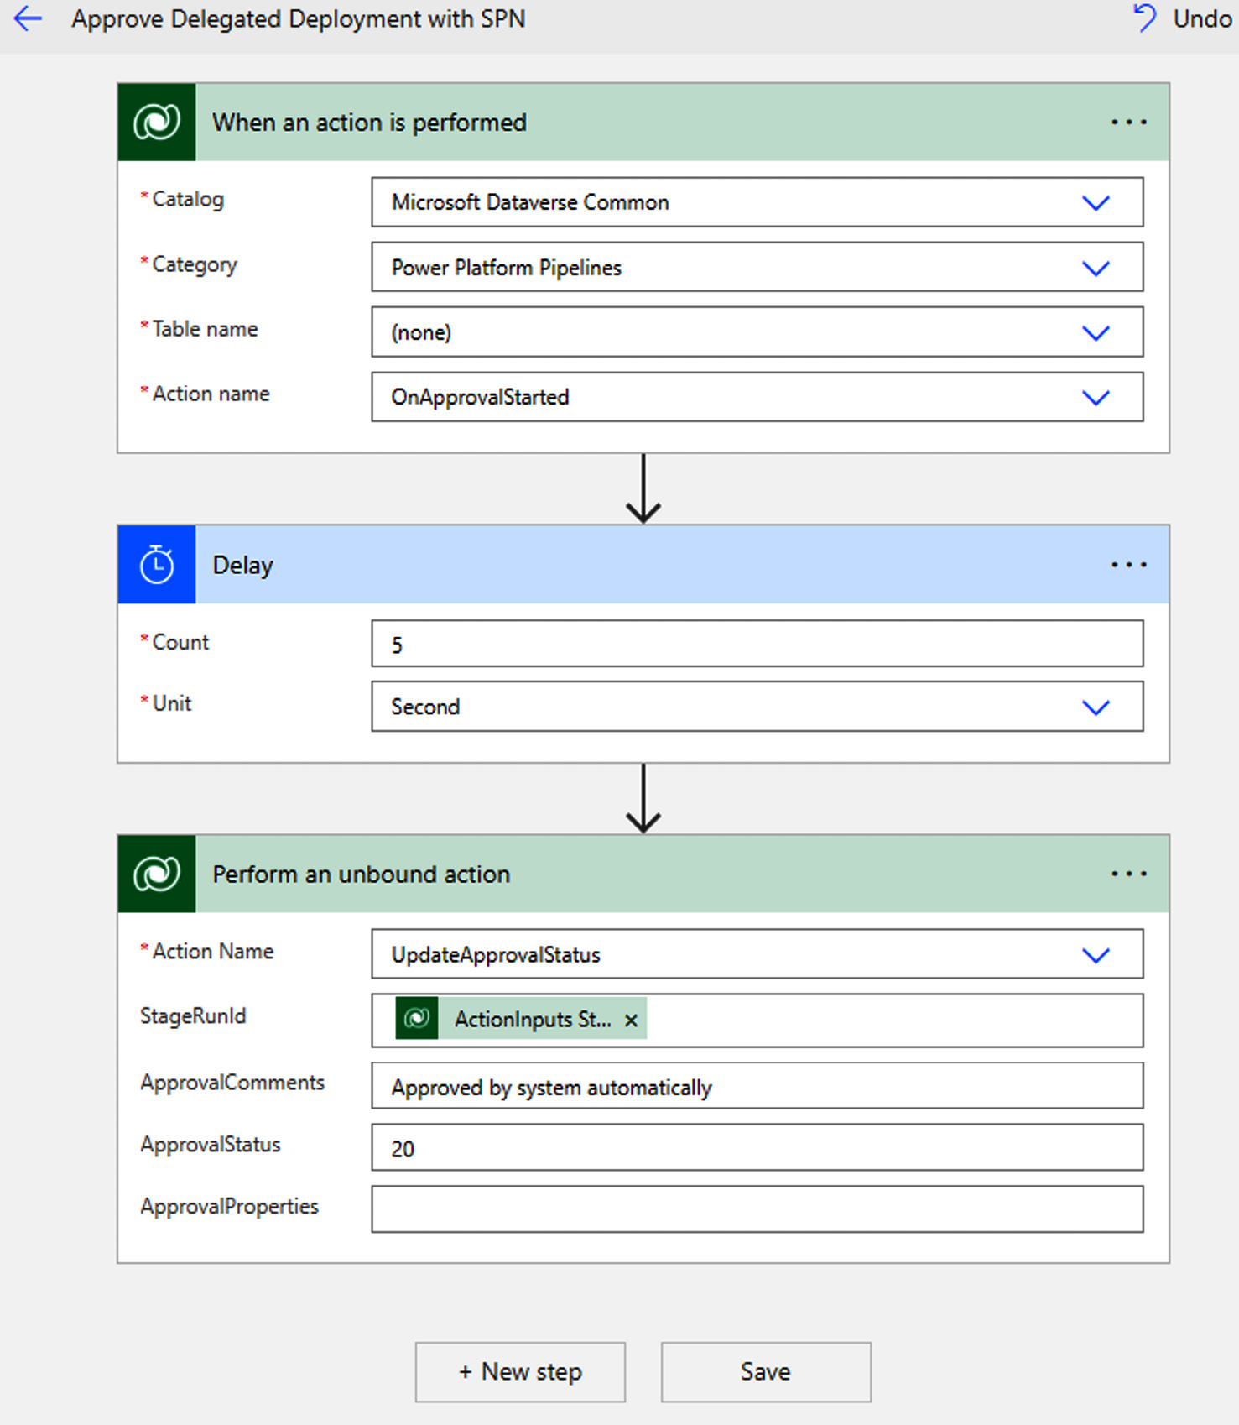

Figure 4.15 – Delegated deployment with he service principal

The underlying Power Platform pipeline engine uses this flow to run on behalf of the defined service principal and not on behalf of the user. With these additional steps, we have significantly improved the resiliency and security of our pipeline.

# Summary

In this chapter, we learned about Power Platform solutions, the modern executables that can move between environments, their upgrade options, and different approaches for how solution layering and versioning can be realized. After that, we discussed Dataverse, the enterprise-grade data platform with advanced security and governance capabilities. We also got familiar with the CDM, a database schema to model our data that’s accepted industry-wide. We also spent time on environments, the execution hosts of our solutions, learned about the advanced features of Managed Environments, and elaborated on the environment strategy at large-scale global enterprises. At the end of the chapter, we learned how Power Platform pipelines – as one of the greatest features of Managed Environments – work under the hood. We also successfully created our first CI/CD pipeline.

In the next chapter, we will discover the pro developer tools available for creating those CI/CD pipelines and other ALM automations that we have partially seen regarding Power Platform pipelines.

# Further reading

* Solution layers: <https://learn.microsoft.com/en-us/power-apps/maker/data-platform/solution-layers>
* ****Common Data Model**** (****CDM****):
  + <https://learn.microsoft.com/en-us/common-data-model/use>
  + <https://github.com/microsoft/CDM>
* Solution patching: <https://learn.microsoft.com/en-us/power-platform/alm/create-patches-simplify-solution-updates>
* Managed Environments: <https://learn.microsoft.com/en-us/power-platform/admin/managed-environment-overview>
* Environment strategy: <https://learn.microsoft.com/en-us/power-platform/guidance/adoption/environment-strategy>
* Enterprise templates: <https://github.com/microsoft/Templates-for-Power-Platform>
* Power Platform pipelines: <https://learn.microsoft.com/en-us/power-platform/alm/pipelines>
* Microsoft Entra ID service principals: <https://learn.microsoft.com/en-us/entra/identity-platform/app-objects-and-service-principals>
* Service principals in pipelines: <https://learn.microsoft.com/en-us/power-platform/alm/delegated-deployments-setup>

# 5

# Streamlining Power Platform Development with DevOps Tooling

In the previous chapter, we created our first Power Platform pipeline using a service principal to deploy our solution from one environment to another. This chapter covers the pro-dev DevOps tools that can help us streamline our development process in Power Platform. The first tool is ****Git****, a distributed version control system that is widely used around the world. We will learn about Git repositories, commonly used ****Git CLI**** commands such as ****clone****, ****push****, ****pull****, ****checkout****, and more. We will also explore how we can manage Power Platform solution plain files and folders in a Git repository and how pull requests and merges are performed even from command lines. We then learn about how Power Platform pipelines can be connected to these Git repos. We will spend some time on ****Power Platform CLI**** (****PAC CLI****), which allows us to interact with Power Platform solutions in any script language. We will also learn how to create Azure DevOps Services pipelines in ****YAML**** (short for ****Yet Another Markup Language****) format, and understand the YAML specification itself and relevant methods, such as variables, parameters, and tasks. We will also understand the build tasks provided by Microsoft for Power Platform solutions. Finally, we will learn how to use ****GitHub Copilot****, an AI-powered code completion tool that can help us write code more efficiently.

By the end of this chapter, we will have a solid understanding of, and hands-on skills in, how to set up end-to-end CI/CD pipelines with the help of pro-dev DevOps tools such as Azure DevOps pipelines and GitHub Actions, which deliver our solutions to different Power Platform environments.

In this chapter, we’re going to cover the following main topics:

* Git – the single source of truth
* Power Platform CLI
* Power Platform build tools for Azure DevOps
* GitHub Actions for Power Platform
* Managed pipelines – source control integration
* Copilots in Power Platform pipeline development

# Technical requirements

To create our first CI/CD pipelines by using pro-dev DevOps tools, we need to have the following:

* A Power Platform subscription. We can sign up for a Power Apps Developer Plan (<https://www.microsoft.com/en-us/power-platform/products/power-apps/free>) if we already have a Microsoft Entra ID work account. Or, we can join the Microsoft 365 Developer Program (<https://developer.microsoft.com/en-us/microsoft-365/dev-program>).
* An Azure DevOps Services organization: we can create a DevOps organization any time *for free* (<https://learn.microsoft.com/en-us/azure/devops/user-guide/sign-up-invite-teammates>). If we create a public project in Azure DevOps, we get multiple free pipelines and free access to every feature of the service – see the ****Azure DevOps for Open Source**** offering.
* A GitHub handle and public repository (<https://github.com/signup>), which is also *free* for public repositories.
* A GitHub Copilot free trial (<https://github.com/login?return_to=%2Fgithub-copilot%2Fsignup>) or access to Microsoft Copilot ([https://copilot.microsoft.com](https://copilot.microsoft.com/)).
* Visual Studio Code – it is highly recommended to use this free code editor to create, edit, and update the YAML files in this chapter. We can download Visual Studio Code on any platform via <https://code.visualstudio.com/download>, and with the help of the VS Code extensions for Power Platform, Git, Azure DevOps pipelines, and GitHub workflows, we can carry out a syntax highlight and a semantic check on our changes. With the Git extension, we can manage our Git repository, too. See the *Further reading* section to learn more about Visual Studio Code. As an alternative, we can directly visit [https://vscode.dev](https://vscode.dev/) to use the Visual Studio Code editor online in our favorite browser to edit any files and to open a remote repository.
* The code files for this chapter can be downloaded from our GitHub repo at <https://github.com/PacktPublishing/Mastering-DevOps-on-Microsoft-Power-Platform/tree/main/Chapter05>.

# Git – the single source of truth

In custom development projects, the source code is maintained in ****version control systems****. These systems let developers work together on the same code base so that they can constantly introduce new features and/or fix bugs without conflicting with the changes of others. One of the reasons we use such code repositories (version control systems) is to provide end-to-end forward and backward traceability between code in production (the running application) and source code changes that have been made before pushing a version to production. In modern DevOps tools, in the project management part, the work items that need to be developed are directly linked to code changes that are made by developers. Version control systems provide a history of items and support transaction-like changes that span over multiple files and folders in repositories. These are very often represented as ****version or history trees****.

For developers to work in the most effective and efficient way *in parallel*, version control systems provide branching capabilities. A ****branch****, as its name suggests, is a snapshot of a line of code – a fork that then manages its own history. Changes that we commit (play back) to this branch are not visible from the branch from which our branch was created. The mainline or root – the main branch itself – is presented as a branch in this approach as well. After completing our backlog item in the child branch, we ****merge**** back the changes to the parent branch. Branches can be created at any depth, but, in general, we recommend keeping the depth of the branch hierarchy as flat as possible to avoid integration debt later. Branches separate the work in progress from stable and tested code.

To maintain and control a healthy development environment, we need to define our branch strategy. A ****branch strategy**** is a set of guidelines and best practices for managing branches in a version control system. It helps teams to organize their code base, streamline their development process, and minimize conflicts when merging code. There are several popular branch strategies. It is important for teams to choose a branch strategy that fits their development process and to follow it consistently to ensure smooth collaboration and efficient code management. Let us have a look at the two most popular branch strategies:

* ****Trunk-based development**** is a version control management practice where developers merge small, frequent updates to a core branch called ****trunk**** or ****main****. The main characteristic of this approach is that the only long-lived branch is the main branch, which is always deployable. Developers can’t commit changes directly to the main branch, but instead, they work on short-lived branches and merge their changes to the main branch frequently.
* ****Git Flow / GitHub flow**** was originally ****Git Flow**** that defined several long-living branches, like release-, hotfix- and patch branches next to the main branch. In the last decade, the software industry has evolved a lot and software development teams usually maintain only one version of software – the latest version. This means that there is no need to maintain such a complex branch hierarchy and this was the reason to move from Git Flow to GitHub flow. ****GitHub flow**** is a lightweight, branch-based workflow that supports teams and projects where deployments are made regularly. This workflow is very popular among developers because it allows them to work on new features, bug fixes, or experiments without affecting the main code base. Once the work on a branch is complete, it can be merged back into the main code base through a pull request. GitHub flow is very similar to trunk-based development but contains GitHub-specific capabilities, like pull requests.

****Git**** is the most widely used version control system. It is a ****distributed version control system****, which means we can download a repository to our own development machines and, without internet connectivity, we can work on the repo by branching and making changes. Of course, if we would like to propagate our changes back to the team, we need to get connected and then *upload* our changes. There are also ****centralized version control systems**** on the market. These require continuous internet connectivity, which slows down the interaction with such repositories in general.

Git, a fast, scalable, distributed revision control system is open source. There are many DevOps tools in which the open source Git engine is available, such as GitHub Enterprise, Azure DevOps Services, and GitLab. Of course, these engines are customized in a way that service providers can realize their own operational approaches and offer Git as a ****Software-as-a-Service**** (****SaaS****) offering, but the client APIs are compatible with any of these distributions.

In general, version control systems manage plain text files because these are the files that can be merged by developers in case of conflict resolution (conflicts are readable). Over the course of software history, more and more binary files, such as images, videos, sound files, 3D objects, and media files have become part of software solutions. In the early days of software development, these files were maintained parallel with the code base, although they were also part of the version that was modified/branched by developers. Git already supports large binary files (****Git Large File Storage****) and large monolith repositories to ease the migration from other version control systems.

*Monolith large repositories*

*Among others, the code base of Microsoft Windows, with its 250 GB, is maintained in one large monolith Git repository in an Azure DevOps Services project.*

The ****Git command-line interface**** (****CLI****) is a powerful tool that allows developers to interact with Git repositories using a command-line terminal. The Git CLI is available on all major operating systems, including Windows, macOS, and Linux. Some very often used Git commands are the following:

* ****git clone****: This command is used to create a copy of a remote repository on your local machine.
* ****git pull****: This command is used to fetch and merge changes from the remote repository into your local repository.
* ****git push****: This command is used to upload your local repository changes (commits and branches) to the remote repository.
* ****git commit****: This command is used to save changes to your local repository. It creates a new ****commit**** object in the repository history with the current state of the repository.
* ****git branch****: This command is used to manage branches in a Git repository. It can be used to list, create, delete, and rename branches.
* ****git checkout****: This command is used to switch between branches or to restore files in your working directory from the repository.
* ****git merge****: This command is used to merge changes from one branch into another. It integrates changes from the named commits into the current branch.

Normally, we clone a repo, create a local branch, commit our changes, push our branch back to the remote origin, and finally, merge the changes back to the parent branch. This last operation is a special one that is sometimes referred to as a pull request depending on the Git distro, like GitHub or GitLab. We can merge branches without pull requests, too.

The ****pull request**** is a mechanism for developers to notify team members that they have completed a feature. Once their feature branch is ready, the developer files a pull request via their online repository. The rest of the team then reviews the code and can make comments and suggestions. Once the team agrees that the code is ready, it can be merged into the main code base. Pull requests are a way to *foster code reviews* and collaboration within a development team.

*Pull requests*

*Pull requests are**more than just a*****git merge*****operation. DevOps tools such as GitHub or Azure DevOps Services provide web UI support and their own CLI tools to initiate pull requests on branches.*

Having understood the key concepts of Git, let us see how it fits with our Power Platform solutions. As we discussed earlier, in *[Chapter 4](https://learning.oreilly.com/library/view/mastering-devops-on/9781835880845/B22208_04.xhtml" \l "_idTextAnchor074)*, Power Platform solutions are available in managed and unmanaged formats. Depending on a solution’s content, the difference between managed and unmanaged solutions can vary significantly. For instance, if a solution contains PowerApps application, then a managed one will contain a few files and one of them will be the ****msapp**** document, which includes every asset of the PowerApps canvas app in compressed format. On the other hand, an unmanaged solution will consist of XML and JSON files in a well-defined folder structure describing the solution with all its assets, such as apps, flows, bots, connection references, and so on, in plain text format.

And this is the exact place where version control systems a play significant role, as the following figure illustrates:

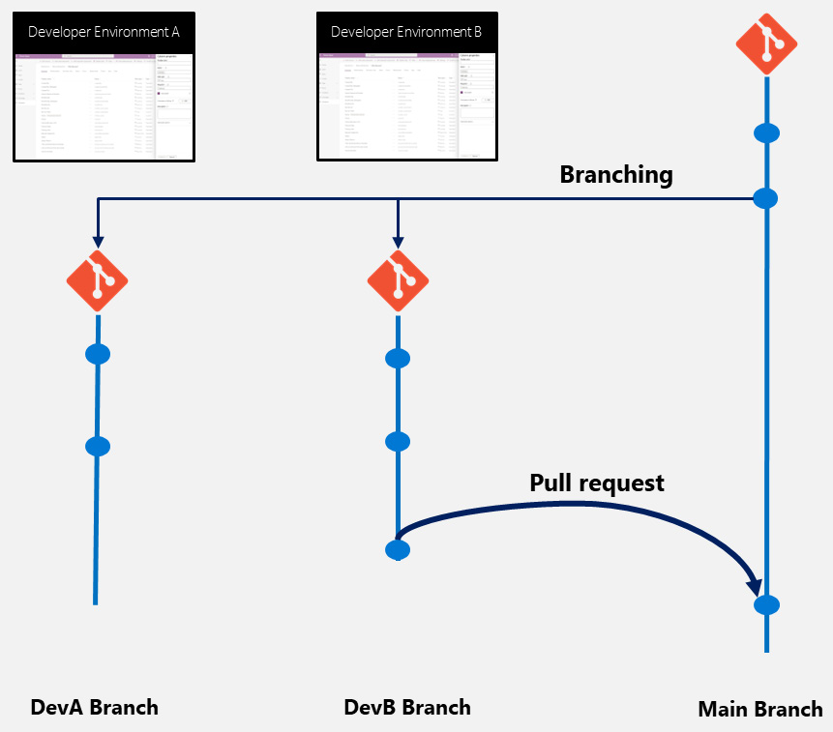

Figure 5.1 – Developer environments with corresponding child branches

App makers and developers (****DevA**** and ****DevB**** in our case) use dedicated developer environments to craft a solution(s). When the first version of their application is created, they commit both the managed and unmanaged Power Platform solutions – the latter one as unpacked – to their own child branches, created from the main branch. After that, they work on these branches, and respectively in the corresponding environments, by constantly synchronizing the changes between environment and branch. When they are ready, they submit a pull request to merge back the changes from the child branch to the main branch. In an ideal case, there is no merge conflict and the changes are integrated into the main branch smoothly. ****Merge conflicts**** are conflicting changes – that is, when the same file in the same position is changed on both parent and child branches. If a merge conflict occurs, then the pull request is refused, and the developer needs to merge the changes back from the main branch to the developer branch and resolve the conflicts there. In the case of Power Platform, it doesn’t mean just resolving conflicts at the code level, but also loading the unmanaged solution back to the developer environment to check everything works as expected and then publishing the changes. After that, we need to export the solution back to the developer branch and resubmit the pull request.

Overall, branching and child branches allow developers to work parallelly even on the same Power Platform solution, but we need to pay careful attention and let developers work on different assets in solutions.

After getting to know the Git features, let us learn about the tool that we can use to export and import solutions in Power Platform.

# Power Platform CLI

We have already seen some of the PAC CLI commands in the previous chapters, such as signing in to the different environments or installing the Power Platform pipeline as a Dynamics 365 application in our environment. Besides these commands, PAC CLI supports many more commands and features that we can authenticate on behalf of service principals and manage our solutions, environments, deployments, pipelines, and more. One of the biggest advantages of PAC CLI is that it runs on any platform, and can be integrated into any DevOps tool.

Some of the most often-used commands of PAC CLI are the following:

* The ****pac admin**** command group provides a set of commands to work with your Power Platform admin account, such as creating an environment, creating service principals, assigning Microsoft Entra ID groups to environments, and so on.
* The ****pac application**** command group is for listing and installing available Dataverse applications from AppSource. We used ****pac application install**** to deploy Power Platform pipelines as a Dynamics 365 application in our production environment in *[Chapter 4](https://learning.oreilly.com/library/view/mastering-devops-on/9781835880845/B22208_04.xhtml" \l "_idTextAnchor074)*.
* The ****pac auth**** command group provides a set of commands to authenticate in different services, such as environments or whole tenants. We can use service accounts as well as service principals. Our credentials are stored locally if needed.
* The ****pac canvas**** commands work with Power Apps ****.msapp**** files. These files are created when we export canvas apps from Power Apps Studio directly or as part of our Power Platform solutions.
* The ****pac catalog**** command group provides commands for managing the ****Power Platform catalog****, which is a repository for sharing and reusing code and components. Some of the commands available in the ****pac catalog**** command group include ****pac catalog install****, which installs a catalog item in the target environment, and ****pac catalog list****, which lists all published catalog items from the current Dataverse organization.
* The ****pac copilot**** command group provides commands for managing chatbots and AI Builder models (among others, new large language models). Some of the commands available include ****pac copilot predict****, which sends text or prompts to an AI model, ****pac copilot create**** for creating a new bot using an existing template file as the reference, and ****pac copilot list**** for listing virtual agents in the current or target Dataverse environment.
* The ****pac package**** command group is a set of tools and utilities for managing packages. It includes commands such as ****pac package add-external-package**** for adding a package that is external to the Dataverse solution system to a ****Package Deployer**** project, ****pac package add-reference**** for adding a reference to a Dataverse solution project, and ****pac package add-solution**** for adding a prebuilt Dataverse solution file to a Package Deployer project. Please note that, in *[Chapter 4](https://learning.oreilly.com/library/view/mastering-devops-on/9781835880845/B22208_04.xhtml" \l "_idTextAnchor074)*, we discussed the Package Deployer in the context of Power Platform Enterprise templates, too.
* The ****pac pcf**** command group is used for managing and working with ****Power Apps component framework**** (****PCF****) projects. It includes commands such as ****pac pcf init**** for initializing a new Power Apps component framework project in the current directory, and ****pac pcf push**** for pushing the component to the Power Apps component framework developer environment.
* The ****pac pipeline**** command group is used to work with Power Platform pipelines. For example, ****pac pipeline deploy**** is used to start pipeline deployment, while ****pac pipeline list**** is used to list pipelines in the given environment. This command group provides the option for administrators and ops teams to start deployments in a fully automated way, as we discussed in *[Chapter 4](https://learning.oreilly.com/library/view/mastering-devops-on/9781835880845/B22208_04.xhtml" \l "_idTextAnchor074)*.
* The ****pac plugin**** command group is used to work with ****Dataverse plug-in**** class libraries in Microsoft Power Platform. For example, ****pac plugin init**** is used to initialize a directory with a new Dataverse plugin class library, while ****pac plugin push**** is used to import a plugin into Dataverse. We can use .NET Framework-based plugins to react to Dataverse events on the server side running in the context of the Dataverse engine.
* The ****pac powerpages**** command group is for managing ****Power Pages websites**** in the Power Platform tenant. For example, ****pac powerpages list**** is used to list all Power Pages websites from the current Dataverse environment, while ****pac powerpages download**** is used to download Power Pages website content from the current Dataverse environment to move it to another environment with ****pac powerpages upload****.
* The ****pac solution**** command group is used to work with ****Power Platform solutions****. Some of the commands available in the ****pac solution**** command group include ****pac solution init****, which initializes an MSBuild-based ****cdsproj**** file for component framework components; ****pac solution add-reference****, which adds a reference from the project in the current directory to the project at the specified path; and ****pac solution add-solution-component****, which adds one or more solution components to the target unmanaged solution in Dataverse. Imports and exports of solutions are also supported by the equivalent ****pac solution**** commands.

*PAC CLI and Power Platform PowerShell modules*

*PAC CLI is the next-generation command-line tool for Power Platform, which runs on any OS platform. PowerShell admin capabilities are continuously migrated to PAC CLI to reach feature parity in the future. PAC CLI and PowerShell modules are wrappers around the underlying REST API endpoints of Power Platform.*

To install PAC CLI, we need to have .NET Core 3.1 or later (.NET 6 is recommended) already deployed to our machine. After that, we can execute the following command in our favorite terminal (CMD on Windows, Bash on Linux, or Terminal on macOS):

**dotnet tool install --global Microsoft.PowerApps.CLI.Tool**

Now that we have learned about the breadth and depth of the commands available in PAC CLI, in the next sections, we will understand how this CLI tool is utilized by Azure DevOps Services and GitHub Enterprise.

# Power Platform build tools for Azure DevOps

****Azure Pipelines**** stands out as a robust feature within Azure DevOps Services, offering a comprehensive ****continuous integration**** (****CI****) and ****continuous delivery**** (****CD****) service. Compatible with your Git provider of choice (GitHub or Azure DevOps), it enables deployments across various major cloud providers, including Microsoft Azure. This service streamlines the process of building, testing, and deploying your code base. It supports an extensive array of programming languages and platforms, such as .NET, Java, Node.js, Android, Xcode, and C++, and allows for a variety of testing frameworks and services to be utilized. Additionally, Azure Pipelines enables the execution of scripts in the command line, PowerShell, Bash, or Shell within your automation workflows.

Azure Pipelines also provides the infrastructure in which our scripts and pipeline tasks can run. ****Azure Pipelines agents**** are containers (virtual machines in a virtual machine scale set) that execute our jobs (pipeline tasks). Agents are installed in these machines, and they use HTTP outbound connectivity to Azure DevOps endpoints to pull the activities they need to run.

There are different types of agents, including Microsoft-hosted agents, self-hosted agents, and Azure Virtual Machine Scale Set agents:

* ****Microsoft-hosted agents**** provide a hassle-free solution for executing your jobs. These agents are fully managed by Microsoft, ensuring that they are always up to date with the latest virtual machine image specified in your YAML pipeline, without requiring any maintenance or upgrades on our part.
* ****Self-hosted agents**** are those that we set up and maintain on our own virtual machines. This option provides us with greater control over the machine specifications and the operating system images utilized by the agents.
* ****Azure Virtual Machine Scale Set agents**** are a kind of self-hosted agent that embraces the Virtual Machine Sale Set’s autoscaling features heavily. Azure DevOps scales out and scales in VMs based on the size of pipeline queues.

In Azure Pipelines, a ****job**** is a series of steps that run sequentially as a unit. Every pipeline has at least one job, and a job is the smallest unit of work that can be scheduled to run. Jobs can be organized into stages, and you can specify conditions and dependencies to control when jobs run. Jobs can run on Microsoft-hosted agents, self-hosted agents, or Azure Virtual Machine Scale Set agents, and can be run directly on the host machine of the agent or in a container. Azure Pipelines supports running jobs in parallel on Linux, macOS, and Windows. You can create and configure pipelines in the Azure DevOps web portal with the classic user interface editor as well as with the latest YAML-based script editor. We prefer the latter because the version control management of these YAML files is also available in that case.

The advanced capabilities of Azure Pipelines, like the infrastructure and topology of Microsoft-hosted and self-hosted build agents, are beyond this book, but you can find further information and learning modules in the *Further reading* section.

On top of Azure Pipelines, ****Microsoft Build Tools for Power Platform (Microsoft Power Platform Build Tools for Azure DevOps)**** provides additional tasks in Azure DevOps that can be used to automate common build and deployment tasks related to solutions built on Microsoft Power Platform. Some of the available tasks include the ****Power Platform Tool Installer****, which installs Power Platform tools (among others, the PAC CLI in the agent). This build task is a mandatory step at the beginning of every build and release pipeline in which we would like to use other Power Platform build tasks. The build tools work for canvas- and model-driven apps, Microsoft Copilot Studio, cloud and desktop flows, Power Pages websites, AI Builder models, custom connectors, and dataflows, for everything that can be added to a solution.

Every build task uses PAC CLI under the hood and the Power Platform wrapper provides a common interface for Azure DevOps Pipelines and GitHub Actions:

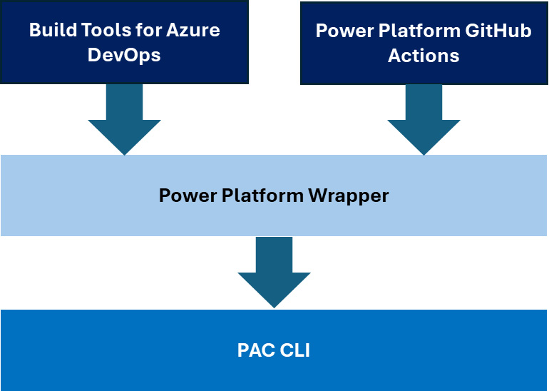

Figure 5.2 – Power Platform build tools and GitHub Actions architecture

This means that when we use a task such as ****PowerPlatformExportSolution@2****, then this pipeline task executes the corresponding PAC CLI command through the wrapper with the appropriate parameters. Let us have a look at a pipeline that exports a managed solution, unpacks it, and publishes it to the build artifacts (see ****.pipelines/powerlatform-exportsolution.yml**** in the ****Chapter05**** folder of the GitHub repo):

trigger:

- none

pool:

  vmImage: ubuntu-latest

steps:

****- task: PowerPlatformToolInstaller@2****

  inputs:

    DefaultVersion: true

****- task: PowerPlatformExportSolution@2****

  inputs:

    authenticationType: 'PowerPlatformSPN'

****PowerPlatformSPN: '[Service\_Connection\_Name]'****

    SolutionName: '[Our\_Solution\_Name]'

    SolutionOutputFile: '$(Build.ArtifactStagingDirectory)/Solution/[Our\_Solution\_Name].zip'

    Managed: true

    AsyncOperation: false

    MaxAsyncWaitTime: '60'

****- task: PowerPlatformUnpackSolution@2****

  inputs:

    SolutionInputFile: '$(Build.ArtifactStagingDirectory)/Solution/TranslatorSolution.zip'

    SolutionTargetFolder: '$(Build.ArtifactStagingDirectory)/Solution/out'

    SolutionType: 'Managed'

- task: PowerPlatformChecker@2

  inputs:

****PowerPlatformSPN: [Service\_Connection\_Name]'****

    FilesToAnalyze: '$(Build.ArtifactStagingDirectory)/Solution/\*.zip'

    RuleSet: '0ad12346-e108-40b8-a956-9a8f95ea18c9'

- task: PublishBuildArtifacts@1

  enabled: true

  inputs:

    PathtoPublish: '$(Build.ArtifactStagingDirectory)'

    ArtifactName: 'Translator'

    publishLocation: 'Container'

The ****PowerPlatformExportSolution@2**** uses a service connection (****PowerPlatformSPN: 'PowerPlatformE5-Default'****) to connect to the Dataverse. ****Service connections**** allow you to connect to external and remote services to execute tasks in your pipelines. They provide a way to authenticate and authorize Azure DevOps with external services so that Azure DevOps can access resources and perform operations on your behalf, or on behalf of service principals. There is a dedicated service connection for Power Platform.

We have just discovered how to use the familiar Azure Pipelines YAML-based approach for Power Platform CI/CD, just as we do for other custom development projects.

# GitHub Actions for Power Platform

****GitHub Actions**** were originally designed and developed by the same engineering teams that created the Azure Pipelines after Microsoft had acquired GitHub. At the time of acquisition, GitHub did not even support any of the automation that Azure Pipelines offered developers.

That’s why it is not surprising that the GitHub Actions engine, the infrastructure, the agents (runners in GitHub), and the concept are more or less the same as in Azure DevOps. And in some cases, GitHub Actions is even better. It can provide much more trigger conditions than Azure Pipelines. For instance GitHub Actions can react to changes in GitHub issues – in pull request comments, in Wiki pages, and in general to changes to any asset surrounding a GitHub project. These actions are lightweight functions, and the trigger framework can easily be extended with webhooks.

GitHub has its own build agents, which are called ****GitHub runners****.

Behind the scenes, the agent runtime, the Windows service, and the Linux/macOS daemon that host GitHub Actions are nearly identical to the runtime used in Azure DevOps Services. GitHub runners are virtual machines that run your GitHub Actions workflows. They are available in two types: ****GitHub-hosted**** and ****self-hosted****. For professionals, GitHub offers a range of managed virtual machines with more RAM, CPU, and disk space for customers on GitHub Team and GitHub Enterprise Cloud plans. These larger runners are hosted by GitHub and have the runner application and other preinstalled tools. GitHub-hosted runners make it easy for GitHub Enterprise plan customers to securely connect their CI/CD machines to other DevOps services in the cloud or on-prem, such as ****Artifactory****, ****Nexus****, or any other service, with the help of reserved static IP ranges or by using Azure Virtual Networks. In the case of public GitHub repositories, every month, the first 2,000 minutes of GitHub-hosted runners’ executions are free of charge.

For more granular control, you can also combine runner groups with labels. ****Runner groups**** can only have large runners or self-hosted runners as members. This provides professionals with the flexibility to choose the best runner for their specific needs. GitHub runners can also run inside Docker containers. By doing so, we can even easily spin up Kubernetes-based build/deployment farms.

Both GitHub runners and Azure DevOps agents are open source projects and welcome contributors from all around the world (see the GitHub repository links under *Further reading*).

Regarding the workflow definitions: there are also some differences in YAML tags and keywords, but the main design principles are the same.

*Azure DevOps Services versus GitHub*

*A frequently asked question in the**industry is whether Azure DevOps Services or**GitHub is the future. The Microsoft strategy at the time of writing is to recommend GitHub for greenfield organizations – organizations who are just starting their DevOps journeys. If an organization already uses Azure DevOps, then Microsoft recommends introducing GitHub only in areas in which it brings a compelling advantage. This compelling advantage is now GitHub Copilot. In the last few years, we have seen that the investment in GitHub features has been 5-10 times greater than in Azure DevOps Services.*

In the next section, we will look closely at GitHub workflows and actions at work.

# Managed pipelines – source control integration with Git

In *[Chapter 4](https://learning.oreilly.com/library/view/mastering-devops-on/9781835880845/B22208_04.xhtml" \l "_idTextAnchor074)*, we created our first Power Platform managed pipeline, which deployed our ****mpa\_ITBase**** solution from the developer environment to the production environment using a service principal. In this section, we continue our journey and, based on the lessons learned about PAC CLI, build tools for Azure DevOps Services, and GitHub Actions for Power Platform, we will commit our solution artifacts to a GitHub repository with the help of GitHub Actions for Power Platform and the Dataverse trigger events available in the context of Power Platform pipelines.

Let us have a look at the events that we can use in our Power Automate cloud flows in the ****Pipelinehost**** environment to react to certain changes in deployment pipelines:

* ****OnApprovalStarted**** – ****OnApprovalCompleted****: These events are triggered when there is approval configured in the deployment stage prior to deploying the solution to that stage. We usually use this step to notify release managers or environment owners about the planned deployment.
* ****OnPredeploymentStarted**** – ****OnPredeploymentCompleted****: These events occur prior to releasing our solution to the deployment stage. We can use these events to do some configuration in the target environment, such as updating environment variables and importing (static) data before solution deployment.
* ****OnDeploymentRequested**** – ****OnDeploymentStarted**** – ****OnDeploymentCompleted****: These events occur over the course of deploying the solution to the deployment stage.

*Dataverse pipeline events*

*Dataverse Power Platform pipeline-related events are triggered in every deployment stage regardless of the number of stages and pipelines. Pipeline triggers provide additional attributes to filter down to the pipeline and to the stage that we are interested in.*

With the help of these building blocks, we can create different strategies for how we are going to manage our pipelines and how we are going to maintain our solutions outside of Power Platform environments. We should decide the following:

* Shall we use a separate Git repository per solution? Or, shall we plan to store multiple solutions per Git repository? Do we plan to introduce pipeline templating for reusability purposes?
* Shall we introduce one Git repository per environment?
* Do we plan to store the solution artifacts deployed to deployment stages in different child branches?
* Shall we use pull requests to merge back the latest changes from child branches to the main branch? Shall we use pull request triggers in our pipelines to finish the deployments in production environments? This would also mean that the managed pipelines would not reach the production environment, just the pre-prod/test environments.
* Do we plan to store only the deployment artifacts that have been successfully deployed to production environments on the main branch? Shall we consider a branching strategy at all?

There is no silver bullet to answer these questions since the selected strategy really depends on the maturity level of the organization, the complexity of the project, and the overall DevOps processes defined internally.

The following figure illustrates a possible approach to commit the solution to the main branch after deploying to production with the help of a Power Platform pipeline:

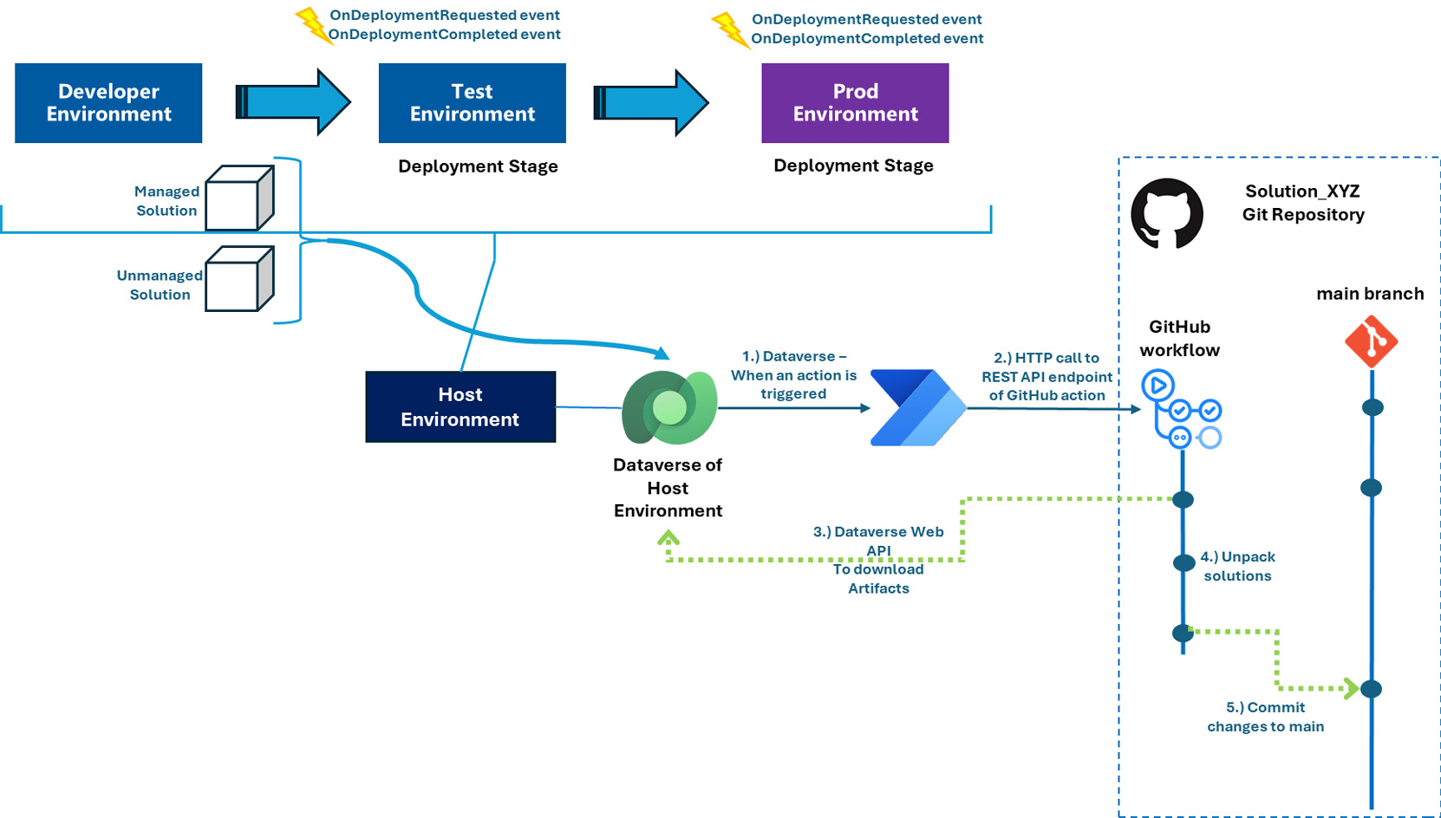

Figure 5.3 – Git integration with Power Platform pipelines

The managed and unmanaged solutions are generated at the beginning of the deployment that we initiated through the Power Platform pipeline. When a managed pipeline runs, other developers cannot queue this pipeline, which guarantees mutual exclusion. The generated artifacts are stored in the Dataverse ****DeploymentArtifacts**** table of the ****Pipelinehost**** environment. As the package (managed solution) goes through the pipeline stages (****Test**** and ****Prod**** environment, in our example) the previously mentioned events are triggered. We use the ****OnDeploymentCompleted**** event to execute our cloud flow, which will dispatch our GitHub workflow through ****HTTP POST****, and that will download the deployment artifacts and unpack and commit them to the main branch.

To be able to download the artifacts from Dataverse, we create a service principal, and we use a Bash script in our GitHub flow to directly call the Dataverse Web API and to download our deployment artifacts through the OData protocol.

Let us use PAC CLI to create a service principal that we are going to use in GitHub workflows:

**# First we need to authenticate**

**pac auth create**

**# List our environments to find the URL of the environment hosting our Power Platform pipelines (HOST)**

**pac admin list**

**# Create the service principal**

**pac admin create-service-principal -env <<URL>> -n VersionControlSPN --role "System Administrator"**

The last call requires administrative privileges not just in the Power Platform tenant, but in Microsoft Entra ID (the ****Application.ReadWrite.Allpermission**** role), too. The output of this call contains the client secret, application ID (client), and tenant ID of the app registration, and, respectively, the enterprise application. This command also registers this service principal in Dataverse by adding it as an application user to the environment. We need to save the output of the last command for later usage of the client ID, client secret, and tenant ID in our GitHub workflow:

**pac admin create-service-principal -env https://org48448b9d.crm4.dynamics.com -n VersionControlSPN**

**Connected as XXXXXX@YYYYYYY.onmicrosoft.com**

**Creating Entra ID Application 'VersionControlSPN'... Done**

**Creating Entra ID Service Principal... Done**

**Connected to... pipelinehost**

**Registering Application '7be14619-8224-4235-9c6b-2701fb98f203' with Dataverse... Done**

**Creating Dataverse system user and assigning role... Done**

**Application Name         VersionControlSPN**

**Tenant Id                XXXXXXXX-XXXX-XXXX-XXXX-XXXXXXXXXXXX**

**Application Id           XXXXXXXX-XXXX-XXXX-XXXX-XXXXXXXXXXXX**

**Service Principal Id     XXXXXXXX-XXXX-XXXX-XXXX-XXXXXXXXXXXX**

**Client Secret            YYYYYYYYYYYYYYYYYYYYYYYYYYYYYYYYY**

**Client Secret Expiration 2025. 02. 24. 16:03:31 +00:00**

**System User Id           XXXXXXXX-XXXX-XXXX-XXXX-XXXXXXXXXXXX**

Having created the service principal with a client ID and client secret, let’s move on to the GitHub workflow that will use them.

## GitHub workflows

It is time to set up GitHub flow in one of our GitHub repositories. We will use ****Visual Studio Code**** in the upcoming steps to create our YAML file. Alternatively, we could use the GitHub UI to create our workflow:

1. Create repository secrets with the names ****TENANT\_ID****, ****CLIENT\_ID****, and ****CLIENT\_SECRET**** in the selected GitHub repository.
2. Create a GitHub flow (with the name ****downloadunpackcommitbash.yml****) and set its trigger condition to ****workflow\_dispatch****:

name: DownloadUnpackCommitBash

run-name: VersionControlIntegration-Bash

on:

  workflow\_dispatch:

1. Introduce input parameters that will be called by the Power Automate cloud flow:

    inputs:

****artifact\_url****:

        description: "The URL of the Dataverse record ID for the artifact created by the pipelines."

        required: true

      solution\_name:

        description: "Name of the solution in Dataverse"

        required: true

      user\_name:

        description: "User name for the commit"

        required: true

      user\_email:

        description: "User name email address"

        required: true

      source\_branch:

        description: "Branch for the solution commit"

        default: "main"

        required: true

      target\_branch:

        description: "Branch to create for the solution"

        required: false

      commit\_message:

        description: "Message to provide for the commit"

        default: "test without Dataverse trigger"

        required: true

1. Configure standard permissions and the GitHub-hosted build agent’s operating system:

permissions:

  contents: write

jobs:

  export-unpack-commit:

    runs-on: ubuntu-latest

1. Check out the source branch in the build agent:

    steps:

      - uses: actions/checkout@v3

        with:

            ref: ${{ github.event.inputs.source\_branch }}

1. Create a new branch if the target branch is specified:

     # Commit changes to the existing or new branch

     - name: create new branch if specified

       shell: bash

       run: |

        if [ -n "${{ github.event.inputs.target\_branch }}" ]; then

              git checkout -b ${{ github.event.inputs.target\_branch }} ${{ github.event.inputs.source\_branch }}

         fi

1. Execute a Bash script that requests an access token from Microsoft Entra ID with the Dataverse scope using the tenant ID, client ID, and client secret generated by PAC CLI. After getting the token, we reach out to the Dataverse Web API endpoint of our table (****DeploymentArtifacts****) and we download the artifact identified by its GUID using *curl*:

      # Export the solution from the artifact created by pipelines

     - name: download solution from artifact

       env:

           CLIENT\_ID: ${{secrets.CLIENT\_ID}}

           TENANT\_ID: ${{secrets.TENANT\_ID}}

           CLIENT\_SECRET: ${{secrets.CLIENT\_SECRET}}

       shell: bash

       run: |

           aadHost="login.microsoftonline.com"

           #adding $value to the end of the artifact url to download binary content

           url="${{ github.event.inputs.artifact\_url }}/\$value"

           dataverseHost=$(echo $url | cut -d'/' -f3)

body="client\_id=${CLIENT\_ID}&client\_secret=${CLIENT\_SECRET}&grant\_type=client\_credentials&scope=https://$dataverseHost/.default"

           OAuthReq=$(curl -s -X POST "https://$aadHost/${TENANT\_ID}/oauth2/v2.0/token" -d $body)

            spnToken=$(echo $OAuthReq | jq -r .access\_token)

            # Download the managed solution

            response=$(curl -H "Authorization: Bearer $spnToken" \

              -X GET $url \

              -o "${{ github.event.inputs.solution\_name }}\_managed.zip")

            # Download the unmanaged solution (for now we will need to use string manipulation to get the unmanaged solution URL, until the API provides this value)

            unmanaged\_artifact\_url=$(echo "$url" | sed 's/artifactfile/artifactfileunmanaged/g')

            response=$(curl -H "Authorization: Bearer $spnToken" \

              -X GET $unmanaged\_artifact\_url \

              -o "${{ github.event.inputs.solution\_name }}.zip")

1. Using the GitHub Power Platform action (****unpack-solution****), we unpack the managed and unmanaged versions of the solution to the repository on the build agent:

      # Unpack the solution to a folder named as the solution

      - name: unpack solution

****uses: microsoft/powerplatform-actions/unpack-solution@v0****

        with:

          solution-file: "${{ github.event.inputs.solution\_name }}.zip"

          solution-folder: "${{ github.event.inputs.solution\_name }}"

          solution-type: 'Both'

          process-canvas-apps: false

          overwrite-files: true

1. Commit the changes locally in the build agent either into the target branch or into the source branch:

      # Commit changes to the existing or new branch

     - name: commit changes

       shell: bash

       run: |

         rm -rf ${{ github.event.inputs.solution\_name }}.zip

         rm -rf ${{ github.event.inputs.solution\_name }}\_managed.zip

         git config user.name ${{ github.event.inputs.user\_name }}

         git config user.email ${{ github.event.inputs.user\_email }}

         git pull

         git add --all

         git commit -am "${{ github.event.inputs.commit\_message }}" --allow-empty

1. Push the changes to the remote origins:

     # Push the committed changes to the source branch

     - name: push to branch

       shell: bash

       run: |

         if [ -n "${{ github.event.inputs.target\_branch }}" ]; then

           git push origin "${{ github.event.inputs.target\_branch }}"

         else

           git push origin "${{ github.event.inputs.source\_branch }}"

         fi

*The Dataverse Web API – OData protocol*

*We use the Dataverse**Web API to query Dataverse tables and records using the REST API on the OData protocol. Our GitHub workflow’s input parameter,*****artifact\_url*****, expects the following string to get the record identified by its unique identifier, and its column,*****ArtifactFile********https://[*****.*****$Value*****, refers to the binary content. Since we’re using Bash and Bash treats the*****$*****sign as a special character, we need to use the escape character (backslash) to add*****$value*****to the end of the artifact URL.*

To test our GitHub flow, we can use the ****run workflow**** command in the GitHub UI by providing the inputs manually:

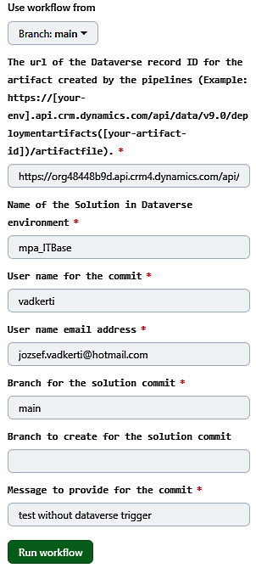

Figure 5.4 – GitHub – run workflow manually

Now, we have a GitHub workflow that can download deployment artifacts and commit them to a child branch or the main branch, based on the input parameters. See ****.github/downloadunpackcommitbash.yml**** in the ****Chapter05**** folder of the book’s GitHub repo, which contains the entire GitHub workflow. The same workflow can be realized with PowerShell commands as well. See ****.github/**** ****downloadunpackcommit.yml**** in the ****Chapter05**** folder for details.

It is good practice to commit changes first to the feature branch and then to submit a pull request because we never work directly on the main branch. There are normally also branch policies in place that block developers from working directly on the main branch. On the other hand, GitHub workflows can initiate a pull request immediately after creating and committing changes to a feature branch.

We can use exactly the same approach in conjunction with the integration of ****Azure DevOps Services**** repositories, pipelines, and ****Power Platform managed pipelines**** while keeping the following considerations in mind:

* Secrets are stored as variables or within variable groups in YAML pipelines.
* GitHub inputs are mapped to Azure DevOps pipeline variables (not parameters).
* We can use the same Bash scripts as in the case of our GitHub workflow. There is no need to change anything. Microsoft-hosted build agents support Ubuntu Linux distros.
* We need to install PowerPlatform Tools by using the Power Platform ****build tool**** task (****PowerPlatformToolInstaller@2****) in the build agent.
* We need to use the ****PowerPlatformUnpackSolution@2**** task to unpack the solution.

## Dataverse with Power Automate cloud flows

Having created the DevOps part, let us introduce the Power Automate cloud flow that will react to the ****OnDeploymentCompleted**** event in [the appropriate deployment sta](https://make.powerautomate.com/)ge. We’ll create this cloud flow in the ****Pipelinehost**** environment:

1. Visit [https://make.powerautomate.com](https://make.powerautomate.com/) and select the environment in which our Power Platform pipelines reside.
2. We then go to the ****My Flows**** blade, open the ****New Flow**** drop-down menu, and click on ****Automated Cloud Flow****.
3. We can name the flow something like ****ManagedPipelineOnDeploymentCompletedFlow**** and need to pick ****When an action is performed**** from Dataverse as the trigger condition.
4. After creating the flow, we need to provide the following values as the parameters of the trigger action:

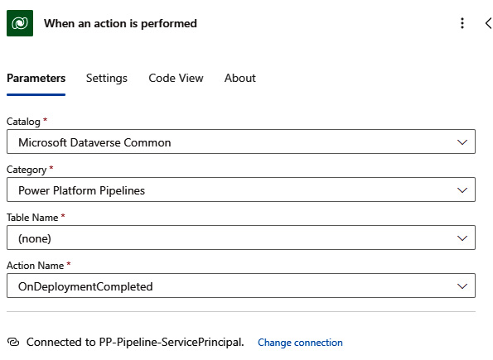

Figure 5.5 – Dataverse – When an action is performed

Please note that, here, we’re using the service principal to connect to the underlying Dataverse, which is *not* the service principal that we used in the GitHub workflow. This is the service principal that we created in *[Chapter 4](https://learning.oreilly.com/library/view/mastering-devops-on/9781835880845/B22208_04.xhtml" \l "_idTextAnchor074)*, for the *on-behalf-of* pipeline deployment.

1. We can use the output data (****ActionOutputs**** ****ArtifactName****, ****ActionOutputs**** ****DeploymentPipeIineName****, ****ActionOutputs**** ****DeploymentStageName****) of the trigger action to introduce multiple conditions to react only on our pipeline (****PipelineToProd****) and in the final deployment stage (****Production****).
2. After introducing these conditions to limit our cloud flow execution only to this managed pipeline, we need to get some additional data from the ****DeploymentStageRun**** Dataverse table in conjunction with this run (identified by ****StageRunId****). We use the ****Get********a row by ID**** action with the ****Row ID**** parameter from the trigger activity to get this information:

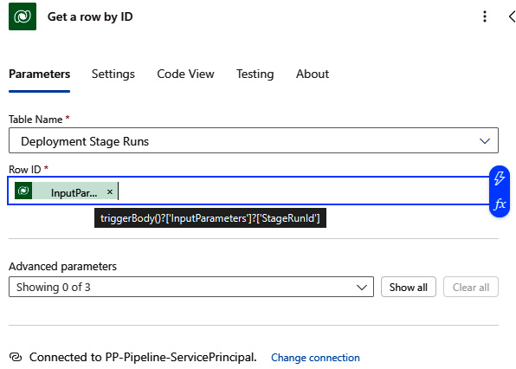

Figure 5.6 – Get a row by ID action

1. Finally, we need to call the REST API endpoint of our GitHub workflow. Since these endpoints are protected, we need to create a ****GitHub personal access token**** with the right scopes (repo and workflow) to access workflows and Git repositories. Then, we can use the ****HTTP action**** to manually dispatch the recently created GitHub workflow. The HTTP action expects the following parameters:
   * URL: ****https://api.github.com/repos/[org-name]/[repository]/actions/workflows/downloadunpackcommitbash.yml/dispatches****
   * HTTP method: POST
   * Headers

We only define the ****Authorization**** header with a bearer token that is exactly the same as our GitHub personal access token, as the following figure shows:

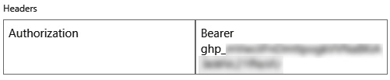

Figure 5.7 – Authorization header with GitHub access token

Please note that we should store the bearer token in an environment variable that is backed by the Azure Key Vault service.

The HTTP payload (body) contains the GitHub workflow’s input parameters:

{

"ref": "main",

"inputs": {

   "artifact\_url": "https://[your-env-id].api.crm4.dynamics.com/api/data/v9.0/deploymentartifacts(@{body('Get\_a\_row\_by\_ID')?['\_artifactid\_value']})/artifactfile",

   "solution\_name": "mpa\_ITBase",

   "user\_name": "jovadker",

   "user\_email": "jozsef.vadkerti@hotmail.com",

   "source\_branch": "main",

   "commit\_message": "new version deployed to prod"

}

}

The following figure shows how we apply these parameters within the HTTP action:

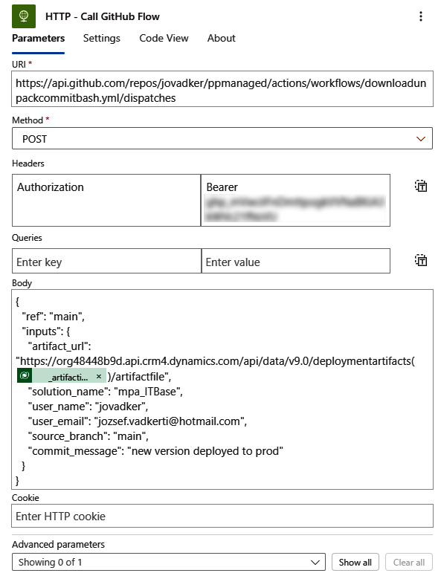

Figure 5.8 – HTTP action to dispatch a GitHub workflow

When everything comes together, our Power Automate cloud flow should contain the following actions and conditional cases:

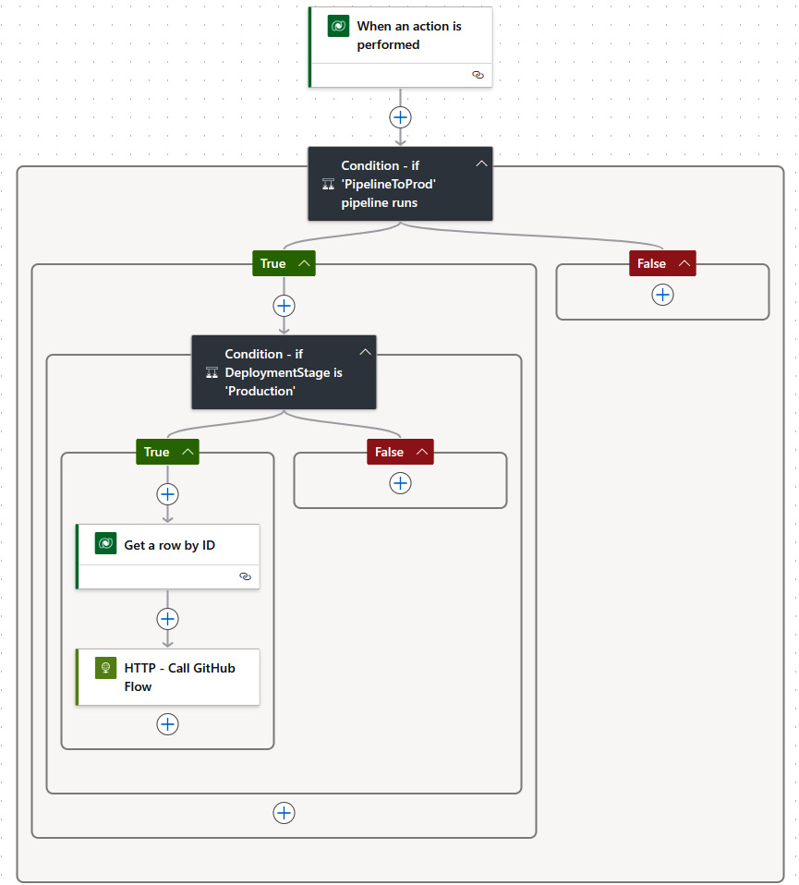

Figure 5.9 – End-to-end cloud flow

With this final step, we have accomplished our original plan to save the deployment artifacts of our Power Platform pipeline to a GitHub repository.

To close the loop, we can introduce another Power Automate cloud flow that is triggered by the *committed to main* or *pull request is submitted* GitHub event via webhooks to track the result of the GitHub workflow dispatch REST API call back to our Power Platform *Pipelinehost* environment. ****Webhooks**** provide a mechanism to register HTTP endpoints as event handlers on other services. In our case, we can register the Power Automate cloud flow as a webhook on the GitHub side. If a well-defined event happens in GitHub, GitHub will execute all registered webhooks. There are already GitHub connectors available for these types of triggers, such as the *When a pull request is created or modified* webhook in the Power Automate cloud flow.

Last but not least, it is worth having a look at the differences when we use Azure DevOps Services instead of GitHub in our Dataverse-triggered cloud flow:

* We need to enable the ****Third-party application access via OAuth**** checkbox at the organization level under ****Organization Settings**** | ****Security**** | ****Policies**** | ****Application access policies**** in Azure DevOps Services to be able to use the available Azure DevOps Services actions in our Power Automate cloud flow
* We then use the ****Queue a new Build**** action under the Azure DevOps connector to execute the pipeline
* As mentioned earlier, our Azure DevOps pipeline expects the input parameters as variables defined in the ****Variable**** pane
* The ****Queue a new build**** action passes over the parameters in the following format:

{

"artifact\_url": "https://[your-env-id].api.crm4.dynamics.com/api/data/v9.0/deploymentartifacts(@{body('Get\_a\_row\_by\_ID')?['\_artifactid\_value']})/artifactfile",

"solution\_name": "mpa\_ITBase",

"user\_name": "jovadker",

"user\_email": "jozsef.vadkerti@hotmail.com",

"source\_branch": "main",

"commit\_message": "new version deployed to prod"

}

Awesome job! We have just learned how we can get the two workflow engines to collaborate in order to use the same DevOps principles that we apply every day during custom software development projects.

# Copilots in Power Platform pipeline development

To significantly reduce the pipeline development effort in GitHub or Azure DevOps Services, we can leverage the capabilities of ****Large Language Models**** (****LLMs****) such as GPT-4 and the products built upon those models to support developers and DevOps engineers. One of these products is ****GitHub Copilot****, which acts as a pair programmer, – an assistant that can synthesize code based on natural language prompts. GitHub Copilot integrates into Visual Studio Code, Visual Studio, Neovim, and the JetBrains IDE (even in Azure Data Studio) and it is also available directly on the GitHub website.

Using the GitHub Copilot inline editor or the ****GitHub Copilot Chat window****, we can prompt the foundation model to create pipelines that use the build tools to interact with our Power Platform environments. The more precise our prompts are, the more accurate GitHub Copilot can synthesize the YAML files. This concept is also referred to as ****prompt engineering****. Here are some real-world prompts for the activities we have carried out in this chapter:

* “*By using the Microsoft Power Platform build tool, tasks create an Azure DevOps pipeline that exports a solution from the Power Platform environment, unpacks it, and commits the changes in a new branch under main.”*
* “*Create a Bash script that gets an access token from Dataverse using AAD app registration and query a Dataverse table*****DeploymentArtifacts**** *row by providing its GUID.” The column with the name “artifactfile” shall be downloaded afterward.”*
* “*By using Power Platform GitHub actions, create a GitHub workflow with a trigger condition dispatch that exports a solution from the Power Platform environment, unpacks it, and commits the changes in a new branch under main.”*

If we don’t have access to GitHub Copilot, we can use ****Microsoft Copilot**** ([https://copilot.microsoft.com](https://copilot.microsoft.com/)) with our personal account or other LLMs to get some templates and step-by-step instructions on how YAML pipelines should be constructed.

Copilot is also available in Power Platform to help us in creating apps, flows, websites, chatbots, and reports more intuitively by using natural language. In the previous example of a Dataverse-triggered workflow, we could use the following prompt in the Power Automate UI in ****Copilot for Power Automate****:

“*Create a workflow that is triggered by the “When an action is performed” Dataverse action on Power Platform pipelines with the OnDeploymentCompleted event. If the pipeline is “PipelineToProd” and the deployment stage is Production, call an HTTP action.”*

Copilots will soon become an integral part of our daily work. It’s essential for us to develop these skills and acquire new competencies to remain at the forefront of technology.

# Summary

In this chapter, we explored the world of Git, the distributed version control system, and discovered how to use PAC CLI to export/import and unpack Power Platform solutions in Git repositories. We also delved into the inner workings of professional DevOps pipelines and saw how build tools such as Azure DevOps tasks and GitHub actions use the underlying PAC CLI to perform actions within provider-hosted or self-hosted agents.

In the second half of the chapter, we combined the Power Platform managed pipeline results from *[Chapter 4](https://learning.oreilly.com/library/view/mastering-devops-on/9781835880845/B22208_04.xhtml" \l "_idTextAnchor074)* with professional DevOps tools and achieved a version control integration directly from managed pipelines. To top it all off, we used GitHub Copilot and Copilot for Power Automate to generate YAML pipelines and Power Automate cloud flows that we had previously created manually.

But hold on to your hats, because in the next chapter, we will go even further and delve into YAML techniques to do some real magic with pipeline templates[, GitHub workflow templates, and AL](https://code.visualstudio.com/learn)M Accelerator for Power Platform.

# Further reading

* [Learn about Visual Studio](https://github.com/git/git)Code: <https://code.visualstudio.com/learn>
* Git open source project – the code base of Git: <https://github.com/git/git>
* GitHub flow: <https://docs.github.com/en/get-started/using-github/github-flow>
* PAC CLI reference: <https://learn.microsoft.com/en-us/power-platform/developer/cli/reference/>
* Azure Pipelines learning module: <https://learn.microsoft.com/en-us/training/modules/explore-azure-pipelines/>
* Integrate Azure pipelines: <https://learn.microsoft.com/en-us/training/modules/integrate-azure-pipelines/>
* Azure DevOps Demo Generator: [https://azuredevopsdemogenerator.azurewebsites.net](https://azuredevopsdemogenerator.azurewebsites.net/)
* GitHub Actions learning module: <https://learn.microsoft.com/en-us/training/modules/introduction-to-github-actions/>
* Implement CI pipelines with Azure DevOps and GitHub Actions: <https://learn.microsoft.com/en-us/training/paths/az-400-implement-ci-azure-pipelines-github-actions/>
* Build continuous integration (CI) workflows by using GitHub Actions: <https://learn.microsoft.com/en-us/training/modules/github-actions-ci/>
* Microsoft Power Platform Build Tools for Azure DevOps Services: <https://learn.microsoft.com/en-us/power-platform/alm/devops-build-tools>
* GitHub Actions for Microsoft Power Platform: <https://learn.microsoft.com/en-us/power-platform/alm/devops-github-actions>
* GitHub repository for Power Platform build tools: <https://github.com/microsoft/powerplatform-build-tools>
* Azure Pipelines agent source code: <https://github.com/microsoft/azure-pipelines-agent>
* GitHub runner source code: <https://github.com/actions/runner/tree/main/src>
* Pipeline Integration with GitHub: <https://learn.microsoft.com/en-us/power-platform/alm/extend-pipelines-github-export>
* Dataverse Web API: ****https://learn.microsoft.com/en-us/power-apps/developer/data-platform/webapi/overview****
* GitHub Invoke REST API: <https://docs.github.com/en/rest/actions/workflows?apiVersion=2022-11-28#create-a-workflow-dispatch-event>
* GitHub Secret Management: <https://docs.github.com/en/actions/security-guides/using-secrets-in-github-actions>
* GitHub Personal Access Tokens: <https://docs.github.com/en/authentication/keeping-your-account-and-data-secure/managing-your-personal-access-tokens>
* Power Platform GitHub Connectors: <https://learn.microsoft.com/en-us/connectors/github/>
* Application Connection Policies in Azure DevOps Services: <https://learn.microsoft.com/en-us/azure/devops/organizations/accounts/change-application-access-policies?view=azure-devops>
* Prompt engineering with GitHub Copilot: <https://learn.microsoft.com/en-us/training/modules/introduction-prompt-engineering-with-github-copilot/>
* OpenAI Prompt Engineering: <https://platform.openai.com/docs/guides/prompt-engineering>

# 6

# A Deep Dive into Continuous Integration/Continuous Deployment (CI/CD) Pipelines

In this chapter, we will get hands-on experience in designing ****Application Life** **Cycle Management**** (****ALM****) processes for applications with both code first and low-code/no-code components. In addition, we will cover how DevOps engineers can standardize pipelines and refuel them in any other new Power Platform projects, using ****pipeline templates**** and ****reusable workflows**** in ****Azure DevOps**** and ****GitHub**** as reusable building blocks. We will gain insights and a solid understanding of the ****ALM Accelerator for Power Platform**** package, part of the Power Platform Center of Excellence Starter Kit, and what we can reuse from this package in our own DevOps environment. We will also learn about ****Power Platform pipelines****, the managed pipelines, and how they can leverage the features of professional DevOps tools, such as automated testing. Finally, the chapter will also teach us about ****automated testing**** with available open source frameworks and their integration into ****Continuous Integration and Continuous Deployment**** (****CI/CD****) pipelines.

In this chapter, we’re going to cover the following main topics:

* When everything comes together – branches, environments, and Power Platform catalog
* Azure pipeline templates and reusable GitHub workflows
* The ALM Accelerator for Power Platform
* Automated testing in DevOps and Power Platform pipelines

# Technical requirements

To do a deep dive into our CI/CD pipelines by using pro-development DevOps tools, we need to have the following:

* ****A Power Platform subscription****: We can sign up for a Power Apps Developer Plan (<https://www.microsoft.com/en-us/power-platform/products/power-apps/free>) if we already have a Microsoft Entra ID work account, or we can join the Microsoft 365 Developer Program (<https://developer.microsoft.com/en-us/microsoft-365/dev-program>).
* ****An Azure DevOps Services organization****: We can create a DevOps organization any time *for free* (<https://learn.microsoft.com/en-us/azure/devops/user-guide/sign-up-invite-teammates>). If we create a public project in Azure DevOps, we get multiple free pipelines and free access to every feature of the service (see the ****Azure DevOps for Open Source**** offering).
* A ****GitHub handle**** and public repository (<https://github.com/signup>), which is also *free* for public repositories.
* Samples and walkthroughs discussed in this chapter are located at <https://github.com/PacktPublishing/Mastering-DevOps-on-Microsoft-Power-Platform/tree/main/Chapter06>.

# When everything comes together

In the previous chapter, we saw how Azure DevOps Services pipelines and GitHub flows can interact with our Dataverse environments and Power Platform solutions to deliver DevOps CI/CD capabilities.

## Branches and environments

If we follow the trunk-based branching strategy or the very similar ****GitHub flow****, we will frequently create short-lived branches for development purposes. These branches are the so-called ****feature branches**** that we can use to implement new user requirements or fix bugs that our customers or our internal quality assurance process have found.

We can use ****Build Tools for Power Platform**** and, respectively, the underlying ****Pac CLI**** to spin up developer environments. A typical branch structure of a particular solution might look as follows:

main

    test

        devA

        devB

        devZ

With the help of ****branch policies****, we can force developers to use pull requests to merge back changes to test and/or main branches. In the case of Azure DevOps Services, if we configure any of the branch policies for a branch (****Require a minimum number of reviewers****, ****Check for linked work items****, ****Check for comment resolution****, or ****Limit merge types****), that branch cannot be deleted and requires ****pull requests**** (****PRs****) for all changes. As such, we can avoid accidental changes directly committed to these dedicated branches:

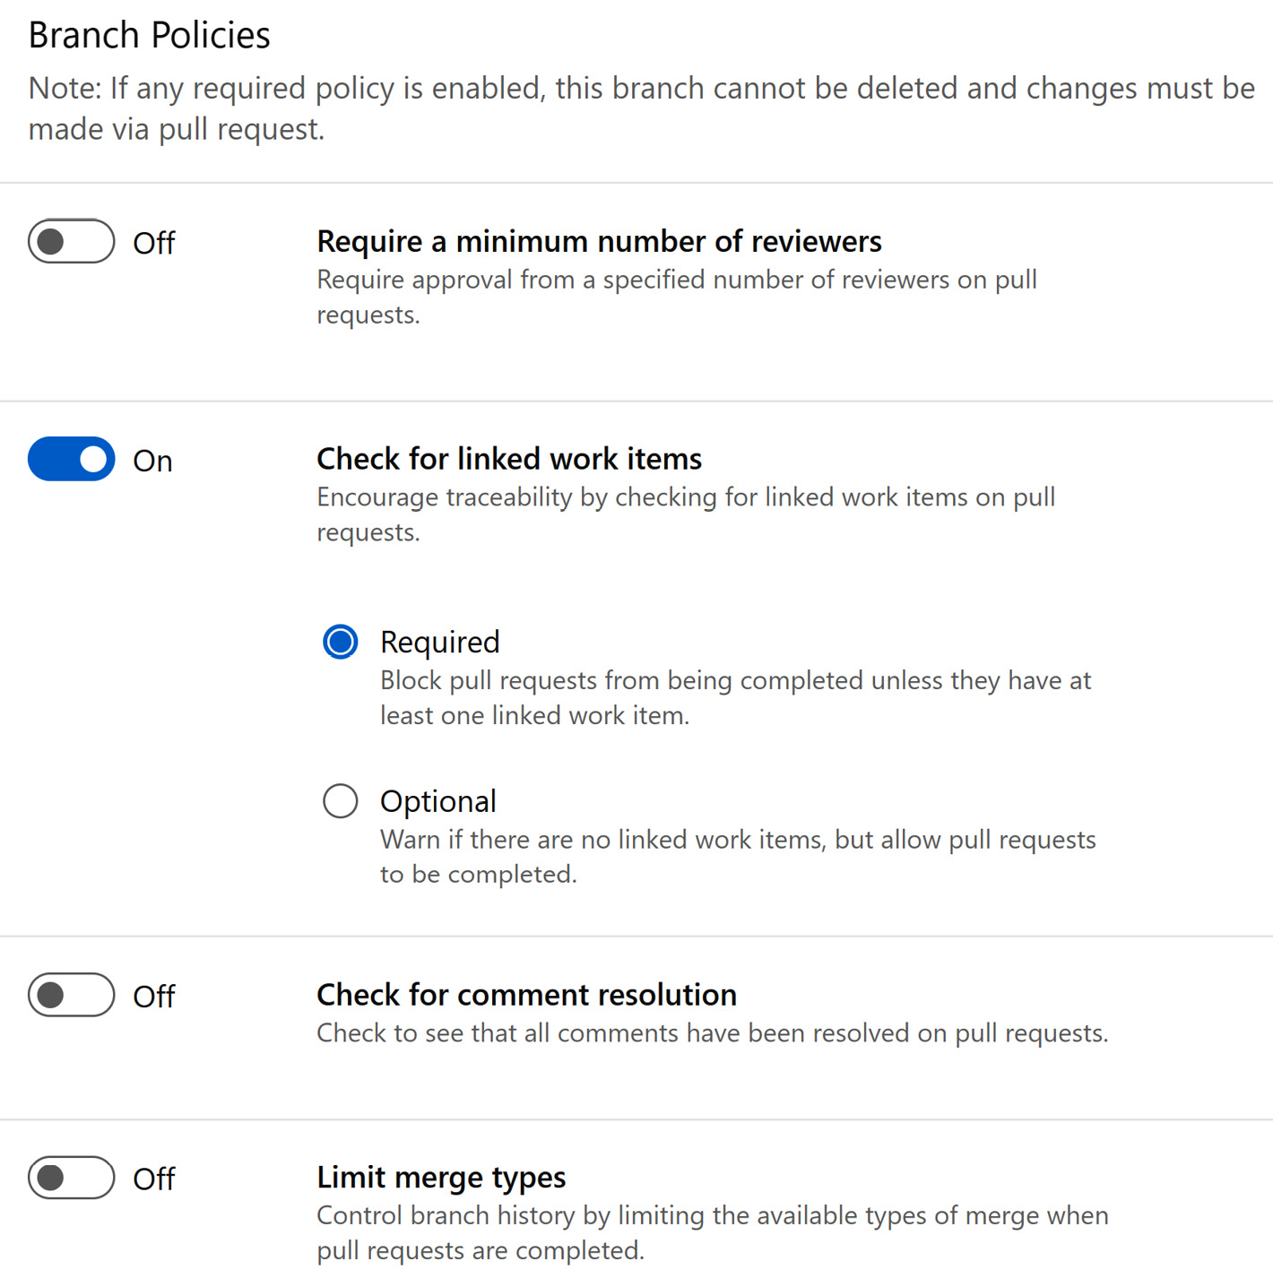

Figure 6.1 – Branch Policies

*Check for linked work items*

*We highly recommend enforcing this setting for your dedicated main and test branches. It just ensures that there can be no changes without well-defined user stories or backlog items.*

We can implement similar configurations on GitHub. This is called ****branch protection rules****, and it provides even more options. For instance, we can require PR reviews before merging, require status checks to pass before merging, and restrict who can push to the branch. We can also force ****signed commits**** to verify the authenticity of a commit, by attaching a cryptographic signature to it. This signature is created using the committer’s private key and can be verified by others, using the committer’s public key. Signed commits provide assurance that code changes are made by a trusted and authorized source.

The following figure shows all the protection rules available for GitHub branches:

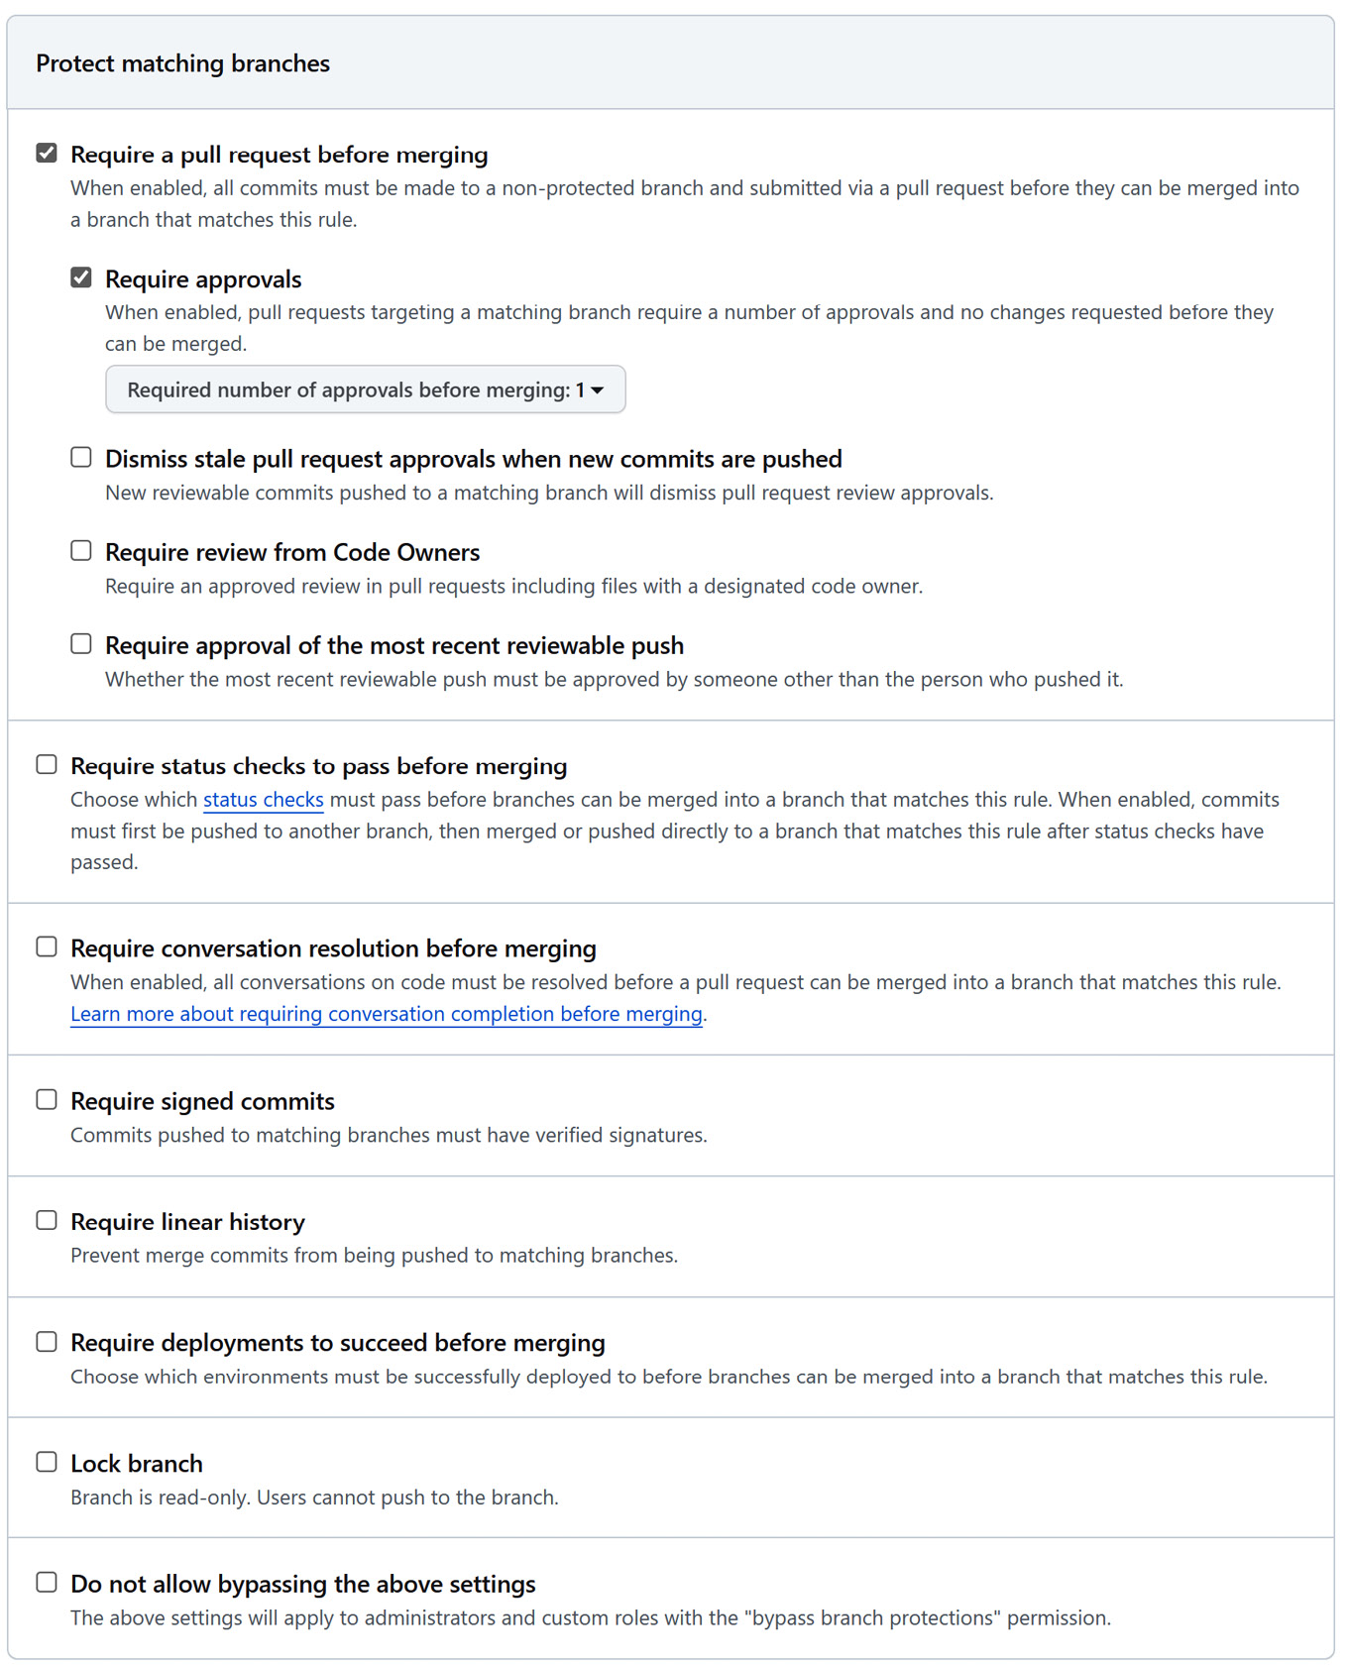

Figure 6.2 – Branch protection rules

Whichever DevOps tool we use, our goal is to create a DevOps framework in which professional developers can collaborate not just with each other but also with every developer (citizen developer). To set up the right ****quality gates**** during development, it is recommended to map our branch structure in dedicated and ad hoc/developer Power Platform environments:

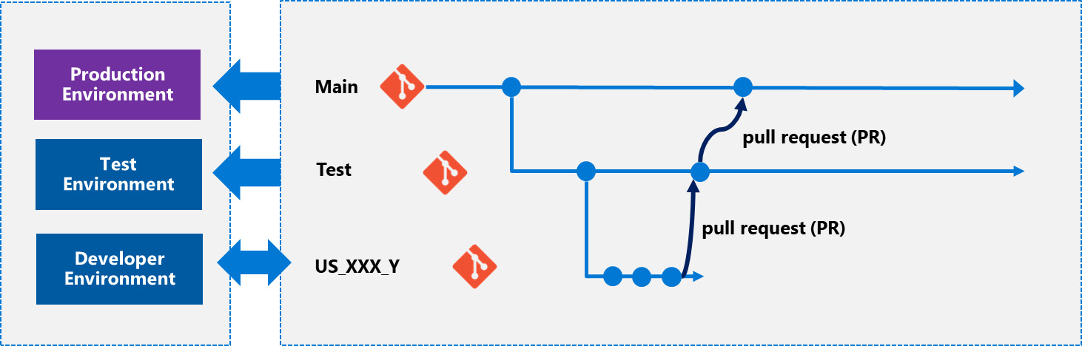

Figure 6.3 – Branches and environments

In the preceding diagram, the arrows between the Power Platform environments and Git branches represent the code and deployment flows. The production environment and test environment can handle only PRs (i.e. the solution is only imported into those environments), whereas developer environments should be bidirectional, since changes in those environments will be exported back to Git repos and, respectively, dev branches. In our case, the ****US\_XXX\_Y**** branch represents a short-lived feature branch containing the implementation of a user story. CI/CD pipelines with different trigger conditions manage the interaction between the two worlds, starting from the beginning of a solution’s life cycle. Pipelines/workflows can even be used to create these automations throughout the developer journey.

Let’s have a detailed look at how we can use Azure Pipelines to automate some of the most common steps:

1. ****Create a developer branch****: We can use the following Bash script to create a branch:

****git config user.name $(Build.RequestedFor)****

****git config user.email $(Build.RequestedForEmail)****

****#creating the branch under "dev" folder****

****newbranch=dev/${{ parameters.devbranch }}****

****git checkout -b $newbranch****

****git -c http.extraheader="AUTHORIZATION: bearer $(System.AccessToken)" push origin $newbranch****

1. ****Provision a Power Platform developer environment****: First, we need to sign in to the Power Platform environment by using a service principal on a Microsoft-hosted Windows machine, as the Pac CLI stores authentication credentials as plain text on Linux machines:

****pac auth create --applicationId 862e5a17-d38b-43ff-b24f-88a77f59623f \****

****--clientSecret $(ClientSecret) \****

****--tenant 4ae51f31-033a-48fa-be48-5ece14d2c081****

We also need to sign in to our Azure tenant, using the same service principal, to figure out who has triggered this Azure Pipeline:

****az login --service-principal \****

****-u 862e5a17-d38b-43ff-b24f-88a77f59623f \****

****-p $(ClientSecret) \****

****--tenant 4ae51f31-033a-48fa-be48-5ece14d2c081****

****AADObjectID=$(az ad user show \****

****--id $(Build.RequestedForEmail) \****

****--query id \****

****--output tsv)****

****echo "AADObject ID: $AADObjectID"****

The ****$(Build.RequestedForEmail)**** system variable contains the email address of the user who started the pipeline. We use the Microsoft Entra ID’s user object ID to create a Power Platform developer environment on behalf of this user (the command, per se, runs under the name of the service principal and not on behalf of our users):

****pac admin create --name "dev-US\_XXX\_Y" \****

****--type Developer \****

****--user $AADObjectID****

After creating the Power Platform environment, we need to assign the developer (who has started the pipeline) to it as the System Administrator:

****# Get the environment Id (the row before the last row contains the information)****

****rawOutput=$(pac admin list --name dev-us\_XXX\_Y | tail -n 2)****

****environmentId=$(echo $rawOutput | cut -d ' ' -f 2)****

****#adding system administrator role to the user who has created the developer environment****

****pac admin assign-user --environment $environmentId --user $AADObjectID --role "System Administrator"****

*Developer environments*

*Every user in Power Platform can create up to three developer environments for free.*

1. ****Create an Azure DevOps Service connection****: As we have seen earlier in *[Chapter 5](https://learning.oreilly.com/library/view/mastering-devops-on/9781835880845/B22208_05.xhtml" \l "_idTextAnchor089)*, ****Azure DevOps Service connections**** are used to connect to first- and third-party services, such as Microsoft Azure, GitHub, AKS, Docker, and Power Platform, from Azure Pipelines. Every task of Power Platform Build Tools expects a ****Power Platform service connection reference**** to be able to authenticate and perform actions, such as ****export solution****, ****import solution****, ****copy environment****, and ****backup****, against the environment. If we want to automate the service connection creation process, it is also possible. We need to create a JSON file that we will post as a payload to the ****REST**** endpoint of Azure DevOps Services (see ****AzDO/.pipelines/config-tokenizer.yml**** in the ****Chapter06**** folder of the GitHub repo):

{

   "authorization": {

      "parameters": {

         "tenantId": "GUID",

         "applicationId": "GUID",

         "clientSecret": "secret"

      },

      "scheme": "None"

   },

   "createdBy": {},

   "data": {},

   "isShared": false,

   "isOutdated": false,

   "name": "ConnenctionName",

   "owner": "library",

   "type": "powerplatform-spn",

   "url": "DataverseURL",

   "administratorsGroup": null,

   "description": "",

   "groupScopeId": null,

   "operationStatus": null,

   "readersGroup": null,

   "serviceEndpointProjectReferences": [

    {

         "description": "",

         "name": "ProjectName",

         "projectReference": {

            "id": "ProjectID",

            "name": "ProjectName"

         }

     }

   ]

}

We can use the following Bash script to tokenize this JSON file (see ****AzDO/.pipelines/create-service-connection.yml**** in the ****Chapter06**** folder of the GitHub repo):

# Set the filename

filename="config\_tokenizer.json"

# Read the JSON file

json\_string=$(cat .pipelines/$filename)

# Replace the value

new\_json\_string=$(jq '.authorization.parameters.clientSecret = "$(ClientSecret)"' <<< "$json\_string")

new\_json\_string=$(jq '.authorization.parameters.tenantId = "$(tenantId)"' <<< "$new\_json\_string")

new\_json\_string=$(jq '.authorization.parameters.applicationId = "$(applicationId)"' <<< "$new\_json\_string")

new\_json\_string=$(jq '.url = "${{ parameters.ppdevenvironmentURL }}"' <<< "$new\_json\_string")

new\_json\_string=$(jq '.name = "${{ parameters.ppdevenvironment }}"' <<< "$new\_json\_string")

new\_json\_string=$(jq '.serviceEndpointProjectReferences[0].projectReference.id = "$(System.TeamProjectId)"' <<< "$new\_json\_string")

new\_json\_string=$(jq '.serviceEndpointProjectReferences[0].projectReference.name = "$(System.TeamProject)"' <<< "$new\_json\_string")

new\_json\_string=$(jq '.serviceEndpointProjectReferences[0].name = "${{ parameters.ppdevenvironment }}"' <<< "$new\_json\_string")

# Write the modified JSON data back to the file

echo $new\_json\_string > config.json

If we want to execute this script locally, then we can use ****Windows Subsystem for Linux**** (****WSL****) on Windows machines to download a Linux distro, such as Ubuntu or Debian. To install WSL, we just need to visit the Microsoft Store and search for the distro. If the WSL feature is missing from our OS, the installation will provide us with a guide on how to enable the feature from the Control Panel by selecting the menu item, ****Turn Windows features on or off****. After installing the distro, we can use Windows Terminal or the terminal in Visual Studio Code to execute the previous scripts. If we want to use PowerShell instead of Bash, we can use ****Microsoft Copilot**** ([https://copilot.microsoft.com](https://copilot.microsoft.com/)) anytime to translate the Bash script to the PowerShell version.

Finally, we can use ****az devops**** CLI commands to automatically create our service connection:

****echo $(PatToken) | az devops login --organization $(System.CollectionUri)****

****az devops service-endpoint create \****

****--organization $(System.CollectionUri) \****

****--project $(System.TeamProject) --service-endpoint-configuration config.json****

1. ****Import the solution to the new developer environment****: Now, we have everything in place to import the solution into our brand-new developer environment as an unmanaged one. Since our branch is derived from the test branch, it contains the latest source code version of the solution (see ****AzDO/.pipelines/import-solution.yml**** in the ****Chapter06**** folder of the GitHub repo):

steps:

- checkout: git://PowerPlatform/Copilot@${{parameters.sourceBranch}}

  displayName: 'Checkout Source Branch'

  persistCredentials: true

- task: PowerPlatformToolInstaller@2

  inputs:

   DefaultVersion: true

- task: PowerPlatformPackSolution@2

  inputs:

    SolutionSourceFolder: '$(System.DefaultWorkingDirectory)/src/$(solutionName)'

    SolutionOutputFile: '$(Build.ArtifactStagingDirectory)/Solution/$(solutionName).zip'

    SolutionType: 'Unmanaged'

- task: PublishBuildArtifacts@1

  inputs:

    PathtoPublish: '$(Build.ArtifactStagingDirectory)/Solution'

    ArtifactName: 'Solution'

    publishLocation: 'Container'

- task: PowerPlatformImportSolution@2

  inputs:

    authenticationType: 'PowerPlatformSPN'

    PowerPlatformSPN: ${{parameters.serviceconnection}}

    SolutionInputFile: '$(Build.ArtifactStagingDirectory)/Solution/$(solutionName).zip'

    AsyncOperation: true

    MaxAsyncWaitTime: '60'

- task: PowerPlatformPublishCustomizations@2

  inputs:

    authenticationType: 'PowerPlatformSPN'

    PowerPlatformSPN: ${{parameters.serviceconnection}}

We use ****${{parameters.serviceconnection}}**** as a string parameter of the pipeline, which represents the name of the service connection previously created.

We can put these steps together into one pipeline or keep them separately. We can also chain these pipelines by using other trigger conditions, such as ****branch created****. For instance, a new dev branch is created under the ****dev/\***** condition looks, as follows:

****trigger:****

****-  dev/\*****

After going through these automation steps, we finally have a developer branch on which we can start our work. It is recommended to assign one or more work items to this branch by using the available tools in Azure DevOps; otherwise, PRs submitted later will be automatically rejected (if recommended branch policies are configured).

The following figure shows us how to assign the branch to an ****Issue**** work item:

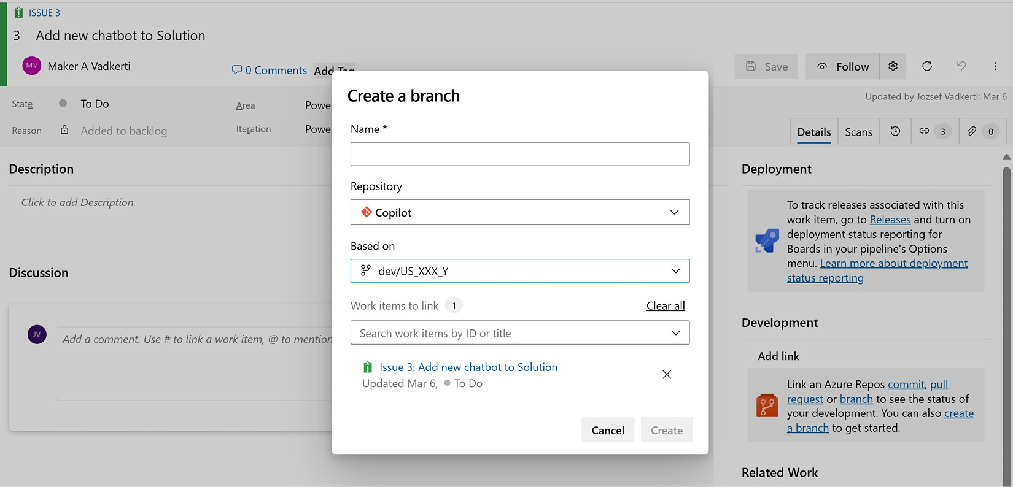

Figure 6.4 – Linking a branch to a work item

Making changes in the Power Platform environment should be reflected on the dev branch to track changes in the version control system. To achieve this, we need to create another pipeline (****Export-to-Git****) that exports our managed and unmanaged solutions, unpacks them, and commits changes to our dev branch. We saw some of these building blocks in *[Chapter 5](https://learning.oreilly.com/library/view/mastering-devops-on/9781835880845/B22208_05.xhtml" \l "_idTextAnchor089)*. In addition to that pipeline, we need to add a step to export the solution as unmanaged and to unpack the solution with type ****Both****. To commit changes back to a branch, we can use the following Git commands, executed as Bash script after our ****PowerPlatformExportSolution@2**** and ****PowerPlatformUnpackSolution@2**** build tasks in the pipeline:

-  checkout:  git://$(System.TeamProject)/$(Build.Repository.Name)@${{parameters.targetBranch}}

    displayName:  'Checkout  Source  Branch'

    persistCredentials:  true

#  Configure  email/name  and  checkout  git  branch

-  script:  |

      git  config  user.name  $(Build.RequestedFor)

      git  config  user.email  $(Build.RequestedForEmail)

      git  checkout  origin/${{parameters.targetBranch}}  --track

[[Adding here those PowerPlatformExportSolution@2 and PowerPlatformUnpackSolution@2 steps discussed earlier.]]

-  script:  |

        #!/bin/bash

        set  -e

        #  Set  the  path  to  the  directory  containing  the  solution

        solution\_dir="$(Build.SourcesDirectory)/src/$(solutionName)"

        #  Find  all  Solution.xml  files  in  the  solution  directory  and  its  subdirectories

        find  "$solution\_dir"  -type  f  -name  "Solution.xml"  |  while  read  -r  file;  do

                #  Replace  the  content  of  the  <Version>  tag  with  0.0.0.0

                sed  -i  's|<Version>.\*</Version>|<Version>0.0.0.0</Version>|g'  "$file"

        done

    displayName:  "Set  version  number  to  0.0.0.0"

-  script:  |

        rm  -rf  ./out/$(solutionName).zip

        rm  -rf  ./out/$(solutionName)\_managed.zip

        git  add  --all

        git  commit  -am  "Solution  is  committed"  --allow-empty

        git  -c  httpO.extraheader="AUTHORIZATION:  bearer  $(System.AccessToken)"  push  origin  ${{parameters.targetBranch}}

With the help of this pipeline, our developers can constantly commit their changes back to their own dedicated dev branches throughout feature development. We set the version number of the solution intentionally to ****0.0.0.0**** to avoid conflicting merges, as well as to manage version numbers with Azure pipelines. When developers are ready, they can submit a PR back to the parent branch.

Let’s discuss some additional DevOps design principles and recommendations in conjunction with our DevOps process:

* ****Do we need a separate pipeline for CI?**** We can use the ****PowerPlatformPackSolution@2**** build task anytime to pack our solution from source control. It is a compression step—actually it zips our folder, so it doesn’t require a long compilation time. Of course, if we have code components to be built, such as ****PowerApps Component Framework**** (****PCF****) controls or Dataverse plugins, or if we target multiple environments with the same manifest (solution), then it is worth creating dedicated pipelines for CI.
* ****Do we need a separate pipeline for CD, pipeline stages, and approval processes?**** After finalizing our work on the dev branch using the ****Export-to-Git**** pipeline, we can submit a PR to merge back our changes to test and later to production branches. We can introduce CD pipelines that are executed upon completion of the PR on the target branch with a simple branch trigger:

****trigger:****

****-  test****

We can also create pipelines for the PR itself that are triggered as a build validation policy. These pipelines validate code by pre-merging and building pull request changes, which – in the case of Power Platform – builds the solution and deploys it to an on-demand provisioned Power Platform environment and then executes various checks, such as calling ****SolutionChecker**** or performing ****automated tests****. We can introduce approval processes for staging environments (test and production) to control when changes are approved by release managers or environment administrators, with the help of ****Azure DevOps Services environments****.

* ****Version numbers of solutions – when do we need to set them?**** As discussed earlier, with the rise of DevOps, we want to maintain only one version, the latest of our applications in production. We use versioning and version numbers to be able to track changes back to the source code:

#  Solution  version  in  source  control  is  not  used.  Instead,  create  version  at  build  time  from  the  current  build  number.

-  pwsh:  |

      Get-ChildItem  -Path  "$(Build.SourcesDirectory)\$(RepoName)\${{parameters.solutionName}}\SolutionPackage\\*\*\Solution.xml"  |

      ForEach-Object  {

                (Get-Content  $\_.FullName)  `

                        -replace  '<Version>0.0.0.0<\/Version>',  '<Version>$(Build.BuildNumber)</Version>'  |

                Out-File  $\_.FullName

      }

    displayName:  'Update  Solution  XML  with  Build  Number'

We can set the ****Build.BuildNumber**** of an Azure pipeline run directly in the YAML file:

name:  1.0.$(Date:yyyyMMdd)$(Rev:.r)

This means that during the build/deployment, the version is calculated on the fly, using the build name of the Azure pipeline. This provides a one-to-one relationship between the solution version and the pipeline that generated that version.

* ****How to keep our developer branch up to date?**** Creating a pipeline that deploys the latest version to our branch from the parent branch. With a slight change in our ****Export-to-Git**** pipeline, we can introduce a parameter that expects the name of the branch in which the parent branch’s current version should be deployed. If we don’t want to override our work in such a way, we can use Git commands such as ****git rebase**** to restore our developer branch to the latest version of the parent branch. After this, we need to import the solution using the other pipeline into our developer environments.

Overall, we can manage our development work with the following four pipelines:

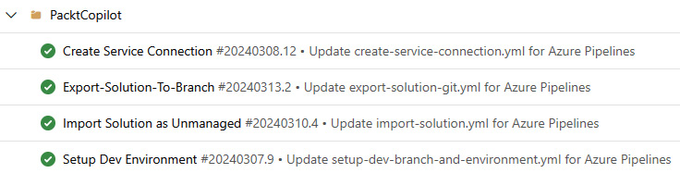

Figure 6.5 – Pipelines to manage a solution

We can create GitHub workflows in the same way. Those Bash and PowerShell scripts can be easily moved to GitHub workflows, and the same branch and repository structure with assigned Power Platform environments can be built upon, like in Azure DevOps Services.

## The Power Platform catalog

In addition to this kind of CI/CD delivery to Power Platform environments, Power Platform provides a new concept for managing our reusable packages. The ****Power Platform catalog**** is a package manager that contains solution templates, PCF components, end-to-end solutions, and other assets for reuse purposes. It is based on the same concept that we use in pro-dev scenarios when we publish our packages in different package management repositories, such as NuGet, npm, Maven, and Pip. The catalog in Power Platform is a feature that allows developers and makers to easily discover and use Power Platform templates and code components within their organization. It provides a private, central location for finding and installing the latest and most reliable versions of components, offering templates that deliver immediate value. For administrators and line of business approvers, the catalog serves as a single source of truth to store and maintain Power Platform artifacts, allowing them to curate and control the content to accelerate value for makers and developers. It also enables approval workflows for the use of sanctioned components and templates in sensitive regulatory and statutory scenarios, providing management capabilities with settings and metadata.

To bring the catalog into one dedicated environment (it is recommended to provide a separate environment, such as ****Catalog****), we need to install it as Dynamics 365 application from AppSource: <https://appsource.microsoft.com/product/dynamics-365/powerappssvc.catalogmanager-preview?flightCodes=dde212e5c66047c59bf2b346c419cef6>.

After installing this D365 application, we can submit and deploy the following assets to it:

* ****Dataverse solutions**** (managed or unmanaged) or ****package deployer packages**** (enterprise templates can also be published to the catalog)
* ****Templates**** for a Power App or a Power Automate flow
* ****Power Platform code-first components**** such as custom connectors or ****Power Apps component framework**** (****PCF****) controls

The Power Platform catalog brings additional security roles to manage the life cycle of catalog items – ****Catalog Submitter**** to submit items to the catalog, ****Catalog Read-Only Member**** to discover and install items from the catalog, ****Catalog Approver**** to approve submissions to the catalog, and ****Catalog Administrator**** to administer the catalog. We get this enterprise-grade security from catalogs as well.

Our Azure pipelines and GitHub workflows can target not just environments but also catalogs. The Pac CLI provides the appropriate commands to submit our solutions, custom connectors, and PCF components to the catalog. The following script creates a submission on our ****mpa\_ITBase\_managed**** solution (we used it in *[Chapter 4](https://learning.oreilly.com/library/view/mastering-devops-on/9781835880845/B22208_04.xhtml" \l "_idTextAnchor074)* for managed pipelines) from the enterprise templates and submits a new catalog item:

# Power Platform Catalog Manager application's GUID

pac admin list --application 83a35943-cb41-4266-b7d2-81d60f383695

# environment is the "Catalog" environment

pac catalog list --environment 0b90d036-e017-e840-9287-b1de3d95e252

# create a submission json file

pac catalog create-submission

# update the generated json file

pac catalog submit --environment 0b90d036-e017-e840-9287-b1de3d95e252 --path .\submission.json --solution-zip .\mpa\_ITBase\_managed.zip

These scripts can run on behalf of service principals as well. By default, submissions need to be approved by catalog administrators, but we can change the configuration so that certain publishers, such as service principals running in Azure Pipelines or GitHub workflows, get automatic approval.

The following figure shows the ****Power Platform Catalog Manager**** UI and an approval dialog after we have successfully submitted our ****mpa\_ITBase\_managed**** solution:

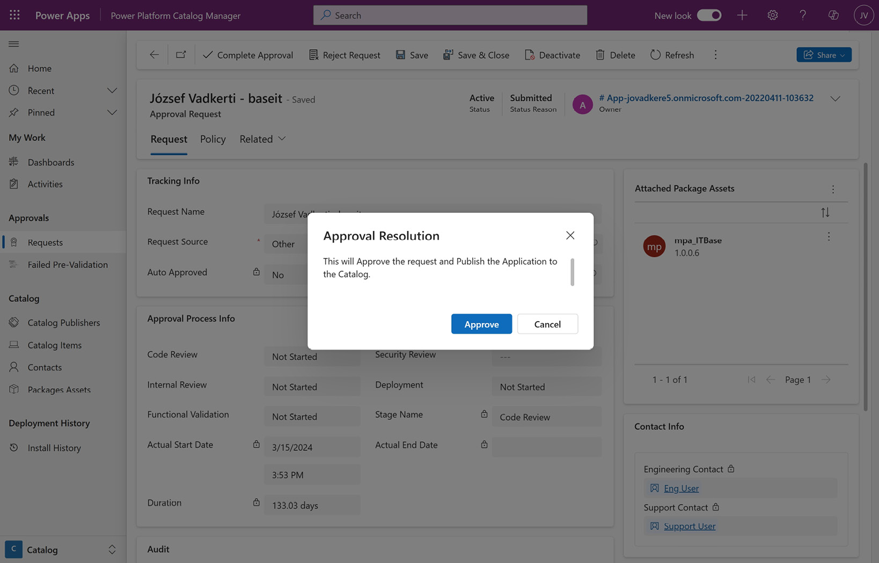

Figure 6.6 – Power Platform Catalog Manager

*Power Platform catalogs*

*Power Platform catalogs**will be part of*****managed environments*****after they become generally**available.*

Let’s now move on to the pipeline templates and reusable workflows that provide reusability of our Azure pipelines and GitHub workflows on a large scale.

# Azure pipeline templates and reusable GitHub workflows

Looking back at our Azure pipelines in the previous section, we can say that it is a pretty good starting point to have everything automated. However, if we need to support hundreds or even thousands of applications, then this approach of keeping three to four pipelines in every single repository, in which those solutions are maintained, will become more complex. The more and more applications we develop, the more and more different versions of these Azure pipelines will exist in parallel. It would be great to have a centralized repository containing the business logic of these pipelines and the solutions only customizing some parameters before calling them. This is the idea behind Azure pipeline templates and reusable GitHub workflows.

****Azure pipeline templates**** make it possible to create reusable business logic that we can use throughout our YAML pipeline instances. These templates can be also used to control what is allowed in a pipeline by defining policies that the “caller” should follow. For example, we can enforce task execution constraints by leveraging a template that acts as a safeguard, ensuring that any task performed follows our organization’s security guidelines.

For instance, the following ****template file**** contains one step to install the Pac CLI (see ****AzDO/.pipelines/template/include-paccli-steps.yml**** in the ****Chapter06**** folder of the GitHub repo):

# File: templates/include-paccli-steps.yml

steps:

-  bash:  |

        echo  "Installing  Pac  CLI"

        dotnet  tool  install  --global  Microsoft.PowerApps.CLI.Tool

    displayName:  "Installing  Pac  CLI"

The pipeline file that consumes this template executes it on Linux and then on the Windows agent (see ****AzDO/.pipelines/azure-pipeline-template.yml****):

# File: azure-pipelines.yml

jobs:

- job: Linux

  pool:

    vmImage: 'ubuntu-latest'

  steps:

  - template: templates/include-paccli-steps.yml

- job: Windows

  pool:

    vmImage: 'windows-latest'

  steps:

  - template: templates/include-paccli-steps.yml

We can also parameterize our Azure pipeline template files, and the caller pipelines can set those parameters according to their customization needs.

The same concept, called ****reusable workflows****, is available on GitHub. To make a GitHub workflow reusable, we need to introduce a special trigger condition – ****workflow\_call****. The following reusable workflow installs the Pac CLI on the target platform. The version number of the tool and the target platform are parameters of this flow (see ****GitHub/.github/workflows/install-paccli.yml****):

on:

  workflow\_call:

    inputs:

      version:

        required: true

        type: number

      platform:

       required: true

       type: string

       description: "platform"

jobs:

  installpac:

    runs-on: ${{inputs.platform}}

    steps:

     - name: install pac cli

       shell: bash

       run: |

          echo "version number: ${{inputs.version}}"

          dotnet tool install --global Microsoft.PowerApps.CLI.Tool

To call our workflow from other workflows, we need to create a dedicated job in our *caller* GitHub workflows (see ****GitHub/.github/workflows/Deploy.yml****):

name: Call a reusable workflow

on:

  workflow\_dispatch:

jobs:

  call-paccli-workflow:

    uses: jovadker/ppmanaged/.github/workflows/install-paccli.yml@main

    with:

      version: 8

      platform: ubuntu-latest

  call-workflow-windows:

    uses: jovadker/ppmanaged/.github/workflows/install-paccli.yml@main

    with:

      version: 8

      platform: windows-latest

The real power of this concept in Azure DevOps and GitHub is that we can place our templates and reusable workflows in different locations in the same repository, or even in different Git repositories. If we look at the pipelines that we created to spin up developer environments, create service connections, and export/import our solutions from/to environments, respectively, we can now place these templates or reusable workflows in a dedicated Git repository. The different projects and solutions can call our templates by using this reusable concept. Conversely, we can improve and maintain these workflows centrally by reducing the overall effort to manage large numbers of projects.

Besides the reusable workflows, GitHub offers so-called ****GitHub starter workflows****. GitHub starter workflows are also templates that are stored in an organization’s *GitHub repository*. These templates are displayed when we create a new workflow in the GitHub UI. Upon creating the workflow, the template will be copied to our repository, and with that, we decouple the instance from the template. We can use GitHub starter workflows to help projects set up their workflows, based on our reusable workflows.

Now that we understand pipeline templates and reusable workflows, let’s learn about the ALM Accelerator for Power Platform, which heavily uses this concept under the hood.

# The ALM Accelerator for Power Platform

The ALM Accelerator for Power Platform is a tool that helps developers automate their software development workflows for Power Platform. Although it is part of the ****Center of Excellence**** (****CoE****) ****Starter Kit****, which is a collection of components and tools that help organizations get started with Power Platform adoption, it can be installed as a standalone solution in one of our Dataverse environments.

The ALM Accelerator includes Azure pipeline templates, Azure pipelines, and Power Platform applications to help professional developers realize DevOps and ALM in their projects. This accelerator package is called the ****ALM Accelerator for Advanced Makers**** (****AA4AM****) solution, and it consists of reference implementations originally developed by the CoE Starter Kit engineering team at Microsoft. After its successful implementation, the team decided to make it open source and available for every organization, proving how healthy application life cycle management can be realized in Power Platform. We can use these pipelines and applications as they are, or we can customize them based on our organizational requirements, and of course, we can learn a lot from the underlying concepts that this team devised a few years ago.

We can find comprehensive documentation about the accelerator, how we can install it, how we can create our pipelines based on the available pipeline templates, and how we can manage our Power Platform solutions in Azure DevOps repositories.

Branches, environments, and pipeline templates, as previously discussed in this chapter, are essential to understand how ALM Accelerator works under the hood. The main features of the accelerator are the following:

* There is a model-driven app, ****ALM Accelerator for Power Platform Administration****, to create and manage deployment profiles. ****Deployment profiles**** describe the CD process of the solution throughout our environments. It is conceptionally the same as how we define Power Platform managed pipelines. It is recommended to create a deployment profile per Power Platform solution, as the profile also contains information about the Azure DevOps project, Git repository and target branches, and the corresponding Power Platform environments.
* There is another canvas app, ALM Accelerator for Power Platform, that provides a UI for developers and visualizes the solutions and assigned deployment profiles in the given Power Platform environment.
* Through the ALM Accelerator for Power Platform canvas app, we can easily create a branch and commit our solution versions (changes) multiple times to this branch.
* The canvas app provides a way to move our changes through the defined environments. Every deployment (release) is a PR to the parent branch. After completing the PR in Azure DevOps, a pipeline imports the solution to the assigned environment defined in the deployment profile.
* It is recommended to create one repository per solution. This repository contains our pipelines, utilizing the pipeline templates provided by the accelerator.
* We can add more environments, and we can create the same branch structure that we discussed at the beginning of this chapter.
* The canvas app uses custom connectors and calls the REST API endpoints of Azure DevOps Services to interact with the defined pipelines.
* The ****coe-alm-accelerator-templates**** GitHub repository contains the pipeline templates that the ALM accelerator also utilizes. We need to fork this repo to our Azure DevOps project as an additional Git repository.
* We can customize the pipeline templates for our organization’s needs.
* The ALM Accelerator for Power Platform is only available for Azure DevOps Services.

The following figure shows the ALM Accelerator for Power Platform at work:

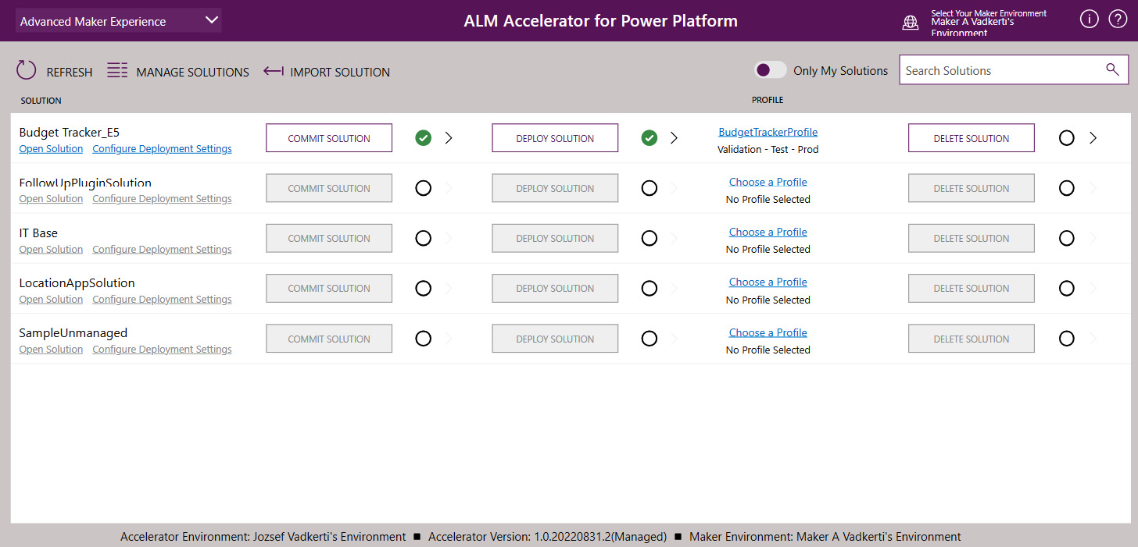

Figure 6.7 – The ALM Accelerator for Power Platform

We can see the unmanaged solutions available in the selected environment (developer environments). We can use the ****Commit Solution****, ****Deploy Solution****, and ****Delete Solution**** buttons to trigger our pipelines, commit our changes, or initiate PRs.

*The ALM Accelerator for Power Platform*

*Having observed the extensive flexibility**of the techniques presented earlier in this chapter, as well as the effectiveness of pipelines in managed environments, we should consider the ALM Accelerator for Power Platform as a tool for acquainting ourselves with various design patterns and concepts. These can then be incorporated into our custom Azure DevOps pipelines and, subsequently, our GitHub workflows.*

Now, we have everything in place to operate and manage a high number of projects and solutions in our organization. One last thing we need to provide to ensure the quality of our applications is ****automated testing****.

# Automated testing in DevOps and Power Platform pipelines

Test automation and automated tests are essential parts of ALM and DevOps processes. Without automated tests, we are not able to share the solutions with other developers, we are not able to work together on solutions as autonomous SCRUM teams, and it is always a great challenge to modify solutions because we cannot know how far our applications can fall into regression. To avoid regression and achieve high test coverage, we need to establish the same quality-assurance processes as in custom development projects. Power Platform provides multiple tools and frameworks to create functional tests for our solutions.

****Power Apps Test Studio**** enables you to create comprehensive end-to-end UI tests for canvas apps, ensuring consistent quality by verifying app performance with each new update or change. Tests can be authored using ****Power Apps expressions****(****Power Fx****) or recorded to capture app interactions, which are then translated into expressions automatically. These tests can be executed within Test Studio, where a playback URL is available, to check app functionality, and they are also runnable in a web browser. These tests can be even built into our app deployment process to be automated with Azure pipelines. Power Apps Studio uses the same terms and definitions that Azure DevOps Services defines for test automation. ****Test cases**** contain a series of instructions or actions, called ****test steps****, which are developed using the Power Apps expression language (****Power Fx language****). ****Test expressions**** can use the functions that we created in our application (such as clicking on a button) and some additional automated test-related functions, such as ****Select****, ****SetProperty****, ****Assert****, and ****Trace****. Test expressions build up test cases. ****Test suites**** are containers for ****our test cases****, which we use to execute our test steps in a hierarchical order. Another term that we often use in test automation is ****test assertion****. This refers to test expressions that are evaluated to be ****true**** or ****false**** in the test. If the assertion returns ****false****, the test case fails.

Tests created with Power Apps Test Studio can be executed by Azure pipelines. The step-by-step guide available in the *Further reading* section (*Automate tests with Azure DevOps Pipelines*) uses the test’s playback URL as input for the automated test execution. The repository available under <https://github.com/microsoft/PowerAppsTestAutomation> provides an ****MSTest**** project that wraps the execution of our playback URL. It is one particular ****MSTest**** test method that uses ****Selenium WebDriver**** under the hood to navigate the browser to the playback URL, log in on behalf of the configured user (no multi-factor authentication is supported), and then wait for the test execution results. The WebDriver is also used to execute the ****AppMagic.TestStudio.GetTestExecutionInfo()**** ****JavaScript**** (****JS****) method in the context of Power Apps Test Studio to get the test results directly from the browser. The ****MSTest**** test method then succeeds or fails, based on these results. The result of the test method is also written back to our Azure pipeline, and we can see the test result directly in Azure DevOps Services build results.

****Power Apps Test Engine**** is the newest approach to test PowerApps canvas apps, using a Playwright-based engine. ****Playwright**** won popularity with its stability and performance, easy setup, unified API for Chromium, Firefox, and WebKit, and official bindings for JavaScript, Python, and C#. Playwright was originally developed by Microsoft, and it has been open sourced and released for community contributions.

PowerApps Test Engine allows us to write tests in the YAML format using the intuitive Power Fx language, with a ****Document Object Model**** (****DOM****) abstraction that permits the crafting of tests using references to control names established during the design phase. This approach means that test authors are not required to possess JS knowledge or familiarity with the browser DOM related to the app’s visual output. The following YAML file shows such an example:

testSuite:

   testSuiteName: Regression test suite

   testSuiteDescription: ''

   persona: User1

   appLogicalName: vadkerti\_contentgenerator\_48e05

   appId: ''

   onTestCaseStart: ""

   onTestCaseComplete: ""

   onTestSuiteComplete: ""

   networkRequestMocks:

   testCases:

   - testCaseName: Test with empty input

      testCaseDescription: ''

      testSteps: |

         =

         SetProperty(Prompt.Text, "Writing some test");

         Select(SystemPrompt);

         SetProperty(Prompt.Text, "");

         Select(SystemPrompt);

         Select(Prompt);

         Select(Button4);

         Assert(IsMatch(TextInput4.Text, "I'm sorry, I'm not sure what you are asking. Can you please provide more context or clarify your question?<|im\_end|>"), "Different output");

testSettings:

   filePath:

   browserConfigurations:

   - browser: Chromium

      device:

      screenWidth: 0

      screenHeight: 0

   locale: en-US

   recordVideo: true

   headless: true

   enablePowerFxOverlay: false

   timeout: 30000

environmentVariables:

   filePath:

   users:

   - personaName: User1

      emailKey: user1Email

      passwordKey: user1Password

We can download this YAML file from Power Apps Test Studio and import it into our PowerApps Test Engine.

Test Engine also supports ****connector mocking****, allowing us to create mocks around the surrounding connectors and connections used in our application. As such, we can test our applications isolated from third-party production services. Furthermore, Test Engine supports screenshots and video recording, enabling us to take screenshots at any time of the test execution and document the test sequence through video recordings, which can be instrumental in troubleshooting unsuccessful tests and analyzing the actual user experience of the test scenario that did not pass.

Other well-known tools that we can call during the pipeline executions, with the help of the Pac CLI and PowerShell modules, are the ****SolutionChecker**** for solutions and the ****AppChecker**** (****pac solution check****) for canvas apps.

When testing ****Microsoft Copilot Studio****, we can use the ****PVA Test Framework****, a sample solution that can be found on GitHub. It demonstrates how to run tests on a Microsoft Copilot Studio chatbot using APIs and the Direct Line channel. The framework confirms that the bot functions as intended in a variety of situations, including the following:

* Testing the natural language understanding model to trigger the right topics.
* Validating the options for multiple matched topics (“*did you mean…*” question is raised by the copilot if the user intent is ambiguous)
* Conducting load testing at scale
* Testing complete end-to-end conversations
* Testing the functionality of adaptive cards
* Including a test step in the CI/CD deployment pipeline to prevent deployment if tests fail

We can create ****conversational scripts**** manually, or we can use the PVA Test Framework to export existing conversations from Dataverse in the *CHAT format*. We can then convert these CHAT files to JSON with the help of the PVA Test Framework and let them execute against the Direct Line REST API endpoints. The framework can be easily integrated into our Azure pipelines and GitHub workflows, since it is a .NET 6 console app that can run on Windows-based hosted agents.

To test ****model-driven Power Apps**** and ****Power Pages websites****, we can use other web test frameworks, such as the following:

* The ****Selenium Test Framework**** is a suite of automation testing tools that allows developers to create robust, browser-based regression automation suites and tests. It can scale and distribute scripts across many environments and supports a wide range of programming languages.
* Playwright is a cross-browser, cross-platform, and cross-language tool for reliable end-to-end testing of web apps. It supports all modern rendering engines, native mobile emulation, auto-wait, web-first assertions, tracing, and full isolation. Playwright interacts with browsers using its own API.
* ****Appium.io for mobile application testing****: Appium is a freely available, open source software suite and ecosystem, engineered to facilitate user interface automation across a wide array of application platforms. This includes mobile OSes (iOS, Android, and Tizen), web browsers (Chrome, Firefox, and Safari), desktop environments (macOS and Windows), and television OSes (Roku, tvOS, Android TV, and Samsung). Its goal is to enable the automation of any mobile application, irrespective of the programming language or testing framework used, granting complete access to backend ****application programming interfaces**** (****APIs****) and ****databases**** (****DBs****) within the test scripts.
* Cypress is a JavaScript-based, end-to-end testing framework built on Mocha. It is designed to simplify the process of setting up, writing, running, and debugging tests for web applications. Cypress tests anything that runs in a web browser and is built to handle modern JavaScript frameworks especially well. Some of the key advantages of Cypress include faster and more reliable tests, reduced flakiness, dashboard support for detailed reporting, parallel test execution, and support for ****behavior-driven development**** (****BDD****) and ****test-driven development**** (****TDD****) testing.
* JMeter is an open source tool developed by the Apache Software Foundation for load-testing and analyzing the performance of a variety of services. JMeter is written in Java and can be used to test the performance and functional behavior of various applications and protocols, such as ****HTTP**** (****Hypertext Transfer Protocol****), ****SOAP**** (****Simple Object Access Protocol****), ****FTP**** (****File Transfer Protocol****), and ****LDAP**** (****Lightweight Directory Access Protocol****). It offers a full-featured IDE, a dynamic HTML report, a multithreaded framework, and a highly extensible core with pluggable samplers and plugins.

Testing Power Automate cloud flows and desktop flows is a more complex engineering challenge than executing UI-automated tests in browsers or on mobile devices. At the time of writing, there is no recommended framework to realize integration and system tests against our cloud and desktop flows. Since these components are considered as part of the business logic layer, we can test them through the UI components in front of them, as end-to-end tests.

Conversely, we can provide partial solutions to test HTTP-triggered and Webhook-triggered cloud flows, by calling their corresponding REST API endpoints and comparing their results with what we expect.

As we learned in *[Chapter 5](https://learning.oreilly.com/library/view/mastering-devops-on/9781835880845/B22208_05.xhtml" \l "_idTextAnchor089)*, ****Power Platform-managed pipelines**** provide multiple hooks to test deployment before, during, and after any deployment stages. The ****OnDeploymentCompleted**** event can be used to test our solution after it is deployed to the target environment, represented as a deployment stage. Our Power Automate cloud flows, as the event handlers of this event, can call Azure pipelines or GitHub workflows to execute code-first, pro-development test automation scripts (similar to how we called GitHub workflows in *[Chapter 5](https://learning.oreilly.com/library/view/mastering-devops-on/9781835880845/B22208_05.xhtml" \l "_idTextAnchor089)*) to commit our solution to a Git repository. The next deployment stage’s pre-approval gate (****OnApprovalStarted**** or ****OnPredeploymentStarted****) can then check the results of the test execution in the previous environment. If the tests pass, deployment to the next environment can continue.

Finally, we can use other Microsoft Azure services, such as the ****Azure Load Testing****service, to execute a ****JMeter**** test against our Power Platform solutions. JMeter also provides recording capabilities, and the Azure Load Testing service can be used to mimic hundreds of parallel users simultaneously interacting with our applications.

Based on the kind of solution, we need to choose a testing tool with the right depth and breadth. The more business- or mission-critical applications we need to design and deliver, the more time we should invest and spend on this DevOps discipline.

# Summary

In this chapter, we explored the advanced patterns of DevOps CI/CD processes and learned how to establish a robust branching strategy that reflects the development, testing, and production environments of our solutions. We examined numerous examples of automating branch creation, spinning up Power Platform environments with service connections, and importing and exporting solutions using various Pac CLI-based scripts.

We also delved into the Power Platform catalog as the package management solution for Power Platform. Additionally, we learned about the ALM Accelerator for Power Platform and how this solution uses pipeline templates, a branching strategy, and environment management. Finally, we became familiar with the test automation frameworks that can be used with Power Platform solutions.

In the next chapter, we will take another step forward and learn about the implementation of DevSecOps processes on Power Platform.

# Further reading

* The ****az devops**** CLI: <https://learn.microsoft.com/en-us/cli/azure/devops?view=azure-cli-latest>
* Windows Subsystem for Linux: <https://learn.microsoft.com/en-us/training/modules/wsl-introduction/>
* Azure DevOps approval flow: <https://learn.microsoft.com/en-us/azure/devops/pipelines/process/approvals?view=azure-devops&tabs=check-pass>
* The Power Platform catalog: <https://learn.microsoft.com/en-us/power-platform/developer/catalog>
* Azure DevOps pipeline templates: <https://learn.microsoft.com/en-us/azure/devops/pipelines/process/templates?view=azure-devops&pivots=templates-includes>
* GitHub starter flows: <https://docs.github.com/en/actions/using-workflows/creating-starter-workflows-for-your-organization>
* GitHub reusable workflows: <https://docs.github.com/en/actions/using-workflows/reusing-workflows>
* The ALM Accelerator for Power Platform: <https://learn.microsoft.com/en-us/power-platform/guidance/alm-accelerator/overview>
* The source code of ALM Accelerator: <https://github.com/microsoft/coe-starter-kit/tree/main/CenterofExcellenceALMAccelerator>
* ALM Accelerator Pipeline templates: <https://github.com/microsoft/coe-alm-accelerator-templates/tree/main>
* Power Apps Test Studio: <https://docs.microsoft.com/en-us/powerapps/maker/canvas-apps/test-studio>
* Visual Studio Unit testing: <https://learn.microsoft.com/en-us/visualstudio/test/getting-started-with-unit-testing?view=vs-2022&tabs=dotnet%2Cmstest>
* Automate tests with Azure DevOps Pipelines: <https://docs.microsoft.com/en-us/powerapps/maker/canvas-apps/test-studio-classic-pipeline-editor>
* PowerApps Test Engine: <https://learn.microsoft.com/en-us/power-apps/developer/test-engine/overview>
* The Azure Load Testing service: <https://learn.microsoft.com/en-us/azure/load-testing/overview-what-is-azure-load-testing>
* Microsoft Copilot Studio test framework: <https://powervirtualagents.microsoft.com/en-us/blog/automate-testing-of-your-power-virtual-agents-chatbots-with-the-pva-test-framework-sample-solution/>
* Microsoft Copilot Studio Implementation Guide: <https://aka.ms/CopilotStudioImplementationGuide>

# 7

# An Overview of DevSecOps in Power Platform

DevSecOps is a software development methodology that integrates security practices into the whole ****software development life cycle**** (****SDLC****) from requirement analysis, planning and design, development, and testing and quality assurance through deployment and maintenance. The Power Platform is a modern application runtime platform that enables developers to build custom applications, automate workflows, create chatbots, design and publish websites, and more. The platform has a robust security model that ensures data protection and compliance with industry standards (*more than 90+ compliance certificates*); application life cycle management and the DevOps processes established by Azure DevOps or GitHub partially consider by default this security infusion when they deal with any kind of development projects.

This chapter will cover the steps and actions that are essential for us to set up a secure DevOps development project with multiple environments and ****Microsoft Entra ID****-backed identity and access management. We will also learn how we can use DevOps tools to spin up Power Platform-based development projects at scale, allowing developers and contributors to quickly build and deploy applications while maintaining security and compliance standards. The platform also provides static analysis tools and reports to monitor certain types of security threats. This helps us enable frictionless productivity while minimizing cyber risk. We will also cover the security implications regarding custom code with open source libraries and we will investigate our DevOps tools from a security perspective.

In this chapter, we are going to cover the following main topics:

* What is DevSecOps?
* Security model of Power Platform
* Secret scanning and static code analysis tools
* Solution checker
* Spinning up DevSecOps projects at scale
* Security of DevOps processes

# Technical requirements

To delve into the details of DevSecOps approaches and tools, we need to have the following:

* ****A Power Platform subscription****: We can sign up for a Power Apps Developer Plan (<https://www.microsoft.com/en-us/power-platform/products/power-apps/free>), if we already have a Microsoft Entra ID work account, or we can join the Microsoft 365 Developer Program (<https://developer.microsoft.com/en-us/microsoft-365/dev-program>)
* ****An Azure DevOps services organization****: We can create a DevOps organization any time for free (<https://learn.microsoft.com/en-us/azure/devops/user-guide/sign-up-invite-teammates>).
* ****A GitHub handle and a public repository****: <https://github.com/signup>
* ****GitHub Advanced Security****: This is available free for public repositories; see <https://docs.github.com/en/get-started/learning-about-github/about-github-advanced-security#about-advanced-security-features>.
* ****Samples and walk-throughs**** discussed in this chapter are located under <https://github.com/PacktPublishing/Mastering-DevOps-on-Microsoft-Power-Platform/tree/main/Chapter07>

# What is DevSecOps?

****DevSecOps**** stands for ****development, security, and operations**** and the collaboration of these areas to deliver secure applications. Its principles were established shortly after defining the DevOps process and methodology. The idea is the same, applying the ****shift-left**** mindset in security in an analogous way to how we have applied the shift-left mindset in quality assurance and later in operations. It is a framework that integrates security into all phases of the SDLC and, in that sense, it is an evolution in the way software development organizations approach security by introducing a security-first mindset culture and automating security into every phase of the software development life cycle from design to delivery. Organizations widely adopt this approach to reduce the risk of releasing code with security vulnerabilities to avoid not just reputation loss but also the high financial impacts of such failures.

If we look back at the main phases of the SDLC that we learned about in *[Chapter 1](https://learning.oreilly.com/library/view/mastering-devops-on/9781835880845/B22208_01.xhtml" \l "_idTextAnchor014)* (requirement analysis, planning and design, development, testing and quality assurance, deployment, and maintenance), then we can map the security activities and automations to those phases, as the following figure shows:

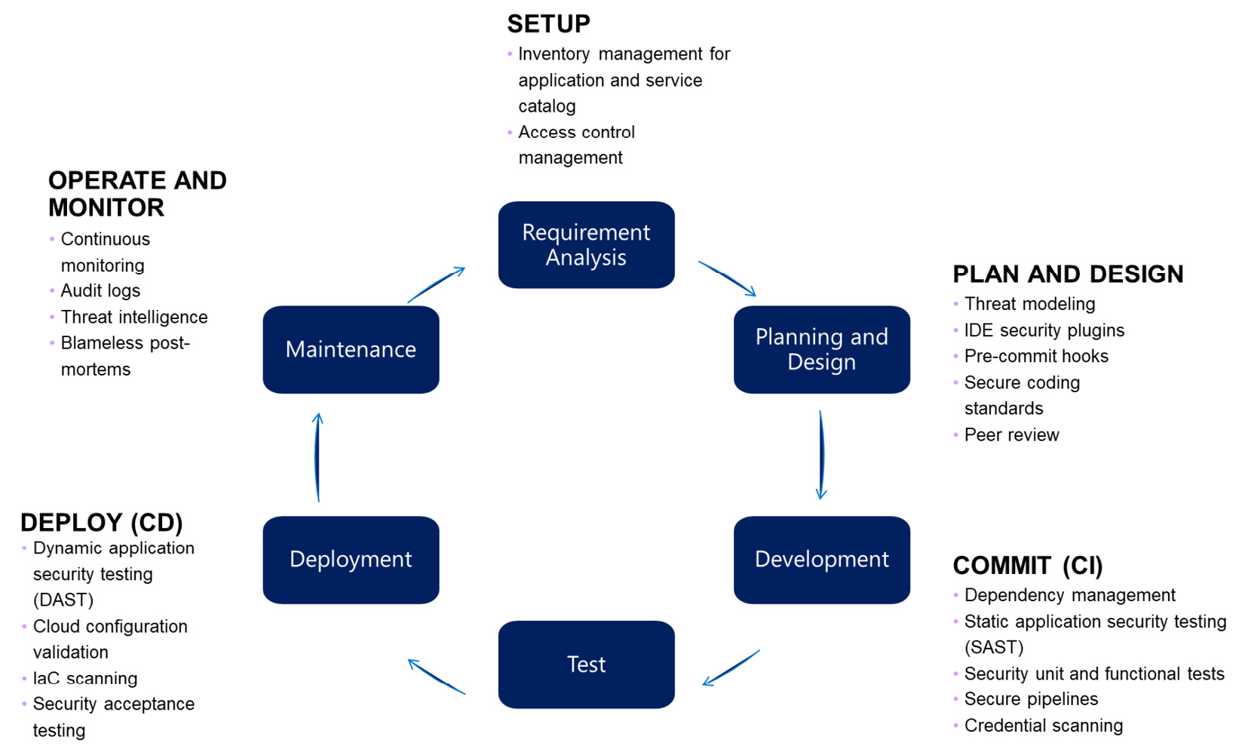

Figure 7.1 – Security in SDLC

These steps and activities and their continuous improvements build up the ****security development life cycle**** (****SDL****). The SDL is a software development process that helps developers build and design more secure software that addresses security compliance requirements while reducing development costs. It standardizes security best practices across services and results in delivering more secure products.

Let us have a look at these activities in detail going through the SDLC and, respectively, the security scopes.

## Setup

During the initial phase of the project, we focus on two major security topics:

* ****Inventory Management**** is one of the key elements of security because this catalogizes the applications and services we provide for our customers. It is our ****app catalog**** that contains our applications (****products****) and services (****service trees****) in production and their assets (source code location, released binaries, version numbers, Azure DevOps projects, Azure pipelines, GitHub projects, GitHub workflows, etc.) within our organization. With the help of Inventory Management, we can easily find the application owners of the impacted components in the case of security breaches. Inventory Management is fully automated in organizations with mature DevSecOps processes, which means every time a new project is kicked off, a new catalog item is created that triggers workflows to spin up Azure DevOps or GitHub projects, Git repositories, Microsoft Entra ID groups, service principals, self-hosted agents, pipelines, and so on.
* ****Access control management**** refers to the access to the application artifacts and, respectively, the underlying DevOps tools from an engineering perspective. We need to define the framework and the ****identity and access management**** (****IAM****) solution that we will use to give access to product owners, engineers, testers, architects, release managers, and ops teams while they interact with development projects. We also need to define how we are going to deal with conditional access policies, such as enforcing ****multi-factor authentication**** (****MFA****) when accessing production environments, and to which extent we are going to work with privileged identities in ****privileged identity management**** (****PIM****), for instance, to provide just-in-time privileged access to Microsoft Entra ID and Azure resources for high privileged users or global administrators. When PIM is enabled, these highly privileged activities are monitored and audited, too. It is worth noting that this access control is not the one that our application or service to be developed will use for authentication and authorization.

## Plan and Design

After setting up the project with the appropriate access rights and Inventory Management in place, we delve into the *Plan and Design* phase from a security perspective:

* ****Threat modeling**** is used to identify threats to our systems through the view of potential attackers and their probabilities and impacts on our applications before implementing any mitigation. It is a typical risk management process focusing on security. There are several tools available on the market to model threats, such as the ****Microsoft Threat Modeling Tool**** (see the *Further reading* section). As part of the sprint planning process, we can conduct threat modeling exercises, and, based on the risk analysis, we can decide whether we should mitigate certain threats and introduce those activities as product backlog items marked with the security category.
* ****Secure coding standards**** are used to define the security coding standards based on our programming languages and technology stacks in our coding guidelines. Nowadays, static code analysis tools can check that our code changes are aligned with our security coding standards in a fully automated way. In C#, for instance, one of the often-used security standards is to use the ****SecureString**** type to handle credentials in our code.
* ****The peer review guide**** is used to lay down the peer review process: when and how often they will be executed and whether we will involve security experts in the process or not. Nowadays, DevOps processes already prescribe code reviews in case of any pull requests, and DevOps tools support and document the findings in detail.
* ****Pre-commit hooks**** define what kind of security checks we perform before committing code changes to repositories, for instance, checking commits for secrets before they reach our repositories. Pre-commit hooks can execute only a small subset of static code analysis rulesets because of time constraints, but they are essential parts to immediately block commits to prevent security breaches. We can use ****IDE security plugins**** to execute lightweight security analysis locally.

## Commit (CI)

After passing the pre-commit hooks and code review results, the next phase is to execute the CI build and the related security activities as part of the pull request validation process:

* ****Dependency management****: Nowadays, custom-developed applications heavily rely on open source packages. On average, 90% of the code in current applications contains components based on external packages or libraries. The term ****software supply chain management**** is very often used, since those packages that we use in our applications also use other third-party components that also use other packages, and the chain goes on in that way. Identifying and exposing vulnerabilities in those third-party packages makes our applications vulnerable unless we refresh our supply chain. Tools such as ****GitHub Dependabot**** can identify the vulnerabilities in our supply chain (*inherited vulnerabilities*) and automatically create Dependabot alerts with pull requests to submit the changes back to our main branches. Dependabot checks can be executed during CI builds.
* ****Static application security testing**** (****SAST****): This is static code analysis and code scanning for security. There are several tools available on the market that we can use to perform such analyses on our code base, such as SonarCloud, Fortify, or GitHub Advanced Security with CodeQL. These tools can be integrated into our CI pipelines for further customization. The output of static code analysis results are ****Static Analysis Results Interchange Format**** (****SARIF****) open standard data. Code scanning alerts are automatically created based on SARIF results and they can be tracked as backlog items. In the case of the GitHub Enterprise version with Advanced Security, we have also the possibility to use GitHub Copilot to fix our security issues fully automated.
* ****Security unit and functional testing****: These are other ways to maintain the high quality of our code base and to avoid implementing security vulnerabilities.
* ****Secure pipelines****: We need to cautiously care about our automated pipelines from a security point of view: who can access which pipeline, where the pipeline secrets are stored (Azure Key Vault), and whether we can use managed identities to execute workflows because insecure CI/CD pipelines can lead to credential leakage or even to execute malicious code in production environments. During CI builds, so-called ****software bills of materials**** (****SBOMs****) are created to track the components used in the build pipeline. An SBOM is a list of software components with their hierarchical relationships, version numbers, dependencies, and license requirements, usually in JSON format, that build up the application. SBOMs help with the transparency and provenance claims for our supply chain and help with conformance enablement. Hosted pools can be used to build and sign the code, ensuring build integrity and component governance. After a successful build, the code is stored in a secure artifact storage.
* ****Credential scanning****: We can use tools to scan our code base for plain text credentials to lower the risk of credential stealing.

## Deploy (CD)

In this stage, we look at the overall health of the code base, in addition to the items checked in the Commit stage (which can be repeated in the deploy stage as well). We introduce additional security checks during the release process:

* ****Dynamic application security testing**** (****DAST****) is a technique used to evaluate the security of a software application in its running state. It involves the use of DAST tools to conduct simulated cyber-attacks on web applications while they are operational, identifying vulnerabilities such as SQL injection, cross-site scripting, and insecure configurations. This form of security testing emulates the actions of a malicious attacker to uncover security weaknesses within the live application, enabling developers to address these issues prior to the application’s release to the public.
* ****Cloud configuration validation**** is the process of verifying that the configuration of cloud resources is correct, secure, and compliant with best practices and policies. This can be done through automated tools that scan the configuration files and settings of cloud resources and report any issues or violations (such as configuration changes in production, and discrepancies between the IaC scripts and the running configuration). Validation can help prevent misconfigurations, security vulnerabilities, and compliance issues, and ensure that cloud resources are set up and managed correctly.
* ****Infrastructure-as-code**** (****IaC****) ****scanning**** is the process of analyzing IaC files for security vulnerabilities, misconfigurations, and compliance with best practices and policies. IaC scanning tools can detect policy violations and suggest fixes for any violations detected. Even LLM-based tools can be used to prompt a GPT-4 model to detect policy violations in IaC files and suggest fixes for any violation detections. The violations and fixes are reported in a SARIF file.
* ****Security acceptance testing**** is the process of verifying that a system meets the defined security requirements and standards before it is released or deployed. This type of testing is typically performed on new systems, upgrades, or deployments and includes the testing of information security requirements and adherence to secure system development practices. Acceptance testing activities may be performed on individual components or integrated systems, and validation activities may be performed using test environments to ensure that the system will not introduce vulnerabilities. Care must be taken when selecting test data or data from information systems that are operational to ensure that no personally identifiable information, secret data such as passwords, or hashes are captured in that dataset.

After successful deployments to test and later to production environments, the SBOM and evidence storage are used to track the releases.

## Operate and Monitor

In this stage, after successfully releasing our application to production, we need to focus on the following security-infused activities:

* ****Continuous monitoring**** is the process of continuously tracking, assessing, and reviewing the security controls and risks of an information system. This process helps to ensure that the security controls remain effective over time and that any changes to the system or its environment do not introduce new vulnerabilities. Continuous monitoring can be achieved by automated tools and processes that collect and analyze data from various sources, such as logs, network traffic, and system configurations. This data is then used to identify potential security issues and to generate alerts or reports that can be used to improve the security of the system.
* ****Audit logs**** are monitored for security detections. Admin monitoring and scanning are performed to ensure the security of the system. We can consider the audit logs of our solutions, as our DevOps tools as well. Audit logs are essential to understand and detect changes that might come from suspicious sources.
* ****Threat intelligence**** is the practice of collecting, analyzing, and disseminating information about current and potential cybersecurity threats. It assists organizations in proactively detecting and addressing security threats. Microsoft Threat Intelligence is a cloud service that uses machine learning algorithms on the collected signals globally to detect and mitigate security risks. This infrastructure is used to support Azure services, traditional products, endpoints (devices), and other corporate assets. It is designed to protect the global infrastructure that powers services such as Microsoft Azure and Power Platform. ****Security incident and event management**** (****SIEM****) tools, such as Microsoft Sentinel or Microsoft Defender for Cloud, use audit logs to detect anomalies and unusual patterns by leveraging different machine learning algorithms.
* ****Blameless post-mortems**** are the process of analyzing incidents or failures in a non-punitive manner, with the goal of identifying the root causes and improving systems and processes to prevent similar incidents from happening again. The focus is on learning and improving, rather than assigning blame or punishment. Blameless post-mortems encourage open and honest communication, allowing team members to share their mistakes and learn from them without fear of retribution. This approach fosters a culture of continuous improvement and helps teams to build more resilient systems.

We will see in the upcoming sections which of these activities we can apply for Power Platform solutions and which of these tasks are provided by the ops teams of the Power Platform SaaS offering.

Let’s now move on to the security model of Power Platform and learn about its security design and principles.

# Security model of Power Platform

Microsoft Power Platform runs on Microsoft Azure, and it benefits from all the security PaaS services available in the hyperscaler, such as Microsoft Sentinel, Microsoft Defender for Cloud, the comprehensive audit logs of Microsoft Entra, and much more.

The security model of Microsoft Power Platform is built on the principle of ****least privileged access**** (****LPA****), which facilitates the creation of applications with finer access control levels. Power Platform leverages the Microsoft Identity Platform for the authorization of all API requests, utilizing the widely recognized OAuth 2.0 protocol. Additionally, Dataverse, which serves as the foundational data layer for Power Platform, boasts a comprehensive security model that encompasses security at the environmental level, role-based, and record- and field-level security, security roles, and business units and teams through security groups and application users, as we learned about in *[Chapter 4](https://learning.oreilly.com/library/view/mastering-devops-on/9781835880845/B22208_04.xhtml" \l "_idTextAnchor074)*.

Additionally, Power Platform is built in distinct environments, which are containers of our apps, flows, connections, and other components along with security and data access management capabilities in geographic locations defined at the creation of those environments.

The architecture of Power Platform is based on the zero-trust security principle, the *never trust, always verify* philosophy. A ****zero-trust strategy**** prescribes strict identity verification for every user and device regardless of their location (corporate or external perimeter), and this check happens every time corporate resources are to be accessed. This approach is realized with the help of Microsoft Identity Platform and the capabilities of Microsoft Entra ID. Every call going to Power Platform service endpoints requires a valid access token (bearer token) to get that endpoint executed. On the server side, the access token is sent to the identity provider (to Microsoft Entra ID to check its validity) every time a request hits the endpoints. These digitally signed access tokens contain claims about the caller that are used for authentication and authorization purposes. After identifying our caller, Power Platform will determine its authorization level in conjunction with that endpoint. Here, custom and built-in security roles, the business unit hierarchy, and team assignments are considered application-level authorizations.

The following figure shows the architecture of Power Platform within one Microsoft Azure region:

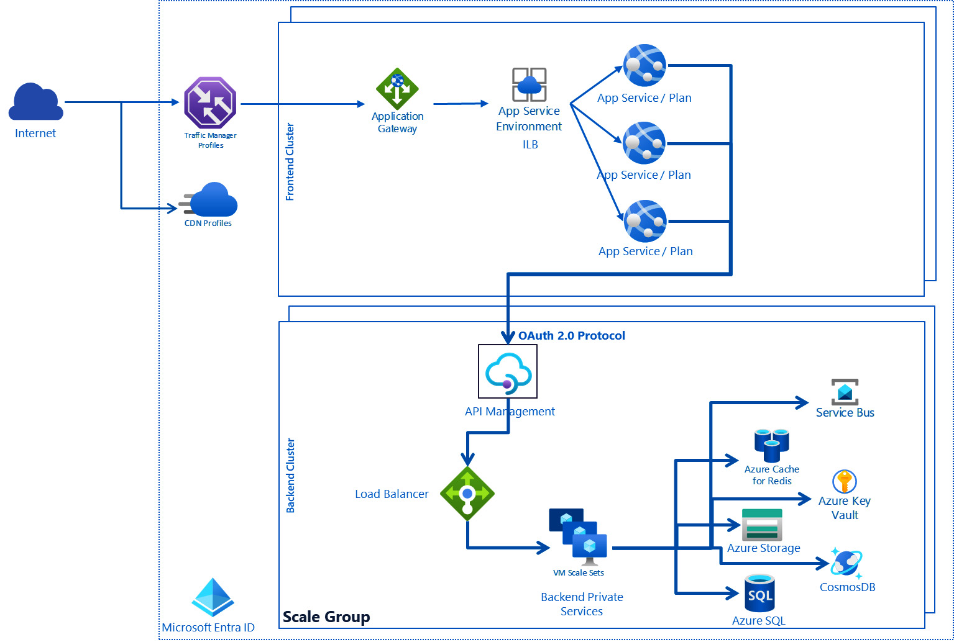

Figure 7.2 – Power Platform architecture

A cluster of web frontend servers contains ASP.NET sites hosted within the Azure App Service Environment. An App Service Environment provides the underlying, dedicated compute units on which App Service Plans are deployed. App Service Plans can host one or more applications (websites). These are part of Azure App Service. When accessing a Power Platform service or app, the client’s DNS is used to direct the request to the closest data center, as determined by Azure Traffic Manager. Azure Traffic Manager provides several options for routing and load-balancing at layer 4 in the OSI model, such as performance routing (closest endpoint by latency), weighted round-robin, and geography-based routing (closest endpoint by geographical location).

The frontend cluster is responsible for handling the sign-in and authentication process. Once a user is verified, they receive a Microsoft Entra ID access token (OAuth2 token). The ASP.NET system examines the token to identify the user’s organization (Azure App Registrations are used internally with the account type *Multitenant* behind the scene). It then communicates with the Power Platform global backend service to inform the browser of the specific backend cluster where the organization’s tenant resides. All further interactions between the client and the backend cluster happen directly, bypassing the web frontend.

For static resources such as JavaScript, CSS, and image files, the browser typically retrieves them from ****Azure Content Delivery Network**** (****CDN****).

The backbone of Power Platform services is running in the ****backend clusters****, which provide service endpoints, background services, databases, caches, and various other elements. The backend clusters span numerous Azure regions. A single region may accommodate multiple clusters (represented as ****Scale Group**** in the previous figure), enabling the Power Platform services to scale horizontally beyond the vertical and horizontal scaling capacities of an individual cluster.

These backend clusters are designed to be *stateful*, hosting the complete dataset for all the tenants they serve. The specific cluster storing a tenant’s data is known as that tenant’s primary cluster. The Power Platform global backend service provides details about a user’s primary cluster to the web frontend cluster, which then directs requests to the appropriate home backend cluster. *Every environment resides within a scale group*, which is a collective infrastructure designed to offer a scalable and maintainable set of resources. A scale group accommodates numerous customer organizations, each possessing its own database while sharing the service infrastructure. This setup leverages a variety of Azure services, such as Azure SQL, Azure Virtual Machines, and Azure Cache for Redis. These scale groups are established in pairs corresponding to the region chosen by the customer. For instance, opting for the United States as the region results in the formation of scale groups in both the West US and East US regions. While tenant metadata and data typically reside within the cluster, there is an exception for data replication to a secondary backend cluster located in a paired region within the same Azure geography. This secondary cluster acts as a contingency during regional disruptions, remaining inactive otherwise. Additionally, microservices dispersed across various machines within the cluster’s virtual network contribute to the backend’s functionality.

DevSecOps processes and activities are realized and operated by the Power Platform product teams, and we embrace those as part of this ****Software-as-a-Service**** (****SaaS****) offering. This means that the product engineering teams have established controls and guardrails starting with Inventory Management, access control, pre-commit hooks, peer review, SAST and DAST analysis, secure pipelines, IaC scanning, and dependency analysis through threat intelligence on their development processes. This approach is audited and certified by third-party independent auditors on a regular basis. During the development process, these teams use Microsoft SDL for coding best practices and threat modeling, too. This leads to the conclusion that we need to focus on only the customization and extensibility points of the platform since these are the places where we can introduce vulnerabilities in our solutions. These include but not limited to the following:

* Environment access management
* Custom-developed ****Power Apps Component Framework**** (****PCF****) components
* Dataverse custom workflow activities and Dataverse web resources (HTML and JavaScript)
* Dataverse configurations and Dataverse custom-developed plugins
* Power Fx expressions
* Power Pages custom code (HTML, JavaScript, and Liquid)
* Our own DevOps processes with automation scripts for CI/CD
* Solution and Inventory Management
* Fusion architecture components in Microsoft Azure

After understanding the security model of Power Platform and the benefits of this SaaS product from a security perspective, let us learn more about the tools we can use for static code analysis, dependency checks, and secret scanning.

# Secret scanning and static code analysis tools

Although there are many other SAST tools on the market, ****GitHub Advanced Security**** (****GHAS****) provides the most comprehensive feature set for static security code analysis together with Copilot security support. GHAS features are the following for private GitHub repositories:

* ****Code scanning**** uses ****CodeQL**** or other tools of your flavor to find vulnerabilities and coding errors. Results are stored in SARIF format, and they are managed at a repository level in GitHub.
* ****CodeQL CLI**** is a standalone tool that we can use to scan our code base for vulnerabilities and coding errors. The ****CodeQL CLI**** is used in conjunction with the previous point (code scanning), or we can use it in other DevOps tools, such as GitLab or Jenkins.
* ****Secret scanning**** looks for secrets, keys, and sensitive tokens in your code base. ****Pre-commit hooks**** are also available to block local commits before reaching the repository and creating a new history record.
* ****Custom auto-triage rules**** assist in orchestrating your ****Dependabot alerts**** on a large scale. With custom auto-triage rules, you can determine which alerts to disregard, postpone, or initiate a Dependabot security update for.
* ****Dependency review**** helps us to catch insecure dependencies before we introduce them in our repositories, and provides information on licenses, dependents, and age of dependencies.

These advanced security features are available in every public GitHub repository without any additional fee.

GHAS for Azure DevOps became generally available in September 2023. The same code scanning, secret scanning, and dependency scanning features are available in this product as in GitHub Enterprise. The GitHub engineering team has shared this feature set with Azure DevOps teams in the same way as, a few years ago, the Azure DevOps team provided the build agent (hosted runners) functionality to the GitHub product group.

*Which tool, when?*

*We can use GHAS for Azure DevOps only for Azure Git repositories. If we have a GitHub repository attached to Azure DevOps pipelines, we need to use GHAS on the GitHub side. Build tasks for GHAS for Azure DevOps will not work.*

GHAS is based on the ****Code Query Language**** (****CodeQL****), which can be used to build up code analysis databases on different programming languages. CodeQL supports C, C++, C#, Java, Go, Kotlin, JavaScript, Python, Ruby, Swift and TypeScript. CodeQL approaches code as data, enabling the discovery of potential security flaws with more assurance than conventional static analysis tools. By creating a CodeQL database that mirrors your code base, you can execute CodeQL queries against this database to pinpoint issues within your code. The query results are shown as *code scanning alerts* in GitHub and Azure DevOps when you use CodeQL with code scanning.

CodeQL creates a relational database under the hood. Every language has its own schema and CodeQL uses ****extractors**** (unique for every language) to read the code files and compiled binaries (except for script languages) and builds up a hierarchical representation of code expressions, abstract syntax tree, data flow graph, and control flow graph. These building blocks are stored in the database and security queries are executed against these tables to find language-specific vulnerabilities and coding errors. CodeQL’s databases are snapshots taken from the time when we executed the analysis. GitHub provides query packs for any supported languages. ****Query packs**** consist of ****CodeQL suites**** (****qls****) that are sets of query language files (****ql files****). These query suites help us to immediately benefit from the security knowledge and expertise of GitHub and to get these code scanning rules executed on our code base. We can also write our own queries using Visual Studio Code and the CodeQL extension and we can derive from existing query suites to introduce our additional checks (the Windows Driver Validation Team did this to introduce their own custom rules: <https://docs.microsoft.com/en-us/windows-hardware/drivers/devtest/static-tools-and-codeql>).

The CodeQL CLI is part of the GHAS offering, and it is free of charge for students and academics. CodeQL CLI as a standalone tool supports macOS, Linux, and Windows operating systems and we can download it as binaries (see the link in *Further reading*).

We can use the CodeQL CLI to execute code analysis even locally, on our Azure DevOps build agents, or on our GitHub runners.

Both Azure DevOps and GitHub offer build tasks and actions around the CodeQL CLI to easily integrate code scanning capabilities in our existing pipelines and workflows:

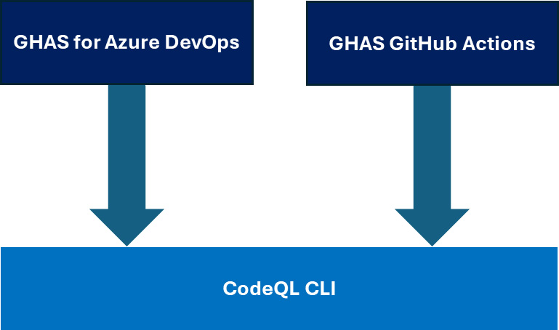

Figure 7.3 – CodeQL CLI wrappers in DevOps tools

Since there are numerous places in Power Platform where we can introduce custom code, it is recommended to have firsthand knowledge of how to use the CodeQL CLI and how to set up pipelines and workflows to execute the different query packs. The best place to [find custom code for Power Platform is the **Pow**](https://github.com/microsoft/PowerApps-Samples)****erApps-Samples**** repository at <https://github.com/microsoft/PowerApps-Samples>. Let us check the custom ****JavaScript**** (****JS****) and ****TypeScript**** (****T********S****) files for vulnerabilities using the following commands in PowerShell (****runcodeql\_javascript.ps1**** in the GitHub repo of this chapter):

1. We can download the CodeQL CLI binaries (see *Further reading* | *CodeQL CLI Binaries*) and add the unpacked folder location to our environment path.
2. We then clone the repo and navigate to the target folder:

****git clone https://github.com/microsoft/PowerApps-Samples****

1. Let us download the query pack for JavaScript and TypeScript:

****codeql.exe pack download codeql/javascript-queries --dir ./codeql-pack/javascript****

1. Let us create our CodeQL database for JavaScript/TypeScript (there is only one extractor for JS/TS in place):

****codeql.exe database create --language=javascript --source-root . codeql-database-js --overwrite****

1. We now execute one of the query suites available in ****codeql-pack**** and export the results in a CSV file:

codeql.exe database analyze .\codeql-database-js .\codeql-pack\javascript\codeql\javascript-queries\0.8.12\codeql-suites\****javascript-code-scanning.qls**** --format=csv --output=results.csv

1. Of course, we can analyze the code and get the results in SARIF format:

****codeql.exe database analyze .\codeql-database-js .\codeql-pack\javascript\codeql\javascript-queries\0.8.12\codeql-suites\javascript-code-scanning.qls --format=sarif-latest --sarif-category=javascript --output=javascript.sarif****

1. We can use ****codeql github upload-results**** to upload our SARIF file to one of our GitHub repositories (we cannot upload back the results to the original repository due to lack of privileges). We need to create a PAT token that grants us access to the repo (****security\_event****):

# Upload results to GitHub repository

$env:GH\_PAT = "ghp\_PAT TOKEN"

$env:GH\_PAT | & codeql.exe github upload-results `

          --repository=ourrepo/test `

          --ref=refs/heads/main `

          --commit 18cd21585b94dd16c48dc13bc1365269696a75a4 `

          --sarif=javascript.sarif --github-auth-stdin

We also need to have a commit hash ID to which we upload the SARIF result.

In the case of C# projects and solutions, the CodeQL commands are a little bit different. For instance, when we need to implement Dataverse plugins, we can use the C# query pack but, in this case, we need also to build our Visual Studio projects during the analysis (see ****runcodeql\_dotnet.ps1**** in the ****Chapter07**** folder of the GitHub repo):

codeql.exe pack download codeql/csharp-queries --dir ./codeql-pack/csharp

codeql.exe database create --language=csharp --source-root . codeql-database ****--command "dotnet build .\dataverse\DiscoveryService\DiscoveryService.sln"**** --overwrite

codeql.exe database analyze .\codeql-database .\codeql-pack\csharp\codeql\csharp-queries\0.8.12\codeql-suites\csharp-code-scanning.qls --format=csv --output=csharp-results.csv

We use the ****--command**** argument to create a database for one or more compiled languages. It expects the ****build**** command that builds our solution, such as ****dotnet build <<path to the sln file>>****. We do not need this option if we are working with Python or TS/JS.

In the case of large code bases, we can use the following tricks to optimize CodeQL run durations:

* ****Query packs****: We can create our own query packs derived from the publicly available ones and we can create our own query suites to focus on different code scanning and security scanning analyses depending on the time we have in our pipelines. For example, during the pull request validation build, we would like to minimize the execution time of the analysis by focusing on the most critical security vulnerabilities, whereas building the main branch would execute every available query suite.
* ****Optional threads parameter in codeql database analyze****: We can use the ****--thread**** parameter if we want to use more than one thread to run queries. The default value is ****1****, which means the analysis runs only in one thread. We can specify more threads to speed up query execution. To set the number of threads to the number of logical processors, we specify ****0**** to this argument.
* ****CodeQL execution targeting only part of our code base****: Ideally, we can have pull request pipelines/workflows that contain not just the trigger condition of whether the pull request happens but also ****path filters**** for the changes in the source code. With that, CodeQL can be executed for only the portion of the code, namely, the area in the source hierarchy that has been changed.

Finally, we delve into the Azure pipeline build tasks available in ****Azure DevOps for GHAS**** (see ****.pipelines/codeql.yml**** in the ****Chapter07**** folder of the GitHub repo):

1. Let us import <https://github.com/microsoft/PowerApps-Samples> into one of our Azure DevOps projects. We need to go to ****Repos**** and click the drop-down list containing all repositories in the project where we will find the ****Import repository**** action item:

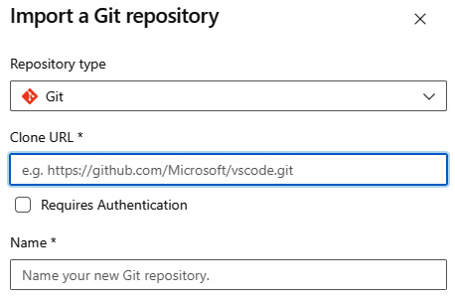

Figure 7.4 – Import a Git repository

Here, we can add the URL to the GitHub public repo and import ****PowerApps-Samples****.

1. Enable the ****Advanced Security**** feature by opening the project settings (project administrator rights are required) and then selecting the recently imported repository. We need to enable ****Advanced Security**** by toggling the button:

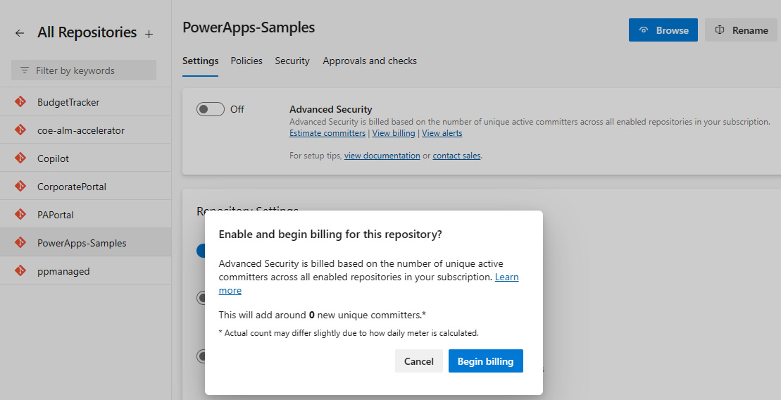

Figure 7.5 – Turning on the Advanced Security feature in Azure DevOps

1. After enabling this security feature, we can navigate to ****Pipelines****, and we can create a new pipeline YAML file that will be stored in the new Git repository.
2. The YAML file should look as follows:

trigger:

- none

pool:

  vmImage: ubuntu-latest

steps:

****- task: PowerPlatformToolInstaller@2****

****inputs:****

****DefaultVersion: true****

****- task: AdvancedSecurity-Codeql-Init@1****

****inputs:****

****languages: 'javascript'****

****querysuite: 'code-scanning'****

****- task: AdvancedSecurity-Codeql-Analyze@1****

****inputs:****

****WaitForProcessing: true****

This YAML file will execute the same CodeQL analysis that we have seen previously with PowerShell for JavaScript via the CodeQL CLI.

1. The code scanning and secret scanning alerts are listed under ****Repos**** in the ****Advanced Security**** tab of Azure DevOps:

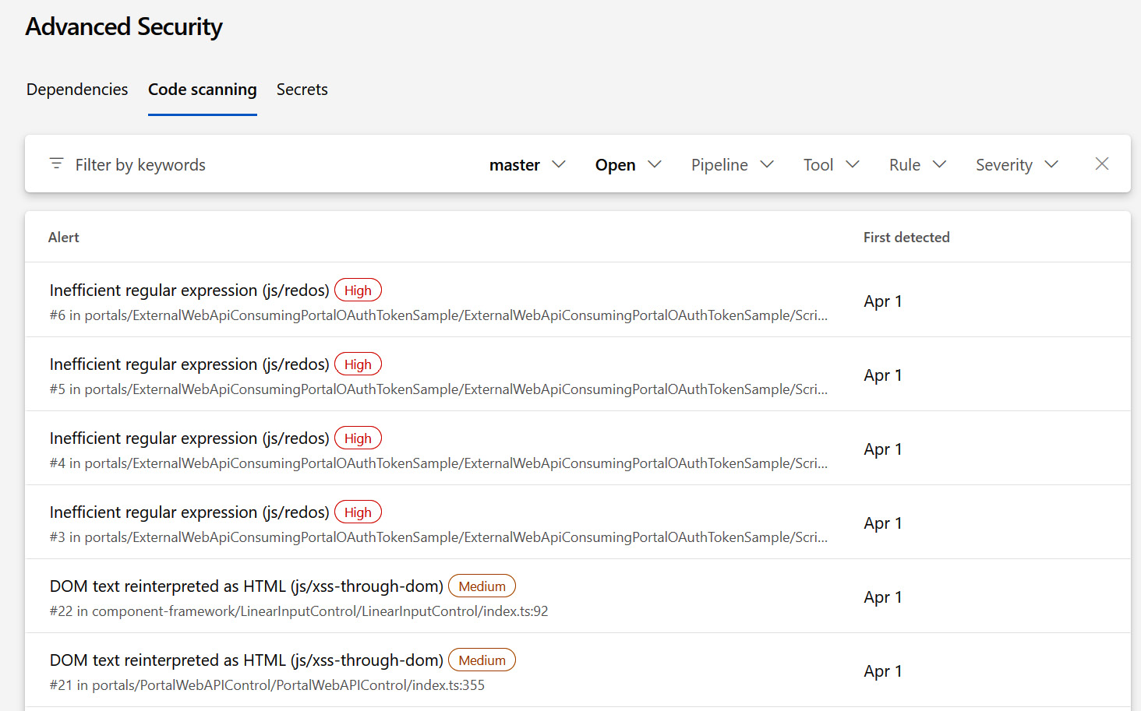

Figure 7.6 – Code and secret scanning results in Azure DevOps

In the case of GitHub, we can apply the same steps by forking ****PowerApps-Samples**** and creating the code analysis-related actions (see ****.github/workflows/codeql.yml**** in the ****Chapter07**** folder of the GitHub repo):

name: "CodeQL"

on:

  workflow\_dispatch:

jobs:

  analyze:

    name: Analyze javascript

    runs-on: ubuntu-latest

    timeout-minutes: 120

    permissions:

      # required for all workflows

      security-events: write

      # only required for workflows in private repositories

      actions: read

      contents: read

    steps:

****- name: Checkout repository****

****uses: actions/checkout@v4****

****- name: Initialize CodeQL****

****uses: github/codeql-action/init@v3****

****with:****

****languages: javascript-typescript****

****build-mode: none****

****- name: Perform CodeQL Analysis****

****uses: github/codeql-action/analyze@v3****

****with:****

****category: "/language:javascript-typescript"****

Using the Azure DevOps pipeline templates and the reusable GitHub workflows, we can easily introduce these additional code scanning and security analysis steps in every project of ours. Fortunately, there is another way to infuse security validation and code scanning checks in Power Platform solutions, which is the ****solution checker****.

# Solution checker

The solution checker embraces the Power Apps checker service to execute code analysis in solutions by submitting jobs for the Power Platform backend. There are predefined ****rulesets**** with ****rules**** to cover certain security recommendations and coding best practices of our solutions. The solution checker can report the found issues in SARIF format, which we can easily upload to our DevOps tools, such as GitHub with GHAS or GHAS for Azure DevOps. The solution checker reviews the following Power Platform assets in unmanaged solutions:

* Dataverse custom workflow activities
* Dataverse web resources (HTML and JavaScript)
* Dataverse configurations, such as SDK message steps
* Power Automate flows (via Power Automate Flow Checker)
* Power Fx expressions (via App Checker – part of the Power Apps checker service)

The rulesets and their rules are predefined and categorized to cover the previously listed components: plug-in or workflow activity, web resources, and canvas app. We can execute the solution checker in multiple ways for unmanaged solutions:

* In the Power Apps maker portal under the ****Solutions**** blade.
* Using the ****pac solution check**** command with the proper parameters, such as the following:

****pac solution check --path c:\Users\Documents\Solution.zip --outputDirectory c:\samplepackage --geo Europe.****

We can also upload our solutions to Blob Storage and use a ****pac solution check**** call on that blob using ****shared access signature**** (****SAS****) tokens.

* Using the PowerShell module, ****Microsoft.PowerApps.Checker.PowerShell****, and respectively the ****Get-PowerAppsCheckerRulesets**** cmdlet for fetching the pre-built rulesets and the ****Invoke-PowerAppsChecker**** cmdlet for submitting the analysis job to the Power Platform backbone. However, these cmdlets are in the pre-release version and they might change.
* Using the ****Power Apps checker web API****: The Power App maker portal, the PAC CLI, and the PowerShell module rely on these REST API endpoints under the hood. We can directly call these endpoints having the appropr[iate access token in place; for instance, the](https://unitedstates.api.advisor.powerapps.com/)US endpoint is reachable under the following URL: [https://unitedstates.api.advisor.powerapps.com](https://unitedstates.api.advisor.powerapps.com/).
* Using ****managed environments**** to enforce solution checker runs before importing solutions to target environments. Here, we can block the import of solutions if violations against these rules are encountered.
* Leveraging the ****build tasks for Azure DevOps**** and ****GitHub Actions for Power Platform****: There are pre-built actions/tasks in both DevOps tools that we can use to execute the solution checker on the appropriate ruleset. The ****ALM Accelerator for Power Platform****, which we discussed in detail in *[Chapter 6](https://learning.oreilly.com/library/view/mastering-devops-on/9781835880845/B22208_06.xhtml" \l "_idTextAnchor103)*, provides pipeline templates that execute solution checker build tasks (****PowerPlatformChecker@2****) during the import process of solutions from Git repositories. This task uses the PAC CLI behind the scenes.

Let us have a look at the build task in Azure pipelines that executes such a static code analysis on our solution (see ****.pipelines/solution-checker.yml**** in the ****Chapter07**** folder of the GitHub repo):

trigger:

- none

pool:

  vmImage: ubuntu-latest

variables:

solutionName: "PacktCopilotSolution"

steps:

- task: PowerPlatformToolInstaller@2

  inputs:

    DefaultVersion: true

- task: PowerPlatformPackSolution@2

  inputs:

    SolutionSourceFolder: '$(System.DefaultWorkingDirectory)/src/$(solutionName)'

    SolutionOutputFile: '$(Build.ArtifactStagingDirectory)/Solution/$(solutionName).zip'

    SolutionType: 'Unmanaged'

****- task: PowerPlatformChecker@2****

****inputs:****

****authenticationType: 'PowerPlatformSPN'****

****PowerPlatformSPN: 'dev-US\_XXX\_Y'****

****FilesToAnalyze: '$(Build.ArtifactStagingDirectory)/Solution/$(solutionName).zip'****

****RuleSet: '0ad12346-e108-40b8-a956-9a8f95ea18c9'****

****ArtifactDestinationName: 'CodeAnalysisLogs'****

Here, we use the unpacked version of a solution in the Git repository, pack that solution as an unmanaged one, and then call the ****PowerPlatformChecker@2**** task to perform the solution check. The ****RuleSet**** GUID is the solution checker ruleset. There is only one other and that is AppSource certification for submitting solutions for Microsoft AppSource. We need to define a service connection, as we did in *[Chapter 6](https://learning.oreilly.com/library/view/mastering-devops-on/9781835880845/B22208_06.xhtml" \l "_idTextAnchor103)*, to connect to an environment because the ****AppChecker**** service job executes solution validations in environments. Although we reference here a local unmanaged solution, that solution is uploaded to the environment before the analysis. The results are not stored in the environment but exported as a SARIF file. The build task also publishes the SARIF result to the artifacts of pipeline results.

In the case of GitHub, we can use the following workflow to achieve the same result (see ****.github/workflows/solution-checker.yml**** in the ****Chapter07**** folder of the GitHub repo):

name: Solution-Checker

on:

  workflow\_dispatch:

jobs:

  solutioncheck:

    runs-on: ubuntu-latest

    env:

     Solution: mpa\_ITBase

    steps:

      - uses: actions/checkout@v3

      - name: Install Power Platform Tools

        uses: microsoft/powerplatform-actions/actions-install@v1

****- name: Pack unmanaged solution****

****uses: microsoft/powerplatform-actions/pack-solution@v1****

****with:****

****solution-folder: ${{ env.Solution }}****

****solution-file: ${{ env.Solution }}\_unmanaged.zip****

****solution-type: Unmanaged****

****- name: Check-solution****

****uses: microsoft/powerplatform-actions/check-solution@v1****

****with:****

****environment-url: https://yourorg.crm.dynamics.com****

****app-id: 862e5a17-d38b-BBBB-FFFF-88a77f59623f****

****client-secret: "${{ secrets.CLIENTSECRET\_DEV }}"****

****tenant-id: 4ae51f31-033a-XXXX-YYYY-5ece14d2c081****

****path: ${{ env.Solution }}\_unmanaged.zip****

The GitHub action, ****microsoft/powerplatform-actions/pack-solution@v1****, also uploads the SARIF result to the artifacts of the GitHub workflow run.

*Managing the findings*

*Whether the solution checker with SARIF results, GHAS, or other code and dependency scanning tools are used to execute SAST, after gathering the results, we also need to manage those findings. We can mitigate these risks by accepting them, such as a security alert in the test code will not be corrected, or we can introduce new issues or work items to update the code according to the finding and respectively the vulnerability described**in the*****Common Weakness Enumeration*****(*****CWE*****) database. Modern DevOps tools support linking the code scanning, dependency scanning, and secret scanning alerts to work items or issues and introduce the demand for fixes in the development life cycle.*

Now we are familiar with the solution checker, the GHAS features, and the tasks in the DevSecOps process related to the SDLC methodology, we now combine this knowledge with the automated DevOps processes from *[Chapter 6](https://learning.oreilly.com/library/view/mastering-devops-on/9781835880845/B22208_06.xhtml" \l "_idTextAnchor103)*.

# Spinning up DevSecOps projects at scale

In *[Chapter 6](https://learning.oreilly.com/library/view/mastering-devops-on/9781835880845/B22208_06.xhtml" \l "_idTextAnchor103)*, we learned how to spin up Power Platform environments with solutions assigned to our Git repositories and, respectively, the underlying branches. We created pipeline templates and reusable workflows in GitHub to provide automations for the following:

* Spinning up new Power Platform developer environments
* Creating service connections to those Power Platform environments
* Exporting solutions from developer environments to Git branches
* Importing solutions from Git repositories and branches to target environments via pull requests or directly to our developer branch

We can take one step forward in this journey and automate the entire development process of Power Platform solutions. First, let us introduce a new term: workload. ****Workloads**** consist of one or more solutions that contribute to each other to implement complex business requirements. We can consider them as the input solutions for package deployer packages, such as the ****Enterprise templates**** we learned about in *[Chapter 4](https://learning.oreilly.com/library/view/mastering-devops-on/9781835880845/B22208_04.xhtml" \l "_idTextAnchor074)*. To set up an enterprise-grade DevSecOps project for workloads or for separate solutions, we need to accomplish the following additional automation tasks:

1. Create AAD groups (Microsoft Entra ID groups) for owners and contributors. There must be at least two owners in the ****Owners**** group. In most cases, we recommend having a budget owner and a technical owner assigned to a project.
2. Create environments for testing and production per each workload or use existing shared environments hosting more solutions for the new one.
3. Create service principals for these environments using ****pac admin create-service-principal**** and the ****System Administrator**** security role. By default, we do not assign any other users from the development team or service accounts to these environments. Depending on the organization, the security group assigned to the environment might be global administrators or the ****Owners**** AAD group created earlier.
4. Create an Azure DevOps project and assign the ****Owners**** AAD group to ****Project Administrators****, whereas assign the ****Contributors**** group to the ****Contributors**** group of Azure DevOps.
5. Create a Git repository for the workload or solution in the Azure DevOps project with branch policies in place.
6. Create service connections for these environments using the service principals that we have created. This is what we did in *[Chapter 6](https://learning.oreilly.com/library/view/mastering-devops-on/9781835880845/B22208_06.xhtml" \l "_idTextAnchor103)*.
7. Create CI/CD pipelines that use pipeline templates available in a separate, dedicated repository and configure them to use those new service connections as parameters.

In the end, we can achieve the following project setup:

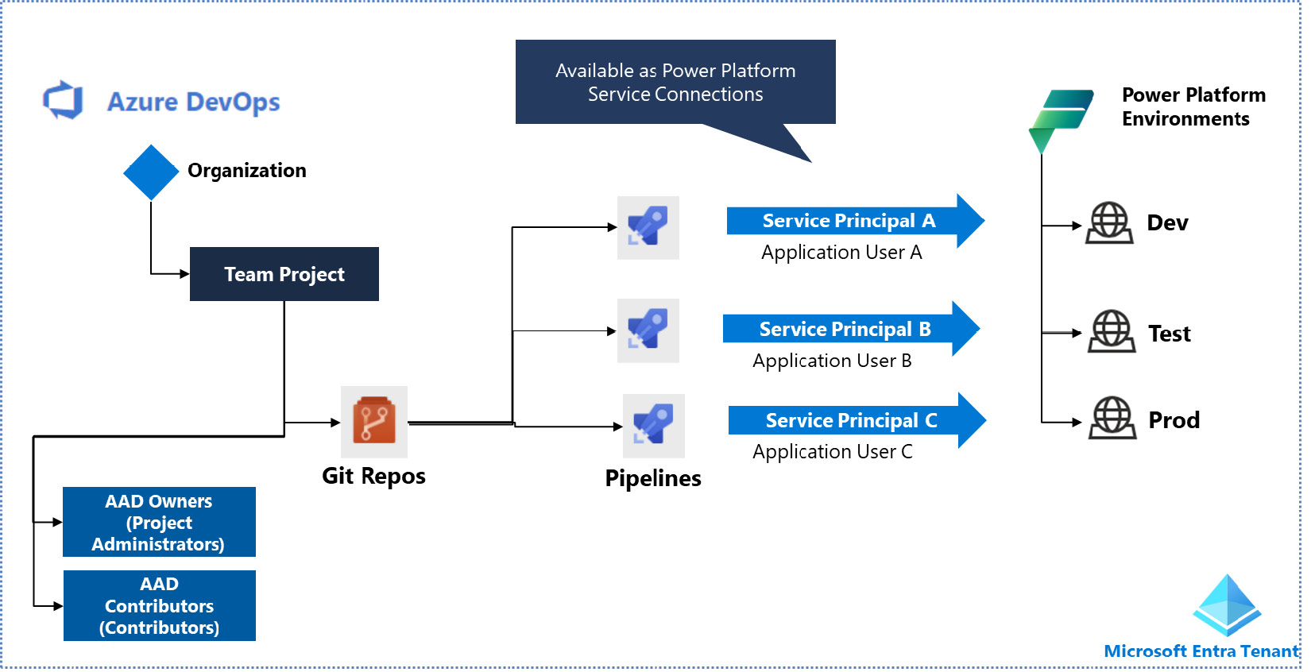

Figure 7.7 – DevSecOps Power Platform project

We can see here the ****Microsoft Entra ID tenant**** as the main glue of our security concept. We give access only to the AAD groups throughout the systems (i.e., for Power Platform and Azure DevOps). Individual user assignments are blocked by policies in both systems. With that, we can guarantee that only the members of the AAD groups (****Owners**** and ****Contributors****) can work on the project. Membership changes are logged into ****Azure Log Analytics workspaces**** and monitored by SIEM solutions, such as Microsoft Sentinel (Threat Intelligence).

We can automate all the previous steps with the help of ****Azure pipelines**** located in a separate Azure DevOps project. Let us see those steps in detail:

1. Create AAD groups:

To create an AAD group, we can use the following script (see ****create-aad-group.sh**** in the ****Chapter07**** folder of the GitHub repo):

#!/bin/bash

set -e

# Variables

SERVICE\_PRINCIPAL\_APP\_ID="<your-service-principal-app-id>"

SERVICE\_PRINCIPAL\_SECRET="<your-service-principal-password>"

TENANT\_ID="<your-tenant-id>"

GROUP\_NAME="<your-group-name>"

# Login as the service principal

****az login --service-principal -u $SERVICE\_PRINCIPAL\_APP\_ID -p $SERVICE\_PRINCIPAL\_SECRET --tenant $TENANT\_ID****

# Create the AAD group

****az ad group create --display-name $GROUP\_NAME --mail-nickname $GROUP\_NAME****

# get the user object id

****AADObjectID=$(az ad user show \****

****--id $userPrincipalName \****

****--query id \****

****--output tsv)****

# add a member to the group

****az ad group member add --group $GROUP\_NAME --member-id $AADObjectID****

The service principal we use here needs to have a privileged administrator role, such as ****User Access Administrator**** in our Microsoft Entra ID tenant, to be able to create AAD groups.

1. Create environments for testing and production:

In *[Chapter 6](https://learning.oreilly.com/library/view/mastering-devops-on/9781835880845/B22208_06.xhtml" \l "_idTextAnchor103)*, we used the ****pac admin create**** commands to create Power Platform developer environments. To create a sandbox or a production environment, we can use the following script (see ****create-powerplatform-env.sh**** in the ****Chapter07**** folder of the GitHub repo):

#!/bin/bash

set -e

# Define environment variables

SERVICE\_PRINCIPAL\_APP\_ID="<your-service-principal-app-id>"

SERVICE\_PRINCIPAL\_SECRET="<your-service-principal-password>"

TENANT\_ID="<your-tenant-id>"

ENV\_NAME="YOUR\_ENV\_NAME"

REGION="YOUR\_REGION"

CURRENCY="YOUR\_CURRENCY"

LANGUAGE="YOUR\_LANGUAGE"

# Login to Power Apps using service principal

****pac auth create --applicationId $SERVICE\_PRINCIPAL\_APP\_ID --clientSecret $SERVICE\_PRINCIPAL\_SECRET \****

****--tenant $TENANT\_ID****

# Create a new environment

****pac admin create --name $ENV\_NAME --region $REGION \****

****--currency $CURRENCY --language $LANGUAGE \****

****--type Production****

****rawOutput=$(pac admin list --name $ENV\_NAME | tail -n 2)****

****environmentId=$(echo $rawOutput | cut -d ' ' -f 2)****

#Enable Managed Environment

****pac admin set-governance-config \****

****--environment $environmentId \****

****--protection-level Standard****

In the case of the production environment, we use the ****pac admin set-governance-config**** command to enable managed environment features.

1. Create service principals for environments:

As we did in *[Chapter 5](https://learning.oreilly.com/library/view/mastering-devops-on/9781835880845/B22208_05.xhtml" \l "_idTextAnchor089)*, we can use the following PAC CLI command to create a service principal assigned to the newly created environments:

****pac admin create-service-principal -env <<URL>> -n VersionControlSPN --role "System Administrator"****

We need to store the application ID, client secret, and tenant ID in a safe location. We can use ****Azure Key Vault**** service to store our secrets, which can be used later in Azure DevOps pipelines with the help of the ****AzureKeyVault@2**** build task.

1. Create an Azure DevOps project:

Here, we need to use a ****personal access token**** (****PAT****) created in Azure DevOps to interact with the Azure DevOps CLI. The PAT token requires more privileges to be able to create a DevOps project in the same organization. These are the scopes that we need to assign to our PAT token:

* + ****Pipeline resources****: Use and manage
  + ****Project and Team****: Read, write, and manage
  + ****Graph****: Read and manage
  + ****Identity****: Read and manage

Azure pipelines also provide a built-in access token on which the pipelines and, respectively, the jobs can execute different tasks. It is called ****System.AccessToken**** and we can refer to this token to perform administrative or organization-wide actions. With this approach, we can eliminate the use of personal access tokens and we can grant access rights and privileges for the build service account at the collection level. For this, we need to disable the ****Limit job authorization scope to current project for non-release pipelines**** and ****Limit job authorization scope to current project for release pipelines**** options under ****Project Settings**** in the pipeline’s ****Settings**** blade in the project that will host our management pipelines, as the following figure shows:

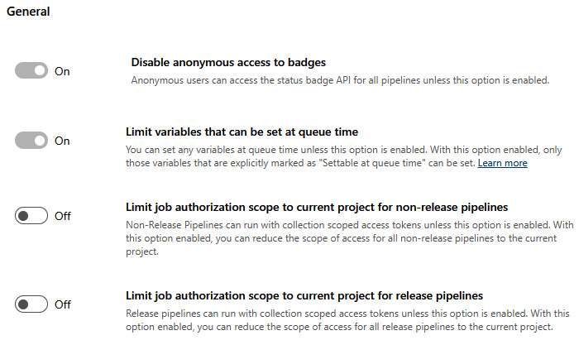

Figure 7.8 – System.AccessToken: project versus organization scope

If these toggle buttons are disabled, then we need to turn them off at the organization level. Finally, we need to grant permission to the ****Project Collection Build Service (organization)**** user to allow the ****Create new projects**** and ****Edit instance-level information**** permissions. After this, we can use the ****$(System.AccessToken)**** system variable in our pipelines to execute the following script (see ****.pipelines/setup-azure-devops-project.yml**** in the ****Chapter07**** folder of the GitHub repo):

****echo $(System.AccessToken) | az devops login --organization $(System.CollectionUri)****

****az devops project create --name ${{ parameters.projectName }} --org $(System.CollectionUri)****

****aadAdminGroupId=$(az ad group show --group $(AADGroupForAdmin) --query id -o tsv)****

echo "Admin group id: $aadAdminGroupId"

****azureDevopsAdminGroupDescriptor=$(az devops security group list --organization $(System.CollectionUri) --project ${{parameters.projectName}} | jq -r '.graphGroups[] | select(.displayName=="Project Administrators") | .descriptor')****

echo "Azure DevOps Admin Group Descriptor: $azureDevopsAdminGroupDescriptor"

# Add the AAD group to the Administrators groups in Azure DevOps

collectionUri=$(System.CollectionUri)

orgnamewithouthttps=${collectionUri//https:\/\//}

****curl -u :$(System.AccessToken) \****

****-H "Content-Type: application/json" \****

****-d "{\"originId\": \"$aadAdminGroupId\"}" \****

****"https://vssps.$ orgnamewithouthttps /\_apis/graph/groups?groupDescriptors=$azureDevopsAdminGroupDescriptor&api-version=6.1-preview.1"****

Unfortunately, we need to call the REST API endpoint of Azure DevOps to add our AAD group to the *Project Administrators* group of Azure DevOps because the ****az devops security group membership add --group-id $azureDevopsAdminGroupId --member-id $aadAdminGroupId --org $(System.CollectionUri)**** command doesn’t work across projects.

1. Create a Git repository:

When creating a new Azure DevOps project, a default Git repository with the name of ****project**** and a default team is created. To create a repository, we can use the ****az repos create**** command with the appropriate parameters. We need the following variables in our Bash script:

# Variables

organizationURL="<Your-Azure-DevOps-Organization-URL>"

project="<Your-Azure-DevOps-Project>"

repository="<Your-New-Repository-Name>"

pat="<Your-Personal-Access-Token>"

This enables us to use the following command to create a new repository:

****repositoryId=$(az repos create --name $repository --organization $organizationURL --project $project --detect false | jq -r .id)****

We need to initiate the repository with the first commit by creating the ****main**** branch:

organizationName=$(basename $organizationURL)

****git clone https://$organizationName@dev.azure.com/$organizationName/$project/\_git/$repository****

cd $repository

****git checkout -b main****

echo "# $repository" >> README.md

****git add .****

****git commit -m "Initial commit"****

****git push -u origin --all****

Finally, we can create a ****branch policy**** to protect our ****main**** branch from direct commits by introducing the check for linked work items on pull requests (see ****create-gitrepo-and-branch-policy.sh**** in the ****Chapter07**** folder of the GitHub repo):

****az repos policy work-item-linking create**** \

****....--branch "refs/heads/main" \****

****--enabled true --organization $organization --project $project \****

****--repository $repositoryId --blocking true --detect false****

1. Create service connections for Power Platform environments:

We did this exercise in *[Chapter 6](https://learning.oreilly.com/library/view/mastering-devops-on/9781835880845/B22208_06.xhtml" \l "_idTextAnchor103)*, in the *Branches and environments* subsection.

1. Create CI/CD pipelines on pipeline templates:

To create an Azure pipeline that uses a pipeline template from a different Git repository in a different Azure DevOps project, we can use the ****resources**** keyword in our pipeline YAML file to specify the repository containing the template. Then, we can reference the template in our pipeline. Here is an example for this (see ****.pipelines/azure-pipelines-using-template.yml**** in the ****Chapter07**** folder of the GitHub repo):

****resources:****

****repositories:****

****- repository: templates****

****type: git****

****name: OtherProject/TemplateRepo****

****ref: refs/heads/main****

****endpoint: MyServiceConnection****

steps: #or stages:

- template: .pipelines\ include-paccli-steps.yml@templates

In this example, ****OtherProject/TemplateRepo**** is the name of the other project and the repository containing the template. ****my-template.yml**** is the name of the template file in the other repository. ****@templates**** at the end of the template line is a reference to the templates repository defined in the ****resources**** section. We need to have sufficient permissions to access the other project and repository. Also, if the other repository is private and located in a different DevOps organization, we need to create a service connection in Azure DevOps to authenticate to the repository and to provide it as an endpoint, highlighted in the script. We can use the Azure DevOps CLI to create a pipeline. However, the Azure DevOps CLI does not currently support defining the pipeline configuration directly in the command. We need to have a YAML file that defines the pipeline configuration, and then we can use the following command to create the pipeline based on that YAML file:

****az pipelines create --name "MyPipeline" --repository "MyRepo" --branch main --yml-path "azure-pipelines.yml" --organization "https://dev.azure.com/MyOrganization" --project "MyProject"****

This command assumes that the YAML file is in the root of the repository. If the YAML file is in a different location, we need to specify the path relative to the root of the repository in the ****--yml-path**** option. To create these YAML files, we can use the previously discussed Git commands to commit the baseline pipelines that already refer to the pipeline templates that are enriched with secret scanning and static code analysis.

At the end of these steps, we have the new Azure DevOps project and the new Git repository with pipelines in place that use the service connections to connect to the Power Platform environments and leverage pipeline templates located in a centralized repository governed by Microsoft Entra ID.

We can realize the same approach in GitHub. The only difference here is that we need to configure our GitHub organization to use Microsoft Entra ID through the ****SAML protocol****. GitHub can provision enterprise accounts with the help of a ****system for cross-domain identity management**** (****SCIM****) configuration. This means we can add Microsoft Entra ID accounts to GitHub Enterprise organizations and, respectively, repositories, and those users can sign in.

*Microsoft Entra ID*

*Regarding**the DevOps tools we use, the main security takeaway is that we need to embrace Microsoft Entra ID accounts and, respectively, groups to manage access to projects, repositories, pipelines, work items, workflows, and so on. From the administration perspective, we want to manage only memberships of Entra ID groups to grant or remove access to DevOps services and we do not allow individuals account-level access to our services.*

Of course, there are many other tasks that we can introduce in our development life cycle stages. One of the most crucial activities is Inventory Management as discussed in the *Setup* section of this chapter. Inventory Management can be realized within Power Platform on Dataverse as well. The setup of new development projects can be managed with the help of Power Automate cloud flows that execute those previously discussed Azure DevOps pipelines behind the scenes. The Inventory Management repository can store the metadata about our projects, such as who the owners are, where the source code/solution packages are located, which Entra ID groups are created, which Power Platform environments are spun up, and so on.

However, as illustrated in the following figure, there are numerous additional tasks, including those activities we discussed at the beginning of the chapter in conjunction with custom development projects, that occur at different stages of the SDLC of Power Platform solutions:

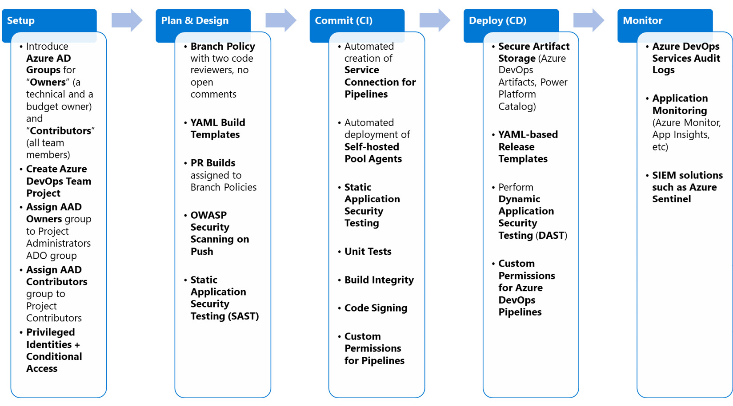

Figure 7.9 – DevSecOps activities in Power Platform solutions

For instance, we can introduce more security analysis tasks in our pipelines, such as using GHAS or CodeQL for SAST, we can create our own build farms for our dedicated builds, apply code signing for our binary components or even for our Power Apps native mobile apps (wrap the app), perform DAST, execute test automation during CI/CD steps, and also set up advanced monitoring to read and analyze the DevOps audit logs or even the application logs. This is only the tip of the iceberg since projects and organizations are continuously improving their DevSecOps practices and, with that, their security postures as well.

We now delve into our final topic, the security of our established DevOps processes.

# Security of DevOps processes

Creating DevSecOps processes and setting up whole development projects fully automated from scratch is necessary to infuse security tasks in every phase and stage of the development life cycle. On the other hand, we need to consider our established DevSecOps processes for security vulnerabilities and the attack surface as well. In the previous sections, we have seen that with the help of Microsoft Entra ID groups, we can control and guardrail access to our running projects, but it is only one of the first steps to create more secure methods in those processes. We need to continuously monitor the activities of our engineers and DevOps teams, such as accessing repositories and executing workflows/pipelines by logging them to Log Analytics workspaces. We can then use threat intelligence tools such as Microsoft Azure Sentinel to discover unusual patterns throughout the application life cycle. We can also create threat models using Microsoft’s Threat Modeling Tool on our own CI/CD pipelines to play around with security scenarios, such as how to avoid vulnerable code injections through DevOps tools, or how to avoid granting access to a developer in production environments via DevOps pipelines or GitHub workflows from risk and probability perspectives.

Mission-critical workloads operating in highly regulated industries and environments, such as the US government cloud or deployments in the financial sector, require even more guardrails in place. We can fully isolate Power Platform development tenants from production ones. The handover between these separate tenants can happen through ****Azure Service Bus**** or other messaging queue services, as the following figure shows:

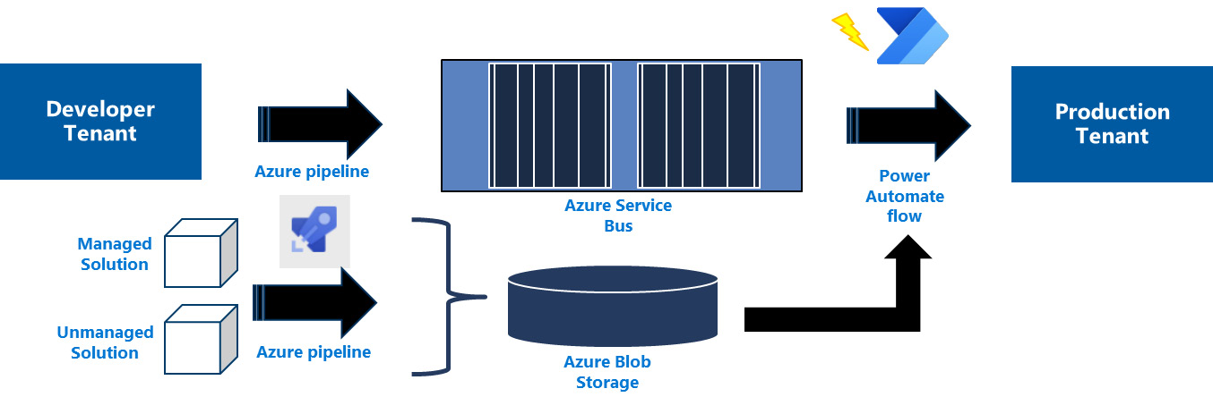

Figure 7.10 – Isolated tenants

On the development side, Azure pipelines or GitHub workflows build the managed and unmanaged solutions and place them in Azure Blob Storage. They also queue new messages in the message queue that contain the metadata information about the deployment, such as which solution from which blob container with which version the production side pipelines should deploy to. They also contain the SAS tokens to access Blob Storage from the production tenant. On the production side, Power Automate cloud flows pick up the queue message triggered by the Service Bus condition and execute the deployment based on the queue message to the targeted environments. With that, there is no direct, synchronous connection between development and production tenants. We apply the ****asynchronous design pattern**** here (pulling model) to terminate the original synchronous deployment call to our production environment.

# Summary

In this chapter, we explored the DevSecOps process, delving into its evolution, the concept of a shift-left mindset, and the integration of security tasks within our SDLC. We then acquainted ourselves with the security architecture and guiding principles underpinning Power Platform. Our journey continued with an examination of GHAS, leveraging CodeQL to conduct SAST. We also investigated the solution checker, utilizing Azure DevOps build tasks and GitHub Actions to perform the platform’s built-in analysis. Our deep dive extended into the realms of the Azure CLI, Azure DevOps scripts, pipelines, and pipeline templates, enabling us to construct an Azure DevOps project embedded with security from the ground up in a fully automated manner. Lastly, we dedicated time to understanding the security threats that could potentially compromise our DevOps pipelines or workflows and discussed strategies to mitigate these risks.

In the next chapter, we will craft a tangible solution, applying every aspect of DevOps and ALM through practical, hands-on walkthroughs.

# Further reading

* DevSecOps controls: <https://learn.microsoft.com/en-us/azure/cloud-adoption-framework/secure/devsecops-controls>
* ****Security Development Life Cycle**** (****SDL****) Practices: <https://www.microsoft.com/en-us/securityengineering/sdl/practices>
* Threat Modeling: <https://www.microsoft.com/en-us/securityengineering/sdl/threatmodeling>
* Microsoft threat modeling tool: <https://aka.ms/threatmodelingtool>
* GitHub Dependabot: <https://docs.github.com/en/code-security/dependabot>
* CodeQL: <https://docs.github.com/en/code-security/code-scanning/introduction-to-code-scanning/about-code-scanning-with-codeql>
* Security in Power Platform: <https://learn.microsoft.com/en-us/power-platform/admin/security/overview>
* GitHub Advanced Security for Azure DevOps: <https://azure.microsoft.com/en-us/products/devops/github-advanced-security>
* CodeQL CLI binaries: <https://github.com/github/codeql-cli-binaries>
* CodeQL query packs: <https://github.com/github/codeql>
* CodeQL analysis: <https://docs.github.com/en/code-security/codeql-cli/getting-started-with-the-codeql-cli/preparing-your-code-for-codeql-analysis>
* Solution checker: <https://learn.microsoft.com/en-us/power-apps/maker/data-platform/use-powerapps-checker>
* PAC CLI for solution checker: <https://learn.microsoft.com/en-us/power-platform/developer/cli/reference/solution#pac-solution-check>
* Microsoft.PowerApps.Checker.PowerShell module: <https://learn.microsoft.com/en-us/powershell/module/microsoft.powerapps.checker.powershell/invoke-powerappschecker?view=pa-ps-latest>
* System access token: <https://learn.microsoft.com/en-us/azure/devops/pipelines/process/access-tokens?view=azure-devops&tabs=yaml>
* Work item branch policy: <https://learn.microsoft.com/en-us/rest/api/azure/devops/policy/configurations/create?view=azure-devops-rest-7.1&tabs=HTTP#work-item-policy>
* GitHub enterprise accounts: [https://docs.github.com/en/enterprise-cloud@latest/admin/managing-your-enterprise-account/about-enterprise-accounts](mailto:https://docs.github.com/en/enterprise-cloud@latest/admin/managing-your-enterprise-account/about-enterprise-accounts)

# 8

# Demonstrating ALM and DevOps Implementation

In this chapter, we will go through a hands-on exercise involving a real-world example, with code snippets and step-by-step instructions. We will use one of the templates available in the ****Power Platform Enterprise template**** to demonstrate the end-to-end scenario of DevOps processes. This template is the ****Employee Kudos template****, which we can use to praise others for their outstanding achievements. The available solution provides a model-driven application (****Kudos Administration App****) to administer the kudos, opt out users, and create badges that can be used in the canvas app to fill out the kudos. This latter canvas app, called the ****Kudos App**** in the solution, provides a user interface for users in an organization. Since the Kudos solution depends on the ****Employee Experience Base**** solution, we will learn how we can manage two solutions simultaneously by introducing multiple ****GitHub workflows**** in the release train and leveraging the deployment package. We will define the branch strategy for this application, and we will delve into the different GitHub workflows with ****DevSecOps**** tasks to manage the development of these solutions. We will introduce backlog management and use the branch policies to protect our main branch from accidental changes. We will create tests for the Kudos app and introduce ****monitoring**** to our app and flows. Finally, we will learn about ****feature flags**** and how we can use them to enable or disable certain features in our applications.

In this chapter, we are going to cover the following main topics:

* Exercise – repository management and branch strategies for the applications
* Exercise – building CD pipelines and a release train
* Exercise – backlog management in GitHub
* Exercise – testing solutions
* Exercise – monitoring applications
* Exercise – introducing feature flags

# Technical requirements

To delve into the details of DevSecOps approaches and tools, we need to have the following:

* ****A Microsoft Azure subscription****: We can sign up for a Microsoft Azure subscription through <https://azure.microsoft.com/en-us/free>. If we have a Visual Studio subscription or are Microsoft Certified Trainers, we can enroll in an MSDN-based subscription with a 150 USD monthly credit.
* ****A Power Platform subscription****: We can sign up for a Power Apps Developer Plan (<https://www.microsoft.com/en-us/power-platform/products/power-apps/free>), if we already have a Microsoft Entra ID work account, or we can join the Microsoft 365 Developer Program (<https://developer.microsoft.com/en-us/microsoft-365/dev-program>).
* ****A GitHub handle and a public repository****: (<https://github.com/signup>)
* ****GitHub Advanced Security features**** are available for free for public repositories: <https://docs.github.com/en/get-started/learning-about-github/about-github-advanced-security#about-advanced-security-features>.
* ****Samples and walkthroughs**** are discussed in this chapter and are located at <https://github.com/PacktPublishing/Mastering-DevOps-on-Microsoft-Power-Platform/tree/main/Chapter08>.
* ****The Azure CLI****: We can install the Azure CLI directly on our machine by following the installation guide (<https://learn.microsoft.com/en-us/cli/azure/install-azure-cli#install>), or we can use ****Azure Cloud Shell**** from the Azure portal to get an interactive Bash or PowerShell session.
* ****GitHub Codespaces****: GitHub provides 60-hour computing resources each month to individuals for free. To create and start GitHub Codespaces, it is enough to have a ****GitHub handle****.
* ****The GitHub CLI****: We can install the GitHub CLI locally from <https://cli.github.com/>, or we can use GitHub Codespaces to start our development container under the chapter’s GitHub repository at ****.devcontainer/devcontaine********r.json****.

# Exercise – repository management and branch strategies for the applications

Before we delve into the hands-on exercises, it is worth getting familiar with the Kudos app of the Power Platform Enterprise template. We can learn more about this solution by visiting the official documentation of the enterprise template: <https://learn.microsoft.com/en-us/power-platform/enterprise-templates/hr/employee-kudos/install-and-set-up>. The source code of this solution we have prepared in the repository provided with the book contains the additional extensions and workflows we will use throughout the exercises.

In this exercise, we are going to create a public ****GitHub repository**** that will host our applications available in the chapter’s own GitHub repository, and we are going to set up our branch strategy and create the prerequisites to be able to deploy the Kudos app in our Power Platform production environment. We will take the following steps:

|  |  |
| --- | --- |
| ****Step**** | ****Description**** |
| 1. | Clone the sample repository in our own GitHub public repository. |
| 2. | Create our Power Platform production environment that will host the Kudos app and the service principal that we will use in GitHub workflows. The credentials of the service principal are stored in GitHub secrets. |
| 3. | Create a Microsoft Entra ID Group (Azure AD group) that will contain the users who can use the application. |
| 4. | Create the connections of the Kudos app in the production environment. |
| 5. | Create the deployment setting file to manage the connection references in the CI/CD workflows, and execute the ****Release to Production**** flow to deploy Kudos app in the production environment. |
| 6. | Define our branch strategy based on the GitHub flow. |
| 7. | Create our first branch protection rule to enforce pull requests on main. |

Table 8.1 – Steps for the exercise

To simplify the script executions in the upcoming steps and sections, we will use ****GitHub Codespaces****. GitHub Codespaces provides computing resources and developer containers that are hosted in the GitHub cloud. We have prepared such a container with various tools, such as the GitHub CLI, ****Git CLI****, ****PAC CLI****, and Azure CLI, which are already pre-installed on it. Its configuration is located directly at <https://github.com/PacktPublishing/Mastering-DevOps-on-Microsoft-Power-Platform/blob/main/.devcontainer/devcontainer.json>.

To start the container, we need to navigate to the book’s GitHub repository in the web browser (<https://github.com/PacktPublishing/Mastering-DevOps-on-Microsoft-Power-Platform>) and click on the ****Code**** button and then the ****Create codespace on main**** button, as shown in the following figure:

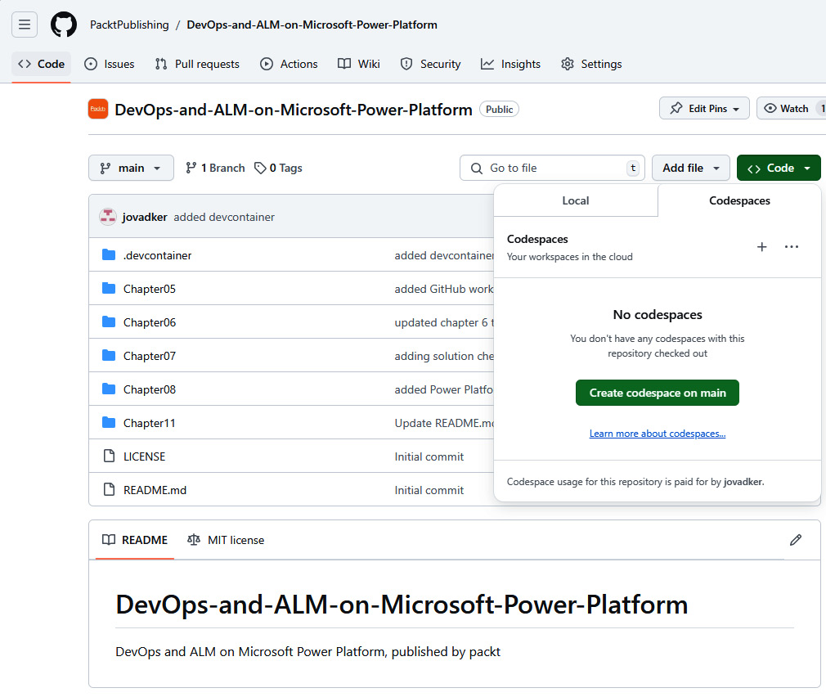

Figure 8.1 – Creating a codespace in GitHub

After clicking the button, the ****devcontainer.json**** file available under the ****.devcontainer**** folder is parsed, and based on that configuration, a new ****Docker image**** is created in the background. This image will run as a container, and in a new browser, Visual Studio Code will soon appear, having pre-installed the features described in the JSON file:

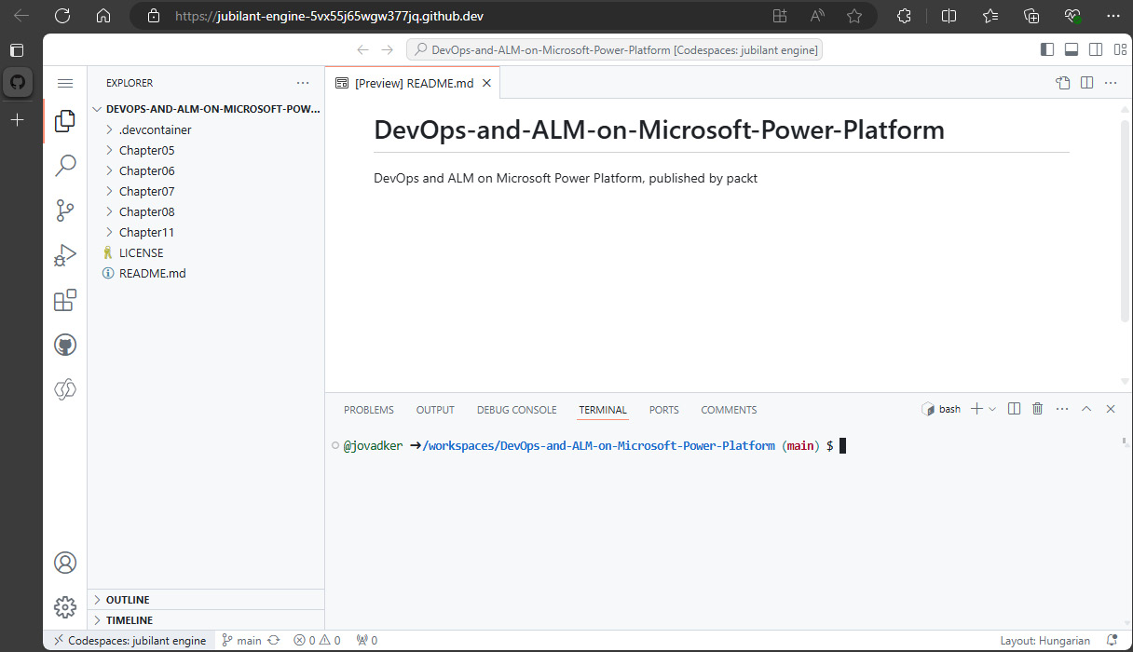

Figure 8.2 – A codespace in a browser

In the terminal window (usually ****Bash****, but ****PowerShell**** is also available) on the screen, we will start the tasks to create our own repository, step by step:

1. ****Create a Git repository in GitHub****: If we want to create a repository in GitHub, we can use the GitHub CLI in the GitHub web portal. The GitHub CLI is an open source tool that provides commands to administer our repositories, start GitHub workflows, authenticate against GitHub APIs, create issues, pull requests and releases, and so on. If we have a ****GitHub Copilot subscription****, then we can use the GitHub CLI with the ****copilot suggest**** or ****copilot explain**** parameters to interact with GitHub Copilot without switching context. ****Gh copilot suggest**** translates our natural language prompt to the correct GitHub CLI command with appropriate parameters, whereas ****gh copilot explain**** describes the command we are interested in by using natural language. We can use the following script to create a repository called ****Kudos**** in our own GitHub Enterprise organization, if available, or using our own GitHub handle after logging in (GitHub Codespaces provides, by default, limited access to GitHub administrative endpoints):

export GITHUB\_TOKEN=

gh auth login

gh auth switch

# move out of the book repoto "/workspaces"

cd ..

gh repo create Kudos --public --clone

The ****clone**** parameter in the command line immediately clones the empty repository to our working folder. Now, we need to copy everything from the ****Chapter08**** folder (<https://github.com/PacktPublishing/Mastering-DevOps-on-Microsoft-Power-Platform/tree/main/Chapter08>) to this new repository and commit those files directly into the main branch. If we don’t use GitHub Codespaces, then we need to clone the ****Mastering-DevOps-on-Microsoft-Power-Platform**** repository with the help of the Git CLI:

git clone https://github.com/PacktPublishing/Mastering-DevOps-on-Microsoft-Power-Platform.git

After cloning, we can copy the files and folder from ****Chapter08**** folder to our ****Kudos**** folder (the git repo):

cp -rT ./Mastering-DevOps-on-Microsoft-Power-Platform/Chapter08/ ./Kudos

Then, we can use the following scripts to add, commit, and push the files to the new repository:

# use the credentials of gh CLI in Git commands

gh auth setup-git

git config --global user.email "ouremail@address.com"

git config --global user.name "Our Name"

git add .

git commit -m "Baseline Kudos app"

git branch -M main

git push -u origin main

With that, we have everything in our new repository that we will use in our hands-on exercises:

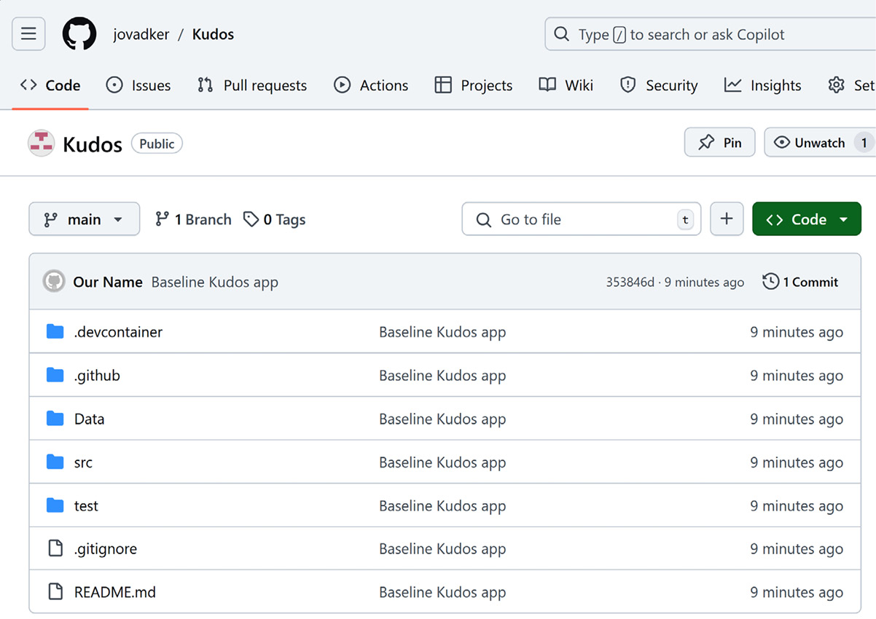

Figure 8.3 – Our own repository with the Kudos app

In our new repository, there is also a ****.devcontainer**** folder containing a GitHub Codespace definition. Here, let’s create our own codespace on the main branch and authenticate against GitHub once again to get write access to the repository:

export GITHUB\_TOKEN=

gh auth login

gh auth switch

In addition, if we have done every preparation step right and if we open up the ****Actions**** tab now, we should see the available GitHub workflows, as shown in the following figure:

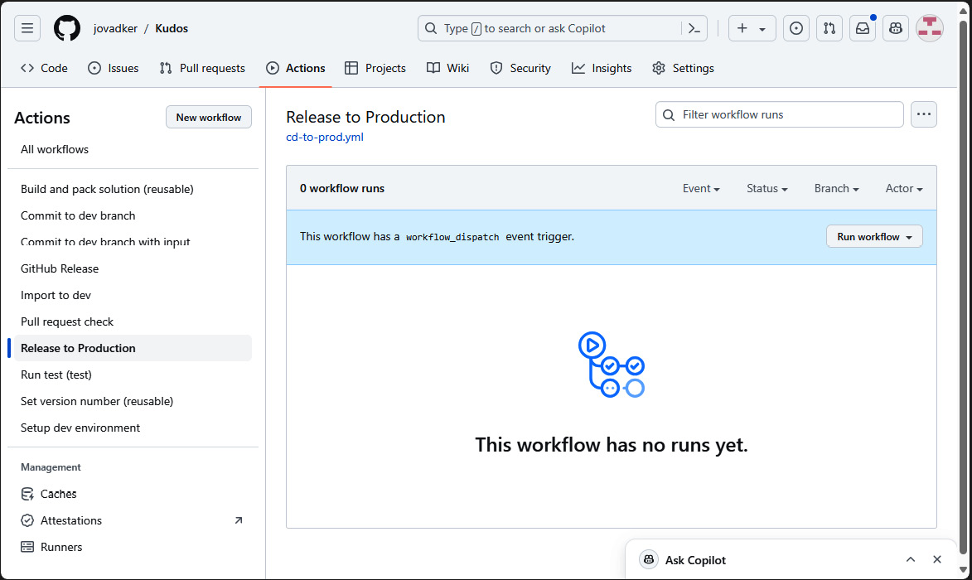

Figure 8.4 – GitHub workflows for the Kudos app

We will use these workflows soon to deploy our Kudos app to a Power Platform production environment.

1. ****Kudos application’s prerequisites****: There are a few prerequisites that we need to fulfill to get these GitHub workflows running as expected. First, we need to create an ****Azure App registration**** in our tenant that we will use in our GitHub workflows to import and export our solutions accordingly. As we learned in *[Chapter 5](https://learning.oreilly.com/library/view/mastering-devops-on/9781835880845/B22208_05.xhtml" \l "_idTextAnchor089)*, the easiest way to create a Power Platform environment is to use the ****pac admin create**** command, whereas to create a service principal, we apply the ****pac admin create-service-principal**** command. So, let’s create the production environment for our Kudos application, using an interactive login to our Power Platform tenant in GitHub Codespaces or locally:

pac auth create

****pac admin create --name Kudos-Prod --region Europe \****

****--currency EUR \****

****--type Production****

We can use the following command to find the recently created environment and its environment URL:

pac admin list --name Kudos-Prod

We then run the following command to create the service principal with the ****System Administrator**** role, using the production URL queried previously, as we did in *[Chapter 5](https://learning.oreilly.com/library/view/mastering-devops-on/9781835880845/B22208_05.xhtml" \l "_idTextAnchor089)* when we integrated a Power Platform pipeline with GitHub:

pac admin create-service-principal -env <<URL>> -n ****KudosSPN**** --role "System Administrator"

The last call requires administrative privileges not just in the Power Platform tenant but also in ****Microsoft Entra ID**** (the ****Application.ReadWrite.Allpermission**** role). This command returns the application ID (****Application Id****), tenant ID (****Tenant Id****), service principal ID (****Service Principal Id****), and client secret (****Client Secret****) that we need to store as ****GitHub repository secrets****. We need to introduce these secrets with the names ****PPAPPID****, ****PPAPPSECRET****, and ****PPTENANTID**** to our new GitHub repository to get the available GitHub workflows to run:

* + ****PPAPPID**** is the application ID returned by the command
  + ****PPAPPSECRET**** is the client secret
  + ****PPTENANTID**** is the tenant ID

We can use the GitHub CLI to create these secrets at a repository level:

echo "<<Application Id>>" | gh secret set PPAPPID

echo "<<Client Secret>>" | gh secret set PPAPPSECRET

echo "<<Tenant Id>>" | gh secret set PPTENANTID

Since we have created the repo with the ****gh repo create**** command in our GitHub codespace, the default repository is our Kudos repository. Otherwise, we can use ****gh repo set-default owner/repo**** command to set it as default.

1. ****Create an AAD group****: If we use the service principal to deploy a solution to our target environment, then the applications within the solution are owned by the service principal. To give others access to the applications, we need to create a ****Microsoft Entra ID security group**** (which we learned how to do in *[Chapter 7](https://learning.oreilly.com/library/view/mastering-devops-on/9781835880845/B22208_07.xhtml" \l "_idTextAnchor115)*). We need to be assigned the *Groups Administrator* Microsoft Entra built-in role to manage group creation and member assignment. Let’s execute the following script to create a Microsoft Entra ID group:

****az login****

****az ad group create --display-name $GROUP\_NAME --mail-nickname $GROUP\_NAME****

# get the user object id

****AADObjectID=$(az ad user show \****

****--id $userPrincipalName \****

****--query id \****

****--output tsv)****

# add a member to the group

****az ad group member add --group $GROUP\_NAME --member-id $AADObjectID****

With the PowerShell script available under ****\.github\workflows\share-app.ps1****, we can share the Kudos app with the created security group. At the time of writing, there is no PAC CLI command that can be used to share an app with Entra ID groups; that’s why we had to use ****PowerShell**** and the cmdlet ****Set-AdminPowerAppRoleAssignment -PrincipalType "Group" -PrincipalObjectId $GroupID -RoleName CanView -AppName $AppName -EnvironmentName $EnvironmentName**** ****cmdlet**** here. The security group’s object ID needs to be provided as an input parameter to the script. The GitHub workflows available in the repository also expect this AAD group ID as input.

1. ****Prepare the Power Platform production environment****: The Kudos app contains four Power Automate cloud flows and Power Apps canvas apps that use connection references and their corresponding connections, created for *Dataverse*, *Office 365 Outlook*, and *Office 365 Users* connectors. The ****connection references**** are used to make the connections adjustable in other environments. The ****connectors**** are the definitions of the connections; like classes in ****object-oriented programming**** (****OOP****), they are ****OpenAPI-based**** ****REST API**** specifications that are instantiated as ****connections**** (i.e., objects in OOP) in the environment. When we use solutions to create our flows, apps, and other Power Platform assets, then every time we initiate a new connection in a flow or an app, a ****connection reference**** is automatically created in the solution. If we work outside of the solution and create a flow under ****My flows****, then direct connections are created instead of connection references. However, a Dataverse connection can be created by the PAC CLI on behalf of a service principal in our production environment with the following script:

pac connection create [--environment] --tenant-id --name --application-id --client-secret

The Office 365 Outlook and Office 365 Users connectors require service accounts and real user accounts, not service principals, to authenticate in Outlook and Office 365 APIs. We cannot assign O365 or M365 licenses to service principals. That’s why we need to create those connections in the target environment before deploying our solutions. We can create these connections in the ****PowerApps maker portal**** under the ****Connections**** blade by clicking the ****+ New connection**** button, as shown in the following figure:

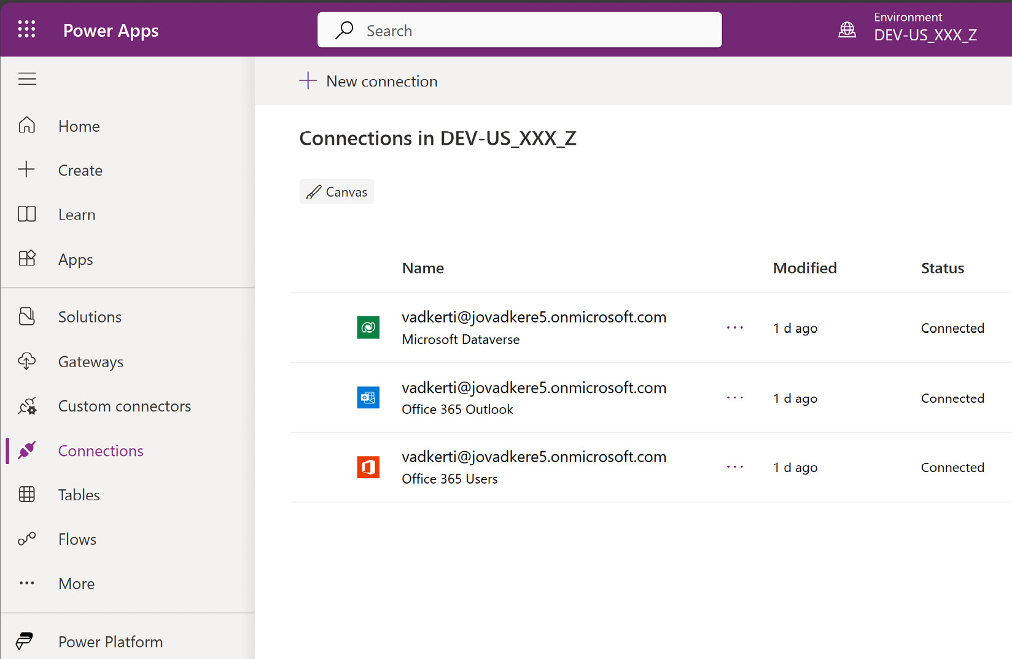

Figure 8.5 – Connections for the Kudos application

After creating the three connections, we should see the same result as displayed in the figure. Finally, we need to share these connections with the service principal and the application user that was created earlier in *step 2*, by clicking the three dots and selecting the ****Share**** menu element in ****Connections****:

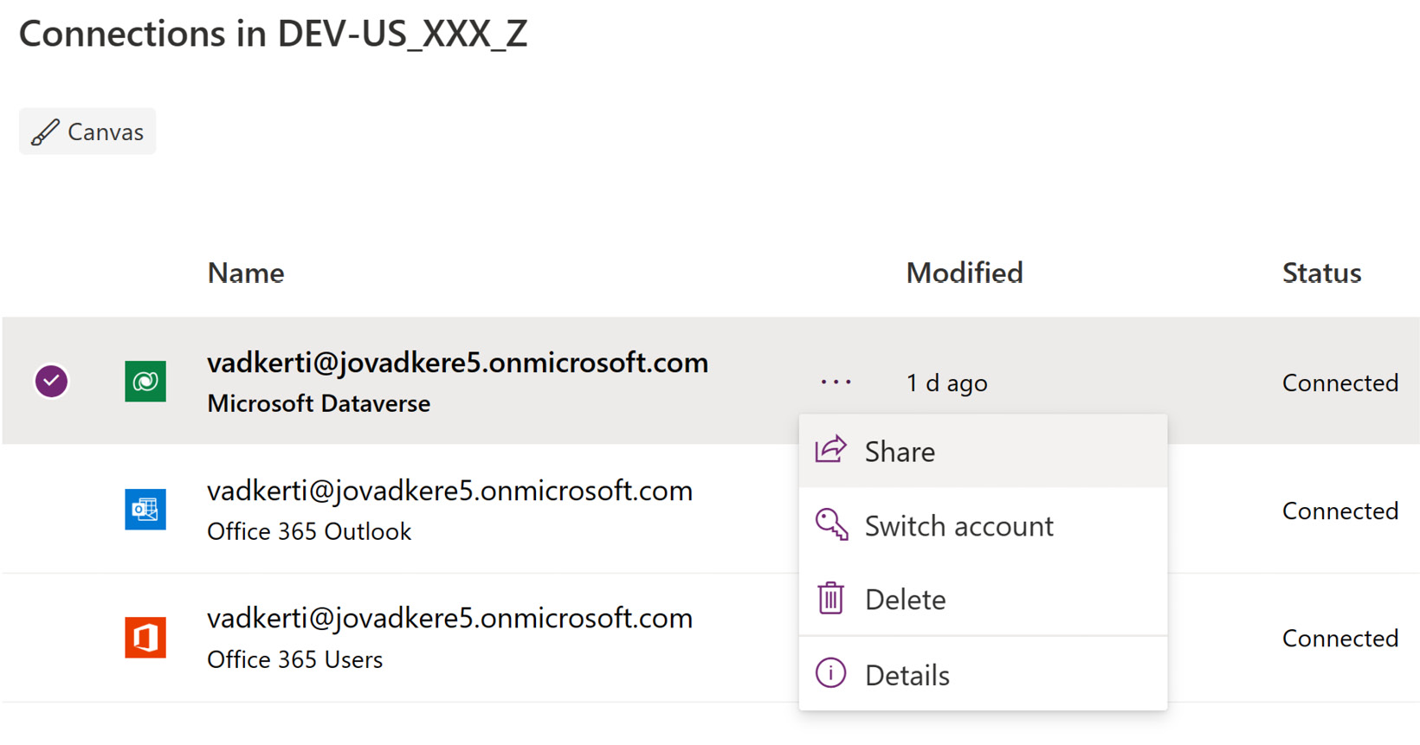

Figure 8.6 – Sharing the connection with the service principal

Let’s use these connections in our deployment by introducing the deployment settings file.

1. ****Deployment settings file****: To use these connections during the deployment of the solution, we need to use a so-called ****deployment setting file****. This file has been already generated for the solution with the following script:

pac solution create-settings --solution-zip .\mpa\_Kudos\_1\_0\_0\_36.zip

This command takes out the ****connection references**** from the solution and exposes them to be set during the import; refer to the ****\src\mpa\_Kudos\deploymentSettings.json**** file in the GitHub repository:

{

  "EnvironmentVariables": [],

****"ConnectionReferences": [****

    {

      "LogicalName": "mpa\_KudosDataverse",

      "ConnectionId": "[Dataverse]",

      "ConnectorId": "/providers/Microsoft.PowerApps/apis/shared\_commondataserviceforapps"

    },

****{****

****"LogicalName": "mpa\_KudosO365",****

****"ConnectionId": "[O365]",****

****"ConnectorId": "/providers/Microsoft.PowerApps/apis/shared\_office365users"****

****},****

    {

      "LogicalName": "mpa\_KudosOutlook",

      "ConnectionId": "[Outlook]",

      "ConnectorId": "/providers/Microsoft.PowerApps/apis/shared\_office365"

    }]}

The missing ****ConnectionId**** values are set during the GitHub workflow runs. These values are the incoming parameters of our workflows. To get these values from our Power Platform environment, we need to click on the connections in the ****Power Apps maker portal**** and copy the IDs of the connections from the corresponding URLs. The following figure shows the connection ID of the Dataverse connection, highlighted in the URL:

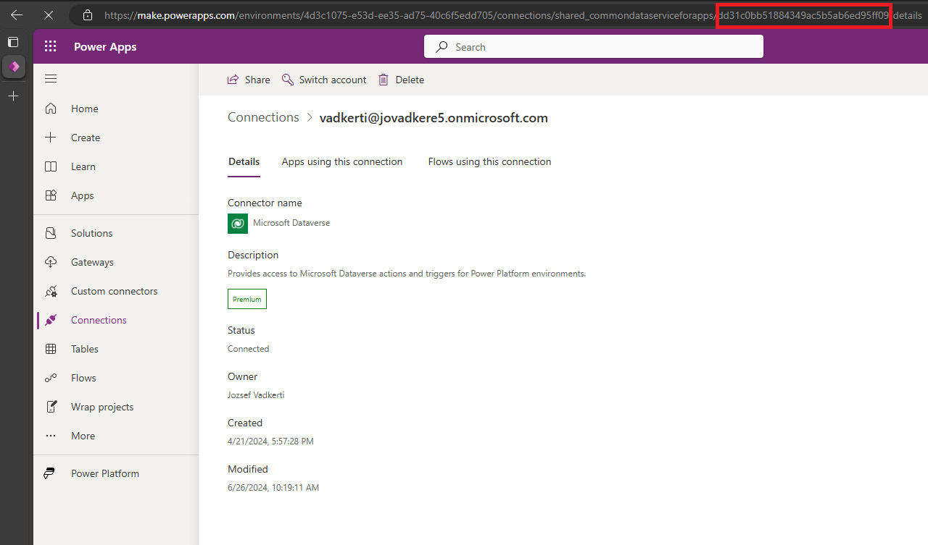

Figure 8.7 – The connection ID in the URL

The first GUID in the URL is the environment ID, whereas the second GUID is the connection ID. The following example highlights the second GUID:

https://make.powerapps.com/environments/<<Environment GUID>>/connections/shared\_commondataserviceforapps/****cc54b39cf98e41e0969dfdd7b90e2e6a****/details#

We need to store these IDs or commit them in our repository. In *[Chapter 10](https://learning.oreilly.com/library/view/mastering-devops-on/9781835880845/B22208_10.xhtml" \l "_idTextAnchor172)*, we will learn more about the deployment settings of Power Platform solutions. The *Release to Production* GitHub workflow under ****\.github\workflows\cd-to-prod.yml**** contains the default values of these connection IDs, which we can overwrite and commit back to the main branch. With everything in place, we can deploy the Kudos app from the main branch to our production Power Platform environment, by starting this workflow with the gathered connection IDs:

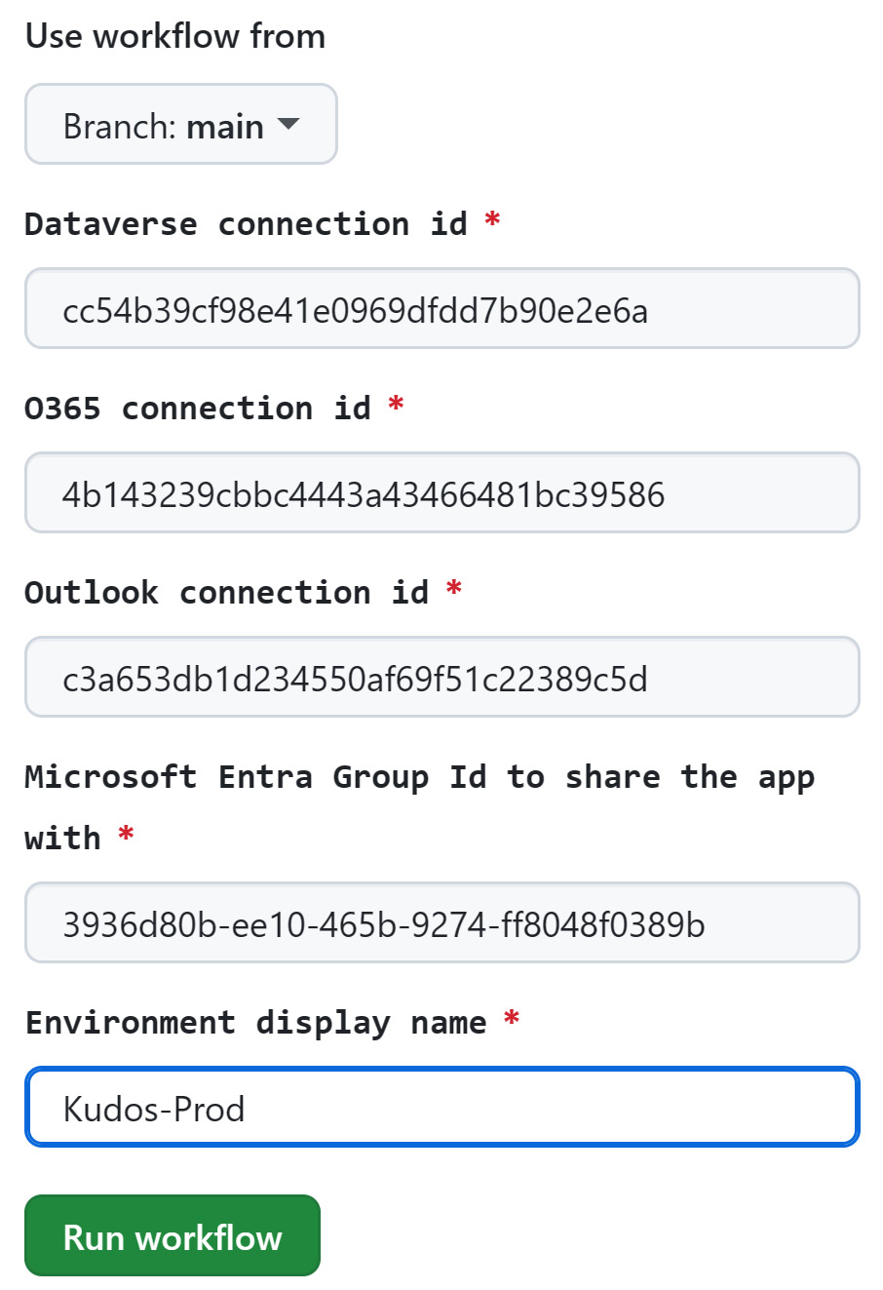

Figure 8.8 – The Release to Production workflow with parameters

To store these connection IDs, we can alternatively use ****GitHub environments****. In the case of our developer branch, we will use a dedicated GitHub environment to pre-configure these values later in this chapter.

1. ****Create our branch strategy****: At the beginning of our development project, we need to design which branching and merging strategy we will use. In *[Chapter 5](https://learning.oreilly.com/library/view/mastering-devops-on/9781835880845/B22208_05.xhtml" \l "_idTextAnchor089)*, we learned about the ****GitHub flow****, and this is what we are going to create for the Kudos application. The following figure shows our strategy and the direct mapping between Power Platform environments and Git branches:

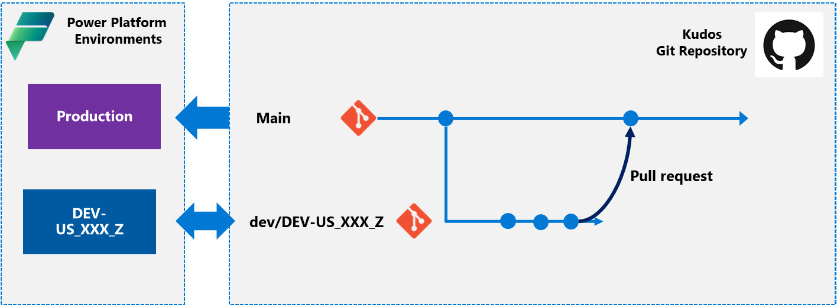

Figure 8.9 – The branch strategy

The arrows between the Power Platform environments and Git branches represent the code and deployment flows. A production environment can handle only ****pull requests**** (i.e., the solutions are only imported into those environments), whereas developer environments should support a bidirectional mode, since changes in those environments shall be exported back to Git repos, to dev branches. In our case, the ****dev/DEV-US\_XXX\_Z**** branch represents a short-lived feature branch containing the implementation of a user story or a bug fix.

1. ****Create our branch protection rule****: In *[Chapter 6](https://learning.oreilly.com/library/view/mastering-devops-on/9781835880845/B22208_06.xhtml" \l "_idTextAnchor103)*, we learned about branch policies and ****branch protection rules****, as well as which settings we can configure to our repositories in ****Azure DevOps Services**** and GitHub. Let’s create our minimum branch protection rule for our main branch by visiting our GitHub repository in a web browser and opening ****Settings****, then the ****Branches**** blade, and then clicking on the ****Add branch protection rule**** button. In the textbox, we need to type ****main**** in the ****Branch name pattern**** field, and we need to select the ****Require a pull request before merging**** checkbox, as shown in the following figure:

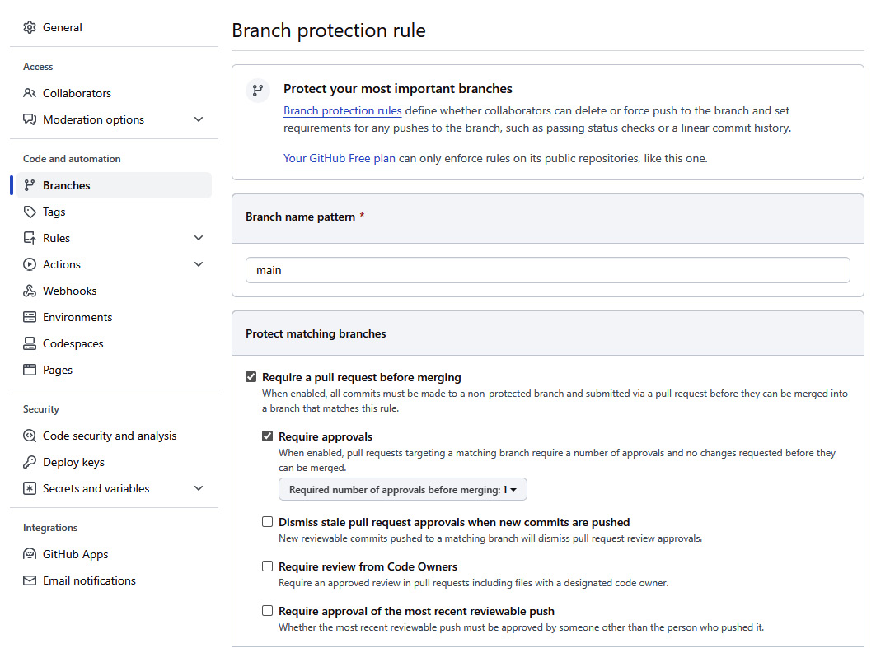

Figure 8.10 – The branch protection rule for main

At the bottom of the page, we need to click on the ****Create**** button. With this setting, we ensure that only pull requests are allowed to our main branch. Note that, by default, ****Require approvals**** is checked, which means at least someone else should review our pull requests. Since we cannot assign a pull request to ourselves, if we work alone, it is recommended to uncheck ****Require approvals****. However, it is obviously not best practice to do so in a real-world project. Besides this setting, we need to define the type of merge that we want to allow developers to do. It is recommended to use ****squash merging****, which combines all commits from the head branch into a single commit in the target branch. This significantly reduces the commit history, since all changes we commit in our developer branch sequentially will be combined into one commit after a successful pull request to the parent branch. We can force this type of merge by going to the ****Settings**** menu in GitHub and, under the ****General**** blade, removing every other merge type:

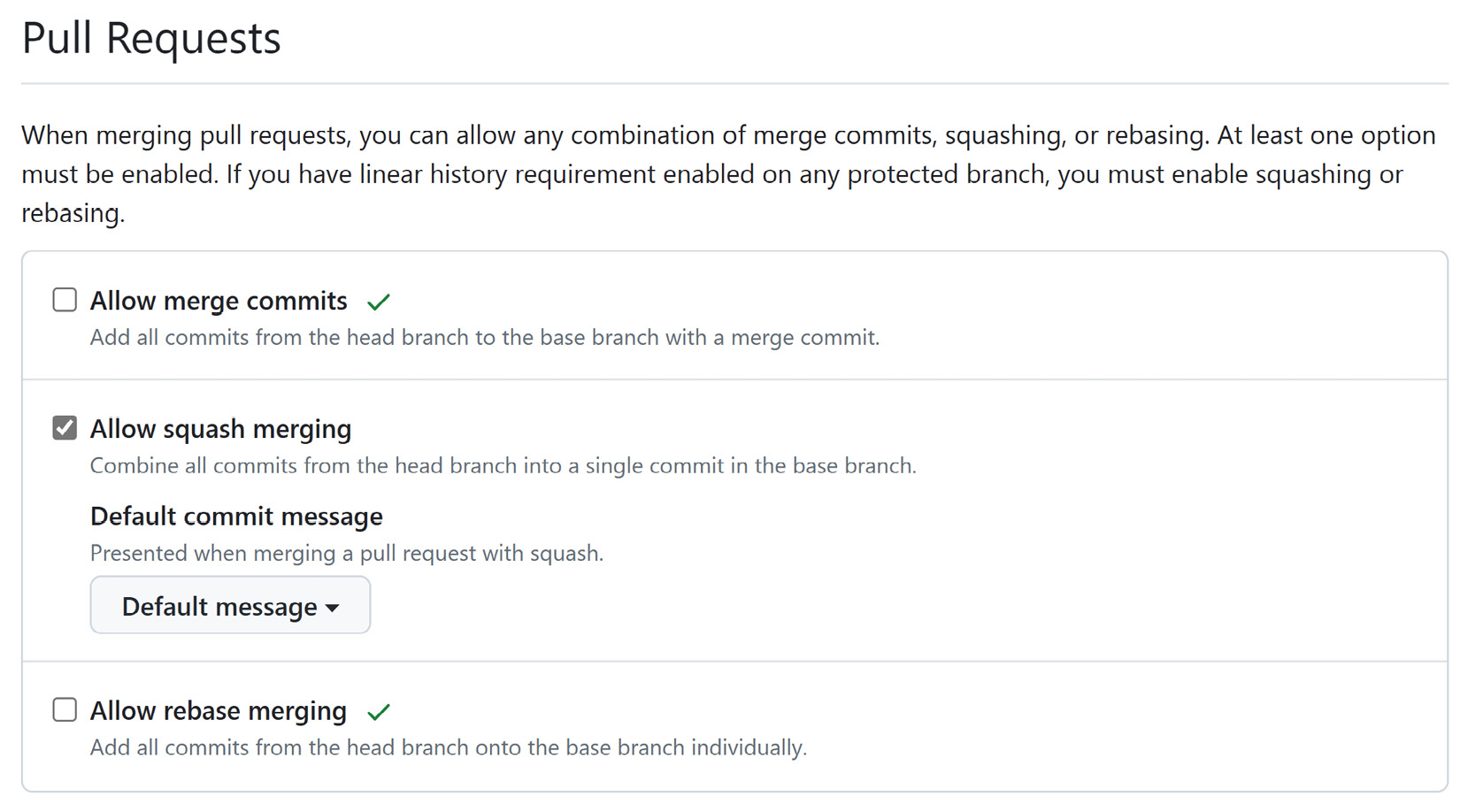

Figure 8.11 – Enforcing squash merging

Checking only ****Allow squash merging**** will force the pull requests to be squash commits. The other two options, ****Allow merge commits**** and ****Allow rebase merging****, will copy the commit history of the child branches into the main branch, leading to large history nodes in the commit history.

If we encounter any issue in the previous steps, we can use the following settings to get verbose logging of the commands.

* ****The GitHub CLI****: We need to introduce the ****GH\_DEBUG**** environment variable. If its value is ****1****, it provides more insights, but if we set this variable to ****api****, then we will see every REST API call to the GitHub endpoints:

export GH\_DEBUG=****api****

After setting this environment variable, every ****gh**** command executed will print the detailed trace in the standard output.

* ****The Azure CLI****: In the case of the Azure CLI, it is enough to add the ****--debug**** flag to the end of every command that we want to troubleshoot:

az login ****--debug****

* ****The PAC CLI****: At the time of writing, the PAC CLI doesn’t offer any flag or environment variable to enrich the verbose logs in the standard output. If we need to troubleshoot PAC CLI commands, we can only use the log available under the following:

****%userprofile%\.dotnet\tools\.store\microsoft.powerapps.cli.tool\1.30.7\microsoft.powerapps.cli.tool\1.30.7\tools\net6.0\any\logs\pac-log.txt****

Now, we are fully prepared to make some changes to the Kudos application. Let’s understand the existing GitHub workflows and their roles in the DevOps processes.

# Exercise – building CD pipelines and a release train

In the GitHub repository, we will find the following prebuilt GitHub workflows to manage the life cycle of our development project, end to end:

1. ****Set up a dev environment GitHub workflow****: Located under ****.github/workflows/setup-dev-environment.yml****, this workflow creates a developer branch with the name provided before the workflow execution (the branch name follows the naming rule, ****dev/branch\_name****). The pipeline spins up a Power Platform developer environment with the same name used for the branch. We need to add the work account that we use in the Power Platform tenant to create the developer environment on behalf of our account. At the end of the workflow, we can see additional steps that grant ****System Administrator rights**** to our work account and to the service principal that we created for the production environment earlier. Let’s execute this workflow with the following parameters:

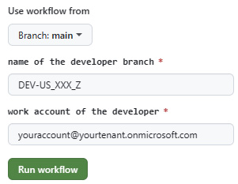

Figure 8.12 – Workflow inputs of “Setup dev environment”

After a successful run, we will see a new Power Platform developer environment with the name ****DEV-US\_XXX\_Z**** and a branch with the name ****dev/DEV-US\_XXX\_Z****.

1. ****The Import to dev GitHub workflow****: After having the dev environment, we want to deploy the solutions (the Employee Experience and Kudos) to our Power Platform developer environment. To do this, we need to create a GitHub environment with the same name that we gave our branch, with the ****dev**** prefix. In our case, it is ****dev/DEV-US\_XXX\_Z****. We can create the GitHub environment by opening the ****Settings**** tab and then the ****Environments**** blade in the GitHub portal (the GH CLI doesn’t support creating GitHub environments). Here, we need to introduce the following three variables that our *Import to dev* workflow will use for connection IDs:
   * ****DATAVERSE\_CONNECTION\_ID****
   * ****O365\_CONNECTION\_ID****
   * ****OUTLOOK\_CONNECTION\_ID****

We can see how we’ve introduced the variables in the following screenshot:

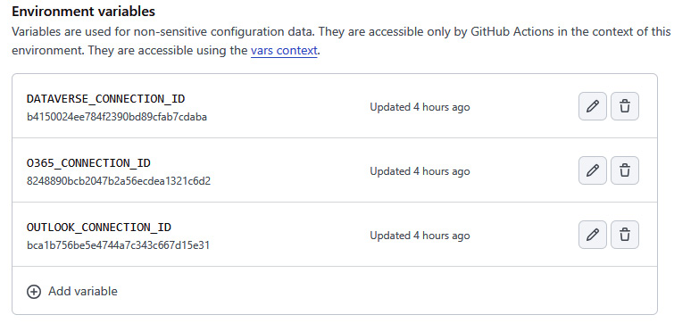

Figure 8.13 – The GitHub environment with connection IDs

As a next step, we need to create these three ****connections**** in our developer environment, share the connections with the service principal (****KudosSPN****), and copy the connection IDs from the appropriate URLs into the ****deploymentSettings.json**** file. Our workflow expects to find this information in the assigned GitHub environment with the matching name. Let’s execute the *Import to dev* workflow located under ****github/workflows/import-to-dev.yml**** from the dev branch, to import the ****unmanaged solutions**** to the developer environment:

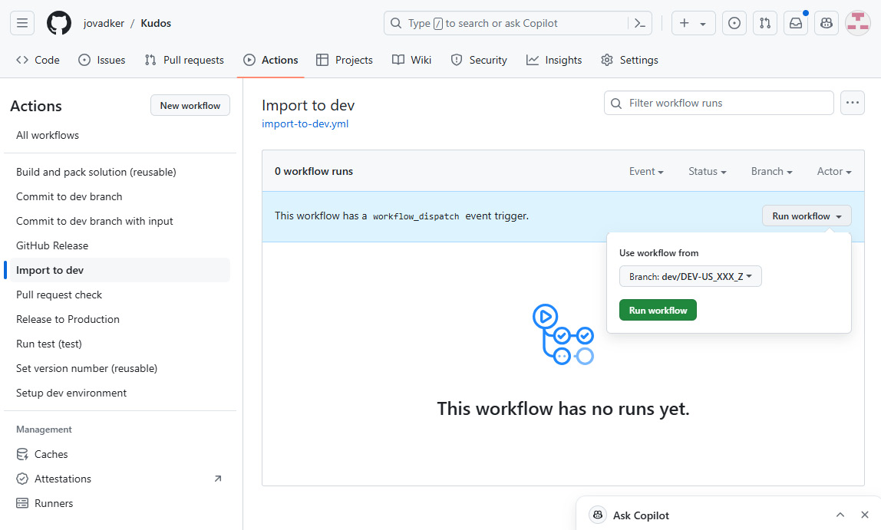

Figure 8.14 – The Import to dev workflow

We need to select our recently created developer branch to use its name to find the right environment in the Power Platform tenant:

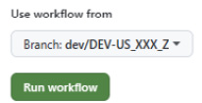

Figure 8.15 – Executing the workflow on the dev branch

When everything is set up right according to the previous steps, we will see the GitHub workflow running during the execution of the job. The ****import-to-dev**** job will run in the ****dev/DEV-US\_XXX\_Z**** environment, displaying the GitHub environment name in the job’s rectangular box of the workflow run (****Import to dev****), as shown in the following figure:

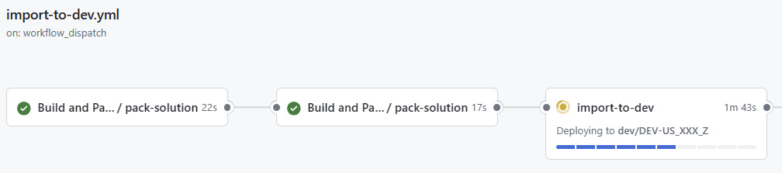

Figure 8.16 – The GitHub workflow import-to-dev job

After the successful run, we have only one task left, which is to turn on the ****Power Automate cloud flow****, *Kudos App – Notification email*, by opening the Kudos solution and viewing the flow under the ****Cloud flows**** solution asset. We will not see the flows under ****My flows**** because these flows are intentionally not shared with us.

When we examine the YML file of the workflow in detail, we can see that this pipeline uses a ****reusable workflow**** to pack and upload the managed and unmanaged versions of the solutions, both Employee Experience Base and Kudos, to ****GitHub artifacts****. Then, upcoming jobs download these artifacts and prepare the ****deploymentSettings.json**** file with the right connection IDs. Finally, we execute the ****microsoft/powerplatform-actions/import-solution@v1**** action to import the unmanaged solutions with the right deployment configurations to our Power Platform environment. We also import data to the ****custom table****, ****Badge****, with the help of the ****microsoft/powerplatform-actions/import-data@v1**** GitHub action.

*The branch name is the glue that ties the Power Platform environment, the Git branch, and the GitHub environment together to help developers easily find their own environments/configurations.*

1. ****The Commit to dev branch GitHub workflow****: Located under ****\.github\workflows\commit-to-dev.yml****, this workflow has been built to easily commit the changes made in the Power Platform developer environment back to the developer branch. We can make changes by going directly to the Kudos solution in the ****maker portal**** and opening the canvas app, (the Kudos app) for editing. On the main screen of the application, let’s change the textbox to include the current date, as shown in the following figure:

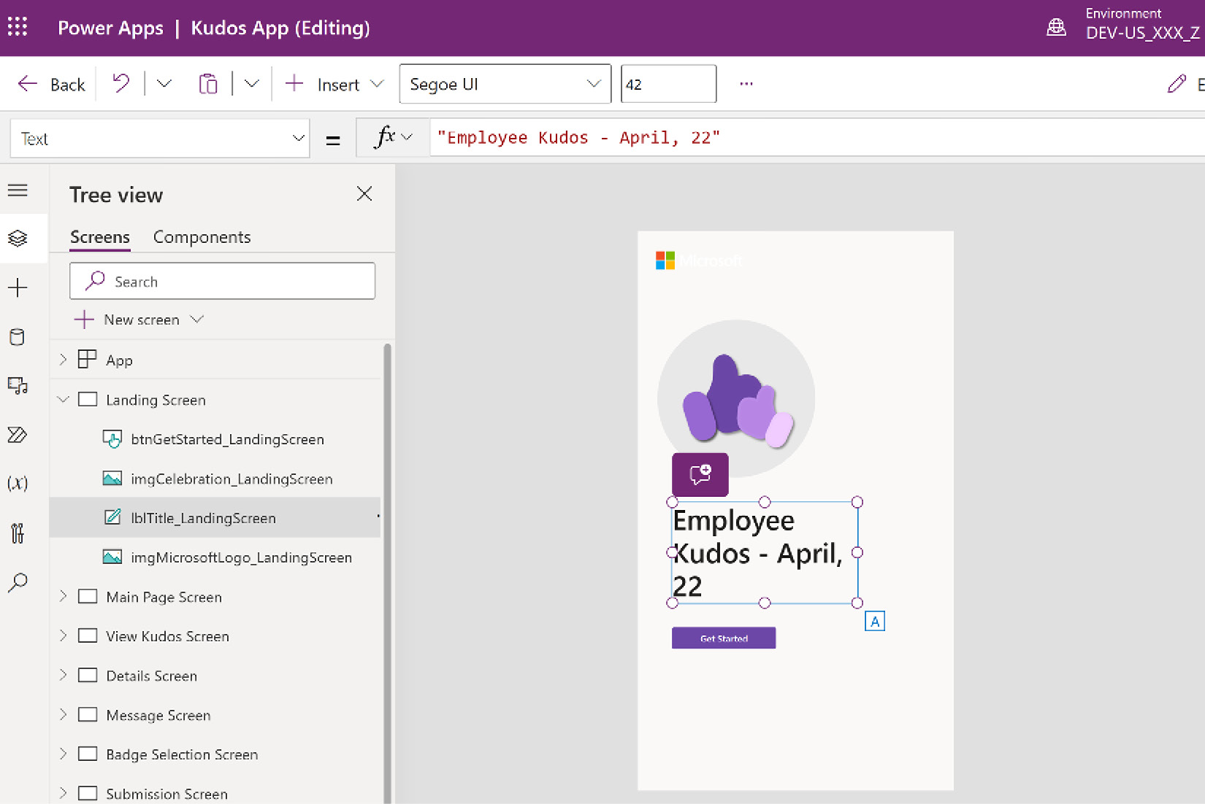

Figure 8.17 – Editing the Kudos App in the developer environment

We need to save the app and publish the customizations before executing the *Commit to dev branch* GitHub workflow. If we want to run the app locally in this environment, we also need to share the application within the solution with our account. The *Commit to dev branch* expects no input parameter; we only need to set the branch to our developer branch. If we started the workflow directly on the main branch, it would fail because of the branch protection rules that are applied. Under the hood, this workflow exports both solutions as managed and unmanaged (****microsoft/powerplatform-actions/export-solution@v1****) and also unpacks them to the right folders in the developer branch (****microsoft/powerplatform-actions/unpack-solution@v1****). Finally, the flow commits the changes to the dev branch. As we did earlier, we use the branch name to find the ****Power Platform environment URL**** to export the solutions from the right Dataverse instance, with the help of the following Bash script snippet:

ref=${{ github.ref }}

branch="${ref#refs/heads/dev/}"

echo "$branch"

# Workflow is executed on the dev branch so we need to get the environment URL from the dev branch

****rawOutput=$(pac admin list --name $branch | tail -n 2)****

****environmentURL=$(echo $rawOutput | cut -d ' ' -f 3)****

echo "Environment URL: $environmentURL"

# setting the env.devEnvironmentURL

echo "devEnvironmentURL=$environmentURL" >> "$GITHUB\_ENV"

In the final line, we create an environment variable with the value of the URL to use in the upcoming actions within the GitHub job. We hand over this URL to other jobs in the workflow by using the ****outputs**** and ****needs**** keywords in the YML file.

1. ****Create a pull request back to the main branch****: After changing the main text box in the solution, we can submit a ****pull request**** to merge our changes back to the main branch. We just need to go to the ****Pull requests**** tab in our GitHub repository and create one pull request from ****dev/DEV-US\_XXX\_Z**** branch to ****main****. The pull request will compare the two branches and list every change that has been made since the creation of the developer branch. We can use ****GitHub Copilot**** to generate a summary of these changes by clicking the Copilot icon on the pull request page:

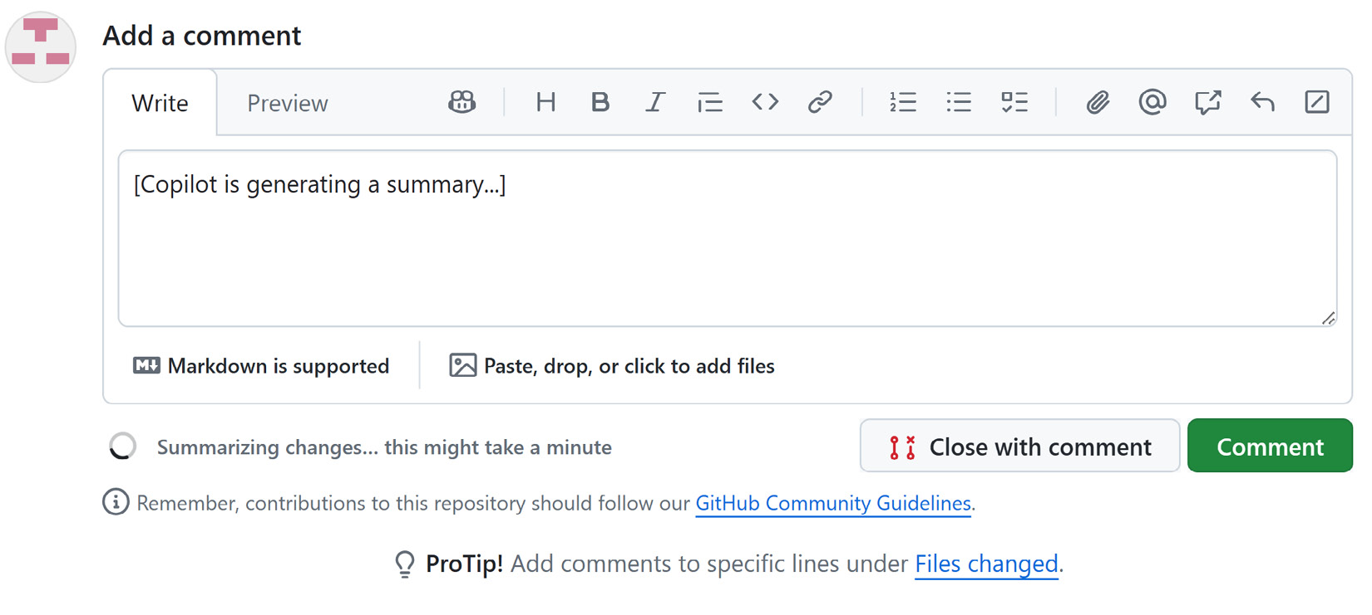

Figure 8.18 – A Copilot-generated pull request summary

By clicking the ****Merge**** button, our pull request will close and the changes will merge back to the parent branch. Usually, we delete developer branches after a successful pull request, but this time, let’s keep our dev branch to execute some additional exercises in the upcoming sections.

1. ****The Release to Production GitHub workflow****: Located under ****\.github\workflows\cd-to-prod.yml****, this workflow deploys the latest version of the main branch to the production environment, as we discussed in the previous section. We can execute this workflow to deploy the latest version of the Kudos app to the production environment.

In *[Chapter 6](https://learning.oreilly.com/library/view/mastering-devops-on/9781835880845/B22208_06.xhtml" \l "_idTextAnchor103)*, we learned about the ****ALM Accelerator for Power Platform****, how it controls the versions of the Power Platform solutions, and why it sets them intentionally to ****0.0.0.0.**** in Azure DevOps Services during the development phase. We can apply the same concept in GitHub by introducing a reusable workflow located under ****\.github\workflows\set-version-number.yml****. This workflow has two parameters; one is the source folder of our solutions, and the other is the version number to be set. The workflow checks out the repository, searches for the ****Solution.xml**** file under the source folder, and replaces the inline version tags with the version number, provided as an input parameter:

- shell: bash

  run: |

   # Find all Solution.xml files in the solution directory and its subdirectories

****find**** ${{ inputs.source\_folder }} -type f -name "Solution.xml" | while read -r file; do

   # Replace the content of the <Version> tag with version number provided in the input

****sed**** -i 's|<Version>.\*</Version>|<Version>${{ inputs.version\_number }}</Version>|g' "$file"

     done

The final action in the flow commits back the changes to the branch on which the workflow runs.

We need to add this reusable workflow to the *Commit to dev branch* workflow to set the version number of the solutions to ****0.0.0.0****. Let’s update the workflow in the dev branch (****dev/DEV-US\_XXX\_Z****) with the following lines, directly adding them to the end of the workflow:

set-version-number:

    needs: [ commit-to-dev-kudos ]

    name: Set the version numbers to 0.0.0.0

    uses: jovadker/ppdemo/.github/workflows/set-version-number.yml@main

    with:

        source\_folder: src/

        version\_number: "0.0.0.0"

Let’s commit the changes locally and push them back to the remote repository. We can work in ****Visual Studio Code**** (****VS Code****) or directly in the ****GitHub UI****, based on our preferences, or we can use GitHub Codespaces and execute the changes there. For the latter option, we need to switch to the branch (****dev/DEV-US\_XXX\_Z****) and create another codespace:

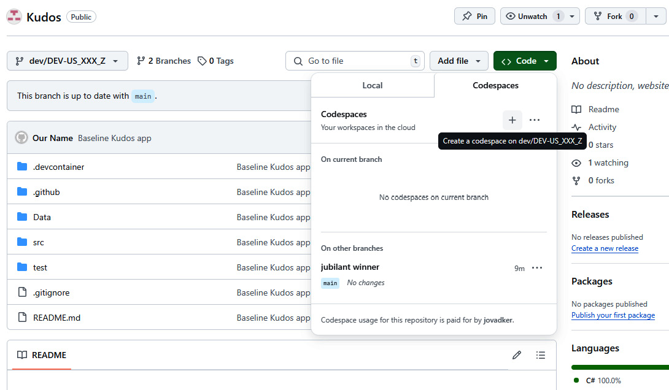

Figure 8.19 – A GitHub codespace on the dev branch

After launching the newly created codespace, we can add the workflow snippet (the GitHub job with the name ****set-version-number****) to the end of the file, as shown in the following figure:

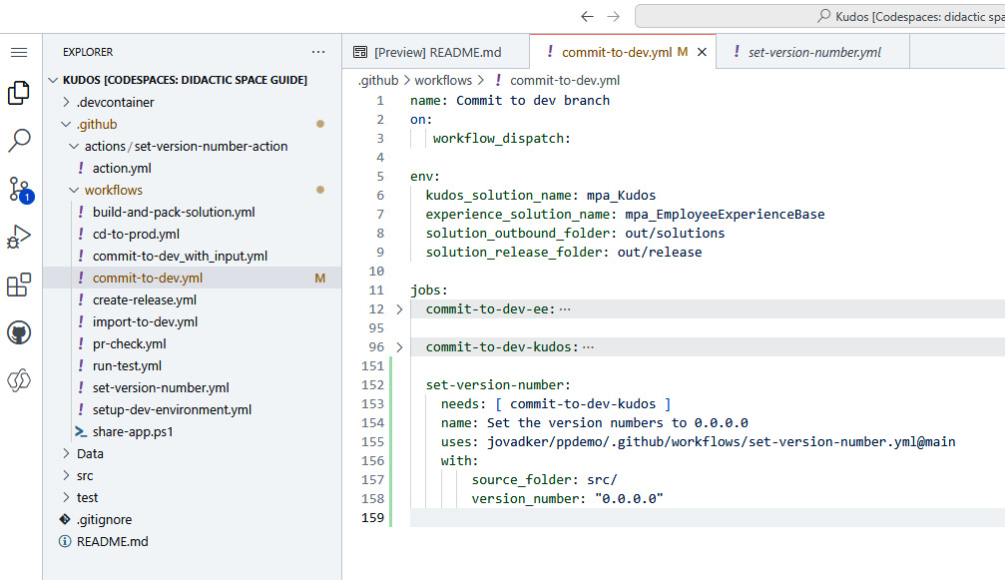

Figure 8.20 – The commit-to-dev.yml file in the GitHub codespace

After saving the file in the VS Code editor in the browser, we can navigate to the source control icon on the left menu and commit our changes, by providing a commit message and clicking on the ****Commit**** button:

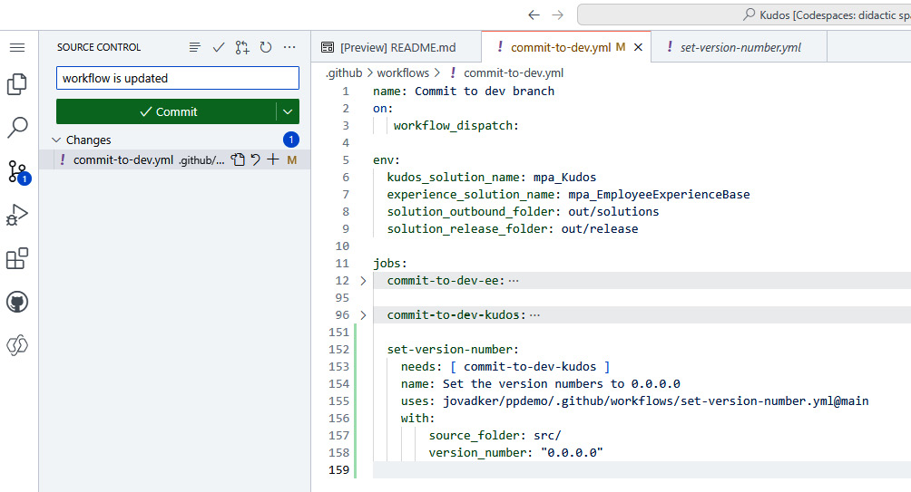

Figure 8.21 – A Git commit in a GitHub codespace

After clicking on the ****Commit**** button, we should not forget to click on ****Sync Changes**** to push back the changes to the remote origin.

To test the GitHub workflow upon our changes, we can start it on the branch, ****dev/DEV-US\_XXX\_Z****, and see how the two solutions and their ****Solution.xml**** files are updated. Similarly, we can introduce this job to other flows if we plan to maintain a homogenous versioning in our solutions.

*Version number – 0.0.0.0*

*If we use the*****0.0.0.0*****version number, then the solutions imported to Power Platform developer environments will also have this version. This approach is ideal for multiple developers working on the same solution or project, since they will not override the versions by committing their changes back to developer branches and later, through pull requests, to the main branch.*

Finally, we can leverage the releases feature of GitHub to publish our new versions. ****GitHub releases**** offer an easy way to package our software, along with release notes and links to binary files, for other people to use. We can manage these releases in GitHub workflows; the platform provides a special trigger that we can use to add our solutions to a release, and there are actions available in the ****GitHub marketplace**** to create releases within workflows. We will create our release by executing a new GitHub workflow that builds our solutions, using ****MSBuild****, creates a deployment package, and publishes the generated artifacts as part of the new release version.

The Kudos application provides ****Visual Studio projects**** to build our solutions like traditional Visual Studio solutions, using the ****MSBuild**** and ****dotnet**** CLIs. We can create these ****.cdsproj files**** at any time by executing the following PAC CLI command in the ****solution**** folder:

pac solution init --publisher-name developer --publisher-prefix dev

This command creates a wrapper around our solution, if empty, and then it will create an empty solution under the ****src**** folder, into which we can copy our solution files (XML and JSON files).

In *[Chapter 4](https://learning.oreilly.com/library/view/mastering-devops-on/9781835880845/B22208_04.xhtml" \l "_idTextAnchor074)*, we learned about deployment packages and the ****Package Deployer tool****. This tool is used to manage the deployment of multiple dependent solutions to target environments. With the following commands, we can create a deployment package that will create a ****.csproj**** file under the ****DeploymentPackage**** folder:

pac package init --outputDirectory DeploymentPackage

cd .\DeploymentPackage

****pac package add-solution --path <<PATHTORELEASE>>\mpa\_EmployeeExperienceBase\_managed.zip****

****pac package add-solution --path <<PATHTORELEASE>>\mpa\_EmployeeExperienceBase\_managed.zip\mpa\_Kudos\_managed.zip****

The ****pac package add-solution**** command adds the managed solutions that were previously built by ****MSBuild**** to this ****.csproj**** file as references. After setting up the deployment package, we can use the ****dotnet publish -c Release**** command to build the release version of the deployment package.

*The deployment package*

*We have created a folder structure in the GitHub repository where the two solutions and the*****DeploymentPackage*****folder are placed under the*****src*****folder. The*****csproj*****file in the*****DeploymentPackage*****folder references the release builds of the two solutions, Employee Experience Base and Kudos.*

Finally, we can create our GitHub release by using the *GitHub Release* workflow, located under ****/.github/workflows/create-release.yml****. The high-level steps and the key takeaways of the workflow are as follows:

1. ****Set the version number****: Here, we use a ****composite GitHub action**** to set the version number instead of a reusable workflow. Composite actions are actions that are built up from multiple other actions, without the need to write ****JavaScript**** code or create ****Docker images**** for our business logic. Our composite action is located under ****/.github/actions/set-version-number-action/action.yml****, and it sets the version number of Power Platform solutions. As we saw earlier, reusable workflows need to be run as jobs, which means the GitHub runner will clean up the local repository after finishing the reusable workflow job and moving on to the next job. If we don’t want to commit our version numbers, we need to run all actions within the same job. That’s why we have created this composite action.
2. ****Build the solutions and deployment package****: We use a ****GitHub-hosted Windows runner**** to make the ****MSBuild**** and ****dotnet**** CLIs available for our build actions. We build the solutions with the following command:

****msbuild .\src\solutions.proj /p:Configuration=Release****

The ****proj**** file contains the references to the ****cdsproj**** files under the ****solutions**** folders. We generate the deployment package with the ****dotnet publish -c Release /p:Version=${{inputs.release\_version}}**** command by setting the version of the package to the one provided as the workflow parameter. After having the binaries generated, we upload every build artifact to the GitHub artifact store.

1. ****Download the deployment package and create the GitHub release****: in this separate job, we download the artifacts and execute the ****gh cli**** command to create a GitHub release:

gh release create ${{inputs.release\_version}} --title "${{inputs.release\_title}}" --generate-notes ${{ env.solution\_release\_folder}}/\*.\*

By using the ****generate-notes**** argument, the GitHub release notes will be automatically generated. We also attach our binaries to the created release by referring to the folder and its content, ****${{ env.solution\_release\_folder}}/\*.\*****.

Let’s now execute this flow with its default parameters and, upon completion, check whether we can see on the main page of our GitHub repository, under ****Releases****, a release called ****Initial release****. By opening it, we should discover more details about our first release – for example, the attached assets:

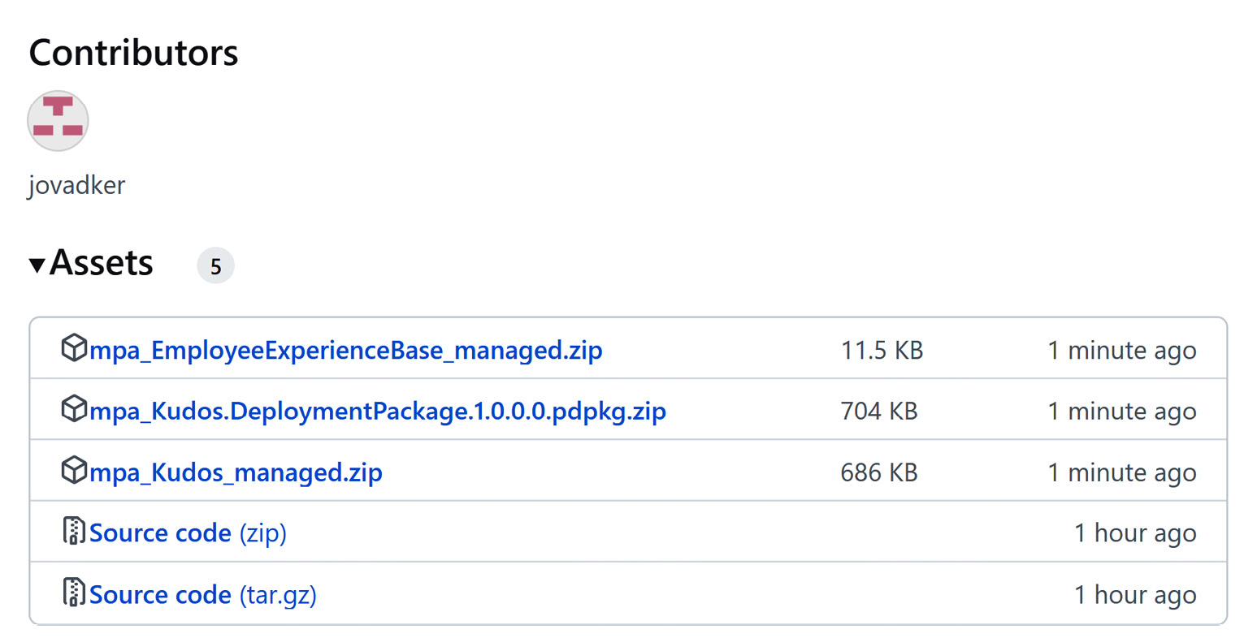

Figure 8.22 – The GitHub release with the Power Platform package

*The package deployer*

*The*****.pdpkg*****(*****package deployer package*****) files are used to package**multiple, interconnected Power Platform solutions into one deployment package that can be moved between tenants. To install these packages, we simply call the*****pac package deploy --package********.\bin\Release\mpa\_Kudos\_DeploymentPackage.1.0.0.pdpkg.zip*****on the other tenant. These packages**can also upload data and prepare the target environment for the solutions.*

With GitHub releases, we can distribute our development project results to IT ops teams responsible for the production tenant, without directly connecting our developer tenant and workflows with the production one.

If you encounter issues when attempting to run the workflows, consider the following troubleshooting options:

* ****Check the run logs****: The first step is to check the logs of the workflow run. GitHub provides detailed logs for each step of the workflow, which can help us identify where an error occurred.
* ****Use debugging tools****: ****GitHub Actions**** supports various debugging tools. We can use the ****ACTIONS\_STEP\_DEBUG**** secret to enable step debug logs, which provide more detailed output for each step.
* ****Run the workflow locally****: We can use tools such as ****act**** (<https://github.com/nektos/act>) to run our workflows locally on our machine. This can help us debug the workflow in an environment we control.
* ****Review the workflow file****: Ensure that the ****.yml**** workflow file is correctly formatted and that all required fields are present. Syntax errors or missing fields can cause workflows to fail. We should very carefully change the indent of the lines in YML files because only one additional space can lead to a syntax error.
* ****Check for external changes****: Sometimes, changes in external dependencies or an environment can cause workflows to fail. We need to ensure that all external services and dependencies are operational.

Now, let’s move on to the next topic and delve into backlog management.

# Exercise – backlog management in GitHub

In *[Chapter 1](https://learning.oreilly.com/library/view/mastering-devops-on/9781835880845/B22208_01.xhtml" \l "_idTextAnchor014)*, we learned about why it is essential to track our activities, user stories, change requests, and bug fixes on any code base. Let’s recall the key takeaways:

* We want to plan our developer work in every sprint ahead to laser-focus on the most critical ****features****, ****bugs****, and ****defects****. The entire ****sprint planning process**** is based on a healthy ****product backlog**** that every developer and product owner needs to maintain.
* Healthy backlog management allows only source code changes that are planned to avoid ****gold plating**** (developers adding extra features that are not part of the activity) and ****scope creeping**** (when a project team works on features that are requested by the customer without adjusting the project’s cost or timeline).
* ****Backlog management**** provides ****backward traceability**** as well as the ability to trace back from the application running in production to the source code that produced the ****binaries**** of the application. We can use this information for root-cause analysis to discover which change, tracked by a work item, led to issues in production.

Both Azure DevOps Services and GitHub provide these requirement engineering and issue management capabilities, with advanced project management features, such as scheduling our activities and assigning them to team members in sprints.

To maintain healthy backlog management in GitHub, we can improve the minimum ****branch protection rule**** we created in the *first exercise of this chapter* (****pull requests are mandatory****) to allow only pull requests to be closed that have descriptions and comments. We need to introduce a GitHub workflow that is triggered by the ****pull\_request**** action targeting the branch main and executes the following actions:

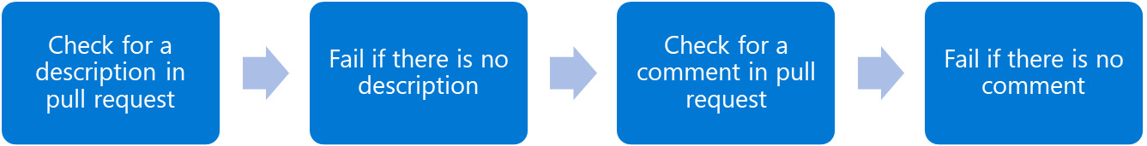

Figure 8.23 – A pull request-triggered workflow for branch protection

The key part of our workflow looks as follows (located under ****/.github/workflows/pr-check.yml****):

****name: Pull request check****

****on:****

****pull\_request:****

****types: [edited, synchronize, opened, reopened]****

****branches: [ "main" ]****

jobs:

  prcheck:

    runs-on: ubuntu-latest

    steps:

      - name: Check for comments in PR

****id: check-comments****

        run: |

          # every pull request is an issue as well

          #- we can address them through /issues/ endpoint

          comments=$(****curl**** -s -H "Authorization: token ${{secrets.GITHUB\_TOKEN}}" \

             "****https://api.github.com/repos/${{ github.repository }}/issues/${{ github.event.pull\_request.number }}/comments")****

          if [ $(echo "$comments" | jq '. | length') -eq 0 ]; then

            echo "There is no comment added to the PR."

****echo "no\_comments=true" >> $GITHUB\_OUTPUT****

          else

            echo "Comments are added to the PR."

****echo "no\_comments=false" >> $GITHUB\_OUTPUT****

          fi

        shell: bash

      - name: Fail if no comments

        run: |

          if [[ ****"${{ steps.check-comments.outputs.no\_comments }}****" == "true" ]]; then

           echo "No comments added to the pull request. Failing the build."

           exit 1

          fi

        shell: bash

We use ****curl**** to query the comments belonging to the issue via the REST API endpoint (****https://api.github.com/repos/${{ github.repository }}/issues/${{ github.event.pull\_request.number }}/comments****), since every pull request is also modeled as an ****issue****. After validating that the comments array is not empty, we set the output property, ****no\_comments****, accordingly. The next action consumes the output of the previous action and passes or fails the build. If the workflow fails, the pull request is blocked, and the merge is not allowed. The workflow also checks at the beginning whether there is a description added to the pull request with the same approach. We can correct our pull request by writing descriptions and adding comments in hindsight. Also, we can use GitHub Copilot to generate our pull request description, based on the changes between the child and parent branches:

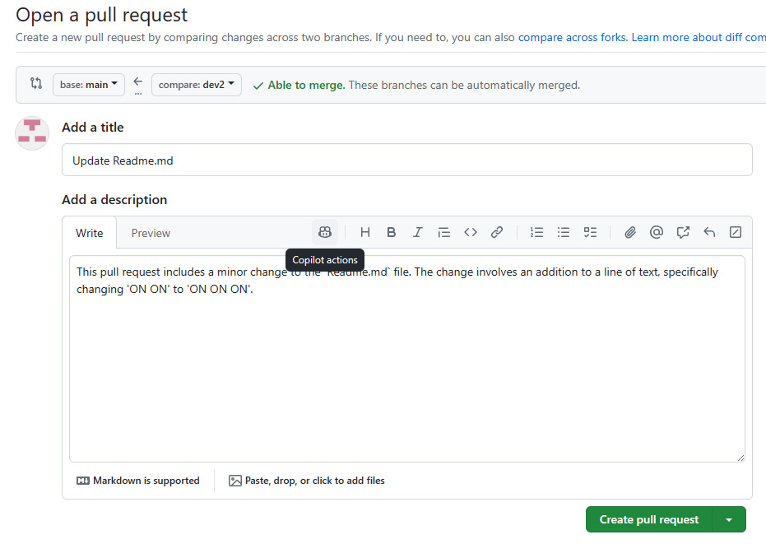

Figure 8.24 – Using GitHub Copilot to generate PR descriptions

We just need to click on the Copilot icon, and then the underlying ****GPT-4 model**** generates the summary for the pull request – in our case, ****The pull request includes a minor change to the Readme.md file…****.

If we want to introduce more complex checks during the pull request in conjunction with backlog management, we can visit the ****GitHub Marketplace**** to find actions, such as ****verify-linked-issue**** (<https://github.com/marketplace/actions/verify-linked-issue>), which checks whether pull requests have at least one linked issue attached.

Now that we have established strict control of our repository and work management, let’s move on to the next topic, ****quality assurance****.

# Exercise – testing solutions

In *[Chapter 6](https://learning.oreilly.com/library/view/mastering-devops-on/9781835880845/B22208_06.xhtml" \l "_idTextAnchor103)*, we delved into the ****quality assurance**** (****QA****) topics and learned about the tools and frameworks that are available for end-to-end UI testing in PowerApps, such as ****Power Apps Test Engine****, or open source web testing frameworks, such as ****Selenium****, ****Playwright****, ****Appium**** or ****Cypress****. We also concluded that Power Automate cloud flows and ****desktop flows**** are considered our business logic layer, and we can test them through the UI components, as end-to-end tests. In this section, we are going to do the following:

* Create a test in Power Apps Test Studio for the Kudos app in our Power Platform developer environment (****DEV-US\_XXX\_Z****).
* Download it as a test suite ****YAML file**** and commit it to our developer branch (remember that this branch is still alive).
* Run it locally with the help of the PAC CLI.
* Introduce this step to our *Commit to dev branch* GitHub workflow.

We also have some prerequisites for this test automation scenario:

* To be able to execute our test during the CI/CD process, we also need to have a user without ****Multifactor Authentication**** (****MFA****) in our development tenant; learn more about it in the link in the *Further reading* section (Power Apps Test Engine).
* We also need to share the Kudos app under the ****Solutions**** blade with this ****Microsoft Entra ID user****.
* We must add this user to the developer environment (****DEV-US\_XXX\_Z****) in the ****Power Platform Admin Center****, and we need to assign the built-in ****Security Role****, ****Basic User****, and the custom one, ****Kudos Employee****, to this user. This latter one gives access to the custom tables created by the Kudos solution and contains the badges, as well as the already shared Kudos.
* We need to start the app interactively once on behalf of our test user without MFA, granting them access to the connections used in the Kudos app, Office 365 Users, and Office 365 Outlook.
* Finally, we need to share the *Kudo App – Share Kudo with Sender*, *Assign to Recipient*, and *Kudos App - Notification email* cloud flows with this user as *Run only users* in the Power Automate cloud flow UI.

We can easily record our tests by using the ****Power Apps Test Studio****. We just need to go to our solution in the developer environment, open the Kudos app for editing, click on ****Advanced tools**** on the left side, and open the ****Open tests**** link. Here, we can use the ****Record**** button to let the studio record our steps, like creating a new kudos for one of the users in our environment. If we have completed the recording, we can download the result as a YAML file by clicking on the ****Download suite**** button. You can find more information about the features of Test Studio in the *Further reading* section under the *Working with Power Apps Test Studio* link. We can use this YAML file or the one that was already added to the repository under the ****/test/SmokeTestSuite.yaml**** file to continue this exercise.

Once we have our YAML file, we need to make some changes to be able to run in ****headless browser mode****, which means the test can be executed without starting a browser in the UI session. This setting is essential to get these ****Playwright-based**** tests executed on GitHub-hosted runners. We need to set the screen resolution to other numbers than the default ****0x0****, such as ****102x768**** pixels (****screenWidth X screenHeight****):

testSettings:

  filePath:

  browserConfigurations:

  - browser: Chromium

    device:

****screenWidth: 1024****

****screenHeight: 768****

  locale: en-US

****recordVideo: true****

****headless: true****

  enablePowerFxOverlay: false

  timeout: 30000

Besides these updates, we can set ****headless**** parameter to ****false**** for local testing purposes to follow the UI actions in a Chromium-based browser. To execute this test YAML file locally, we can use the following script in Bash:

export user1Email="USEREMAIL"

export user1Password="PASSWORD"

pac test run --test-plan-file ./test/SmokeTestSuite.yaml -env 4d3c1075-FFFF-GGGG-VVVV-40c6f5edd705 --tenant 4ae51f31-XXXX-YYYY-ZZZZ-5ece14d2c081

We need to set the test user email address and password as environment variables, and we also need to provide the test file location, the environment ID, and tenant ID. After successful execution, we will find the test results in the ****TestOutput**** folder with the video recording, as well in the ****.webm**** format.

To execute this test in GitHub, we need to create two additional ****repository secrets****, one for the test user’s email address and the other for the test user’s password – ****TESTUSER**** and ****TESTUSERPSW****, and – similar to the other three ones (****PPAPPID****, ****PPAPPSECRET****, and ****PPTENANTID****) that we created at the beginning of this chapter.

We have crafted a GitHub workflow in advance to execute our ****SmokeTestSuite.yaml**** file easily on the dev branch. This workflow is available under ****/.github/workflows/run-test.yml**** and uses the following Bash script to run the test:

- name: Run test

****shell: bash****

****run: |****

       set -e

****ref=${{ github.ref }}****

       branch="${ref#refs/heads/dev/}"

       echo "$branch"

       # Get the environment Id

****rawOutput=$(pac admin list --name $branch | tail -n 2)****

       environmentId=$(echo $rawOutput | cut -d ' ' -f 2)

****export user1Email="${{secrets.TESTUSER}}****"

****export user1Password="${{secrets.TESTUSERPSW}}****"

****pac test run \****

****--test-plan-file ./test/SmokeTestSuite.yaml \****

****-env $environmentId \****

****--tenant ${{secrets.PPTENANTID}}****

We can run this workflow, *Run test (test)*, directly on our developer branch (****DEV-US\_XXX\_Z****). Based on the branch name, the workflow finds our developer environment and then calls ****pac test run**** with the appropriate parameters.

To avoid feature regression and maintain the high quality of our solution, we can introduce this step in our *Commit to dev branch* GitHub workflow to fail fast and early in the development process. All we need to do is to append the entire job, called ****test****, from the ****/.github/workflows/run-test.yml**** as the first job in the workflow, as we want to only allow new commits landing in the branch when our automated tests pass:

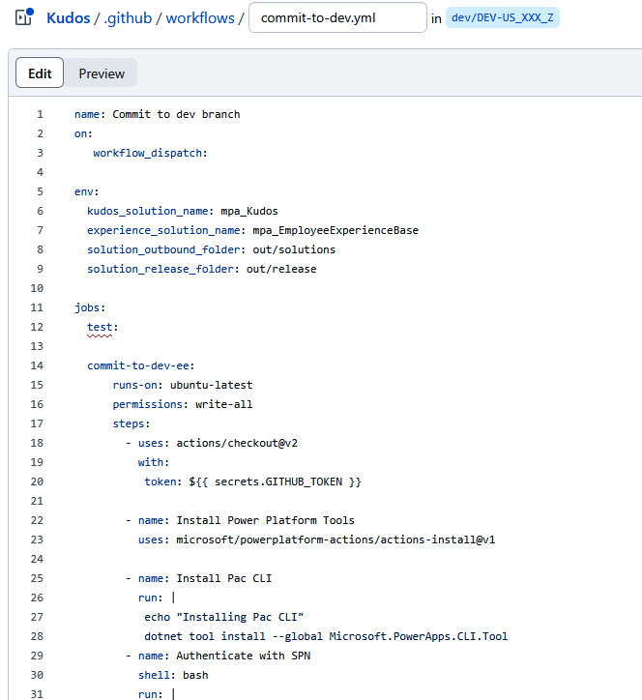

Figure 8.25 – The Commit to dev branch with a placeholder for “test” job

Additionally, we can introduce this quality check in our pull request triggered workflow (*Pull request check*), in the production workflow (*Release to Production*), or even in the release workflow (*GitHub Release*) based on our preferences. Some of these workflows need to be extended, for instance, to be able to spin up new Power Platform environments, deploy the release candidate, and execute the tests. Only our imagination and project costs can limit our QA investments.

Now, our application is ready to run in production. There is only one task left, which is to get real-time insights and telemetry data about our application’s runtime characteristics and behavior. Let’s discover what monitoring options we have in Power Platform.

# Exercise – monitoring the applications

After publishing our application to the production environment, we want to understand how it performs, how users interact with the application, and how far the application is stable and can run without errors. As Microsoft Power Platform runs on ****Microsoft Azure****, it can leverage the existing Azure ****platform-as-a-service**** (****PaaS****) services to provide real-time telemetry data collection and analysis for the Power Platform portfolio – Power Apps, Power Automate, Copilot Studio, Power Pages, and even Dataverse. Azure’s PaaS service is ****Azure Application Insights****, which is tidily connected to ****Azure Monitor**** and ****Azure Log Analytics workspaces****. Azure Application Insights is an ****Application Performance Management**** (****APM****) solution that can be used in live production monitoring scenarios. Application Insights provides application dashboards, application maps, live metrics, transaction search, availability view, failures view, performance view, monitoring alerts, workbooks, and so on. With Application Insights, we can also discover the usage patterns of our users, how people interact with the app, and how the churn rate or the conversion rate looks. It also visualizes the user journey on web applications. The Application Insights service offers machine learning-based analysis of telemetry data (called ****Smart Detection****) to identify anomalies or performance degradation before outages or blackouts occur. If the built-in detection features are not enough, we can write our own queries to look for anomalies with the help of ****Kusto Query Language**** (****KQL****). We can introduce our custom alerting and notifications based on the query results of KQL scripts that can trigger ****Azure Playbooks****, ****Azure Logic Apps****, ****Azure Functions****, ****Azure EventHub****, and ****custom Webhooks****. The custom webhooks can trigger Power Automate cloud flows to react to the anomalies and outriders in the Power Platform. Last but not least, Application Insights provides SDKs, available in JavaScript, Java, C#, Node.js, and Python, based on the ****OpenTelemetry framework****.

Since Power Apps are browser-based applications and the web player that hosts the apps in the browser is based on ****Apache Cordova framework****, which is also used with ****react-native**** in the native mobile apps through ****wrap functionality****, it is a very straightforward approach to embrace Application Insights’ capabilities in our low-code/no-code platform. We can add Application Insights’ endpoint directly to the canvas app – in our case, to the Kudos app. We just need to edit the app in the developer environment through the Kudos solution and select the ****App**** node in the tree view on the left side:

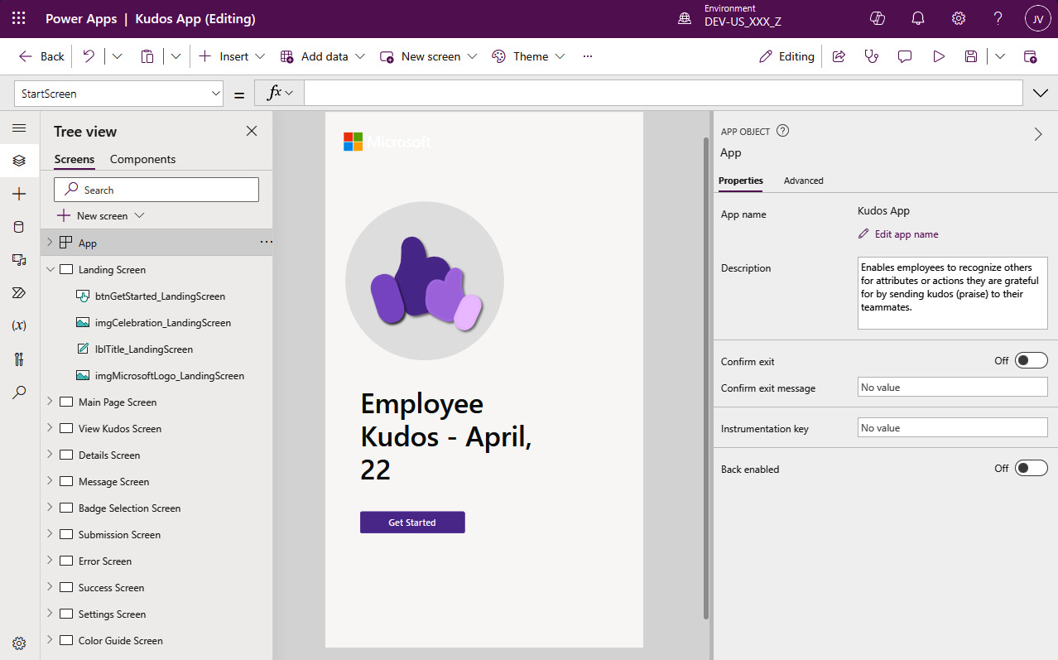

Figure 8.26 – Application Insights in Power Apps Studio

On the right side, among the properties of ****App****, we will find the ****Instrumentation key**** field, and here, we should provide the instrumentation key of our Application Insights instance. Let’s create an Application Insights instance in our Azure subscription:

# Login interactively

az login

# Select the right subscription

az account set --subscription baa70448-593c-4dc7-8a91-c92cf7eaf66e

az group create --location westeurope --resource-group KudosApp.AI.RG

****workspace=$(az monitor log-analytics workspace create \****

****--resource-group KudosApp.AI.RG \****

****--workspace-name KudosWorkspace \****

****--location westeurope --query id --output tsv)****

****az monitor app-insights component create \****

****--app KudosAppInsights \****

****--location westeurope \****

****--workspace $workspace \****

****--resource-group KudosApp.AI.RG****

The final command will return a JSON object with the ****instrumentationKey**** key as well. We can now add the key to the Kudos app and try it out to see how data is ingested into the ****Application Insights**** dashboard.

*Canvas app insights*

*To view telemetry**information, we need to enable canvas app insights in the Power Platform admin center. Go to*****Settings*****, which lists all the tenant settings, and select the*****Canvas app insights*****item. In the*****Canvas app insights*****pane on the right side, we can turn this feature on.*

Of course, we don’t want to store directly the instrumentation key in the canvas app. The simplest way to make the instrumentation key independent from the app would be to introduce a new environment variable, but at the time of writing, it is not supported for the instrumentation key property. What we can do is update our deployment pipeline and replace the instrumentation key with the correct value, stored as a ****GitHub environment variable****. In the previous sections, we saw examples of how we can use the GitHub environments and the defined variables to create environment-related customizations. If we introduce the instrumentation key, then we will find an additional ****json file**** in our solution folder – ****/src/mpa\_Kudos/src/CanvasApps/src/mpa\_KudosApp/AppInsightsKey.json****. This contains the instrumentation key that we can replace with the correct one inside our GitHub workflow.

Although we don’t have a custom chatbot in this solution, ****Microsoft Copilot Studio**** also supports this kind of integration with Azure Application Insights. We can configure the connection string of our Azure Application Insights instance under ****Settings**** in the ****Copilot details**** menu, under the ****Advanced**** tab, as shown in the following figure:

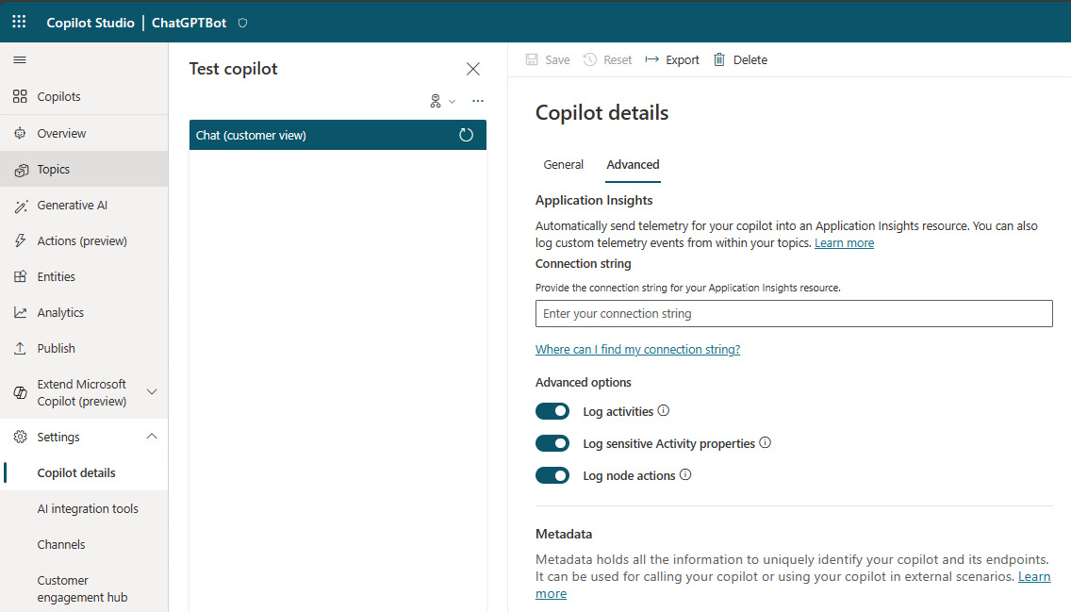

Figure 8.27 – Application Insights in Microsoft Copilot Studio

Here, we should provide the entire connection string in the following format:

InstrumentationKey=XXXXXXXX-YYYY-YYYY-YYYY-XXXXXXXXXXXX;IngestionEndpoint=https://westeurope-5.in.applicationinsights.azure.com/;LiveEndpoint=https://westeurope.livediagnostics.monitor.azure.com/;ApplicationId=TTTTTTTT-ZZZZ-ZZZZ-ZZZZ-SSSSSSSSSSSS

We can find this string in the ****Overview**** blade of our Azure Application Insights instance.

In the case of ****Power Pages websites****, we need to infuse the code snippet that tracks the user actions on the website and ingests the telemetry data into the Azure Application Insights endpoint. We just need to get the client-side JavaScript snippet available in the documentation and add it as a content snippet in our ****Power Pages management**** app:

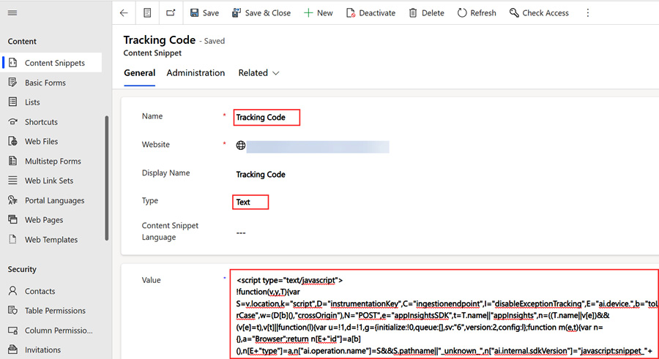

Figure 8.28 – Application Insights in Power Pages

The snippet itself is available here at <https://learn.microsoft.com/en-us/azure/azure-monitor/app/javascript-sdk?tabs=javascriptwebsdkloaderscript>, and only the connection string should be updated with our one.

Besides canvas apps, custom chatbots, and Power Pages websites, Azure Application Insights as the common APM framework for Power Platform can be used to monitor ****model-driven applications****, Power Automate cloud flows, and ****Dataverse diagnostics and performance events****. This can be done using the ****Export data to Application Insights**** feature, which is available in the Power Platform admin center if we own paid/premium Dataverse licenses. For us, it means we can create export packages that push the telemetry data from the selected environment to our Application Insights service, without infusing the endpoint or the connection string to our Power Platform assets. We don’t need to prepare or create anything in our solutions; the environment and this export job will take care of the telemetry ingestion. It is recommended to use one Application Insights instance per environment, and note that this feature is turned on and supported in managed environments only.

*Delayed ingestion of telemetry data*

*The timeframe set out in the*****service level agreement*****(*****SLA*****) for the delivery of telemetry data streams**from Power Platform products supported by this feature to Application Insights is 24 hours.*

If we want to collect real-time telemetry from these Power Platform assets, we can create our own extensions, such as the following:

* In model-driven apps, we can create a ****Power Platform Component Framework**** (****PCF****) control that is displayed in the UI and connects to the Application Insights endpoint with client-side JavaScript.
* With Power Automate cloud flows, we can use the information that is logged in Dataverse about the start time, durations, end time, status (e.g., failing, canceling, or succeeding), and executed actions of cloud flows and send it, with the help of the ****Dataverse plugin****, to the Application Insights endpoint. The other option to monitor these flows is to use the new built-in ****Automation center**** blade in Power Automate:

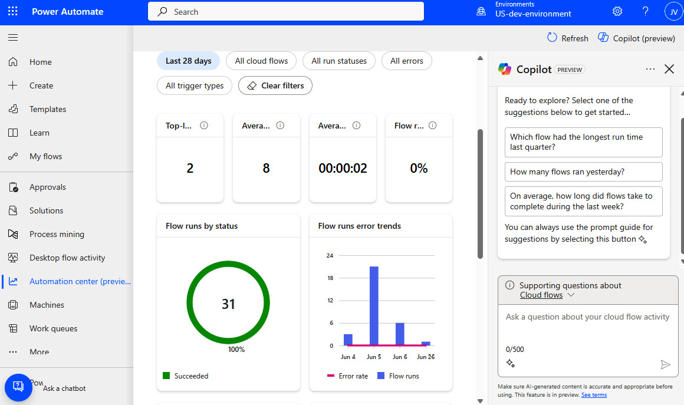

Figure 8.29 – The Power Automate Automation center

Here, we can visualize the data logged in Dataverse, and we can use Copilot on the right-hand side to get help with troubleshooting.

* With Dataverse, we can develop a ****custom Dataverse plugin**** that sends this information to the Application Insights endpoint, with the help of the ****C# SDK****.

As we have seen, Azure Application Insights is an enterprise-ready application performance management PaaS solution that we can easily integrate into our Power Platform product portfolio.

Now, we will delve into our final topic, the world of feature flags, and what they can bring to our Power Platform solutions.

# Exercise – introducing feature flags

In custom development projects, ****feature flags**** are used to turn on or off features of applications. Agile teams benefit from this concept very much because features with great impact and long development time, which span over multiple sprints, can be kept hidden from end users until they are fully developed. Consider features such as enabling the Copilot feature in Microsoft Azure or making GitHub Copilot available in public repositories. These features were developed behind feature flags before they were released to the public audience. We also very often use feature flags to turn on new features for a group of users (e.g., users who participate in beta-testing activities). The aforementioned Copilots were first available as a private preview for dedicated customers, then they went to the public preview stage, and finally, they became generally available.

The solution-specific ****environment variables**** in Power Platform can provide this feature flag capability, if we use it in front of new features. To use environment variables in Power Platform solutions as feature flags, we can follow these steps:

1. Create an environment variable within our solution. This can be done by selecting ****New**** | ****More**** | the ****Environment**** variable in the solution we are working on.
2. Set the data type for the environment variable, which can be ****Boolean****, ****Option Set****, or ****Text****, depending on what we need for the feature flag.
3. Use the environment variable in our solution components, such as Power Automate flows, Power Apps canvas apps, or custom connectors. For Power Apps, we can access the environment variable value using the ****LookUp()**** PowerFX function, and for Power Automate, we can use Dataverse’s ****Perform an outbound action**** with the action name ****RetrieveEnvironmentVariableSecretValue****.
4. Deploy our solution to different environments, and change the environment variable value according to our feature flag settings. This allows us to enable or disable certain features or functionalities based on the environment settings.

Let’s introduce a feature flag to our Kudos app solution to control which label needs to be displayed on the landing page – the original one, or the one that we created in the *Exercise – building CD pipelines and a release train* section earlier in this chapter:

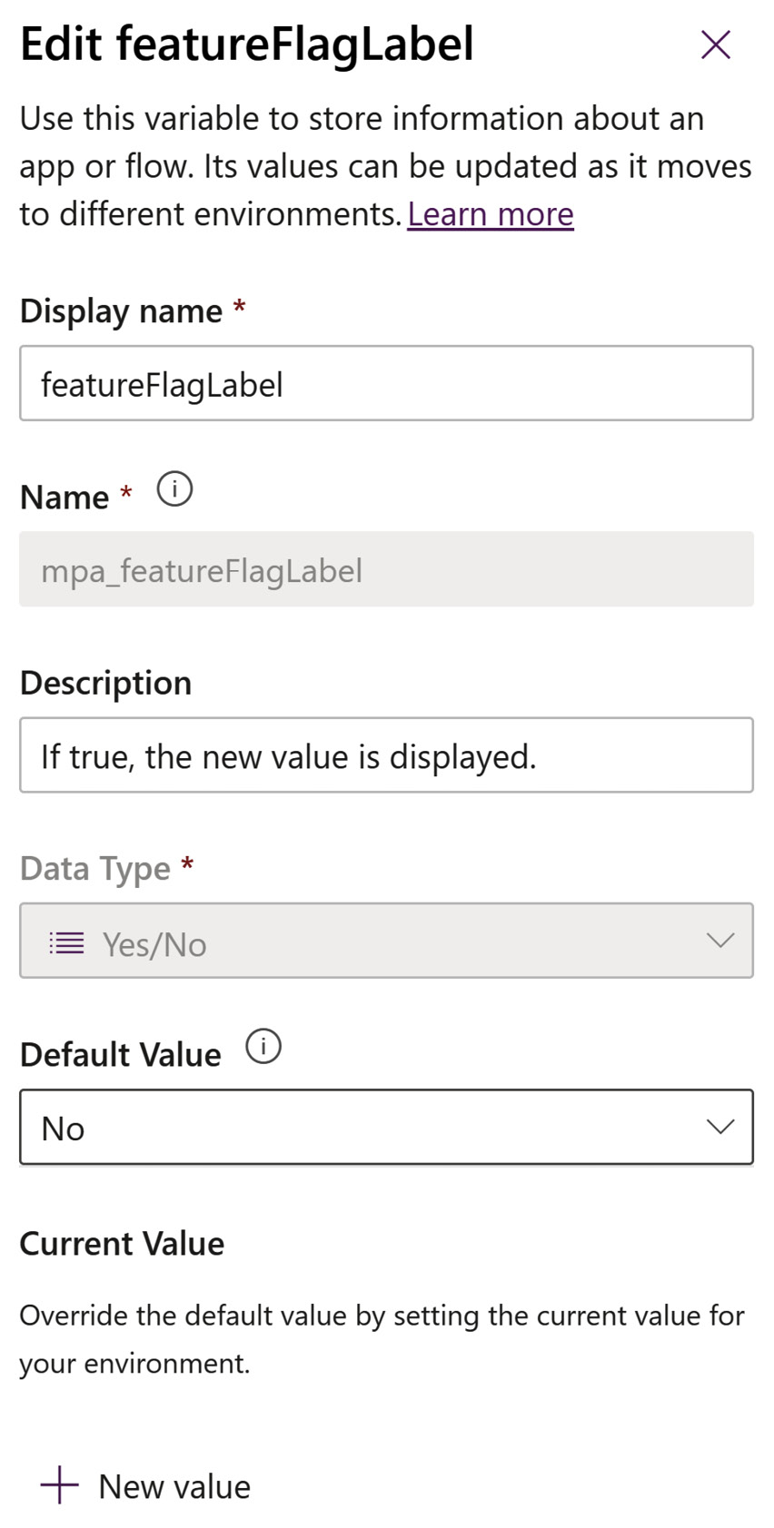

Figure 8.30 – An environment variable as a feature flag

We define this environment variable with the ****Boolean**** data type and its default value is set to ****No****. If we want to set the value in the environment, we just need to click on ****+ New value**** to set the value to ****Yes****. The environment variable is called ****featureFlagLabel****.

To read the value of an environment variable in a canvas app using PowerFX, we can use the following method:

* Make sure we have added the ****Environment Variable Values**** table to our canvas app’s data sources.
* Use the ****LookUp()**** function with the schema name of our environment variable – for example, ****LookUp('Environment Variable Values', 'Environment Variable Definition'.'Schema Name' = "YourEnvironmentVariableSchemaName").Value****.
* This will retrieve the current value of the environment variable we specified.

Let’s open our Kudos app to edit from our solution, and then introduce the new data source, ****Environment Variable Values****. After that, we need to change the ****Text**** property of ****lblTitle\_LandingScreen**** from static text to the following:

If(

****IsBlank(LookUp('Environment Variable Values', 'Environment Variable Definition'.'Schema Name' = "mpa\_featureFlagLabel").Value)****,

    "Employee Kudos",

    If(

****LookUp('Environment Variable Values', 'Environment Variable Definition'.'Schema Name' = "mpa\_featureFlagLabel").Value = "no"****,

        "Employee Kudos",

        "Employee Kudos - April 2024"

    )

)

As we learned in the first section of this chapter, deployment settings files do not only contain connection references but also environment variables. Our ****deploymentSettings.json**** file is located under ****\src\mpa\_Kudos\deploymentSettings.json****. With the help of the ****cat**** command, we have already updated this file in our GitHub workflows (*Release to Production* and *Import to dev*) regarding connection references:

newDataverseId="${{ github.event.inputs.dataverseConnectionId }}"

newO365Id="${{ github.event.inputs.o365IdConnectionId }}"

newOutlookId="${{ github.event.inputs.outlookIdConnectionId }}"

cat ${{ env.solution\_source\_folder}}/${{ env.kudos\_solution\_name }}/deploymentSettings.json | jq --arg dataverseId "$newDataverseId" --arg o365Id "$newO365Id" --arg outlookId "$newOutlookId" '****.ConnectionReferences[]**** |=

         if .ConnectionId == "[Dataverse]" then .ConnectionId = $dataverseId

         elif .ConnectionId == "[O365]" then .ConnectionId = $o365Id

         elif .ConnectionId == "[Outlook]" then .ConnectionId = $outlookId

        else . end' > temp.json && mv temp.json ${{ env.solution\_source\_folder}}/${{ env.kudos\_solution\_name }}/deploymentSettings.json

Similarly, we can update the values of environment variables in this JSON file to fully automate them in our deployment pipelines. We just need to replace the ****.ConnectionReferences[]**** array with the ****.EnvironmentVariables[]**** one to adjust our variables.

In this section, we learned how we can use environment variables to add feature flags to our applications and cloud flows.

# Summary

In this chapter, we embarked on an exciting journey, diving into the practical application of DevOps and ALM principles. We explored a variety of hands-on exercises, from mastering repository branch strategies to constructing robust CD pipelines, managing backlogs effectively, and enforcing branch protection rules. We also delved into automated testing of our solutions, monitored our application’s performance in runtime with APM, and harnessed the power of feature flags. These exercises were not just theoretical; we also applied them to a real-world example, utilizing GitHub as our DevOps tool of choice. Through these practical walkthroughs, we’ve woven every thread of DevOps and ALM into a[hands-on experience tapestry.](https://learn.microsoft.com/en-us/power-platform/enterprise-templates/overview)

[In the forthcoming chapter, we will delve into](https://learn.microsoft.com/en-us/power-platform/enterprise-templates/overview)fusion architecture and see how we can leverage Azure PaaS services in our Power Platform solutions.

# Further reading

* Power Platform Enterprise template: <https://learn.microsoft.com/en-us/power-platform/enterprise-templates/overview>
* Kudos application: <https://learn.microsoft.com/en-us/power-platform/enterprise-templates/hr/employee-kudos/install-and-set-up>
* The GitHub CLI: https://github.com/cli/cli
* The GitHub CLI with GitHub Copilot: <https://docs.github.com/en/copilot/github-copilot-in-the-cli/using-github-copilot-in-the-cli>
* Pre-populate connection references: <https://learn.microsoft.com/en-us/power-platform/alm/conn-ref-env-variables-build-tools#get-the-connection-reference-information>
* GitHub environments: <https://docs.github.com/en/actions/learn-github-actions/variables#using-the-vars-context-to-access-configuration-variable-values>
* GitHub outputs: <https://docs.github.com/en/actions/using-jobs/defining-outputs-for-jobs>
* GitHub jobs and needs: <https://docs.github.com/en/actions/using-jobs/using-jobs-in-a-workflow>
* GitHub composite actions: <https://docs.github.com/en/actions/creating-actions/creating-a-composite-action>
* GitHub pull requests: <https://docs.github.com/en/pull-requests/collaborating-with-pull-requests/proposing-changes-to-your-work-with-pull-requests/about-pull-requests>
* GitHub Marketplace: <https://github.com/marketplace>
* Power Apps Test Engine: <https://learn.microsoft.com/en-us/power-apps/developer/test-engine/overview>
* Working with Power Apps Test Studio: <https://learn.microsoft.com/en-us/power-apps/maker/canvas-apps/working-with-test-studio>
* Azure Application Insights overview: <https://learn.microsoft.com/en-us/azure/azure-monitor/app/app-insights-overview>
* Metric alerts: <https://learn.microsoft.com/en-us/azure/azure-monitor/alerts/tutorial-metric-alert>
* Action groups: <https://learn.microsoft.com/en-us/azure/azure-monitor/alerts/action-groups>
* Power Apps with Application Insights: <https://learn.microsoft.com/en-us/power-apps/maker/canvas-apps/application-insights>
* An overview of Application Insights integration: <https://learn.microsoft.com/en-us/power-platform/admin/overview-integration-application-insights>
* Export data to Application Insights: <https://learn.microsoft.com/en-us/power-platform/admin/set-up-export-application-insights>
* Power Pages and Application Insights: <https://learn.microsoft.com/en-us/power-pages/go-live/telemetry-monitoring>
* Environment variables: <https://learn.microsoft.com/en-us/power-apps/maker/data-platform/environmentvariables>
* Power Automate automation center: <https://learn.microsoft.com/en-us/power-automate/automation-center-overview>

# Part 3:Exploring DevOps Best Practices and the Road Ahead

In this part, we will be exploring the possibilities of building fusion teams, where pro developers and DevOps engineers can help with the low-code/no-code development approach. We will understand how culture plays a significant role in faster development cycles and the importance of building reusable components. We will look at how Microsoft Azure cloud services can integrate with Power Platform solutions. Pro developers will understand how extensible Power Platform is with the ability to utilize custom code components that can extend the capabilities of Power Platform. We will conclude this chapter by investigating how artificial intelligence has changed the way we develop our business applications and how it enables us to build custom copilots that not only support our DevOps process but also enrich our business solutions.

This part has the following chapters:

* *[Chapter 9](https://learning.oreilly.com/library/view/mastering-devops-on/9781835880845/B22208_09.xhtml" \l "_idTextAnchor149)*, *Implementing the Fusion Development Approach*
* *[Chapter 10](https://learning.oreilly.com/library/view/mastering-devops-on/9781835880845/B22208_10.xhtml" \l "_idTextAnchor172)*, *Enabling Pro-Dev Extensibility in Power Platform*
* *[Chapter 11](https://learning.oreilly.com/library/view/mastering-devops-on/9781835880845/B22208_11.xhtml" \l "_idTextAnchor208)*, *Managing the Environment Life Cycle with Design Best Practices*
* *[Chapter 12](https://learning.oreilly.com/library/view/mastering-devops-on/9781835880845/B22208_12.xhtml" \l "_idTextAnchor231)*, *Looking Ahead with Copilots, ChatOps, and AI-Infused Applications*

# 9

# Implementing the Fusion Development Approach

Power Platform, with its low-code/no-code approach, allows citizen developers who are close to business processes to use their knowledge of the business problem to design and bring new applications to usage faster. It often can happen, that the challenges they are facing scale to be more complex or the feature demand surpasses their capabilities, thus pro-developers are required to support the development process and help citizen developers avoid repetitive tasks.

In this chapter, we will look at how organizations can connect different personas to build effective teams that will work together to solve challenges and enable organizations with digitized business solutions. We will start by focusing on the general understanding of the fusion development approach and how teams are represented by different personas. We will continue with some good open source development practices that can be applied also in low-code/no-code and drill into a tool in Power Platform that supports them.

The final part will focus on the integration between the Azure cloud and Power Platform. The emphasis here will be on specific Azure services, such as the Azure API Management service, which serves as the integration service between Azure and Power Platform. Some other common Azure services that are often used in the integration scenarios with Power Platform will be covered as well. We will finish off by looking into an example of building an integration between a low-code application and a code-first solution.

We will cover the following main topics in this chapter:

* What is the fusion development approach?
* Microsoft Azure and Power Platform together
* Example of an Azure and Power Platform integration scenario

# Technical requirements

This chapter connects Power Platform solutions together with Azure services. To follow along, we recommend having these requirements in place:

* ****Power Platform subscription****: You can sign up for a Power Platform Developer Plan (<https://powerapps.microsoft.com/en-us/developerplan/>) if you already have a Microsoft Entra ID work account, or you can join the Microsoft 365 Developer Program (<https://developer.microsoft.com/en-us/microsoft-365/dev-program>).
* ****Azure subscription****: You can provision a free Azure account following the guidance on this website: <https://azure.microsoft.com/en-us/free>. Once provisioned, the Microsoft Azure portal can be accessed via the following URL: <https://portal.azure.com/>.
* ****Visual Studio****: If you do not have access to any other version of Visual Studio, you can use the free Community Edition (<https://visualstudio.microsoft.com/vs/community/>). Some examples demonstrate the capabilities of Power Platform tools for Visual Studio that are not available in Visual Studio Code. For other cases, you can also use ****Visual Studio Code**** (****VS Code****) with the ****Power Platform Tools**** extension. VS Code can be found here: <https://code.visualstudio.com/>.
* ****Samples**** discussed in this chapter are located in the following repository: <https://github.com/PacktPublishing/Mastering-DevOps-on-Microsoft-Power-Platform/tree/main/Chapter09>.

# What is the fusion development approach?

This section covers how individuals from different teams collaborate to realize projects through a concept known as the ****fusion development approach****. We will explain what this is and how it bridges the gap between citizen developers and pro-developers. We will explain how Power Platform can also benefit from the practices coming from the open source development world, and finish off by preparing our development environment to be connected with Power Platform.

Fusion development involves merging diverse teams and their skillset, to facilitate the digitization of business capabilities and deliver value. It is a term that was first defined by Gartner as a multidisciplinary digital business team that blends technology and business domain expertise and is responsible for delivering digital products. Gartner’s research showed that implementing distributed fusion teams can help speed up the progress of realizing the organization’s digital transformation agenda much faster compared to the traditional centralized teams. You can read more about Gartner’s research in the article published on this page: <https://www.gartner.com/en/articles/why-fusion-teams-matter>.

In the world of Power Platform, the fusion development approach blends together a low-code/no-code development approach with a traditional software development approach and IT operations for managing resources and platforms. The purpose of these multidisciplinary teams working together is to take advantage of the knowledge that teams have and use that to scale the application modernization or the digitization of the business processes with the use of low-code/no-code tools. It helps organizations succeed with business transformation in a fast-changing business environment, where it is imperative to have business solutions available in the market soon enough to gain a competitive advantage.

We can group team members of fusion teams into three different persona groups:

* ****Citizen developers****: This group consists of people who have business knowledge, understand the business processes and the business challenges, and are determined to digitize existing business processes. Here, we can find business users, business analysts, and business engineers. They will be using tools that support low-code/no-code development approaches, such as Microsoft Power Platform, to visually design and build certain parts of the project. This could be building a frontend prototype of the application in Power Apps or workflows that support business processes in Power Automate.
* ****Professional developers****: This is a group of skilled professional developers who are experienced in various programming languages that will be used to solve complex application development challenges. Using traditional software development tools, such as Visual Studio, they will primarily be building extensions for low-code solutions. Their work will focus on developing backend APIs, integration scenarios, or custom code components that will be used by citizen developers in their low-code/no-code projects. Where possible, it is recommended that professional developers also use the same low-code development tool as citizen developers, to support the development of simpler tasks and to integrate custom solutions into the newly developed solution.
* ****IT professionals/DevOps engineers****: The last group is where we will find IT professionals, who will look after the resources that will be running newly built business applications in order to be used in a managed and governed way, aligned with organizational IT policies. In this group, we will find DevOps engineers, who will be responsible for managing the DevOps processes of the business solution. They will make sure the project is aligned with DevOps practices, such as having CI/CD pipelines up and running and ensuring that all components of the business solution are properly version-controlled.

The following figure shows how the personas are all connected and work together to achieve the goal of building a business solution:

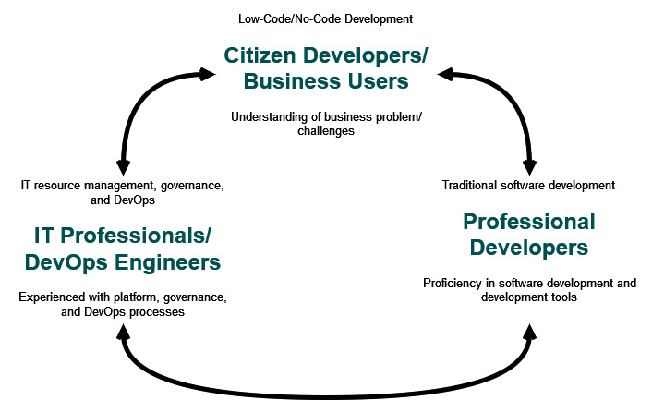

Figure 9.1 – The fusion development approach

Additionally, we should introduce two more personas in the fusion development approach that will bring benefit to the fusion team.

The first one is the ****fusion team leader****. Their role is to oversee the entire project development and coordinate team members, taking care of the communication and the project delivery.

The second one is the ****solution architect**** role. It is recommended to include a solution architect in the planning and designing phase of the project, as they will dive into the technical details and help with creating a high-level architectural design of the solution, take care of the design patterns, share recommendations on the tools and technology selection, and more.

The recommendation for the fusion team size is very similar to the general recommendation for the agile team size. There is no one-size-fits-all; it will all depend on the project’s complexity and organizational maturity. However, we should keep the fusion teams *small* in size in order to maintain the autonomy and agility of the team.

Somewhere between 5 and 7 people in a team is considered the appropriate agile team size. This is many times linked to Amazon’s *two-pizza rule* which states that the teams should be small enough to be fed by two pizzas. Smaller teams allow communication and collaboration to be efficient while maintaining agility. This includes the ability to rapidly adapt to the challenges the team is facing, without introducing necessary bottlenecks.

The fusion team itself may be a temporary, ****short-lived team****. Its purpose could be to solve a particular business problem and once this is done, the team disperses and team members continue their normal work routine – for example, citizen developers, who could be business users and business analysts, will continue their work, while software developers might go back to another traditional software development project.

As mentioned, in some ways, fusion development overlaps with an agile culture. The fusion development approach follows the lean methodology, which we described in *[Chapter 1](https://learning.oreilly.com/library/view/mastering-devops-on/9781835880845/B22208_01.xhtml" \l "_idTextAnchor014)*. The idea of the lean methodology is to focus on delivering value in a fast iterative development. Fusion teams can work in sprints to track and deliver work, using DevOps tools and project planning tools, such as Azure Boards.

## Common examples of the fusion development approach in Power Platform

Fusion teams come together to solve business problems. During the planning and design phase, these challenges are thought through and tasks are divided between the stakeholders. Next, we will provide a couple of examples of how, with a fusion approach, pro-developers and citizen developers can tackle these problems with technological solutions.

### Custom connector to backend API

We often see in organizations that there are already a set of systems and services that are being utilized in legacy applications and business processes. If we wish to modernize only our frontend application or build an entirely new application from scratch, but utilize some of the backend services, we can use custom connectors in Power Platform to connect backend services with the Power Platform applications. Building custom connectors in Power Platform helps organizations unlock access to those APIs from different Power Platform services and allows makers to reuse them for any potential new scenario.

If we are building new APIs, we can keep in mind that they might be used in Power Platform. Therefore, building and using custom connectors is a common practice when building applications, flows, and copilots with Power Platform services. From the roles perspective, as an example, we might see professional developers building new Web APIs, citizen developers utilizing them in Power Apps applications, and IT operations taking control of managing Power Platform environments, building data loss prevention policies, and describing required infrastructure, using an ****infrastructure as code**** (****IaC****) approach, which will be used to provision the required infrastructure, including Azure API Management, to run supporting services. DevOps engineers would, together with pro-developers, make sure that the CI/CD pipelines are configured to build and deploy applications and APIs in an automated way.

Once a custom connector is built and deployed to Power Platform, we can reuse it in Power Automate to bring the capabilities of our legacy systems and services into the business logic that the Power Automate flow is implementing.

Copilot Studio now also offers the ability to use connectors, including custom connectors directly within the custom copilot.

### Extending with PCF control

Sometimes, controls that are available out of the box in Power Pages or Power Apps, canvas, and model-driven apps might not be enough. Maybe we are looking for a graphically richer component or just a custom component that does a very specific job. In this case, we can reach out to pro-developers to support us by building custom code components with ****Power Apps Component Framework**** (****PCF****). PCF components are reusable and enrich the user experience.

This is another good example of where pro-developers utilize their skills in software development. By using the TypeScript programming language, they develop a component that citizen developers can add to their applications built in Power Apps or websites built with Power Pages, to improve the user experience or enable certain additional business scenarios.

While the previous example with custom connectors allowed pro-developers to be almost separated from Power Platform as they were focusing only on Web APIs, with code components, pro-developers should know about Power Platform since each application type (canvas, model-driven, or website/portal) has its own set of development best practices and limitations.

### Enabling complex skills in custom copilots

Another example of the fusion approach is related to building custom copilots or bots in Copilot Studio. Copilot Studio allows extending capabilities of custom copilots with Power Automate flows, connectors, plugins, and Copilot framework skills. If using existing connectors and building flows that integrate with Copilot Studio is something that can be done by a citizen developer, building skill actions requires the involvement of pro-developers.

A skill is a bot that can perform a set of actions for another bot/skill consumer, which is often a user-facing bot. It supports multi-turn operations, such as making a product order, as opposed to integrations with Power Automate flows, which allow single-turn operations, such as getting the status of a parcel.

In this case, pro-developers will be using the Copilot framework SDK to build a skill that will be then used by citizen developers in a user-facing custom copilot bot that will be built in Copilot Studio.

All these examples have one thing in common – reusability. Let’s take a look at how building a catalog in Power Platform can help with the discoverability and reusability of the built components.

## Empowering collaboration with open source development practices

Organizations will move at a rapid pace to implement new applications, flows, or chatbots. Fusion teams will develop many components in Power Platform that can be reusable in other projects instead of wasting time on reinventing the wheel. How can we remove silos in the organizations and empower any developer, no matter whether they are pro-developers or citizen developers, to understand what has already been done and allow them to reuse that in their own projects? Before answering this question, let us step back a bit and see how this has been solved in the traditional software development world.

Not too long ago, many organizations were very closed, independently working on projects without collaboration. This led to duplicated efforts and inefficiencies in the development processes. Teams were isolated and collaboration and communication were very poor or non-existent. We also sometimes experienced resistance to new ideas or practices that could lead to changing the way teams operated.

However, if we look at the software development practices in the open source world, we can see how open source software is potentially shared with anyone, open for use and modifications. Practically anyone can review the project, and modify and reuse the open source software. The goal of such an approach is to build code that is more reliable and better.

This is where we need to introduce ****InnerSource****. InnerSource is a development methodology that takes the good practices of open source software development and applies them to a closed group – employees of an organization. This would mean that software development projects become private open-sourced projects of an organization.

The interesting thing is that this kind of development approach, which uses DevOps tools such as Azure DevOps and GitHub, can be used for any kind of project, even outside of software development.

InnerSource brings a modern approach to software development and helps us to remove challenges that older and more rigid ways of building proprietary software have on an organization. Collaborating openly in the organization will help improve innovation since more people can collaborate and contribute to the project. Developers don’t always have to build projects from the beginning, as InnerSource helps with ****discoverability****. It may be that something already exists within our organization that can be reused. This will drive rapid development, decrease development costs, and improve time to market. It will improve collaboration and, most importantly, foster a culture of openness.

The annual research that is done by the InnerSource Commons Foundation, called the *State of InnerSource Report* (available at <https://innersourcecommons.org/>), identifies the benefits and blockers of InnerSource. Common blockers for not applying InnerSource practices are due to the organizational culture, siloed thinking, and lack of awareness and familiarity with Innersource principles. This is why it is important to make sure developers get familiar with these practices and there is a buy-in for this strategy in the organization, which will help us allocate resources and time for implementing and unlocking the benefits of InnerSource within the organization.

These good practices can also be applied to the low-code/no-code development approach.

Fusion development teams – more specifically, pro-developers and DevOps engineers – perform many tasks with DevOps tools, such as Azure DevOps and GitHub, where the InnerSource approach is at the heart of the product. Tools such as Azure Boards or GitHub Issues enable developers to bring up ideas for new features, report bugs in the product, comment on tasks, and more. Pull request mechanisms enable better results, as build validations and peer reviews make sure the final artifact meets all requirements. To further support good DevOps practices, companies can expand their set of tools with products such as Microsoft Teams to improve communication and collaboration of fusion teams and implement ChatOps.

Services and features of DevOps tools are built in a way that helps organizations enable and foster InnerSource more easily. For an organization to understand whether they are moving toward the desired goal, they should implement periodic reviews to understand how InnerSource is being adopted.

## Building a catalog process

When working on a business solution for Power Platform, we should also consider how to follow InnerSource best practices, allow fusion teams to share their work, and allow other teams to reuse components and built templates. While opening projects in Azure DevOps and GitHub would allow pro-developers to understand which projects are available in the organizations, we cannot expect our business users to follow the same steps as pro-developers. There is another way to share our work with anyone in the organization.

The ****catalog**** in Power Platform is the single source of truth of all components and templates that were deployed to the catalog to be cataloged and reused. It is presented as a model-driven app within Power Apps and it helps us understand what is already available in the organization. The Power Platform catalog is not a version control system and does not replace DevOps tools for version control and CI/CD pipelines. However, it does enhance the ALM/DevOps processes as it supports the automation scenarios through the PAC CLI commands, as we have seen in an example in *[Chapter 6](https://learning.oreilly.com/library/view/mastering-devops-on/9781835880845/B22208_06.xhtml" \l "_idTextAnchor103)*.

Components and templates are represented in the catalog as items. Pro-developers and citizen developers will use the catalog to understand which existing items are available in the organization and who has published them. It will serve also to find and reuse components in new projects or start by using the built templates. On the other hand, the IT operations team will use the management capabilities of the catalog to control the usage of code components and templates.

We recommend starting by installing one catalog in the organization. However, there are cases when an organization needs to install more than one catalog in the Power Platform tenant – for example, if an organization has very sensitive projects that have to be isolated from others. In this case, another catalog should be installed to provide the level of isolation needed.

*Preview functionality*

*Note that as**of the time of writing,*****Catalog in Power Platform*****is a preview feature and so has some limitations in functionalities, such as, for example, that it cannot be utilized in an environment that uses a customer-managed key. During preview, the catalog can be used in all types of environments, but when released to general**availability, this will only be available in the*****managed*****environments.*

### Catalog process

Catalog in Power Platform follows a process life cycle from the creation of catalog items to the acquisition phase when a new team reuses the previously developed catalog item.

It starts with the fusion team of pro-developers and citizen developers creating components and building catalog items with all the components that solved their initial business challenges. These catalog items also include configuration parameters that would be required for the catalog item to be properly configured.

These catalog items are then submitted to the catalog for reuse purposes. Once submitted, IT administrators and line-of-business approvers will review these new catalog items and approve them accordingly.

Other pro-developers and app makers will use the catalog to find existing solutions and templates. Those catalog items that seem fit for their business problem will be reused. In order to finish the configuration, makers have to provide all necessary configuration parameters and establish required connections. After that, this catalog item is successfully provisioned in their environment. Now, they can reuse the components in their own solutions that they are building.

### Starting with the Catalog Manager

Before we can start using Catalog in Power Platform, we must first install it from Microsoft AppSource. We should have a *system administrator* security role assigned in the environment to be able to install the Catalog Manager. The Catalog Manager will be installed in a Dataverse environment, which should have a minimum database version of ****9.2.22122.00148****. We can check the Dataverse version in the ****Version**** card inside the environment settings. We need to first open ****Power Platform admin center**** | ****Environments**** and then select the environment and the ****Version**** card.

We recommend having a separate Power Platform environment that will be used for the catalog. This allows anyone to access the environment and review the catalog items as well as install catalog items from this catalog to their environments.

Once we have cleared all the prerequisites, we can proceed to the installation.

We have the option to install the Catalog Manager via the PAC CLI. In order to do this, we first connect to the Power Platform environment where we would like to install it. There, we use ****pac application list**** to find all applications that are available in our tenant. One of these will be ****Catalog in Power Platform Manager****, with the unique name ****mspcat\_CatalogManager**** or a GUID of ****83a35943-cb41-4266-b7d2-81d60f383695****. This unique name or GUID can be used to install the application in the current environment by using ****pac application install --application-name mspcat\_CatalogManager****. To install the application to a different environment, switch ****--environment <ENV\_ID>**** with the appropriate environment ID or URL. To verify that we have installed the catalog in our tenant, we can use ****pac admin list --application 83a35943-cb41-4266-b7d2-81d60f383695****, which will return information on the environments where Catalog Manager is installed.

If we would like to install this application using the UI, we will need to use this link directly to install it: <https://appsource.microsoft.com/product/dynamics-365/powerappssvc.catalogmanager-preview?flightCodes=dde212e5c66047c59bf2b346c419cef6>. When prompted to sign in to Microsoft AppSource, we need to do so with our system administrator and confirm the installation by clicking ****Get it now****. This takes us to ****Dynamics 365 apps**** inside ****Power Platform admin center**** to complete the installation process. As a final step, we need to select an environment in which this application will be installed. We need to agree with the terms and privacy statements and then we can click ****Install**** to install the app. The process of installation takes a couple of minutes.

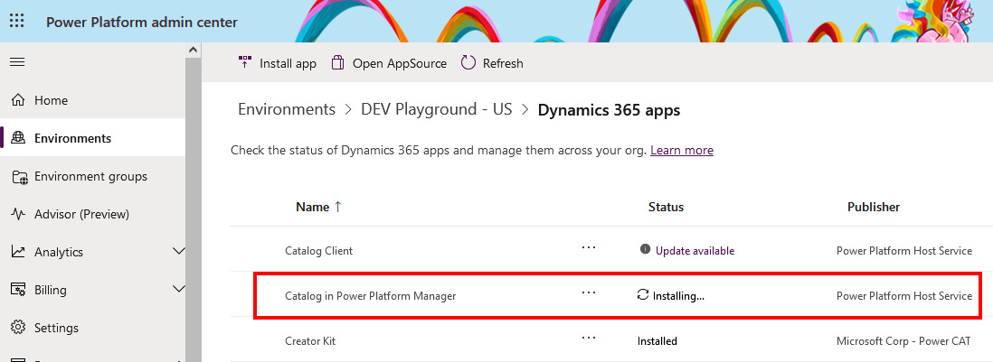

Figure 9.2 – Installing the Catalog Manager app

The installation process installs a new Power Apps application. After installation is done, we will need to configure the catalog metadata. First, we need to run the Catalog Manager. Accessing the Catalog Manager is done through Power Apps. We can find the application in the list of apps in the corresponding environment. Simply go to ****Power Apps**** | ****Apps****, hover over the ****Power Platform Catalog Manager**** app name, and click on the *play* icon to run the application, or click on the three dots next to the name and then click ****Play**** to run the application.

Now that we have the application running, we can configure metadata by opening the configuration group. In the left navigation bar, at the very bottom, click ****Catalog****, which opens an option to select an area; from there, click ****Settings****. This will open the configuration group, where we have options to configure ****Catalog****, ****Rule sets for PowerApps checker****, ****Static Analysis Policies****, and ****Configurations for PowerApps checker****. Clicking ****Catalog**** will open ****Catalog Configuration****, as can be seen in *Figure 9.3*. Here, we can change the catalog name, description, help link, and image to help us identify the catalog. On the right, in ****Catalog Configuration****, we have the option to enable the catalog, allow unmanaged solutions (future feature plans) to be deployed to the catalog, and enable global auto-approval for the published catalog items on the catalog level. This final setting of auto-approval, if configured on a global level, will override the setting on the publisher level.

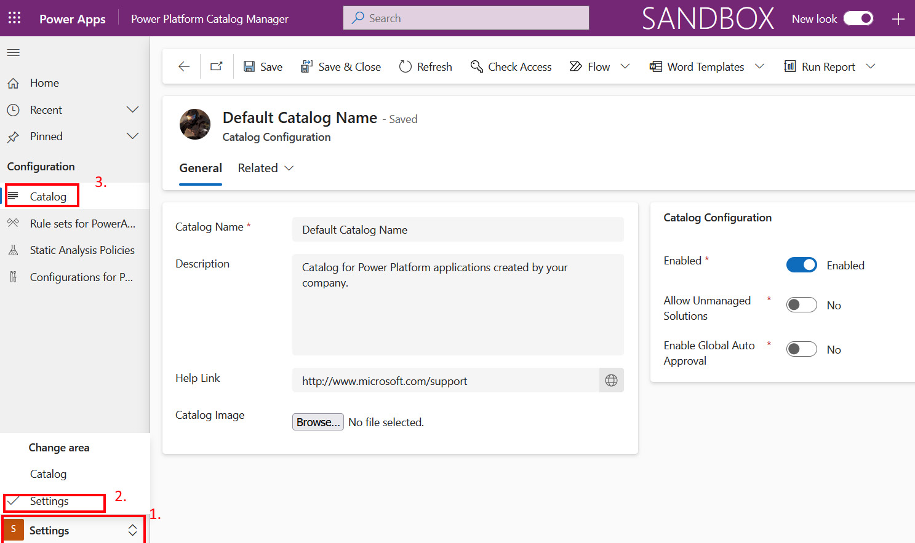

Figure 9.3 – Catalog metadata and configuration

To return to the main ****Catalog**** area, we can click on the ****Home**** navigation in the left navigation bar. Among other things, here we will find individual dashboards with action items, an ****Approvals**** section with all the approval requests, ****Catalog**** section with published catalog items, and the deployment history. Details of each section and explanation can be found here: <https://learn.microsoft.com/en-us/power-platform/developer/administer-catalog>.

### Publishing a new catalog item

Let’s say we have successfully built a solution that we would like to publish to a catalog and allow its reuse. To publish an item to the catalog, we need a solution or package deployer package with items that we wish to publish as well as a submission metadata JSON file.

We will be using the PAC CLI to perform operations with the catalog item. As we are already used to doing, we will start our terminal and run the ****pac auth create**** command to create an authentication profile (if we do not have one yet) or reuse an existing authentication profile. We can check the existing authentication profiles by using the ****pac auth list**** command. Keep in mind that when we need to connect to an environment with the catalog in which we would like to publish items, we use the ****pac auth create –-environment**** or ****-env**** switch with the name or ID of the environment in which the catalog is installed.

Using ****pac catalog list**** will show us all published catalog items.

Now, we are ready to publish new items to the catalog. We will use the ****pac catalog create-submission**** command to generate a default submission metadata JSON document called ****submission.json**** in the current operating folder of your terminal (to change the path, we can use the ****--path**** switch). We need to edit this file to prepare it for the catalog item that we plan to submit.

*Note*

*This command is also subject to change when this preview feature comes closer to general availability. Use*****pac catalog --help*****to find a list of all possible commands.*

The submission metadata JSON file contains submission attributes that we need to update to match our catalog item. An example file, created using the previous command, looks similar to this:

{

  "modelVersion": "1.0.0.0",

  "sourcePortal": 526430000,

  "operation": "CreateOrUpdate",

  "businessJustification": "Business Justification",

  "publisherDetails": {

    "publisherId": "742d02b8-59ad-4aa4-b95a-bd41cd0459ed",

    "publisherDisplayName": "Publisher Display Name"

  },

  "catalogItemDefinition": {

    "id": "1cd8fe87-f508-42ad-8dcd-d12dda7d8668",

    "displayName": "Catalog Item Display Name",

    "description": "Catalog Item Description",

    "offer": {

      "type": "Component\_Collection",

      "deploymentType": "Normal",

      "engineeringName": {

...},

      "supportName": {...}

    },

    "packageFile": {...}

  }

}

From the submission metadata file, four attributes are required for submission: publisher, catalog item, engineering contact, and support contact.

The publisher attributes are in the section in JSON described as ****publisherDetails****. They are one or more Microsoft Entra ID groups, which will allow users who are part of that group to update catalog items in the future. When we think of ****publisher****, this can be a fusion development team that is working on a specific project or a group of developers who are part of a specific department in the organization. We recommend providing ****publisherID**** and ****publisherDisplayName****, as these are used to verify whether the publisher already exists.

The catalog item is the solution that we plan to publish. We need to provide ****id**** and ****displayName**** as well as ****engineeringName**** and ****supportName****, as these are required attributes. The engineering contact helps those who would like to reuse the catalog item to understand who to contact in case of any additional questions about the item. The support name helps identify who can offer support if there are any technical issues with the catalog item.

A full description of attributes can be found on this documentation page: <https://learn.microsoft.com/en-us/power-platform/developer/submit-catalog-items>.

### Example – submitting items to the catalog

Imagine we have a template app, built as a canvas app in Power Apps. This will represent our templatized canvas app. Along with the app, we could also have additional components as part of the solution, such as flows, Dataverse tables, and more. All of that is packaged in a solution.

From the catalog process perspective, in the creation stage, we are working on our solution. In the previous chapters, we have already seen how we can create packages as part of the ALM process. Now, once we have the exported solution ready, we can create a submission JSON file by running a ****pac catalog create-submission**** command. We will need to update the submission attributes to correctly reflect our catalog item. We will update the business category, provide publisher details, and modify the catalog item definition, by providing the ID, display name, description, contacts, and other required attributes. An example of a submission JSON file for an example solution is uploaded in a chapter folder in the book’s GitHub repository (<https://github.com/PacktPublishing/Mastering-DevOps-on-Microsoft-Power-Platform/tree/main/Chapter09>).

When we are ready with the JSON file and would like to start the ****submit**** process, we use ****pac catalog submit --path <submission JSON file location> –-solution-zip <solution file location>****.

If we would like to submit to a catalog in a different environment, we can add the **–**environment**** switch to the command and specify the environment. This will produce an output similar to the following one:

**PS E:\PACKT\CH9> pac catalog submit -p .\claims-submission.json -sz .\Claims\_managed.zip**

**Connected as <your\_user@domain>**

**Connected to... <your environment name>**

**Creating package for catalog submit request...**

**Tracking ID for this submission is 9dc32d51-9de4-ee11-904d-000d3a1e7712**

We can check the status of the submission using the ****pac catalog status --tracking-id <submission tracking id> --type submit**** command. If we are submitting to a different environment, we need to also provide the environment name to the command. The ****type**** parameter allows us to check the status of ****install**** and ****submit**** operations. The preceding command would generate a similar output to the following, which also demonstrates the use of short aliases for tracking ID and type:

**PS E:\PACKT\CH9> pac catalog status -id 9dc32d51-9de4-ee11-904d-000d3a1e7712 -t submit**

**Connected as <your\_user@domain>**

**Connected to... <your environment name>**

**Status of the Submit request: Submitted**

If the status is ****Failed Prevalidation****, we can check the details of the error in the Catalog Manager, under ****Failed Pre-Validation****.

Now that we see our status as ****Submitted****, the second stage of the catalog process (submit) is complete and we are moving to the next stage (approve and store). Our catalog items are submitted for approval. The approval can be seen in the Catalog Manager application either in the dashboard section of ****Approval Request Status**** or in ****Approvals**** | ****Request****.

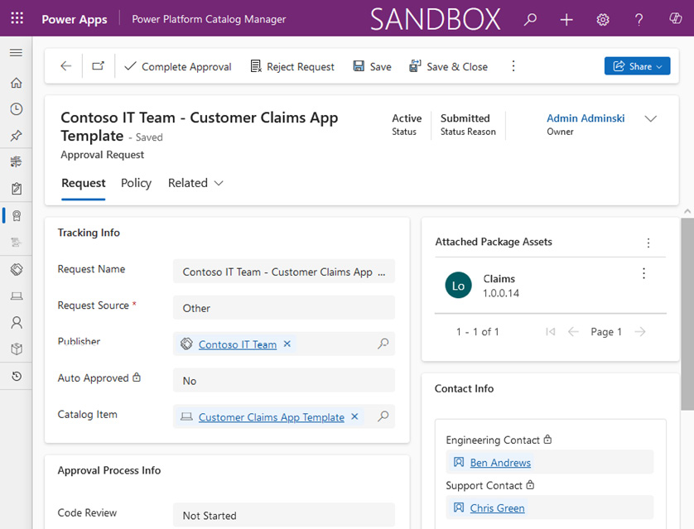

Figure 9.4 – Approval request for submitted catalog items

Once the catalog item gets approved, it gets stored in the catalog and can be found by going to the Catalog Manager and navigating to ****Catalog Items****. Publishers will also be visible in ****Catalog Publishers**** and engineering and support contacts are added to the ****Contact Info**** list.

Pro-developers will find a convenient attribute in the catalog item details that can provide a ****Code Repository**** link, which can be found in the ****Links and Legal**** section of the catalog item. This allows us to inform pro-developers where the source code is located, which only improves the InnerSource methodology described earlier, as now pro-developers can also review the code and contribute to the development process.

### Example – installing a catalog item from the catalog

We are moving now to the discovery phase of the catalog process. Here, app makers or pro-developers review the catalog or use the PAC CLI to list any catalog item from a given catalog by using the ****pac catalog list**** command. This returns all catalog items inside an environment. We can also use ****--catalog-item-name**** or ****--catalog-item-id**** as an additional search mechanism, to find only specific catalog items by name or ID.

Once we have reviewed the catalog items and are determined to test them out in our development environment, we can install an item by using ****pac catalog install --catalog-item-id <catalog-item-id> --environment <your environment guid or absolute https URL>****. This moves us to the final stage of the catalog process, called acquisition.

Keep in mind that if we plan to install the catalog item in another environment, we need to have the Catalog Manager installed in that environment as well.

Once we run the command, we will get output similar to this:

**PS E:\PACKT\CH9> pac catalog install -env https://<orgid>.crm.dynamics.com/ -cid 1cd8fe87-f508-51ad-8dcd-d12dda7d8668**

**Connected as <user@domain>**

**Connected to... <your environment name>**

**Tracking ID for this installation is 34f8e610-a7e4-ee12-904d-000d3a1d5312**

To discover, review, and install available catalog items using the UI, app makers can also go to Power Apps or Power Automate and click ****More**** | ****Catalog**** in the left navigation bar (be informed that this functionality is currently in public preview). This will open the ****Catalog**** area where we can search across all available catalog items within one or more catalogs in our tenant. Here, we will find all reusable published catalog items and information about personal activity in either acquiring catalog items or submitting new catalog items.

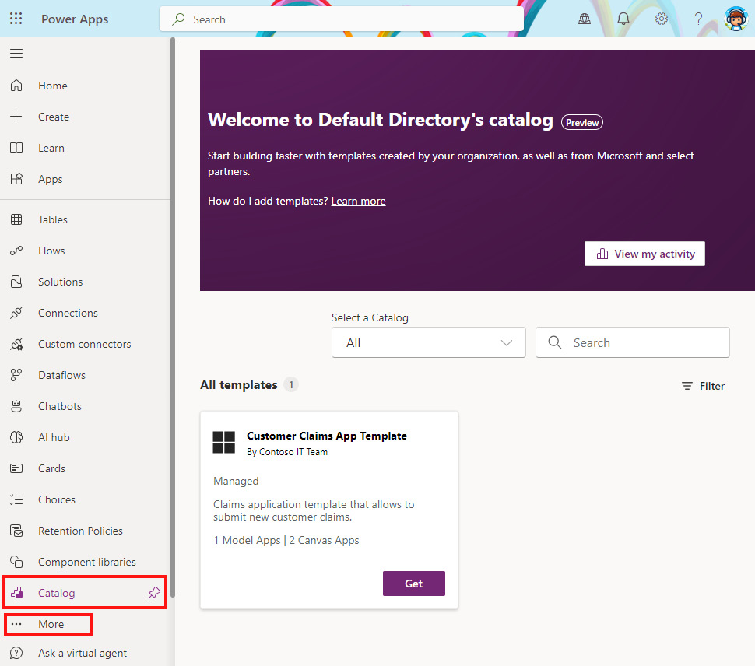

Figure 9.5 – Catalog area in Power Apps

We can proceed by using the ****Get**** button for each catalog item that we would like to install in a current environment, following the installation wizard, and completing the installation process.

Now that the item has been installed either using the UI or PAC CLI, we can use this new component. If the solution is deployed as unmanaged to a development environment with the intention of further developing it, we can proceed with developing it to our needs and then follow the ALM process to get it deployed to the production environment with the created changes.

Let’s not forget that the catalog process is continuous and involves development and deployment to the catalog for further reuse. As developers, we will spend more time in the development phase, so let’s explore some of the additional tools that developers, using Visual Studio, can use in Power Platform.

## Additional tools for developers using Visual Studio

From the tooling perspective, citizen developers focus on using low-code/no-code development tools, such as Microsoft Power Platform. Although pro-developers should also use the same low-code/no-code tool as citizen developers where possible, integrations and custom components would require custom coding, for which an IDE such as Visual Studio or VS Code will be used. Some of the developer’s tools have already been mentioned and used in previous chapters, such as Power Platform CLI and Power Platform Build Tools, together with Azure DevOps and GitHub. Similar to the Power Platform Tools extension for VS Code, developers who write code in Visual Studio can install the Power Platform Tools for Visual Studio extension.

The Power Platform Tools extension for Visual Studio can be found in Visual Studio Marketplace, similar to what we described in *[Chapter 2](https://learning.oreilly.com/library/view/mastering-devops-on/9781835880845/B22208_02.xhtml" \l "_idTextAnchor030)* for VS Code. As a prerequisite for the installation, we will need to have at least Visual Studio 2019 or higher and .NET Framework 4.6.2, if we want to build plug-ins or workflow activities.

We can install the extension from Visual Studio Marketplace ([https://marketplace.visualstudio.com](https://marketplace.visualstudio.com/)) or in Visual Studio: on the top menu bar, click ****Extensions**** | ****Manage Extensions****. Once the new window for managing extensions opens, we must make sure that we have selected ****Online**** | ****Visual Studio Marketplace**** on the left menu bar. Now, we can search for ****Power Platform**** in the search bar and click ****Download****. When the download completes, we must restart Visual Studio for the scheduled extension installation to complete.

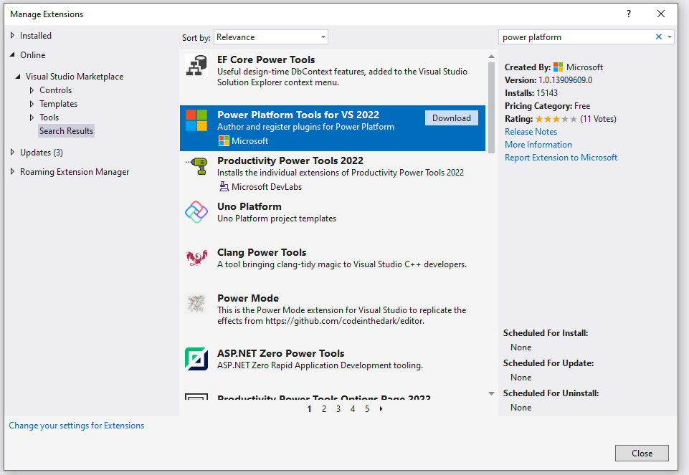

Figure 9.6 – Installing the extension for Visual Studio

Uninstallation can be done in a similar way as installation. Go to ****Extensions**** | ****Manage Extensions****. This time, select ****Installed**** in the left navigation bar, find the Power Platform Tools extension, and click ****Uninstall****.

The extension will only be visible when we either create a new project using Power Platform project templates or open an existing project that already contains at least one project created with the Power Platform Tools template.

We can also show ****Power Platform Explorer**** after we first connect to the Dataverse environment. We can do that by selecting ****Tools**** in the top menu bar and then clicking ****Connect to Dataverse…****.

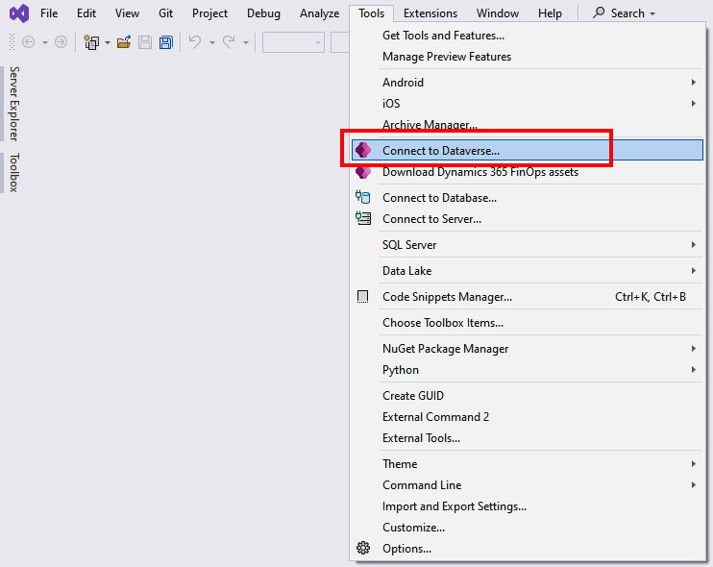

Figure 9.7 – Connecting to Dataverse from Visual Studio

This will open a new wizard window, where we will authenticate with our user to our Dataverse environment. For the login deployment type, we select ****Office 365**** since this will allow us to use Microsoft Entra ID as the authentication provider. Once we authenticate with our user, we will be prompted to select the solution in which we will be operating.

If all steps complete successfully, then Power Platform Explorer should appear in front of us, connected to the environment in which the selected solution resides. We have a chance now to explore our environment and add plug-ins to the selected tables, register webhooks, add workflow activities, and more. Note that for the developing custom workflow activity, we need to have installed ****Windows Workflow Foundation****. This can be installed through Visual Studio Installer by selecting ****Modify**** on the version of Visual Studio that we use for the development. Once in Installer, a window for modifying installation will open. Here, we select ****Individual components**** and search for the Windows Workflow Foundation. We select it and click ****Modify****, which will download and install the functionality.

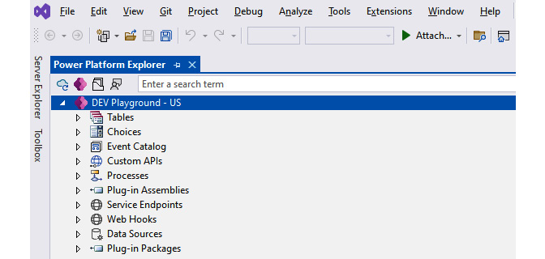

Figure 9.8 – Power Platform Explorer

Power Platform Tools for Visual Studio offers a set of project templates that allow us to use the C# programming language to develop the aforementioned Power Platform plug-ins, custom workflow activity, solution templates, and packages that are used to deploy solution and custom code libraries to our Dataverse environment.

Developers who are using Visual Studio to develop backend APIs can also extend the capabilities of Visual Studio with ****Connected Services**** in order to create customer connectors in Power Platform. In order to leverage this capability, we should be using at least Visual Studio 2022, version 17.7, with ASP.NET and the web development workload installed. This is a capability that, at this moment, is not enabled in Visual Studio for Mac. Our API should be developed as an ASP.NET Core Web API project.

We will be talking more about custom connectors, code components, and pro-developer extensibilities in *[Chapter 10](https://learning.oreilly.com/library/view/mastering-devops-on/9781835880845/B22208_10.xhtml" \l "_idTextAnchor172)*.

Now that we have all the tools ready, we can look at how Power Platform can be integrated with Azure services.

# Microsoft Azure and Power Platform together

This section focuses on explaining the most commonly used Azure services in the integration scenarios with Power Platform. We have grouped these services into workloads specific to the capabilities they provide and briefly described them. For each workload, we provide an example of how the Azure service could be used with Power Platform.

Microsoft Azure, as a cloud platform, allows us to run different workloads in the cloud, such as hosting our applications entirely in Azure or extending and connecting our on-premise applications with Azure services. As we have seen in previous chapters, when organizations are modernizing their applications or building new applications, they always have a chance to select the path of using a low-code/no-code development approach to modernize existing apps or build new ones. However, many times, scenarios are too complex and require teams to work as a fusion team, where pro-developers focus on developing complex scenarios with the services that Azure provides.

Microsoft Azure, with its vast array of cloud computing services, can cover complex scenarios that span compute services, networking, storage, web services, and more. Let’s take a look at some Azure services that are widely used with Power Platform. We will not be able to cover all of them, as there are too many options, so we encourage you to navigate to the Azure ****Products**** web page to read more about them: <https://azure.microsoft.com/en-us/products>.

## Application hosting services

Azure provides a wide range of services that are able to host applications. They have different purposes, from services that can run Spring Boot applications to container hosting services to multi-purpose web hosting services, such as Azure App Service:

* ****Azure App Service**** is a managed service that allows us to host web applications, Web APIs, and mobile backends. Since it is a managed PaaS service, it is up to the cloud provider to maintain the operating system and underlying infrastructure, while we focus on building the application. It is a scalable, enterprise-grade service that allows applications to be scaled automatically depending on the load while keeping a high degree of security.
* ****Azure Container Apps**** is a serverless platform designed to run containerized applications. Compared to ****Azure Kubernetes Service**** (****AKS****), a managed Kubernetes cluster in which we need to manage nodes attached to the AKS cluster, with Azure Container Apps, we get a fully managed Kubernetes service that provides automatic scaling of our application workloads without the need to manage the infrastructure.

Let’s look at a Power Platform integration example. Both of the preceding services are used for running either frontend applications or backend API endpoints. We can use them to run background processing jobs or to build and run our Web APIs. When we choose containers as the packaging and deployment option, we can also deploy our microservices to Azure Container Apps or similar container-running services on Azure. These APIs will be exposed securely through Azure API Management and will serve as a backend for our custom connectors.

## Integration Services

Azure Integration Services is a set of Azure services that allow organizations to build solutions that connect different systems and applications together. They can be used to provide a highly secure messaging platform, build ETL processes, and perform data transformation, or to securely expose backend systems through APIs for internal and external use:

* ****Azure API Management**** (****Azure APIM****) enables organizations to manage APIs and expose them to other applications easily and securely. It is built from three components: the gateway, developer portal, and admin management plane. Backend applications and data can reside in Azure or in other environments (including on-premises) while providing the clients with this front door, which allows routing requests to the backend while keeping control of the request and response flow.

****Power Platform integration example****: Once we have APIs ready, exposing them through Azure APIM enables us to quickly create custom connectors in Power Platform. Custom connectors will be used in our applications or flows.

* ****Azure Functions**** is an event-driven, serverless compute platform that allows developers to use event-driven triggers and bindings to connect functions to other services and execute the application logic. Since it is a serverless platform, the overhead of managing the cloud infrastructure is managed by the cloud provider and the platform. Azure Functions are commonly used in scenarios where processing data needs to be done (such as responding to an event, database changes, or reading requests that are stored in Azure Service Bus) or where data is captured from different IoT streams and needs to be processed in real time.

****Power Platform integration example****: Azure Functions is used for processing data that is stored in a data store, including Dataverse. It allows implementing Web APIs through REST endpoints to perform specific complex logic. Such APIs can be connected through custom connectors with our Power Platform solution to perform an API operation.

* ****Azure Service Bus**** is an asynchronous messaging cloud platform that allows us to create reliable messaging solutions. It is designed to enable application decoupling and building scalable systems.

****Power Platform integration example****: It allows us to enable asynchronous communication between applications and backend services in order to decouple applications and services from each other. Using the Service Bus connector in Power Platform, we can perform operations such as sending or receiving messages to/from queues.

* ****Azure Logic Apps**** is a cloud platform to create and run automated workflows, similar to Power Automate, with more emphasis on pro-developers and IT professionals. It has some unique capabilities that Power Automate does not have, such as utilizing Visual Studio and VS Code with extensions in order to develop and review workflows through code.

****Power Platform integration example****: It can be used to automate Azure-related tasks or more complex processes that are not Power Platform solution-related. We can build custom connectors that are connected to Logic Apps workflows and run the workflow through custom connectors in Power Automate or Power Apps.

## Data analytics

Azure offers a set of data analytics services that help us gain insights into the data stored anywhere, enable real-time data streaming from IoT devices, take care of the telemetry ingestion, and more:

* ****Azure Event Hubs**** brings a common point to integration scenarios where applications need to respond to events that are happening in real time. It allows the ingestion of real-time event data from different sources. It is very common to use it when working with IoT scenarios or application monitoring. Since Power Platform includes a connector for Azure Event Hubs, we can build integrations more easily.

****Power Platform integration example****: When an IoT device sends data to IoT Hub, that data gets processed by Azure Functions and sent to Azure Event Hubs. When events are available in Event Hubs, a Power Automate flow gets triggered and performs the logic.

* ****Microsoft Fabric**** is a single unified analytics platform that connects tools such as Azure Data Factory, Azure Synapse Analytics, and Power BI together. Fabric includes a multi-cloud data lake, called OneLake, which sits underneath the mentioned Fabric tools and helps eliminate data silos. OneLake works as a single storage system allowing organizations to combine data from different data sources, including Dynamics 365 data. Once data is represented in OneLake, organizations can perform different types of analytics in Microsoft Fabric.

****Power Platform integration example****: Recently, Power Platform introduced a Dataverse integration with Microsoft Fabric. It opens possibilities to connect Dataverse to Fabric, using ****Link to Fabric****, and a scenario where Fabric is connected to Dataverse, using virtual tables. Link to Fabric allows organizations to keep the data in Dataverse while enabling analytical capabilities in Fabric to find insights into the data. These insights can be sent back to Dataverse in the format of virtual tables, which allows developers to utilize these findings in a business process. Similar to before where data stayed in Dataverse, here, data resides in OneLake.

## AI services

****Azure AI services**** are a set of REST APIs and client library SDKs that enable pro-developers to create intelligent applications with pre-built and customizable AI models that have cognitive capabilities such as natural language understanding through conversation, speech capabilities, vision, and more. Azure AI services are an umbrella for services such as Azure OpenAI, Azure AI Search, Vision, Speech, and more.

Let’s look at a Power Platform integration example. Although Power Platform includes AI Builder, which utilizes some of these pre-built models, Azure AI services allow additional capabilities, such as integrating speech-to-text and text-to-speech capabilities or utilizing other AI models in our business applications.

## Data storage

****Azure SQL Database**** is a fully managed relational database. It is a PaaS deployment of Azure SQL that enables hyperscale (unlimited database storage) and autoscaling. As many organizations are already utilizing SQL Server for their database systems, such an option enables them to modernize their database and eliminate the need to manage the infrastructure.

Let’s look at a Power Platform integration example. Power Platform meets customers where they are with their data. This is why there are more than 1,000 connectors available in Power Platform, and one of them is also for connecting to SQL Servers. This allows us to build applications and flows that connect to the existing data sources.

Azure provides additional database services. Depending on the need of the project, we could utilize other relational databases, such as PostgreSQL, MySQL, or MariaDB, or non-relational database services such as Cosmos DB. For each of these data services, there is a connector that we can use to build our automation flows or business applications using the existing databases.

The aforementioned services are just a handful of services in the pool of all the available options on Azure. When planning a project, consult with a solution architect or enterprise architect in the organization who has a knowledge of cloud computing to determine which services are best suited for the planned project.

# Example of an Azure and Power Platform integration scenario

This section focuses on a practical example that demonstrates how fusion teams could work together. This case shows a connection between Power Platform and Azure through the use of custom connectors and Azure services, such as Azure API Management.

For the example in this chapter, we focus on integrating Web API templates written in the C# programming language in Visual Studio 2022, with Power Platform as a custom connector. We have already installed Power Platform Tools in Visual Studio 2022 in the previous chapter. This will demonstrate how pro-developers can use modern tools to build and test Web APIs that support business applications in Power Apps. The Web API will be deployed to the Azure service and exposed over Azure API Management.

Here, we will introduce two ways of creating a custom connector: one with the support of Visual Studio 2022 and the other with the support of Azure API Management.

Once a custom connector is created, our citizen developers can use operations in Power Platform in their business solution.

The next chapter will focus on the ALM process for many different Power Platform components, so here we will be showing the concept of the fusion development approach.

Let’s jump into creating a Web API first.

## Creating a Web API and a Power Platform custom connector with Visual Studio 2022

We will put on our pro-developer hats and create our sample API using the ASP.NET Core Web API template in Visual Studio 2022. We will do this to demonstrate the capabilities that pro-developers gain using Visual Studio while working in the fusion development team on a project that will mainly reside on Power Platform services.

When Visual Studio starts, it welcomes us with a window in which we can create a new project by clicking on the ****Create a new project**** button. This will take us to the next screen, where we will select a template for our project. We will search for ****web api****, select the ****ASP.NET Core Web API**** template in the C# language, and click ****Next****, as shown in the following figure:

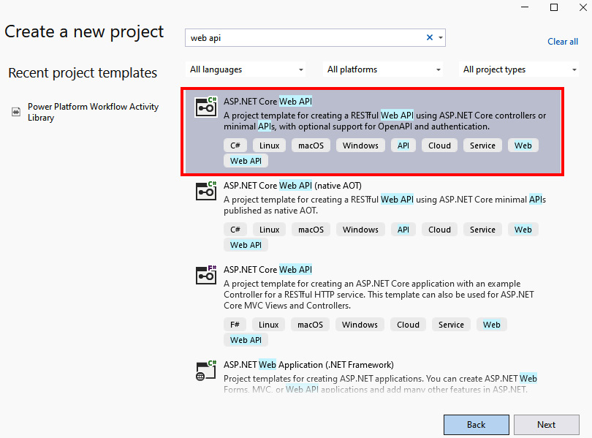

Figure 9.9 – Creating a new Web API project

On the next screen, we will provide our ****Project name****, ****Location**** (where to save the project), and ****Solution name**** details. After providing the location and names, we can click ****Next**** to get to the final screen, where we can select the framework and other additional information for the project, such as whether we would like to enable HTTPS, Docker, and so on. We will keep the default options here, with the LTS version of .NET 8.0, and click ****Create****. Our Web API template is now ready with one ****GET**** operation, called ****WeatherForecast****, which is already part of the template.

As part of the DevOps experience, our task would be to version control our code, which would mean that we either create a new project in Azure DevOps or GitHub or use an existing project for this part of the project, and then commit our code to the repository with the initial commit. We enable branch protection on the ****main**** branch and configure other policies, as we have learned in previous chapters. At this point, our pro-developers who are working on the API can continue their work following the DevOps best practices.

Coming back to our example, we can test the newly created project or continue with development and remove the existing ****WeatherForecast**** operation and go ahead and develop the API operations that the business project that we are working on is requesting from us.

When we want to test our developed API, we can simply hit *F5* on our keyboard to launch a debugging process or head over to the top navigation bar, expand ****Debug****, and select ****Start Debugging**** to launch our API in a browser. This will open the Swagger UI, which shows our Swagger file with all the operations that exist in our Web API. Swagger provides a convenient way to design, document, and consume our API. It uses ****OpenAPI**** specification and provides a set of open source and commercial tools to work with the Swagger file, which is in a JSON format describing our API operations. An OpenAPI definition is also consumed by Power Platform when creating a custom connector and it needs to be in OpenAPI 2.0 (previously known as Swagger) format.

When we are ready with our API and would like to test it in the Power Apps application or Power Automate flow, we can add Power Platform as a connected service. This way, Visual Studio will automatically create a custom connector for us in Power Platform. To do this, we head to our Web API project in Visual Studio. Inside ****Solution Explorer****, we expand our project so that we are able to see ****Connected Services**** | ****Add**** | ****Microsoft Power Platform****. This will open a new tab, opened in the ****Connected Services**** part, and a ****Connect to Microsoft Power Platform**** window:

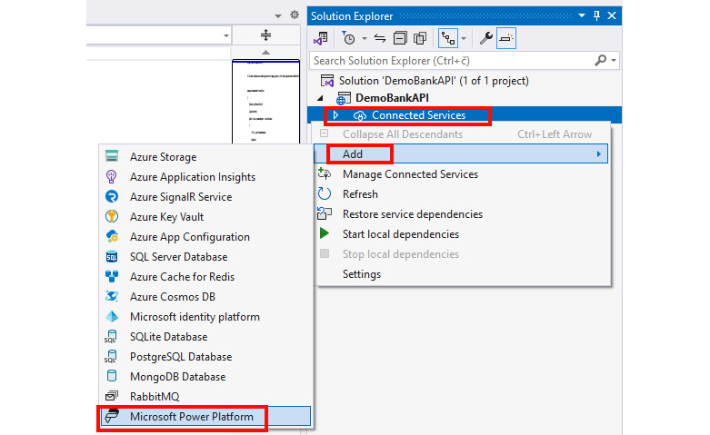

Figure 9.10 – Adding Power Platform as a connected service

This new window holds all parameters for a new custom connector. Before creating it, we need to make sure that we are signed in. If not, in the top-right corner, we can sign in and provide the right credentials of the user. Once authenticated, we select a Power Platform environment into which we would like to deploy our custom connector. In the ****Power Platform Solutions**** dropdown, we select the solution in which the connector will be deployed.

Next, we connect to the custom connector. In our case, we are creating it for the first time, so we will click ****+**** (the plus icon) to create a new custom connector. We will check ****Auto-generate the OpenAPI V2 specification**** so that Visual Studio generates the OpenAPI definition for us. Lastly, we will create a ****public dev tunnel**** by clicking ****+**** (the plus icon) next to ****Select a public dev tunnel****, which will be used for debugging purposes between the custom connector and our instance of Visual Studio.

*Dev tunnel*

*Dev tunnels in Visual Studio provide a quick and secure way to test Web APIs across the internet. In our case within Power Platform services, it will create a connection between our local machine, which is running Visual Studio, and a Power Platform service that is utilizing the custom connector (i.e., the Power Apps application using a custom connector). This approach is intended to create ad hoc connections for development and testing purposes only, not for production workloads.*

The following screenshot shows us how a public dev tunnel can be created after connecting to Microsoft Power Platform. When we click on ****Next****, we can see the ****Summary of changes**** screen, which informs us that a custom connector will be created in Microsoft Power Platform. We confirm this by clicking ****Finish****. The process will build our project, configure a dev tunnel, generate a Swagger JSON file (OpenAPI specification file), and create a custom connector in our selected Power Platform environment:

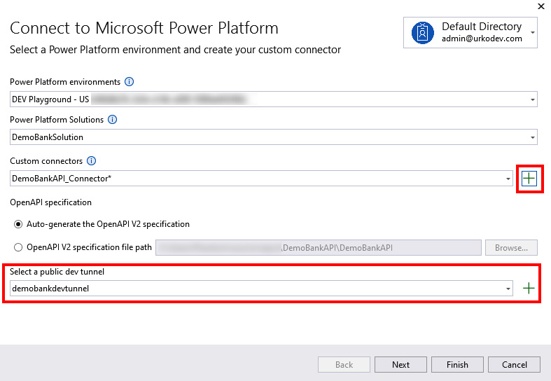

Figure 9.11 – Creating a custom connector

Now that the dev tunnel and custom connector are created, if we run our API now (by pressing *F5* or clicking on ****Debug**** | ****Start Debugging****), we will see that Visual Studio will use the *dev tunnels* feature and will expose our web API to the public endpoint, which we are also informed about in the notification that has opened in the web browser. Once we confirm it, the dev tunnel is established and we can use a custom connector in Power Platform, which is now connected to our Visual Studio dev environment. This is a very convenient way for debugging our Web API and custom connector. We can now use this custom connector in any Power Apps application or other Power Platform services and set breakpoints in the source code of our Web API in Visual Studio for the debugging purposes. We will be able to see in Visual Studio that our breakpoint was hit by debug engine once the API operation is executed . This will allow us to continue with the debugging/testing process.

As a citizen developer or an app maker, we can now see the newly created custom connector in Power Apps. Navigate to ****Power Automate**** or ****Power Apps****. Either click on ****Solutions**** in the left navigation bar and open the solution that was used to deploy the custom connector from Visual Studio, or go to ****Custom connectors**** and find our custom connector and click ****Edit**** (the pencil icon):

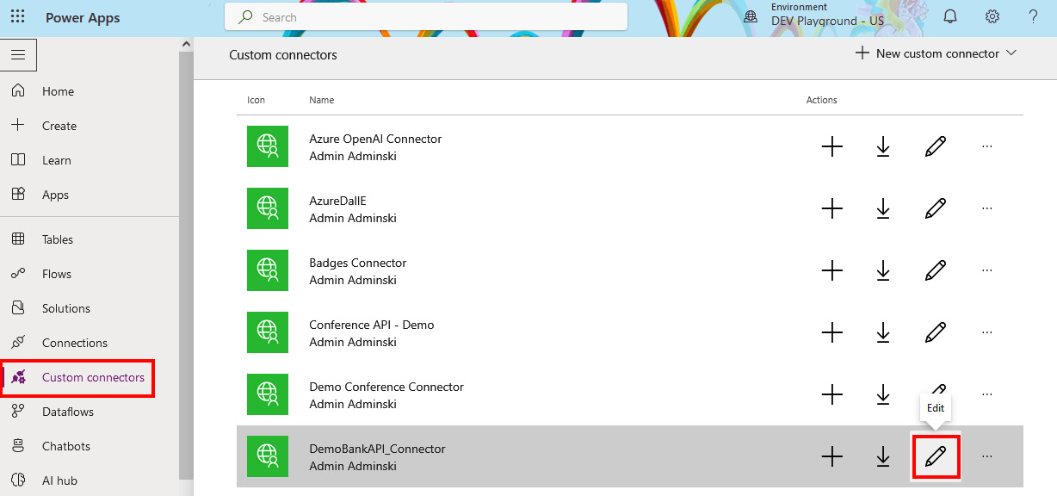

Figure 9.12 – Opening the custom connector definition

We can see that the host and the URL in the definition of the API operations are pointing to the dev tunnel.

We can create a Power Apps application, a flow, or anything else in Power Platform and utilize the custom connector. As long as the connection via the dev tunnel is active in Visual Studio, our custom connector will be able to get the results of an API operation that we will be calling. Using the ****pac connector list**** command, we will be able to see all custom connectors registered in Dataverse and their display names and IDs. As an example, we can use this information about connectors to create a sample canvas app from the PAC CLI. The app is generated based on the OpenAI definition from a custom connector:

**pac canvas create --msapp <new-msapp-file> --connector-id <connector-id>**

## Creating a Power Platform custom connector with Azure APIM

Let us continue with the example. Let’s say that our pro-developers are progressing with their new Web API. They are using DevOps principles to build, test, and deploy the Web API to a test environment. The test environment differs from the local development machine, as this environment is now provisioned in Azure. For our Web API to be hosted, we can choose from the plethora of application hosting services available in Azure. We will be using Azure App Services, a PaaS service that is capable of hosting Web APIs.

As with DevOps best practices, we are following an IaC approach and describing the environment in a Bicep or ARM template file. This IaC definition file is also version-controlled in our Azure DevOps/GitHub repository, so we can keep track of changes and run validation checks over the template file.

The CI/CD pipelines make sure that our Web API, as an artifact, is deployable and we deploy it automatically to the newly provisioned test environment. Once our API is deployed to a hosting platform, we are ready to connect our Web API to Azure API Management.

Azure services such as Logic Apps, App Service, Functions, and Container Apps provide a seamless integration between the Web API and the Azure APIM to register the API in APIM. However, Azure APIM also provides options to add APIs by providing definition files, such as OpenAPI, WSDL, OData, and WADL. Of course, we can also start completely from scratch and manually add all properties and operations of the API.

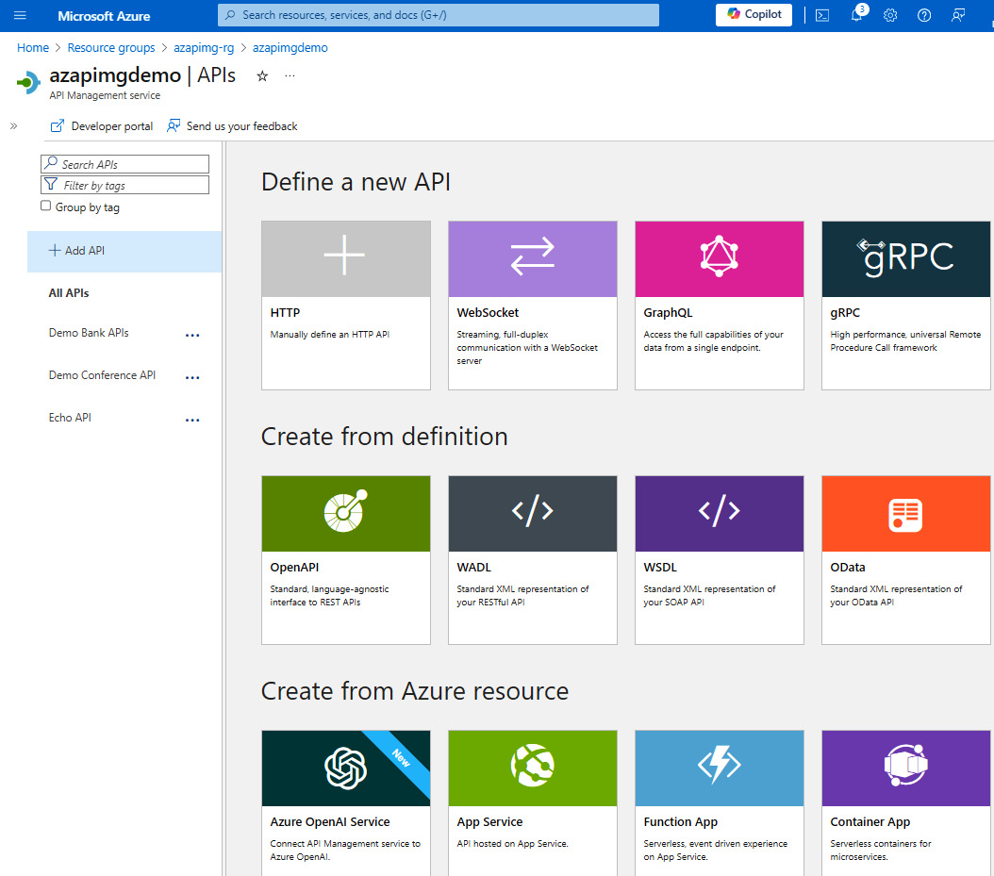

Figure 9.13 – Creating new APIs in APIM

APIM provides a convenient way to configure *mock responses*. This allows to speed up development time, as pro-developers can add all operations to Azure APIM with mocked responses, while app makers in Power Platform utilize such an API and build the rest of the service in Power Platform. For example, citizen developers use the custom connector that has all the operations available, but the responses are mocked by APIM. Once the backend Web API is developed and ready to be used, pro-developers disable mock responses on the operation and leave it to the Web API to perform the logic and return correct responses. On the other hand, the frontend that has been developed by citizen developers does not see any differences – only the returned data from the API is different.

Once our API is ready to be consumed, we can create a connector in Power Platform directly from Azure APIM:

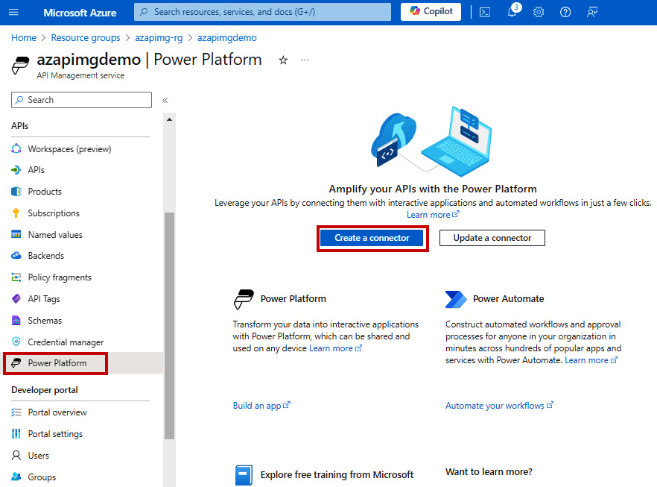

Figure 9.14 – Creating a custom connector from Azure APIM

After we click on the ****Create a connector**** button, the next step asks us to provide the ****API**** name, which will be used for the custom connector. We need to select the one that we were working on. Following that, we need to provide the Power Platform environment and API display name, as this will represent the custom connector that will be deployed to the selected environment. Once we have provided this information, we can proceed by clicking on the ****Create**** button. After that, a new custom connector will appear in the selected Power Platform environment and will be ready to be used by any app maker in Power Platform.

## Applying ALM to custom connectors

The preceding examples demonstrated how to create a custom connector through either Visual Studio or Azure APIM. However, if we would like to use CI/CD pipelines to deploy our custom connectors to different environments, it is good to know how to follow a code-first approach to operate with custom connectors in order to deploy them to different target environments. We will be using Power Platform CLI commands for these purposes.

In order to create a custom connector using the PAC CLI, we need to obtain the API definition file and generate supporting properties files. An API definition file is an OpenAPI 2.0 (Swagger) definition file that describes the API and its operations. We can either create a Swagger definition file from scratch or obtain it from the existing custom connector that we created in the previous exercise.

Along with the API definition file, we will require the API properties file. An API properties file is a JSON file that holds supporting information for our connector, such as authentication information, brand color, publisher information, and so on.

Optionally, we can use additional files such as icons files, script files (CSX files), and settings files.

We can start creating a custom connector from scratch using the ****pac connector init**** command with additional parameters that will generate the additional files needed for the custom connector. Next, we can see an example that generates an API properties file with an API key that will be used to authenticate requests against the custom connector. It also generates settings files, a properties file, and a script file in a separate ****DemoBankAPI**** folder:

**pac connector init --connection-template "ApiKey" --generate-script-file --generate-settings-file --outputDirectory "DemoBankAPI"**

If we want to generate an API definition file from an existing custom connector that we have created in the previous examples, we can use the ****pac connector list**** command to get a list of all the connectors in the current environment with the connector IDs of each connector.

Once we have found the connector ID information for a custom connector, we can use ****pac connector download --connector-id <CONNECTOR-ID>**** to download ****apiDefinition.json**** and ****apiProperties.json**** for the selected custom connector.

At this point, we should already commit our files to the repository so that any modification is version-controlled. We will perform changes to the files so that they reflect the right values for the target environment. This means changing the *host* value, which is an endpoint to which our custom connector is pointing, as well as any additional property values.

When we want to create a custom connector in a target environment, we can use a simple ****pac connector create --settings-file .\settings.json**** command, since the settings file already includes information about all supporting files as well as the environment value for deploying to the target environment. Next, we can see a sample ****settings.json**** file:

{

  "connectorId": null,

  "environment": "1f9283b6-deea-eed7-899c-4da273a3f957",

  "apiProperties": "apiProperties.json",

  "apiDefinition": "apiDefinition.json",

  "icon": null,

  "script": "script.csx"

}

Values in ****settings.json**** and any supporting file, such as an API properties file, which holds information for authentication, should be changed and parameterized so that we will not have values hardcoded in the file, but rather, only variable names, which get changed with actual values during the CI/CD pipelines.

Another variation of the ****create**** command, using manually defined values, is as follows:

**pac connector create --environment 1f9283b6-deea-eed7-899c-4da273a3f957 --api-definition-file .\apiDefinition.json --api-properties-file .\apiProperties.json**

When we need to update the custom connector in the target environments, we should use ****pac connector update --settings-file .\settings.json****.

Once we have a custom connector created in the target environment, we can use it to test the operations in our existing application or create a new dummy application using ****pac canvas create --msapp <new-msapp-file> --connector-id <connector-id>****. We are now ready to test our newly deployed connector.

# Summary

This chapter covered the important aspect of the methodology that embraces collaboration, agility, and innovation. Organizations should recognize that fusion teams can lead to reduced time to solve business challenges since these teams break down the traditional barriers between business users, pro-developers, and IT professionals with their agile approach and synergy.

Organizations should also adopt best practices that are coming from open source development, which enhance the possibilities of app makers within the organization, as we are empowering makers to be able to discover and reuse what has already been done internally. Similar to the traditional software development tools, Power Platform provides all the tools to support this experience, such as Catalog Manager and integrations with Azure.

Integrations with Azure are even more important for organizations that are already onboarded on Azure and running business workloads on this public cloud. With integration in mind, we investigated some common cases of how Power Platform can be connected with Azure services.

We finished the chapter with an example of a pro-developer experience when building a Web API that will be used as a backend for the Power Platform services and how Visual Studio enables quicker development and efficient testing experience. When the Web API was ready, we showed how fast and smooth the integration between Azure APIM and Power Platform services can be.

The next chapter will focus on pro-developer extensibility in Power Platform. We will continue exploring the possibilities for pro-developers when it comes to connectors, code components, and more, with examples that can be reused in the DevOps process.

# Further reading

* InnerSource fundamentals: <https://resources.github.com/innersource/fundamentals/>
* View Dataverse data in Microsoft Fabric: <https://learn.microsoft.com/en-us/power-apps/maker/data-platform/azure-synapse-link-view-in-fabric>
* Azure and Power Platform architecture examples: <https://learn.microsoft.com/en-us/azure/architecture/browse/?products=power-platform>
* Dev tunnels in Visual Studio: <https://learn.microsoft.com/en-us/connectors/custom-connectors/port-tunneling>
* Exporting APIs from Azure APIM to Power Platform: <https://learn.microsoft.com/en-us/azure/api-management/export-api-power-platform>
* Custom connectors with PAC CLI: <https://learn.microsoft.com/en-us/power-platform/developer/cli/reference/connector>

# 10

# Enabling Pro-Dev Extensibility in Power Platform

This chapter focuses on the capabilities provided by Power Platform to professional developers to extend the experience of business solutions built on top of Power Platform. We will take a look at how Power Platform ensures the smooth integration of these extensibility options with ALM/DevOps processes in order to support the software development life cycle of these components.

We will start the chapter by looking into connectors and continue our work on custom connectors. In the previous chapter, we showed how pro developers can build web APIs and deploy them to Power Platform directly from Visual Studio; here, we will explore the concept of using the PAC CLI to ensure we enable ALM for custom connectors. We will also look into the other aspects of the custom connectors, such as environmental variables and connection references, and explain their role when moving solutions across different target environments.

After that, we will discuss canvas components in Power Apps and the key benefits of using them. From there, we will delve into the Power Platform code components, more specifically the Power Apps component framework. For both canvas components and code components, we will explain the process of including them in the ALM process.

We will close this chapter with coverage of Power Pages, how pro developers can extend Power Pages with custom code, and how the ALM process can be implemented.

We will cover the following main topics:

* Enabling the power of integration – connectors
* Overview of canvas components and the component library
* Getting to know the code components
* ALM for Power Pages

# Technical requirements

To follow this chapter, you need the following:

* ****Power Platform subscription****: You can sign up for a Power Platform development plan (<https://powerapps.microsoft.com/en-us/developerplan/>) if you already have a Microsoft Entra ID work account, or you can join the Microsoft 365 developer program (<https://developer.microsoft.com/en-us/microsoft-365/dev-program>).
* ****Visual Studio Code****: We recommend using Visual Studio Code or Visual Studio with the Power Platform Tools extension, or the IDE of your choice. Visual Studio Code can be found here: <https://code.visualstudio.com/>. Visual Studio is also available as a free Community edition: <https://visualstudio.microsoft.com/vs/community/>.
* ****Power Platform CLI****: We will be using the PAC CLI inside the command line or terminal. Installation guidance can be found here: <https://learn.microsoft.com/en-us/power-platform/developer/cli/introduction?tabs=windows>.
* ****Azure DevOps or GitHub****: We can create an Azure DevOps service organization any time *for free* (<https://learn.microsoft.com/en-us/azure/devops/user-guide/sign-up-invite-teammates>). We can also create a GitHub handle and public repository (<https://github.com/signup>), which is also *free* for public repositories.
* ****Node.js****: To build PCF code components, you require Node.js. The LTS version is recommended (<https://nodejs.org/en>).
* ****.NET build tools****: You will need either ****msbuild**** (part of Visual Studio) or ****dotnet build**** tools (part of the .NET SDK: <https://learn.microsoft.com/en-us/dotnet/core/sdk>).

# Enabling the power of the integration – connectors

This section provides a deeper look into how connectors and custom connectors can be reused across environments with the help of ALM. We will take a look at the concepts of environmental variables and connection references, which are two important concepts for when we plan to scale. We will learn how solutions can be used to wrap connectors for potential reuse across different environments.

## Connectors

We were introduced to connectors in *[Chapter 2](https://learning.oreilly.com/library/view/mastering-devops-on/9781835880845/B22208_02.xhtml" \l "_idTextAnchor030)*. Our discussion on connectors so far has covered that connectors enable us to connect to different services and data sources from within our applications, flows, and chatbots. Connectors can be either certified ones, which connect to first- or third-party services, or they can be custom ones. Certified connectors are prebuilt and cannot be changed, whereas custom connectors give us the freedom to create our own connectors to connect to either our own custom services/APIs or other services for which a prebuilt connector does not yet exist.

Connectors act as wrappers around sets of API operations, which are categorized as either triggers or actions.

****Triggers**** are operations in a connector that respond to a certain event, for example, a SharePoint list item being created. Two types of triggers exist: polling triggers and pushing triggers. ****Polling**** triggers proactively check for changes. They repeatedly, at regular intervals, perform calls of the specified service endpoint to look for new data. ****Pushing**** triggers, or webhook triggers, are able to react to external events. When a certain event occurs, the service endpoint notifies the trigger via the callback URL.

****Actions**** are operations that help us perform methods (retrieve, create, update, and delete) specified in an API definition file. Operations are performed over the data in a service that a connector is connected to, for example, getting all SharePoint lists from a site.

We worked with custom connectors in *[Chapter 9](https://learning.oreilly.com/library/view/mastering-devops-on/9781835880845/B22208_09.xhtml" \l "_idTextAnchor149)*. They give us the ability to define our own triggers and actions based on the API operations of our service.

*Microsoft Power Platform’s open source repository*

*Microsoft published an open source repository that allows anyone to review existing certified and custom connectors as well as collaborate by submitting new connectors to the repository. The list of predefined connectors and custom connectors with the corresponding definition files is published in Microsoft’s GitHub repository, which is open to anyone for contributions:*<https://github.com/microsoft/PowerPlatformConnectors/>*.*

*Anyone who wants to certify a connector can follow the step-by-step approach, described here:*<https://learn.microsoft.com/en-us/connectors/custom-connectors/submit-certification>*.*

When planning to deploy applications to different target environments, we must ensure that our connectors utilize connections that exist in the target environments. To be able to switch to the right connection in a target environment in an automated way using pipelines, we recommend using connection references. Let us now take a look at what connection references are and how they can be used.

## Connection references

When a connector is used in an application or flow to run a certain connector operation, a ****connection**** for the connector is created in the specific environment. Connections are bound to an environment and store authentication credentials to perform the operation.

Since connections are not solution-aware and do not provide an option of decoupling our business solution from the connection, connection references were introduced.

****Connection references**** are solution components that point to a connection for a specific connector. Using connection references allows us to build flexible solutions that enable us to programmatically change the connection information in applications and flows. This simplifies the deployment of our solution to different target environments when using the DevOps approach, as it allows us to connect to resources that are relevant to the target environment.

Let’s explore another method for parameterizing solution configuration: environment variables.

## Environment variables

Environment variables act as configuration parameters for solution components, allowing us to dynamically change configuration values specific to the target environment. Environment variables are well known in traditional application development, where developers use them to decouple the configuration from the application. This allows developers to adapt the application to the target environment without changing the application code. In Power Platform, we follow the same concept to use the application components across different target environments by only changing the environmental variables. This way, we can connect to a data source or set of APIs that is specific to the target environment.

Environmental variables are usually stored in the format of key-value pairs, with values stored outside of the application source code in a secure location, such as ****Azure App Configuration**** or ****Azure Key Vault****, so that the values are not easily accessible. During application runtime or CI/CD pipeline execution, the values are retrieved from these services and used accordingly.

Utilizing such an approach allows us to enable one of the DevOps best practices: parameterizing as much as possible to enable the flexibility of our applications. Hardcoding values in the application source code could lead not only to maintenance issues but also to potential security vulnerabilities.

In summary, here are some of the benefits of using environment variables:

* We can decouple the application from the configuration, allowing us to easily change the configuration values for data sources and other secrets. For example, we can change the connection to the data sources, such as API keys and server URLs, as we deploy our application to different target environments.
* We can reuse environment variables across other solution components. For example, we can create an environment variable that will be used in both Power Automate and Power Apps, which simplifies configuration.
* We can improve security by separating the secrets from the solution components and storing them in a key vault to reduce the risk of misuse.

When we add environment variables to our solution, Power Platform automatically creates entries in two Dataverse tables: ****Environment Variable Value**** and ****Environment Variable Definition****. To use environment variables in Power Apps applications, we should use a lookup function on these two tables and obtain the values based on the names of the environment variables that we create, as seen in the *Introducing feature flags* exercise in *[Chapter 8](https://learning.oreilly.com/library/view/mastering-devops-on/9781835880845/B22208_08.xhtml" \l "_idTextAnchor134)*. In Power Automate, we are able to access environment variables by using the dynamic content selector.

To better understand how we can streamline this operation and follow DevOps best practices, we will take a closer look at this approach through an example.

## Example – Decoupling configuration from the application

In this example, we will be utilizing connection references and environment variables to decouple a configuration from our business solution.

First, we need to create a solution and add all components that are part of our business solution, including new environment variables and connection references. Then, we will create a deployment settings file, which will decouple the configuration settings from our actual application. This will allow us to configure the values specific to the target environment. We will use the deployment settings file to import the solution to a target environment with the relevant configuration values.

### Preparing a solution

Let us explore the first step of preparing the solution with configuration settings:

1. On the Power Apps ([https://make.powerapps.com](https://make.powerapps.com/)) or Power Automate ([https://make.powerautomate.com](https://make.powerautomate.com/)) home page, we can find a ****Solutions**** option in the left navigation bar. Selecting it will open a screen with a list of all solutions in the current environment.
2. We either click ****New solution**** to create a new solution or select an existing solution from the list and click ****Edit**** to edit the existing solution.

Creating a new solution and importing it to the environment can also be done with the PAC CLI, as we have seen in previous chapters, with the ****pac solution init**** and ****pac solution import**** commands.

1. Once we are in the solution object explorer, we can add a new connection reference by clicking ****New**** | ****More**** | ****Connection Reference****.

To add an existing connection reference, we click on ****Add existing**** | ****More**** | ****Connection Reference****, select the existing connection reference, and click ****Next****, as we can see in *Figure 10.1.*This will add any existing components to the solution:

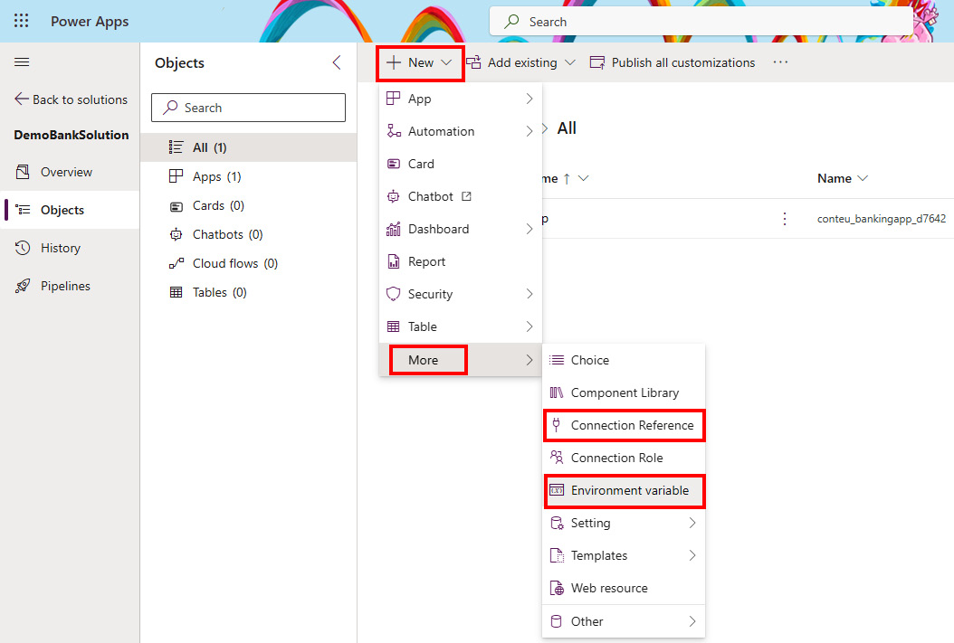

Figure 10.1 – Adding components in the solution object explorer

1. Whenever we are creating new connection references, the ****New Connection Reference**** screen will open, as can be seen in *Figure 10.2*.

Here we must provide the ****Display name****, ****Name****, ****Connector**** values, as well as a ****Connection**** value for the selected connector. Providing a description is optional but is recommended to have a better understanding of the use of connection references:

* + If there are no connections for a selected connector in the environment, we need to create a new one by selecting ****+ New connection****, which opens a new connections screen with a pop-up box for our selected connector. We need to provide all required parameters for the connection and click ****Create**** to create a connection.

1. Going back to the previous ****New Connection Reference**** screen, we can now click the ****Refresh**** button next to the drop-down list of connections, as can be seen in *Figure 10.2*, which will update the list of connections and show the newly created connection. We can select it and proceed by clicking ****Create****, which creates a new component in our solution.

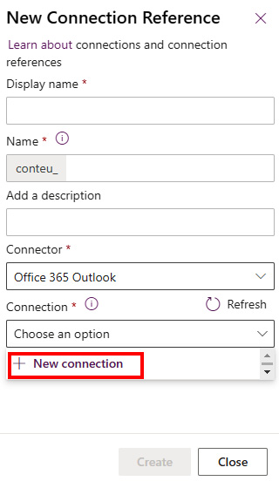

Figure 10.2 – Creating a new connection reference

1. To add an environment variable, we follow similar steps to those mentioned in *step 3*. This time, we select ****New**** | ****More**** | ****Environment variable****.
2. A new screen will appear, which will require us to provide more information about the environment variable, such as ****Display name****, ****Name****, ****Description****, and ****Data Type****:
   * ****Data Type**** specifies the type of our environment variable. This could be ****Decimal number****, ****Yes/No****, ****Text****, ****Data source****, ****Secret****, and so on. After selecting a data type, we can configure the default and current value, as can be seen in *Figure 10.3*. If we are creating an environment variable of type ****Data source****, we get the possibility of selecting ****Connector****.

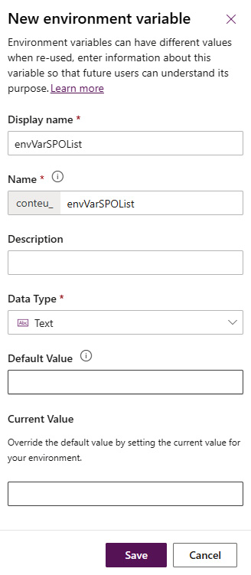

Figure 10.3 – Adding a new environment variable

* ****Default Value**** is not a required field; however, it is something that is used when no ****Current Value**** setting is configured. ****Current Value**** overrides ****Default Value**** and is something that is very useful when deploying to different target environments.

Once we have configured the environment variable as needed, we can click ****Save**** to store the configuration, which adds a new component to our solution.

If we need to add existing environment variables to our solution, we can do so by clicking ****Add existing****| ****More**** | ****Environment variable**** in the solution object explorer, selecting the existing variables from the list, and clicking ****Next****. The next screen shows us the selected environment variables, and for each, we have options to select ****Include definition**** and ****Include current value**** checkboxes. We can review the existing selected environment variable and click ****Add**** to have it added to our solution.

*Current limitations of environment variables*

*There are still some limitations when using environment variables; for example, data source environment variables cannot currently be managed using Microsoft Power Platform Build Tools. Please make sure to review limitations and use environment variables accordingly. Refer to the updated information about the limitations**here:*<https://learn.microsoft.com/en-us/power-apps/maker/data-platform/environmentvariables>*.*

Now that we have prepared our solution, we can deploy it to different environments. When importing a solution manually, the import process will check whether any connection already exists in the environment for the defined connection reference. If so, import process will link it to that connection; if not, it will offer us the chance to automatically create and link the connection . Once the connections are configured, the next step allows us to update environment variables with the actual values for the target environment.

To decouple the settings and allow our solution to be imported in a more programmatic way, we will take a look at how a deployment settings file can be generated and used.

### Building a deployment settings file

A****deployment settings file**** is a JSON-format file that stores the information about the connection references and environment variables that are being used in our solution. This same file will be used during the solution import process with Power Platform Build Tools or the PAC CLI. We touched on it briefly in *[Chapter 8](https://learning.oreilly.com/library/view/mastering-devops-on/9781835880845/B22208_08.xhtml" \l "_idTextAnchor134)*:

1. We should export our solution or clone it. We need to have either a solution ZIP file or an unpacked solution folder to which we can point to generate a settings file. We can do this in two ways:
   * By selecting the solution, clicking ****Export solution****, and downloading the package file
   * By using a PAC CLI command such as ****pac solution clone --name <solution-name>**** or ****pac solution export --name <name>****, which means the solution folder will be cloned locally or the solution ZIP file will be downloaded locally
2. Now that we have exported the solution package file, we are ready to create the deployment settings file, using the following approach.

Generating a deployment setting file can be done by using the following PAC CLI command:

pac solution create-settings --solution-zip <solution-file.zip> --solution-folder <unpacked-solution-folder> --settings-file <JSON-file-name>

Pointing to the solution can be done by passing either of the following arguments – the solution ZIP file or the solution folder. Here is an example of this command in practice:

****pac solution create-settings --solution-zip .\EnvConnRef\_1\_1\_managed.zip****

This command generates a ****deploymentSettings.json**** file in the current folder.

An example of the structure of the ****deploymentSettings.json**** file is present in the *[Chapter 10](https://learning.oreilly.com/library/view/mastering-devops-on/9781835880845/B22208_10.xhtml" \l "_idTextAnchor172)* folder of this book’s GitHub repository. In the file, we can see the structure of the environment variables and connection references with the respective values.

For each environment variable in the file, there is a ****Value**** property. Initially, it is an empty string that we update with the value for the target environment. The same should be done for the connection references, where the ****ConnectionId**** property is initially empty and needs to be provided.

To update the connection reference values, we can use the PAC CLI to connect to the target environment and list all connections. This will allow us to see whether any of the connections for the given connector already exist there. Once we are pointing the PAC CLI at the target environment, we can use the ****pac connection list**** command to list all connections established in the selected environment. If a connection exists, copy the ****Id**** value of the connection into the deployment settings file under the right connection reference ****ConnectionId**** value, as shown in *[Chapter 8](https://learning.oreilly.com/library/view/mastering-devops-on/9781835880845/B22208_08.xhtml" \l "_idTextAnchor134)*; otherwise, a create new connection.

1. Now that we have prepared the deployment settings file for the solution, we can proceed with the solution import process, including the specified deployment settings file. If no environment value or path is provided with the command, the current environment and the current folder structure will be used for the solution import:

pac solution import --path <path\_to\_zip\_file> --settings-file .\deploymentSettings.json

The preceding approach presents a programmatic approach for generating a deployment settings file, editing it, and importing the solution to the target environment. To follow the DevOps approach, we can use extra tasks in the pipelines to manage the deployment settings file and deploy to the target environment.

### The deployment settings file and the DevOps approach

In *[Chapter 8](https://learning.oreilly.com/library/view/mastering-devops-on/9781835880845/B22208_08.xhtml" \l "_idTextAnchor134)*, we saw how the deployment settings file can be used within DevOps. In order to keep things automated, we can add an extra task in the pipeline, which will create a deployment settings file and store it in the repository, next to our exported solution. We can do that using the PAC CLI. We have to make sure that when we use the Power Platform Tool Installer task in our export pipeline, we add the PAC CLI to the ****PATH**** environment variable. The following example shows how it can be done in Azure DevOps:

- task: PowerPlatformToolInstaller@2

  inputs:

    DefaultVersion: true

    AddToolsToPath: true

To generate a deployment settings file, we will use a ****Command line**** task, with a command that we are now familiar with:

- task: CmdLine@2

  inputs:

    script: |

      echo 'Create Deployment Settings File'

      pac solution create-settings --solution-zip '$(Build.ArtifactStagingDirectory)/$(SolutionName).zip' --settings-file '$(SolutionName).json'

The ****git commit**** command that we have as part of our export pipeline will now make sure that this new deployment settings file will be added to our repository. If we are creating an artifact within the export pipeline, we should make sure that we add the deployment settings file to the artifact using a ****Copy files**** task in the pipeline.

Now that we have the deployment settings file in our repository, it is time to update the values in the files. As we do not want to keep any sensitive information in our source code, and these values can be readable, we recommend parameterizing the values for environmental variables and connection IDs for connection references. As an example, in the deployment settings file, we could have values of environment variables written like this: **„**Value": „#{ENV\_NAME}#"****, and values of connection IDs for connection references written like this: **„**ConnectionId": „#{CONN\_O365OUTLOOK}#****. A similar approach was shown in *[Chapter 8](https://learning.oreilly.com/library/view/mastering-devops-on/9781835880845/B22208_08.xhtml" \l "_idTextAnchor134)*.

As part of our deployment pipeline, where we import the solution to the environment, we can update the values to be correct. We can do that using a task/action in our DevOps pipeline that searches for the tokens with the right prefix and suffix, in our case ****#{ … }#****, and replaces those tokens with the actual value stored in the variables within the DevOps tool or a secure key vault. As an example, in Azure DevOps and GitHub, we can achieve this with a ****Replace tokens**** task/action.

Once the tokens have been replaced with the actual values during the deployment pipeline, the next step is to import the solution using the ****Power Platform Import Solution**** task, which is part of Power Platform Build Tools. This allows us to reference the deployment settings file when importing the solution. Here, we can see an example of such a task in an Azure DevOps pipeline:

- task: PowerPlatformImportSolution@2

  inputs:

    authenticationType: 'PowerPlatformSPN'

    PowerPlatformSPN: '<PP-SPN>'

    SolutionInputFile: '$(Build.ArtifactStagingDirectory)/$(SolutionName).zip'

    UseDeploymentSettingsFile: true

    DeploymentSettingsFile: '$(SolutionName).json'

    AsyncOperation: true

    MaxAsyncWaitTime: '60'

Now that we have a better understanding of how our solutions can have configuration settings files that make them reusable across environments, this will also help us with building other components, such as canvas components and code components. We will start with canvas components and component libraries.

# Overview of canvas components and component libraries

When developing applications in Power Apps, app makers use various controls for application building blocks. In order to avoid repetition and to build reusable parts of the application that can be used across the same application or across multiple apps, app makers should look to canvas components. This section introduces a canvas component together with a component library and will help you understand their differences and how they fit into the ALM process.

## Canvas components

****Canvas components**** serve as individual modular building blocks that encapsulate specific functionality or elements of the user interface. Canvas components are reusable across Power Apps canvas apps and model-driven apps. Not only do these components play a crucial role in creating larger and more complex enterprise-grade applications, but they are also significant when it comes to working in a larger team in a co-development environment, as developers can divide tasks and focus each individual component when building a business solution. An additional benefit of creating canvas components is that they can be updated centrally in one place, with all updates being reflected in all instances within the application.

Creating canvas components is done inside Power Apps Studio while building a canvas application. In the left navigation bar, under ****Tree view****, we can see all the screens and components that are part of our application. Clicking ****Components**** allows us to see all existing components as well as create new ones, by clicking ****New component****. This creates a blank canvas component to which we can add controls:

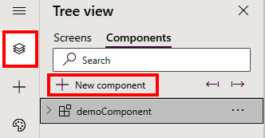

Figure 10.4 – Creating a canvas component in Power Apps

Each component can hold custom properties. Custom properties allow components to either receive values from the application, known as input properties, or send data or state from the component to the app, known as output properties. No matter the property type (input/output), a custom property can hold data of any data type, spanning from traditional data types, such as text and number, to more Power Apps-specific types, such as screen, color, and table. Using custom properties allows the sharing of information between the component and the app host. There is one more setting on the canvas component level, ****Access app scope****, and it can be found in the properties of the component itself. It can be turned on or off to allow access to a greater set of information available within the application, such as global variables, collections, and controls within the application. This is only applicable to the canvas components within the application and not to the components within the component library. We can turn off this setting and feed the information to the component through the custom properties.

## Component libraries

Since canvas components can only be used within one application, in order to reuse the components across applications in the environment, we can create a component library. A ****component library**** serves as a repository for component definitions. This allows an application to manage dependencies on the components that it utilizes, which means that whenever a component update is available, the app maker will be informed about it. The information about the available update will appear when editing the application in Power Apps Studio or by manually clicking a refresh button to check for the component library updates.

Creating a component library is different from creating a canvas component:

1. Component libraries can be found by navigating to the Power Apps home screen and selecting ****Component libraries**** from the left navigation panel. If you do not see this option in the left navigation panel, click on ****More**** | ****Discover all****, where you can find it under ****App enhancements****:

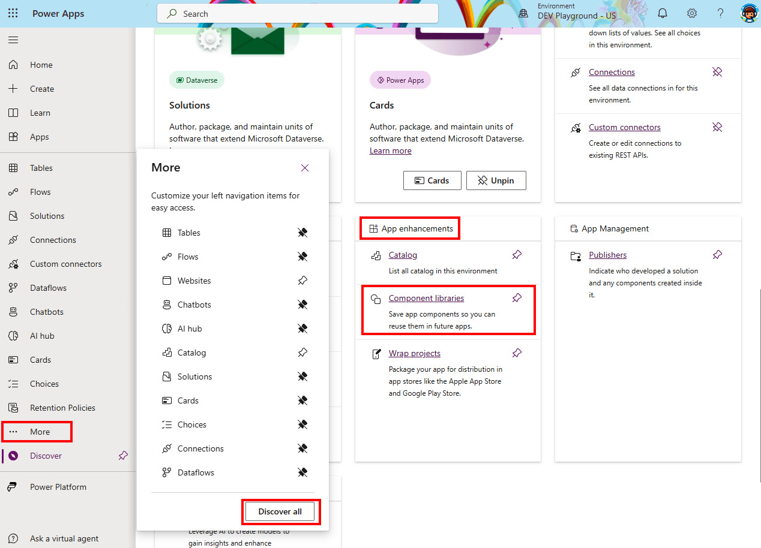

Figure 10.5 – Accessing Component libraries

1. Once we are on the component libraries screen, we can click on ****+ New component library**** to create a blank canvas for adding app components.
2. Here we can import existing components or create new ones by following the same process as with the regular canvas component. Each component that is created or imported in a component library allows makers to make customizations in the target environment. ****Allow customization**** is a property of the component inside Power Apps Studio. If customization is allowed, then once the app maker starts making changes to the component in the application, this will break the reference to the component library and create a local copy of the component. In order to maintain control over components and allow component changes only from within the component library, turning off this component setting is a good practice.
3. Once all components are added to the component library, we need to publish the changes. The publishing process is the same as with any other canvas component or canvas app. If the component library is not published, it cannot be reused.
4. Once published, we are ready to reuse the components from the library in our application. To do so, we open our canvas app in Power Apps Studio and, in the left navigation panel, click on ****Insert****, which opens an option for adding controls and components.

We click on the icon that represents directory search, which opens an ****Import components**** screen. Here we can find our component library and all components that are part of the library. We can select those that we need and click ****Import****:

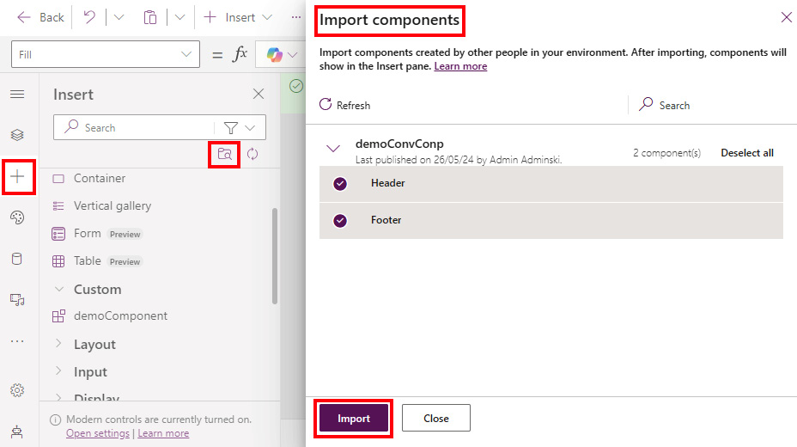

Figure 10.6 – Importing components from a component library

1. Components from the component library will appear in the left navigation panel under the ****Insert**** option. We can find them in a ****Library components**** group, just underneath the ****Custom**** category, which holds locally created canvas components, as shown here:

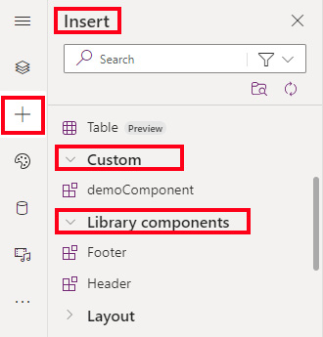

Figure 10.7 – Accessing components from the added component library

Now that we have learned how to build canvas components and component libraries that support the reusability of the components across canvas applications in an environment, let’s investigate how we can manage the component library life cycle.

## Managing the life cycle of the component library

As we saw earlier, in order to reuse components across multiple apps, they need to be added to the component library. Once added to the library, they can be inserted into the application. With that, the application creates a dependency on the selected component from the component library and simplifies our solution management.

To deploy our application with a component dependency into a different environment, we have to make sure that the component library exists in the target environment prior to deploying the application. Otherwise, the import solution process will not succeed. It is on us to make sure that the component library is either bundled together with the application inside the solution or moved to the target environment in a separate solution, prior to deploying the application that has a component dependency.

We can check whether the application has any dependencies by navigating to ****Solutions****, selecting our solution, clicking ****Object****, clicking on the three dots next to the name of the application, clicking ****Advanced****, and clicking ****Show dependen********cies****, as shown in *Figure 10.8*:

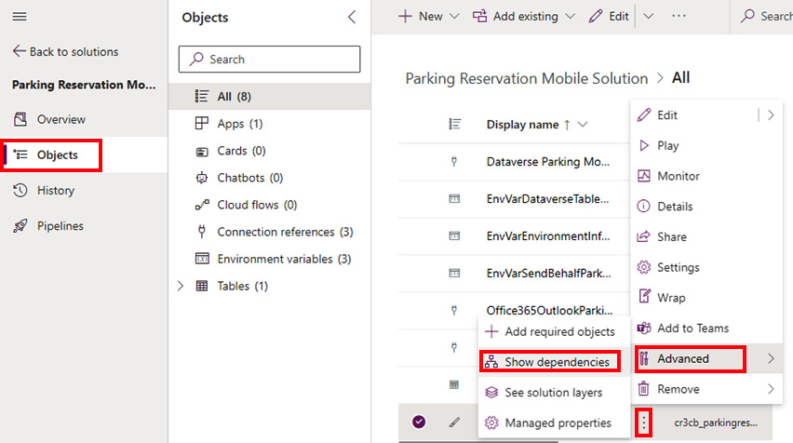

Figure 10.8 – Checking application dependencies

There we will find a tab called ****Uses****, which shows which objects are being used by our application. Selecting the three dots next to the name of the component library will redirect us to ****Default Solution****. It is important to note that component libraries are placed in the default solution within the environment. This will be the same when we have moved to the target environment, as long as the environment has Dataverse enabled.

Adding a component library to the solution where our application resides can be easily achieved by going to our solution, clicking on ****Objects****, and either creating a new component library or adding an existing one. Creating a new one is done by clicking ****New**** | ****More**** | ****Component Library****. Adding an existing component library can be done through ****Add existing**** | ****More**** | ****Component Library****. Once the component library is added to the solution, we can enable/disable the option that allows customizations in the target environment. This setting is available inside the solution explorer. We select our component library, click on the three dots next to its name, and then click ****Advanced**** | ****Managed properties****. This will open a screen for editing the managed properties of the component library. Here we can toggle on or off the option to allow customizations in the target environment:

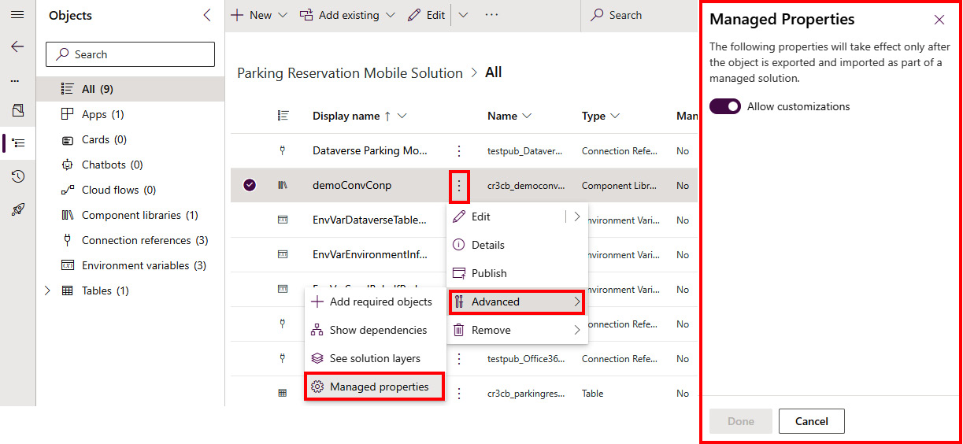

Figure 10.9 – Enabling/disabling customization in the target environment

Once we have added our component library with all components in the solution, we can follow the ALM process that we are already familiar with: export the solution from Power Apps using the export pipeline, followed by an import pipeline to the target environment, with all other relevant steps in between for testing.

Should we wish to update the component library separately from the application, it makes sense to have a separate pipeline process just for updating the component libraries. We can create a separate solution and add one or more component libraries that we would like to manage the application life cycles of separately. We need to keep in mind that the component library has to be deployed to the target environment prior to importing the solution that has reference to that component library. Once the component is updated, the app maker will be informed about the updates through the component update process (automatically or proactively).

Now that we have learned about canvas components and their reusability, we will go further and look what additional customizations are possible with the code components.

# Getting to know code components

Going one step further in pro-dev extensibility, the ****Power Apps component framework**** (****PCF****) allows professional developers to create code components that enrich the user experience whenever the look and feel of the built-in components is not sufficient. The PCF is such a big topic that it could have its own chapter in this book. In this section, we will try to give you at least an initial understanding of what the PCF is, how the PAC CLI can help us to build code components, and how to perform ALM using DevOps tools.

The PCF is a unified framework that allows developers to build custom code components that are reusable across applications in Power Apps and websites in Power Pages. This opens a great opportunity for organizations to build code components and leverage them across business solutions. Using the PCF, we can develop code components that will include not only information about the visual appearance of the component but also the business logic. This allows us to make applications and websites more appealing and customized to the business problem. The PCF is a successor of HTML web resources, which were used prior to PCF to render custom UI components inside model-driven applications. The PCF is more optimized for performance compared to HTML web resources, making it suitable for complex business solutions.

*Custom pages in model-driven apps*

*Custom pages**are flexible and powerful type of pages in model-driven apps that enable us to bring the experience from building canvas apps to model-driven apps. We can add canvas and code components to a custom page, which can be shown in a model-driven app as a main page, center dialog screen, or side dialog view. This gives us a great range of flexibility for building the experience of our business application.*

Currently, we know two types of PCF components: ****standard**** and ****virtual****. Both types of components leverage HTML, CSS, and TypeScript. However, virtual components use two platform-provided libraries, React and Fluent UI. They are added to the parent virtual ****Document Object Model**** (****DOM****), which means that there is no need to instantiate a React virtual DOM separately with each component. Although React and Fluent UI can be used with standard PCF components, doing so requires the developer to package libraries individually within the components. In the case of virtual components, we are able to use platform-provided libraries, which allows us to improve the performance of our applications using these code components. It is important to note that even if we start with a standard code component, we can later convert it to a virtual component.

Depending on how the component will be used, we can differentiate between two types of PCF components:

* ****Field****, where a code component can be bound to a field in a form
* ****Dataset****, which is a code component that is bound to a view, dataset, or collection in a canvas app and works with the rows of data from a dataset

Using these two types of PCF components, developers can build custom fields, columns, and views over datasets and dashboards that can replace built-in components in our business applications.

*Community resources for the PCF*

*For those who are willing to learn**more about the PCF and would like to see some examples that the wider community has developed using the PCF, Microsoft offers a set of links (to videos, blogs, and a code component gallery) that can be used for this purpose. For more information, go to:*<https://learn.microsoft.com/en-us/power-apps/developer/component-framework/community-resources>*.*

## Code component composition

No matter which control type or kind of component we decide to build, code components consist of three main elements—a manifest file, a component implementation, and resource files.

### Manifest file

A control manifest is an XML file that is used to register and manage the code component. The name of the manifest file is ****ControlManifest.Input.xml****.

It holds all information about the code component, such as the following:

* The component metadata information
* Information about the control type (standard or virtual)
* Whether any external services are going to be used (which would require premium licensing)
* Properties that are available for use
* Used resources
* Other metadata and config data

The properties available in the code component can then be either manually entered or dynamically set to a value or data from other components in the application.

### Component implementation

Code component logic is implemented in a file called ****index.ts****. Here we are able to place the code that will define the behavior of our code component. This is the place where we can find methods that control the life cycle of our code component.

The life cycle of the code component can be divided into four main methods:

* ****init****: This method is used to initialize the component instance. This function not only configures the component but can also register any event listeners or add other functionalities for the component to properly behave. This method is required to be implemented in the code implementation file.
* ****updateView****: This method gets called when any value in the component’s properties or component metadata changes. It is used to reflect the changes in the component’s UI. This method is required to be implemented in the code implementation file.
* ****getOutputs****: This method gets called prior to a component receiving new data. This method is optional in the code implementation file.
* ****destroy****: This method gets called when the component is to be removed from the DOM tree. It should be used to perform any cleanup operation and release any memory that the component is using. This method is required to be implemented in the code implementation file.

### Resource files

In the manifest file, one of the nodes that defines code components is ****resources****. This node holds the information about the code resource, which is our ****index.ts**** file, which contains code logic. Next to the ****code**** resource, we have static files that define the visual appearance of the code component. Here we can find a ****Cascading Style Sheets**** (****CSS****) file that contains code that controls the visual representation of the component.

Since code components can be reused across applications and environments, support for localization is beneficial, as it allows us to share components across applications where there might be other language requirements. The PCF supports localization. Localized strings can be stored in RESX web resource files and registered in the manifest file. Other files, for images, icons, or anything else that is required for the component to work properly, can be added. Files are usually stored in a separate folder structure, registered in the manifest file, and referenced in the code logic.

Now that we have learned what the file structure of the code components looks like, let us go ahead and create our simple code component.

## Creating your code component

In this exercise, we will be creating a virtual (React) control type, since this will be the recommended control type going forward.

### Prerequisites

In order to build the code component, we need to have installed the tools mentioned in the *Technical requirements* section.

To get the .NET build tools, Visual Studio 2019 or higher (Visual Studio 2022) should be installed. Instead of installing the complete Visual Studio, we can select just the .NET build tools as the workload during the installation wizard. An alternative to this is to install the .NET 8.0 SDK. Currently, .NET 8.0 is the latest long-term support version.

### Initializing the project

First, we need to initialize the project. For this, we will be using the PAC CLI and its set of commands specific to the PCF. We can achieve this using the following command:

pac pcf init --name <COMPONENT\_NAME> --namespace <COMPONENT\_NAMESPACE> --template <COMPONENT\_TYPE> --framework <RENDERING\_FRAMEWORK> -npm

Two parameters stand out – ****template**** and ****framework****. Now, ****template**** describes whether we will be creating a code component that will be used with fields or datasets. ****framework**** defines which framework will we be using. If using ****React****, then this will be marked as a virtual control type; otherwise, it will be a standard control type. If we do not provide a ****--run-npm-install**** or ****--npm**** switch in the command, we will need to run the ****npm install**** command separately, to install the project dependencies.

In our example, we used the following command to initialize the project of a folder structure with some supporting files:

**pac pcf init --name SimpleReactPCF --namespace SimpleReactNS --template field --framework react -npm**

Here is the folder structure:

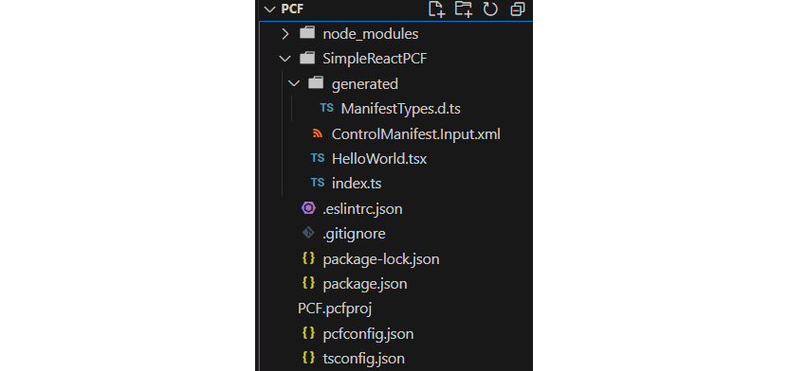

Figure 10.10 – Folder structure of the PCF initialized project

Now that we have initialized the project and have files and a folder structure, we can move on to start implementing the code logic.

### Implementing the code component

As we can see in the folder structure of our code component, our manifest file is also present in the PCF project.

Inside the ****ControlManifest.Input.xml**** file, we can see the ****control**** element, which includes information about our code component, including the control type being set to ****virtual****:

**<control namespace="SimpleReactNS" constructor="SimpleReactPCF" version="0.0.1" display-name-key="SimpleReactPCF" description-key="SimpleReactPCF description" **control-type="virtual"** >**

Another part of the manifest file is the ****property**** node, where we can have multiple properties for our code components.

We will change the property from ****SingleLine.Text**** to a number (****Whole.None****) by changing the highlighted property:

**<property name="sampleProperty" display-name-key="Property\_Display\_Key" description-key="Property\_Desc\_Key" **of-type="Whole.None"** usage="bound" required="true" />**

During this step, extensive coding may be done to develop the PCF component. Making changes to the code of the component requires knowledge of TypeScript and React.

### Debugging a developed code component

With a simple ****npm start watch**** command, we can run the project in debugging mode, which opens a browser with our local PCF test environment. On the right side of the test application, we can see all the configured data properties that are specified in the manifest file, as shown in *Figure 10.11*. Here we can adjust the values of the properties and check whether the state of the code component reflects the desired behavior.

Additionally, we can use the test environment to understand how our code component adjusts to different screen sizes. We can use the ****Form Factor**** settings as well as ****Component Container Width**** and ****Co********mponent Container Height**** to adjust the screen size:

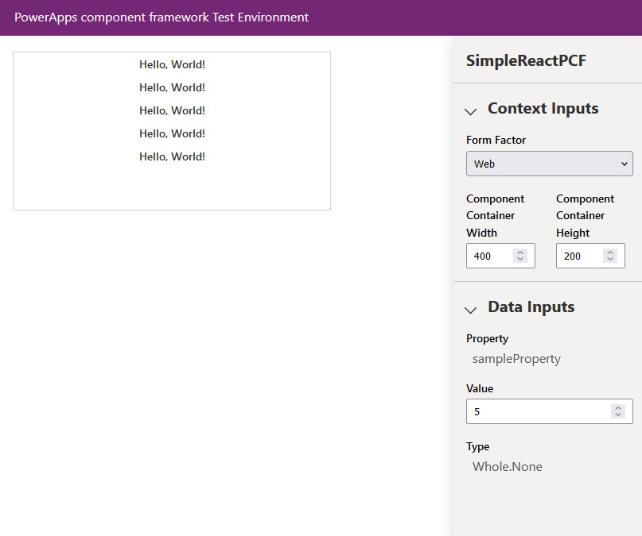

Figure 10.11 – The PCF test environment

### Packaging the code component

Code components can be added to solutions to enable reusability across environments. If we already have solutions available, we can simply upload the code component to the solution using the ****pac pcf push**** command, as shown in the next section. In other cases, we can utilize a set of commands to first create a solution and then add a reference to that solution.

We will be adding a reference for our code component project to a newly created solution project. The solution project (****cdsproj****) can contain multiple code component references, while the code component project can only contain a single code component. Adding references to multiple code components within a single solution project allows us to reference all the code components required for a particular business solution. They can also be packaged together with other solution objects if needed.

First, we will initialize a solution using the following command:

pac solution init

Then we will add a reference to the code component project:

pac solution add-reference --path <LOCATION\_TO\_PCFPROJ\_FILE>

This will create a reference inside the ****.cdsproj**** file, like this:

**<ItemGroup>**

**<ProjectReference Include="..\SamPCF\SamPCF.pcfproj" />**

**</ItemGroup>**

When we are ready to generate a ZIP file from the solution project, we can use the following:

dotnet build /t:build /restore

This will restore all code component projects that are referenced in the solution project and build the project. The final outcome of the process is a ZIP package artifact that can be imported with the code components solutions. Such a solution can now be imported into the downstream environment.

If we have a business application in another solution that is referencing our code components, we need to make sure that the solution with the code components is deployed to the environment first, before importing the business application that references them.

### Importing the solution into Power Platform

Importing the solution into Power Platform (Dataverse) can be done manually using the Power Platform web portal or the ****pac pcf push**** command. It can also be done automatically using Power Platform Build Tools and the DevOps tool of choice. In the next section, we will take a look at how this can be done automatically. In this section, we will complete the process manually.

First, we should make sure that we are in the right Dataverse environment. To select the right environment, we can proceed with ****pac env list**** and ****pac env select -env <ENVIRONMENT\_ID>****. After confirming the environment, we can proceed with the ****push**** command.

It is worth noting that the ****pac pcf push**** command also has a ****-env**** setting, which allows us to push to a selected environment if we are operating across multiple environments.

As we are still in the folder of our code component, we can run the command, in which we can either use a publisher prefix from our environment or the unique name of our solution. In both cases, the PAC CLI will check whether the publisher or solution already exists. If it does, it will use it to push the component – here is one option:

pac pcf push –solution-unique-name <SOLUTION\_NAME>

Here is the other:

pac pcf push -pp <PUBLISHER\_PREFIX>

Without the name of the solution, this code component will be imported to a temporary ****PowerAppsTools\_<prefix>**** solution.

### Preparing the component for release

When preparing our code component for release to the production environment, we should add the ****<PcfBuildMode>production</PcfBuildMode>**** property inside the ****pcfproj**** file underneath ****OutputPath****, as in the following example:

**<PropertyGroup>**

**<Name>PCF</Name>**

**<ProjectGuid>e71d2e10-908c-4123-9f29-3283cbd224ab</ProjectGuid>**

**<OutputPath>$(MSBuildThisFileDirectory)out\controls</OutputPath>**

**<PcfBuildMode>production</PcfBuildMode>**

**</PropertyGroup>**

Development mode produces a larger bundle that holds debugging information, which might impact performance in production. This is why the change should be made to the ****pcfproj**** file before building and deploying to production.

Additionally, when preparing the solution project, ****SolutionPackagerType****, which is part of ****PropertyGroup**** in the ****cdsproj**** file, defines the solution type, stating whether we would like to go for managed, unmanaged, or both solution types:

**<PropertyGroup>**

**<SolutionPackageType>Managed</SolutionPackageType>**

**</PropertyGroup>**

When running the ****dotnet build**** command, this information will be taken to generate a ZIP file of the defined solution type. When we are preparing for release to production, we can use ****dotnet build /p:configuration=Release**** to create a release build for the selected solution type.

### Adding code components to applications

Code components can be used across canvas applications, model-driven apps, and websites. The following are some examples of adding components to apps.

#### Model-driven apps

Adding components to model-driven apps is very easy:

1. When editing the form, click on ****Components**** in the left navigation bar and click ****Get more components****.
2. This will open a ****Get more components**** sidebar, where newly created code components will appear. Select the necessary components and click ****Add****, as can be seen in *Figure 10.12*:

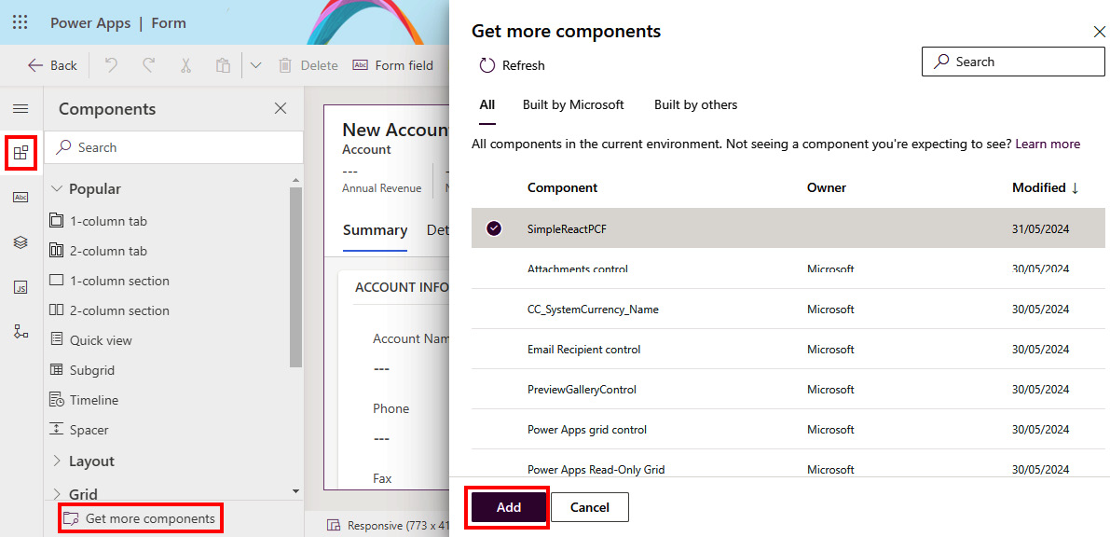

Figure 10.12 – Adding code component to a form in a model-driven app

1. After adding the code components to the list of components, they appear under the ****More components**** group inside the ****Components**** option. Simply drag and drop the components to the right places in the form and connect the component values with the correct values.

#### Canvas apps

Adding code components to canvas applications has to be enabled before it’s possible. The setting for enabling it is currently available in the Power Platform admin center:

1. Go to ****Environments****, select the environment, and then click ****Settings**** | ****Product**** | ****Features****.
2. Here we will find the ****Power Apps component framework for canvas apps**** setting, which is turned off by default. If needed, enable it.
3. Once done, we can go to our canvas application and click ****Insert**** to see a list of all controls. Then we can proceed to the ****Code**** tab, select the components, and click ****Import****, as shown in *Figure 10.13*.

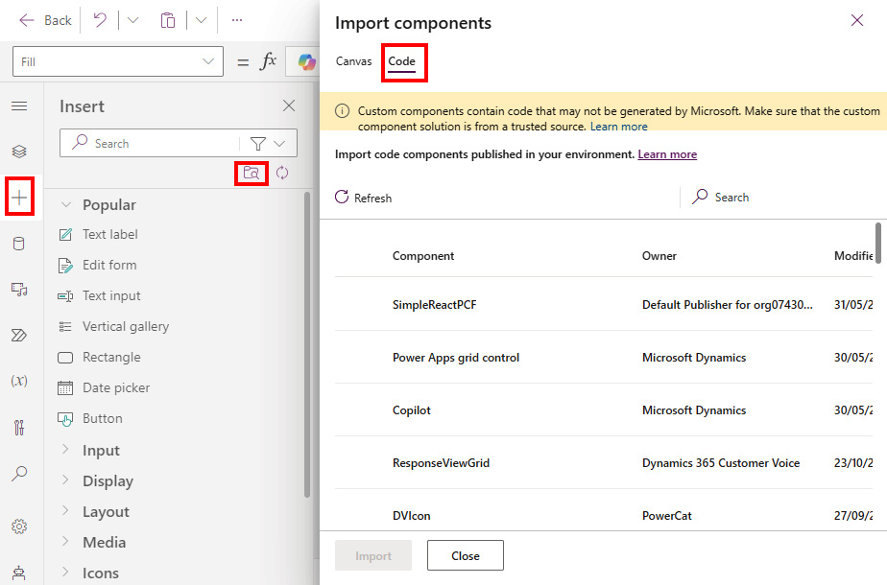

Figure 10.13 – Adding a code component to the canvas app

#### Power Pages

Adding code components to Power Pages is similar to the process of doing so for model-driven apps:

1. Your components can be found by going to ****Data**** in the left navigation bar.
2. Select the table of choice, click ****Forms**** (or ****V********iews****, depending on the use case), and click ****Get more components****.

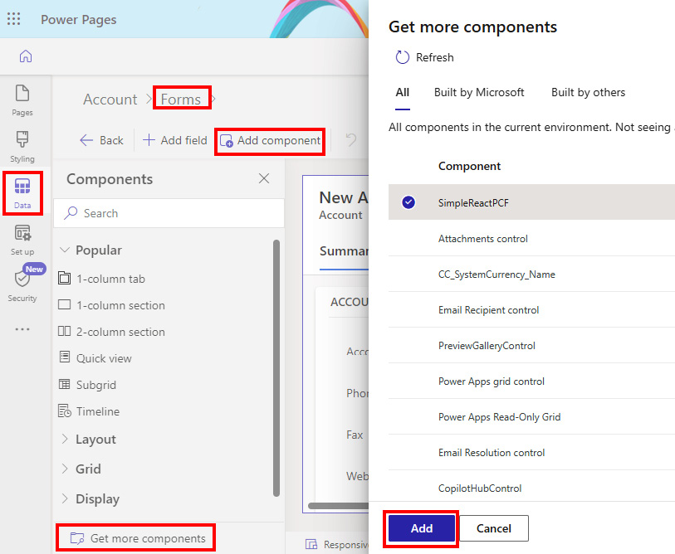

Figure 10.14 – Adding code components in Power Pages

1. This will open a sidebar to help you find a custom code component. Select the one you require and click ****Add****, as can be seen in *Figure 10.14.*

Now that we have learned how code components are created and added to an application, let’s understand how the application life cycle is managed for these components.

## ALM for code components

As we saw in the previous section, the development life cycle of a code component consists of the following steps:

1. The initialization of the PCF project
2. Working on the code component’s implementation
3. Testing/local debugging of the developed code component and pushing it to the Power Platform development environment
4. Adding the component project reference to the solution in the development environment
5. Testing the business solution with the included code components
6. Preparing the code component for release
7. Importing the solution to other environments and testing

We recommend building automated pipelines by leveraging Power Platform Build Tools in Azure DevOps or GitHub, together with the PAC CLI, to perform these tasks automatically.

As with any other development project, when developing code components, it is also recommended that developers use a source code repository, such as GitHub or Azure DevOps, from the beginning, in which to collaborate. Using ****pac pcf init**** also creates a ****.gitignore**** file, which instructs the version control system as to which files and folders should be left out since they will be either created or restored during the build process.

It is worth noting that when we have a code component in a solution, we can export the solution together with the code component using Power Platform Build Tools or ****SolutionPackager /action: Extract****, which incrementally exports changes to the solution metadata. When a code component is extracted from a solution package, a ****Controls**** subfolder will be created for each code component that is included in the solution.

Using ****pac pcf push**** to push a code component to an environment, and then using commands such as ****msbuild**** and ****SolutionPackage /action: Pack**** to build a solution, allows us to build and repack the solution and make it ready for import.

### Solution strategy for code components

Another consideration with code components is the solution strategy. As we have learned, our business applications can have dependencies on various solution components. Power Platform allows us to deploy components together, as part of a ****single solution****, or separately, in ****segmented solutions****, where functionalities of our business applications are split between multiple solutions.

The segmented approach allows us to be more agile with the development approach of our business solution. Teams can each focus on their own parts of the business solution and can develop and test independently of the final solution. Such an approach allows us to decouple and share code components between multiple applications and across environments. Single solutions have everything in one solution, which means that it is important to follow a good branching strategy if you want to have control over updates to the complete solution.

### Versioning and updates to code components

Whenever we deliver changes to our code components that should be pushed to our business applications, we should make sure that we follow the standard versioning strategy (****MAJOR.MINOR.PATCH****), which will ensure that Power Apps applications detect and update dependencies to the latest version.

Inside the manifest file (****ControlManifest.Input.Xml****), under the ****control**** element, there is a ****version**** property that should get at least a ****PATCH**** version increase whenever an update to a code component is deployed. This will ensure that the change can be detected and that both canvas and model-driven apps will receive the latest version of the component:

**<control namespace="SimpleReactNS" constructor="SimpleReactPCF" **version="0.0.1"** display-name-key="SimpleReactPCF" description-key="SimpleReactPCF description" control-type="virtual" >**

An increase of the version can be done manually by changing the number in the manifest file, or it can be done automatically with the following command:

pac pcf version --strategy manifest

There are also other strategies, such as ****gittags****; however, the manifest strategy is by far the simplest, since it does everything automatically.

If we would like to specify the exact value of a version, we can do the following:

pac pcf version --patchversion <PATCH VERSION>

****MAJOR**** and ****MINOR**** versions should be aligned with the version of our Dataverse solution. If a significant change is made to a solution, then the ****MAJOR**** and/or ****MINOR**** version of the Dataverse solution should be incremented, which should lead also to incrementing the ****MAJOR**** and/or ****MINOR**** version of the code component.

*Code component updates for canvas apps*

*In order to update a code component to a newer version inside canvas applications, app makers must open the canvas app in Power Apps Studio and click*****Update*****on the*****Update code components*****popup. If the update is not done, then the canvas app will continue to use the old version of the code component.*

### Automated build pipelines for segmented solutions

To create a code component from scratch and keep control over it, we start by creating the code component locally and committing the changes to the Git repository:

1. Using the ****pac pcf init**** command, we will create a ****pcfproj**** folder. Once the project is created, we will be committing the changes to the Git repository. Using ****pac pcf push****, we will deploy our code component to the environment.
2. Separately, we will be creating a solution project using ****pac solution init****, to create a new blank solution, or ****pac solution clone****, if we already have a solution that we would like to reuse. The solution is also version-controlled in the Git repository.
3. Next, we need to add a reference to the solution using the ****pac solution add-reference**** command with the path to our PCF component project.
4. Now we need to update the solution version in ****Solution.xml**** to reflect the version of the current build. This can be done by formulating the ****MAJOR.MINOR.BUILD.REVISION**** version with the variables in Azure DevOps/GitHub. For ****MAJOR****, we can create ****$(majorVersion)**** variables; for ****MINOR****, we can create ****$(minorVersion)**** variables; for ****BUILD****, we can use the predefined ****$(Build.BuildId)****; and for ****REVISION****, we can use ****$(Rev:r)****.
5. We will also need to change the version value inside ****ControlManifest.Input.xml****.
6. Once the version numbers are updated, we can run a task, as part of our build pipeline, using the ****dotnet build /restore /p:configuration=Release**** command (or ****msbuild****, depending on what tools are we using). We configure the task in a way that means it builds only the ****cdsproj**** project. We can achieve this by setting the ****\*.cdsproj**** wildcard.

Once the build has been completed, we will store the produced ZIP file in the pipeline release artifact using a ****Copy file**** task, which can be used for deployment. The deployment process is the same as with other solution import processes.

### Automated build pipelines for single mixed solutions

The single mixed solutions approach needs to be configured in the solution object explorer, where all the required solution components are added. Then, we utilize ****SolutionPackager /action: Extract**** to extract the components into the source control system. Just as earlier, we need to update the solution version in ****Solution.xml**** to reflect the version of the current build. We also need to change the version value inside ****ControlManifest.Input.xml****.

We will add a task to the pipeline called ****Power Platform Tool Installer****.

Next, we will restore ****node\_modules**** using ****npm task**** with the ****npm ci**** command. For the production release mode, we will use ****npm task**** with a custom command parameter: ****npm run build -- --buildMode release****. The output of the build needs to be stored separately in a folder. Then we will use a ****Power Platform Pack Solution**** task or ****SolutionPackager /action: Pack**** to package the files and collect the built solution ZIP in the pipeline artifact.

*More information on ALM for PCF components*

*To support this section, we recommend visiting the documentation on ALM for PCF components**here:*<https://learn.microsoft.com/en-us/power-apps/developer/component-framework/code-components-alm>*.*

We have mentioned many times that code components can also be used with Power Pages. Since Power Pages allows developers to extend websites greatly with custom code, it is important to take a look at how we can apply ALM to Power Pages.

# ALM for Power Pages

Power Pages allows app makers and professional developers to build engaging, scalable, and secure websites. Since Power Pages websites are built using the HTML, CSS, JavaScript, and Liquid templating languages, developers can follow common web development practices and use known tools, such as Visual Studio Code. Once changes are made to their websites, developers should follow a process of committing those changes to the repository and applying them to different environments. This section focuses on describing how ALM is applied to Power Pages websites. We will take a look at how Power Platform pipelines enable easier and faster configuration of deployment pipelines and how to use Power Platform Build Tools in Azure DevOps to create the pipelines necessary for exporting and importing solutions into different environments.

Power Pages was previously known as Power Apps Portals. The older data model, known also as the standard data model, used custom tables to store the configurations of Power Apps Portals websites. As configurations were stored separately, this prevented us from using solutions as was possible with other Power Platform services. However, in the second half of 2023, Microsoft introduced a new and enhanced data model that was built on system tables, non-config tables, and virtual tables. This new approach allows us to contain website configurations in solutions, which simplifies the ALM approach.

Information about each site, including whether it uses the enhanced or standard data model, can be found inside the ****Site details**** | ****Data model**** setting for each website in Power Pages. The same website information can also be found on ****Power Platform Admin center**** | ****Resources**** | ****Power Pages sites****, where you can select a site and then click ****Manage****. The information about the data model is found under ****Site Details****.

*Migrating from the standard model to the enhanced data model*

*Although all newly created sites in Power Pages use the enhanced data model by default, you might still come across legacy Power Pages websites that are built on the standard data model. Customers who have websites that use the previous data model should consider migrating their websites to the new model. The enhanced data model provides benefits over the standard one, such as faster website provisioning, solution support, and ALM.*

*Microsoft has introduced a migration guide that helps customers to migrate from one data model to the other:*<https://learn.microsoft.com/en-us/power-pages/admin/migrate-enhanced-data-model>*.*

Now that we’ve had a short introduction to Power Pages, we can take a look at how the PAC CLI can support website life cycle management.

## Use of the PAC CLI for Power Pages

The PAC CLI offers tools for managing the configuration of Power Pages websites, which includes downloading and uploading website content from and to Power Pages.

There are two specific commands that we will be using in this section. The first one is the ****pac pages download**** command, which is able to download website content from Dataverse. The other one is the ****pac pages upload**** command, which can upload website content together with all the manifest files and the deployment profile that is appropriate for the target environment.

These two commands support ALM for Power Pages and can be used together in our CI/CD pipelines, wherever we are not using Power Platform Build Tools.

### Deployment profiles

A deployment profile is a file in YAML format that holds a set of values and settings that are relevant to the target environment. Deployment profiles are used in a similar way as deployment settings files are in Power Apps. It is possible to have a deployment profile file for each target environment that we are deploying a website to. Each of these files contains values that match the configuration settings of the target environment.

Deployment profiles should be added in the ****deployment-profiles**** folder, in the root of the downloaded website folder. A new folder will need to be created if it has not been created yet. There we can add the ****<profileTag>.deployment.yml**** files.

These files will then be used later on, during the upload process, with a ****--deploymentProfile test**** argument:

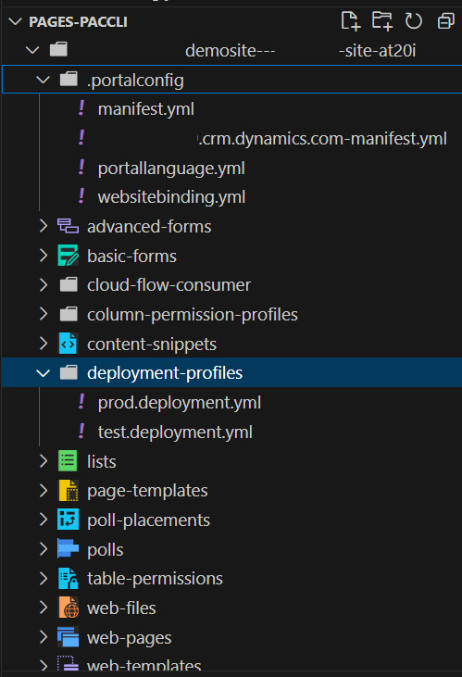

Figure 10.15 – Deployment profiles and manifest files in Power Pages

### Manifest files

When downloading a website from Power Pages, the PAC CLI creates two additional manifest files: an environment manifest file (****org-url-manifest.yml****) and a delete-tracking manifest file (****manifest.yml****). Both files are in YAML format and stored with the ****.portalconfig**** root folder structure of the downloaded website.

The environment manifest file is created with the purpose of optimizing the upload process. After each download method is run with the PAC CLI, the download method creates a new manifest file, in case one doesn’t exist yet. If the manifest file exists, it reads the existing manifest file and updates the changes, such as any entries that were removed. When uploading content, only the updated and new entries are uploaded to Power Pages.

The environment manifest file is environment-specific, intended mainly for development environments, and it should be added to the ****git ignore**** list.

The delete-tracking manifest file is used to keep track of entries removed from the environment. Whenever a download method is called, all the deleted entries are added to the delete-tracking manifest file. Once an upload method is called, the method removes the unnecessary entries from Power Pages. This file is important and should be added to the source control system and transferred to the target environment.

### Example of using the PAC CLI for Power Pages

We will take a look at the example of using the PAC CLI for the download and upload of Power Pages content:

# Show all Power Pages websites

pac pages list

# download content of a website with Website Id from Power Pages to a selected location.

pac pages download -id <PAGES\_WEB\_ID> -p <DOWNLOAD\_LOCATION>

# we perform changes to the file and decide to upload the changes, using the deployment profiles.

pac pages upload –path <PATH\_LOCATION> --environment <ENVIRONMENT\_ID> --deploymentProfile <PROFILETAG>

## Using Power Platform Build Tools with Power Pages

Power Platform Build Tools offers two tasks that we have not yet explored: ****Power Platform Download PAPortal**** and ****Power Platform Upload PAPortal****. Both tasks are intended to operate with Power Pages.

We will first create an export pipeline that will download the website content and commit everything to the main branch. The following is a snippet of steps with the tasks needed to enable such a pipeline:

steps:

- task: PowerPlatformToolInstaller@2

  inputs:

    DefaultVersion: true

- task: PowerPlatformDownloadPaportal@2

  inputs:

    authenticationType: 'PowerPlatformSPN'

    PowerPlatformSPN: 'PP-DevUS-SPN'

    DownloadPath: 'Portal/'

    WebsiteId: '$(WebsiteID)'

- task: CmdLine@2

  inputs:

    script: |

      echo commit all changes

      git config user.email "<EMAIL@DOMAIN.COM>"

      git config user.name "<USER\_NAME>"

      git init

      git checkout -B main

      git add --all

      git commit -m "code commit"

      git push --set-upstream origin main

      git -c http.extraheader="AUTHORIZATION: bearer $(System.AccessToken)" push -f origin HEAD:main

After running the export pipeline, we now have the source code in Azure Repos.

As a next step, we should create deployment profiles with the necessary configuration values, as mentioned in the previous section (on creating a ****deployment-profiles**** folder with corresponding deployment YAML files). The deployment profile files might not change that often, as they might be environment-specific, but it is worth setting them up and updating them when necessary; it is a good practice to use them from the beginning in order to keep the configuration settings separate between environments.

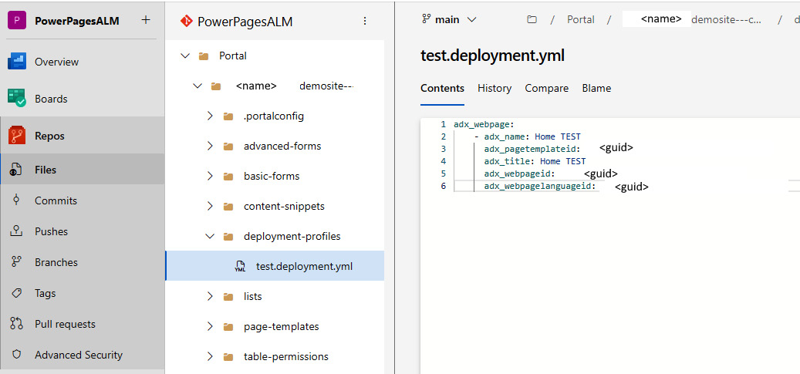

Figure 10.16 – Deployment profiles in Azure Repos

Whenever developers have to work on their website, we recommend using a branching strategy and pull request mechanism, in order to keep the main branch protected and always in a deployable state.

After the pull request is validated and approved, branches can be merged to the main branch.

Merging branches can automatically trigger the deployment pipeline. The following is a snippet of tasks from the deployment pipeline:

steps:

- task: PowerPlatformToolInstaller@2

  inputs:

    DefaultVersion: true

- task: PowerPlatformUploadPaportal@2

  inputs:

    authenticationType: 'PowerPlatformSPN'

    PowerPlatformSPN: 'PP-DevUS-SPN'

    UploadPath: 'Portal/$(WebsiteName)'

    DeploymentProfile: '$(profileTag)'

Here we have two variables, ****WebsiteName**** and ****profileTag****. The first is the name of our Power Pages instance as it appears in our Azure Repos; ****profileTag**** should match the tag of the deployment profile.

We should not forget to perform proper testing of our Power Pages websites in order to validate our work and confirm the rollout to our target environment.

We familiarized ourselves with Power Platform pipelines in *[Chapter 5](https://learning.oreilly.com/library/view/mastering-devops-on/9781835880845/B22208_05.xhtml" \l "_idTextAnchor089)*, where we talked about managed pipelines. Let’s take a look at how we can utilize Power Platform pipelines to deploy our Power Pages websites.

## Using Power Platform pipelines with Power Pages

****Power Platform pipelines**** allow the quick and easy configuration of deployment pipelines that enable organizations to automate the release of a build from the development environment to other environments, such as test and production.

In order to utilize Power Platform pipelines, all target environments must be enabled as ****Managed Environments****, and all environments that are used in pipelines must be Dataverse-enabled. All websites have to be created using the enhanced data model.

Once the prerequisites are met, we are able to proceed with deploying our websites to target environments.

First, we need to prepare the solution. In Power Apps, we open ****Solutions****, where we either create a new solution or open an existing one. Then, we open the solution and add our existing website to the solution by selecting ****Add existing**** | ****Site****. In the sidebar that opens, we select the website that we would like to add to the solution. Once the solution objects are added to the solution, we can proceed with setting up the pipeline. While still in the newly created solution, we click ****Pipelines****, which can be found in the left navigation bar. In ****Pipelines****, we can select existing pipelines that the DevOps or IT operations team has created for us in advance, or we can click ****Create new pipeline****. The new popup screen allows us to define the deployment pipeline, which will take our solutions from the source to the target environment:

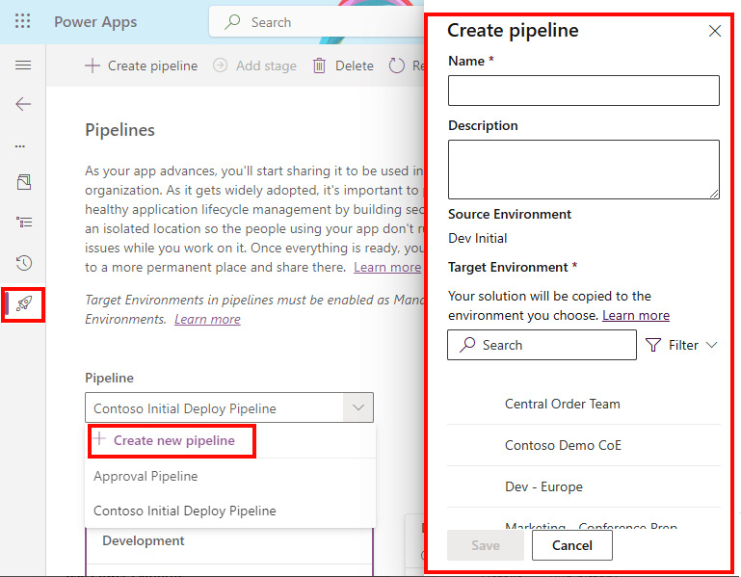

Figure 10.17 – Power Platform pipelines

Once the pipeline is configured, we can press the ****Deploy here**** button and the deployment process will start.

This is a more simplified kind of deployment process. Still, it is suitable for many scenarios. It opens the door for app makers who might not be skilled in DevOps processes and CI/CD pipelines but are still aware of the importance of the automated approach of deploying business solutions and keeping environments separate.

# Summary

This chapter continued building on the possibilities that Microsoft Power Platform provides to pro-developers. The platform definitely shouldn’t be taken lightly, even though it is a part of the low-code development toolset. As we have seen, it offers many opportunities for pro-developers to extend the user experience and integrate solutions with complex backend and legacy systems. Now we can see how important it is to form agile fusion teams where pro-developers have the ability to customize solutions using different custom components, in order to deliver on project requirements.

We looked at examples of how connection references and environment variables can be used together with the DevOps approach. We continued with a look at canvas components and component libraries. We then covered the Power Apps component framework and code components. All these components can be added to solutions as solution objects, and DevOps pipelines can be used to deploy them securely to other environments as development progresses. We closed this chapter by taking a look at Power Pages ALM. We have investigated how we can use Power Platform Build Tools to support ALM process for our websites, as well as checked a simpler approach using managed pipelines in Power Platform.

The next chapter will focus on best practices for managing environments in a governed and secure way and how the IT operations team can describe environments using code. This is a very important part of the DevOps life cycle that we have to address, even though it is not very pro-dev-oriented.

# Further reading

* Connectors architecture: <https://learn.microsoft.com/en-us/connectors/connector-architecture>
* Connection references: <https://learn.microsoft.com/en-us/power-apps/maker/data-platform/create-connection-reference>
* Environmental variables: <https://learn.microsoft.com/en-us/power-apps/maker/data-platform/environmentvariables>
* Component library: <https://learn.microsoft.com/en-us/power-apps/maker/canvas-apps/component-library>
* Power Apps component framework: <https://learn.microsoft.com/en-us/power-apps/developer/component-framework/overview>
* Power Pages ALM: <https://learn.microsoft.com/en-us/power-pages/configure/portals-alm>

# 10

# Enabling Pro-Dev Extensibility in Power Platform

This chapter focuses on the capabilities provided by Power Platform to professional developers to extend the experience of business solutions built on top of Power Platform. We will take a look at how Power Platform ensures the smooth integration of these extensibility options with ALM/DevOps processes in order to support the software development life cycle of these components.

We will start the chapter by looking into connectors and continue our work on custom connectors. In the previous chapter, we showed how pro developers can build web APIs and deploy them to Power Platform directly from Visual Studio; here, we will explore the concept of using the PAC CLI to ensure we enable ALM for custom connectors. We will also look into the other aspects of the custom connectors, such as environmental variables and connection references, and explain their role when moving solutions across different target environments.

After that, we will discuss canvas components in Power Apps and the key benefits of using them. From there, we will delve into the Power Platform code components, more specifically the Power Apps component framework. For both canvas components and code components, we will explain the process of including them in the ALM process.

We will close this chapter with coverage of Power Pages, how pro developers can extend Power Pages with custom code, and how the ALM process can be implemented.

We will cover the following main topics:

* Enabling the power of integration – connectors
* Overview of canvas components and the component library
* Getting to know the code components
* ALM for Power Pages

# Technical requirements

To follow this chapter, you need the following:

* ****Power Platform subscription****: You can sign up for a Power Platform development plan (<https://powerapps.microsoft.com/en-us/developerplan/>) if you already have a Microsoft Entra ID work account, or you can join the Microsoft 365 developer program (<https://developer.microsoft.com/en-us/microsoft-365/dev-program>).
* ****Visual Studio Code****: We recommend using Visual Studio Code or Visual Studio with the Power Platform Tools extension, or the IDE of your choice. Visual Studio Code can be found here: <https://code.visualstudio.com/>. Visual Studio is also available as a free Community edition: <https://visualstudio.microsoft.com/vs/community/>.
* ****Power Platform CLI****: We will be using the PAC CLI inside the command line or terminal. Installation guidance can be found here: <https://learn.microsoft.com/en-us/power-platform/developer/cli/introduction?tabs=windows>.
* ****Azure DevOps or GitHub****: We can create an Azure DevOps service organization any time *for free* (<https://learn.microsoft.com/en-us/azure/devops/user-guide/sign-up-invite-teammates>). We can also create a GitHub handle and public repository (<https://github.com/signup>), which is also *free* for public repositories.
* ****Node.js****: To build PCF code components, you require Node.js. The LTS version is recommended (<https://nodejs.org/en>).
* ****.NET build tools****: You will need either ****msbuild**** (part of Visual Studio) or ****dotnet build**** tools (part of the .NET SDK: <https://learn.microsoft.com/en-us/dotnet/core/sdk>).

# Enabling the power of the integration – connectors

This section provides a deeper look into how connectors and custom connectors can be reused across environments with the help of ALM. We will take a look at the concepts of environmental variables and connection references, which are two important concepts for when we plan to scale. We will learn how solutions can be used to wrap connectors for potential reuse across different environments.

## Connectors

We were introduced to connectors in *[Chapter 2](https://learning.oreilly.com/library/view/mastering-devops-on/9781835880845/B22208_02.xhtml" \l "_idTextAnchor030)*. Our discussion on connectors so far has covered that connectors enable us to connect to different services and data sources from within our applications, flows, and chatbots. Connectors can be either certified ones, which connect to first- or third-party services, or they can be custom ones. Certified connectors are prebuilt and cannot be changed, whereas custom connectors give us the freedom to create our own connectors to connect to either our own custom services/APIs or other services for which a prebuilt connector does not yet exist.

Connectors act as wrappers around sets of API operations, which are categorized as either triggers or actions.

****Triggers**** are operations in a connector that respond to a certain event, for example, a SharePoint list item being created. Two types of triggers exist: polling triggers and pushing triggers. ****Polling**** triggers proactively check for changes. They repeatedly, at regular intervals, perform calls of the specified service endpoint to look for new data. ****Pushing**** triggers, or webhook triggers, are able to react to external events. When a certain event occurs, the service endpoint notifies the trigger via the callback URL.

****Actions**** are operations that help us perform methods (retrieve, create, update, and delete) specified in an API definition file. Operations are performed over the data in a service that a connector is connected to, for example, getting all SharePoint lists from a site.

We worked with custom connectors in *[Chapter 9](https://learning.oreilly.com/library/view/mastering-devops-on/9781835880845/B22208_09.xhtml" \l "_idTextAnchor149)*. They give us the ability to define our own triggers and actions based on the API operations of our service.

*Microsoft Power Platform’s open source repository*

*Microsoft published an open source repository that allows anyone to review existing certified and custom connectors as well as collaborate by submitting new connectors to the repository. The list of predefined connectors and custom connectors with the corresponding definition files is published in Microsoft’s GitHub repository, which is open to anyone for contributions:*<https://github.com/microsoft/PowerPlatformConnectors/>*.*

*Anyone who wants to certify a connector can follow the step-by-step approach, described here:*<https://learn.microsoft.com/en-us/connectors/custom-connectors/submit-certification>*.*

When planning to deploy applications to different target environments, we must ensure that our connectors utilize connections that exist in the target environments. To be able to switch to the right connection in a target environment in an automated way using pipelines, we recommend using connection references. Let us now take a look at what connection references are and how they can be used.

## Connection references

When a connector is used in an application or flow to run a certain connector operation, a ****connection**** for the connector is created in the specific environment. Connections are bound to an environment and store authentication credentials to perform the operation.

Since connections are not solution-aware and do not provide an option of decoupling our business solution from the connection, connection references were introduced.

****Connection references**** are solution components that point to a connection for a specific connector. Using connection references allows us to build flexible solutions that enable us to programmatically change the connection information in applications and flows. This simplifies the deployment of our solution to different target environments when using the DevOps approach, as it allows us to connect to resources that are relevant to the target environment.

Let’s explore another method for parameterizing solution configuration: environment variables.

## Environment variables

Environment variables act as configuration parameters for solution components, allowing us to dynamically change configuration values specific to the target environment. Environment variables are well known in traditional application development, where developers use them to decouple the configuration from the application. This allows developers to adapt the application to the target environment without changing the application code. In Power Platform, we follow the same concept to use the application components across different target environments by only changing the environmental variables. This way, we can connect to a data source or set of APIs that is specific to the target environment.

Environmental variables are usually stored in the format of key-value pairs, with values stored outside of the application source code in a secure location, such as ****Azure App Configuration**** or ****Azure Key Vault****, so that the values are not easily accessible. During application runtime or CI/CD pipeline execution, the values are retrieved from these services and used accordingly.

Utilizing such an approach allows us to enable one of the DevOps best practices: parameterizing as much as possible to enable the flexibility of our applications. Hardcoding values in the application source code could lead not only to maintenance issues but also to potential security vulnerabilities.

In summary, here are some of the benefits of using environment variables:

* We can decouple the application from the configuration, allowing us to easily change the configuration values for data sources and other secrets. For example, we can change the connection to the data sources, such as API keys and server URLs, as we deploy our application to different target environments.
* We can reuse environment variables across other solution components. For example, we can create an environment variable that will be used in both Power Automate and Power Apps, which simplifies configuration.
* We can improve security by separating the secrets from the solution components and storing them in a key vault to reduce the risk of misuse.

When we add environment variables to our solution, Power Platform automatically creates entries in two Dataverse tables: ****Environment Variable Value**** and ****Environment Variable Definition****. To use environment variables in Power Apps applications, we should use a lookup function on these two tables and obtain the values based on the names of the environment variables that we create, as seen in the *Introducing feature flags* exercise in *[Chapter 8](https://learning.oreilly.com/library/view/mastering-devops-on/9781835880845/B22208_08.xhtml" \l "_idTextAnchor134)*. In Power Automate, we are able to access environment variables by using the dynamic content selector.

To better understand how we can streamline this operation and follow DevOps best practices, we will take a closer look at this approach through an example.

## Example – Decoupling configuration from the application

In this example, we will be utilizing connection references and environment variables to decouple a configuration from our business solution.

First, we need to create a solution and add all components that are part of our business solution, including new environment variables and connection references. Then, we will create a deployment settings file, which will decouple the configuration settings from our actual application. This will allow us to configure the values specific to the target environment. We will use the deployment settings file to import the solution to a target environment with the relevant configuration values.

### Preparing a solution

Let us explore the first step of preparing the solution with configuration settings:

1. On the Power Apps ([https://make.powerapps.com](https://make.powerapps.com/)) or Power Automate ([https://make.powerautomate.com](https://make.powerautomate.com/)) home page, we can find a ****Solutions**** option in the left navigation bar. Selecting it will open a screen with a list of all solutions in the current environment.
2. We either click ****New solution**** to create a new solution or select an existing solution from the list and click ****Edit**** to edit the existing solution.

Creating a new solution and importing it to the environment can also be done with the PAC CLI, as we have seen in previous chapters, with the ****pac solution init**** and ****pac solution import**** commands.

1. Once we are in the solution object explorer, we can add a new connection reference by clicking ****New**** | ****More**** | ****Connection Reference****.

To add an existing connection reference, we click on ****Add existing**** | ****More**** | ****Connection Reference****, select the existing connection reference, and click ****Next****, as we can see in *Figure 10.1.*This will add any existing components to the solution:



Figure 10.1 – Adding components in the solution object explorer

1. Whenever we are creating new connection references, the ****New Connection Reference**** screen will open, as can be seen in *Figure 10.2*.

Here we must provide the ****Display name****, ****Name****, ****Connector**** values, as well as a ****Connection**** value for the selected connector. Providing a description is optional but is recommended to have a better understanding of the use of connection references:

* + If there are no connections for a selected connector in the environment, we need to create a new one by selecting ****+ New connection****, which opens a new connections screen with a pop-up box for our selected connector. We need to provide all required parameters for the connection and click ****Create**** to create a connection.

1. Going back to the previous ****New Connection Reference**** screen, we can now click the ****Refresh**** button next to the drop-down list of connections, as can be seen in *Figure 10.2*, which will update the list of connections and show the newly created connection. We can select it and proceed by clicking ****Create****, which creates a new component in our solution.



Figure 10.2 – Creating a new connection reference

1. To add an environment variable, we follow similar steps to those mentioned in *step 3*. This time, we select ****New**** | ****More**** | ****Environment variable****.
2. A new screen will appear, which will require us to provide more information about the environment variable, such as ****Display name****, ****Name****, ****Description****, and ****Data Type****:
   * ****Data Type**** specifies the type of our environment variable. This could be ****Decimal number****, ****Yes/No****, ****Text****, ****Data source****, ****Secret****, and so on. After selecting a data type, we can configure the default and current value, as can be seen in *Figure 10.3*. If we are creating an environment variable of type ****Data source****, we get the possibility of selecting ****Connector****.



Figure 10.3 – Adding a new environment variable

* ****Default Value**** is not a required field; however, it is something that is used when no ****Current Value**** setting is configured. ****Current Value**** overrides ****Default Value**** and is something that is very useful when deploying to different target environments.

Once we have configured the environment variable as needed, we can click ****Save**** to store the configuration, which adds a new component to our solution.

If we need to add existing environment variables to our solution, we can do so by clicking ****Add existing****| ****More**** | ****Environment variable**** in the solution object explorer, selecting the existing variables from the list, and clicking ****Next****. The next screen shows us the selected environment variables, and for each, we have options to select ****Include definition**** and ****Include current value**** checkboxes. We can review the existing selected environment variable and click ****Add**** to have it added to our solution.

*Current limitations of environment variables*

*There are still some limitations when using environment variables; for example, data source environment variables cannot currently be managed using Microsoft Power Platform Build Tools. Please make sure to review limitations and use environment variables accordingly. Refer to the updated information about the limitations**here:*<https://learn.microsoft.com/en-us/power-apps/maker/data-platform/environmentvariables>*.*

Now that we have prepared our solution, we can deploy it to different environments. When importing a solution manually, the import process will check whether any connection already exists in the environment for the defined connection reference. If so, import process will link it to that connection; if not, it will offer us the chance to automatically create and link the connection . Once the connections are configured, the next step allows us to update environment variables with the actual values for the target environment.

To decouple the settings and allow our solution to be imported in a more programmatic way, we will take a look at how a deployment settings file can be generated and used.

### Building a deployment settings file

A****deployment settings file**** is a JSON-format file that stores the information about the connection references and environment variables that are being used in our solution. This same file will be used during the solution import process with Power Platform Build Tools or the PAC CLI. We touched on it briefly in *[Chapter 8](https://learning.oreilly.com/library/view/mastering-devops-on/9781835880845/B22208_08.xhtml" \l "_idTextAnchor134)*:

1. We should export our solution or clone it. We need to have either a solution ZIP file or an unpacked solution folder to which we can point to generate a settings file. We can do this in two ways:
   * By selecting the solution, clicking ****Export solution****, and downloading the package file
   * By using a PAC CLI command such as ****pac solution clone --name <solution-name>**** or ****pac solution export --name <name>****, which means the solution folder will be cloned locally or the solution ZIP file will be downloaded locally
2. Now that we have exported the solution package file, we are ready to create the deployment settings file, using the following approach.

Generating a deployment setting file can be done by using the following PAC CLI command:

pac solution create-settings --solution-zip <solution-file.zip> --solution-folder <unpacked-solution-folder> --settings-file <JSON-file-name>

Pointing to the solution can be done by passing either of the following arguments – the solution ZIP file or the solution folder. Here is an example of this command in practice:

****pac solution create-settings --solution-zip .\EnvConnRef\_1\_1\_managed.zip****

This command generates a ****deploymentSettings.json**** file in the current folder.

An example of the structure of the ****deploymentSettings.json**** file is present in the *[Chapter 10](https://learning.oreilly.com/library/view/mastering-devops-on/9781835880845/B22208_10.xhtml" \l "_idTextAnchor172)* folder of this book’s GitHub repository. In the file, we can see the structure of the environment variables and connection references with the respective values.

For each environment variable in the file, there is a ****Value**** property. Initially, it is an empty string that we update with the value for the target environment. The same should be done for the connection references, where the ****ConnectionId**** property is initially empty and needs to be provided.

To update the connection reference values, we can use the PAC CLI to connect to the target environment and list all connections. This will allow us to see whether any of the connections for the given connector already exist there. Once we are pointing the PAC CLI at the target environment, we can use the ****pac connection list**** command to list all connections established in the selected environment. If a connection exists, copy the ****Id**** value of the connection into the deployment settings file under the right connection reference ****ConnectionId**** value, as shown in *[Chapter 8](https://learning.oreilly.com/library/view/mastering-devops-on/9781835880845/B22208_08.xhtml" \l "_idTextAnchor134)*; otherwise, a create new connection.

1. Now that we have prepared the deployment settings file for the solution, we can proceed with the solution import process, including the specified deployment settings file. If no environment value or path is provided with the command, the current environment and the current folder structure will be used for the solution import:

pac solution import --path <path\_to\_zip\_file> --settings-file .\deploymentSettings.json

The preceding approach presents a programmatic approach for generating a deployment settings file, editing it, and importing the solution to the target environment. To follow the DevOps approach, we can use extra tasks in the pipelines to manage the deployment settings file and deploy to the target environment.

### The deployment settings file and the DevOps approach

In *[Chapter 8](https://learning.oreilly.com/library/view/mastering-devops-on/9781835880845/B22208_08.xhtml" \l "_idTextAnchor134)*, we saw how the deployment settings file can be used within DevOps. In order to keep things automated, we can add an extra task in the pipeline, which will create a deployment settings file and store it in the repository, next to our exported solution. We can do that using the PAC CLI. We have to make sure that when we use the Power Platform Tool Installer task in our export pipeline, we add the PAC CLI to the ****PATH**** environment variable. The following example shows how it can be done in Azure DevOps:

- task: PowerPlatformToolInstaller@2

  inputs:

    DefaultVersion: true

    AddToolsToPath: true

To generate a deployment settings file, we will use a ****Command line**** task, with a command that we are now familiar with:

- task: CmdLine@2

  inputs:

    script: |

      echo 'Create Deployment Settings File'

      pac solution create-settings --solution-zip '$(Build.ArtifactStagingDirectory)/$(SolutionName).zip' --settings-file '$(SolutionName).json'

The ****git commit**** command that we have as part of our export pipeline will now make sure that this new deployment settings file will be added to our repository. If we are creating an artifact within the export pipeline, we should make sure that we add the deployment settings file to the artifact using a ****Copy files**** task in the pipeline.

Now that we have the deployment settings file in our repository, it is time to update the values in the files. As we do not want to keep any sensitive information in our source code, and these values can be readable, we recommend parameterizing the values for environmental variables and connection IDs for connection references. As an example, in the deployment settings file, we could have values of environment variables written like this: **„**Value": „#{ENV\_NAME}#"****, and values of connection IDs for connection references written like this: **„**ConnectionId": „#{CONN\_O365OUTLOOK}#****. A similar approach was shown in *[Chapter 8](https://learning.oreilly.com/library/view/mastering-devops-on/9781835880845/B22208_08.xhtml" \l "_idTextAnchor134)*.

As part of our deployment pipeline, where we import the solution to the environment, we can update the values to be correct. We can do that using a task/action in our DevOps pipeline that searches for the tokens with the right prefix and suffix, in our case ****#{ … }#****, and replaces those tokens with the actual value stored in the variables within the DevOps tool or a secure key vault. As an example, in Azure DevOps and GitHub, we can achieve this with a ****Replace tokens**** task/action.

Once the tokens have been replaced with the actual values during the deployment pipeline, the next step is to import the solution using the ****Power Platform Import Solution**** task, which is part of Power Platform Build Tools. This allows us to reference the deployment settings file when importing the solution. Here, we can see an example of such a task in an Azure DevOps pipeline:

- task: PowerPlatformImportSolution@2

  inputs:

    authenticationType: 'PowerPlatformSPN'

    PowerPlatformSPN: '<PP-SPN>'

    SolutionInputFile: '$(Build.ArtifactStagingDirectory)/$(SolutionName).zip'

    UseDeploymentSettingsFile: true

    DeploymentSettingsFile: '$(SolutionName).json'

    AsyncOperation: true

    MaxAsyncWaitTime: '60'

Now that we have a better understanding of how our solutions can have configuration settings files that make them reusable across environments, this will also help us with building other components, such as canvas components and code components. We will start with canvas components and component libraries.

# Overview of canvas components and component libraries

When developing applications in Power Apps, app makers use various controls for application building blocks. In order to avoid repetition and to build reusable parts of the application that can be used across the same application or across multiple apps, app makers should look to canvas components. This section introduces a canvas component together with a component library and will help you understand their differences and how they fit into the ALM process.

## Canvas components

****Canvas components**** serve as individual modular building blocks that encapsulate specific functionality or elements of the user interface. Canvas components are reusable across Power Apps canvas apps and model-driven apps. Not only do these components play a crucial role in creating larger and more complex enterprise-grade applications, but they are also significant when it comes to working in a larger team in a co-development environment, as developers can divide tasks and focus each individual component when building a business solution. An additional benefit of creating canvas components is that they can be updated centrally in one place, with all updates being reflected in all instances within the application.

Creating canvas components is done inside Power Apps Studio while building a canvas application. In the left navigation bar, under ****Tree view****, we can see all the screens and components that are part of our application. Clicking ****Components**** allows us to see all existing components as well as create new ones, by clicking ****New component****. This creates a blank canvas component to which we can add controls:



Figure 10.4 – Creating a canvas component in Power Apps

Each component can hold custom properties. Custom properties allow components to either receive values from the application, known as input properties, or send data or state from the component to the app, known as output properties. No matter the property type (input/output), a custom property can hold data of any data type, spanning from traditional data types, such as text and number, to more Power Apps-specific types, such as screen, color, and table. Using custom properties allows the sharing of information between the component and the app host. There is one more setting on the canvas component level, ****Access app scope****, and it can be found in the properties of the component itself. It can be turned on or off to allow access to a greater set of information available within the application, such as global variables, collections, and controls within the application. This is only applicable to the canvas components within the application and not to the components within the component library. We can turn off this setting and feed the information to the component through the custom properties.

## Component libraries

Since canvas components can only be used within one application, in order to reuse the components across applications in the environment, we can create a component library. A ****component library**** serves as a repository for component definitions. This allows an application to manage dependencies on the components that it utilizes, which means that whenever a component update is available, the app maker will be informed about it. The information about the available update will appear when editing the application in Power Apps Studio or by manually clicking a refresh button to check for the component library updates.

Creating a component library is different from creating a canvas component:

1. Component libraries can be found by navigating to the Power Apps home screen and selecting ****Component libraries**** from the left navigation panel. If you do not see this option in the left navigation panel, click on ****More**** | ****Discover all****, where you can find it under ****App enhancements****:



Figure 10.5 – Accessing Component libraries

1. Once we are on the component libraries screen, we can click on ****+ New component library**** to create a blank canvas for adding app components.
2. Here we can import existing components or create new ones by following the same process as with the regular canvas component. Each component that is created or imported in a component library allows makers to make customizations in the target environment. ****Allow customization**** is a property of the component inside Power Apps Studio. If customization is allowed, then once the app maker starts making changes to the component in the application, this will break the reference to the component library and create a local copy of the component. In order to maintain control over components and allow component changes only from within the component library, turning off this component setting is a good practice.
3. Once all components are added to the component library, we need to publish the changes. The publishing process is the same as with any other canvas component or canvas app. If the component library is not published, it cannot be reused.
4. Once published, we are ready to reuse the components from the library in our application. To do so, we open our canvas app in Power Apps Studio and, in the left navigation panel, click on ****Insert****, which opens an option for adding controls and components.

We click on the icon that represents directory search, which opens an ****Import components**** screen. Here we can find our component library and all components that are part of the library. We can select those that we need and click ****Import****:



Figure 10.6 – Importing components from a component library

1. Components from the component library will appear in the left navigation panel under the ****Insert**** option. We can find them in a ****Library components**** group, just underneath the ****Custom**** category, which holds locally created canvas components, as shown here:



Figure 10.7 – Accessing components from the added component library

Now that we have learned how to build canvas components and component libraries that support the reusability of the components across canvas applications in an environment, let’s investigate how we can manage the component library life cycle.

## Managing the life cycle of the component library

As we saw earlier, in order to reuse components across multiple apps, they need to be added to the component library. Once added to the library, they can be inserted into the application. With that, the application creates a dependency on the selected component from the component library and simplifies our solution management.

To deploy our application with a component dependency into a different environment, we have to make sure that the component library exists in the target environment prior to deploying the application. Otherwise, the import solution process will not succeed. It is on us to make sure that the component library is either bundled together with the application inside the solution or moved to the target environment in a separate solution, prior to deploying the application that has a component dependency.

We can check whether the application has any dependencies by navigating to ****Solutions****, selecting our solution, clicking ****Object****, clicking on the three dots next to the name of the application, clicking ****Advanced****, and clicking ****Show dependen********cies****, as shown in *Figure 10.8*:



Figure 10.8 – Checking application dependencies

There we will find a tab called ****Uses****, which shows which objects are being used by our application. Selecting the three dots next to the name of the component library will redirect us to ****Default Solution****. It is important to note that component libraries are placed in the default solution within the environment. This will be the same when we have moved to the target environment, as long as the environment has Dataverse enabled.

Adding a component library to the solution where our application resides can be easily achieved by going to our solution, clicking on ****Objects****, and either creating a new component library or adding an existing one. Creating a new one is done by clicking ****New**** | ****More**** | ****Component Library****. Adding an existing component library can be done through ****Add existing**** | ****More**** | ****Component Library****. Once the component library is added to the solution, we can enable/disable the option that allows customizations in the target environment. This setting is available inside the solution explorer. We select our component library, click on the three dots next to its name, and then click ****Advanced**** | ****Managed properties****. This will open a screen for editing the managed properties of the component library. Here we can toggle on or off the option to allow customizations in the target environment:



Figure 10.9 – Enabling/disabling customization in the target environment

Once we have added our component library with all components in the solution, we can follow the ALM process that we are already familiar with: export the solution from Power Apps using the export pipeline, followed by an import pipeline to the target environment, with all other relevant steps in between for testing.

Should we wish to update the component library separately from the application, it makes sense to have a separate pipeline process just for updating the component libraries. We can create a separate solution and add one or more component libraries that we would like to manage the application life cycles of separately. We need to keep in mind that the component library has to be deployed to the target environment prior to importing the solution that has reference to that component library. Once the component is updated, the app maker will be informed about the updates through the component update process (automatically or proactively).

Now that we have learned about canvas components and their reusability, we will go further and look what additional customizations are possible with the code components.

# Getting to know code components

Going one step further in pro-dev extensibility, the ****Power Apps component framework**** (****PCF****) allows professional developers to create code components that enrich the user experience whenever the look and feel of the built-in components is not sufficient. The PCF is such a big topic that it could have its own chapter in this book. In this section, we will try to give you at least an initial understanding of what the PCF is, how the PAC CLI can help us to build code components, and how to perform ALM using DevOps tools.

The PCF is a unified framework that allows developers to build custom code components that are reusable across applications in Power Apps and websites in Power Pages. This opens a great opportunity for organizations to build code components and leverage them across business solutions. Using the PCF, we can develop code components that will include not only information about the visual appearance of the component but also the business logic. This allows us to make applications and websites more appealing and customized to the business problem. The PCF is a successor of HTML web resources, which were used prior to PCF to render custom UI components inside model-driven applications. The PCF is more optimized for performance compared to HTML web resources, making it suitable for complex business solutions.

*Custom pages in model-driven apps*

*Custom pages**are flexible and powerful type of pages in model-driven apps that enable us to bring the experience from building canvas apps to model-driven apps. We can add canvas and code components to a custom page, which can be shown in a model-driven app as a main page, center dialog screen, or side dialog view. This gives us a great range of flexibility for building the experience of our business application.*

Currently, we know two types of PCF components: ****standard**** and ****virtual****. Both types of components leverage HTML, CSS, and TypeScript. However, virtual components use two platform-provided libraries, React and Fluent UI. They are added to the parent virtual ****Document Object Model**** (****DOM****), which means that there is no need to instantiate a React virtual DOM separately with each component. Although React and Fluent UI can be used with standard PCF components, doing so requires the developer to package libraries individually within the components. In the case of virtual components, we are able to use platform-provided libraries, which allows us to improve the performance of our applications using these code components. It is important to note that even if we start with a standard code component, we can later convert it to a virtual component.

Depending on how the component will be used, we can differentiate between two types of PCF components:

* ****Field****, where a code component can be bound to a field in a form
* ****Dataset****, which is a code component that is bound to a view, dataset, or collection in a canvas app and works with the rows of data from a dataset

Using these two types of PCF components, developers can build custom fields, columns, and views over datasets and dashboards that can replace built-in components in our business applications.

*Community resources for the PCF*

*For those who are willing to learn**more about the PCF and would like to see some examples that the wider community has developed using the PCF, Microsoft offers a set of links (to videos, blogs, and a code component gallery) that can be used for this purpose. For more information, go to:*<https://learn.microsoft.com/en-us/power-apps/developer/component-framework/community-resources>*.*

## Code component composition

No matter which control type or kind of component we decide to build, code components consist of three main elements—a manifest file, a component implementation, and resource files.

### Manifest file

A control manifest is an XML file that is used to register and manage the code component. The name of the manifest file is ****ControlManifest.Input.xml****.

It holds all information about the code component, such as the following:

* The component metadata information
* Information about the control type (standard or virtual)
* Whether any external services are going to be used (which would require premium licensing)
* Properties that are available for use
* Used resources
* Other metadata and config data

The properties available in the code component can then be either manually entered or dynamically set to a value or data from other components in the application.

### Component implementation

Code component logic is implemented in a file called ****index.ts****. Here we are able to place the code that will define the behavior of our code component. This is the place where we can find methods that control the life cycle of our code component.

The life cycle of the code component can be divided into four main methods:

* ****init****: This method is used to initialize the component instance. This function not only configures the component but can also register any event listeners or add other functionalities for the component to properly behave. This method is required to be implemented in the code implementation file.
* ****updateView****: This method gets called when any value in the component’s properties or component metadata changes. It is used to reflect the changes in the component’s UI. This method is required to be implemented in the code implementation file.
* ****getOutputs****: This method gets called prior to a component receiving new data. This method is optional in the code implementation file.
* ****destroy****: This method gets called when the component is to be removed from the DOM tree. It should be used to perform any cleanup operation and release any memory that the component is using. This method is required to be implemented in the code implementation file.

### Resource files

In the manifest file, one of the nodes that defines code components is ****resources****. This node holds the information about the code resource, which is our ****index.ts**** file, which contains code logic. Next to the ****code**** resource, we have static files that define the visual appearance of the code component. Here we can find a ****Cascading Style Sheets**** (****CSS****) file that contains code that controls the visual representation of the component.

Since code components can be reused across applications and environments, support for localization is beneficial, as it allows us to share components across applications where there might be other language requirements. The PCF supports localization. Localized strings can be stored in RESX web resource files and registered in the manifest file. Other files, for images, icons, or anything else that is required for the component to work properly, can be added. Files are usually stored in a separate folder structure, registered in the manifest file, and referenced in the code logic.

Now that we have learned what the file structure of the code components looks like, let us go ahead and create our simple code component.

## Creating your code component

In this exercise, we will be creating a virtual (React) control type, since this will be the recommended control type going forward.

### Prerequisites

In order to build the code component, we need to have installed the tools mentioned in the *Technical requirements* section.

To get the .NET build tools, Visual Studio 2019 or higher (Visual Studio 2022) should be installed. Instead of installing the complete Visual Studio, we can select just the .NET build tools as the workload during the installation wizard. An alternative to this is to install the .NET 8.0 SDK. Currently, .NET 8.0 is the latest long-term support version.

### Initializing the project

First, we need to initialize the project. For this, we will be using the PAC CLI and its set of commands specific to the PCF. We can achieve this using the following command:

pac pcf init --name <COMPONENT\_NAME> --namespace <COMPONENT\_NAMESPACE> --template <COMPONENT\_TYPE> --framework <RENDERING\_FRAMEWORK> -npm

Two parameters stand out – ****template**** and ****framework****. Now, ****template**** describes whether we will be creating a code component that will be used with fields or datasets. ****framework**** defines which framework will we be using. If using ****React****, then this will be marked as a virtual control type; otherwise, it will be a standard control type. If we do not provide a ****--run-npm-install**** or ****--npm**** switch in the command, we will need to run the ****npm install**** command separately, to install the project dependencies.

In our example, we used the following command to initialize the project of a folder structure with some supporting files:

**pac pcf init --name SimpleReactPCF --namespace SimpleReactNS --template field --framework react -npm**

Here is the folder structure:



Figure 10.10 – Folder structure of the PCF initialized project

Now that we have initialized the project and have files and a folder structure, we can move on to start implementing the code logic.

### Implementing the code component

As we can see in the folder structure of our code component, our manifest file is also present in the PCF project.

Inside the ****ControlManifest.Input.xml**** file, we can see the ****control**** element, which includes information about our code component, including the control type being set to ****virtual****:

**<control namespace="SimpleReactNS" constructor="SimpleReactPCF" version="0.0.1" display-name-key="SimpleReactPCF" description-key="SimpleReactPCF description" **control-type="virtual"** >**

Another part of the manifest file is the ****property**** node, where we can have multiple properties for our code components.

We will change the property from ****SingleLine.Text**** to a number (****Whole.None****) by changing the highlighted property:

**<property name="sampleProperty" display-name-key="Property\_Display\_Key" description-key="Property\_Desc\_Key" **of-type="Whole.None"** usage="bound" required="true" />**

During this step, extensive coding may be done to develop the PCF component. Making changes to the code of the component requires knowledge of TypeScript and React.

### Debugging a developed code component

With a simple ****npm start watch**** command, we can run the project in debugging mode, which opens a browser with our local PCF test environment. On the right side of the test application, we can see all the configured data properties that are specified in the manifest file, as shown in *Figure 10.11*. Here we can adjust the values of the properties and check whether the state of the code component reflects the desired behavior.

Additionally, we can use the test environment to understand how our code component adjusts to different screen sizes. We can use the ****Form Factor**** settings as well as ****Component Container Width**** and ****Co********mponent Container Height**** to adjust the screen size:



Figure 10.11 – The PCF test environment

### Packaging the code component

Code components can be added to solutions to enable reusability across environments. If we already have solutions available, we can simply upload the code component to the solution using the ****pac pcf push**** command, as shown in the next section. In other cases, we can utilize a set of commands to first create a solution and then add a reference to that solution.

We will be adding a reference for our code component project to a newly created solution project. The solution project (****cdsproj****) can contain multiple code component references, while the code component project can only contain a single code component. Adding references to multiple code components within a single solution project allows us to reference all the code components required for a particular business solution. They can also be packaged together with other solution objects if needed.

First, we will initialize a solution using the following command:

pac solution init

Then we will add a reference to the code component project:

pac solution add-reference --path <LOCATION\_TO\_PCFPROJ\_FILE>

This will create a reference inside the ****.cdsproj**** file, like this:

**<ItemGroup>**

**<ProjectReference Include="..\SamPCF\SamPCF.pcfproj" />**

**</ItemGroup>**

When we are ready to generate a ZIP file from the solution project, we can use the following:

dotnet build /t:build /restore

This will restore all code component projects that are referenced in the solution project and build the project. The final outcome of the process is a ZIP package artifact that can be imported with the code components solutions. Such a solution can now be imported into the downstream environment.

If we have a business application in another solution that is referencing our code components, we need to make sure that the solution with the code components is deployed to the environment first, before importing the business application that references them.

### Importing the solution into Power Platform

Importing the solution into Power Platform (Dataverse) can be done manually using the Power Platform web portal or the ****pac pcf push**** command. It can also be done automatically using Power Platform Build Tools and the DevOps tool of choice. In the next section, we will take a look at how this can be done automatically. In this section, we will complete the process manually.

First, we should make sure that we are in the right Dataverse environment. To select the right environment, we can proceed with ****pac env list**** and ****pac env select -env <ENVIRONMENT\_ID>****. After confirming the environment, we can proceed with the ****push**** command.

It is worth noting that the ****pac pcf push**** command also has a ****-env**** setting, which allows us to push to a selected environment if we are operating across multiple environments.

As we are still in the folder of our code component, we can run the command, in which we can either use a publisher prefix from our environment or the unique name of our solution. In both cases, the PAC CLI will check whether the publisher or solution already exists. If it does, it will use it to push the component – here is one option:

pac pcf push –solution-unique-name <SOLUTION\_NAME>

Here is the other:

pac pcf push -pp <PUBLISHER\_PREFIX>

Without the name of the solution, this code component will be imported to a temporary ****PowerAppsTools\_<prefix>**** solution.

### Preparing the component for release

When preparing our code component for release to the production environment, we should add the ****<PcfBuildMode>production</PcfBuildMode>**** property inside the ****pcfproj**** file underneath ****OutputPath****, as in the following example:

**<PropertyGroup>**

**<Name>PCF</Name>**

**<ProjectGuid>e71d2e10-908c-4123-9f29-3283cbd224ab</ProjectGuid>**

**<OutputPath>$(MSBuildThisFileDirectory)out\controls</OutputPath>**

**<PcfBuildMode>production</PcfBuildMode>**

**</PropertyGroup>**

Development mode produces a larger bundle that holds debugging information, which might impact performance in production. This is why the change should be made to the ****pcfproj**** file before building and deploying to production.

Additionally, when preparing the solution project, ****SolutionPackagerType****, which is part of ****PropertyGroup**** in the ****cdsproj**** file, defines the solution type, stating whether we would like to go for managed, unmanaged, or both solution types:

**<PropertyGroup>**

**<SolutionPackageType>Managed</SolutionPackageType>**

**</PropertyGroup>**

When running the ****dotnet build**** command, this information will be taken to generate a ZIP file of the defined solution type. When we are preparing for release to production, we can use ****dotnet build /p:configuration=Release**** to create a release build for the selected solution type.

### Adding code components to applications

Code components can be used across canvas applications, model-driven apps, and websites. The following are some examples of adding components to apps.

#### Model-driven apps

Adding components to model-driven apps is very easy:

1. When editing the form, click on ****Components**** in the left navigation bar and click ****Get more components****.
2. This will open a ****Get more components**** sidebar, where newly created code components will appear. Select the necessary components and click ****Add****, as can be seen in *Figure 10.12*:



Figure 10.12 – Adding code component to a form in a model-driven app

1. After adding the code components to the list of components, they appear under the ****More components**** group inside the ****Components**** option. Simply drag and drop the components to the right places in the form and connect the component values with the correct values.

#### Canvas apps

Adding code components to canvas applications has to be enabled before it’s possible. The setting for enabling it is currently available in the Power Platform admin center:

1. Go to ****Environments****, select the environment, and then click ****Settings**** | ****Product**** | ****Features****.
2. Here we will find the ****Power Apps component framework for canvas apps**** setting, which is turned off by default. If needed, enable it.
3. Once done, we can go to our canvas application and click ****Insert**** to see a list of all controls. Then we can proceed to the ****Code**** tab, select the components, and click ****Import****, as shown in *Figure 10.13*.



Figure 10.13 – Adding a code component to the canvas app

#### Power Pages

Adding code components to Power Pages is similar to the process of doing so for model-driven apps:

1. Your components can be found by going to ****Data**** in the left navigation bar.
2. Select the table of choice, click ****Forms**** (or ****V********iews****, depending on the use case), and click ****Get more components****.



Figure 10.14 – Adding code components in Power Pages

1. This will open a sidebar to help you find a custom code component. Select the one you require and click ****Add****, as can be seen in *Figure 10.14.*

Now that we have learned how code components are created and added to an application, let’s understand how the application life cycle is managed for these components.

## ALM for code components

As we saw in the previous section, the development life cycle of a code component consists of the following steps:

1. The initialization of the PCF project
2. Working on the code component’s implementation
3. Testing/local debugging of the developed code component and pushing it to the Power Platform development environment
4. Adding the component project reference to the solution in the development environment
5. Testing the business solution with the included code components
6. Preparing the code component for release
7. Importing the solution to other environments and testing

We recommend building automated pipelines by leveraging Power Platform Build Tools in Azure DevOps or GitHub, together with the PAC CLI, to perform these tasks automatically.

As with any other development project, when developing code components, it is also recommended that developers use a source code repository, such as GitHub or Azure DevOps, from the beginning, in which to collaborate. Using ****pac pcf init**** also creates a ****.gitignore**** file, which instructs the version control system as to which files and folders should be left out since they will be either created or restored during the build process.

It is worth noting that when we have a code component in a solution, we can export the solution together with the code component using Power Platform Build Tools or ****SolutionPackager /action: Extract****, which incrementally exports changes to the solution metadata. When a code component is extracted from a solution package, a ****Controls**** subfolder will be created for each code component that is included in the solution.

Using ****pac pcf push**** to push a code component to an environment, and then using commands such as ****msbuild**** and ****SolutionPackage /action: Pack**** to build a solution, allows us to build and repack the solution and make it ready for import.

### Solution strategy for code components

Another consideration with code components is the solution strategy. As we have learned, our business applications can have dependencies on various solution components. Power Platform allows us to deploy components together, as part of a ****single solution****, or separately, in ****segmented solutions****, where functionalities of our business applications are split between multiple solutions.

The segmented approach allows us to be more agile with the development approach of our business solution. Teams can each focus on their own parts of the business solution and can develop and test independently of the final solution. Such an approach allows us to decouple and share code components between multiple applications and across environments. Single solutions have everything in one solution, which means that it is important to follow a good branching strategy if you want to have control over updates to the complete solution.

### Versioning and updates to code components

Whenever we deliver changes to our code components that should be pushed to our business applications, we should make sure that we follow the standard versioning strategy (****MAJOR.MINOR.PATCH****), which will ensure that Power Apps applications detect and update dependencies to the latest version.

Inside the manifest file (****ControlManifest.Input.Xml****), under the ****control**** element, there is a ****version**** property that should get at least a ****PATCH**** version increase whenever an update to a code component is deployed. This will ensure that the change can be detected and that both canvas and model-driven apps will receive the latest version of the component:

**<control namespace="SimpleReactNS" constructor="SimpleReactPCF" **version="0.0.1"** display-name-key="SimpleReactPCF" description-key="SimpleReactPCF description" control-type="virtual" >**

An increase of the version can be done manually by changing the number in the manifest file, or it can be done automatically with the following command:

pac pcf version --strategy manifest

There are also other strategies, such as ****gittags****; however, the manifest strategy is by far the simplest, since it does everything automatically.

If we would like to specify the exact value of a version, we can do the following:

pac pcf version --patchversion <PATCH VERSION>

****MAJOR**** and ****MINOR**** versions should be aligned with the version of our Dataverse solution. If a significant change is made to a solution, then the ****MAJOR**** and/or ****MINOR**** version of the Dataverse solution should be incremented, which should lead also to incrementing the ****MAJOR**** and/or ****MINOR**** version of the code component.

*Code component updates for canvas apps*

*In order to update a code component to a newer version inside canvas applications, app makers must open the canvas app in Power Apps Studio and click*****Update*****on the*****Update code components*****popup. If the update is not done, then the canvas app will continue to use the old version of the code component.*

### Automated build pipelines for segmented solutions

To create a code component from scratch and keep control over it, we start by creating the code component locally and committing the changes to the Git repository:

1. Using the ****pac pcf init**** command, we will create a ****pcfproj**** folder. Once the project is created, we will be committing the changes to the Git repository. Using ****pac pcf push****, we will deploy our code component to the environment.
2. Separately, we will be creating a solution project using ****pac solution init****, to create a new blank solution, or ****pac solution clone****, if we already have a solution that we would like to reuse. The solution is also version-controlled in the Git repository.
3. Next, we need to add a reference to the solution using the ****pac solution add-reference**** command with the path to our PCF component project.
4. Now we need to update the solution version in ****Solution.xml**** to reflect the version of the current build. This can be done by formulating the ****MAJOR.MINOR.BUILD.REVISION**** version with the variables in Azure DevOps/GitHub. For ****MAJOR****, we can create ****$(majorVersion)**** variables; for ****MINOR****, we can create ****$(minorVersion)**** variables; for ****BUILD****, we can use the predefined ****$(Build.BuildId)****; and for ****REVISION****, we can use ****$(Rev:r)****.
5. We will also need to change the version value inside ****ControlManifest.Input.xml****.
6. Once the version numbers are updated, we can run a task, as part of our build pipeline, using the ****dotnet build /restore /p:configuration=Release**** command (or ****msbuild****, depending on what tools are we using). We configure the task in a way that means it builds only the ****cdsproj**** project. We can achieve this by setting the ****\*.cdsproj**** wildcard.

Once the build has been completed, we will store the produced ZIP file in the pipeline release artifact using a ****Copy file**** task, which can be used for deployment. The deployment process is the same as with other solution import processes.

### Automated build pipelines for single mixed solutions

The single mixed solutions approach needs to be configured in the solution object explorer, where all the required solution components are added. Then, we utilize ****SolutionPackager /action: Extract**** to extract the components into the source control system. Just as earlier, we need to update the solution version in ****Solution.xml**** to reflect the version of the current build. We also need to change the version value inside ****ControlManifest.Input.xml****.

We will add a task to the pipeline called ****Power Platform Tool Installer****.

Next, we will restore ****node\_modules**** using ****npm task**** with the ****npm ci**** command. For the production release mode, we will use ****npm task**** with a custom command parameter: ****npm run build -- --buildMode release****. The output of the build needs to be stored separately in a folder. Then we will use a ****Power Platform Pack Solution**** task or ****SolutionPackager /action: Pack**** to package the files and collect the built solution ZIP in the pipeline artifact.

*More information on ALM for PCF components*

*To support this section, we recommend visiting the documentation on ALM for PCF components**here:*<https://learn.microsoft.com/en-us/power-apps/developer/component-framework/code-components-alm>*.*

We have mentioned many times that code components can also be used with Power Pages. Since Power Pages allows developers to extend websites greatly with custom code, it is important to take a look at how we can apply ALM to Power Pages.

# ALM for Power Pages

Power Pages allows app makers and professional developers to build engaging, scalable, and secure websites. Since Power Pages websites are built using the HTML, CSS, JavaScript, and Liquid templating languages, developers can follow common web development practices and use known tools, such as Visual Studio Code. Once changes are made to their websites, developers should follow a process of committing those changes to the repository and applying them to different environments. This section focuses on describing how ALM is applied to Power Pages websites. We will take a look at how Power Platform pipelines enable easier and faster configuration of deployment pipelines and how to use Power Platform Build Tools in Azure DevOps to create the pipelines necessary for exporting and importing solutions into different environments.

Power Pages was previously known as Power Apps Portals. The older data model, known also as the standard data model, used custom tables to store the configurations of Power Apps Portals websites. As configurations were stored separately, this prevented us from using solutions as was possible with other Power Platform services. However, in the second half of 2023, Microsoft introduced a new and enhanced data model that was built on system tables, non-config tables, and virtual tables. This new approach allows us to contain website configurations in solutions, which simplifies the ALM approach.

Information about each site, including whether it uses the enhanced or standard data model, can be found inside the ****Site details**** | ****Data model**** setting for each website in Power Pages. The same website information can also be found on ****Power Platform Admin center**** | ****Resources**** | ****Power Pages sites****, where you can select a site and then click ****Manage****. The information about the data model is found under ****Site Details****.

*Migrating from the standard model to the enhanced data model*

*Although all newly created sites in Power Pages use the enhanced data model by default, you might still come across legacy Power Pages websites that are built on the standard data model. Customers who have websites that use the previous data model should consider migrating their websites to the new model. The enhanced data model provides benefits over the standard one, such as faster website provisioning, solution support, and ALM.*

*Microsoft has introduced a migration guide that helps customers to migrate from one data model to the other:*<https://learn.microsoft.com/en-us/power-pages/admin/migrate-enhanced-data-model>*.*

Now that we’ve had a short introduction to Power Pages, we can take a look at how the PAC CLI can support website life cycle management.

## Use of the PAC CLI for Power Pages

The PAC CLI offers tools for managing the configuration of Power Pages websites, which includes downloading and uploading website content from and to Power Pages.

There are two specific commands that we will be using in this section. The first one is the ****pac pages download**** command, which is able to download website content from Dataverse. The other one is the ****pac pages upload**** command, which can upload website content together with all the manifest files and the deployment profile that is appropriate for the target environment.

These two commands support ALM for Power Pages and can be used together in our CI/CD pipelines, wherever we are not using Power Platform Build Tools.

### Deployment profiles

A deployment profile is a file in YAML format that holds a set of values and settings that are relevant to the target environment. Deployment profiles are used in a similar way as deployment settings files are in Power Apps. It is possible to have a deployment profile file for each target environment that we are deploying a website to. Each of these files contains values that match the configuration settings of the target environment.

Deployment profiles should be added in the ****deployment-profiles**** folder, in the root of the downloaded website folder. A new folder will need to be created if it has not been created yet. There we can add the ****<profileTag>.deployment.yml**** files.

These files will then be used later on, during the upload process, with a ****--deploymentProfile test**** argument:



Figure 10.15 – Deployment profiles and manifest files in Power Pages

### Manifest files

When downloading a website from Power Pages, the PAC CLI creates two additional manifest files: an environment manifest file (****org-url-manifest.yml****) and a delete-tracking manifest file (****manifest.yml****). Both files are in YAML format and stored with the ****.portalconfig**** root folder structure of the downloaded website.

The environment manifest file is created with the purpose of optimizing the upload process. After each download method is run with the PAC CLI, the download method creates a new manifest file, in case one doesn’t exist yet. If the manifest file exists, it reads the existing manifest file and updates the changes, such as any entries that were removed. When uploading content, only the updated and new entries are uploaded to Power Pages.

The environment manifest file is environment-specific, intended mainly for development environments, and it should be added to the ****git ignore**** list.

The delete-tracking manifest file is used to keep track of entries removed from the environment. Whenever a download method is called, all the deleted entries are added to the delete-tracking manifest file. Once an upload method is called, the method removes the unnecessary entries from Power Pages. This file is important and should be added to the source control system and transferred to the target environment.

### Example of using the PAC CLI for Power Pages

We will take a look at the example of using the PAC CLI for the download and upload of Power Pages content:

# Show all Power Pages websites

pac pages list

# download content of a website with Website Id from Power Pages to a selected location.

pac pages download -id <PAGES\_WEB\_ID> -p <DOWNLOAD\_LOCATION>

# we perform changes to the file and decide to upload the changes, using the deployment profiles.

pac pages upload –path <PATH\_LOCATION> --environment <ENVIRONMENT\_ID> --deploymentProfile <PROFILETAG>

## Using Power Platform Build Tools with Power Pages

Power Platform Build Tools offers two tasks that we have not yet explored: ****Power Platform Download PAPortal**** and ****Power Platform Upload PAPortal****. Both tasks are intended to operate with Power Pages.

We will first create an export pipeline that will download the website content and commit everything to the main branch. The following is a snippet of steps with the tasks needed to enable such a pipeline:

steps:

- task: PowerPlatformToolInstaller@2

  inputs:

    DefaultVersion: true

- task: PowerPlatformDownloadPaportal@2

  inputs:

    authenticationType: 'PowerPlatformSPN'

    PowerPlatformSPN: 'PP-DevUS-SPN'

    DownloadPath: 'Portal/'

    WebsiteId: '$(WebsiteID)'

- task: CmdLine@2

  inputs:

    script: |

      echo commit all changes

      git config user.email "<EMAIL@DOMAIN.COM>"

      git config user.name "<USER\_NAME>"

      git init

      git checkout -B main

      git add --all

      git commit -m "code commit"

      git push --set-upstream origin main

      git -c http.extraheader="AUTHORIZATION: bearer $(System.AccessToken)" push -f origin HEAD:main

After running the export pipeline, we now have the source code in Azure Repos.

As a next step, we should create deployment profiles with the necessary configuration values, as mentioned in the previous section (on creating a ****deployment-profiles**** folder with corresponding deployment YAML files). The deployment profile files might not change that often, as they might be environment-specific, but it is worth setting them up and updating them when necessary; it is a good practice to use them from the beginning in order to keep the configuration settings separate between environments.



Figure 10.16 – Deployment profiles in Azure Repos

Whenever developers have to work on their website, we recommend using a branching strategy and pull request mechanism, in order to keep the main branch protected and always in a deployable state.

After the pull request is validated and approved, branches can be merged to the main branch.

Merging branches can automatically trigger the deployment pipeline. The following is a snippet of tasks from the deployment pipeline:

steps:

- task: PowerPlatformToolInstaller@2

  inputs:

    DefaultVersion: true

- task: PowerPlatformUploadPaportal@2

  inputs:

    authenticationType: 'PowerPlatformSPN'

    PowerPlatformSPN: 'PP-DevUS-SPN'

    UploadPath: 'Portal/$(WebsiteName)'

    DeploymentProfile: '$(profileTag)'

Here we have two variables, ****WebsiteName**** and ****profileTag****. The first is the name of our Power Pages instance as it appears in our Azure Repos; ****profileTag**** should match the tag of the deployment profile.

We should not forget to perform proper testing of our Power Pages websites in order to validate our work and confirm the rollout to our target environment.

We familiarized ourselves with Power Platform pipelines in *[Chapter 5](https://learning.oreilly.com/library/view/mastering-devops-on/9781835880845/B22208_05.xhtml" \l "_idTextAnchor089)*, where we talked about managed pipelines. Let’s take a look at how we can utilize Power Platform pipelines to deploy our Power Pages websites.

## Using Power Platform pipelines with Power Pages

****Power Platform pipelines**** allow the quick and easy configuration of deployment pipelines that enable organizations to automate the release of a build from the development environment to other environments, such as test and production.

In order to utilize Power Platform pipelines, all target environments must be enabled as ****Managed Environments****, and all environments that are used in pipelines must be Dataverse-enabled. All websites have to be created using the enhanced data model.

Once the prerequisites are met, we are able to proceed with deploying our websites to target environments.

First, we need to prepare the solution. In Power Apps, we open ****Solutions****, where we either create a new solution or open an existing one. Then, we open the solution and add our existing website to the solution by selecting ****Add existing**** | ****Site****. In the sidebar that opens, we select the website that we would like to add to the solution. Once the solution objects are added to the solution, we can proceed with setting up the pipeline. While still in the newly created solution, we click ****Pipelines****, which can be found in the left navigation bar. In ****Pipelines****, we can select existing pipelines that the DevOps or IT operations team has created for us in advance, or we can click ****Create new pipeline****. The new popup screen allows us to define the deployment pipeline, which will take our solutions from the source to the target environment:



Figure 10.17 – Power Platform pipelines

Once the pipeline is configured, we can press the ****Deploy here**** button and the deployment process will start.

This is a more simplified kind of deployment process. Still, it is suitable for many scenarios. It opens the door for app makers who might not be skilled in DevOps processes and CI/CD pipelines but are still aware of the importance of the automated approach of deploying business solutions and keeping environments separate.

# Summary

This chapter continued building on the possibilities that Microsoft Power Platform provides to pro-developers. The platform definitely shouldn’t be taken lightly, even though it is a part of the low-code development toolset. As we have seen, it offers many opportunities for pro-developers to extend the user experience and integrate solutions with complex backend and legacy systems. Now we can see how important it is to form agile fusion teams where pro-developers have the ability to customize solutions using different custom components, in order to deliver on project requirements.

We looked at examples of how connection references and environment variables can be used together with the DevOps approach. We continued with a look at canvas components and component libraries. We then covered the Power Apps component framework and code components. All these components can be added to solutions as solution objects, and DevOps pipelines can be used to deploy them securely to other environments as development progresses. We closed this chapter by taking a look at Power Pages ALM. We have investigated how we can use Power Platform Build Tools to support ALM process for our websites, as well as checked a simpler approach using managed pipelines in Power Platform.

The next chapter will focus on best practices for managing environments in a governed and secure way and how the IT operations team can describe environments using code. This is a very important part of the DevOps life cycle that we have to address, even though it is not very pro-dev-oriented.

# Further reading

* Connectors architecture: <https://learn.microsoft.com/en-us/connectors/connector-architecture>
* Connection references: <https://learn.microsoft.com/en-us/power-apps/maker/data-platform/create-connection-reference>
* Environmental variables: <https://learn.microsoft.com/en-us/power-apps/maker/data-platform/environmentvariables>
* Component library: <https://learn.microsoft.com/en-us/power-apps/maker/canvas-apps/component-library>
* Power Apps component framework: <https://learn.microsoft.com/en-us/power-apps/developer/component-framework/overview>
* Power Pages ALM: <https://learn.microsoft.com/en-us/power-pages/configure/portals-alm>

# 11

# Managing the Environment Life Cycle with Design Best Practices

Every organization should prioritize building resilient solutions on top of governed and secure environments when developing any kind of business application. Implementing ****DevOps**** in an uncontrolled and ungoverned environment can lead to non-compliant and inconsistent processes that can affect the efficiency and reliability of the application workloads. Ungoverned environments are more prone to vulnerabilities, even if the potential harm is done inadvertently by internal employees.

This chapter focuses on exploring proven best practices and guidelines that can help organizations build environments that foster responsible innovation while ensuring compliance and security. We will look into different design principles that touch areas of governance, compliance, security, and automation and look for ways how to automatically configure Power Platform environments to make them less prone to misconfigurations.

We will look into the ****Power Platform Well-Architected framework**** and ****Power Platform landing zones**** and explain how landing zones can be deployed in organizations. We will continue with understanding what it means to describe application workloads with code and how environments can be managed with an automated approach instead of manually. As operation teams are here to set a governed workspace for everyone to innovate, we will finish the chapter by looking at Power Platform ****Center of Excellence**** (****CoE****), which helps organizations nurture app makers and improve adoption while looking at governance.

As we can see, this chapter switches gears a bit and talks more about the capabilities that would be more relevant to operations teams. These are very important aspects of the adoption of the platform as well as the successful adoption of the DevOps approach. Nevertheless, it might be still valuable for developers and app makers to be aware of these options.

We will cover the following main topics:

* Building on the design best practices
* Automating environment life cycle management
* Power Platform CoE

# Technical requirements

To follow along with this chapter, we recommend having the following in place:

* ****Power Platform subscription****: We can sign up for a Power Platform development plan (<https://powerapps.microsoft.com/en-us/developerplan/>), if we already have a Microsoft Entra ID work account, or we can join the ****Microsoft 365 Developer Program**** (<https://developer.microsoft.com/en-us/microsoft-365/dev-program>).
* ****Azure subscription****: We can provision a free Azure account following the guidance on this website: <https://azure.microsoft.com/en-us/free>. Once provisioned, the Azure portal can be accessed via the following URL: <https://portal.azure.com/>.
* ****Azure DevOps Services****: We can create a DevOps organization any time for free: <https://learn.microsoft.com/en-us/azure/devops/user-guide/sign-up-invite-teammates>.
* ****Visual Studio Code****: This could be the other IDE of choice or text editing tool.
* ****Terraform****: The installation guidance for Terraform can be found here: <https://developer.hashicorp.com/terraform/install>.
* ****Samples****: The samples discussed in this chapter are located in the repository at <https://github.com/PacktPublishing/Mastering-DevOps-on-Microsoft-Power-Platform/tree/main/Chapter11>.

# Building on the design best practices

This section focuses on the guidelines and best practices defined in the Power Platform Well-Architected framework, as well as the reference implementation known as a Power Platform ****landing zone****. Following these practices will help organizations build robust, scalable, and secure Power Platform workloads.

## Power Platform Well-Architected

****Power Platform Well-Architected**** is a framework that brings together best practices and recommendations that help organizations of every size design, build, and achieve the most optimal architecture design for their workload running on Power Platform.

In the context of the framework, the term ****workload**** refers to the entire business solution that is built on the Power Platform. This solution is mapped to the business requirements, and it encompasses the application, data, and surrounding infrastructure that is supporting its operation.

Power Platform Well-Architected contains guidance that should be applied throughout all stages of the business solution development. These recommendations are applicable even as the enhancements options for the existing DevOps or DevSecOps process for Power Platform. A key objective of the Well-Architected framework is to allow organizations to continuously evaluate their business solution against the guidance and, through the received score, verify the stance of the organization with each pillar of the framework. This helps organizations to continue improving while keeping the workload aligned with the business requirements.

Power Platform Well-Architected framework is built on the guidance of the Microsoft ****Azure Well-Architected Framework**** (****Azure WAF****). Similarly to Azure landing zones, which we will meet later in this section, Power Platform Well-Architected can also be used together with Azure WAF to help with the architectural design of the workloads that are spanning across Power Platform and Azure. This is significant for organizations that have already adopted Microsoft Azure services and have workloads in Azure.

Power Platform Well-Architected consists of five foundational pillars that aim to enhance the quality of Power Platform workloads. These five pillars are organized around the following:

* ****Reliability****: Making sure that the workloads, used for running our business solutions, are meeting the uptime and that we have a recovery plan in place
* ****Security****: This helps with protecting the services from various threats and vulnerabilities
* ****Operational excellence****: This focuses on promoting responsible development and safe deployment practices
* ****Performance efficiency****: This focuses on making sure the workload is scalable and through health monitoring, we gain insights into the performance efficiency
* ****Experience optimization****: This is done to make the workload on which the solution is running easy to use

Each pillar has its own design principles, checklist, design recommendations, trade-offs, and set of assessment questions. For each pillar, some recommendations are easily achievable, while others require proper planning from the infrastructure and application standpoint to enable them. We also need to be aware that for every pillar there are trade-offs, where we might be losing characteristics of one pillar to benefit the other.

*The Power Platform Well-Architected assessment*

*Whether**we are building new workloads or already have one up and running but would like to understand potential improvement points, Power Platform Well-Architected provides an assessment for each of the pillars that gives us recommendations and supporting material to help improve workload’s design. Recommendations that are received from the assessment tool should be exported and added to the project backlog in the DevOps tool, such as Azure Boards or GitHub Issues. We should be following a continuous improvement process by regularly assessing our environments. The Power Platform Well-Architected assessment can be found here:*<https://aka.ms/powa/assessment>*.*

### Reliability

This pillar focuses on making sure that we are building a resilient and reliable workload that is capable of recovering from any potential operational failures in a reasonable timeframe.

When we are building our workload on Power Platform, it is on us to gather and document all business requirements. Business requirements will help us decide which tools and technologies will be supporting the workload as well as how both the infrastructure and application design will look. These decisions around technology and following the business requirements will be crucial for creating a recovery plan in case of an outage. To support the workload to be more resilient, we should incorporate monitoring capabilities, through which the workload can identify and act on operational failures. It will also serve as insights into the usage and can be used to improve the workload.

#### Recommendation examples

There are currently eight recommendation practices in the context of the reliability pillar, with some of them directly relevant to developers, for instance, implementing robust error handling and transient fault handling mechanisms in the business solution. Other recommendations are more for IT operations teams, such as continuously capturing the uptime to measure the solution’s health indicators.

One of the recommendations might be particularly interesting since it connects DevOps practices with application resiliency testing by applying the principles of chaos engineering. ****Chaos engineering**** is a practice that helps organizations harden their workloads by systematically introducing controlled disruptions to the entire application workload to simulate real-world outages.

Related to chaos engineering is another interesting practice for testing our workload called ****fault injection testing****. This practice helps us to identify how our solution would respond to a specific component or dependency failure. In this case, the test is more intentional with injecting the fault into a specific component during the testing process.

If we want to conduct such tests, it is good to know what our baseline behavior is. Depending on the experiment and what we plan to test, we can build a hypothesis of an experiment for which we measure the baseline behavior. Baseline behavior will serve as a benchmark to which we will compare the outcome of the performed experiment. To measure the baseline, we can simply just run and test our application/flow normally as is, without any interruptions. We then start by injecting the fault into the system and gathering insights from the analytics and telemetry data that we gathered by monitoring the workload. As an example of fault injection, we can introduce delays into the backend service or Power Automate flow, or return (mock) error codes when retrieving results from our Power Automate flow or backend service, to mimic service failures. Insights that we gathered are then documented and as we learn from them, we can build a remediation plan and improve our workload.

As we can see, these practices are disruptive, therefore they should be performed in pre-production environments.

Both of these testing practices are connected and should be part of the continuous improvement process that DevOps promotes. We can build our own fault injection tests using ****Power Apps Test Engine****, for example, by using the connector mocking capability. The test can be called through PAC CLI, which allows us to automatize it within the CI/CD pipelines. We have shown an example of such in *[Chapter 8](https://learning.oreilly.com/library/view/mastering-devops-on/9781835880845/B22208_08.xhtml" \l "_idTextAnchor134)*.

For those cases where we might have backend systems on Azure or are utilizing Azure API Management to securely expose APIs through custom connectors, we can utilize a service called ****Azure Chaos Studio**** for running experiments against the services that are running on Azure. ****Azure Chaos Studio**** is a managed chaos engineering experimentation platform that allows us to set up different experiments, with the targets being in Azure. With this tool, we can define experiments that will simulate real-life disruptions, such as network connectivity issues and backend service performance degradations. More on Azure Chaos Studio can be found here: <https://azure.microsoft.com/en-us/products/chaos-studio>.

### Security

The next pillar in Well-Architected is related to security. It focuses on building workloads that can withstand potential attacks and integrates three essential security principles – confidentiality, integrity, and availability. When designing a business solution or workload architecture, we recommend adopting the ****Microsoft Zero Trust model**** to mitigate security risks. The Microsoft Zero Trust model centers around three key principles:

* ****Verify explicitly****: Ensure the access is granted only to the trusted entities by performing authentication and authorization based on various data points. Doing so will allow entities to access only what they are entrusted to access and perform only those actions that are available to them.
* ****Least privilege access****: Follows the principle of least privilege. By limiting permissions to the identities, we are restricting what can be done for how long and over which resources.
* ****Assume breach****: Workloads should be designed in a way that we assume a breach can happen. With this in mind, we are implementing controls to lower the risk and potential damage if it comes to this.

#### Recommendation examples

This security pillar focuses on 10 recommendations. Some of them were already covered in *[Chapter 7](https://learning.oreilly.com/library/view/mastering-devops-on/9781835880845/B22208_07.xhtml" \l "_idTextAnchor115)* when we talked about DevSecOps. This included practices such as threat modeling, static application security testing, and application secrets protection. We also mentioned that it is important to start hardening our security posture on the identity level, as it is the first line of defense. Since all Power Platform products utilize Microsoft Entra ID, we can build identity perimeter through configuring conditional access control, access permissions through security roles, and more. To understand who did what in the system, we should be enabling audit logs for relevant environments. Keeping an audit trail is important for preventing any potential repudiation attack. However, instead of manually reviewing the logs to try and find common attack patterns, we can utilize tools that are purposely built.

****Microsoft Sentinel**** is a cloud ****security information and event management**** (****SIEM****) tool in Microsoft Azure that helps monitor and detect potential threats by analyzing activity logs from different Power Platform services. By using the solution for Power Platform, we can now use Microsoft Sentinel to detect different anomalies that are related to Power Platform, including Dataverse. Through different data connectors, the solution ingests and analyzes activity logs and inventory data. Data connectors collect data from different data sources, allowing Sentinel to use built-in analytics rules to detect the following:

* Whether multiple Power Apps applications were deleted
* Whether any compromised user, flagged by Entra ID, accessed Power Platform
* Whether apps were shared with newly created guest users
* Whether the DLP policy got updated or removed and more
* Where departing employees create or modify Power Automate flows, and more

The installation of the solution is done in the Microsoft Sentinel service in the Azure portal. To use the Azure portal, we are required to log in to our Azure subscription. There, we would need to provision a Log Analytics workspace and Microsoft Sentinel services. Once we have done that, we can proceed to our Sentinel service. In the left navigation bar under ****Content management**** | ****Content hub****, we can find a list of all solutions available for Microsoft Sentinel. Using the search, we can easily find the Power Platform solution. Select it and click ****Install****. Once installed, we need to enable data connectors, as can be seen in *Figure 11.1*. To complete the process, we need to follow a series of steps, such as creating an ****Azure Data Lake Storage Gen2**** instance, which will be used for Power Platform self-service analytics, and making sure that we have all the necessary permissions to deploy the required components to Azure. All seven data connectors have to be configured since each has its own purpose. We recommend following the guidance mentioned in the note following *Figure 11.1* to verify whether the installation completed successfully:

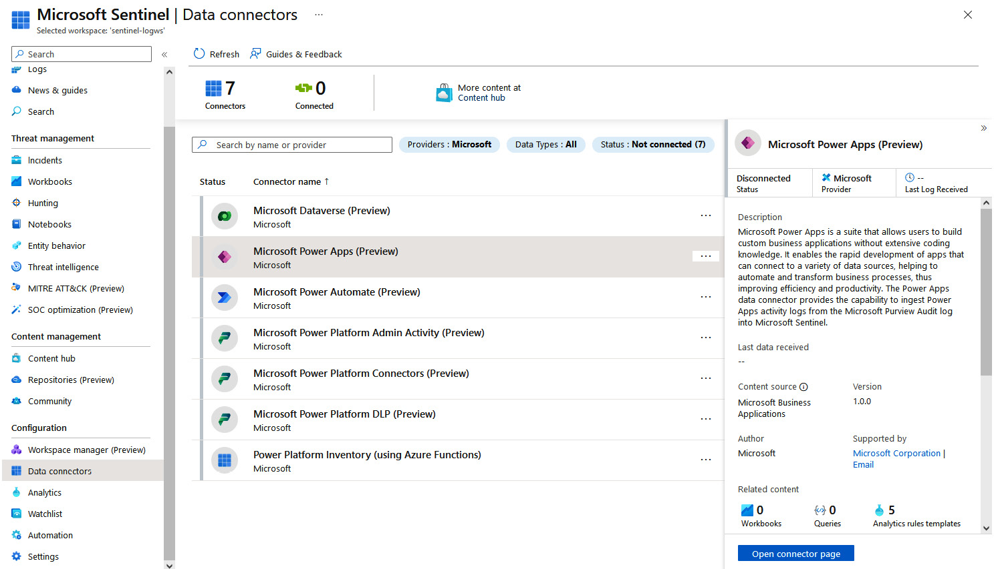

Figure 11.1 – Microsoft Sentinel solution for Power Platform

*Microsoft Sentinel solution for Power Platform – prerequisites and installation*

*This solution helps us detect and respond to potential threats and incidents related to Power Platform. The solution is currently in preview. Information about the prerequisites and how they can be deployed is accessible here:*<https://learn.microsoft.com/en-us/azure/sentinel/business-applications/deploy-power-platform-solution>*.*

In the context of Power Platform Well-Architected, one additional practice recommended by the security pillar involved conducting ****simulated attacks****. These simulations serve different purposes. Of course, through such an exercise, we would like to identify any potential threats, but by doing so we can also verify the preparedness of our engineers and the remediation processes, especially with the war game exercise, where we have red and blue teams. This involves first attempting to deliver a simulated attack, while the other team is trying to identify and defend from the attack.

Apart from simulated attacks, the ****Security**** workspace in Power Pages is a place where we can run security scans to assess websites for any potential security vulnerabilities. It is a one-stop shop to also find information on all configured roles and permissions related to the pages. We can also configure additional rules for the web application firewall that protects our websites. More information about security scans can be found here: <https://learn.microsoft.com/en-gb/power-pages/security/security-scan>.

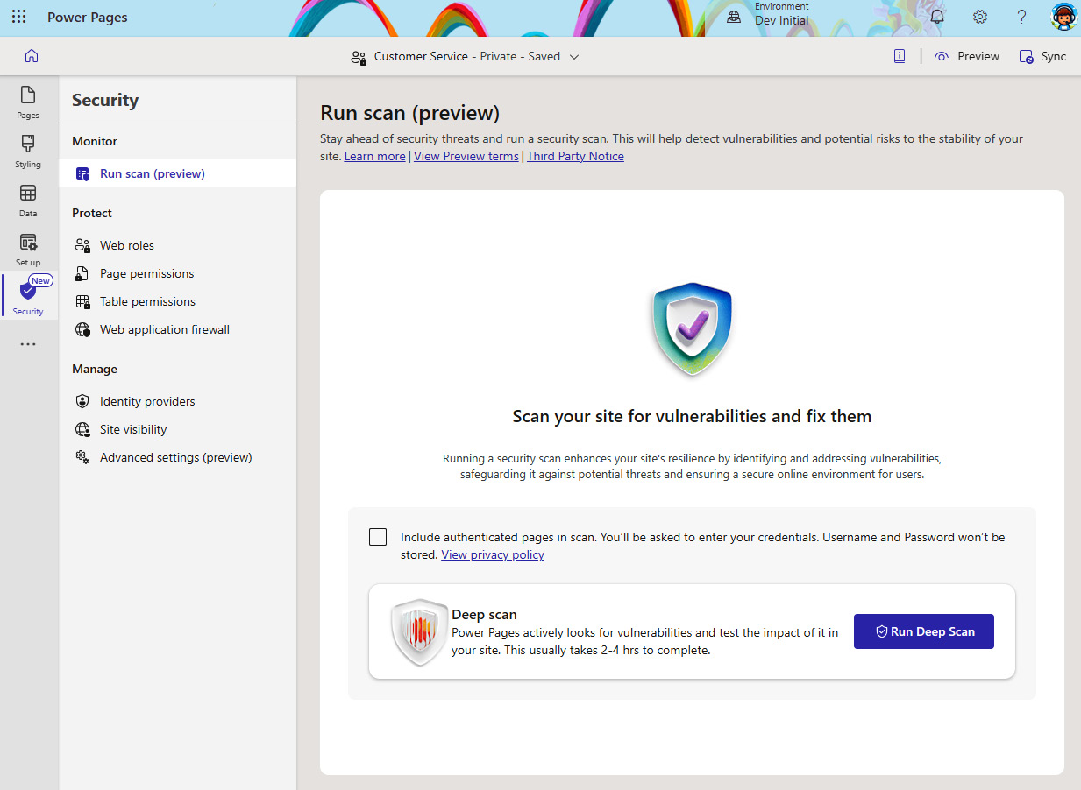

Figure 11.2 – A Power Pages security scan

To understand the overall security posture of our Power Platform tenant, Microsoft recently introduced the ****Security**** hub in the Power Platform admin center. It allows administrators to quickly act on the identified recommendations for improving the security posture, such as applying DLP policies to the environment, configuring tenant isolation, and auditing.

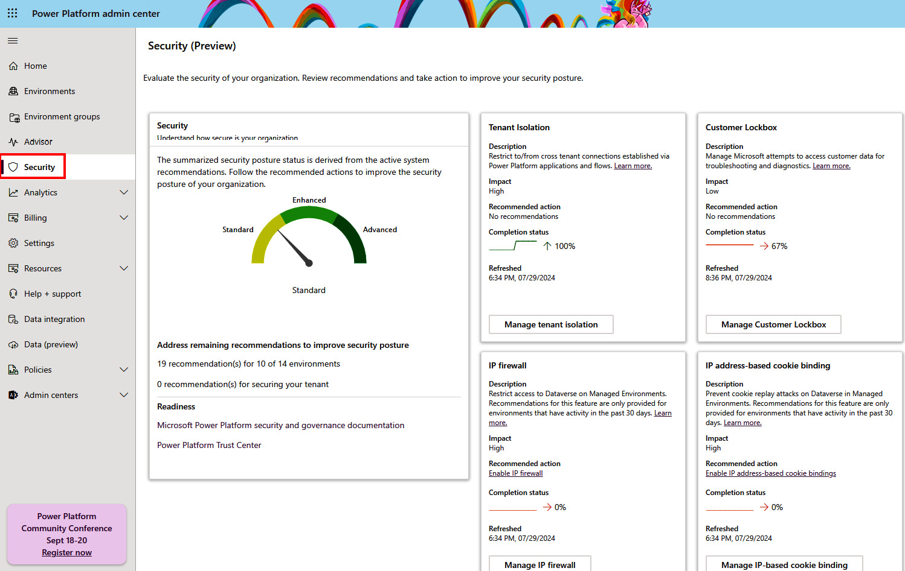

Figure 11.3 – The Power Platform Security hub

### Operational excellence

This pillar emphasizes creating a work environment that prioritizes operational excellence. With this, we mean bringing development best practices to workload teams by implementing a fusion development approach and adopting a DevOps culture. Doing so will allow workload teams to follow processes that are automated and repeatable and will lead to safe development and deployment practices. Processes have to follow compliance and governance standards that are set within the organization to be efficient and effective. Building consistent processes that are aligned with organizational policies will most probably lead to additional time and cost when delivering the project.

There are currently 11 recommendations for this pillar that are focused on the fusion development approach and building DevOps practices, standardizing development practices, building a monitoring system, finding automation opportunities for reducing manual tasks, and implementing a testing strategy.

Since many of these recommendations were already covered throughout the book, we will skip to the next pillar. For in-depth guidance, follow the provided link in *Further reading*.

### Performance efficiency

The next pillar concentrates on recommendations and understanding trade-offs that are related to building scalable and performant workloads without sacrificing user experience. Design principles help us set performance targets around the business requirements for the workload that we are developing. When defining performance objectives, we should consider how users will perceive our solution and what would be an unacceptable performance for them. We should set targets that are achievable and document them.

To make sure that the performance targets are met, we are continuously monitoring the workload throughout its life cycle to understand whether we are reaching the agreed targets. In case the targets are not met properly, we should optimize the workload. For monitoring, we are using the built-in capabilities of Power Platform. As we have already seen throughout this book, Power Platform can extend with ****Azure Application Insights****. Azure Application Insights, being an application performance monitoring tool that is part of Azure Monitor, allows us to not only gather telemetry data from our Power Platform applications but also from other services that might be running on the Azure cloud or in an on-premises environment. This helps us understand the broader picture and bottlenecks in our solution architecture since users could blame Power Platform for poor performance since this is the interaction for them. However, the performance issues might be in other backend systems or with database systems, where procedures are taking a long time to execute various queries.

One of the important aspects of planning for performant workloads is also to consider Power Platform request limits. As Power Platform is a ****software-as-a-service**** (****SaaS****) platform, services and the backend systems that are powering the services have predefined limits to make sure that quality and service-level agreements are met for every Power Platform user. Power Platform has ****service protection limitations**** in place that protect Power Platform services from an abnormal or excessive number of requests. These resource limitations should be considered by the solution architect when designing the architecture for the workload.

*Power Platform request limits*

*Although**Power Platform request limits have been increasing and it is highly unlikely that the request limit will be reached by regular users, it is worth noting that these limits exist and should be considered when preparing architecture design. More information about the request limits can be found here:*<https://learn.microsoft.com/en-us/power-platform/admin/api-request-limits-allocations>*.*

#### Recommendation examples

Currently, this pillar contains 10 recommendations that focus on monitoring the workload, operations, and user behavior, which will help us analyze and improve the performance of the Power Platform workload. A large portion of this pillar focuses on optimizing business logic, custom code, and data performance, as well as understanding the performance of the business process flows and finding potential optimization opportunities. Capturing telemetry data in Azure Monitor allows us to gain insights into the performance and set alerts to be informed about the current state of the workload. Such analytical data could serve us also as a deployment gate in CI/CD pipelines – a common example of that would be a backend service that is being used through a custom connector in Power Platform. If the utilization of the service is high for some time due to high peak or performance issues, we can stop and postpone the deployment of our workload until this gets resolved.

One important DevOps practice is implementing the ****feedback loop****. Apart from setting up monitoring to gather performance bottlenecks, see how the workload is operating during peak times, and see whether any errors occurred, we can use Azure Application Insights to gain insights into user behavior and use this information to plan application improvements. We should also consider implementing channels through which users will be able to share their feedback and suggestions to the workload team regarding the developed business solution. This will help us to make sure that the solution is relevant to their needs. Such a practice already exists in many off-the-shelf products, where some sort of feedback button is implemented in the application.

Something similar can also be implemented in the business solutions developed in Power Platform. An example of this with step-by-step guidance is available on this website: <https://learn.microsoft.com/en-us/power-apps/maker/canvas-apps/application-insights#create-custom-trace-events>.

### Experience optimization

The last of the core pillars of the Power Platform Well-Architected framework focuses on the user experience and what developers should consider during development. Applications should be built in a way that they are aligned with the user expectations as well as designed to meet any specific requirements. Interaction with the application should be simple and logical for users to complete the work that is required most effectively. Processes around application should also be simple to understand and intuitive.

We should build user-friendly applications that are inclusive and can be used by users with disabilities. If the application will be used by users worldwide, we should consider providing localized versions to improve user engagement.

#### Recommendation examples

This pillar contains nine recommendations that are focused on building applications that are inclusive, engaging, and intuitive. Here, we can find guidelines on how to build applications to be responsive, how to build reusable components utilizing ****Fluent Design**** using the ****Power Platform Creator Kit****, how to implement robust error-handling controls, and more. In the context of this pillar, DevOps practices help us to follow standardized processes through which we can bring changes more rapidly to the users.

*In-depth guidance on Power Platform Well-Architected*

*This section**went through some of the Power Platform Well-Architected core pillars and shared some recommendation examples. Each pillar has its own set of design principles, recommendations, and, more importantly, trade-offs, which workload teams should be familiar with**when following this guidance. To get more information about the tools available and the assessment, please navigate to this URL:*<https://learn.microsoft.com/en-us/power-platform/well-architected/>*.*

We have briefly touched on some of the recommendations that help us understand what the purpose of Power Platform Well-Architected is. Going through each pillar and understanding recommendations through a set of best practices and guidelines for making informed decisions on the design of the modern applications in Power Platform would greatly help everyone when building in Power Platform, from simple to very complex business solutions.

In the next part, we will look at how to follow architecture best practices with a reference implementation that is described in *Power Platform landing zones*.

## Power Platform landing zones

When starting the Power Platform adoption journey, it is common to start working in a default, personal productivity environment and gradually expand from there. As we have seen in the Power Platform adoption maturity model, this kind of approach aligns with the early stages of organizational maturity. However, as organizations become more familiar with the platform, they start looking for ways to protect their tenant, set up an environment strategy, and build policies around them. Often, organizations inquire about the optimal architecture design to set up Power Platform to handle enterprise-scale scenarios. This is where landing zones can be a valuable resource to turn to.

****Landing zones**** serve as reference implementations that establish well-managed environments for running specific workloads. They follow best practices for building a strong, secure, and scalable foundation that will be used inside the organization to grow further as the companies continue with the adoption of certain technologies. They follow key design principles that span across different design areas, such as licensing, security, governance, automation, and DevOps. Through landing zones, Microsoft provides a reference implementation for various technologies and services. One of the most widely known is Azure landing zones, the umbrella landing zone that helps organizations set up Azure environments and services.

### Power Platform landing zones

****Power Platform landing zones**** represent a reference implementation that organizations can use to build their initial Power Platform architecture design within their Power Platform tenant. It can be seen also as a methodology that includes guidelines on an architectural design, following implementation best practices. In the context of Power Platform, a landing zone would represent an environment with all the supporting services, policies, and security roles configured to provide organizations with a starting point that is aligned with best practices and recommendations. Through available controls, organizations can decide which security policies and governance requirements should be provisioned to match the organization’s requirements.

Power Platform landing zones extend Azure landing zones in a way that can be plugged into the existing Azure subscriptions, which allows customers that have already adopted Azure cloud services to unlock new application modernization scenarios using the LCNC development platform, such as Microsoft Power Platform. The central point that connects Azure subscriptions with Power Platform environments is Microsoft Entra ID, an identity and access management system:

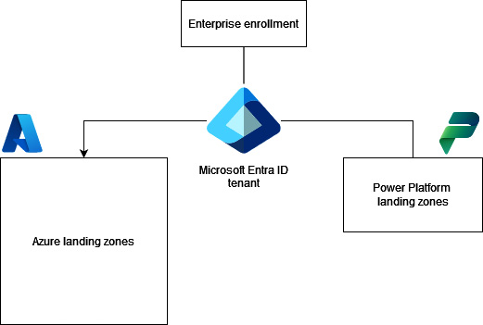

Figure 11.4 – Extending Azure landing zones with Power Platform landing zones

### Design principles and critical design areas

Power Platform landing zone architecture is built on five design principles. These principles serve as a guideline when any further design decisions need to be taken:

* ****Environment democratization****: Environments serve as a unit of management, with security and policy boundaries. They are created to support business units and developers and address business requirements.
* ****Policy-driven governance****: Implementing DLP policies gives app makers flexibility to create application workloads while staying compliant.
* ****Single control and management plane****: Power Platform management is done through native Power Platform admin tools, to provide a consistent experience.
* ****Persona agnostic****: Any makers are welcome to innovate in Power Platform and are treated equally from the perspective of capabilities.
* ****Power Platform native design and platform roadmap alignment****: Whenever possible, native services and capabilities should be used, which will ensure that once new features are released, applications can benefit from these new capabilities. The Power Platform roadmap allows admins and makers to be informed about the new capabilities and adopt them accordingly.

Next to the design principles, the Power Platform landing zone architecture includes design areas that play an important part in the design decisions. They serve as a compass for deciding on the architecture’s design. There are eight design areas that include considerations and recommendations, which we should consider when planning the architectural design. We can see that some of these design areas are similar to the recommendations in the Well-Architected pillars, such as platform automation and DevOps.

Here are the critical design areas for Power Platform:

* ****Licensing and AD tenants****: Since licenses are the first point of control for allowing users access to Power Platform services, this design area focuses on understanding how licenses impact environment access, which licensing model would be most appropriate (including a pay-as-you-go plan), and the recommendations around assigning licenses to users.
* ****Identity and access management****: Identity and access management together with ****role-based access control**** (****RBAC****) play an important part in enabling users’ ability to operate with Power Platform. This design area focuses on possible controls to secure access to tenants through conditional access policies and multifactor authentication, as well as other authorization rules that are aligned with the organization’s security and regulatory requirements.
* ****Environments****: Environments play an important part in isolating data and application workloads. This design area covers the importance of good environment strategy and configuration options, such as selecting the geo-location of the environment, enabling auditing, and other controls for monitoring the behavior of users’ environments. Additionally, it focuses also on enabling managed environments to provide an additional set of premium capabilities and control.
* ****Security, governance, and compliance****: Next to licenses and RBAC, this design area focuses on providing recommendations around DLP policies that define the classification of connectors and their usage policy. Controlling the usage of connectors plays an important part in safe platform adoption.
* ****Management and monitoring****: With the use of the admin center and other first-party tools, administrators are equipped with the tools needed to manage Power Platform environments and build automation tasks. For monitoring performance and reviewing audit trails, Power Platform can connect with other services such as Azure Monitor, Microsoft Entra ID, and Microsoft Purview to enable additional monitoring and auditing capabilities.
* ****Business continuity and disaster recovery****: Organizations should have scenarios in place to ensure resilient environments with continuous availability. Among continuous availability, here we also focus on backups and the environment restoring process.
* ****Connectivity and interoperability****: This design area touches on possible connectivity models to and from the Power Platform services. As data can be located outside of the Power Platform, it’s important to understand the possibilities to connect to it, either through the on-premises data gateway or ****virtual network**** (****VNet****) data gateway (when using Azure data services). Both of these services have their own limitations and requirements, including licensing requirements, which can impact decisions. Where needed, Azure ExpressRoute can be used to connect organizations with Microsoft cloud services using private connectivity between the organization’s on-premises network and Microsoft cloud services. This also makes connections more predictable, which is more suitable for mission-critical applications. Organizations that have strict regulatory requirements might be also interested in ExpressRoute.
* ****Platform automation and DevOps****: Power Platform landing zones are encouraging organizations to implement DevOps practices so that IT admin teams and pro-developers collaborate to not only manage the application life cycle, but also manage Power Platform holistically through environment life cycle management, security monitoring, cost management, and more.

As we can see, Power Platform landing zones provide a great insight into a set of design considerations and recommendations that can serve as a starting point for organizations to build an architectural design that incorporates these design considerations. Combined with Power Platform Well-Architected, we now have extensive guidance to drive decisions on architecture guidance for modern application solutions on Power Platform.

To see these design areas in action, we can take a look at the reference implementation.

### Deploying a Power Platform landing zone reference implementation

A Power Platform landing zone reference implementation is a modular architecture reference that uses design principles and critical design areas to help organizations build environments that will support application workloads. This reference implementation can be customized so that only needed parts of it are deployed to the organization’s tenant.

To deploy a Power Platform landing zone reference implementation, we need an Azure subscription and a Power Platform tenant. We have provided links to guidance in the *Technical requirements* part of this chapter to provision them if needed.

As part of the prerequisites before deploying landing zones, we need to first create a ****user-assigned managed identity**** (****UMI****), which has permission to use the Power Platform APIs. This can be done by going to the Azure portal and creating a new UMI:

1. On the Azure portal, we should search for ****Managed Identities**** and open the ****Managed Identities**** page, which presents all the managed identities in your tenant:

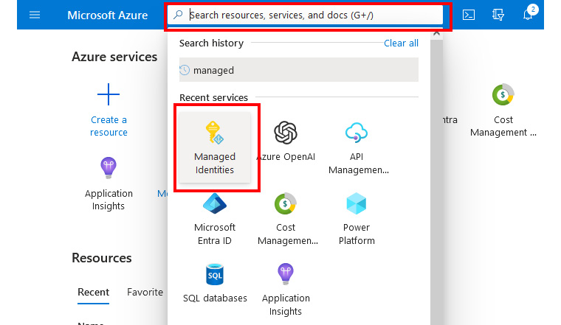

Figure 11.5 – Managed Identities

1. To create a new UMI, we then click on ****Create****:

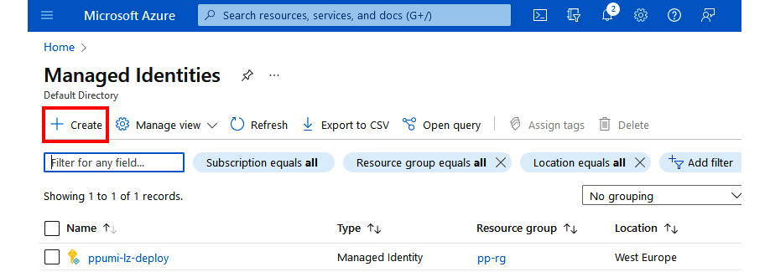

Figure 11.6 – Creating a new managed identity

At this stage, we need to provide all the details for creating the managed identity. This includes selecting ****Azure Subscription****, where we either already have a resource group or we can provide a new resource group from this screen directly.

1. By providing managed identity instance details, such as selecting the Azure region in which the UMI will be provisioned and the name, we are ready to create the UMI by clicking ****Next****:

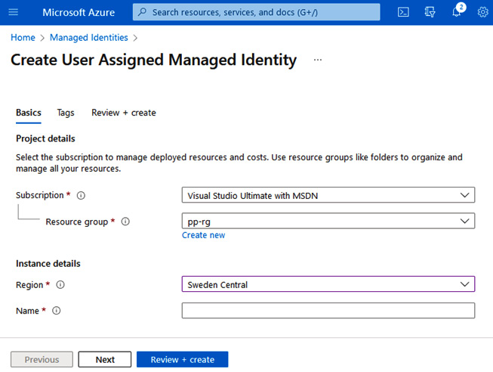

Figure 11.7 – Provisioning a new UMI

1. On the next screen, we can add tags. We recommend adding tags to the Azure resources to be able to categorize them later and map them to the correct cost center in the organization. Once completed, we proceed by clicking ****Review + create****. This will launch a validation process to validate the ****Azure Resource Manager**** (****ARM****) template. Once the validation process completes, we can provision resources by clicking ****Create****.
2. Once a new UMI is created, we proceed with opening the resource, and on the ****Overview**** screen of ****Managed Identity****, we find and copy the ****Client ID**** information. This will be required for the next step in PowerShell:

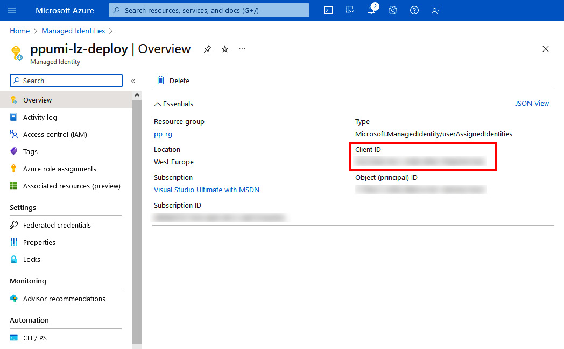

Figure 11.8 – The managed identity Overview information

Now, we are ready to run a local PowerShell session or proceed with ****Azure Cloud Shell****. Azure Cloud Shell comes with many tools and modules preinstalled, which simplifies the management, especially if we are working on a device where we have limited permissions.

The following code shows us how to use the ****PowerOps**** PowerShell module to access Power Platform APIs and register newly created UMI as an admin management application. This is a prerequisite for the successful deployment of a Power Platform landing zone reference implementation through ARM templates.

If we are running these commands locally, we should make sure that we install both the ****Az.Accounts**** and ****PowerOps**** modules. With Azure Cloud Shell, this step is not required:

**Install-Module -Name Az.Accounts -Force**

**Install-Module -Name PowerOps -Force**

Once the modules are installed, we need to connect to our Azure tenant. We do this using the ****Connect-AzAccount**** command. If our Azure administrator is configured with multifactor authentication, we need to use the special flag with a command that will provide us the interactive authentication with device code:

**Connect-AzAccount -UseDeviceAuthentication**

Once connected to Azure, we need to make sure we are using the right Azure subscription. If the one that we will be working in is the default, then we do not need to perform this command. If we have multiple subscriptions, we should make sure that we are in the right Azure subscription. The Azure subscription ID can be found in the Azure portal or by using ****Get-AzSubscription****, which returns a list of all subscriptions, their IDs, and their states. To set the current working context, we use the command with the subscription ID:

**Set-AzContext -Subscription "xxxx-xxxx-xxxx-xxxx"**

Finally, we are ready to perform the registration of the UMI. We can copy the client ID from the previously created identity on the Azure portal:

**$clientId = '<Azure UMI Client Id>'**

**Register-PowerOpsAdminApplication -ClientId $clientId**

Once the registration process is done, we can proceed with the deployment setup. On the GitHub repository that hosts Power Platform landing zones implementation guidance (<https://github.com/microsoft/industry/tree/main/foundations/powerPlatform>), we will find a ****Deploy to Microsoft Cloud**** button. By selecting this option, we are transferred to the Azure portal, where deployment of Power Platform landing zones through a custom ARM template will initiate:

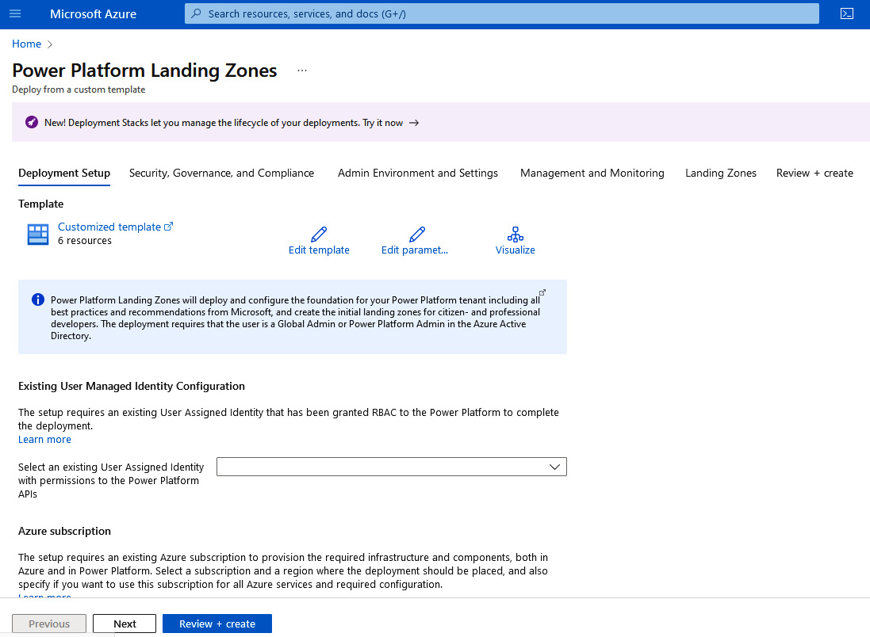

Figure 11.9 – The Power Platform landing zones deployment template in the Azure portal

1. Looking at *Figure 11.9*, we can see that the first tab in the process of setting up a landing zone reference implementation is ****Deployment Setup****. This is where we connect to the newly created UMI and select our Azure subscription as well as location.
2. The next tab, ****Security, Governance, and Compliance****, allows tenant-wide DLP policy configuration, by selecting different levels of restrictions for connectors. The DLP policy created in this step will serve as a baseline policy and new DLP policies can be added later. Additional policies such as tenant isolation and guest users and sharing settings can be applied here.
3. The next tab is ****Admin Environment and Settings****, which allows organizations to create separate admin environments that will be used for administration purposes only – for example, we can create a separate environment in which we will deploy a ****CoE Starter Kit****. Creating separate admin environments will result in having separate development, test, and production environments, to support the application life cycle management of our business solutions. Here, we can also find a policy to disallow users to create different types of environments by themselves.
4. Continuing forward, we have ****Management and Monitoring****. Here, we can configure additional Azure services to be used for monitoring purposes, such as Application Insights in Azure Monitor. Additionally, we can enable tenant-level analytics for Power Platform.
5. The final step in the process is to configure additional landing zones (environments) that will be specific to citizen developers, pro-developers, or industry solutions. If we want, we can skip this step and later, as we realize that the demand has increased and more specific environments would be needed, we can use the ****Landing Zones vending machine template**** option available on the same Power Platform landing zones GitHub repository, to provision more environments.
6. At the end of the process, we can review all the configuration options we have made and finish the provisioning process by selecting the ****Create**** button.

These tabs hold configuration settings that address critical design areas for the reference implementation. These are the things that we should consider when creating our own architectural design. Even if we are coming from a smaller organization where implementing landing zones seems too much to handle, we should still be following critical design areas and look at the landing zone reference implementation as our north star, our guidance on where we should be heading to implement best practices and guardrails in our environments to protect organizational data. We can start small, but as we grow our adoption, we will see the benefits of landing zones through the standardized and consistent approach for provisioning governed environments.

Now that we have looked at how a landing zone reference implementation can be used to provision new environments, we will move toward the idea of creating and managing environments automatically using various tools, while still including the important parts of design areas, such as adding DLP policies and licensing.

# Automating environment life cycle management

So far, we have used the Power Platform admin center for managing environments and the Power Platform tenant. Those that are coming from the world of cloud services and DevOps might know that Azure cloud services can be managed in a more descriptive way and through CI/CD pipelines, rather than using the Azure portal for the management. Doing things manually through the portal also doesn’t scale well. One of the recommendations in both Well-Architected and critical design areas mentioned that we should look to automate whatever is possible and where human intervention is not required. In this section, we will experiment with the idea of managing environments in a similar fashion as other Azure cloud services. We will look at how we can enable a more automated way of managing the environment following well-known practices from the custom development and DevOps world.

## Infrastructure as code (IaC) over ClickOps

Let’s start first by explaining what IaC and ****configuration as code**** (****CaC****) are since they are both touching infrastructure, yet they are different. Both are well-known DevOps practices that automate IT operations and help with consistent software delivery. These two practices allow DevOps teams to use DevOps practices to not only deliver the application but also the underlying infrastructure and required configuration on which the application will be deployed. Both are using some sort of script or code templates through which they can manage the underlying infrastructure. IaC is all about provisioning infrastructure; this could be servers, databases, specific ****platform-as-a-service**** (****PaaS****) services, and other components. CaC, on the other hand, is about managing the settings and configuration of the system components that our application requires on that infrastructure, for example, setting up server configuration, installing and configuring database server, and configuring network settings.

Different tools use different languages to describe or configure the infrastructure. The tool usually defines what type of approach is used with the code. This means that the code is described in a *declarative* (functional) or in an *imperative* (procedural) way. If the approach is declarative, then in the code we describe *what* we want the target environment to be and the tool will perform the required steps to get to the desired state. If the approach is imperative, we describe *how* we can get to the target environment, which means that we need to define a set of commands, in the appropriate order, that will lead us to the desired state.

In the Power Platform landing zones, we have used a reference implementation that we configured through the Azure portal, however, in the backend, the configuration from the portal is mapped to an ARM template, which describes the state of the Power Platform environment that we wish to have. The ARM template is a JSON file type following a JSON deployment template schema, where in a declarative way we describe the infrastructure that ARM then provisions in our target subscription.

*Example of ARM template file – Power Platform landing zone ARM template*

*The landing zone ARM template file can be accessed here:*<https://github.com/microsoft/industry/blob/main/foundations/powerPlatform/landingZones/ppNorthStarLzs-arm.json>*.*

Azure offers one more way of describing IaC – using ****Bicep****. However, on the market, there are other tools available that support IaC, one of which is ****Terraform****, which we will take a closer look at because of its connection with Power Platform.

IaC deployments are repeatable and prevent configuration drifts or missing dependencies since all information about the infrastructure is provided in the IaC files. ARM, Bicep, Terraform, and other IaC tools support idempotent operations. This means that even if we are applying configuration multiple times, the result will be the same, as described.

This is also one of the main reasons why the IaC approach has all the advantages over ClickOps. Now, what is ClickOps? The term ****ClickOps**** comes from ****clickable operations**** and it is used for a process where people click through configuration options on a configuration portal. In the case of Power Platform, when administrators click through different options in the Power Platform admin center to provision and configure environments.

Although it is possible to automate manual operations using ****user interface**** (****UI****) automation tools or ****robotic process automation**** (****RPA****) tools with a recorded set of manual operations, ClickOps in general is error prone. Either engineers forget some steps, make mistakes along the way, or the website changes and the automated UI approach fails. The approach is also not scalable as it is slow and can lead to configuration drifts, where we might have different states of environments.

As IaC code can be version-controlled and supported by SDLC, the clickable approach lacks this sort of collaboration as well as transparency.

## Power Platform management with Terraform

We now understand that there must be a better way to automate platform management that will be more scalable than the ClickOps approach. The critical design area around platform automation and DevOps, in the Power Platform landing zones, mentions a recommendation for building a cross-functional team that will build and manage functions to support environment provisioning with DLP, RBAC, and other capabilities. This team would also take care of the management of landing zone template files. However, we will also take a look at another option – building IaC templates with Terraform. Doing so, using Terraform files, the platform operations team will take care of the environment provisioning, platform management, billing, and DLP policy creation. This will help us to automatize tasks around environment management and move away from ClickOps.

****Terraform**** is an IaC tool created by ****HashiCorp**** that uses declarative configuration language to provision and manage infrastructure in multi-cloud environments. The language that Terraform uses is also known as ****HashiCorp Configuration Language**** (****HCL****). Terraform consists of core elements as well as plugin extensions called ****providers****, which are used to perform operations against various cloud services, including Azure and Power Platform. To use Terraform, we would require the tool itself and a Terraform configuration file. The workload team first creates a branch for work on the Terraform file, which defines infrastructure and configuration files. Usually, we separate the IaC configuration into different files:

* ****terraform.tf**** is the configuration file that defines all used providers, the remote backend, and the Terraform version that should be used.
* ****main.tf**** will include used resources and data sources.
* ****variables.tf**** describes all variables that are used in the configuration.
* ****variables.tfvar**** is used to specify actual values for different environments. We could also have variables with default values in the ****variables.tf**** file, however, this approach gives us flexibility when dealing with different environments.
* ****output.tf**** could be used to store output variables from the created resources

After configuration files are written, three main steps define the core Terraform workflow and should take place to apply this configuration to the cloud service, which also includes Power Platform:

1. ****Initialize****: Terraform initializes and prepares the workspace, based on the ****terraform.tf**** configuration file provided. Here is where specified providers will get installed. To launch this step, we use the ****terraform init**** command. This command creates a Terraform lock file, which holds the information of the provider used in this workspace. This file can be also version-controlled, should we wish to use the same provider version in different environments.
2. ****Plan****: Terraform creates an execution plan that consists of all the changes that will have to be applied to match the state of the service with the description in the ****main.tf**** file. The plan will include steps to either provision, update, or remove infrastructure or its components. In this step, we use the ****terraform plan**** command. If we use the ****-out**** flag, the plan will be saved to a file, which allows us to reuse the same plan if needed. To have a flexible IaC configuration file, we recommend storing variables outside of ****main.tf**** in a separate variables file. We declare variables and provide optional default values with ****variables.tf****, where the actual values for separate environments are set with the ****variables.tfvars**** file.
3. ****Apply****: Terraform performs operations to meet the desired state with the specified plan. In case the plan from the previous step is not specified, Terraform creates a plan and asks for confirmation before applying changes. In this step, we use the ****terraform apply**** command.

As part of the DevOps practice, it is recommended to store the Terraform configuration files in the source code repository to allow collaboration and version control and follow branch strategy as well as pull requests to merge changes.

If we would like to remove the infrastructure that we have created, we can clean up resources by using the ****terraform destroy**** command. This will permanently delete all created resources. To protect the production workload from accidental deletion, we can set ****prevent\_destroy = true**** inside the ****lifecycle**** block in the resource that we are building.

****Power Platform Terraform Provider**** is a Terraform plugin that allows management of the Power Platform environment and additional resources following the IaC approach. It defines a set of resources that Terraform can manage and data sources that can be used to retrieve information from Power Platform. Using Power Platform provider, organizations can follow the same approach and utilize already existing knowledge to manage Power Platform in the same way as they do it now for Azure services, using the IaC approach. This is especially important for organizations with workloads that span over the boundaries of Power Platform toward other cloud providers, such as the Microsoft Azure cloud.

Such an approach helps to unlock scenarios of deploying and managing Power Platform at scale. It gives us the ability to provision different types of environments in a completely automated way, which allows developers to be more flexible with deploying their workloads.

*Experimental feature*

*Power Platform Terraform Provider is currently in experimental mode and it should not be used by a production user. However, we believe that going forward, this will be one of the key capabilities for the platform operations team to manage environments at scale.*

### Using Power Platform Terraform Provider

This provider requires Terraform version ****>= 0.13**** (when considering the latest version of the provider). Current Terraform versions are way past version 1.8, so this requirement should not be a problem. To enable this Power Platform provider, we need to add the following code snippet to the ****terraform.tf**** configuration file:

terraform {

  required\_providers {

    power-platform = {

      source = "microsoft/power-platform"

      version = "2.3.1-preview" # change to the latest stable version for your production workload

    }

  }

}

With this, we are making sure that Terraform will install needed providers when running the ****terraform init**** command, to initialize a workspace.

For Terraform to access Power Platform, we would need to authenticate the provider to Power Platform. We can utilize Azure CLI, a service principle with OpenID Connect, or a service principle with a client secret. All options would require us to first do the *app registration process* in Microsoft Entra ID for Power Platform Terraform Provider. During the app registration process, we need to give API permissions against Dataverse, the Power Apps service, and Power Platform API. Power Platform API is a preview feature and is available to manage environments, billing policies, Power Pages management, and more. If we authenticate with Azure CLI, we should also configure the ****Expose API**** section during the app registration process.

*API permissions – app registration process*

*Terraform has thoroughly documented which API permissions should be set during the app registration process. The link to the APIs is available here:*<https://registry.terraform.io/providers/microsoft/power-platform/latest/docs/guides/app_registration>*.*

If Power Platform API does not appear on the list of APIs for which we can give API permissions, during the app registration process, we might need to make it visible with the following commands in PowerShell:

**Install-Module AzureAD**

**Connect-AzureAD**

**New-AzureADServicePrincipal -AppId 8578e004-a5c6-46e7-913e-12f58912df43 -DisplayName "Power Platform API"**

****AppId**** is the value of the API service when we are using the Azure public cloud. In any other case, it needs to be updated with the correct ****AppId**** of the service.

After this intervention, the Power Platform API should be visible in the list and we can add API permission in our app registration process, as shown in *Figure 11.10*:

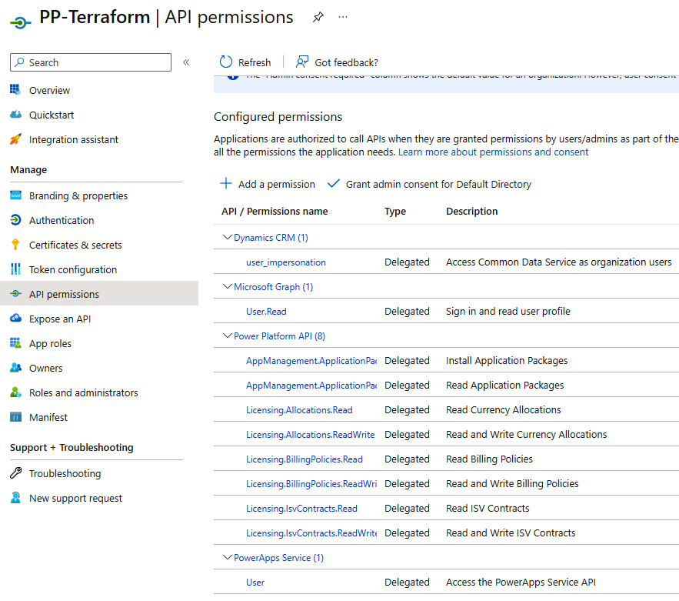

Figure 11.10 – API permissions for Power Platform provider for Terraform

*App registration process – Power Platform API*

*For additional help regarding the app registration process, here is the link:*<https://learn.microsoft.com/en-us/power-platform/admin/programmability-authentication-v2>*.*

Separately, we can work on preparing the ****main.tf**** file and any supporting configuration files. The example Terraform files are uploaded to the GitHub repository for this book in ****Chapter11**** folder.

Note that when planning to use Terraform to manage Power Platform environments, the service principle should be added as an app user on the Power Platform environments to be able to make changes to the existing environments. We can do that by going to ****Power Platform admin center**** | ****Environments****, selecting the environment, and clicking ****See all**** underneath ****Users**** in the ****Access**** sections. Then, click on ****app users list**** | ****New app user**** and use the wizard to add the newly created service principal to your environment.

After preparing all Terraform configuration files, we are now ready to run the next steps in the workflow:

**terraform plan -var-file dev.variables.tfvars -out <outfile>**

If the plan completes successfully, we should see a longer output with the entire plan of changes in the terminal and at the end something like this (using the provided example files):

**Plan: 2 to add, 0 to change, 0 to destroy.**

──────────────────────────────────────────────────────────────

**Saved the plan to: <outfile>**

Here, ****<outfile>**** represents the name of the out file from the previous step.

Now, we can proceed with applying the plan to our environment using the following command:

**terraform apply <outfile>**

If we wish to perform these steps in a DevOps pipeline, since we would like to automatize the steps during the CI/CD pipeline, we can use script tasks or specific Terraform tasks in Azure DevOps or actions in GitHub. Most probably, we will need to first install Terraform tasks/actions from the available marketplace. Once this is complete, we will be able to use them. Now, we can create a DevOps pipeline where, in the planning stage, we will use the ****terraform plan**** command to prepare the ****tfstate**** file and then in the deploy stage, we will use the same ****tfstate**** file to apply configurations to the Power Platform service.

When creating the Terraform plan, the ****tfstate**** file can either get stored locally or somewhere centrally in some sort of storage repository, from where it can be accessed. Since we are using a multi-stage pipeline and DevOps service, we have decided to use an Azure Storage account where we will be storing the Terraform state file.

Here we have a simple, single-stage DevOps pipeline, where we are utilizing Terraform tasks to perform all steps of the Terraform workflow. In the GitHub repository, we have uploaded a ****simple-tf-iac.yml**** pipeline file that can serve as a reference for the Azure DevOps pipeline using Terraform tasks. An example of a Terraform task is as follows:

  - task: TerraformTaskV4@4

    inputs:

      provider: 'azurerm'

      command: 'init'

      workingDirectory: '$(System.DefaultWorkingDirectory)/tf-iac/'

      backendServiceArm: '<SERVICE\_CONNECTION>'

      backendAzureRmResourceGroupName: $(test-rg)

      backendAzureRmStorageAccountName: $(storageaccountname)

      backendAzureRmContainerName: $(containername)

      backendAzureRmKey: 'terraform.tfstate'

Although IaC is bringing benefits to the environment life cycle management, there are always pros and cons to every approach, and the same is true with IaC. It might be that we do not have resources knowledgeable on IaC and Terraform, maybe we do not want to use Terraform Power Platform provider, because it is currently still in an experimental mode (it should not be used in production workloads), or maybe because we do not want to bring another tool in the portfolio, or any other reason. In such cases, we can always revert to utilizing more traditional ways to manage Power Platform tenants.

## Traditional automated environment management approaches

Apart from using an IaC approach with Terraform Provider, there are other options available to manage the environment life cycle, as well as the Power Platform tenant, which has been with us for many years now. We will be mentioning some of the examples ahead:

* By now, we are already familiar with the ****Power Platform Build Tools**** and ****Power Platform Actions**** for Azure DevOps and GitHub.

Power Platform Build Tools provides tasks that can be used for the Power Platform tenant management, including environment management. We can create new environments, configure governance settings, and configure environment settings, such as changing the environment to managed environments, and so on.

Following such an approach allows us to build DevOps pipelines that do not focus only on provisioning the application solution but rather focus on configuring the end-to-end solution life cycle with provisioning of the environment, configuring the environment, deploying an application to the environment, testing an application, and potentially removing the environment if it is not needed any longer. This brings additional flexibility to holistic solution management.

* The next option is with PAC CLI. We can install PAC CLI onto the build agent/runner that is running the CI/CD pipeline and use PAC CLI tasks to run automated tasks for managing environment life cycles. Using command-line or Bash tasks, we can write scripts that will use PAC CLI for operations and will perform operations on our Power Platform tenant.
* For those administrators who would like to build automated flows outside of CI/CD pipelines, we would recommend creating Power Automate flows using the ****Power Platform for Admins**** connector, which focuses on environment life cycle management and DLP policies. *Figure 11.11* shows an example that is part of the bigger *Create Approved Environment* process flow, which belongs to the CoE Starter Kit. It nicely demonstrates the usage of the Power Platform Management connector to build an environment life cycle using workflows:

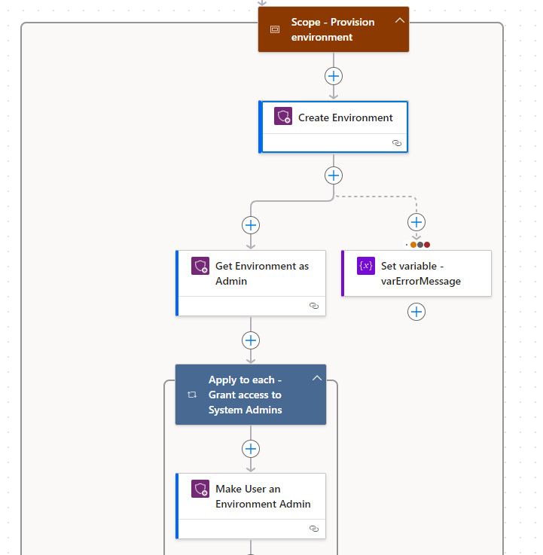

Figure 11.11 – Environment management with Power Automate

## DLP considerations when managing environments

In the Power Platform landing zone part, we addressed critical design areas and what should be considered when designing Power Platform architecture. This includes licensing and managing identities in Entra ID, but there is one very important area that goes together with the environment life cycle management. ****Data loss prevention**** (****DLP****) is one of the most important parts of protecting data from leaving certain boundaries. DLP policies help us to set guardrails that will make sure our data is protected and isn’t shared with unnecessary audiences.

When creating an environment strategy in an organization, we should also agree on a minimum set of DLP policies that should be in place to protect users from non-compliant usage. These can be set on a tenant level or environment level. Tenant-level policies could be associated with all or only specific environments and are acting as organization-wide policies across multiple environments.

Setting up DLP policies should be done automatically when creating environments. It can also be done after adjusting the policies based on the workload or organizational requirements.

Creating and assigning DLP policies can be done in different ways. We have touched on two examples, first with Terraform, and the other with connectors in Power Automate flows. Both support creating and assigning DLP policies. In Terraform, we can achieve it by creating a ****powerplatform\_data\_loss\_prevention\_policy**** resource in which, through a set of parameters, we specify a list of all business (sensitive), non-business (non-sensitive), blocked, and custom connectors patterns. This will define which connectors are grouped and what kind of sensitivity label they have. We can also specify the list of environments for which the DLP policy is applied.

When using Power Automate, we achieve the same outcome by creating flows that use the ****Power Platform for Admins**** connector, which are actions for creating and managing DLP policies. Through visual experience, they provide all the required information.

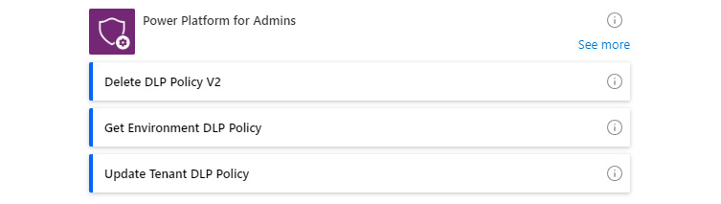

Figure 11.12 – The Power Platform for Admins connector

The approach of using Power Platform for Admins connector is well established in the process of management environments and other tenant settings. We can find this approach in many flows that are part of the CoE Starter Kit. Let us look at what is available in the CoE Starter Kit and how it can be used.

# Power Platform CoE

Another section that focuses on delivering guidance and best practices for Power Platform will focus on adopting and understanding the existing usage. As organizations mature in Power Platform usage, the number of workloads running on Power Platform can drastically increase. Organizations should invest in fostering this growth while keeping the environments governed and secure. This section will talk about the Power Platform CoE, what it is, and why organizations should be creating such teams in their environment. We will look at what tools are available for CoE teams and go through environment management examples to understand how it is all connected.

CoE extends beyond a specific team in the organization; it demonstrates a cultural commitment in the organization that helps drive innovation and continuous improvement. The CoE team acts as a hub of knowledge that is focused on improving the adoption of Power Platform while making sure that the usage is aligned with internal governance and compliance standards.

CoE teams could be represented by one or more people, depending on the size and maturity of the organization. It can start by forming a team of enthusiastic Power Platform individuals who are committed to supporting the organization’s business strategy using the LCNC platform. From there, it can grow to a larger and more diverse team, represented by personas from different departments with different skills. It can include app makers, DevOps engineers, IT teams, support engineers, training experts, and business representatives. CoE teams should not be confused with fusion teams. ****Fusion teams**** are focused on accelerating the development of business solutions using LCNC and code-first development, while CoE teams aim to drive governance and adoption on the LCNC platform following best practices and guidance.

CoE teams follow a continuous process, through which they gain a view into the current situation. Where needed, they establish security and governance practices to control the environment. Finally, they are supporting the employee community by helping improve its adoption. To facilitate their work, CoE teams are leveraging the capabilities of the Power Platform admin center as well as the CoE Starter Kit.

Microsoft also provides the Automation Kit, which is a complementing suite of tools to the CoE Starter Kit, designed to increase the adoption of the Power Automate automation platform. This kit provides ready-made solutions for managing automation projects, as well as gaining insights into the savings and estimated ****return on investment**** (****ROI****).

*Installation of the CoE Starter Kit and Automation Kit*

*Setting up the**CoE Starter Kit and Automation Kit is a lengthier process with many steps. We will not go into the details of installation but rather provide a link to the documentation website where a step-by-step approach is provided. We**would recommend following it and installing the CoE Starter Kit in a separate environment.*

****CoE Starter Kit installation*****:*<https://learn.microsoft.com/en-us/power-platform/guidance/coe/setup>*.*

****Automation Kit installation*****:*<https://learn.microsoft.com/en-us/power-automate/guidance/automation-kit/setup/prerequisites>*.*

## The CoE Starter Kit

The CoE Starter Kit provides different modules that include a set of ready-made applications and flows to help with admin, governance, and adoption activities. These modules are separated into different components:

* ****Core components****: This is where the main application ****CoE Admin Command Center**** is placed. This application is a central control plane for accessing other admin-related applications. Here, we can find the ****Set App Permissions**** and ****Set Flow Permissions**** settings, for discovering applications and flows and changing user access and ownership permissions. The ****DLP Editor**** helps oversee all DLP policies and understand which apps/flows are impacted by it. The ****CoE Power BI report**** with its dashboard provides a comprehensive overview of the current situation in Power Platform. One more important set of components is related to ****environment request management****.
* ****Governance****: This group is focused on making sure the Power Platform components are governed and compliant. Many flows are part of the auditing process and are reviewing the states of apps, flows, and bots and informing admins or owners about the steps to take to make sure they are compliant. The ****Developer Compliance Center**** is included in this group and provides an app for makers to understand the compliance status of their applications, flows, bots, solutions, and so on.
* ****Nurture****: Components in this group are nurturing the internal Power Platform community. Components such as ****Video hub****, to find and watch training video content, ****Nurture apps for makers****, to find training events, and the ****Solution Assessment**** page in ****Nurture apps for makers****, to help makers understand the licensing and governance implications of their planned solutions.
* ****Theming****: This group helps makers create and manage themes for canvas apps. ****Theme Editor**** and ****Theme Gallery**** allow the creation and browsing of published themes that will be used across canvas apps. Here, we would like to once again mention ****Power Platform Creator Kit****, which is not part of the CoE Starter Kit, but is richer from a capability standpoint, as it allows the use of the Fluent UI framework, which will help organizations create consistent modern applications across both model-driven and canvas apps.
* ****Innovation Backlog****: This contains the ****Innovation Backlog**** application for adding innovative ideas and voting on existing ones.

Each of these component groups has an additional set of tables, flows, and applications, which we have not mentioned, but are supporting the overall CoE experience. These components can be used in different ways. We can use CoE Power BI dashboard just to have a holistic overview of the current situation in Power Platform, or we can use it in a way to drive some conclusion and action from it. Through the dashboard, we can identify, for example, orphaned apps and take action on reassigning ownership or retiring them if they are not needed anymore. We can also see the adoption of services over time and which connectors and apps are mostly used. Some of this information is also already available in ****Power Platform admin center**** | ****Analytics****, where we can track usage and activity across Dataverse, Power Apps, and Power Automate. More information on the CoE Starter Kit and its components can be found here: <https://learn.microsoft.com/en-us/power-platform/guidance/coe/starter-kit-explained>.

## Example of environment management

Since we have already seen briefly what environment management could look like through CI/CD pipelines and by building flows in Power Automate, we will look at how the CoE Starter Kit supports the environment request process.

If we have configured the setting in Power Platform that only administrators can create environments, then for regular users, there is no way to create their own development environment for a particular project. They should use the existing environments that are probably shared across business units or organizations, depending on the organizational environment policy. If app makers believe that their project requires isolation, then they should request their own environment. The creation of the environment could be done through a Power Platform landing zone reference implementation, automated through DevOps pipelines, Power Automate flows, or manually. However, in all of these cases, administrators would need to launch the process, which makes them a bottleneck in the entire process. Therefore, in the CoE Starter Kit, we can find an environment request management process that will help anyone to request new environments and associated DLP policies:

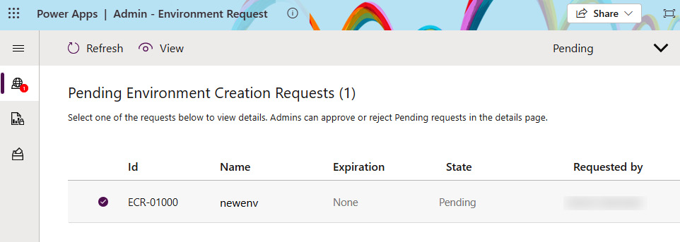

Figure 11.13 – Environment management process

Using the ****Maker - Environment Request**** application, app makers can submit new environment requests. They select which connectors would be required and who would be the owners, and they provide more information about the environment, such as environment type, whether Dataverse is required, and whether other data is required to provision the environment. After the request is submitted, it is up to the administrators to review the request. Through their ****Admin – Environment Request**** application, administrators can review which connectors were selected, whether any DLP policies are impacting the selected connectors, and which modifications to DLP policies would be needed. Once the administrator reviews the process and approves the creation, the Power Platform for Admins connector in Power Automate flow starts, gathers all data, and provisions an environment together with supporting DLP policies. If the environment was set with an expiration date, the environment would automatically be deleted after this date, unless the owner of the environment requests an extension of the expiration date before that. For the deletion of the environment, again, the Power Platform for Admins connector is used withing a Power Automate flow to remove the environment.

This represents a real-world example of how the Power Platform operations team can set up an environment life cycle management process with a combination of application and Power Automate flows. With the CoE Starter Kit, we are already getting such flows and they can be reused by anyone, but can also serve as an idea in case organizations would like to build their own platform management processes.

# Summary

In this chapter, we focused mostly on the operations part of the Power Platform management. We went through different design best practices and guidelines. We started with Power Platform Well-Architected and learned about how its purpose is to design application workloads that are resilient, reliable, and efficient, and give users a great user experience. From there, we moved on to Power Platform landing zones, which help administrators spin up needed environments that follow proven architecture designs and allow organizations to scale rapidly to support efforts in digital transformation while giving app makers a place to innovate. We looked into the design principles and design areas that the operations team should consider when planning the architecture design.

From design best practices, we moved to the actual implementation of one of these recommendations – platform automation. We experimented with the idea of how it looks if a low-code/no-code platform such as Power Platform would incorporate the same concept of describing the infrastructure as it comes from the world of pro-development, where infrastructure workloads and system configurations are written in IaC files. We’ve demonstrated, with Terraform, how IaC files can be created and used with Terraform to manage Power Platform environments. Since Power Platform Terraform Provider is still in experimentation mode and organizations might prefer other ways to manage environments, we have looked at how other tools can help us with this challenge, including using Power Platform for Admins connector in Power Automate, which is also very much used in the management flows within the CoE Starter Kit. On a very high level, we touched on what the CoE is and what kind of tools the CoE Starter Kit brings to the organizations. Through an example of environment management requests, we have seen how these best practices can be implemented in real life.

In the next chapter, we will look beyond DevOps and into the innovative things that generative AI is bringing into Power Platform. We will look at how ****ChatOps**** connects people, processes, and tools and can improve the way we do DevOps processes.

# Further reading

* Power Platform landing zones: <https://github.com/microsoft/industry/tree/main/foundations/powerPlatform>
* Power Platform Well-Architected: <https://learn.microsoft.com/en-us/power-platform/well-architected/>
* Microsoft Zero-Trust model: <https://www.microsoft.com/en-us/security/business/zero-trust>
* Terraform documentation: <https://developer.hashicorp.com/terraform>
* Power Platform Terraform Provider: <https://playbook.microsoft.com/business-applications/Enterprise-Solutions/Power-Platform-Terraform-Provider/>
* Power Platform for Admins connector: <https://learn.microsoft.com/en-us/connectors/powerplatformforadmins/>
* Power Platform CoE: <https://learn.microsoft.com/en-us/power-platform/guidance/coe/starter-kit>
* Power Platform Automation Kit: <https://learn.microsoft.com/en-us/power-automate/guidance/automation-kit/overview/introduction>

# 12

# Looking Ahead with Copilots, ChatOps, and AI-Infused Applications

We are currently living in times wherein building applications augmented with ****artificial intelligence**** (****AI****) has become very straightforward. The ability to plug in ****large language models**** (****LLMs****) to our applications and enrich them with AI is unlocking new options and allowing organizations to innovate and redefine their business processes. This chapter will close this book by talking about the AI-infused low-code/no-code development approach. With the introduction of LLMs, such as OpenAI’s ****Generative Pre-trained Transformer**** (****GPT****) models, we have seen a massive shift in the tools that help makers and developers be more productive with their work and achieve outcomes faster. Microsoft Copilot is infusing AI into every Microsoft product, which helps makers and developers build even more apps with the no-code approach by using natural language to describe the desired state. We will dive into Copilot for Power Platform and how Copilot can be used across Power Platform products. We will look at the capabilities of AI Builder and understand how to extend Power Platform’s capabilities with the Azure OpenAI models through the use of custom connectors. The chapter will finish with a discussion of ChatOps. We will look at how it can enrich existing DevOps processes and how we can use Copilot Studio to help us implement ChatOps in the organization.

We will cover the following main topics:

* The era of AI and the rise of GPTs
* Microsoft Copilot and Copilot in Power Platform
* Copilot usage from the perspective of a maker
* Extending business solutions with AI Builder and Azure OpenAI
* ChatOps and Copilot Studio

# Technical requirements

To follow along this chapter, we recommend having these requirements in place:

* ****A Power Platform subscription****: We can sign up for a Power Platform development plan (<https://powerapps.microsoft.com/en-us/developerplan/>), if we already have a Microsoft Entra ID work account, or we can join the Microsoft 365 developer program (<https://developer.microsoft.com/en-us/microsoft-365/dev-program>).
* ****An Azure subscription****: We can provision a free Azure account following the guidance at <https://azure.microsoft.com/en-us/free>. Once provisioned, the Azure portal can be accessed at <https://portal.azure.com/>.
* ****An Azure DevOps Services organization****: We can create a DevOps organization any time for free (<https://learn.microsoft.com/en-us/azure/devops/user-guide/sign-up-invite-teammates>).
* ****A GitHub handle and a repository****: As an alternative to creating a DevOps organization, we can sign up for a free account (<https://github.com/signup>). For access to GitHub Enterprise Cloud we can obtain a 30-day trial ([https://docs.github.com/en/enterprise-cloud@latest/admin/overview/setting-up-a-trial-of-github-enterprise-cloud](mailto:https://docs.github.com/en/enterprise-cloud@latest/admin/overview/setting-up-a-trial-of-github-enterprise-cloud)).
* ****A Microsoft 365 or Teams license****: To get access to Teams, a Microsoft 365 trial license or Teams license is required. We can use Teams exploratory (<https://learn.microsoft.com/en-us/microsoftteams/teams-exploratory>).
* ****Visual Studio Code****: You could use another IDE or text editing tool of choice instead.

# The era of AI and the rise of GPTs

This section will provide a helicopter view of how we came to this point in time where innovation with AI has almost become a commodity. We will explore the GPTs that have shaken the world and made a huge impact on society and global industries. Now, app makers can even use these GPT models in business solutions across Power Platform services, but we will come to that later. Let’s first start at the beginning.

GPTs have been on the market for some time already. They have disrupted the market and brought some fear to people, but they have also brought new ideas for innovation. Since everyone can access these models, anyone can innovate and build inspiring solutions using AI. This means that the competitive advantage when using AI that’s built using publicly available LLMs has decreased. This pushes companies to be innovative with ideas on how to use this new technology in their business processes. However, like with any project, in AI infused projects too, how fast we can bring a reliable and secure solution to the market is very important. Here is where innovation and development should follow DevSecOps processes that allow organizations to bring reliable solutions to the market.

In order to understand the current situation, we need to go back in time.

## Introduction to AI

AI is an intelligent computer system that uses mathematical algorithms and statistical models to simulate human thinking when analyzing data in order to make decisions.

In 1955, computer scientist John McCarthy came up with the term AI. This term describes the concept of machines that can exhibit human-like intelligence. However, the origins of AI date even further back. In 1940, Alan Turing created a machine learning algorithm that was used to crack the Enigma code. This led to the creation of the ****Turing test**** later in 1950. This test is used to determine whether a machine can mimic human intelligence under specific conditions. After so many years, AI experts now debate whether the Turing test is still relevant due to the advancements in AI models and natural language understanding.

Described in a simple way, behind artificial intelligence is a computer science and engineering fields that create various algorithms that power these AI systems. Algorithms are described as a set of rules and programmed instructions that an AI system follows to process and analyze data. These algorithms can be used for things such as sentiment analysis, object detection, and more. AI models follow algorithms and have been taught on a large dataset with representative data in order to make use of these algorithms and solve specific tasks or problems.

Once an AI model is trained on representative data, it understands the relationships in data, which allows it to apply the learning with new, unknown data. A well-known practice for such an approach to training AI is in ****machine learning****. More data and diverse data that we use to train it, the better the trained model will be. For example, training object detection model with more images of an object and providing exact information about each picture, will lead to better results of such model.

AI enables computer systems to perform task that find its use in many applications. Through ****natural language processing**** (****NLP****), a subfield of machine learning, systems can now understand human language and perform operations such as language detection, language translation, and sentiment analysis over a text. Expanding this with voice, Microsoft claims that they reached human parity in conversational speech recognition back in 2016. By adding computer vision, machines are even able, with the support of AI, to understand visual objects.

There are also other subsets of machine learning, such as ****reinforcement learning**** and, going even further, ****neural networks****. Neural networks are a model which is inspired by the way human brains function. Neural networks consist of neurons, which are interconnected nodes that are grouped in layers. Neurons receive an input, which is used in the computational function to determine to which neuron in the next layer the data will be sent. Neural networks can be used for very complex data relationships.

One might ask why we are talking about all of these models. Well, this is where GPT comes in.

## GPTs

AI advancements in the last few years have brought us generative AI. Generative AI is a type of AI that uses LLMs. Generative AIs are capable of responding to prompts by generating new content with text, image, speech, or even video. There are many LLMs available; however, one of the most recognizable is GPT due to the popularity of OpenAI’s ****ChatGPT****. It is always fascinating to see how much time certain technology needs to reach 100 million monthly average users. It only took ChatGPT two months to reach 100 million monthly average users. This also shows how new innovative solutions are reducing the time needed to hit this big milestone.

GPTs are part of LLMs or text-generation models that are capable of producing new content (hence, *generative*), have been trained on a large dataset (hence, *pre-trained*), and use neural networks to process the input request and provide output (hence, *transformer*).

As mentioned earlier, many LLMs are available, including those that are made available to open source communities. Currently, the most well-known and popular GPTs include OpenAI’s GPTs. OpenAI has also other models available that serve their own purposes. With each new version of a given GPT, we can see it become more sophisticated and knowledgeable. In May 2024, OpenAI introduced ****GPT-4o****, also known as ****omni****, which is a multimodal model that accepts both text and images as inputs and can produce text as output. During the announcement, OpenAI highlighted how the new GPT-4o model is able to interact with the users through audio, visual, and text. OpenAI also presented a new model that is able to turn text into a video, called ****OpenAI Sora****, in February 2024.

Other models that are currently already available include the following:

* ****GPT-4 Turbo****, ****GPT-4****, and ****GPT-3.5 Turbo**** are models that can understand instructions in natural language and generate outputs in natural language or code
* ****DALL-E**** (text to image) is a model for generating images with a provided natural language instruction
* ****Whisper**** is a model that converts audio into text

Although LLMs have paved the way for generative AI, we also see the emergence of small language models. These are much smaller in size due to small training data sizes but are capable of running locally on devices, which opens the door to new innovation ideas for organizations.

AI models require components such as data, AI algorithms or models, and extensive computational capacity for their operation. Microsoft has formed a partnership with OpenAI and opened up Microsoft Azure Cloud for OpenAI to leverage computational power for the research and development of new models. In return, the partnership specifies that OpenAI GPT models are exclusively available on Microsoft platforms. They are available for consumption as part of the Azure OpenAI service. This allows customers who are either already using Azure or would like to do so to use a secure and compliant platform to build secure enterprise applications utilizing AI capabilities. The partnership enables Microsoft to integrate OpenAI LLMs into their own products and build new functionalities that help boost user productivity. A good example of such a product is GitHub Copilot, which acts like an AI pair programmer. It helps developers understand and produce code while using IDEs such as Visual Studio, Visual Studio Code, JetBrains IDEs, and Neovim. Another example of such collaboration is the various copilots for Microsoft products and services, which integrate into various tools and enrich the user experience by helping users achieve results faster and more effectively.

## Responsible AI

With the advancements in AI, concerns about its potential misuse have become valid. Therefore, the responsible use of AI is imperative. Microsoft, as well as other companies, communities, and individuals, has recognized this and has begun taking an active share to advocate for the need for responsible use. Microsoft has made significant investments internally to make sure its AI systems are designed with responsibility in mind.

Microsoft has made its ****responsible AI standard****, which lays down practical guidance on how to ensure organizations use AI responsibly. It is defined by six responsible AI principles that will guide AI development and use:

* ****Fairness****: AI systems should treat all people equally, without bias or discrimination
* ****Reliability and safety****: AI systems should perform reliably and prioritize safety in order to prevent undesired consequences
* ****Privacy and security****: AI systems should be secure and maintain privacy by protecting user data
* ****Inclusiveness****: AI systems should engage a wide range of users and be inclusive by considering diverse perspectives
* ****Transparency****: AI decisions and processes should be understandable, with clear explanations in order to improve trust
* ****Accountability****: Developers and organizations should be held accountable for the developed AI systems

Apart from the responsible AI principles, we should ensure that AI systems are developed in a compliant and governed way in order to be compliant with local regulatory requirements. Microsoft also went a step further and implemented a five-point blueprint that focuses on governing AI. These are the principles that make sure that AI is used responsibly and in compliance with government AI safety standards. They also ensure that we maintain control over AI systems so they can be used safely.

Microsoft has integrated responsible AI practices not just into the copilots but also into other tools and the culture of people. They have done this to promote the safe and responsible use of AI.

# Microsoft Copilots and Copilots in Power Platform

Microsoft has placed copilots in many Microsoft products for enabling different scenarios. This section will start with explaining what a copilot is, then go through explaining what some of the available copilots are and how they can be used. We will then focus on understanding the capabilities of copilots in Power Platform.

Microsoft uses the term copilot to describe an AI assistant that is capable of retrieving information and performing specific tasks such as summarization and content generation. Copilots utilize LLMs, such as OpenAI’s GPT model, to respond to user prompts. Not all copilots behave the same way. Some copilots are more generic, such as Microsoft Copilot, while others are product-specific, such as ****Copilots for Microsoft 365**** or ****Copilot for Power Platform****. These copilots operate within the context of a specific product and are aware of the data and operations that are available in the specific product.

All these copilots share a common conversational chat experience with users. However, when we look at the copilots, we can see that some copilots are integrated into the product itself and that their main task is to support users to be more productive while using a specific product, such as copilots in Power Platform. Other copilots are also product-specific, such as Copilot for Microsoft 365 or Copilot for Sales, and they come with a standard set of functionalities that includes a copilot component, but they can also be extensible with the support of Copilot Studio. The last group of copilots would be custom copilots, which a user can build by themself on either Copilot Studio or using Azure AI services and expose through different channels for user consumption.

Examples of copilots include the following:

* ****Microsoft Copilot****: This uses OpenAI LLMs to provide responses to a user’s prompt in a chat-like experience. It can search for a result across the web and can summarize responses to a specific question while providing links to relevant content sources.
* ****Copilot for Microsoft 365****: This generates responses anchored in organizational data that a user has access to. It utilizes Microsoft Graph and LLMs and is integrated within Microsoft 365 suite (Word, Excel, Teams, and so on) and aims to improve personal productivity.
* ****GitHub Copilot****: This is an AI pair programmer or code completion tool that helps developers during the SDLC. It is grounded around coding-related topics, so it can provide code suggestions, explain code, build unit tests, and more.

## Copilots in Power Platform

AI in Power Platform has been present for a few years now. In 2019, AI Builder was introduced in Power Platform, which helped incorporate AI models into the business process and enrich apps and flows. In 2021, a capability to turn natural language prompts to Power Fx functions was introduced in Power Apps. Since then, new AI capabilities have come to Power Platform each year.

Enabling copilots in Power Platform brings the platform closer to no-code development with assistance from AI. This means that no matter whether we are pro-developers, low-code app makers, or people who are just learning to work with Power Platform, copilots in Power Platform will provide us with the ability to use natural language in order to generate meaningful business-oriented solutions. This helps makers and organizations save time and boost productivity.

Each product in the Power Platform family includes its own copilot. These copilots act as AI assistants that hold product-specific capabilities that can be used as a maker or as a user of the business solution built on Power Platform.

Copilots are integrated into the product and always share the product’s main screen, which makes it convenient for makers or users to be more productive while working on the solution as it does not require them to leave the context of the work:

* ****Copilot in Power Apps****: This enables makers to build new or edit existing applications by using natural language descriptions and write or understand the Power Fx functions. As a user, we can use the copilot component in the app that allows us to get answers about the data used in the application.
* ****Copilot in Power Automate****: Using this, makers can create new flows with the needed connectors to support problem descriptions in natural language. We can also alter existing flows and get inspiration for business processes. Soon, we will be able to build AI flows where LLMs will create dynamic automation flows and, utilizing multimodal models through voice record instructions, build Power Automate desktop flows. Users are able to get insights into the processes and flows analyzed by Power Automate Process Mining.
* ****Copilot in Copilot Studio****: Makers can create new custom copilots with a conversational builder, as well as create and alter topics using natural language.
* ****Copilot in Power Pages****: This facilitates the creation of external websites and pages, allowing us to add forms, text content, and AI-generated code using a natural language chat interface. Users can leverage a custom copilot chat experience and a GenAI-enriched search experience reasoned over search results.
* ****Copilot for Power BI****: This helps build report pages across cloud services and Power BI Desktop. As users, we can get answers to questions about the data in the model, get a summarization of the reports, and more.

*Copilots in Power Platform – preview capabilities*

*It is important to note that some of the copilots’ capabilities in Power Platform are in preview. These are not meant for production use. In order to access them, we might need to have our environment**set to*****early release cycle*****(*<https://learn.microsoft.com/en-gb/power-platform/admin/early-release>*). We can use sandbox environments using a*****preview URL*****(Power Apps:*<https://make.preview.powerapps.com/>*) or by enabling*****Try the new data experience*****in the Power Apps home screen.*

Some of the copilots’ configuration settings can be turned on or off in ****Power Platform admin center**** | ****Settings****. Under ****Tenant settings****, we can find configuration settings that we can enable or disable based on the organization’s policy, as can be seen in *Figure 12.1*:

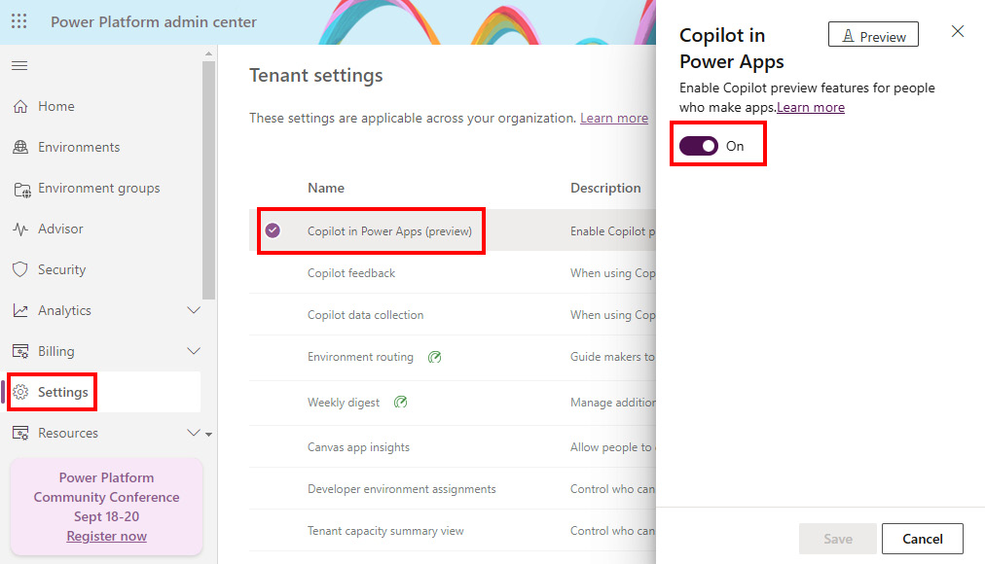

Figure 12.1 – Enabling or disabling copilots in Power Platform

Some of these settings include capabilities such as enabling data collection, an ability for users to send feedback, and abilities to enable or disable copilot preview features in Power Apps.

# Copilots’ usage from the perspective of a maker

In this section, we will take a look at how copilots in Power Platform can be used to generate Power Apps canvas applications with data tables on Dataverse and supported by flows in Power Automate. This demonstrates how AI is helping app makers get additional support during the low-code development with copilots and shift toward a no-code approach.

One of the benefits that using copilots in Power Platform provides is that such an approach enables makers to build prototypes of solutions much faster. This is because prototypes do not need to have all the functionalities of an application up and running, but are there to provide a look and feel of the idea. With the help of copilots in the Power Platform app, makers can build mockups of an application or flow using natural language descriptions and quickly validate the feasibility of the idea for a business application. For each step of the provided suggestions, we can revert the changes made by Copilot by clicking the ****Undo**** button. This makes it easy to test ideas and revert back in case we are not satisfied with the suggested work.

Copilots in Power Platform all have the same user experience. On the home screen of the service, we can find a big text input component, which allows us to add descriptions of what we would like to do. Prompts that we write to the copilot should be clear and specific, as this will help it return more relevant results for the ask. In order to achieve better results using copilots, we should provide more details on the context of the ask or, if needed, provide some examples of how something should be achieved:

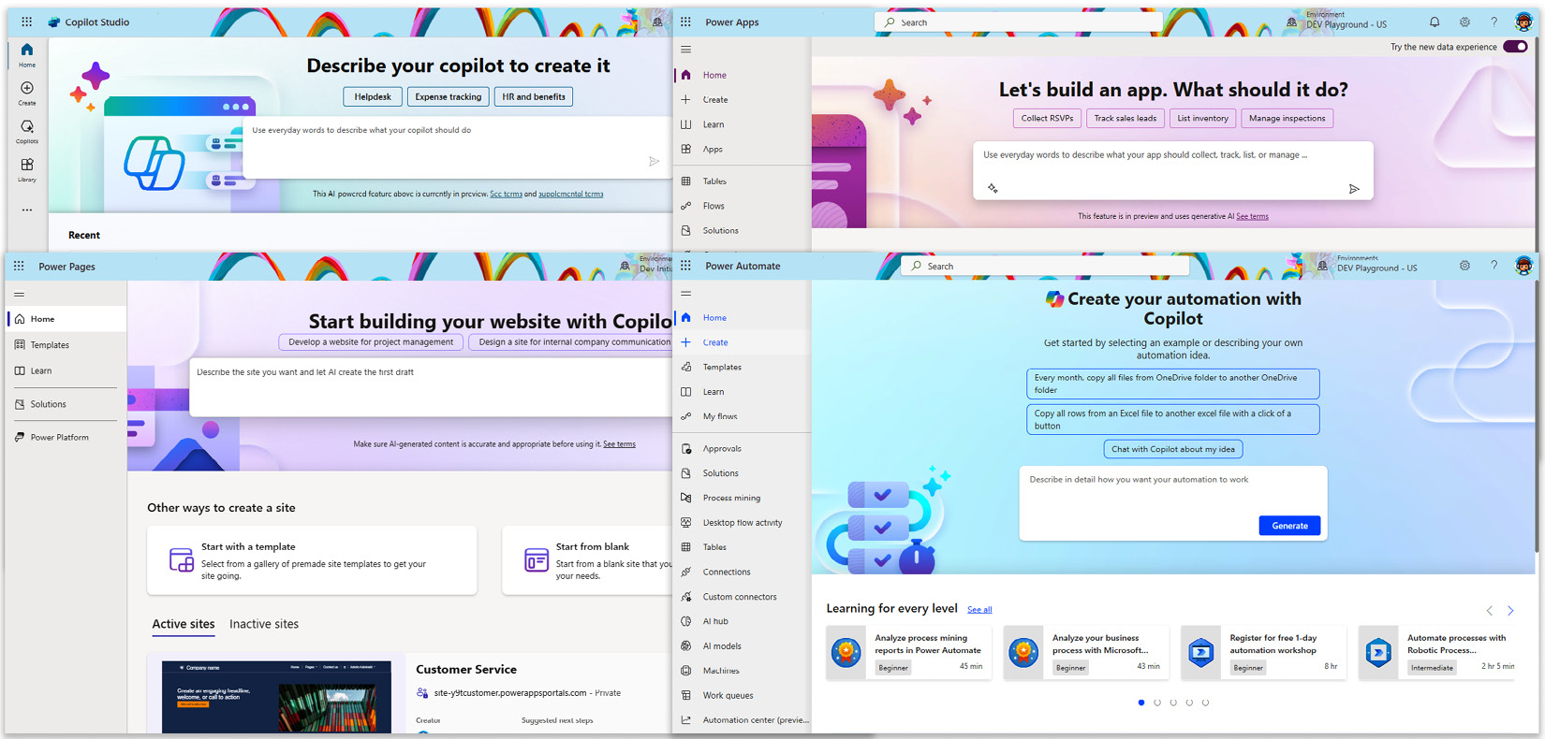

Figure 12.2 – Copilot in Power Platform on the home page

On the Power Apps home screen (<https://make.powerapps.com/>), we are going to start by describing the idea of an application that we would like to build. Since more or less any business application relies on data, Copilot will go ahead and start creating a data schema in Dataverse as our data source to manage data. During this step, copilot extracts the context of our prompt and, based on the inputs, starts creating an entity-relationship diagram.

We can use prompt suggestions to alter a data schema, add more tables, configure the relationship between them, add more test data in the tables, and more. The ****View prompts**** button acts as a prompt guide and gives us suggestions of what copilot can do. This includes the abilities to create tables and relationships, alter tables and columns, and serve as inspiration, with suggestions based on the current data schema design:

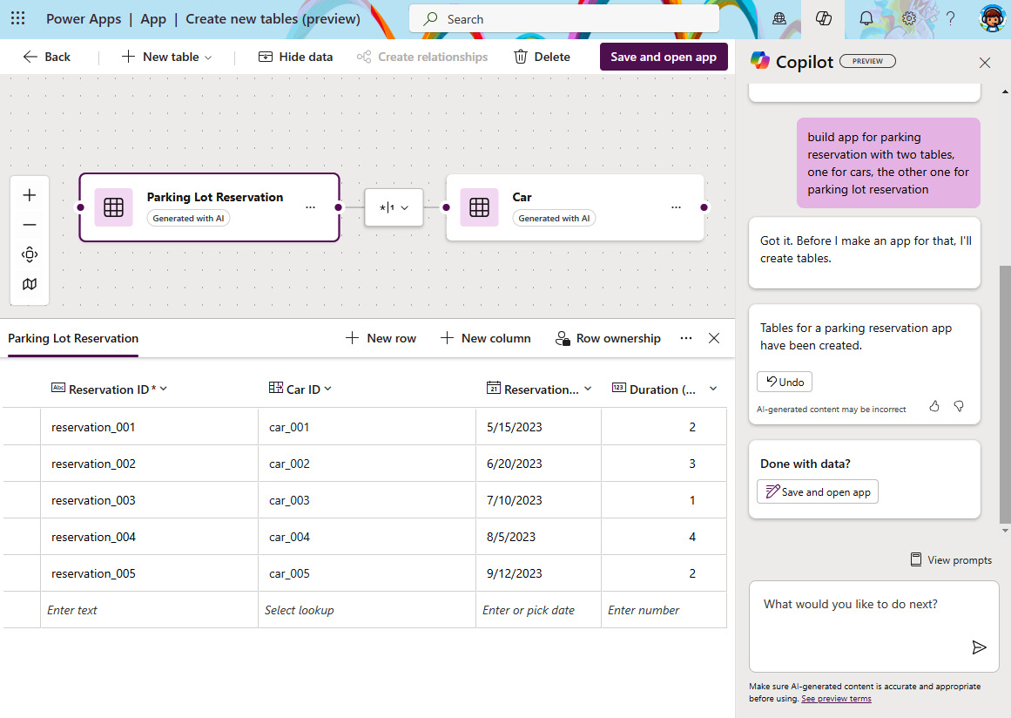

Figure 12.3 – Rich data model creation

Once we click ****Save and open app****, Copilot will use this data schema to create a sample application with separate screens that have forms to perform operations over tables, as well as a separate welcome screen that can serve as a navigation between screens.

In Power Apps Studio, we can utilize copilot to ask questions on how we can achieve things in Power Apps. This utilizes Bing Search to find relevant content and provide us with guidance. For example, we can ask a question such as “*How can I add a picture to an image component*?” and it will produce the response relevant to the question. In this case, that would be step-by-step guidance on how to achieve this with a relevant link to the documentation explaining the process. We can ask it to add some specific components, such as a button or text label to the screen, but at this point, we might still need to do some tasks manually, as it is not yet able to complete all tasks.

Building Power Fx formulas can be challenging sometimes, especially for someone who is working with Power Platform for the first time. Similar to the capabilities of GitHub Copilot, to support developers, now we are able to use comments in a natural language to generate Power Fx formulas. It also works the other way around, helping understand what a formula does by clicking a copilot icon next to the formula box and selecting ****Explain this formula****:

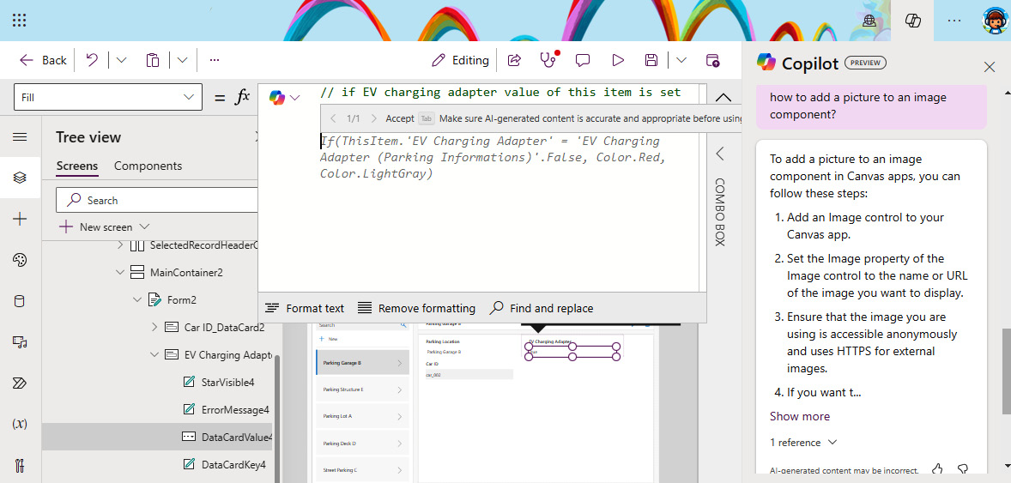

Figure 12.4 – Using copilot to provide Power Fx formula suggestions

As developers, we can also get a view of the code in the Power Apps Studio directly. By selecting the three dots next to a screen or a component (or right-clicking), we can now see a ****View code (preview)**** option, which shows a code in YAML format for the selected part. This allows us to copy the code and discuss it with other developers, make changes in the code directly, or even use copy/paste to place only this part in another screen or application.

If we switch gears to Power Automate, copilot allows us to complete similar tasks there. That means using natural language to describe the flow we would like to create and perform changes to existing flows, such as adding actions to the flow, configuring the parameters of actions, and more.

With the advancements in AI, soon, we will be able to build AI flows, where AI will determine how to build an automation plan with all the conditions needed to fulfill requirements. We will also soon be able to use voice to record instructions for building a Power Automate Desktop flow.

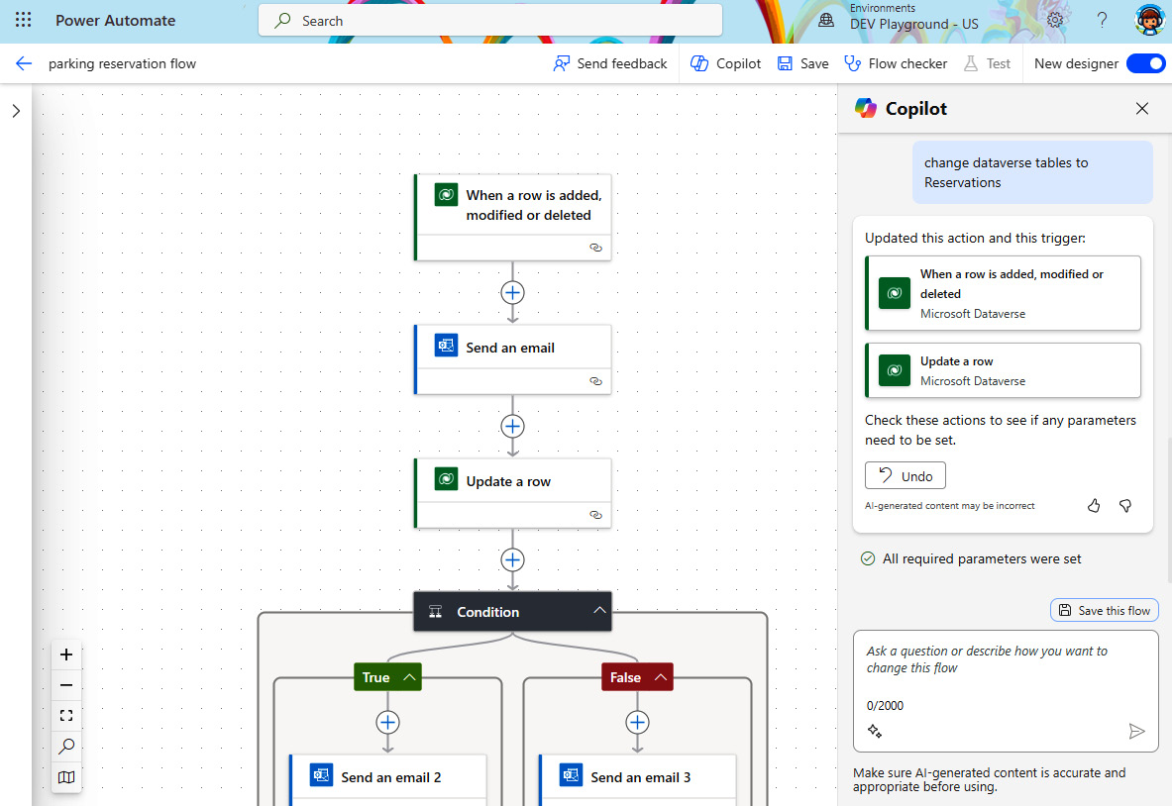

Figure 12.5 – Copilot in Power Automate

We have to keep in mind that at this time, some of the copilot features are still in preview. From a DevOps perspective, we can see one main problem currently, and that is that the ability to use the same building approach is not enabled from the solution’s level.

We mentioned in *[Chapter 4](https://learning.oreilly.com/library/view/mastering-devops-on/9781835880845/B22208_04.xhtml" \l "_idTextAnchor074)* that we should be starting off building our Power Platform components from within solution explorer. There we use an existing solution or create a new one, since solutions enable us to move applications between environments and manage dependencies required by our solution components. The current approach of development with the copilots is starting from the designer experience instead of from the solution explorer. This way, all components that we create through copilot’s initial designer experience will be added to the ****Default Solution**** and be unmanaged. Currently, a copilot-first approach for building business applications does not support starting from the solution, which leaves us only with the option of adding existing components to a new solution and making sure all required dependencies are added to the solution. However, if we would like to start with the manual creation of custom copilot, we can first create a solution and, from there, create new components (such as a Power Apps application). We hope that the copilot experience for the initial creation of apps and other components will also be enabled through the solution approach.

# Extending business solutions with AI Builder and Azure OpenAI

Now that we have seen how AI is helping us build Power Platform components, we will look for ways to infuse AI capabilities into our applications and flows. This section will go through the AI Builder capabilities and how it compares to Azure OpenAI. We will take a look at how to set up a custom connector to connect to Azure OpenAI, where we will use our Azure OpenAI model of choice to enrich the user experience or improve our business process in Power Platform.

## Introducing AI Builder

AI Builder is a Power Platform service that allows makers to utilize different AI models and prompts inside their solutions without requiring coding or special data science knowledge. It allows organizations to improve their business processes by adding additional AI capabilities, which can help automate manual and repetitive tasks and help achieve better outcomes.

It can be integrated into Power Apps applications through a Power Fx formula or by using AI Builder components. AI Builder can also be used in Power Automate workflows by using AI Builder actions. We also have the option to use its capabilities in plugins within Copilot Studio.

### AI models

AI Builder comes with a set of pre-built models that are commonly used in many business processes. When we require more custom-built models specific to our data, we can build custom models and train them on a custom dataset.

AI models can be grouped together based on the type of data that they use. These groups can hold both pre-built and custom models:

* ****Document processing****: This group contains models such as invoice processing, text recognition, document processing as a custom model, and a business card reader
* ****Text processing****: Here, we can find models that are used for text processing, such as key phrase extraction, sentiment analysis, language detection, and category classification
* ****Image processing****: Models that extract information from images, such as image description to generate descriptions of an image or object detection in images, are found here
* ****Structured data processing****: Only one custom model so far can make forecasts and predict outcomes using data

Each model has its own specifics and requirements in order to get the best result. To learn more about each specific model, we recommend going through the documentation: <https://learn.microsoft.com/en-us/ai-builder/model-types>.

With pre-built models, we do not require any special configuration – they are ready to be used out of the box and do not require any training. We can use the component or connector action, point it to the data, and receive an output. When using a custom model, we are building a model that is specific to a line of business. It has to be trained first with the historical data in order to be able to complete specific tasks. For document processing, we would require at least five examples that use the same layout in order to train a model accurately.

### AI prompts

AI prompts allow makers to build prompts that will instruct an LLM on the kind of task it has to perform. The more precise the instruction is, the better the outcome of the task will be. AI Builder has pre-built prompts that build these instructions to GPT faster, such as tasks around text summarization, text classification, sentiment analysis, drafting a reply, and more. However, just as before with AI models, makers have the opportunity to create custom AI prompts. With the help of ****prompt engineering****, we can provide instructions that will guide a GPT model to the needed outcome. It is important to know that the quality of instructions will have a direct impact on the output. AI prompts allow us to provide input variables and Dataverse data, which creates prompts that are highly dynamic and related to our business process.

AI Builder currently uses GPT-3.5-Turbo or GPT-4 (in preview) for AI prompts. These are powered by Azure OpenAI.

As creating a prompt is important and as there are other parameters that define how the model will behave, such as model selection and temperature settings, it’s a good idea to learn more about building AI prompts at <https://learn.microsoft.com/en-us/ai-builder/create-a-custom-prompt>.

As a safety precaution, we recommend implementing human inspection of the response before using the response in an important business process, where a wrong or irrelevant response could bring harm or have negative implications.

## Using AI models and AI prompts

We can start creating AI models or AI prompts from the ****AI hub****:

1. In Power Apps or Power Automate, we can find the AI hub in the left navigation menu. In case we do not see it there yet, we can find it under ****More**** and pin it to the left navigation bar from there or by going to ****More**** | ****Discover all****, where we will find ****AI hub**** and can pin it to the left navigation menu.
2. Once we are in ****AI hub****, we can start building AI prompts and models. There, we can also find a document automation solution that combines the RPA process and AI to extract information from various documents and proceed with the document processing workflow.
3. Starting with AI prompts – in ****AI hub****, select ****Prompts****. There, we will see a list of all pre-built prompts and the option of creating a custom prompt with GPT.

AI prompts are made of the ****Prompt****, which should be precise and clear, and ****Prompt settings****. We can configure multiple input variables and add them to the prompt to make it highly dynamic. We can use data from Dataverse to additionally ground the GPT model with the knowledge source. Outputs can be text or JSON and the latter option could sometimes be more suitable, as we have more control over the presentation layer. In ****Settings****, we can select the model and temperature we’d like to use.

1. Now that we have created an AI prompt, we can add it to our application or flow. When we are developing our canvas app inside Power Apps Studio, we can find AI prompts or AI models in the ****Data**** section.
2. In the left navigation bar, click on ****Data**** | ****Add data****, which opens an option to select a data source. There, we can use the search bar to find our AI prompt or model and add them to our application:

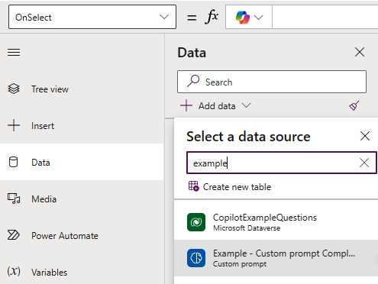

Figure 12.6 – Adding an AI prompt to the canvas app

1. In order to use the AI prompt or AI model, we will trigger it from the Power Fx function:

Set(varComplaint, 'Example - Custom prompt Complaint Accommodation'.Predict(txtComplaint.Text,txtApartmentName.Text))

In the preceding code, we can see an example of the Power Fx function that stores the response of the AI prompt as a variable, which can then later be consumed in the application based on our business process. In Power Apps, we can find AI Builder components that are focused on specific AI models and can be implemented in the application through the component to enable some additional capabilities, such as a receipt and form processor, object detection, and more.

Adding AI prompts and AI models in Power Automate is as easy as adding any other action in the workflow:

1. In the Power Automate designer, when working on our workflow, click ****Add an action**** in the place where we would like to add AI capability.
2. Search for ****AI Builder**** and select a model or prompt type from the list.
3. We first select the model type and, in the next step, we can link a connector action to our model or prompt.

Related to the preceding example, where we used a custom AI prompt, we can find our custom AI prompt by using the Power Automate action: ****AI Builder**** | ****Create text with GPT using a prompt****.

1. We authenticate to a connector and, under ****Parameters**** | ****Prompt****, select our prompt from the list.
2. We provide any inputs if needed and continue building our flow.

In any subsequent action, we will be able to use the output from the previous actions, which is the same for AI Builder actions. As an example, in *Figure 12.7*, we are using outputs from the generated complaint response, built by GenAI, in the ****Approvals**** action, to allow reviewers to review whether the generated complaint reply is appropriate or not. If it is, we send the complaint message to the customer:

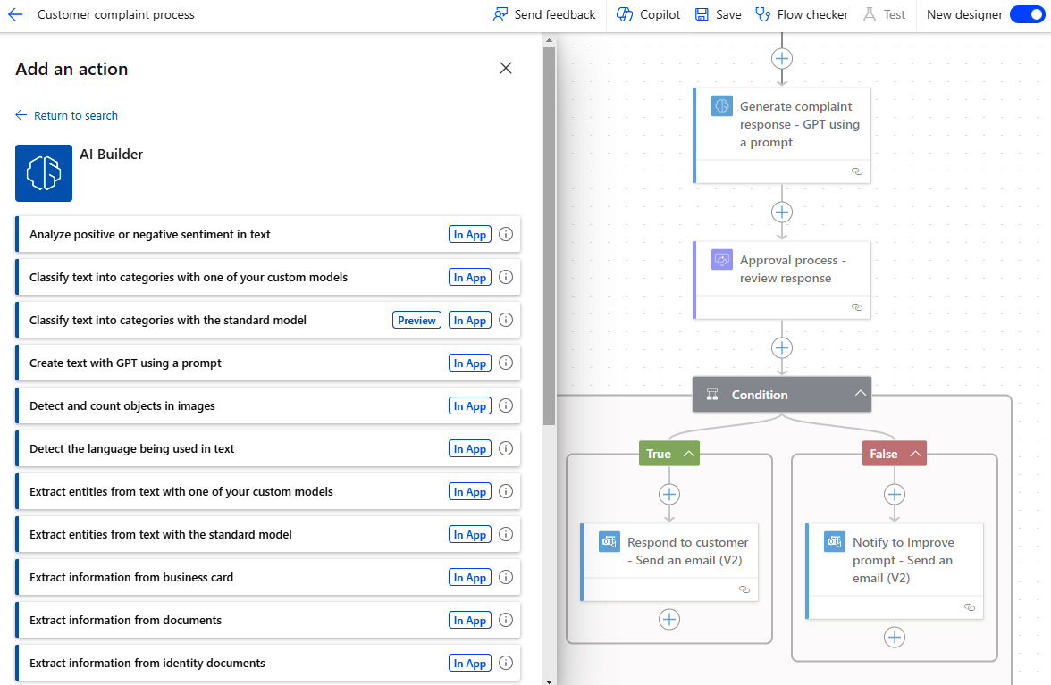

Figure 12.7 – Integrating AI Builder with Power Automate

*Important notes*

*From the perspective of**using**solutions for packaging our business applications, we need to keep in mind that AI models and prompts are not considered as app dependency. We will need to manually add AI prompts and models to our solution to accompany the app or flow.*

*Also, AI models and prompts use AI Builder credits. Different model types consume different amounts of credits, so make sure to review the licensing guide (*<https://go.microsoft.com/fwlink/?linkid=2085130>*) to better understand the credit utilization for your project.*

### AI Builder ALM

Whenever we create a custom AI model or AI prompt that we would like to reuse across environments, we can apply the same principles of application life cycle management that we have already covered in the previous chapters with other Power Platform components.

Since an AI model or prompt cannot be created from within solution explorer, a custom AI model or AI prompt first needs to be created using AI Builder, where we can train the AI model with our collection of data or build a custom AI prompt. We recommend following an environment strategy and developing a custom model in a development or sandbox environment and from there deploying it to other target environments. Once the model has been trained, we need to publish it so that we can add it to the solution.

Since the model is not considered an application or flow dependency, we need to manually add the custom AI model or AI prompt along with the app or flow that will be using it. At this stage, we are ready to add existing models to solutions. We need to be aware that when a model is added to the solution, only the model executable is added to the solution and not the data that was used for training. This is why when we use models such as document processing, object detection, or entity extraction, the modification of models in the target environment won’t be possible, as the data is not transferred to the target environment. In such cases and if modifications are needed, a new model should be created in the target environment.

As part of the ALM for AI Builder, we should also consider implementing a ****continuous improvement process**** to improve our models. So far, we can automate this approach with the out-of-the-box capabilities only for custom document processing models. However, we should implement a feedback loop that at least informs owners of AI models or prompts about the relevancy and appropriateness of the model by using different metrics to measure that. One of these can be the model confidence score. However, we can also incorporate a manual review process, as we have seen in an example earlier. In order to achieve continuous improvement for a custom document processing model, we can implement a Power Automate flow that uses the ****Save file to AI Builder feedback loop**** AI Builder action whenever the total confidence score of an existing AI model is below a certain threshold. A detailed description of this process is documented here: <https://learn.microsoft.com/en-us/ai-builder/feedback-loop>.

Once we are ready with our solution, we can use the CI/CD pipelines that we have configured in the previous chapters to export the solution and have the source code added to a repository. After that, we can follow the DevOps process and, once ready, we can use our import pipeline to import the models to the target environment. After that, models and prompts can be used in applications and flows. In case we are using managed pipelines or pipelines for all, we only need to make sure that we have AI Builder components added to the solution.

## Introducing Azure OpenAI

Sometimes, makers and organizations would like to use the latest version of GPT models or have maybe already built models on Azure OpenAI, where they have grounded models around their company data. They might want to reuse the work that they have already done on Azure OpenAI for other applications, or maybe the included version of the GPT model in Power Platform is the one they wish to use. Luckily, Power Platform is a very extensible platform and supports such cases as well.

As we have already mentioned in *[Chapter 9](https://learning.oreilly.com/library/view/mastering-devops-on/9781835880845/B22208_09.xhtml" \l "_idTextAnchor149)*, Power Platform supports many pro-dev integration scenarios between Azure and Power Platform. Building fusion development teams would help us to bring relevant engineers to the project. We can then distribute tasks to data scientists, AI architects, or similar roles that would make sure that the models are designed and fine-tuned in Azure OpenAI. Developers or more seasoned app makers will make sure that custom connectors are integrated with Azure OpenAI. And lastly, app makers will use custom connectors as part of the business application or flow, to produce the outcome for which they are built.

The Azure OpenAI service is a PaaS service that brings OpenAI models to the Azure cloud platform. Models are exposed through a REST API endpoint through which we can consume these LLMs while benefiting from the security, scalability, and reliability of the Azure platform. These models support different tasks that span across NLP, computer vision, speech, and more.

Azure OpenAI is designed for data scientists and AI engineers, who need more control over the models, by enabling them to fine-tune the models, generate embeddings, apply content filters, and more. Additionally, in AI Builder, we can use GPT-4 over text with AI prompts. Azure OpenAI provides other LLM models and if we take a look at the Azure AI service in general, we can see that there are also other LLM models as well as SLM models available that we can utilize. This way, we can go beyond text and get the support of multimodality if needed, such as with the latest GPT-4o or other models such as Whisper or GPT-4 Turbo with Vision. With all the advancements in AI, as well as optimizing hardware and AI operations, it is just a matter of time until Power Platform becomes richer with additional LLM models that will also support multimodality out of the box.

### Integrating Azure OpenAI with Power Platform

Azure OpenAI provides a UI experience, called ****Azure OpenAI Studio****, through which users can build, test, and manage their Azure OpenAI deployments. To start using it, Azure OpenAI service can be provisioned manually using Azure portal, using Azure CLI, or using infrastructure as code approach that we have already familiarized ourselves with in the previous chapter.

To better understand the process of creating Azure OpenAI resources and model deployment, we recommend going through this documentation article: <https://learn.microsoft.com/en-us/azure/ai-services/openai/how-to/create-resource>.

The Azure OpenAI model can be grounded around the organizational data, keeping the data secure within the organizational Azure subscription. Our new Azure OpenAI service can now be used in custom-developed applications using REST API and SDKs. In Power Platform, it can be integrated using connectors.

*Access to Azure OpenAI services*

*Before provisioning Azure OpenAI service in our Azure subscription for the first time, we must submit an application to have access to Azure OpenAI services granted. This can be done using a form that is accessible at*<https://aka.ms/oai/access>*.*

We have already seen examples of building custom connectors in *[Chapter 9](https://learning.oreilly.com/library/view/mastering-devops-on/9781835880845/B22208_09.xhtml" \l "_idTextAnchor149)*. However, we will provide specifics that should be considered when connecting to the Azure OpenAI service. We can find all the required information within Azure OpenAI Studio:

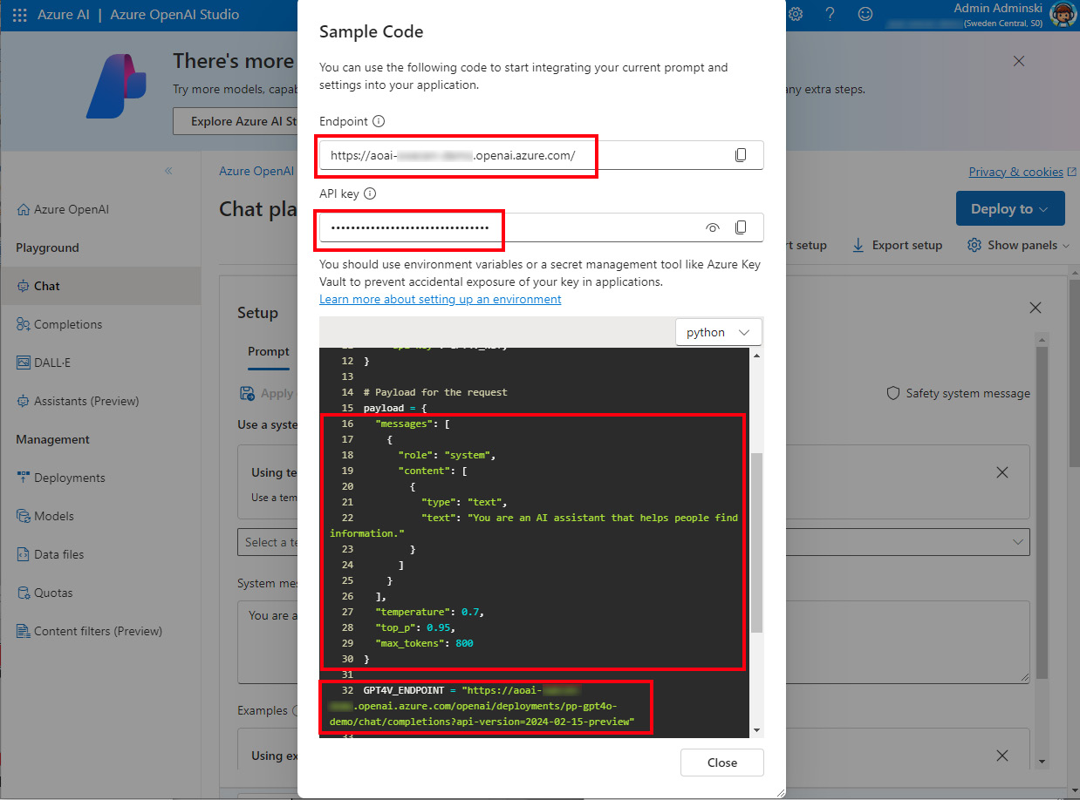

Figure 12.8 – The Azure OpenAI chat playground

Here are the steps:

1. In Power Apps or Power Automate, select ****Custom connectors**** in the left navigation bar and click on ****New custom connector**** | ****Create from blank****.
2. Among other data, we need to provide ****Host****. This would be our Azure OpenAI service’s endpoint URL in the ****<name>.openai.azure.com**** format, as shown in *Figure 12.8*.
3. Within the ****Security**** tab, we specify ****API Key**** as the authentication type, which is added in the ****Header**** location. This key is what we will provide at the creation of the connection in Power Platform. It can be found next to the endpoint URL, as seen in *Figure 12.8*, or in the Azure portal by going to ****Azure OpenAI resource**** | ****Resource Management**** | ****Keys and Endpoints****.
4. In the ****Definition**** tab, click ****New action**** to define the chat completion API operation. In the ****Request**** part, we can use ****Import from sample**** to create an HTTP POST request. Under ****URL****, we provide the complete endpoint URL, which can also be found in ****Azure OpenAI Chat playground**** | ****View code****, as can be seen in *Figure 12.8*. The chat completions API also requires a body with a message that contains content for a system and user roles. We can include a sample payload with a message from Azure OpenAI Chat Playground to facilitate adding the parameters.

Actions can be further customized in the ****Definition**** tab to make sure that we are providing the required information for the model.

1. Once we are satisfied, we can proceed to the ****Test**** tab, where we will create a connection by providing the API key for Azure OpenAI service. After that, we can test the connector.
2. Once we have a working connector, we can utilize it in our Power Platform solutions in the same way as with any other connector.

Microsoft has recently published a premium ****Azure OpenAI connector**** (in preview) for Azure Logic Apps and it also lights up in Power Platform. We can expect that at some point, it will be announced as a generally available connector for Azure OpenAI. Azure OpenAI connector simplifies building connections between Azure OpenAI service and Power Platform solutions, allowing makers to utilize the chat completion operation against their Azure OpenAI GPT models. However, since the connector is in preview, we would recommend still building and using custom connectors that connect to Azure OpenAI:

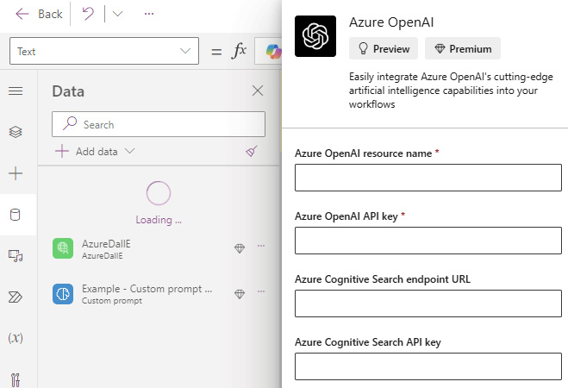

Figure 12.9 – Creating connections to Azure OpenAI

Once the connector is announced and becomes generally available, we can use it in the same way as any other connector, as we have seen with AI Builder in the previous example.

It is also good to remember the possibility of using ****connection references**** in our solutions, as mentioned in *[Chapter 10](https://learning.oreilly.com/library/view/mastering-devops-on/9781835880845/B22208_10.xhtml" \l "_idTextAnchor172)*. Using the deployment settings file (as seen in the following snippet) allows us to move our solution more effectively between environments:

"ConnectionReferences": [

    {

      "LogicalName": "<CONNECTION-REFERENCE-NAME>",

      "ConnectionId": "<CONNECTION-ID-TARGET-ENVIRONMENT>",

      "ConnectorId": ****"/providers/Microsoft.PowerApps/apis/shared\_azureopenai"****

    }

  ]

With that, we have seen how easy it is to build AI models and plug them into existing business solutions in order to improve our business processes. Using AI Builder or even Azure OpenAI can support many business processes:

* Automating expense reports by extracting information from attached invoices and documents
* Extracting sentiment from the product reviews to respond to them accordingly
* Writing replies to customer complaints
* Summarizing the content of meetings
* Building transcripts of customer calls with speech-to-text operations
* Translating documents to various languages
* Identifying fraudulent transactions

We will now switch gears and move from the specifics of AI Builder and Azure Open AI toward custom copilots or virtual AI assistants and how they can support our DevOps process.

# ChatOps and Copilot Studio

We have already looked into various copilots that are embedded in the product. Now it is time to look at how we can create a custom copilot. This section will focus on a tool that enables us to build custom copilots: ****Copilot Studio****. From there, we will learn about ****ChatOps**** and, through an example, look at how we can use Copilot Studio to build an assistant that will help us with implementing ChatOps practice. We will also look at PAC CLI commands that we can use to support ALM for Copilot Studio.

## A closer look at Copilot Studio

We briefly introduced Copilot Studio at the beginning of the book. Let us refresh what it is. Copilot Studio is a low-code tool for managing custom copilots. It has evolved from a product, previously known as ****Power Virtual Agents**** (****PVA****), that was used to build chatbots. With the introduction of generative AI and the emergence of copilots, Microsoft expanded the functional capabilities of PVA and renamed the product to Copilot Studio. This change resonates well, considering that this tool is not only for building chatbots but also a product that can extend existing copilots with additional custom capabilities. Copilot Studio now allows anyone to build custom copilots with generative AI capabilities.

Custom copilots act as AI assistants that can handle different kinds of requests, from performing specific operations that are supported by business process to simply answering questions utilizing the GPT model that is grounded around the business data. Due to their generative AI capabilities, they are more than just chatbots, although we often refer to them as bots. Organizations can build different internal or external bots that will support internal teams, work with customers, help drive internal processes, and more. Given the fact that it is a low-code tool, it enables organizations’ rapid development of copilots that meet business requirements and contribute to ROI.

Copilot Studio comes with a set of predefined and system topics. It also allows us to create our own custom topics. Topics are a fundamental building block of copilot. They define a specific part of the conversation between a user and a copilot, allowing natural interaction and communication. Each topic includes a trigger, which could be represented as a set of trigger phrases and a set of conversation nodes. These elements together define the conversational path that a topic can follow. Nodes could represent a message or a question that the bot will place to a user. Nodes can run an action such as triggering a Power Automate workflow or utilizing any of the connectors available in Power Platform. They could also involve topic management capabilities, such as setting up variables, checking the conditions of certain values, calling other topics, and more. Building topics allows us to have complete control over the conversation between the bot and the user.

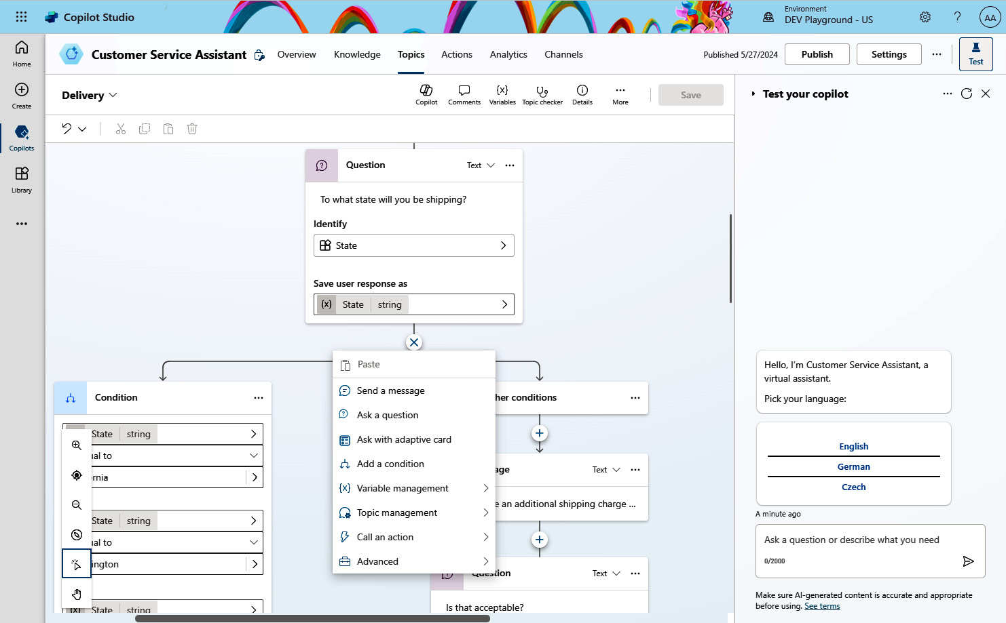

Figure 12.10 – The Copilot Studio topic authoring experience

From a generative AI perspective, Copilot Studio allows organizations to enhance user productivity and improve conversation flow by enabling generative answers and generative actions.

Generative answers is a functionality whereby a GPT uses different knowledge sources, such as public websites, internal SharePoint sites, various documents, custom data sources, and more, to generate answers to questions. When the generative answers functionality is enabled, we can add GPT-powered answers to any custom topic as well as use a fallback system topic that triggers whenever no other topics can be matched. Copilot Studio also allows integration with the Azure OpenAI model instead of using the embedded GPT model inside Copilot Studio. In this case, the user’s question is sent to Azure OpenAI, where an answer is prepared and sent back to Copilot Studio, which then presents this answer to the user.

****Generative mode****, also previously known as ****generative actions****, allows us to build highly dynamic chatbots by connecting various actions (connector actions, Power Automate flows, AI Builder prompts, or Bot Framework skills) with our bot, together with all custom and system topics, and allow generative AI to determine on its own how to respond to a user request by picking the most appropriate action or topic to continue the conversation.

After we have developed a bot, we can test its functionalities directly in Copilot Studio. Once we are satisfied with the work, we can expose custom copilots through different channels. They can be published via Microsoft Teams or custom websites. We can build our own custom application that will implement chat capabilities with a custom copilot, publish this on internal SharePoint, or deploy it to various other communication channels, such as Facebook Messenger, Twilio, Slack, Direct Line API, and more.

Let’s continue by learning what ChatOps is and then taking a look at how to implement a ChatOps process using Copilot Studio.

## What is ChatOps

The term ChatOps is not new; it’s been with us for more than 10 years and was introduced by GitHub. ChatOps has somehow dissolved in today’s DevOps community, as people are not talking about it that much. However, we can see that many DevOps teams have implemented parts of ChatOps practices in communication platforms such as Teams or Slack. We can see that even though DevOps communities do not talk that much about ChatOps, DevOps engineers do recognize the benefits of ChatOps and might have already implemented some ChatOps practices inside their team channels without even knowing that these are ChatOps practices.

ChatOps is a practice also known as a *conversation-driven DevOps*. It uses a chatbot and a communication platform, such as Microsoft Teams or Slack, to support developers and IT operations teams by automating different DevOps-related tasks. This would include tasks such as creating new issues or work items, provisioning infrastructure, creating new a branch in a repository, approving pull requests, deploying applications, and more.

There are many benefits of ChatOps. ChatOps can increase and improve collaboration and communication between teams, which also allows better knowledge sharing and visibility into the DevOps process and project. It allows certain processes to be automated and provided to members through a unified communication platform. As we are automating tasks, the operations can be done faster. Such an approach also helps to reduce any potential human error during the process. Team members also have an overview of the history of operations that were performed by team members. It promotes increased sharing within the team so that team members can help each other. Just as with DevOps, it is not all about tools and processes here but also about people and culture.

ChatOps can be paired with chatbots to help deliver automation capabilities. With the recent announcements around custom copilots with agent capabilities in Copilot Studio, we believe that the frequency of cases of using chatbots and custom copilots to support DevOps processes and IT operations can only increase.

A *custom copilot with agent capabilities* is a new feature in Copilot Studio (it was announced during the Microsoft Build 2024 conference and is not yet available) that enables makers to create copilots that are triggered by events rather than just user conversation. They can support long-running and complex processes with less human interaction. We could create a custom copilot that would respond to a given event in Azure DevOps or GitHub Enterprise and understand the outcomes of the event. An example would be that if a new task has been assigned to the engineer, the custom copilot could open a feature branch for that engineer and notify the engineer about the planned work. It might also execute a series of actions when a build fails. Both of these examples could be handled completely by utilizing generative AI capabilities and registered actions in Copilot Studio.

Let’s expand what could be other use cases for support DevOps processes with the capabilities accessible in Copilot Studio already today.

### Use cases for ChatOps

We can start building our ChatOps practices by covering simple yet relevant cases.

The first set of use cases focuses on informing team members about a specific activity. Using a communication platform, such as Microsoft Teams, we can start bringing in information from our version control system and project management tools. While DevOps team members work on their projects, they might sometimes miss some important changes to the project. This is why we can bring information to their team chat room and provide them with curated content, such as information about new pull requests, failed pipeline executions, the creation of tasks or new bugs, and more. We should also consider implementing a mechanism of notifying team members about any incident.

When providing the information to the team chat channel, we should make sure that we do not overload them with all the information that is available. We should filter the content and post what is relevant, which is something that teams can decide to set. However, these types of activities are informational in nature, informing of an activity. Whenever we would like to perform an action based on this information or based on the task, we should look at the other set of activities that can be delivered through a bot, or in our case, a custom copilot.

Here in the second part of activities that we can implement through ChatOps, we can place any activities that teams would like to automate. Since custom copilots, through Copilot Studio, can integrate with many first-party and third-party tools through connectors, as well as custom connectors, the options are limitless. We can call a connector or an API to obtain information that is relevant to the project, such as getting all bugs for the project or allowing team members to ask general questions about how to do some activities. We can integrate with tools such as Azure DevOps or GitHub to create new issues or bug work items, or we can call Terraform or Power Automate flow to provision a new environment through a process that we have already discussed in the previous chapter. We can set activities such as pull request approvals and more. As we can see, the options are almost limitless.

*Authorization before the operation*

*Chatbots can be shared among all team members of a given project. Using Microsoft Teams and Copilot Studio allows us to utilize Microsoft Entra ID as an identity management system. Connectors and actions that we register should authorize users in order to verify whether those users have permission to perform a task before launching it. This prevents them from performing some sensitive actions.*

## Integrating Microsoft Teams with GitHub and Azure DevOps

Let us take a look at how we can integrate Microsoft Teams with Azure DevOps or GitHub so that the changes in our project are reflected in the common team channel. Both of these tools have native integrations with Microsoft Teams. In order to configure notifications from Azure DevOps or GitHub to Microsoft Teams, we need to install a connector in Microsoft Teams. In the Microsoft Teams team channel, we right-click on a channel and select ****Manage channel****. When we are in channel settings, we can see the ****Connectors**** section, where we click ****Edit****. This opens a new screen with all connectors for a specific channel. Here, we can use the search feature to find either Azure DevOps or GitHub Enterprise. We click on ****Configure**** and follow the process of setting up a connector.

Currently, for GitHub Enterprise, only the following events are supported: issues, pull requests, push, and comments for all these categories. When configuring the GitHub connector, we are also provided with very detailed step-by-step guidance on how to configure the webhook:

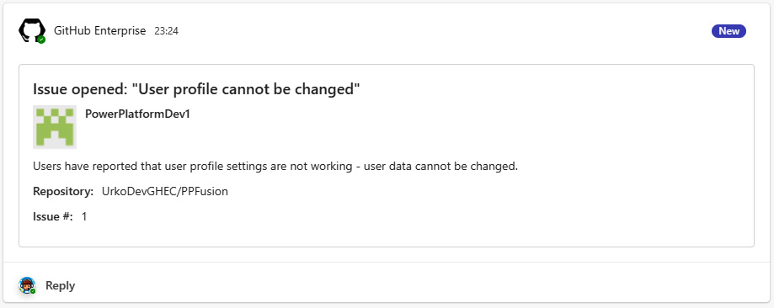

Figure 12.11 – An example of a GitHub notification in Teams

Azure DevOps supports event notifications about completed builds, pushed code, and operations with pull request, releases, and work items. We also have more granular control for these event types, such as only receiving information when new work items of the ****Bug**** type have been added to the project. Once we add a connector, the wizard will guide us through the process and create service hook subscriptions in Azure DevOps:

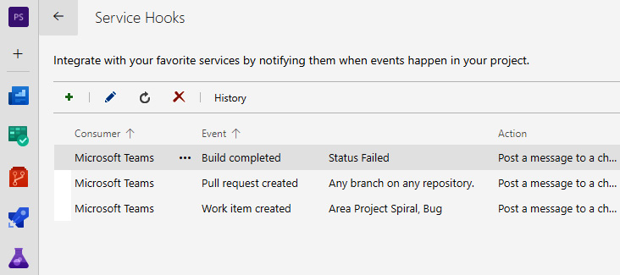

Figure 12.12 – Creating service hook subscriptions through the connector for Azure DevOps

In addition to receiving notifications, Azure DevOps integrates with MS Teams by allowing us to add tabs to the channel. These tabs can display the Azure DevOps dashboard or Kanban board, which provides us with real-time information about the project’s current state. Team members now do not need to change the context and switch tools to get this information.

GitHub provides additional capabilities in regards to integration with Microsoft Teams. We can use ****GitHub integration for Microsoft Teams****, which installs a chatbot in Microsoft Teams, through which we can also receive notifications about the project, open or close issues, comment on pull requests, and more. The installation link can be found at <https://teams.github.com/>.

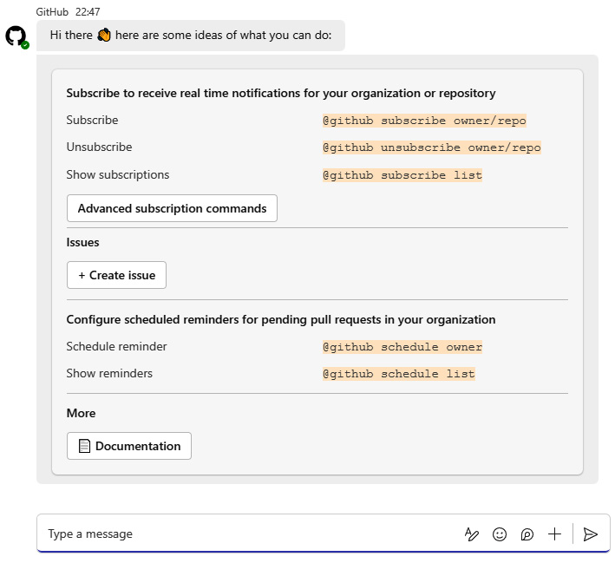

Figure 12.13 – GitHub and Microsoft Teams integrations through the chatbot

GitHub’s bot already points us in the direction of chatbot-supported ChatOps practices. Let us look at how we can build our own custom copilot to support ChatOps with Copilot Studio.

## Building ChatOps for Power Platform with Copilot Studio

We will proceed by creating a simple ChatOps chatbot with Copilot Studio to demonstrate how Copilot Studio can be used to support DevOps tasks.

We will head to Copilot Studio at <https://copilotstudio.microsoft.com/> and click on ****Create**** | ****New copilot****:

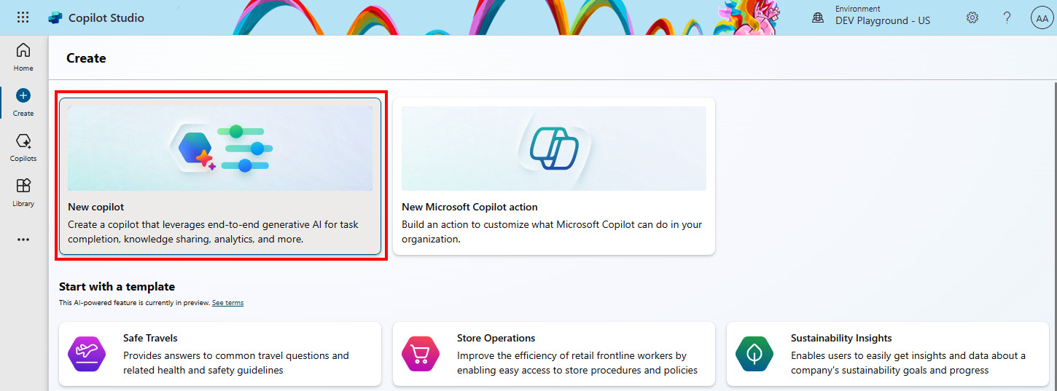

Figure 12.14 – Creating a new custom copilot

If our environment is located in the United States region, we will be offered a conversational creation approach. However, we will click ****Skip to configure****, fill in the ****Name**** and ****Description**** fields for our copilot, and click ****Create****. This will provision our copilot with prebuilt topics.

If we would like to enhance our copilot with generative answers that are grounded around our data, we can select the ****Knowledge**** tab on top, then click ****Add knowledge****:

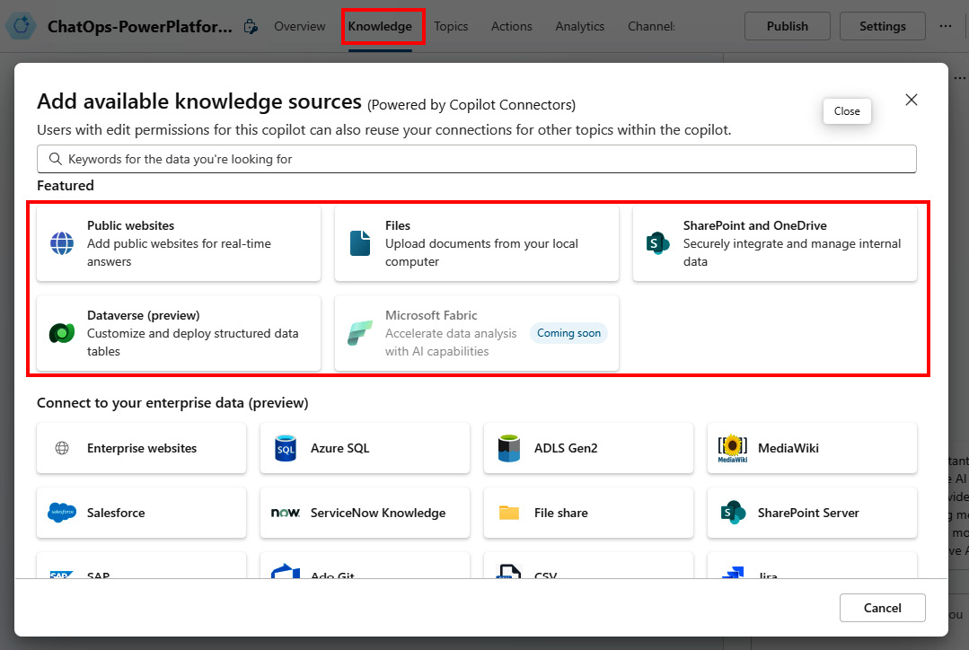

Figure 12.15 – Adding knowledge to our copilot

Here, we will use the ****Files**** option to upload any file that contains relevant information that might be useful for our team. This could be some document with general guidance or project-specific documentation. We can upload a file by dragging and dropping it or by using the ****click to browse**** option. This enables our copilot to be able to answer questions about this document’s topic. It takes a few minutes for the document to be indexed and ready to use. The documents are stored in Dataverse file storage.

Once ready, we can already test this capability using the ****Test your copilot**** option.

In the copilot ****Overview**** section, go to ****Knowledge**** | ****Allow the AI to use its own general knowledge (preview)****, where we can enable or disable general knowledge that the GPT model has. This is the data on which GPT has been trained. For now, Copilot Studio still uses GPT-3.5-Turbo, with a cutoff date of September 2021. We recommend disabling it for this case.

The next step is to enable some action in our copilot. Whichever scenario we would like to enable, we either need to create a topic or add an action to our copilot. Let’s start with topics first.

We select ****Topics**** from the top menu. There, we can see that we have some prebuilt topics named ****Lesson 1****, ****Lesson 2****, and ****Lesson 3****. These are prebuilt topics that we do not need, so we can delete or disable them. We can do this by selecting the three dots next to each of them and switching the status to disabled or by clicking ****Delete****.

We will create a new topic by clicking ****Add a topic**** | ****From blank****. We could also use Copilot in Copilot Studio and describe what kind of topic we need and let Copilot come up with a rough proposal of the conversation flow using the provided description. We are now inside the designer, where we can author a topic. We can specify a few phrases that will trigger this topic by clicking ****Edit**** inside ****Phrases**** in the ****Trigger**** node. Phrases refer to user utterances, or phrases, that will trigger this topic.

Once phrases have been added, we can continue by selecting Add node, which is represented with a plus (****+****) sign. Here, we can add conversational nodes that control the conversation. For this example, we will go to ****Call an action**** | ****Connector (preview)**** and search for ****Azure DevOps****. We can select any action that we would like to add to our copilot to support ChatOps. For example, we will select ****Create a work item****. This adds a connector action with all inputs that we have to configure in order for this connector action to work properly:

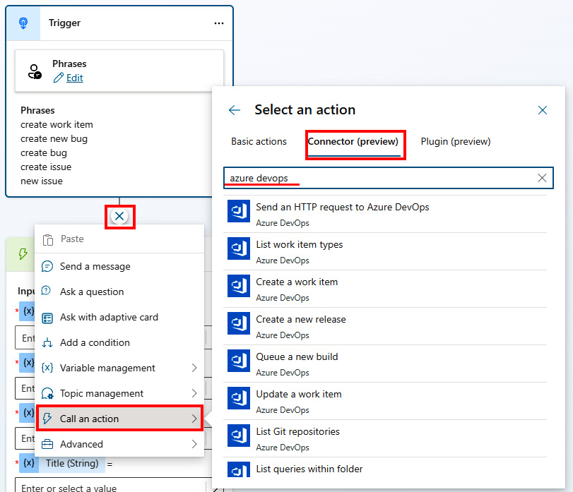

Figure 12.16 – Adding an action to a topic

Instead of manually providing the values, we can create a conversation path before this connector action with a set of questions, where we will be asking user questions and storing responses to the variables that will be used as parameters for the connector action. An alternative to this is to utilize generative mode in Copilot Studio, register connector actions, and let generative AI figure out which values are missing from the context of the user’s question. Generative AI can then provide a set of questions to the user to retrieve missing values for the connector action. Let us use generative mode in Copilot Studio and add generative actions. First, we will need to enable generative mode. We need to go to ****Settings**** | ****Generative AI**** | ****Generative (preview)****. Keep in mind that this functionality is currently still in preview and should not be used on production cases. It currently only works for copilots in English.

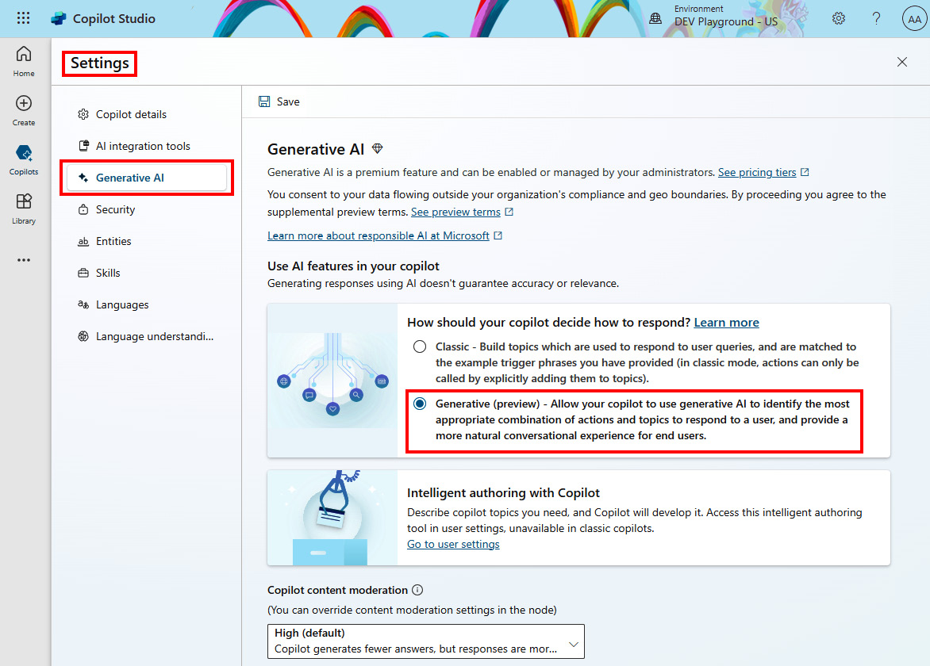

Figure 12.17 – Enabling generative mode (preview) in custom copilot

Once selected, click ****Save**** above this setting. With this, we allow generative AI to determine which action or topic it should call based on the user’s message. This also changes our triggers for topics. Instead of phrases, they are converted to topic descriptions. A topic description holds information about what our topic does. An example of a topic description can be seen in *Figure 12.18*. This is used by the GPT model to determine which action or topic to call. The better the description of the action or topic is, the better the chances are that the GPT model will call the right action or topic:

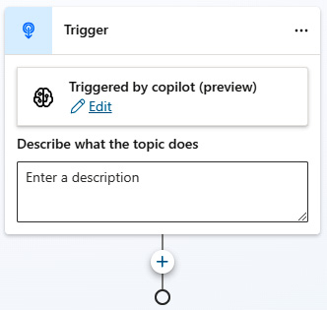

Figure 12.18 – Triggering topics in generative mode

We can close the copilot settings by clicking ****X**** in the top-right corner of Copilot Studio. Next, we will click ****Actions**** | ****Add an action**** in the top menu bar. Here, we can use the search bar to find all available actions for Azure DevOps or GitHub connector. We can select the connector action that we would like to enable, such as ****Create an issue**** from GitHub, and proceed to the configuration options:

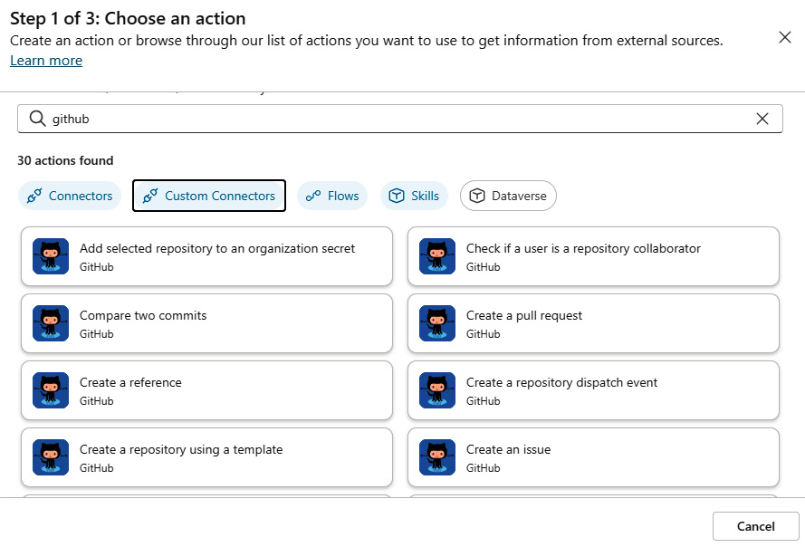

Figure 12.19 – Adding connector actions in Copilot Studio

Each connector action comes with a set of inputs and outputs. We can set input values statically or let generative AI understand the context of a user’s message and try to extract the right entities from the message and feed them to the input parameters. For the output, we can let AI dynamically generate an output message, or we configure it manually. We will leave the default settings as they are and allow the AI to ask us questions for each parameter that is required. In ****Outputs****, we will configure the default setting and let the AI dynamically generate a response. With this, we have now enabled the ****Create new issue**** action in our copilot. We can continue enabling other actions that we would like to have in our ChatOps process.

Lastly, we will create an integration with a Power Automate workflow for a more complex process. Flows can be registered as actions in the same way as we have seen earlier. Alternatively, we can build a topic and add a node to call the Power Automate flow. Since we have changed the generative AI settings for our copilot to generative mode, we need to provide precise and clear information about our topic. After describing the topic, we can add a flow by adding a conversation node using the plus sign | ****Call an action**** | ****Basic actions**** | ****Create a flow****. This opens Power Automate separately with the input trigger and output action, both referring to the integration with copilot:

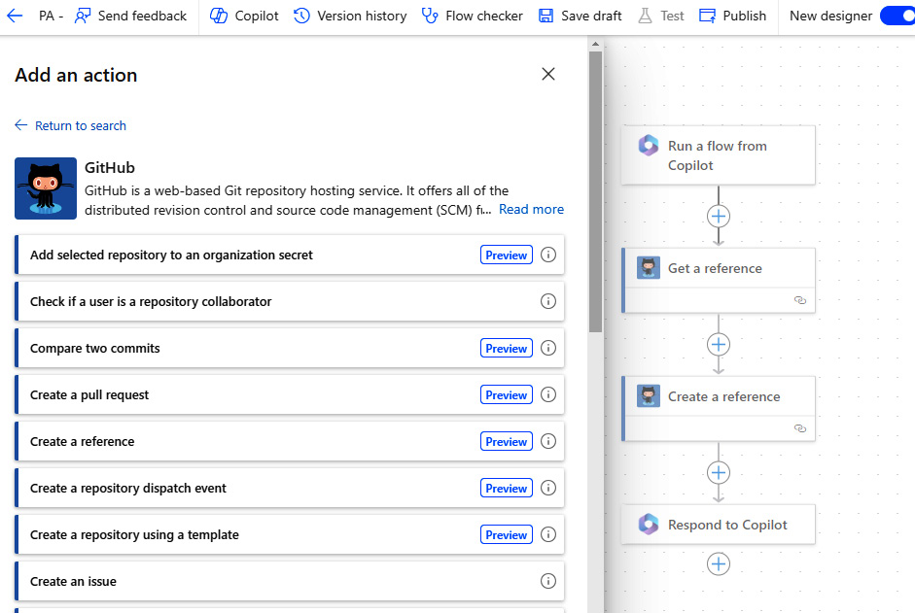

Figure 12.20 – Creating a flow for copilot

We can continue this process for building topics and flows, as well as connecting to actions that will support our ChatOps process.

Once we are satisfied with the work and would like to deploy it to Microsoft Teams, we will need to publish the bot. In the top right in our copilot, we have the ****Publish**** option. A popup appears where we have to confirm the publishing process with ****Publish****. We can head back to ****Copilot Studio copilot**** | ****Channels**** | ****Microsoft Teams****. We can click ****Turn on Teams**** to enable this bot in Teams. Here, we have ****Availability options****, which allows us to share the copilot in the Teams app store. Going back to the Teams settings, we have the ****Open copilot**** option, which opens copilot as an application in Teams. Our bot is now ready to talk to users and run DevOps operations. If we would like to add the copilot to a Teams channel, we have an ability under ****Edit details**** to allow users from the same tenant to add this copilot to a team. However, this will enable users to add copilot to any team they are part of. We would recommend looking at the Teams administration options and managing the roll-out of the copilot via Teams from there.

In the following figure, we can see an example of a successful deployment of a custom copilot into Microsoft Teams. We can see how the generative AI capability is able to switch between topics, perform operations, and even ask questions to get values for all of the required parameters:

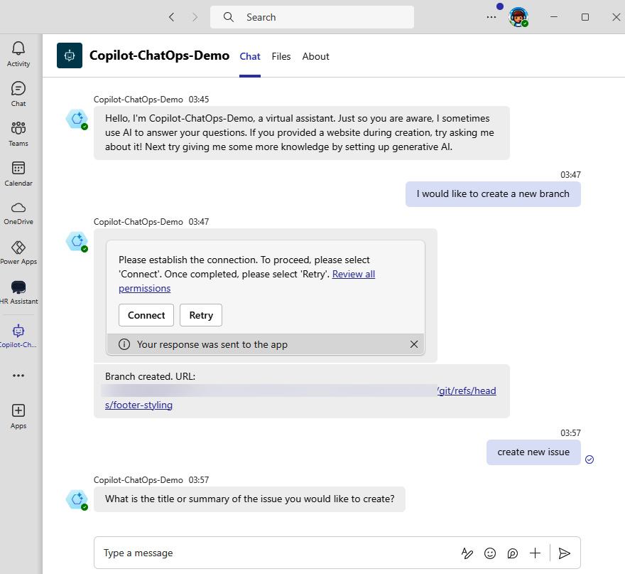

Figure 12.21 – Using a custom copilot in Microsoft Teams

## ALM for Copilot Studio

Copilot Studio, in the same way as other Power Platform products, supports application life cycle management through solutions. We should start by going to ****Solutions****and clicking ****New solution**** or opening an existing one. Once we are in the solution, we can click ****New**** | ****Chatbot**** to start working on our custom copilot in Copilot Studio. Using this approach lets us ensure that any potential connectors that we might be using and registering inside copilot as an action will be added to the solution as a connection reference.

We can follow the same approach for exporting and importing solutions as we have already seen in the previous chapters using Azure DevOps or GitHub.

Since we can utilize different connectors in Copilot Studio, it is imperative to have valid DLP policies in place, which will make sure that in any given environment only connectors that are allowed by organizational policies can be used.

Apart from the approach mentioned earlier, we can utilize PAC CLI specifically for copilot management. We can use these commands and package them into scripts if we would like to maintain ALM only for our custom copilots.

Using the following PAC CLI command, we can export the YAML template file of our copilot:

pac copilot extract-template --bot <BOT-ID> --templateFileName <templateName>.yaml

This serves two purposes. First, we can export the entire copilot as code, store it in the repository, and collaborate on it through code. Second, using this approach, we can build templates for our organizational copilots. We can use this approach to prepare a template as a wireframe or starting point for how our organization’s copilots should look per specific department. This will include some predefined topics as a starting point. We can then export the definition of such copilots as template files and store those files somewhere in a central repository. When someone requests a specific copilot, we can create it with these prebuilt topics inside using the template files that we have prepared in advance, and share the copilot with the right people. The import process can be done using the following PAC CLI command.

Before we can import the copilot to the target environment, we need to make sure that the ****connectionReferences**** part is updated correctly to reflect the appropriate value in the target environment. In the created template YAML file, at the bottom of the file, we can find connection references, as can be seen in the following snippet:

connectionReferences:

  - managedProperties:

      isCustomizable: false

****connectionId: <CONNECTION-ID-TARGET-ENVIRONMENT>****

    connectorId: /providers/Microsoft.PowerApps/apis/shared\_visualstudioteamservices

    connectionReferenceLogicalName: template.connectionreference.cr6a8\_chatOpsDemo.cr.SyS11HJP

    displayName: cr6a8\_chatOpsDemo.cr.SyS11HJP

connectorDefinitions:

  - connectorId: /providers/Microsoft.PowerApps/apis/shared\_visualstudioteamservices

Additionally, we need to make sure that we have the solution ready in the target environment before launching this command. We can either create a new solution or use an existing one.

Once all of this has been set, we can launch the command for import:

**pac copilot create --environment <ENVIRONMENT\_ID> --schemaName <SCHEMA\_NAME> --templateFileName <TEMPLATE-FILE>.yaml --displayName <DISPLAY-NAME> --solution <SOLUTON-NAME>**

If any error comes up, this will be logged in the ****pac-log.txt**** file, as written in the error.

Now that the copilot has been provisioned, we can share the copilot with the group of makers. If we share the copilot with users individually, they get the maker role to co-edit the bot. If we share it with the security group, then the users in the security group get use-only permissions.

# Summary

In this chapter, we took a helicopter view of AI, as well as a hot topic for the last two years: GPTs. AI has become an integral part of our daily tasks. It is everywhere, in almost every application that we use. Organizations are looking for ways to be innovative with AI or simply to improve business processes to be more effective. Either way, it is on us to ensure that we build AI solutions in a responsible, ethical, and safe way, as we learned in this chapter. Next, we looked at how Microsoft is building AI assistants, called Copilots, into every product so that we can all be more productive while using these tools. We looked specifically into copilot in Power Platform and how we, as makers, can benefit from it to quickly set up data schemas, prototype applications, flows, and more.

As organizations are finding ways to innovate with AI, they might be faced with the question of which AI services are available for use in Power Platform. The next section focused on understanding AI Builder and its components such as AI models and AI prompts. We looked at how we can use them in our applications, as well as apply the ALM process across AI Builder components. However, AI Builder is not the only service that can be used to enhance our business applications with AI. Azure OpenAI provides organizations with safe and reliable OpenAI models that can be used in any flow or application, as we learned.

We close the chapter by focusing on custom copilots with Copilot Studio and ChatOps. We introduced Copilot Studio, which enables us to build custom copilots or simple chatbots. With AI infused into Copilot Studio, we can build a rich conversational AI experience for internal or external audiences in a matter of hours, not months. Copilot Studio is a platform that can support business processes including support around ChatOps. So, at the end of this part, we looked at ChatOps, which extends DevOps by providing a conversational experience with a bot that is capable of performing DevOps-oriented operations. Lastly, we looked practically at how the ChatOps process can be supported by Copilot Studio and what some small specialties are when it comes to ALM for Copilot Studio.

With this, we will close this book. It has been a journey through different stages of the DevOps life cycle, from planning the business solutions to building pipelines, managing DevSecOps, taking care of the environment life cycle, understanding best practices, and closing with AI and ChatOps. We hope that by now, we have managed to demonstrate that Microsoft Power Platform is a robust and mature platform that is extensible and ready to empower organizations and individuals to build their applications and support their business process with the services and features available in Power Platform.

# Further reading

* Microsoft on responsible AI practices: <https://www.microsoft.com/en-us/ai/responsible-ai>
* Azure OpenAI Service: <https://learn.microsoft.com/en-us/azure/ai-services/openai/overview>
* Copilot Studio guidance: <https://learn.microsoft.com/en-us/microsoft-copilot-studio/guidance/>
* Documentation on GitHub and Microsoft Teams integrations: <https://github.com/integrations/microsoft-teams/blob/master/Readme.md>
* Details on the Azure DevOps and Microsoft Teams integration: <https://learn.microsoft.com/en-us/azure/devops/service-hooks/services/teams?view=azure-devops>
* The PAC CLI command for copilot: <https://learn.microsoft.com/en-us/power-platform/developer/cli/reference/copilot>

# Index

*As this ebook edition doesn't have fixed pagination, the page numbers below are hyperlinked for reference only, based on the printed edition of this book.*

A

A/B testing [22](https://learning.oreilly.com/library/view/mastering-devops-on/9781835880845/B22208_01.xhtml" \l "_idIndexMarker131)

Access Teams [99](https://learning.oreilly.com/library/view/mastering-devops-on/9781835880845/B22208_04.xhtml" \l "_idIndexMarker438)

actions [293](https://learning.oreilly.com/library/view/mastering-devops-on/9781835880845/B22208_10.xhtml" \l "_idIndexMarker1252)

admin and management connectors [49](https://learning.oreilly.com/library/view/mastering-devops-on/9781835880845/B22208_02.xhtml" \l "_idIndexMarker234)

Agile [14](https://learning.oreilly.com/library/view/mastering-devops-on/9781835880845/B22208_01.xhtml" \l "_idIndexMarker076)-[16](https://learning.oreilly.com/library/view/mastering-devops-on/9781835880845/B22208_01.xhtml" \l "_idIndexMarker085)

cons [15](https://learning.oreilly.com/library/view/mastering-devops-on/9781835880845/B22208_01.xhtml" \l "_idIndexMarker083)

pros [15](https://learning.oreilly.com/library/view/mastering-devops-on/9781835880845/B22208_01.xhtml" \l "_idIndexMarker081)

versus RAD [14](https://learning.oreilly.com/library/view/mastering-devops-on/9781835880845/B22208_01.xhtml" \l "_idIndexMarker078)

Agile manifesto [16](https://learning.oreilly.com/library/view/mastering-devops-on/9781835880845/B22208_01.xhtml" \l "_idIndexMarker086)

core values [16](https://learning.oreilly.com/library/view/mastering-devops-on/9781835880845/B22208_01.xhtml" \l "_idIndexMarker087)

Agile Release Train [26](https://learning.oreilly.com/library/view/mastering-devops-on/9781835880845/B22208_01.xhtml" \l "_idIndexMarker161)

AI Builder [377](https://learning.oreilly.com/library/view/mastering-devops-on/9781835880845/B22208_12.xhtml" \l "_idIndexMarker1544)

AI Builder ALM [381](https://learning.oreilly.com/library/view/mastering-devops-on/9781835880845/B22208_12.xhtml" \l "_idIndexMarker1563), [382](https://learning.oreilly.com/library/view/mastering-devops-on/9781835880845/B22208_12.xhtml" \l "_idIndexMarker1566)

AI hub [378](https://learning.oreilly.com/library/view/mastering-devops-on/9781835880845/B22208_12.xhtml" \l "_idIndexMarker1556)

AI models [377](https://learning.oreilly.com/library/view/mastering-devops-on/9781835880845/B22208_12.xhtml" \l "_idIndexMarker1545), [378](https://learning.oreilly.com/library/view/mastering-devops-on/9781835880845/B22208_12.xhtml" \l "_idIndexMarker1547)

using [378](https://learning.oreilly.com/library/view/mastering-devops-on/9781835880845/B22208_12.xhtml" \l "_idIndexMarker1554)-[381](https://learning.oreilly.com/library/view/mastering-devops-on/9781835880845/B22208_12.xhtml" \l "_idIndexMarker1562)

AI prompts [378](https://learning.oreilly.com/library/view/mastering-devops-on/9781835880845/B22208_12.xhtml" \l "_idIndexMarker1550)

using [378](https://learning.oreilly.com/library/view/mastering-devops-on/9781835880845/B22208_12.xhtml" \l "_idIndexMarker1555)-[381](https://learning.oreilly.com/library/view/mastering-devops-on/9781835880845/B22208_12.xhtml" \l "_idIndexMarker1561)

ALM Accelerator for Advanced Makers (AA4AM) [166](https://learning.oreilly.com/library/view/mastering-devops-on/9781835880845/B22208_06.xhtml" \l "_idIndexMarker685)

ALM Accelerator for Power Platform [149](https://learning.oreilly.com/library/view/mastering-devops-on/9781835880845/B22208_06.xhtml" \l "_idIndexMarker623), [166](https://learning.oreilly.com/library/view/mastering-devops-on/9781835880845/B22208_06.xhtml" \l "_idIndexMarker683)-[168](https://learning.oreilly.com/library/view/mastering-devops-on/9781835880845/B22208_06.xhtml" \l "_idIndexMarker691), [195](https://learning.oreilly.com/library/view/mastering-devops-on/9781835880845/B22208_07.xhtml" \l "_idIndexMarker847), [231](https://learning.oreilly.com/library/view/mastering-devops-on/9781835880845/B22208_08.xhtml" \l "_idIndexMarker1015)

features [167](https://learning.oreilly.com/library/view/mastering-devops-on/9781835880845/B22208_06.xhtml" \l "_idIndexMarker687)

ALM, for code components [318](https://learning.oreilly.com/library/view/mastering-devops-on/9781835880845/B22208_10.xhtml" \l "_idIndexMarker1331), [319](https://learning.oreilly.com/library/view/mastering-devops-on/9781835880845/B22208_10.xhtml" \l "_idIndexMarker1332)

automated build pipelines, for segmented solutions [320](https://learning.oreilly.com/library/view/mastering-devops-on/9781835880845/B22208_10.xhtml" \l "_idIndexMarker1340), [321](https://learning.oreilly.com/library/view/mastering-devops-on/9781835880845/B22208_10.xhtml" \l "_idIndexMarker1341)

automated build pipelines, for single mixed solutions [321](https://learning.oreilly.com/library/view/mastering-devops-on/9781835880845/B22208_10.xhtml" \l "_idIndexMarker1342)

solution strategy [319](https://learning.oreilly.com/library/view/mastering-devops-on/9781835880845/B22208_10.xhtml" \l "_idIndexMarker1333)

updates [320](https://learning.oreilly.com/library/view/mastering-devops-on/9781835880845/B22208_10.xhtml" \l "_idIndexMarker1337)

versioning [320](https://learning.oreilly.com/library/view/mastering-devops-on/9781835880845/B22208_10.xhtml" \l "_idIndexMarker1336)

ALM for PCF components

reference link [321](https://learning.oreilly.com/library/view/mastering-devops-on/9781835880845/B22208_10.xhtml" \l "_idIndexMarker1344)

Apache Cordova framework [244](https://learning.oreilly.com/library/view/mastering-devops-on/9781835880845/B22208_08.xhtml" \l "_idIndexMarker1098)

app catalog [179](https://learning.oreilly.com/library/view/mastering-devops-on/9781835880845/B22208_07.xhtml" \l "_idIndexMarker758)

products [179](https://learning.oreilly.com/library/view/mastering-devops-on/9781835880845/B22208_07.xhtml" \l "_idIndexMarker759)

service trees [179](https://learning.oreilly.com/library/view/mastering-devops-on/9781835880845/B22208_07.xhtml" \l "_idIndexMarker760)

Appium [240](https://learning.oreilly.com/library/view/mastering-devops-on/9781835880845/B22208_08.xhtml" \l "_idIndexMarker1062)

for mobile application testing [172](https://learning.oreilly.com/library/view/mastering-devops-on/9781835880845/B22208_06.xhtml" \l "_idIndexMarker732)

application hosting services [277](https://learning.oreilly.com/library/view/mastering-devops-on/9781835880845/B22208_09.xhtml" \l "_idIndexMarker1193)

Application Life Cycle Management (ALM) [3](https://learning.oreilly.com/library/view/mastering-devops-on/9781835880845/B22208_01.xhtml" \l "_idIndexMarker000), [19](https://learning.oreilly.com/library/view/mastering-devops-on/9781835880845/B22208_01.xhtml" \l "_idIndexMarker116), [20](https://learning.oreilly.com/library/view/mastering-devops-on/9781835880845/B22208_01.xhtml" \l "_idIndexMarker117), [25](https://learning.oreilly.com/library/view/mastering-devops-on/9781835880845/B22208_01.xhtml" \l "_idIndexMarker158), [45](https://learning.oreilly.com/library/view/mastering-devops-on/9781835880845/B22208_02.xhtml" \l "_idIndexMarker221), [63](https://learning.oreilly.com/library/view/mastering-devops-on/9781835880845/B22208_03.xhtml" \l "_idIndexMarker293), [64](https://learning.oreilly.com/library/view/mastering-devops-on/9781835880845/B22208_03.xhtml" \l "_idIndexMarker295), [149](https://learning.oreilly.com/library/view/mastering-devops-on/9781835880845/B22208_06.xhtml" \l "_idIndexMarker618)

applying, to Power Platform custom connector [288](https://learning.oreilly.com/library/view/mastering-devops-on/9781835880845/B22208_09.xhtml" \l "_idIndexMarker1243), [289](https://learning.oreilly.com/library/view/mastering-devops-on/9781835880845/B22208_09.xhtml" \l "_idIndexMarker1247)

build and test phase [67](https://learning.oreilly.com/library/view/mastering-devops-on/9781835880845/B22208_03.xhtml" \l "_idIndexMarker307), [68](https://learning.oreilly.com/library/view/mastering-devops-on/9781835880845/B22208_03.xhtml" \l "_idIndexMarker309)

deploy phase [68](https://learning.oreilly.com/library/view/mastering-devops-on/9781835880845/B22208_03.xhtml" \l "_idIndexMarker310)

development phase [67](https://learning.oreilly.com/library/view/mastering-devops-on/9781835880845/B22208_03.xhtml" \l "_idIndexMarker304)

for Copilot Studio [400](https://learning.oreilly.com/library/view/mastering-devops-on/9781835880845/B22208_12.xhtml" \l "_idIndexMarker1631), [401](https://learning.oreilly.com/library/view/mastering-devops-on/9781835880845/B22208_12.xhtml" \l "_idIndexMarker1633)

monitor and learn phase [69](https://learning.oreilly.com/library/view/mastering-devops-on/9781835880845/B22208_03.xhtml" \l "_idIndexMarker315), [70](https://learning.oreilly.com/library/view/mastering-devops-on/9781835880845/B22208_03.xhtml" \l "_idIndexMarker316)

operate phase [69](https://learning.oreilly.com/library/view/mastering-devops-on/9781835880845/B22208_03.xhtml" \l "_idIndexMarker312)

plan and track phase [65](https://learning.oreilly.com/library/view/mastering-devops-on/9781835880845/B22208_03.xhtml" \l "_idIndexMarker298), [66](https://learning.oreilly.com/library/view/mastering-devops-on/9781835880845/B22208_03.xhtml" \l "_idIndexMarker302)

application modernization, with LCNC approach [73](https://learning.oreilly.com/library/view/mastering-devops-on/9781835880845/B22208_03.xhtml" \l "_idIndexMarker339)-[77](https://learning.oreilly.com/library/view/mastering-devops-on/9781835880845/B22208_03.xhtml" \l "_idIndexMarker353)

database modernization [77](https://learning.oreilly.com/library/view/mastering-devops-on/9781835880845/B22208_03.xhtml" \l "_idIndexMarker354), [78](https://learning.oreilly.com/library/view/mastering-devops-on/9781835880845/B22208_03.xhtml" \l "_idIndexMarker362)

options [74](https://learning.oreilly.com/library/view/mastering-devops-on/9781835880845/B22208_03.xhtml" \l "_idIndexMarker343)

process modernization [75](https://learning.oreilly.com/library/view/mastering-devops-on/9781835880845/B22208_03.xhtml" \l "_idIndexMarker344)

Application Performance Management (APM) [244](https://learning.oreilly.com/library/view/mastering-devops-on/9781835880845/B22208_08.xhtml" \l "_idIndexMarker1089)

tools [23](https://learning.oreilly.com/library/view/mastering-devops-on/9781835880845/B22208_01.xhtml" \l "_idIndexMarker141)

application programming interfaces (APIs) [35](https://learning.oreilly.com/library/view/mastering-devops-on/9781835880845/B22208_02.xhtml" \l "_idIndexMarker183), [172](https://learning.oreilly.com/library/view/mastering-devops-on/9781835880845/B22208_06.xhtml" \l "_idIndexMarker733)

application rationalization [75](https://learning.oreilly.com/library/view/mastering-devops-on/9781835880845/B22208_03.xhtml" \l "_idIndexMarker349)

application runtime platform [6](https://learning.oreilly.com/library/view/mastering-devops-on/9781835880845/B22208_01.xhtml" \l "_idIndexMarker022)

applications

branch strategies [211](https://learning.oreilly.com/library/view/mastering-devops-on/9781835880845/B22208_08.xhtml" \l "_idIndexMarker895)-[225](https://learning.oreilly.com/library/view/mastering-devops-on/9781835880845/B22208_08.xhtml" \l "_idIndexMarker996)

monitoring [244](https://learning.oreilly.com/library/view/mastering-devops-on/9781835880845/B22208_08.xhtml" \l "_idIndexMarker1083)-[249](https://learning.oreilly.com/library/view/mastering-devops-on/9781835880845/B22208_08.xhtml" \l "_idIndexMarker1120)

repository management [211](https://learning.oreilly.com/library/view/mastering-devops-on/9781835880845/B22208_08.xhtml" \l "_idIndexMarker891)-[225](https://learning.oreilly.com/library/view/mastering-devops-on/9781835880845/B22208_08.xhtml" \l "_idIndexMarker994)

app templates [56](https://learning.oreilly.com/library/view/mastering-devops-on/9781835880845/B22208_02.xhtml" \l "_idIndexMarker278)

ArgoCD [23](https://learning.oreilly.com/library/view/mastering-devops-on/9781835880845/B22208_01.xhtml" \l "_idIndexMarker136)

Artifactory [130](https://learning.oreilly.com/library/view/mastering-devops-on/9781835880845/B22208_05.xhtml" \l "_idIndexMarker582)

artificial intelligence (AI) [365](https://learning.oreilly.com/library/view/mastering-devops-on/9781835880845/B22208_12.xhtml" \l "_idIndexMarker1485)-[367](https://learning.oreilly.com/library/view/mastering-devops-on/9781835880845/B22208_12.xhtml" \l "_idIndexMarker1490)

asynchronous design pattern [207](https://learning.oreilly.com/library/view/mastering-devops-on/9781835880845/B22208_07.xhtml" \l "_idIndexMarker881)

audit logs [183](https://learning.oreilly.com/library/view/mastering-devops-on/9781835880845/B22208_07.xhtml" \l "_idIndexMarker791)

automated testing [149](https://learning.oreilly.com/library/view/mastering-devops-on/9781835880845/B22208_06.xhtml" \l "_idIndexMarker625)

in DevOps [169](https://learning.oreilly.com/library/view/mastering-devops-on/9781835880845/B22208_06.xhtml" \l "_idIndexMarker692)-[173](https://learning.oreilly.com/library/view/mastering-devops-on/9781835880845/B22208_06.xhtml" \l "_idIndexMarker746)

in Power Platform pipelines [169](https://learning.oreilly.com/library/view/mastering-devops-on/9781835880845/B22208_06.xhtml" \l "_idIndexMarker693)-[173](https://learning.oreilly.com/library/view/mastering-devops-on/9781835880845/B22208_06.xhtml" \l "_idIndexMarker747)

automated tests [160](https://learning.oreilly.com/library/view/mastering-devops-on/9781835880845/B22208_06.xhtml" \l "_idIndexMarker660)

Automation Kit installation

reference link [359](https://learning.oreilly.com/library/view/mastering-devops-on/9781835880845/B22208_11.xhtml" \l "_idIndexMarker1474)

Azure AI services [279](https://learning.oreilly.com/library/view/mastering-devops-on/9781835880845/B22208_09.xhtml" \l "_idIndexMarker1214), [280](https://learning.oreilly.com/library/view/mastering-devops-on/9781835880845/B22208_09.xhtml" \l "_idIndexMarker1215)

Azure and Power Platform integration scenario

example [280](https://learning.oreilly.com/library/view/mastering-devops-on/9781835880845/B22208_09.xhtml" \l "_idIndexMarker1217), [281](https://learning.oreilly.com/library/view/mastering-devops-on/9781835880845/B22208_09.xhtml" \l "_idIndexMarker1218)

Azure API Management (Azure APIM) [278](https://learning.oreilly.com/library/view/mastering-devops-on/9781835880845/B22208_09.xhtml" \l "_idIndexMarker1199)

Power Platform integration example [278](https://learning.oreilly.com/library/view/mastering-devops-on/9781835880845/B22208_09.xhtml" \l "_idIndexMarker1200)

used, for creating Power Platform custom connector [285](https://learning.oreilly.com/library/view/mastering-devops-on/9781835880845/B22208_09.xhtml" \l "_idIndexMarker1237)-[287](https://learning.oreilly.com/library/view/mastering-devops-on/9781835880845/B22208_09.xhtml" \l "_idIndexMarker1238)

Azure App Configuration [294](https://learning.oreilly.com/library/view/mastering-devops-on/9781835880845/B22208_10.xhtml" \l "_idIndexMarker1255)

Azure Application Insights [23](https://learning.oreilly.com/library/view/mastering-devops-on/9781835880845/B22208_01.xhtml" \l "_idIndexMarker142), [244](https://learning.oreilly.com/library/view/mastering-devops-on/9781835880845/B22208_08.xhtml" \l "_idIndexMarker1086), [338](https://learning.oreilly.com/library/view/mastering-devops-on/9781835880845/B22208_11.xhtml" \l "_idIndexMarker1398)

Azure App registration [216](https://learning.oreilly.com/library/view/mastering-devops-on/9781835880845/B22208_08.xhtml" \l "_idIndexMarker925)

Azure App Service [277](https://learning.oreilly.com/library/view/mastering-devops-on/9781835880845/B22208_09.xhtml" \l "_idIndexMarker1194)

Azure Artifacts [71](https://learning.oreilly.com/library/view/mastering-devops-on/9781835880845/B22208_03.xhtml" \l "_idIndexMarker327)

Azure Blob storage [95](https://learning.oreilly.com/library/view/mastering-devops-on/9781835880845/B22208_04.xhtml" \l "_idIndexMarker412)

Azure Boards [66](https://learning.oreilly.com/library/view/mastering-devops-on/9781835880845/B22208_03.xhtml" \l "_idIndexMarker303), [71](https://learning.oreilly.com/library/view/mastering-devops-on/9781835880845/B22208_03.xhtml" \l "_idIndexMarker322)

Azure Chaos Studio [333](https://learning.oreilly.com/library/view/mastering-devops-on/9781835880845/B22208_11.xhtml" \l "_idIndexMarker1375)

reference link [333](https://learning.oreilly.com/library/view/mastering-devops-on/9781835880845/B22208_11.xhtml" \l "_idIndexMarker1376)

Azure Cloud Shell [346](https://learning.oreilly.com/library/view/mastering-devops-on/9781835880845/B22208_11.xhtml" \l "_idIndexMarker1427)

Azure Container Apps [277](https://learning.oreilly.com/library/view/mastering-devops-on/9781835880845/B22208_09.xhtml" \l "_idIndexMarker1195)

Azure Content Delivery Network (CDN) [186](https://learning.oreilly.com/library/view/mastering-devops-on/9781835880845/B22208_07.xhtml" \l "_idIndexMarker803)

Azure Cosmos DB [95](https://learning.oreilly.com/library/view/mastering-devops-on/9781835880845/B22208_04.xhtml" \l "_idIndexMarker416)

Azure Data Lake Storage [95](https://learning.oreilly.com/library/view/mastering-devops-on/9781835880845/B22208_04.xhtml" \l "_idIndexMarker413)

Azure Data Lake Storage Gen2 instance [334](https://learning.oreilly.com/library/view/mastering-devops-on/9781835880845/B22208_11.xhtml" \l "_idIndexMarker1390)

Azure DevOps [70](https://learning.oreilly.com/library/view/mastering-devops-on/9781835880845/B22208_03.xhtml" \l "_idIndexMarker317)

code scanning and secret scanning [191](https://learning.oreilly.com/library/view/mastering-devops-on/9781835880845/B22208_07.xhtml" \l "_idIndexMarker835)-[194](https://learning.oreilly.com/library/view/mastering-devops-on/9781835880845/B22208_07.xhtml" \l "_idIndexMarker839)

Microsoft Teams, integrating with [390](https://learning.oreilly.com/library/view/mastering-devops-on/9781835880845/B22208_12.xhtml" \l "_idIndexMarker1598)-[392](https://learning.oreilly.com/library/view/mastering-devops-on/9781835880845/B22208_12.xhtml" \l "_idIndexMarker1607)

Power Platform build tools [127](https://learning.oreilly.com/library/view/mastering-devops-on/9781835880845/B22208_05.xhtml" \l "_idIndexMarker563)-[130](https://learning.oreilly.com/library/view/mastering-devops-on/9781835880845/B22208_05.xhtml" \l "_idIndexMarker577)

services [71](https://learning.oreilly.com/library/view/mastering-devops-on/9781835880845/B22208_03.xhtml" \l "_idIndexMarker321)

Azure DevOps for GHAS [191](https://learning.oreilly.com/library/view/mastering-devops-on/9781835880845/B22208_07.xhtml" \l "_idIndexMarker834)

Azure DevOps Service connections [155](https://learning.oreilly.com/library/view/mastering-devops-on/9781835880845/B22208_06.xhtml" \l "_idIndexMarker646)

Azure DevOps Services [222](https://learning.oreilly.com/library/view/mastering-devops-on/9781835880845/B22208_08.xhtml" \l "_idIndexMarker981)

versus GitHub [131](https://learning.oreilly.com/library/view/mastering-devops-on/9781835880845/B22208_05.xhtml" \l "_idIndexMarker586)

Azure DevOps Services environments [160](https://learning.oreilly.com/library/view/mastering-devops-on/9781835880845/B22208_06.xhtml" \l "_idIndexMarker661)

Azure DevOps Services pipelines [106](https://learning.oreilly.com/library/view/mastering-devops-on/9781835880845/B22208_04.xhtml" \l "_idIndexMarker470)

Azure DevOps Services project [105](https://learning.oreilly.com/library/view/mastering-devops-on/9781835880845/B22208_04.xhtml" \l "_idIndexMarker460)

Azure DevOps Services repositories [139](https://learning.oreilly.com/library/view/mastering-devops-on/9781835880845/B22208_05.xhtml" \l "_idIndexMarker600)

Azure Event Hubs [244](https://learning.oreilly.com/library/view/mastering-devops-on/9781835880845/B22208_08.xhtml" \l "_idIndexMarker1095), [279](https://learning.oreilly.com/library/view/mastering-devops-on/9781835880845/B22208_09.xhtml" \l "_idIndexMarker1208)

Power Platform integration example [279](https://learning.oreilly.com/library/view/mastering-devops-on/9781835880845/B22208_09.xhtml" \l "_idIndexMarker1209)

Azure Functions [244](https://learning.oreilly.com/library/view/mastering-devops-on/9781835880845/B22208_08.xhtml" \l "_idIndexMarker1094), [278](https://learning.oreilly.com/library/view/mastering-devops-on/9781835880845/B22208_09.xhtml" \l "_idIndexMarker1201)

Power Platform integration example [278](https://learning.oreilly.com/library/view/mastering-devops-on/9781835880845/B22208_09.xhtml" \l "_idIndexMarker1202)

Azure Integration Services [278](https://learning.oreilly.com/library/view/mastering-devops-on/9781835880845/B22208_09.xhtml" \l "_idIndexMarker1198)

Azure Key Vault [200](https://learning.oreilly.com/library/view/mastering-devops-on/9781835880845/B22208_07.xhtml" \l "_idIndexMarker864), [294](https://learning.oreilly.com/library/view/mastering-devops-on/9781835880845/B22208_10.xhtml" \l "_idIndexMarker1256)

Azure Kubernetes Service (AKS) [277](https://learning.oreilly.com/library/view/mastering-devops-on/9781835880845/B22208_09.xhtml" \l "_idIndexMarker1196)

Azure Load Testing [173](https://learning.oreilly.com/library/view/mastering-devops-on/9781835880845/B22208_06.xhtml" \l "_idIndexMarker748)

Azure Log Analytics workspaces [199](https://learning.oreilly.com/library/view/mastering-devops-on/9781835880845/B22208_07.xhtml" \l "_idIndexMarker858), [244](https://learning.oreilly.com/library/view/mastering-devops-on/9781835880845/B22208_08.xhtml" \l "_idIndexMarker1087)

Azure Logic Apps [244](https://learning.oreilly.com/library/view/mastering-devops-on/9781835880845/B22208_08.xhtml" \l "_idIndexMarker1093), [278](https://learning.oreilly.com/library/view/mastering-devops-on/9781835880845/B22208_09.xhtml" \l "_idIndexMarker1205)

Power Platform integration example [279](https://learning.oreilly.com/library/view/mastering-devops-on/9781835880845/B22208_09.xhtml" \l "_idIndexMarker1206)

Azure Monitor [244](https://learning.oreilly.com/library/view/mastering-devops-on/9781835880845/B22208_08.xhtml" \l "_idIndexMarker1088)

Azure Monitor Application Insights JavaScript SDK

reference link [247](https://learning.oreilly.com/library/view/mastering-devops-on/9781835880845/B22208_08.xhtml" \l "_idIndexMarker1108)

Azure OpenAI [382](https://learning.oreilly.com/library/view/mastering-devops-on/9781835880845/B22208_12.xhtml" \l "_idIndexMarker1567)

integrating, with Power Platform [382](https://learning.oreilly.com/library/view/mastering-devops-on/9781835880845/B22208_12.xhtml" \l "_idIndexMarker1568)-[386](https://learning.oreilly.com/library/view/mastering-devops-on/9781835880845/B22208_12.xhtml" \l "_idIndexMarker1580)

Azure OpenAI connector [384](https://learning.oreilly.com/library/view/mastering-devops-on/9781835880845/B22208_12.xhtml" \l "_idIndexMarker1575)

Azure OpenAI Studio [382](https://learning.oreilly.com/library/view/mastering-devops-on/9781835880845/B22208_12.xhtml" \l "_idIndexMarker1570)

Azure Pipelines [71](https://learning.oreilly.com/library/view/mastering-devops-on/9781835880845/B22208_03.xhtml" \l "_idIndexMarker325), [127](https://learning.oreilly.com/library/view/mastering-devops-on/9781835880845/B22208_05.xhtml" \l "_idIndexMarker559), [199](https://learning.oreilly.com/library/view/mastering-devops-on/9781835880845/B22208_07.xhtml" \l "_idIndexMarker859)

using, for automation [153](https://learning.oreilly.com/library/view/mastering-devops-on/9781835880845/B22208_06.xhtml" \l "_idIndexMarker643)-[159](https://learning.oreilly.com/library/view/mastering-devops-on/9781835880845/B22208_06.xhtml" \l "_idIndexMarker656)

Azure Pipelines agents [127](https://learning.oreilly.com/library/view/mastering-devops-on/9781835880845/B22208_05.xhtml" \l "_idIndexMarker564)

Azure pipeline templates [149](https://learning.oreilly.com/library/view/mastering-devops-on/9781835880845/B22208_06.xhtml" \l "_idIndexMarker619), [164](https://learning.oreilly.com/library/view/mastering-devops-on/9781835880845/B22208_06.xhtml" \l "_idIndexMarker675)-[166](https://learning.oreilly.com/library/view/mastering-devops-on/9781835880845/B22208_06.xhtml" \l "_idIndexMarker680)

Azure Playbooks [244](https://learning.oreilly.com/library/view/mastering-devops-on/9781835880845/B22208_08.xhtml" \l "_idIndexMarker1092)

Azure products

reference link [277](https://learning.oreilly.com/library/view/mastering-devops-on/9781835880845/B22208_09.xhtml" \l "_idIndexMarker1192)

Azure Repos [71](https://learning.oreilly.com/library/view/mastering-devops-on/9781835880845/B22208_03.xhtml" \l "_idIndexMarker323)

Azure Resource Manager (ARM) template [345](https://learning.oreilly.com/library/view/mastering-devops-on/9781835880845/B22208_11.xhtml" \l "_idIndexMarker1425)

Azure Service Bus [206](https://learning.oreilly.com/library/view/mastering-devops-on/9781835880845/B22208_07.xhtml" \l "_idIndexMarker879), [278](https://learning.oreilly.com/library/view/mastering-devops-on/9781835880845/B22208_09.xhtml" \l "_idIndexMarker1203)

Power Platform integration example [278](https://learning.oreilly.com/library/view/mastering-devops-on/9781835880845/B22208_09.xhtml" \l "_idIndexMarker1204)

Azure SQL Database [280](https://learning.oreilly.com/library/view/mastering-devops-on/9781835880845/B22208_09.xhtml" \l "_idIndexMarker1216)

Azure SQL Managed Instance [95](https://learning.oreilly.com/library/view/mastering-devops-on/9781835880845/B22208_04.xhtml" \l "_idIndexMarker411)

Azure Test Plans [71](https://learning.oreilly.com/library/view/mastering-devops-on/9781835880845/B22208_03.xhtml" \l "_idIndexMarker326)

Azure Virtual Machine Scale Set agents [128](https://learning.oreilly.com/library/view/mastering-devops-on/9781835880845/B22208_05.xhtml" \l "_idIndexMarker567)

Azure Well-Architected Framework (Azure WAF) [331](https://learning.oreilly.com/library/view/mastering-devops-on/9781835880845/B22208_11.xhtml" \l "_idIndexMarker1361)

B

backend clusters [186](https://learning.oreilly.com/library/view/mastering-devops-on/9781835880845/B22208_07.xhtml" \l "_idIndexMarker805)

backlog management

in GitHub [237](https://learning.oreilly.com/library/view/mastering-devops-on/9781835880845/B22208_08.xhtml" \l "_idIndexMarker1047)-[240](https://learning.oreilly.com/library/view/mastering-devops-on/9781835880845/B22208_08.xhtml" \l "_idIndexMarker1055)

backward traceability [237](https://learning.oreilly.com/library/view/mastering-devops-on/9781835880845/B22208_08.xhtml" \l "_idIndexMarker1045)

basic deployment [22](https://learning.oreilly.com/library/view/mastering-devops-on/9781835880845/B22208_01.xhtml" \l "_idIndexMarker125)

Basic User [240](https://learning.oreilly.com/library/view/mastering-devops-on/9781835880845/B22208_08.xhtml" \l "_idIndexMarker1072)

behavior-driven development (BDD) [172](https://learning.oreilly.com/library/view/mastering-devops-on/9781835880845/B22208_06.xhtml" \l "_idIndexMarker736)

Bicep [350](https://learning.oreilly.com/library/view/mastering-devops-on/9781835880845/B22208_11.xhtml" \l "_idIndexMarker1437)

binaries [237](https://learning.oreilly.com/library/view/mastering-devops-on/9781835880845/B22208_08.xhtml" \l "_idIndexMarker1046)

blameless post-mortems [183](https://learning.oreilly.com/library/view/mastering-devops-on/9781835880845/B22208_07.xhtml" \l "_idIndexMarker794)

blast radius [25](https://learning.oreilly.com/library/view/mastering-devops-on/9781835880845/B22208_01.xhtml" \l "_idIndexMarker157)

blue-green deployment [22](https://learning.oreilly.com/library/view/mastering-devops-on/9781835880845/B22208_01.xhtml" \l "_idIndexMarker127)

branch [121](https://learning.oreilly.com/library/view/mastering-devops-on/9781835880845/B22208_05.xhtml" \l "_idIndexMarker509), [150](https://learning.oreilly.com/library/view/mastering-devops-on/9781835880845/B22208_06.xhtml" \l "_idIndexMarker627), [153](https://learning.oreilly.com/library/view/mastering-devops-on/9781835880845/B22208_06.xhtml" \l "_idIndexMarker642)

branch policies [151](https://learning.oreilly.com/library/view/mastering-devops-on/9781835880845/B22208_06.xhtml" \l "_idIndexMarker633), [203](https://learning.oreilly.com/library/view/mastering-devops-on/9781835880845/B22208_07.xhtml" \l "_idIndexMarker870)

branch protection rules [152](https://learning.oreilly.com/library/view/mastering-devops-on/9781835880845/B22208_06.xhtml" \l "_idIndexMarker635), [222](https://learning.oreilly.com/library/view/mastering-devops-on/9781835880845/B22208_08.xhtml" \l "_idIndexMarker980), [223](https://learning.oreilly.com/library/view/mastering-devops-on/9781835880845/B22208_08.xhtml" \l "_idIndexMarker983), [238](https://learning.oreilly.com/library/view/mastering-devops-on/9781835880845/B22208_08.xhtml" \l "_idIndexMarker1049)

branch strategies

for applications [211](https://learning.oreilly.com/library/view/mastering-devops-on/9781835880845/B22208_08.xhtml" \l "_idIndexMarker894)-[225](https://learning.oreilly.com/library/view/mastering-devops-on/9781835880845/B22208_08.xhtml" \l "_idIndexMarker995)

Git Flow / GitHub flow [121](https://learning.oreilly.com/library/view/mastering-devops-on/9781835880845/B22208_05.xhtml" \l "_idIndexMarker513)

trunk-based development [121](https://learning.oreilly.com/library/view/mastering-devops-on/9781835880845/B22208_05.xhtml" \l "_idIndexMarker510)

bugs [237](https://learning.oreilly.com/library/view/mastering-devops-on/9781835880845/B22208_08.xhtml" \l "_idIndexMarker1039)

build agents [71](https://learning.oreilly.com/library/view/mastering-devops-on/9781835880845/B22208_03.xhtml" \l "_idIndexMarker320)

build farms [21](https://learning.oreilly.com/library/view/mastering-devops-on/9781835880845/B22208_01.xhtml" \l "_idIndexMarker121)

Build Tools for Power Platform [150](https://learning.oreilly.com/library/view/mastering-devops-on/9781835880845/B22208_06.xhtml" \l "_idIndexMarker630)

business unit [98](https://learning.oreilly.com/library/view/mastering-devops-on/9781835880845/B22208_04.xhtml" \l "_idIndexMarker435)

C

canary deployment [22](https://learning.oreilly.com/library/view/mastering-devops-on/9781835880845/B22208_01.xhtml" \l "_idIndexMarker129)

canvas app [56](https://learning.oreilly.com/library/view/mastering-devops-on/9781835880845/B22208_02.xhtml" \l "_idIndexMarker282), [246](https://learning.oreilly.com/library/view/mastering-devops-on/9781835880845/B22208_08.xhtml" \l "_idIndexMarker1102)

components, adding to [316](https://learning.oreilly.com/library/view/mastering-devops-on/9781835880845/B22208_10.xhtml" \l "_idIndexMarker1323), [317](https://learning.oreilly.com/library/view/mastering-devops-on/9781835880845/B22208_10.xhtml" \l "_idIndexMarker1326)

creating, from Figma UI Kit [60](https://learning.oreilly.com/library/view/mastering-devops-on/9781835880845/B22208_02.xhtml" \l "_idIndexMarker289)

canvas components [302](https://learning.oreilly.com/library/view/mastering-devops-on/9781835880845/B22208_10.xhtml" \l "_idIndexMarker1281)

creating [303](https://learning.oreilly.com/library/view/mastering-devops-on/9781835880845/B22208_10.xhtml" \l "_idIndexMarker1282)

Capability Maturity Model (CMM) [79](https://learning.oreilly.com/library/view/mastering-devops-on/9781835880845/B22208_03.xhtml" \l "_idIndexMarker366)

Cascading Style Sheets (CSS) file [310](https://learning.oreilly.com/library/view/mastering-devops-on/9781835880845/B22208_10.xhtml" \l "_idIndexMarker1303)

catalog [264](https://learning.oreilly.com/library/view/mastering-devops-on/9781835880845/B22208_09.xhtml" \l "_idIndexMarker1162)

catalog item, installing from [271](https://learning.oreilly.com/library/view/mastering-devops-on/9781835880845/B22208_09.xhtml" \l "_idIndexMarker1178)-[273](https://learning.oreilly.com/library/view/mastering-devops-on/9781835880845/B22208_09.xhtml" \l "_idIndexMarker1179)

item, publishing to [268](https://learning.oreilly.com/library/view/mastering-devops-on/9781835880845/B22208_09.xhtml" \l "_idIndexMarker1170), [269](https://learning.oreilly.com/library/view/mastering-devops-on/9781835880845/B22208_09.xhtml" \l "_idIndexMarker1172)

item, submitting to [269](https://learning.oreilly.com/library/view/mastering-devops-on/9781835880845/B22208_09.xhtml" \l "_idIndexMarker1175)-[271](https://learning.oreilly.com/library/view/mastering-devops-on/9781835880845/B22208_09.xhtml" \l "_idIndexMarker1177)

preview functionality [265](https://learning.oreilly.com/library/view/mastering-devops-on/9781835880845/B22208_09.xhtml" \l "_idIndexMarker1163)

Catalog Administrator [162](https://learning.oreilly.com/library/view/mastering-devops-on/9781835880845/B22208_06.xhtml" \l "_idIndexMarker671)

Catalog Approver [162](https://learning.oreilly.com/library/view/mastering-devops-on/9781835880845/B22208_06.xhtml" \l "_idIndexMarker670)

Catalog Manager

installing [266](https://learning.oreilly.com/library/view/mastering-devops-on/9781835880845/B22208_09.xhtml" \l "_idIndexMarker1168)

metadata and configuration [267](https://learning.oreilly.com/library/view/mastering-devops-on/9781835880845/B22208_09.xhtml" \l "_idIndexMarker1169)

reference link [162](https://learning.oreilly.com/library/view/mastering-devops-on/9781835880845/B22208_06.xhtml" \l "_idIndexMarker664)

working with [265](https://learning.oreilly.com/library/view/mastering-devops-on/9781835880845/B22208_09.xhtml" \l "_idIndexMarker1167)

catalog process [265](https://learning.oreilly.com/library/view/mastering-devops-on/9781835880845/B22208_09.xhtml" \l "_idIndexMarker1165)

Catalog Read-Only Member [162](https://learning.oreilly.com/library/view/mastering-devops-on/9781835880845/B22208_06.xhtml" \l "_idIndexMarker669)

Catalog Submitter [162](https://learning.oreilly.com/library/view/mastering-devops-on/9781835880845/B22208_06.xhtml" \l "_idIndexMarker668)

catalog, using with Power Platform CLI

reference link [269](https://learning.oreilly.com/library/view/mastering-devops-on/9781835880845/B22208_09.xhtml" \l "_idIndexMarker1174)

CD pipelines

building [225](https://learning.oreilly.com/library/view/mastering-devops-on/9781835880845/B22208_08.xhtml" \l "_idIndexMarker997)-[233](https://learning.oreilly.com/library/view/mastering-devops-on/9781835880845/B22208_08.xhtml" \l "_idIndexMarker1020)

Center of Excellence (CoE) [69](https://learning.oreilly.com/library/view/mastering-devops-on/9781835880845/B22208_03.xhtml" \l "_idIndexMarker314)

centralized version control systems [122](https://learning.oreilly.com/library/view/mastering-devops-on/9781835880845/B22208_05.xhtml" \l "_idIndexMarker517)

chaos engineering [332](https://learning.oreilly.com/library/view/mastering-devops-on/9781835880845/B22208_11.xhtml" \l "_idIndexMarker1371)

ChatGPT [368](https://learning.oreilly.com/library/view/mastering-devops-on/9781835880845/B22208_12.xhtml" \l "_idIndexMarker1499)

ChatOps [386](https://learning.oreilly.com/library/view/mastering-devops-on/9781835880845/B22208_12.xhtml" \l "_idIndexMarker1582), [388](https://learning.oreilly.com/library/view/mastering-devops-on/9781835880845/B22208_12.xhtml" \l "_idIndexMarker1591)

building, for Power Platform with Copilot Studio [392](https://learning.oreilly.com/library/view/mastering-devops-on/9781835880845/B22208_12.xhtml" \l "_idIndexMarker1611)-[399](https://learning.oreilly.com/library/view/mastering-devops-on/9781835880845/B22208_12.xhtml" \l "_idIndexMarker1628)

use cases [389](https://learning.oreilly.com/library/view/mastering-devops-on/9781835880845/B22208_12.xhtml" \l "_idIndexMarker1593)

CI/CD pipeline

creating [109](https://learning.oreilly.com/library/view/mastering-devops-on/9781835880845/B22208_04.xhtml" \l "_idIndexMarker480)-[116](https://learning.oreilly.com/library/view/mastering-devops-on/9781835880845/B22208_04.xhtml" \l "_idIndexMarker500)

citizen developers [64](https://learning.oreilly.com/library/view/mastering-devops-on/9781835880845/B22208_03.xhtml" \l "_idIndexMarker296), [259](https://learning.oreilly.com/library/view/mastering-devops-on/9781835880845/B22208_09.xhtml" \l "_idIndexMarker1129)

ClickOps [350](https://learning.oreilly.com/library/view/mastering-devops-on/9781835880845/B22208_11.xhtml" \l "_idIndexMarker1439)

cloud configuration validation [182](https://learning.oreilly.com/library/view/mastering-devops-on/9781835880845/B22208_07.xhtml" \l "_idIndexMarker785)

Cloud services [50](https://learning.oreilly.com/library/view/mastering-devops-on/9781835880845/B22208_02.xhtml" \l "_idIndexMarker240)

code component

adding, to canvas apps [316](https://learning.oreilly.com/library/view/mastering-devops-on/9781835880845/B22208_10.xhtml" \l "_idIndexMarker1324), [317](https://learning.oreilly.com/library/view/mastering-devops-on/9781835880845/B22208_10.xhtml" \l "_idIndexMarker1325)

adding, to model-driven apps [316](https://learning.oreilly.com/library/view/mastering-devops-on/9781835880845/B22208_10.xhtml" \l "_idIndexMarker1320)

adding, to Power Pages [317](https://learning.oreilly.com/library/view/mastering-devops-on/9781835880845/B22208_10.xhtml" \l "_idIndexMarker1328), [318](https://learning.oreilly.com/library/view/mastering-devops-on/9781835880845/B22208_10.xhtml" \l "_idIndexMarker1329)

creating [311](https://learning.oreilly.com/library/view/mastering-devops-on/9781835880845/B22208_10.xhtml" \l "_idIndexMarker1304)

developed code component, debugging [313](https://learning.oreilly.com/library/view/mastering-devops-on/9781835880845/B22208_10.xhtml" \l "_idIndexMarker1309)

implementation [310](https://learning.oreilly.com/library/view/mastering-devops-on/9781835880845/B22208_10.xhtml" \l "_idIndexMarker1301)-[312](https://learning.oreilly.com/library/view/mastering-devops-on/9781835880845/B22208_10.xhtml" \l "_idIndexMarker1308)

manifest file [309](https://learning.oreilly.com/library/view/mastering-devops-on/9781835880845/B22208_10.xhtml" \l "_idIndexMarker1299)

packaging [313](https://learning.oreilly.com/library/view/mastering-devops-on/9781835880845/B22208_10.xhtml" \l "_idIndexMarker1313), [314](https://learning.oreilly.com/library/view/mastering-devops-on/9781835880845/B22208_10.xhtml" \l "_idIndexMarker1314)

preparing, for release [315](https://learning.oreilly.com/library/view/mastering-devops-on/9781835880845/B22208_10.xhtml" \l "_idIndexMarker1317)

prerequisites [311](https://learning.oreilly.com/library/view/mastering-devops-on/9781835880845/B22208_10.xhtml" \l "_idIndexMarker1305)

project, initializing [311](https://learning.oreilly.com/library/view/mastering-devops-on/9781835880845/B22208_10.xhtml" \l "_idIndexMarker1306)

resource files [310](https://learning.oreilly.com/library/view/mastering-devops-on/9781835880845/B22208_10.xhtml" \l "_idIndexMarker1302)

solution, importing into Power Platform [314](https://learning.oreilly.com/library/view/mastering-devops-on/9781835880845/B22208_10.xhtml" \l "_idIndexMarker1315), [315](https://learning.oreilly.com/library/view/mastering-devops-on/9781835880845/B22208_10.xhtml" \l "_idIndexMarker1316)

CodeQL CLI [187](https://learning.oreilly.com/library/view/mastering-devops-on/9781835880845/B22208_07.xhtml" \l "_idIndexMarker813)

used, for code analysis [189](https://learning.oreilly.com/library/view/mastering-devops-on/9781835880845/B22208_07.xhtml" \l "_idIndexMarker824), [190](https://learning.oreilly.com/library/view/mastering-devops-on/9781835880845/B22208_07.xhtml" \l "_idIndexMarker828)

CodeQL suites (qls) [188](https://learning.oreilly.com/library/view/mastering-devops-on/9781835880845/B22208_07.xhtml" \l "_idIndexMarker823)

Code Query Language (CodeQL) [187](https://learning.oreilly.com/library/view/mastering-devops-on/9781835880845/B22208_07.xhtml" \l "_idIndexMarker811), [188](https://learning.oreilly.com/library/view/mastering-devops-on/9781835880845/B22208_07.xhtml" \l "_idIndexMarker820)

run durations, optimizing [190](https://learning.oreilly.com/library/view/mastering-devops-on/9781835880845/B22208_07.xhtml" \l "_idIndexMarker829), [191](https://learning.oreilly.com/library/view/mastering-devops-on/9781835880845/B22208_07.xhtml" \l "_idIndexMarker833)

code scanning [187](https://learning.oreilly.com/library/view/mastering-devops-on/9781835880845/B22208_07.xhtml" \l "_idIndexMarker812)

CoE Admin Command Center [360](https://learning.oreilly.com/library/view/mastering-devops-on/9781835880845/B22208_11.xhtml" \l "_idIndexMarker1476)

CoE Power BI report [360](https://learning.oreilly.com/library/view/mastering-devops-on/9781835880845/B22208_11.xhtml" \l "_idIndexMarker1478)

CoE Starter Kit [166](https://learning.oreilly.com/library/view/mastering-devops-on/9781835880845/B22208_06.xhtml" \l "_idIndexMarker684), [348](https://learning.oreilly.com/library/view/mastering-devops-on/9781835880845/B22208_11.xhtml" \l "_idIndexMarker1430)

reference link, for installation [359](https://learning.oreilly.com/library/view/mastering-devops-on/9781835880845/B22208_11.xhtml" \l "_idIndexMarker1473)

command-line interface (CLI) [45](https://learning.oreilly.com/library/view/mastering-devops-on/9781835880845/B22208_02.xhtml" \l "_idIndexMarker223)

Common Data Model (CDM) [97](https://learning.oreilly.com/library/view/mastering-devops-on/9781835880845/B22208_04.xhtml" \l "_idIndexMarker431)

Common Weakness Enumeration (CWE) database [197](https://learning.oreilly.com/library/view/mastering-devops-on/9781835880845/B22208_07.xhtml" \l "_idIndexMarker851)

compliance [51](https://learning.oreilly.com/library/view/mastering-devops-on/9781835880845/B22208_02.xhtml" \l "_idIndexMarker243), [53](https://learning.oreilly.com/library/view/mastering-devops-on/9781835880845/B22208_02.xhtml" \l "_idIndexMarker259)

component library [303](https://learning.oreilly.com/library/view/mastering-devops-on/9781835880845/B22208_10.xhtml" \l "_idIndexMarker1284)

creating [303](https://learning.oreilly.com/library/view/mastering-devops-on/9781835880845/B22208_10.xhtml" \l "_idIndexMarker1285)-[305](https://learning.oreilly.com/library/view/mastering-devops-on/9781835880845/B22208_10.xhtml" \l "_idIndexMarker1287)

life cycle, managing [306](https://learning.oreilly.com/library/view/mastering-devops-on/9781835880845/B22208_10.xhtml" \l "_idIndexMarker1288), [307](https://learning.oreilly.com/library/view/mastering-devops-on/9781835880845/B22208_10.xhtml" \l "_idIndexMarker1289)

composite GitHub action [235](https://learning.oreilly.com/library/view/mastering-devops-on/9781835880845/B22208_08.xhtml" \l "_idIndexMarker1029)

configuration as code (CaC) [349](https://learning.oreilly.com/library/view/mastering-devops-on/9781835880845/B22208_11.xhtml" \l "_idIndexMarker1434)

configuration, decoupling from application [295](https://learning.oreilly.com/library/view/mastering-devops-on/9781835880845/B22208_10.xhtml" \l "_idIndexMarker1259)

deployment settings file, building [299](https://learning.oreilly.com/library/view/mastering-devops-on/9781835880845/B22208_10.xhtml" \l "_idIndexMarker1269), [300](https://learning.oreilly.com/library/view/mastering-devops-on/9781835880845/B22208_10.xhtml" \l "_idIndexMarker1271)

deployment settings file, using within DevOps [301](https://learning.oreilly.com/library/view/mastering-devops-on/9781835880845/B22208_10.xhtml" \l "_idIndexMarker1275), [302](https://learning.oreilly.com/library/view/mastering-devops-on/9781835880845/B22208_10.xhtml" \l "_idIndexMarker1280)

solution, preparing [295](https://learning.oreilly.com/library/view/mastering-devops-on/9781835880845/B22208_10.xhtml" \l "_idIndexMarker1260)-[299](https://learning.oreilly.com/library/view/mastering-devops-on/9781835880845/B22208_10.xhtml" \l "_idIndexMarker1265)

connection references [217](https://learning.oreilly.com/library/view/mastering-devops-on/9781835880845/B22208_08.xhtml" \l "_idIndexMarker944), [219](https://learning.oreilly.com/library/view/mastering-devops-on/9781835880845/B22208_08.xhtml" \l "_idIndexMarker959), [294](https://learning.oreilly.com/library/view/mastering-devops-on/9781835880845/B22208_10.xhtml" \l "_idIndexMarker1253), [385](https://learning.oreilly.com/library/view/mastering-devops-on/9781835880845/B22208_12.xhtml" \l "_idIndexMarker1578)

connector mocking [171](https://learning.oreilly.com/library/view/mastering-devops-on/9781835880845/B22208_06.xhtml" \l "_idIndexMarker719)

connectors [36](https://learning.oreilly.com/library/view/mastering-devops-on/9781835880845/B22208_02.xhtml" \l "_idIndexMarker193), [217](https://learning.oreilly.com/library/view/mastering-devops-on/9781835880845/B22208_08.xhtml" \l "_idIndexMarker945), [292](https://learning.oreilly.com/library/view/mastering-devops-on/9781835880845/B22208_10.xhtml" \l "_idIndexMarker1248)

continuous delivery (CD) [21](https://learning.oreilly.com/library/view/mastering-devops-on/9781835880845/B22208_01.xhtml" \l "_idIndexMarker122), [127](https://learning.oreilly.com/library/view/mastering-devops-on/9781835880845/B22208_05.xhtml" \l "_idIndexMarker561)

continuous deployment (CD) [3](https://learning.oreilly.com/library/view/mastering-devops-on/9781835880845/B22208_01.xhtml" \l "_idIndexMarker003), [21](https://learning.oreilly.com/library/view/mastering-devops-on/9781835880845/B22208_01.xhtml" \l "_idIndexMarker123), [68](https://learning.oreilly.com/library/view/mastering-devops-on/9781835880845/B22208_03.xhtml" \l "_idIndexMarker311), [88](https://learning.oreilly.com/library/view/mastering-devops-on/9781835880845/B22208_04.xhtml" \l "_idIndexMarker382)

continuous improvement process [381](https://learning.oreilly.com/library/view/mastering-devops-on/9781835880845/B22208_12.xhtml" \l "_idIndexMarker1564)

Continuous Integration and Continuous Deployment (CI/CD) pipelines [41](https://learning.oreilly.com/library/view/mastering-devops-on/9781835880845/B22208_02.xhtml" \l "_idIndexMarker210), [149](https://learning.oreilly.com/library/view/mastering-devops-on/9781835880845/B22208_06.xhtml" \l "_idIndexMarker626)

continuous integration (CI) [3](https://learning.oreilly.com/library/view/mastering-devops-on/9781835880845/B22208_01.xhtml" \l "_idIndexMarker002), [21](https://learning.oreilly.com/library/view/mastering-devops-on/9781835880845/B22208_01.xhtml" \l "_idIndexMarker120), [68](https://learning.oreilly.com/library/view/mastering-devops-on/9781835880845/B22208_03.xhtml" \l "_idIndexMarker308), [89](https://learning.oreilly.com/library/view/mastering-devops-on/9781835880845/B22208_04.xhtml" \l "_idIndexMarker389), [127](https://learning.oreilly.com/library/view/mastering-devops-on/9781835880845/B22208_05.xhtml" \l "_idIndexMarker560)

continuous monitoring [183](https://learning.oreilly.com/library/view/mastering-devops-on/9781835880845/B22208_07.xhtml" \l "_idIndexMarker790)

control manifest [309](https://learning.oreilly.com/library/view/mastering-devops-on/9781835880845/B22208_10.xhtml" \l "_idIndexMarker1298)

conversational scripts [172](https://learning.oreilly.com/library/view/mastering-devops-on/9781835880845/B22208_06.xhtml" \l "_idIndexMarker725)

conversations

app, creating from [59](https://learning.oreilly.com/library/view/mastering-devops-on/9781835880845/B22208_02.xhtml" \l "_idIndexMarker287)

Copilot for Microsoft 365 [370](https://learning.oreilly.com/library/view/mastering-devops-on/9781835880845/B22208_12.xhtml" \l "_idIndexMarker1522)

Copilot for Power Automate [145](https://learning.oreilly.com/library/view/mastering-devops-on/9781835880845/B22208_05.xhtml" \l "_idIndexMarker617)

Copilot for Power Platform [370](https://learning.oreilly.com/library/view/mastering-devops-on/9781835880845/B22208_12.xhtml" \l "_idIndexMarker1518)

copilots [370](https://learning.oreilly.com/library/view/mastering-devops-on/9781835880845/B22208_12.xhtml" \l "_idIndexMarker1517)

for Power BI [371](https://learning.oreilly.com/library/view/mastering-devops-on/9781835880845/B22208_12.xhtml" \l "_idIndexMarker1532)

in Copilot Studio [371](https://learning.oreilly.com/library/view/mastering-devops-on/9781835880845/B22208_12.xhtml" \l "_idIndexMarker1530)

in Power Apps [371](https://learning.oreilly.com/library/view/mastering-devops-on/9781835880845/B22208_12.xhtml" \l "_idIndexMarker1528)

in Power Automate [371](https://learning.oreilly.com/library/view/mastering-devops-on/9781835880845/B22208_12.xhtml" \l "_idIndexMarker1529)

in Power Pages [371](https://learning.oreilly.com/library/view/mastering-devops-on/9781835880845/B22208_12.xhtml" \l "_idIndexMarker1531)

in Power Platform [370](https://learning.oreilly.com/library/view/mastering-devops-on/9781835880845/B22208_12.xhtml" \l "_idIndexMarker1525)-[372](https://learning.oreilly.com/library/view/mastering-devops-on/9781835880845/B22208_12.xhtml" \l "_idIndexMarker1534)

usage, from maker’s perspective [372](https://learning.oreilly.com/library/view/mastering-devops-on/9781835880845/B22208_12.xhtml" \l "_idIndexMarker1538)-[376](https://learning.oreilly.com/library/view/mastering-devops-on/9781835880845/B22208_12.xhtml" \l "_idIndexMarker1542)

Copilots for Microsoft 365 [370](https://learning.oreilly.com/library/view/mastering-devops-on/9781835880845/B22208_12.xhtml" \l "_idIndexMarker1519)

Copilot Studio [35](https://learning.oreilly.com/library/view/mastering-devops-on/9781835880845/B22208_02.xhtml" \l "_idIndexMarker185), [262](https://learning.oreilly.com/library/view/mastering-devops-on/9781835880845/B22208_09.xhtml" \l "_idIndexMarker1145), [386](https://learning.oreilly.com/library/view/mastering-devops-on/9781835880845/B22208_12.xhtml" \l "_idIndexMarker1581)-[388](https://learning.oreilly.com/library/view/mastering-devops-on/9781835880845/B22208_12.xhtml" \l "_idIndexMarker1590)

Application Life Cycle Management (ALM) [400](https://learning.oreilly.com/library/view/mastering-devops-on/9781835880845/B22208_12.xhtml" \l "_idIndexMarker1632), [401](https://learning.oreilly.com/library/view/mastering-devops-on/9781835880845/B22208_12.xhtml" \l "_idIndexMarker1634)

ChatOps for Power Platform, building [392](https://learning.oreilly.com/library/view/mastering-devops-on/9781835880845/B22208_12.xhtml" \l "_idIndexMarker1612)-[399](https://learning.oreilly.com/library/view/mastering-devops-on/9781835880845/B22208_12.xhtml" \l "_idIndexMarker1627)

Create-Read-Update-Delete (CRUD) operations [94](https://learning.oreilly.com/library/view/mastering-devops-on/9781835880845/B22208_04.xhtml" \l "_idIndexMarker406)

credential scanning [181](https://learning.oreilly.com/library/view/mastering-devops-on/9781835880845/B22208_07.xhtml" \l "_idIndexMarker782)

C# SDK [249](https://learning.oreilly.com/library/view/mastering-devops-on/9781835880845/B22208_08.xhtml" \l "_idIndexMarker1119)

custom auto-triage rules [187](https://learning.oreilly.com/library/view/mastering-devops-on/9781835880845/B22208_07.xhtml" \l "_idIndexMarker816)

custom Dataverse plugin [249](https://learning.oreilly.com/library/view/mastering-devops-on/9781835880845/B22208_08.xhtml" \l "_idIndexMarker1118)

customer-managed encryption key (CMK) [54](https://learning.oreilly.com/library/view/mastering-devops-on/9781835880845/B22208_02.xhtml" \l "_idIndexMarker272)

customer stories [61](https://learning.oreilly.com/library/view/mastering-devops-on/9781835880845/B22208_02.xhtml" \l "_idIndexMarker292)

custom pages [308](https://learning.oreilly.com/library/view/mastering-devops-on/9781835880845/B22208_10.xhtml" \l "_idIndexMarker1293)

custom table [228](https://learning.oreilly.com/library/view/mastering-devops-on/9781835880845/B22208_08.xhtml" \l "_idIndexMarker1007)

custom Webhooks [244](https://learning.oreilly.com/library/view/mastering-devops-on/9781835880845/B22208_08.xhtml" \l "_idIndexMarker1096)

Cypress [172](https://learning.oreilly.com/library/view/mastering-devops-on/9781835880845/B22208_06.xhtml" \l "_idIndexMarker735), [240](https://learning.oreilly.com/library/view/mastering-devops-on/9781835880845/B22208_08.xhtml" \l "_idIndexMarker1061)

D

daily Scrum [19](https://learning.oreilly.com/library/view/mastering-devops-on/9781835880845/B22208_01.xhtml" \l "_idIndexMarker113)

DALL-E [368](https://learning.oreilly.com/library/view/mastering-devops-on/9781835880845/B22208_12.xhtml" \l "_idIndexMarker1508)

data [54](https://learning.oreilly.com/library/view/mastering-devops-on/9781835880845/B22208_02.xhtml" \l "_idIndexMarker267)

data analytics services [279](https://learning.oreilly.com/library/view/mastering-devops-on/9781835880845/B22208_09.xhtml" \l "_idIndexMarker1207)

database modernization [77](https://learning.oreilly.com/library/view/mastering-devops-on/9781835880845/B22208_03.xhtml" \l "_idIndexMarker355)

databases (DBs) [172](https://learning.oreilly.com/library/view/mastering-devops-on/9781835880845/B22208_06.xhtml" \l "_idIndexMarker734)

data loss prevention (DLP) policies [43](https://learning.oreilly.com/library/view/mastering-devops-on/9781835880845/B22208_02.xhtml" \l "_idIndexMarker216), [357](https://learning.oreilly.com/library/view/mastering-devops-on/9781835880845/B22208_11.xhtml" \l "_idIndexMarker1466)

data protection [53](https://learning.oreilly.com/library/view/mastering-devops-on/9781835880845/B22208_02.xhtml" \l "_idIndexMarker265), [54](https://learning.oreilly.com/library/view/mastering-devops-on/9781835880845/B22208_02.xhtml" \l "_idIndexMarker271)

data residency [51](https://learning.oreilly.com/library/view/mastering-devops-on/9781835880845/B22208_02.xhtml" \l "_idIndexMarker248), [52](https://learning.oreilly.com/library/view/mastering-devops-on/9781835880845/B22208_02.xhtml" \l "_idIndexMarker249)

Data Subject Rights (DSR) requests [52](https://learning.oreilly.com/library/view/mastering-devops-on/9781835880845/B22208_02.xhtml" \l "_idIndexMarker255)

reference link [52](https://learning.oreilly.com/library/view/mastering-devops-on/9781835880845/B22208_02.xhtml" \l "_idIndexMarker258)

Dataverse [33](https://learning.oreilly.com/library/view/mastering-devops-on/9781835880845/B22208_02.xhtml" \l "_idIndexMarker176), [36](https://learning.oreilly.com/library/view/mastering-devops-on/9781835880845/B22208_02.xhtml" \l "_idIndexMarker190), [248](https://learning.oreilly.com/library/view/mastering-devops-on/9781835880845/B22208_08.xhtml" \l "_idIndexMarker1117)

with Power Automate cloud flows [139](https://learning.oreilly.com/library/view/mastering-devops-on/9781835880845/B22208_05.xhtml" \l "_idIndexMarker602)-[144](https://learning.oreilly.com/library/view/mastering-devops-on/9781835880845/B22208_05.xhtml" \l "_idIndexMarker611)

Dataverse diagnostics and performance events [247](https://learning.oreilly.com/library/view/mastering-devops-on/9781835880845/B22208_08.xhtml" \l "_idIndexMarker1111)

Dataverse Web API [137](https://learning.oreilly.com/library/view/mastering-devops-on/9781835880845/B22208_05.xhtml" \l "_idIndexMarker598)

day 0 company mindset [23](https://learning.oreilly.com/library/view/mastering-devops-on/9781835880845/B22208_01.xhtml" \l "_idIndexMarker139)

defects [237](https://learning.oreilly.com/library/view/mastering-devops-on/9781835880845/B22208_08.xhtml" \l "_idIndexMarker1040)

delegated deployment process [115](https://learning.oreilly.com/library/view/mastering-devops-on/9781835880845/B22208_04.xhtml" \l "_idIndexMarker497)

dependabot alerts [187](https://learning.oreilly.com/library/view/mastering-devops-on/9781835880845/B22208_07.xhtml" \l "_idIndexMarker817)

dependency management [181](https://learning.oreilly.com/library/view/mastering-devops-on/9781835880845/B22208_07.xhtml" \l "_idIndexMarker775)

dependency review [187](https://learning.oreilly.com/library/view/mastering-devops-on/9781835880845/B22208_07.xhtml" \l "_idIndexMarker818)

deployability [24](https://learning.oreilly.com/library/view/mastering-devops-on/9781835880845/B22208_01.xhtml" \l "_idIndexMarker154)

Deployment Environment [111](https://learning.oreilly.com/library/view/mastering-devops-on/9781835880845/B22208_04.xhtml" \l "_idIndexMarker487)

Deployment Pipeline Configuration tool [110](https://learning.oreilly.com/library/view/mastering-devops-on/9781835880845/B22208_04.xhtml" \l "_idIndexMarker485)

deployment profiles [167](https://learning.oreilly.com/library/view/mastering-devops-on/9781835880845/B22208_06.xhtml" \l "_idIndexMarker689), [323](https://learning.oreilly.com/library/view/mastering-devops-on/9781835880845/B22208_10.xhtml" \l "_idIndexMarker1347)

deployment settings file [219](https://learning.oreilly.com/library/view/mastering-devops-on/9781835880845/B22208_08.xhtml" \l "_idIndexMarker958), [299](https://learning.oreilly.com/library/view/mastering-devops-on/9781835880845/B22208_10.xhtml" \l "_idIndexMarker1267)

building [299](https://learning.oreilly.com/library/view/mastering-devops-on/9781835880845/B22208_10.xhtml" \l "_idIndexMarker1268), [300](https://learning.oreilly.com/library/view/mastering-devops-on/9781835880845/B22208_10.xhtml" \l "_idIndexMarker1270)

within DevOps [301](https://learning.oreilly.com/library/view/mastering-devops-on/9781835880845/B22208_10.xhtml" \l "_idIndexMarker1274), [302](https://learning.oreilly.com/library/view/mastering-devops-on/9781835880845/B22208_10.xhtml" \l "_idIndexMarker1279)

deployment strategies

A/B testing [22](https://learning.oreilly.com/library/view/mastering-devops-on/9781835880845/B22208_01.xhtml" \l "_idIndexMarker130)

basic deployment [22](https://learning.oreilly.com/library/view/mastering-devops-on/9781835880845/B22208_01.xhtml" \l "_idIndexMarker124)

blue-green deployment [22](https://learning.oreilly.com/library/view/mastering-devops-on/9781835880845/B22208_01.xhtml" \l "_idIndexMarker126)

canary deployment [22](https://learning.oreilly.com/library/view/mastering-devops-on/9781835880845/B22208_01.xhtml" \l "_idIndexMarker128)

rolling deployment [22](https://learning.oreilly.com/library/view/mastering-devops-on/9781835880845/B22208_01.xhtml" \l "_idIndexMarker132)

Designated Response Individual (DRI) [24](https://learning.oreilly.com/library/view/mastering-devops-on/9781835880845/B22208_01.xhtml" \l "_idIndexMarker150)

design best practices [330](https://learning.oreilly.com/library/view/mastering-devops-on/9781835880845/B22208_11.xhtml" \l "_idIndexMarker1360)

desktop flows [240](https://learning.oreilly.com/library/view/mastering-devops-on/9781835880845/B22208_08.xhtml" \l "_idIndexMarker1065)

developed code component

debugging [313](https://learning.oreilly.com/library/view/mastering-devops-on/9781835880845/B22208_10.xhtml" \l "_idIndexMarker1310)

Developer Compliance Center [360](https://learning.oreilly.com/library/view/mastering-devops-on/9781835880845/B22208_11.xhtml" \l "_idIndexMarker1480)

development team [18](https://learning.oreilly.com/library/view/mastering-devops-on/9781835880845/B22208_01.xhtml" \l "_idIndexMarker107), [19](https://learning.oreilly.com/library/view/mastering-devops-on/9781835880845/B22208_01.xhtml" \l "_idIndexMarker110)

DevOps [23](https://learning.oreilly.com/library/view/mastering-devops-on/9781835880845/B22208_01.xhtml" \l "_idIndexMarker138), [149](https://learning.oreilly.com/library/view/mastering-devops-on/9781835880845/B22208_06.xhtml" \l "_idIndexMarker621)

automated testing [169](https://learning.oreilly.com/library/view/mastering-devops-on/9781835880845/B22208_06.xhtml" \l "_idIndexMarker694)-[173](https://learning.oreilly.com/library/view/mastering-devops-on/9781835880845/B22208_06.xhtml" \l "_idIndexMarker744)

design principles and recommendations, in conjunction with DevOps process [160](https://learning.oreilly.com/library/view/mastering-devops-on/9781835880845/B22208_06.xhtml" \l "_idIndexMarker657), [161](https://learning.oreilly.com/library/view/mastering-devops-on/9781835880845/B22208_06.xhtml" \l "_idIndexMarker662)

DevOps engineers [259](https://learning.oreilly.com/library/view/mastering-devops-on/9781835880845/B22208_09.xhtml" \l "_idIndexMarker1135)

DevOps processes

security [206](https://learning.oreilly.com/library/view/mastering-devops-on/9781835880845/B22208_07.xhtml" \l "_idIndexMarker877), [207](https://learning.oreilly.com/library/view/mastering-devops-on/9781835880845/B22208_07.xhtml" \l "_idIndexMarker880)

DevSecOps [105](https://learning.oreilly.com/library/view/mastering-devops-on/9781835880845/B22208_04.xhtml" \l "_idIndexMarker462), [178](https://learning.oreilly.com/library/view/mastering-devops-on/9781835880845/B22208_07.xhtml" \l "_idIndexMarker751), [209](https://learning.oreilly.com/library/view/mastering-devops-on/9781835880845/B22208_08.xhtml" \l "_idIndexMarker888)

DevSecOps projects

spinning up [197](https://learning.oreilly.com/library/view/mastering-devops-on/9781835880845/B22208_07.xhtml" \l "_idIndexMarker852)-[205](https://learning.oreilly.com/library/view/mastering-devops-on/9781835880845/B22208_07.xhtml" \l "_idIndexMarker876)

dev teams [4](https://learning.oreilly.com/library/view/mastering-devops-on/9781835880845/B22208_01.xhtml" \l "_idIndexMarker007)

Digital Process Automation (DPA) [32](https://learning.oreilly.com/library/view/mastering-devops-on/9781835880845/B22208_02.xhtml" \l "_idIndexMarker172), [35](https://learning.oreilly.com/library/view/mastering-devops-on/9781835880845/B22208_02.xhtml" \l "_idIndexMarker184)

Directly Responsible Individual (DRI) role [24](https://learning.oreilly.com/library/view/mastering-devops-on/9781835880845/B22208_01.xhtml" \l "_idIndexMarker148)

discoverability [263](https://learning.oreilly.com/library/view/mastering-devops-on/9781835880845/B22208_09.xhtml" \l "_idIndexMarker1158)

distributed version control system [122](https://learning.oreilly.com/library/view/mastering-devops-on/9781835880845/B22208_05.xhtml" \l "_idIndexMarker516)

DLP Editor [360](https://learning.oreilly.com/library/view/mastering-devops-on/9781835880845/B22208_11.xhtml" \l "_idIndexMarker1477)

Docker images [212](https://learning.oreilly.com/library/view/mastering-devops-on/9781835880845/B22208_08.xhtml" \l "_idIndexMarker906), [235](https://learning.oreilly.com/library/view/mastering-devops-on/9781835880845/B22208_08.xhtml" \l "_idIndexMarker1030)

Document Object Model (DOM) [170](https://learning.oreilly.com/library/view/mastering-devops-on/9781835880845/B22208_06.xhtml" \l "_idIndexMarker710), [308](https://learning.oreilly.com/library/view/mastering-devops-on/9781835880845/B22208_10.xhtml" \l "_idIndexMarker1296)

dynamic application security testing (DAST) [182](https://learning.oreilly.com/library/view/mastering-devops-on/9781835880845/B22208_07.xhtml" \l "_idIndexMarker784)

E

early release cycle

reference link [371](https://learning.oreilly.com/library/view/mastering-devops-on/9781835880845/B22208_12.xhtml" \l "_idIndexMarker1533)

Elastic Tables [95](https://learning.oreilly.com/library/view/mastering-devops-on/9781835880845/B22208_04.xhtml" \l "_idIndexMarker414)

Employee Experience Base [209](https://learning.oreilly.com/library/view/mastering-devops-on/9781835880845/B22208_08.xhtml" \l "_idIndexMarker886)

Employee Kudos template [209](https://learning.oreilly.com/library/view/mastering-devops-on/9781835880845/B22208_08.xhtml" \l "_idIndexMarker883)

reference link [211](https://learning.oreilly.com/library/view/mastering-devops-on/9781835880845/B22208_08.xhtml" \l "_idIndexMarker892)

enterprise templates [56](https://learning.oreilly.com/library/view/mastering-devops-on/9781835880845/B22208_02.xhtml" \l "_idIndexMarker280), [57](https://learning.oreilly.com/library/view/mastering-devops-on/9781835880845/B22208_02.xhtml" \l "_idIndexMarker284)

reference link [56](https://learning.oreilly.com/library/view/mastering-devops-on/9781835880845/B22208_02.xhtml" \l "_idIndexMarker281)

environment life cycle management automation [349](https://learning.oreilly.com/library/view/mastering-devops-on/9781835880845/B22208_11.xhtml" \l "_idIndexMarker1432)

configuration as code (CaC) [349](https://learning.oreilly.com/library/view/mastering-devops-on/9781835880845/B22208_11.xhtml" \l "_idIndexMarker1435)

DLP considerations [357](https://learning.oreilly.com/library/view/mastering-devops-on/9781835880845/B22208_11.xhtml" \l "_idIndexMarker1465), [358](https://learning.oreilly.com/library/view/mastering-devops-on/9781835880845/B22208_11.xhtml" \l "_idIndexMarker1467)

infrastructure as code (IaC) [349](https://learning.oreilly.com/library/view/mastering-devops-on/9781835880845/B22208_11.xhtml" \l "_idIndexMarker1433)

Power Platform management, with Terraform [350](https://learning.oreilly.com/library/view/mastering-devops-on/9781835880845/B22208_11.xhtml" \l "_idIndexMarker1442)-[352](https://learning.oreilly.com/library/view/mastering-devops-on/9781835880845/B22208_11.xhtml" \l "_idIndexMarker1448)

Power Platform Terraform Provider, using [352](https://learning.oreilly.com/library/view/mastering-devops-on/9781835880845/B22208_11.xhtml" \l "_idIndexMarker1450)-[355](https://learning.oreilly.com/library/view/mastering-devops-on/9781835880845/B22208_11.xhtml" \l "_idIndexMarker1456)

traditional automated environment management approaches [356](https://learning.oreilly.com/library/view/mastering-devops-on/9781835880845/B22208_11.xhtml" \l "_idIndexMarker1460), [357](https://learning.oreilly.com/library/view/mastering-devops-on/9781835880845/B22208_11.xhtml" \l "_idIndexMarker1464)

Environment maker [108](https://learning.oreilly.com/library/view/mastering-devops-on/9781835880845/B22208_04.xhtml" \l "_idIndexMarker476)

environment request management [360](https://learning.oreilly.com/library/view/mastering-devops-on/9781835880845/B22208_11.xhtml" \l "_idIndexMarker1479)

environments [98](https://learning.oreilly.com/library/view/mastering-devops-on/9781835880845/B22208_04.xhtml" \l "_idIndexMarker433), [153](https://learning.oreilly.com/library/view/mastering-devops-on/9781835880845/B22208_06.xhtml" \l "_idIndexMarker641)

capacity add-ons [100](https://learning.oreilly.com/library/view/mastering-devops-on/9781835880845/B22208_04.xhtml" \l "_idIndexMarker445)

developer environment [99](https://learning.oreilly.com/library/view/mastering-devops-on/9781835880845/B22208_04.xhtml" \l "_idIndexMarker443)

geographic location [99](https://learning.oreilly.com/library/view/mastering-devops-on/9781835880845/B22208_04.xhtml" \l "_idIndexMarker444)

production environment [99](https://learning.oreilly.com/library/view/mastering-devops-on/9781835880845/B22208_04.xhtml" \l "_idIndexMarker440)

sandbox environment [99](https://learning.oreilly.com/library/view/mastering-devops-on/9781835880845/B22208_04.xhtml" \l "_idIndexMarker442)

trial environment [99](https://learning.oreilly.com/library/view/mastering-devops-on/9781835880845/B22208_04.xhtml" \l "_idIndexMarker441)

environment strategies [102](https://learning.oreilly.com/library/view/mastering-devops-on/9781835880845/B22208_04.xhtml" \l "_idIndexMarker451)

ad-hoc [102](https://learning.oreilly.com/library/view/mastering-devops-on/9781835880845/B22208_04.xhtml" \l "_idIndexMarker452)

departmental [102](https://learning.oreilly.com/library/view/mastering-devops-on/9781835880845/B22208_04.xhtml" \l "_idIndexMarker453)

multi-tenant [102](https://learning.oreilly.com/library/view/mastering-devops-on/9781835880845/B22208_04.xhtml" \l "_idIndexMarker455)

of business unit [103](https://learning.oreilly.com/library/view/mastering-devops-on/9781835880845/B22208_04.xhtml" \l "_idIndexMarker456)

of global organization [104](https://learning.oreilly.com/library/view/mastering-devops-on/9781835880845/B22208_04.xhtml" \l "_idIndexMarker457)

project-based [102](https://learning.oreilly.com/library/view/mastering-devops-on/9781835880845/B22208_04.xhtml" \l "_idIndexMarker454)

environment variables [249](https://learning.oreilly.com/library/view/mastering-devops-on/9781835880845/B22208_08.xhtml" \l "_idIndexMarker1122), [294](https://learning.oreilly.com/library/view/mastering-devops-on/9781835880845/B22208_10.xhtml" \l "_idIndexMarker1254)

benefits [294](https://learning.oreilly.com/library/view/mastering-devops-on/9781835880845/B22208_10.xhtml" \l "_idIndexMarker1257)

reference link [299](https://learning.oreilly.com/library/view/mastering-devops-on/9781835880845/B22208_10.xhtml" \l "_idIndexMarker1266)

EU Data Boundary [52](https://learning.oreilly.com/library/view/mastering-devops-on/9781835880845/B22208_02.xhtml" \l "_idIndexMarker251)

European Free Trade Association (EFTA) [52](https://learning.oreilly.com/library/view/mastering-devops-on/9781835880845/B22208_02.xhtml" \l "_idIndexMarker252)

European Union (EU) [52](https://learning.oreilly.com/library/view/mastering-devops-on/9781835880845/B22208_02.xhtml" \l "_idIndexMarker250)

experience optimization, Power Platform Well-Architected [339](https://learning.oreilly.com/library/view/mastering-devops-on/9781835880845/B22208_11.xhtml" \l "_idIndexMarker1404)

recommendation examples [339](https://learning.oreilly.com/library/view/mastering-devops-on/9781835880845/B22208_11.xhtml" \l "_idIndexMarker1406), [340](https://learning.oreilly.com/library/view/mastering-devops-on/9781835880845/B22208_11.xhtml" \l "_idIndexMarker1411)

Export data to Application Insights feature [247](https://learning.oreilly.com/library/view/mastering-devops-on/9781835880845/B22208_08.xhtml" \l "_idIndexMarker1112)

extractors [188](https://learning.oreilly.com/library/view/mastering-devops-on/9781835880845/B22208_07.xhtml" \l "_idIndexMarker821)

Extreme Programming (XP) [10](https://learning.oreilly.com/library/view/mastering-devops-on/9781835880845/B22208_01.xhtml" \l "_idIndexMarker042)

cons [12](https://learning.oreilly.com/library/view/mastering-devops-on/9781835880845/B22208_01.xhtml" \l "_idIndexMarker055)

pros [11](https://learning.oreilly.com/library/view/mastering-devops-on/9781835880845/B22208_01.xhtml" \l "_idIndexMarker053)

Extreme Programming (XP), principles

CI [11](https://learning.oreilly.com/library/view/mastering-devops-on/9781835880845/B22208_01.xhtml" \l "_idIndexMarker051)

customer involvement [11](https://learning.oreilly.com/library/view/mastering-devops-on/9781835880845/B22208_01.xhtml" \l "_idIndexMarker047)

frequent releases [11](https://learning.oreilly.com/library/view/mastering-devops-on/9781835880845/B22208_01.xhtml" \l "_idIndexMarker048)

pair programming [11](https://learning.oreilly.com/library/view/mastering-devops-on/9781835880845/B22208_01.xhtml" \l "_idIndexMarker049)

test-driven development [11](https://learning.oreilly.com/library/view/mastering-devops-on/9781835880845/B22208_01.xhtml" \l "_idIndexMarker050)

F

fault injection testing [332](https://learning.oreilly.com/library/view/mastering-devops-on/9781835880845/B22208_11.xhtml" \l "_idIndexMarker1372)

feature branches [150](https://learning.oreilly.com/library/view/mastering-devops-on/9781835880845/B22208_06.xhtml" \l "_idIndexMarker629)

feature flags [209](https://learning.oreilly.com/library/view/mastering-devops-on/9781835880845/B22208_08.xhtml" \l "_idIndexMarker889), [249](https://learning.oreilly.com/library/view/mastering-devops-on/9781835880845/B22208_08.xhtml" \l "_idIndexMarker1121)-[252](https://learning.oreilly.com/library/view/mastering-devops-on/9781835880845/B22208_08.xhtml" \l "_idIndexMarker1126)

features [237](https://learning.oreilly.com/library/view/mastering-devops-on/9781835880845/B22208_08.xhtml" \l "_idIndexMarker1038)

feedback loop [339](https://learning.oreilly.com/library/view/mastering-devops-on/9781835880845/B22208_11.xhtml" \l "_idIndexMarker1403)

Figma [60](https://learning.oreilly.com/library/view/mastering-devops-on/9781835880845/B22208_02.xhtml" \l "_idIndexMarker288)

Figma UI Kit

canvas app, creating [60](https://learning.oreilly.com/library/view/mastering-devops-on/9781835880845/B22208_02.xhtml" \l "_idIndexMarker290)

files [54](https://learning.oreilly.com/library/view/mastering-devops-on/9781835880845/B22208_02.xhtml" \l "_idIndexMarker269)

five Rs migration strategy [76](https://learning.oreilly.com/library/view/mastering-devops-on/9781835880845/B22208_03.xhtml" \l "_idIndexMarker351)

Fluent Design [339](https://learning.oreilly.com/library/view/mastering-devops-on/9781835880845/B22208_11.xhtml" \l "_idIndexMarker1407)

FluxCD [23](https://learning.oreilly.com/library/view/mastering-devops-on/9781835880845/B22208_01.xhtml" \l "_idIndexMarker137)

four-quadrants method [65](https://learning.oreilly.com/library/view/mastering-devops-on/9781835880845/B22208_03.xhtml" \l "_idIndexMarker300), [66](https://learning.oreilly.com/library/view/mastering-devops-on/9781835880845/B22208_03.xhtml" \l "_idIndexMarker301)

fourth-generation languages (4GLs) [31](https://learning.oreilly.com/library/view/mastering-devops-on/9781835880845/B22208_02.xhtml" \l "_idIndexMarker166)

FTP (File Transfer Protocol) [172](https://learning.oreilly.com/library/view/mastering-devops-on/9781835880845/B22208_06.xhtml" \l "_idIndexMarker741)

fusion development approach [258](https://learning.oreilly.com/library/view/mastering-devops-on/9781835880845/B22208_09.xhtml" \l "_idIndexMarker1127)-[261](https://learning.oreilly.com/library/view/mastering-devops-on/9781835880845/B22208_09.xhtml" \l "_idIndexMarker1141)

collaboration, empowering with open source development practices [263](https://learning.oreilly.com/library/view/mastering-devops-on/9781835880845/B22208_09.xhtml" \l "_idIndexMarker1154), [264](https://learning.oreilly.com/library/view/mastering-devops-on/9781835880845/B22208_09.xhtml" \l "_idIndexMarker1161)

complex skills, enabling in custom copilots [262](https://learning.oreilly.com/library/view/mastering-devops-on/9781835880845/B22208_09.xhtml" \l "_idIndexMarker1150)

custom connector, to backend API [261](https://learning.oreilly.com/library/view/mastering-devops-on/9781835880845/B22208_09.xhtml" \l "_idIndexMarker1142), [262](https://learning.oreilly.com/library/view/mastering-devops-on/9781835880845/B22208_09.xhtml" \l "_idIndexMarker1144)

PCF control, using [262](https://learning.oreilly.com/library/view/mastering-devops-on/9781835880845/B22208_09.xhtml" \l "_idIndexMarker1146)

fusion team leader [260](https://learning.oreilly.com/library/view/mastering-devops-on/9781835880845/B22208_09.xhtml" \l "_idIndexMarker1138)

fusion teams [359](https://learning.oreilly.com/library/view/mastering-devops-on/9781835880845/B22208_11.xhtml" \l "_idIndexMarker1470)

citizen developers [259](https://learning.oreilly.com/library/view/mastering-devops-on/9781835880845/B22208_09.xhtml" \l "_idIndexMarker1130)

IT professionals/DevOps engineers [259](https://learning.oreilly.com/library/view/mastering-devops-on/9781835880845/B22208_09.xhtml" \l "_idIndexMarker1136)

professional developers [259](https://learning.oreilly.com/library/view/mastering-devops-on/9781835880845/B22208_09.xhtml" \l "_idIndexMarker1131)

G

General Data Protection Regulation (GDPR) [52](https://learning.oreilly.com/library/view/mastering-devops-on/9781835880845/B22208_02.xhtml" \l "_idIndexMarker254)

Generative AI (GenAI) [52](https://learning.oreilly.com/library/view/mastering-devops-on/9781835880845/B22208_02.xhtml" \l "_idIndexMarker253), [368](https://learning.oreilly.com/library/view/mastering-devops-on/9781835880845/B22208_12.xhtml" \l "_idIndexMarker1498)

generative answers [387](https://learning.oreilly.com/library/view/mastering-devops-on/9781835880845/B22208_12.xhtml" \l "_idIndexMarker1588)

generative mode [388](https://learning.oreilly.com/library/view/mastering-devops-on/9781835880845/B22208_12.xhtml" \l "_idIndexMarker1589)

Generative Pre-trained Transformer (GPT) models [365](https://learning.oreilly.com/library/view/mastering-devops-on/9781835880845/B22208_12.xhtml" \l "_idIndexMarker1487)-[369](https://learning.oreilly.com/library/view/mastering-devops-on/9781835880845/B22208_12.xhtml" \l "_idIndexMarker1511)

Git [119](https://learning.oreilly.com/library/view/mastering-devops-on/9781835880845/B22208_05.xhtml" \l "_idIndexMarker501), [122](https://learning.oreilly.com/library/view/mastering-devops-on/9781835880845/B22208_05.xhtml" \l "_idIndexMarker515)

git branch command [123](https://learning.oreilly.com/library/view/mastering-devops-on/9781835880845/B22208_05.xhtml" \l "_idIndexMarker528)

Git branches [153](https://learning.oreilly.com/library/view/mastering-devops-on/9781835880845/B22208_06.xhtml" \l "_idIndexMarker640)

git checkout command [123](https://learning.oreilly.com/library/view/mastering-devops-on/9781835880845/B22208_05.xhtml" \l "_idIndexMarker529)

Git CLI [122](https://learning.oreilly.com/library/view/mastering-devops-on/9781835880845/B22208_05.xhtml" \l "_idIndexMarker522), [211](https://learning.oreilly.com/library/view/mastering-devops-on/9781835880845/B22208_08.xhtml" \l "_idIndexMarker901)

commands [119](https://learning.oreilly.com/library/view/mastering-devops-on/9781835880845/B22208_05.xhtml" \l "_idIndexMarker502), [122](https://learning.oreilly.com/library/view/mastering-devops-on/9781835880845/B22208_05.xhtml" \l "_idIndexMarker524), [123](https://learning.oreilly.com/library/view/mastering-devops-on/9781835880845/B22208_05.xhtml" \l "_idIndexMarker531)

git clone command [122](https://learning.oreilly.com/library/view/mastering-devops-on/9781835880845/B22208_05.xhtml" \l "_idIndexMarker523)

git commit command [123](https://learning.oreilly.com/library/view/mastering-devops-on/9781835880845/B22208_05.xhtml" \l "_idIndexMarker527)

Git Flow [121](https://learning.oreilly.com/library/view/mastering-devops-on/9781835880845/B22208_05.xhtml" \l "_idIndexMarker512)

GitHub [149](https://learning.oreilly.com/library/view/mastering-devops-on/9781835880845/B22208_06.xhtml" \l "_idIndexMarker622)

backlog management [237](https://learning.oreilly.com/library/view/mastering-devops-on/9781835880845/B22208_08.xhtml" \l "_idIndexMarker1048)-[240](https://learning.oreilly.com/library/view/mastering-devops-on/9781835880845/B22208_08.xhtml" \l "_idIndexMarker1054)

Microsoft Teams, integrating with [390](https://learning.oreilly.com/library/view/mastering-devops-on/9781835880845/B22208_12.xhtml" \l "_idIndexMarker1597)-[392](https://learning.oreilly.com/library/view/mastering-devops-on/9781835880845/B22208_12.xhtml" \l "_idIndexMarker1610)

versus Azure DevOps Services [131](https://learning.oreilly.com/library/view/mastering-devops-on/9781835880845/B22208_05.xhtml" \l "_idIndexMarker587)

GitHub Actions [72](https://learning.oreilly.com/library/view/mastering-devops-on/9781835880845/B22208_03.xhtml" \l "_idIndexMarker333), [236](https://learning.oreilly.com/library/view/mastering-devops-on/9781835880845/B22208_08.xhtml" \l "_idIndexMarker1037)

for Power Platform [130](https://learning.oreilly.com/library/view/mastering-devops-on/9781835880845/B22208_05.xhtml" \l "_idIndexMarker578), [195](https://learning.oreilly.com/library/view/mastering-devops-on/9781835880845/B22208_07.xhtml" \l "_idIndexMarker846)

GitHub Advanced Security (GHAS) [73](https://learning.oreilly.com/library/view/mastering-devops-on/9781835880845/B22208_03.xhtml" \l "_idIndexMarker337), [187](https://learning.oreilly.com/library/view/mastering-devops-on/9781835880845/B22208_07.xhtml" \l "_idIndexMarker809)

features [187](https://learning.oreilly.com/library/view/mastering-devops-on/9781835880845/B22208_07.xhtml" \l "_idIndexMarker810)

GitHub artifacts [228](https://learning.oreilly.com/library/view/mastering-devops-on/9781835880845/B22208_08.xhtml" \l "_idIndexMarker1006)

GitHub Codespaces [72](https://learning.oreilly.com/library/view/mastering-devops-on/9781835880845/B22208_03.xhtml" \l "_idIndexMarker335), [211](https://learning.oreilly.com/library/view/mastering-devops-on/9781835880845/B22208_08.xhtml" \l "_idIndexMarker900)

GitHub Copilot [73](https://learning.oreilly.com/library/view/mastering-devops-on/9781835880845/B22208_03.xhtml" \l "_idIndexMarker336), [119](https://learning.oreilly.com/library/view/mastering-devops-on/9781835880845/B22208_05.xhtml" \l "_idIndexMarker505), [145](https://learning.oreilly.com/library/view/mastering-devops-on/9781835880845/B22208_05.xhtml" \l "_idIndexMarker613), [230](https://learning.oreilly.com/library/view/mastering-devops-on/9781835880845/B22208_08.xhtml" \l "_idIndexMarker1012), [369](https://learning.oreilly.com/library/view/mastering-devops-on/9781835880845/B22208_12.xhtml" \l "_idIndexMarker1510), [370](https://learning.oreilly.com/library/view/mastering-devops-on/9781835880845/B22208_12.xhtml" \l "_idIndexMarker1523)

GitHub Copilot Chat window [145](https://learning.oreilly.com/library/view/mastering-devops-on/9781835880845/B22208_05.xhtml" \l "_idIndexMarker614)

GitHub Copilot subscription [213](https://learning.oreilly.com/library/view/mastering-devops-on/9781835880845/B22208_08.xhtml" \l "_idIndexMarker912)

GitHub Dependabot [181](https://learning.oreilly.com/library/view/mastering-devops-on/9781835880845/B22208_07.xhtml" \l "_idIndexMarker777)

GitHub Enterprise [72](https://learning.oreilly.com/library/view/mastering-devops-on/9781835880845/B22208_03.xhtml" \l "_idIndexMarker328), [73](https://learning.oreilly.com/library/view/mastering-devops-on/9781835880845/B22208_03.xhtml" \l "_idIndexMarker338)

repository [105](https://learning.oreilly.com/library/view/mastering-devops-on/9781835880845/B22208_04.xhtml" \l "_idIndexMarker461)

GitHub environments [221](https://learning.oreilly.com/library/view/mastering-devops-on/9781835880845/B22208_08.xhtml" \l "_idIndexMarker970)

GitHub environment variable [246](https://learning.oreilly.com/library/view/mastering-devops-on/9781835880845/B22208_08.xhtml" \l "_idIndexMarker1103)

GitHub flow [121](https://learning.oreilly.com/library/view/mastering-devops-on/9781835880845/B22208_05.xhtml" \l "_idIndexMarker514), [150](https://learning.oreilly.com/library/view/mastering-devops-on/9781835880845/B22208_06.xhtml" \l "_idIndexMarker628), [222](https://learning.oreilly.com/library/view/mastering-devops-on/9781835880845/B22208_08.xhtml" \l "_idIndexMarker974)

GitHub-hosted [130](https://learning.oreilly.com/library/view/mastering-devops-on/9781835880845/B22208_05.xhtml" \l "_idIndexMarker580)

GitHub-hosted Windows runner [235](https://learning.oreilly.com/library/view/mastering-devops-on/9781835880845/B22208_08.xhtml" \l "_idIndexMarker1031)

GitHub Issues [72](https://learning.oreilly.com/library/view/mastering-devops-on/9781835880845/B22208_03.xhtml" \l "_idIndexMarker330)

GitHub marketplace [234](https://learning.oreilly.com/library/view/mastering-devops-on/9781835880845/B22208_08.xhtml" \l "_idIndexMarker1023), [240](https://learning.oreilly.com/library/view/mastering-devops-on/9781835880845/B22208_08.xhtml" \l "_idIndexMarker1057)

GitHub Packages [72](https://learning.oreilly.com/library/view/mastering-devops-on/9781835880845/B22208_03.xhtml" \l "_idIndexMarker334)

GitHub personal access token [141](https://learning.oreilly.com/library/view/mastering-devops-on/9781835880845/B22208_05.xhtml" \l "_idIndexMarker605)

GitHub Projects [72](https://learning.oreilly.com/library/view/mastering-devops-on/9781835880845/B22208_03.xhtml" \l "_idIndexMarker331)

GitHub release [234](https://learning.oreilly.com/library/view/mastering-devops-on/9781835880845/B22208_08.xhtml" \l "_idIndexMarker1022)

building [234](https://learning.oreilly.com/library/view/mastering-devops-on/9781835880845/B22208_08.xhtml" \l "_idIndexMarker1026)-[236](https://learning.oreilly.com/library/view/mastering-devops-on/9781835880845/B22208_08.xhtml" \l "_idIndexMarker1035)

GitHub repository [72](https://learning.oreilly.com/library/view/mastering-devops-on/9781835880845/B22208_03.xhtml" \l "_idIndexMarker332), [211](https://learning.oreilly.com/library/view/mastering-devops-on/9781835880845/B22208_08.xhtml" \l "_idIndexMarker893)

GitHub repository secrets [216](https://learning.oreilly.com/library/view/mastering-devops-on/9781835880845/B22208_08.xhtml" \l "_idIndexMarker933)

GitHub runners [130](https://learning.oreilly.com/library/view/mastering-devops-on/9781835880845/B22208_05.xhtml" \l "_idIndexMarker579)

GitHub starter workflows [166](https://learning.oreilly.com/library/view/mastering-devops-on/9781835880845/B22208_06.xhtml" \l "_idIndexMarker682)

GitHub UI [231](https://learning.oreilly.com/library/view/mastering-devops-on/9781835880845/B22208_08.xhtml" \l "_idIndexMarker1018)

GitHub workflows [134](https://learning.oreilly.com/library/view/mastering-devops-on/9781835880845/B22208_05.xhtml" \l "_idIndexMarker592)-[139](https://learning.oreilly.com/library/view/mastering-devops-on/9781835880845/B22208_05.xhtml" \l "_idIndexMarker599), [209](https://learning.oreilly.com/library/view/mastering-devops-on/9781835880845/B22208_08.xhtml" \l "_idIndexMarker887)

Git Large File Storage [122](https://learning.oreilly.com/library/view/mastering-devops-on/9781835880845/B22208_05.xhtml" \l "_idIndexMarker521)

git merge command [123](https://learning.oreilly.com/library/view/mastering-devops-on/9781835880845/B22208_05.xhtml" \l "_idIndexMarker530)

GitOps [23](https://learning.oreilly.com/library/view/mastering-devops-on/9781835880845/B22208_01.xhtml" \l "_idIndexMarker135)

git pull command [122](https://learning.oreilly.com/library/view/mastering-devops-on/9781835880845/B22208_05.xhtml" \l "_idIndexMarker525)

git push command [122](https://learning.oreilly.com/library/view/mastering-devops-on/9781835880845/B22208_05.xhtml" \l "_idIndexMarker526)

gold plating [237](https://learning.oreilly.com/library/view/mastering-devops-on/9781835880845/B22208_08.xhtml" \l "_idIndexMarker1043)

GPT-3.5 Turbo [368](https://learning.oreilly.com/library/view/mastering-devops-on/9781835880845/B22208_12.xhtml" \l "_idIndexMarker1507)

GPT-4 [240](https://learning.oreilly.com/library/view/mastering-devops-on/9781835880845/B22208_08.xhtml" \l "_idIndexMarker1056), [368](https://learning.oreilly.com/library/view/mastering-devops-on/9781835880845/B22208_12.xhtml" \l "_idIndexMarker1506)

GPT-4o [368](https://learning.oreilly.com/library/view/mastering-devops-on/9781835880845/B22208_12.xhtml" \l "_idIndexMarker1501)

GPT-4 Turbo [368](https://learning.oreilly.com/library/view/mastering-devops-on/9781835880845/B22208_12.xhtml" \l "_idIndexMarker1505)

H

Hardware Security Module (HSM) [54](https://learning.oreilly.com/library/view/mastering-devops-on/9781835880845/B22208_02.xhtml" \l "_idIndexMarker273)

HashiCorp [351](https://learning.oreilly.com/library/view/mastering-devops-on/9781835880845/B22208_11.xhtml" \l "_idIndexMarker1444)

HashiCorp Configuration Language (HCL) [351](https://learning.oreilly.com/library/view/mastering-devops-on/9781835880845/B22208_11.xhtml" \l "_idIndexMarker1445)

headless browser mode [241](https://learning.oreilly.com/library/view/mastering-devops-on/9781835880845/B22208_08.xhtml" \l "_idIndexMarker1077)

history trees [121](https://learning.oreilly.com/library/view/mastering-devops-on/9781835880845/B22208_05.xhtml" \l "_idIndexMarker507)

host environment [105](https://learning.oreilly.com/library/view/mastering-devops-on/9781835880845/B22208_04.xhtml" \l "_idIndexMarker467)

HTTP action [141](https://learning.oreilly.com/library/view/mastering-devops-on/9781835880845/B22208_05.xhtml" \l "_idIndexMarker606)

HTTP (Hypertext Transfer Protocol) [172](https://learning.oreilly.com/library/view/mastering-devops-on/9781835880845/B22208_06.xhtml" \l "_idIndexMarker739)

hyperautomation [32](https://learning.oreilly.com/library/view/mastering-devops-on/9781835880845/B22208_02.xhtml" \l "_idIndexMarker171)

I

identity and access management (IAM) solution [180](https://learning.oreilly.com/library/view/mastering-devops-on/9781835880845/B22208_07.xhtml" \l "_idIndexMarker762)

IDE security plugins [180](https://learning.oreilly.com/library/view/mastering-devops-on/9781835880845/B22208_07.xhtml" \l "_idIndexMarker773)

-ilities [24](https://learning.oreilly.com/library/view/mastering-devops-on/9781835880845/B22208_01.xhtml" \l "_idIndexMarker151)

infrastructure as a service (IaaS) [51](https://learning.oreilly.com/library/view/mastering-devops-on/9781835880845/B22208_02.xhtml" \l "_idIndexMarker245)

infrastructure as code (IaC) [182](https://learning.oreilly.com/library/view/mastering-devops-on/9781835880845/B22208_07.xhtml" \l "_idIndexMarker787), [261](https://learning.oreilly.com/library/view/mastering-devops-on/9781835880845/B22208_09.xhtml" \l "_idIndexMarker1143)

InnerSource [263](https://learning.oreilly.com/library/view/mastering-devops-on/9781835880845/B22208_09.xhtml" \l "_idIndexMarker1157)

InnerSource Commons

URL [263](https://learning.oreilly.com/library/view/mastering-devops-on/9781835880845/B22208_09.xhtml" \l "_idIndexMarker1159)

Integrated Development Environments (IDEs) [67](https://learning.oreilly.com/library/view/mastering-devops-on/9781835880845/B22208_03.xhtml" \l "_idIndexMarker305)

International Organization of Standardization (ISO) [53](https://learning.oreilly.com/library/view/mastering-devops-on/9781835880845/B22208_02.xhtml" \l "_idIndexMarker260)

Internet of Things (IoT) [95](https://learning.oreilly.com/library/view/mastering-devops-on/9781835880845/B22208_04.xhtml" \l "_idIndexMarker415)

iterative and incremental development [12](https://learning.oreilly.com/library/view/mastering-devops-on/9781835880845/B22208_01.xhtml" \l "_idIndexMarker060)

cons [13](https://learning.oreilly.com/library/view/mastering-devops-on/9781835880845/B22208_01.xhtml" \l "_idIndexMarker064)

pros [12](https://learning.oreilly.com/library/view/mastering-devops-on/9781835880845/B22208_01.xhtml" \l "_idIndexMarker061), [13](https://learning.oreilly.com/library/view/mastering-devops-on/9781835880845/B22208_01.xhtml" \l "_idIndexMarker063)

IT professionals [259](https://learning.oreilly.com/library/view/mastering-devops-on/9781835880845/B22208_09.xhtml" \l "_idIndexMarker1135)

J

JavaScript (JS) files [189](https://learning.oreilly.com/library/view/mastering-devops-on/9781835880845/B22208_07.xhtml" \l "_idIndexMarker826)

JMeter [172](https://learning.oreilly.com/library/view/mastering-devops-on/9781835880845/B22208_06.xhtml" \l "_idIndexMarker738)

JMeter test [173](https://learning.oreilly.com/library/view/mastering-devops-on/9781835880845/B22208_06.xhtml" \l "_idIndexMarker749)

job [128](https://learning.oreilly.com/library/view/mastering-devops-on/9781835880845/B22208_05.xhtml" \l "_idIndexMarker568)

Just-Enough-Access (JEA) policy [97](https://learning.oreilly.com/library/view/mastering-devops-on/9781835880845/B22208_04.xhtml" \l "_idIndexMarker429)

Just-in-Time (JIT) policy [97](https://learning.oreilly.com/library/view/mastering-devops-on/9781835880845/B22208_04.xhtml" \l "_idIndexMarker428)

K

Key Performance Indicator (KPI) [9](https://learning.oreilly.com/library/view/mastering-devops-on/9781835880845/B22208_01.xhtml" \l "_idIndexMarker036)

Kubernetes [23](https://learning.oreilly.com/library/view/mastering-devops-on/9781835880845/B22208_01.xhtml" \l "_idIndexMarker145)

Kudos Administration App [209](https://learning.oreilly.com/library/view/mastering-devops-on/9781835880845/B22208_08.xhtml" \l "_idIndexMarker884)

Kudos App [209](https://learning.oreilly.com/library/view/mastering-devops-on/9781835880845/B22208_08.xhtml" \l "_idIndexMarker885)

Kudos Employee [240](https://learning.oreilly.com/library/view/mastering-devops-on/9781835880845/B22208_08.xhtml" \l "_idIndexMarker1073)

Kusto Query Language (KQL) [244](https://learning.oreilly.com/library/view/mastering-devops-on/9781835880845/B22208_08.xhtml" \l "_idIndexMarker1091)

L

Large Language Models (LLMs) [35](https://learning.oreilly.com/library/view/mastering-devops-on/9781835880845/B22208_02.xhtml" \l "_idIndexMarker186), [145](https://learning.oreilly.com/library/view/mastering-devops-on/9781835880845/B22208_05.xhtml" \l "_idIndexMarker612), [365](https://learning.oreilly.com/library/view/mastering-devops-on/9781835880845/B22208_12.xhtml" \l "_idIndexMarker1486)

LDAP (Lightweight Directory Access Protocol) [172](https://learning.oreilly.com/library/view/mastering-devops-on/9781835880845/B22208_06.xhtml" \l "_idIndexMarker740)

Lead Time (LT) [17](https://learning.oreilly.com/library/view/mastering-devops-on/9781835880845/B22208_01.xhtml" \l "_idIndexMarker099)

lean management [16](https://learning.oreilly.com/library/view/mastering-devops-on/9781835880845/B22208_01.xhtml" \l "_idIndexMarker090), [17](https://learning.oreilly.com/library/view/mastering-devops-on/9781835880845/B22208_01.xhtml" \l "_idIndexMarker096)

flow [17](https://learning.oreilly.com/library/view/mastering-devops-on/9781835880845/B22208_01.xhtml" \l "_idIndexMarker093)

perfection [17](https://learning.oreilly.com/library/view/mastering-devops-on/9781835880845/B22208_01.xhtml" \l "_idIndexMarker095)

pull [17](https://learning.oreilly.com/library/view/mastering-devops-on/9781835880845/B22208_01.xhtml" \l "_idIndexMarker094)

value [17](https://learning.oreilly.com/library/view/mastering-devops-on/9781835880845/B22208_01.xhtml" \l "_idIndexMarker091)

value stream [17](https://learning.oreilly.com/library/view/mastering-devops-on/9781835880845/B22208_01.xhtml" \l "_idIndexMarker092)

least privileged access (LPA) [184](https://learning.oreilly.com/library/view/mastering-devops-on/9781835880845/B22208_07.xhtml" \l "_idIndexMarker798)

least privileged strategy [97](https://learning.oreilly.com/library/view/mastering-devops-on/9781835880845/B22208_04.xhtml" \l "_idIndexMarker427)

Link to Fabric [279](https://learning.oreilly.com/library/view/mastering-devops-on/9781835880845/B22208_09.xhtml" \l "_idIndexMarker1213)

logs [54](https://learning.oreilly.com/library/view/mastering-devops-on/9781835880845/B22208_02.xhtml" \l "_idIndexMarker268)

low-code/no-code (LCNC) development [30](https://learning.oreilly.com/library/view/mastering-devops-on/9781835880845/B22208_02.xhtml" \l "_idIndexMarker163), [31](https://learning.oreilly.com/library/view/mastering-devops-on/9781835880845/B22208_02.xhtml" \l "_idIndexMarker165), [63](https://learning.oreilly.com/library/view/mastering-devops-on/9781835880845/B22208_03.xhtml" \l "_idIndexMarker294)

benefits [32](https://learning.oreilly.com/library/view/mastering-devops-on/9781835880845/B22208_02.xhtml" \l "_idIndexMarker174)

current state [31](https://learning.oreilly.com/library/view/mastering-devops-on/9781835880845/B22208_02.xhtml" \l "_idIndexMarker168)

future state [32](https://learning.oreilly.com/library/view/mastering-devops-on/9781835880845/B22208_02.xhtml" \l "_idIndexMarker169)

low-code platforms [6](https://learning.oreilly.com/library/view/mastering-devops-on/9781835880845/B22208_01.xhtml" \l "_idIndexMarker021)

M

machine learning [367](https://learning.oreilly.com/library/view/mastering-devops-on/9781835880845/B22208_12.xhtml" \l "_idIndexMarker1492)

maker portal [228](https://learning.oreilly.com/library/view/mastering-devops-on/9781835880845/B22208_08.xhtml" \l "_idIndexMarker1008)

managed environments [100](https://learning.oreilly.com/library/view/mastering-devops-on/9781835880845/B22208_04.xhtml" \l "_idIndexMarker447), [163](https://learning.oreilly.com/library/view/mastering-devops-on/9781835880845/B22208_06.xhtml" \l "_idIndexMarker674), [265](https://learning.oreilly.com/library/view/mastering-devops-on/9781835880845/B22208_09.xhtml" \l "_idIndexMarker1164)

features [100](https://learning.oreilly.com/library/view/mastering-devops-on/9781835880845/B22208_04.xhtml" \l "_idIndexMarker448), [101](https://learning.oreilly.com/library/view/mastering-devops-on/9781835880845/B22208_04.xhtml" \l "_idIndexMarker450)

managed pipelines [105](https://learning.oreilly.com/library/view/mastering-devops-on/9781835880845/B22208_04.xhtml" \l "_idIndexMarker463), [131](https://learning.oreilly.com/library/view/mastering-devops-on/9781835880845/B22208_05.xhtml" \l "_idIndexMarker588)-[133](https://learning.oreilly.com/library/view/mastering-devops-on/9781835880845/B22208_05.xhtml" \l "_idIndexMarker590)

CI/CD pipeline, creating [109](https://learning.oreilly.com/library/view/mastering-devops-on/9781835880845/B22208_04.xhtml" \l "_idIndexMarker479)-[116](https://learning.oreilly.com/library/view/mastering-devops-on/9781835880845/B22208_04.xhtml" \l "_idIndexMarker499)

CI/CD pipelines [105](https://learning.oreilly.com/library/view/mastering-devops-on/9781835880845/B22208_04.xhtml" \l "_idIndexMarker464)

Power Platform pipelines [105](https://learning.oreilly.com/library/view/mastering-devops-on/9781835880845/B22208_04.xhtml" \l "_idIndexMarker465)-[109](https://learning.oreilly.com/library/view/mastering-devops-on/9781835880845/B22208_04.xhtml" \l "_idIndexMarker478)

managed solutions [88](https://learning.oreilly.com/library/view/mastering-devops-on/9781835880845/B22208_04.xhtml" \l "_idIndexMarker384)

merge conflicts [124](https://learning.oreilly.com/library/view/mastering-devops-on/9781835880845/B22208_05.xhtml" \l "_idIndexMarker536)

Microsoft 365 admin center

URL [37](https://learning.oreilly.com/library/view/mastering-devops-on/9781835880845/B22208_02.xhtml" \l "_idIndexMarker201)

Microsoft 365 E3 trial account

obtaining [37](https://learning.oreilly.com/library/view/mastering-devops-on/9781835880845/B22208_02.xhtml" \l "_idIndexMarker197)

Microsoft 365 E3 trial environment [36](https://learning.oreilly.com/library/view/mastering-devops-on/9781835880845/B22208_02.xhtml" \l "_idIndexMarker196)

Microsoft 365 E5 trial account

obtaining [37](https://learning.oreilly.com/library/view/mastering-devops-on/9781835880845/B22208_02.xhtml" \l "_idIndexMarker198)

Microsoft 365 E5 trial environment [36](https://learning.oreilly.com/library/view/mastering-devops-on/9781835880845/B22208_02.xhtml" \l "_idIndexMarker195)

Microsoft Azure [244](https://learning.oreilly.com/library/view/mastering-devops-on/9781835880845/B22208_08.xhtml" \l "_idIndexMarker1084), [277](https://learning.oreilly.com/library/view/mastering-devops-on/9781835880845/B22208_09.xhtml" \l "_idIndexMarker1191)

Microsoft Build Tools for Power Platform [128](https://learning.oreilly.com/library/view/mastering-devops-on/9781835880845/B22208_05.xhtml" \l "_idIndexMarker571)

Microsoft Copilot [370](https://learning.oreilly.com/library/view/mastering-devops-on/9781835880845/B22208_12.xhtml" \l "_idIndexMarker1520)

URL [145](https://learning.oreilly.com/library/view/mastering-devops-on/9781835880845/B22208_05.xhtml" \l "_idIndexMarker616), [156](https://learning.oreilly.com/library/view/mastering-devops-on/9781835880845/B22208_06.xhtml" \l "_idIndexMarker652)

Microsoft Copilot Studio [171](https://learning.oreilly.com/library/view/mastering-devops-on/9781835880845/B22208_06.xhtml" \l "_idIndexMarker721), [246](https://learning.oreilly.com/library/view/mastering-devops-on/9781835880845/B22208_08.xhtml" \l "_idIndexMarker1104)

Microsoft Dataverse [94](https://learning.oreilly.com/library/view/mastering-devops-on/9781835880845/B22208_04.xhtml" \l "_idIndexMarker407), [96](https://learning.oreilly.com/library/view/mastering-devops-on/9781835880845/B22208_04.xhtml" \l "_idIndexMarker417), [98](https://learning.oreilly.com/library/view/mastering-devops-on/9781835880845/B22208_04.xhtml" \l "_idIndexMarker432)

Common Data Model (CDM) [97](https://learning.oreilly.com/library/view/mastering-devops-on/9781835880845/B22208_04.xhtml" \l "_idIndexMarker430)

Data Loss Prevention (DLP) capabilities [96](https://learning.oreilly.com/library/view/mastering-devops-on/9781835880845/B22208_04.xhtml" \l "_idIndexMarker424)

field-level security [96](https://learning.oreilly.com/library/view/mastering-devops-on/9781835880845/B22208_04.xhtml" \l "_idIndexMarker423)

high-level architecture [94](https://learning.oreilly.com/library/view/mastering-devops-on/9781835880845/B22208_04.xhtml" \l "_idIndexMarker409)

polyglot concept [95](https://learning.oreilly.com/library/view/mastering-devops-on/9781835880845/B22208_04.xhtml" \l "_idIndexMarker410)

zero trust security principle [96](https://learning.oreilly.com/library/view/mastering-devops-on/9781835880845/B22208_04.xhtml" \l "_idIndexMarker425)

Microsoft Entra ID [114](https://learning.oreilly.com/library/view/mastering-devops-on/9781835880845/B22208_04.xhtml" \l "_idIndexMarker496), [204](https://learning.oreilly.com/library/view/mastering-devops-on/9781835880845/B22208_07.xhtml" \l "_idIndexMarker875), [216](https://learning.oreilly.com/library/view/mastering-devops-on/9781835880845/B22208_08.xhtml" \l "_idIndexMarker932)

Microsoft Entra ID security group [217](https://learning.oreilly.com/library/view/mastering-devops-on/9781835880845/B22208_08.xhtml" \l "_idIndexMarker937)

Microsoft Entra ID tenant [199](https://learning.oreilly.com/library/view/mastering-devops-on/9781835880845/B22208_07.xhtml" \l "_idIndexMarker857)

Microsoft Entra ID user [240](https://learning.oreilly.com/library/view/mastering-devops-on/9781835880845/B22208_08.xhtml" \l "_idIndexMarker1069)

Microsoft Fabric [279](https://learning.oreilly.com/library/view/mastering-devops-on/9781835880845/B22208_09.xhtml" \l "_idIndexMarker1210)

Power Platform integration example [279](https://learning.oreilly.com/library/view/mastering-devops-on/9781835880845/B22208_09.xhtml" \l "_idIndexMarker1212)

Microsoft-hosted agents [127](https://learning.oreilly.com/library/view/mastering-devops-on/9781835880845/B22208_05.xhtml" \l "_idIndexMarker565)

Microsoft Power Platform [18](https://learning.oreilly.com/library/view/mastering-devops-on/9781835880845/B22208_01.xhtml" \l "_idIndexMarker101), [33](https://learning.oreilly.com/library/view/mastering-devops-on/9781835880845/B22208_02.xhtml" \l "_idIndexMarker175), [184](https://learning.oreilly.com/library/view/mastering-devops-on/9781835880845/B22208_07.xhtml" \l "_idIndexMarker796)

architecture [185](https://learning.oreilly.com/library/view/mastering-devops-on/9781835880845/B22208_07.xhtml" \l "_idIndexMarker800)

environment setup [36](https://learning.oreilly.com/library/view/mastering-devops-on/9781835880845/B22208_02.xhtml" \l "_idIndexMarker194)

reference link, for capabilities and pricing [34](https://learning.oreilly.com/library/view/mastering-devops-on/9781835880845/B22208_02.xhtml" \l "_idIndexMarker179)

security model [184](https://learning.oreilly.com/library/view/mastering-devops-on/9781835880845/B22208_07.xhtml" \l "_idIndexMarker797)-[186](https://learning.oreilly.com/library/view/mastering-devops-on/9781835880845/B22208_07.xhtml" \l "_idIndexMarker804)

Microsoft Sentinel [334](https://learning.oreilly.com/library/view/mastering-devops-on/9781835880845/B22208_11.xhtml" \l "_idIndexMarker1386)

Microsoft Service Trust Portal [53](https://learning.oreilly.com/library/view/mastering-devops-on/9781835880845/B22208_02.xhtml" \l "_idIndexMarker264)

Microsoft Teams

integrating, with Azure DevOps [390](https://learning.oreilly.com/library/view/mastering-devops-on/9781835880845/B22208_12.xhtml" \l "_idIndexMarker1596)-[392](https://learning.oreilly.com/library/view/mastering-devops-on/9781835880845/B22208_12.xhtml" \l "_idIndexMarker1608)

integrating, with GitHub [390](https://learning.oreilly.com/library/view/mastering-devops-on/9781835880845/B22208_12.xhtml" \l "_idIndexMarker1595)-[392](https://learning.oreilly.com/library/view/mastering-devops-on/9781835880845/B22208_12.xhtml" \l "_idIndexMarker1609)

Microsoft Threat Modeling Tool [180](https://learning.oreilly.com/library/view/mastering-devops-on/9781835880845/B22208_07.xhtml" \l "_idIndexMarker768)

Microsoft Trust Center [53](https://learning.oreilly.com/library/view/mastering-devops-on/9781835880845/B22208_02.xhtml" \l "_idIndexMarker263)

URL [52](https://learning.oreilly.com/library/view/mastering-devops-on/9781835880845/B22208_02.xhtml" \l "_idIndexMarker257)

Microsoft Zero Trust model [333](https://learning.oreilly.com/library/view/mastering-devops-on/9781835880845/B22208_11.xhtml" \l "_idIndexMarker1379)

assume breach [333](https://learning.oreilly.com/library/view/mastering-devops-on/9781835880845/B22208_11.xhtml" \l "_idIndexMarker1384)

least privilege access [333](https://learning.oreilly.com/library/view/mastering-devops-on/9781835880845/B22208_11.xhtml" \l "_idIndexMarker1382)

verify explicitly [333](https://learning.oreilly.com/library/view/mastering-devops-on/9781835880845/B22208_11.xhtml" \l "_idIndexMarker1381)

Minimum Viable Products (MVPs) [10](https://learning.oreilly.com/library/view/mastering-devops-on/9781835880845/B22208_01.xhtml" \l "_idIndexMarker045)

model-driven applications [56](https://learning.oreilly.com/library/view/mastering-devops-on/9781835880845/B22208_02.xhtml" \l "_idIndexMarker283), [247](https://learning.oreilly.com/library/view/mastering-devops-on/9781835880845/B22208_08.xhtml" \l "_idIndexMarker1110)

components, adding to [316](https://learning.oreilly.com/library/view/mastering-devops-on/9781835880845/B22208_10.xhtml" \l "_idIndexMarker1319)

model-driven Power Apps [172](https://learning.oreilly.com/library/view/mastering-devops-on/9781835880845/B22208_06.xhtml" \l "_idIndexMarker728)

modernization strategies

refactor [78](https://learning.oreilly.com/library/view/mastering-devops-on/9781835880845/B22208_03.xhtml" \l "_idIndexMarker359)

rehosting [78](https://learning.oreilly.com/library/view/mastering-devops-on/9781835880845/B22208_03.xhtml" \l "_idIndexMarker358)

replace and rebuild [78](https://learning.oreilly.com/library/view/mastering-devops-on/9781835880845/B22208_03.xhtml" \l "_idIndexMarker361)

retain [77](https://learning.oreilly.com/library/view/mastering-devops-on/9781835880845/B22208_03.xhtml" \l "_idIndexMarker357)

retire [77](https://learning.oreilly.com/library/view/mastering-devops-on/9781835880845/B22208_03.xhtml" \l "_idIndexMarker356)

monolith architecture-based deployment

versus modern microservices-based approach [25](https://learning.oreilly.com/library/view/mastering-devops-on/9781835880845/B22208_01.xhtml" \l "_idIndexMarker156)

MSBuild [234](https://learning.oreilly.com/library/view/mastering-devops-on/9781835880845/B22208_08.xhtml" \l "_idIndexMarker1024)

MSTest [169](https://learning.oreilly.com/library/view/mastering-devops-on/9781835880845/B22208_06.xhtml" \l "_idIndexMarker706)

Multi-Factor Authentication (MFA) [48](https://learning.oreilly.com/library/view/mastering-devops-on/9781835880845/B22208_02.xhtml" \l "_idIndexMarker230), [180](https://learning.oreilly.com/library/view/mastering-devops-on/9781835880845/B22208_07.xhtml" \l "_idIndexMarker763), [240](https://learning.oreilly.com/library/view/mastering-devops-on/9781835880845/B22208_08.xhtml" \l "_idIndexMarker1068)

N

Natural Language Processing (NLP) [367](https://learning.oreilly.com/library/view/mastering-devops-on/9781835880845/B22208_12.xhtml" \l "_idIndexMarker1493)

.NET tool (dotnet tool) [46](https://learning.oreilly.com/library/view/mastering-devops-on/9781835880845/B22208_02.xhtml" \l "_idIndexMarker226)

neural networks [367](https://learning.oreilly.com/library/view/mastering-devops-on/9781835880845/B22208_12.xhtml" \l "_idIndexMarker1495)

Nexus [130](https://learning.oreilly.com/library/view/mastering-devops-on/9781835880845/B22208_05.xhtml" \l "_idIndexMarker583)

no-code platforms [6](https://learning.oreilly.com/library/view/mastering-devops-on/9781835880845/B22208_01.xhtml" \l "_idIndexMarker020)

O

object-oriented programming (OOP) [217](https://learning.oreilly.com/library/view/mastering-devops-on/9781835880845/B22208_08.xhtml" \l "_idIndexMarker946)

omni [368](https://learning.oreilly.com/library/view/mastering-devops-on/9781835880845/B22208_12.xhtml" \l "_idIndexMarker1502)

OneLake [279](https://learning.oreilly.com/library/view/mastering-devops-on/9781835880845/B22208_09.xhtml" \l "_idIndexMarker1211)

Online Service Terms (OST) [53](https://learning.oreilly.com/library/view/mastering-devops-on/9781835880845/B22208_02.xhtml" \l "_idIndexMarker262)

OpenAI Sora [368](https://learning.oreilly.com/library/view/mastering-devops-on/9781835880845/B22208_12.xhtml" \l "_idIndexMarker1504)

OpenAPI [282](https://learning.oreilly.com/library/view/mastering-devops-on/9781835880845/B22208_09.xhtml" \l "_idIndexMarker1225)

OpenAPI-based REST API [217](https://learning.oreilly.com/library/view/mastering-devops-on/9781835880845/B22208_08.xhtml" \l "_idIndexMarker947)

open source development practices

used, for empowering collaboration [263](https://learning.oreilly.com/library/view/mastering-devops-on/9781835880845/B22208_09.xhtml" \l "_idIndexMarker1153), [264](https://learning.oreilly.com/library/view/mastering-devops-on/9781835880845/B22208_09.xhtml" \l "_idIndexMarker1160)

OpenTelemetry framework [244](https://learning.oreilly.com/library/view/mastering-devops-on/9781835880845/B22208_08.xhtml" \l "_idIndexMarker1097)

ops teams [4](https://learning.oreilly.com/library/view/mastering-devops-on/9781835880845/B22208_01.xhtml" \l "_idIndexMarker006)

OWASP Top 10 [51](https://learning.oreilly.com/library/view/mastering-devops-on/9781835880845/B22208_02.xhtml" \l "_idIndexMarker247)

Owner Teams [99](https://learning.oreilly.com/library/view/mastering-devops-on/9781835880845/B22208_04.xhtml" \l "_idIndexMarker437)

P

pac admin command group [125](https://learning.oreilly.com/library/view/mastering-devops-on/9781835880845/B22208_05.xhtml" \l "_idIndexMarker538)

pac application command group [125](https://learning.oreilly.com/library/view/mastering-devops-on/9781835880845/B22208_05.xhtml" \l "_idIndexMarker540)

pac auth command group [125](https://learning.oreilly.com/library/view/mastering-devops-on/9781835880845/B22208_05.xhtml" \l "_idIndexMarker541)

pac canvas commands [125](https://learning.oreilly.com/library/view/mastering-devops-on/9781835880845/B22208_05.xhtml" \l "_idIndexMarker542)

pac catalog command group [125](https://learning.oreilly.com/library/view/mastering-devops-on/9781835880845/B22208_05.xhtml" \l "_idIndexMarker543)

PAC CLI, for Power Pages [322](https://learning.oreilly.com/library/view/mastering-devops-on/9781835880845/B22208_10.xhtml" \l "_idIndexMarker1346)

deployment profiles [323](https://learning.oreilly.com/library/view/mastering-devops-on/9781835880845/B22208_10.xhtml" \l "_idIndexMarker1348)

example [324](https://learning.oreilly.com/library/view/mastering-devops-on/9781835880845/B22208_10.xhtml" \l "_idIndexMarker1351)

manifest files [324](https://learning.oreilly.com/library/view/mastering-devops-on/9781835880845/B22208_10.xhtml" \l "_idIndexMarker1349)

pac copilot command group [125](https://learning.oreilly.com/library/view/mastering-devops-on/9781835880845/B22208_05.xhtml" \l "_idIndexMarker545)

package deployer packages [162](https://learning.oreilly.com/library/view/mastering-devops-on/9781835880845/B22208_06.xhtml" \l "_idIndexMarker665)

Package Deployer project [126](https://learning.oreilly.com/library/view/mastering-devops-on/9781835880845/B22208_05.xhtml" \l "_idIndexMarker548)

Package Deployer tool [94](https://learning.oreilly.com/library/view/mastering-devops-on/9781835880845/B22208_04.xhtml" \l "_idIndexMarker405), [234](https://learning.oreilly.com/library/view/mastering-devops-on/9781835880845/B22208_08.xhtml" \l "_idIndexMarker1027)

packages

versioning [90](https://learning.oreilly.com/library/view/mastering-devops-on/9781835880845/B22208_04.xhtml" \l "_idIndexMarker395)

pac package command group [126](https://learning.oreilly.com/library/view/mastering-devops-on/9781835880845/B22208_05.xhtml" \l "_idIndexMarker546)

pac pcf command group [126](https://learning.oreilly.com/library/view/mastering-devops-on/9781835880845/B22208_05.xhtml" \l "_idIndexMarker549)

pac pipeline command group [126](https://learning.oreilly.com/library/view/mastering-devops-on/9781835880845/B22208_05.xhtml" \l "_idIndexMarker551)

pac plugin command group [126](https://learning.oreilly.com/library/view/mastering-devops-on/9781835880845/B22208_05.xhtml" \l "_idIndexMarker552)

pac powerpages command group [126](https://learning.oreilly.com/library/view/mastering-devops-on/9781835880845/B22208_05.xhtml" \l "_idIndexMarker554)

pac solution command group [126](https://learning.oreilly.com/library/view/mastering-devops-on/9781835880845/B22208_05.xhtml" \l "_idIndexMarker557)

pair programming [10](https://learning.oreilly.com/library/view/mastering-devops-on/9781835880845/B22208_01.xhtml" \l "_idIndexMarker044)

path filters [191](https://learning.oreilly.com/library/view/mastering-devops-on/9781835880845/B22208_07.xhtml" \l "_idIndexMarker832)

Pay-as-You-Go (PAYGO) services [100](https://learning.oreilly.com/library/view/mastering-devops-on/9781835880845/B22208_04.xhtml" \l "_idIndexMarker446)

.pdpkg (package deployer package) [236](https://learning.oreilly.com/library/view/mastering-devops-on/9781835880845/B22208_08.xhtml" \l "_idIndexMarker1033)

peer review guide [180](https://learning.oreilly.com/library/view/mastering-devops-on/9781835880845/B22208_07.xhtml" \l "_idIndexMarker770)

performance efficiency, Power Platform Well-Architected [338](https://learning.oreilly.com/library/view/mastering-devops-on/9781835880845/B22208_11.xhtml" \l "_idIndexMarker1397)

recommendation examples [338](https://learning.oreilly.com/library/view/mastering-devops-on/9781835880845/B22208_11.xhtml" \l "_idIndexMarker1402)

personal access token (PAT) [201](https://learning.oreilly.com/library/view/mastering-devops-on/9781835880845/B22208_07.xhtml" \l "_idIndexMarker865)

planning poker [5](https://learning.oreilly.com/library/view/mastering-devops-on/9781835880845/B22208_01.xhtml" \l "_idIndexMarker014)

platform as a service (PaaS) [51](https://learning.oreilly.com/library/view/mastering-devops-on/9781835880845/B22208_02.xhtml" \l "_idIndexMarker246), [244](https://learning.oreilly.com/library/view/mastering-devops-on/9781835880845/B22208_08.xhtml" \l "_idIndexMarker1085), [349](https://learning.oreilly.com/library/view/mastering-devops-on/9781835880845/B22208_11.xhtml" \l "_idIndexMarker1436)

Playwright [170](https://learning.oreilly.com/library/view/mastering-devops-on/9781835880845/B22208_06.xhtml" \l "_idIndexMarker709), [172](https://learning.oreilly.com/library/view/mastering-devops-on/9781835880845/B22208_06.xhtml" \l "_idIndexMarker731), [240](https://learning.oreilly.com/library/view/mastering-devops-on/9781835880845/B22208_08.xhtml" \l "_idIndexMarker1063)

Playwright-based tests [241](https://learning.oreilly.com/library/view/mastering-devops-on/9781835880845/B22208_08.xhtml" \l "_idIndexMarker1078)

polling triggers [293](https://learning.oreilly.com/library/view/mastering-devops-on/9781835880845/B22208_10.xhtml" \l "_idIndexMarker1250)

polyglot persistence layer [94](https://learning.oreilly.com/library/view/mastering-devops-on/9781835880845/B22208_04.xhtml" \l "_idIndexMarker408)

Power Apps [34](https://learning.oreilly.com/library/view/mastering-devops-on/9781835880845/B22208_02.xhtml" \l "_idIndexMarker180), [35](https://learning.oreilly.com/library/view/mastering-devops-on/9781835880845/B22208_02.xhtml" \l "_idIndexMarker181)

Power Apps checker web API [195](https://learning.oreilly.com/library/view/mastering-devops-on/9781835880845/B22208_07.xhtml" \l "_idIndexMarker845)

Power Apps Component Framework (PCF) [160](https://learning.oreilly.com/library/view/mastering-devops-on/9781835880845/B22208_06.xhtml" \l "_idIndexMarker658), [186](https://learning.oreilly.com/library/view/mastering-devops-on/9781835880845/B22208_07.xhtml" \l "_idIndexMarker807), [262](https://learning.oreilly.com/library/view/mastering-devops-on/9781835880845/B22208_09.xhtml" \l "_idIndexMarker1147), [308](https://learning.oreilly.com/library/view/mastering-devops-on/9781835880845/B22208_10.xhtml" \l "_idIndexMarker1291)

community resources [309](https://learning.oreilly.com/library/view/mastering-devops-on/9781835880845/B22208_10.xhtml" \l "_idIndexMarker1297)

controls [162](https://learning.oreilly.com/library/view/mastering-devops-on/9781835880845/B22208_06.xhtml" \l "_idIndexMarker666)

projects [126](https://learning.oreilly.com/library/view/mastering-devops-on/9781835880845/B22208_05.xhtml" \l "_idIndexMarker550)

standard components [308](https://learning.oreilly.com/library/view/mastering-devops-on/9781835880845/B22208_10.xhtml" \l "_idIndexMarker1294)

virtual components [308](https://learning.oreilly.com/library/view/mastering-devops-on/9781835880845/B22208_10.xhtml" \l "_idIndexMarker1295)

Power Apps Customer Stories

URL [61](https://learning.oreilly.com/library/view/mastering-devops-on/9781835880845/B22208_02.xhtml" \l "_idIndexMarker291)

Power Apps Developer Plan [40](https://learning.oreilly.com/library/view/mastering-devops-on/9781835880845/B22208_02.xhtml" \l "_idIndexMarker206), [41](https://learning.oreilly.com/library/view/mastering-devops-on/9781835880845/B22208_02.xhtml" \l "_idIndexMarker209)

URL [40](https://learning.oreilly.com/library/view/mastering-devops-on/9781835880845/B22208_02.xhtml" \l "_idIndexMarker207)

Power Apps expressions (Power Fx) [169](https://learning.oreilly.com/library/view/mastering-devops-on/9781835880845/B22208_06.xhtml" \l "_idIndexMarker697)

Power Apps for Admins [50](https://learning.oreilly.com/library/view/mastering-devops-on/9781835880845/B22208_02.xhtml" \l "_idIndexMarker236)

Power Apps for Makers [50](https://learning.oreilly.com/library/view/mastering-devops-on/9781835880845/B22208_02.xhtml" \l "_idIndexMarker237)

Power Apps maker portal [218](https://learning.oreilly.com/library/view/mastering-devops-on/9781835880845/B22208_08.xhtml" \l "_idIndexMarker952), [220](https://learning.oreilly.com/library/view/mastering-devops-on/9781835880845/B22208_08.xhtml" \l "_idIndexMarker964)

Power Apps Test Engine [170](https://learning.oreilly.com/library/view/mastering-devops-on/9781835880845/B22208_06.xhtml" \l "_idIndexMarker708), [240](https://learning.oreilly.com/library/view/mastering-devops-on/9781835880845/B22208_08.xhtml" \l "_idIndexMarker1060), [333](https://learning.oreilly.com/library/view/mastering-devops-on/9781835880845/B22208_11.xhtml" \l "_idIndexMarker1374)

Power Apps Test Studio [169](https://learning.oreilly.com/library/view/mastering-devops-on/9781835880845/B22208_06.xhtml" \l "_idIndexMarker696), [241](https://learning.oreilly.com/library/view/mastering-devops-on/9781835880845/B22208_08.xhtml" \l "_idIndexMarker1075)

Power Automate [35](https://learning.oreilly.com/library/view/mastering-devops-on/9781835880845/B22208_02.xhtml" \l "_idIndexMarker182)

Power Automate cloud flow [228](https://learning.oreilly.com/library/view/mastering-devops-on/9781835880845/B22208_08.xhtml" \l "_idIndexMarker1003)

Power Automate flows [104](https://learning.oreilly.com/library/view/mastering-devops-on/9781835880845/B22208_04.xhtml" \l "_idIndexMarker458)

Power Automate for Admins [50](https://learning.oreilly.com/library/view/mastering-devops-on/9781835880845/B22208_02.xhtml" \l "_idIndexMarker238)

Power Automate Management [50](https://learning.oreilly.com/library/view/mastering-devops-on/9781835880845/B22208_02.xhtml" \l "_idIndexMarker239)

Power Automate Process Mining [75](https://learning.oreilly.com/library/view/mastering-devops-on/9781835880845/B22208_03.xhtml" \l "_idIndexMarker347)

Power BI [35](https://learning.oreilly.com/library/view/mastering-devops-on/9781835880845/B22208_02.xhtml" \l "_idIndexMarker189)

Power BI admin center

URL [42](https://learning.oreilly.com/library/view/mastering-devops-on/9781835880845/B22208_02.xhtml" \l "_idIndexMarker213)

Power Fx [36](https://learning.oreilly.com/library/view/mastering-devops-on/9781835880845/B22208_02.xhtml" \l "_idIndexMarker191), [169](https://learning.oreilly.com/library/view/mastering-devops-on/9781835880845/B22208_06.xhtml" \l "_idIndexMarker702)

Power Pages [35](https://learning.oreilly.com/library/view/mastering-devops-on/9781835880845/B22208_02.xhtml" \l "_idIndexMarker187), [322](https://learning.oreilly.com/library/view/mastering-devops-on/9781835880845/B22208_10.xhtml" \l "_idIndexMarker1345)

components, adding to [317](https://learning.oreilly.com/library/view/mastering-devops-on/9781835880845/B22208_10.xhtml" \l "_idIndexMarker1327), [318](https://learning.oreilly.com/library/view/mastering-devops-on/9781835880845/B22208_10.xhtml" \l "_idIndexMarker1330)

Power Pages management [247](https://learning.oreilly.com/library/view/mastering-devops-on/9781835880845/B22208_08.xhtml" \l "_idIndexMarker1107)

Power Pages security scan [335](https://learning.oreilly.com/library/view/mastering-devops-on/9781835880845/B22208_11.xhtml" \l "_idIndexMarker1393)

Power Pages websites [126](https://learning.oreilly.com/library/view/mastering-devops-on/9781835880845/B22208_05.xhtml" \l "_idIndexMarker555), [172](https://learning.oreilly.com/library/view/mastering-devops-on/9781835880845/B22208_06.xhtml" \l "_idIndexMarker729), [247](https://learning.oreilly.com/library/view/mastering-devops-on/9781835880845/B22208_08.xhtml" \l "_idIndexMarker1106)

Power Platform [24](https://learning.oreilly.com/library/view/mastering-devops-on/9781835880845/B22208_01.xhtml" \l "_idIndexMarker152)

Azure OpenAI, integrating with [382](https://learning.oreilly.com/library/view/mastering-devops-on/9781835880845/B22208_12.xhtml" \l "_idIndexMarker1569)-[386](https://learning.oreilly.com/library/view/mastering-devops-on/9781835880845/B22208_12.xhtml" \l "_idIndexMarker1579)

copilots [370](https://learning.oreilly.com/library/view/mastering-devops-on/9781835880845/B22208_12.xhtml" \l "_idIndexMarker1524)-[372](https://learning.oreilly.com/library/view/mastering-devops-on/9781835880845/B22208_12.xhtml" \l "_idIndexMarker1535)

request limits [338](https://learning.oreilly.com/library/view/mastering-devops-on/9781835880845/B22208_11.xhtml" \l "_idIndexMarker1401)

service protection limitations [338](https://learning.oreilly.com/library/view/mastering-devops-on/9781835880845/B22208_11.xhtml" \l "_idIndexMarker1400)

Power Platform Actions [356](https://learning.oreilly.com/library/view/mastering-devops-on/9781835880845/B22208_11.xhtml" \l "_idIndexMarker1462)

Power Platform Admin Center [42](https://learning.oreilly.com/library/view/mastering-devops-on/9781835880845/B22208_02.xhtml" \l "_idIndexMarker211), [43](https://learning.oreilly.com/library/view/mastering-devops-on/9781835880845/B22208_02.xhtml" \l "_idIndexMarker215), [240](https://learning.oreilly.com/library/view/mastering-devops-on/9781835880845/B22208_08.xhtml" \l "_idIndexMarker1070)

environment settings [44](https://learning.oreilly.com/library/view/mastering-devops-on/9781835880845/B22208_02.xhtml" \l "_idIndexMarker217)

URL [42](https://learning.oreilly.com/library/view/mastering-devops-on/9781835880845/B22208_02.xhtml" \l "_idIndexMarker212)

Power Platform adoption journey

adoption best practices [83](https://learning.oreilly.com/library/view/mastering-devops-on/9781835880845/B22208_03.xhtml" \l "_idIndexMarker378)

building [78](https://learning.oreilly.com/library/view/mastering-devops-on/9781835880845/B22208_03.xhtml" \l "_idIndexMarker363)

maturity level, improving [82](https://learning.oreilly.com/library/view/mastering-devops-on/9781835880845/B22208_03.xhtml" \l "_idIndexMarker377)

Power Platform adoption maturity model [79](https://learning.oreilly.com/library/view/mastering-devops-on/9781835880845/B22208_03.xhtml" \l "_idIndexMarker365), [80](https://learning.oreilly.com/library/view/mastering-devops-on/9781835880845/B22208_03.xhtml" \l "_idIndexMarker368)

level 100, initial [80](https://learning.oreilly.com/library/view/mastering-devops-on/9781835880845/B22208_03.xhtml" \l "_idIndexMarker369), [81](https://learning.oreilly.com/library/view/mastering-devops-on/9781835880845/B22208_03.xhtml" \l "_idIndexMarker370)

level 200, repeatable [81](https://learning.oreilly.com/library/view/mastering-devops-on/9781835880845/B22208_03.xhtml" \l "_idIndexMarker371)

level 300, defined [81](https://learning.oreilly.com/library/view/mastering-devops-on/9781835880845/B22208_03.xhtml" \l "_idIndexMarker372)

level 400, capable [82](https://learning.oreilly.com/library/view/mastering-devops-on/9781835880845/B22208_03.xhtml" \l "_idIndexMarker374)

level 500, efficient [82](https://learning.oreilly.com/library/view/mastering-devops-on/9781835880845/B22208_03.xhtml" \l "_idIndexMarker375)

levels [80](https://learning.oreilly.com/library/view/mastering-devops-on/9781835880845/B22208_03.xhtml" \l "_idIndexMarker367)

Power Platform Build Tools [324](https://learning.oreilly.com/library/view/mastering-devops-on/9781835880845/B22208_10.xhtml" \l "_idIndexMarker1352), [356](https://learning.oreilly.com/library/view/mastering-devops-on/9781835880845/B22208_11.xhtml" \l "_idIndexMarker1461)

for Azure DevOps [127](https://learning.oreilly.com/library/view/mastering-devops-on/9781835880845/B22208_05.xhtml" \l "_idIndexMarker562)-[130](https://learning.oreilly.com/library/view/mastering-devops-on/9781835880845/B22208_05.xhtml" \l "_idIndexMarker576)

using, with Power Pages [325](https://learning.oreilly.com/library/view/mastering-devops-on/9781835880845/B22208_10.xhtml" \l "_idIndexMarker1353), [326](https://learning.oreilly.com/library/view/mastering-devops-on/9781835880845/B22208_10.xhtml" \l "_idIndexMarker1355)

Power Platform catalog [125](https://learning.oreilly.com/library/view/mastering-devops-on/9781835880845/B22208_05.xhtml" \l "_idIndexMarker544), [161](https://learning.oreilly.com/library/view/mastering-devops-on/9781835880845/B22208_06.xhtml" \l "_idIndexMarker663)-[163](https://learning.oreilly.com/library/view/mastering-devops-on/9781835880845/B22208_06.xhtml" \l "_idIndexMarker672)

Power Platform CLI (PAC CLI) [45](https://learning.oreilly.com/library/view/mastering-devops-on/9781835880845/B22208_02.xhtml" \l "_idIndexMarker220)-[47](https://learning.oreilly.com/library/view/mastering-devops-on/9781835880845/B22208_02.xhtml" \l "_idIndexMarker227), [67](https://learning.oreilly.com/library/view/mastering-devops-on/9781835880845/B22208_03.xhtml" \l "_idIndexMarker306), [119](https://learning.oreilly.com/library/view/mastering-devops-on/9781835880845/B22208_05.xhtml" \l "_idIndexMarker503), [125](https://learning.oreilly.com/library/view/mastering-devops-on/9781835880845/B22208_05.xhtml" \l "_idIndexMarker537), [150](https://learning.oreilly.com/library/view/mastering-devops-on/9781835880845/B22208_06.xhtml" \l "_idIndexMarker631), [211](https://learning.oreilly.com/library/view/mastering-devops-on/9781835880845/B22208_08.xhtml" \l "_idIndexMarker902)

commands [125](https://learning.oreilly.com/library/view/mastering-devops-on/9781835880845/B22208_05.xhtml" \l "_idIndexMarker539), [126](https://learning.oreilly.com/library/view/mastering-devops-on/9781835880845/B22208_05.xhtml" \l "_idIndexMarker547)

Power Platform CoE [358](https://learning.oreilly.com/library/view/mastering-devops-on/9781835880845/B22208_11.xhtml" \l "_idIndexMarker1469), [359](https://learning.oreilly.com/library/view/mastering-devops-on/9781835880845/B22208_11.xhtml" \l "_idIndexMarker1471)

CoE Starter Kit [360](https://learning.oreilly.com/library/view/mastering-devops-on/9781835880845/B22208_11.xhtml" \l "_idIndexMarker1475)

environment management example [361](https://learning.oreilly.com/library/view/mastering-devops-on/9781835880845/B22208_11.xhtml" \l "_idIndexMarker1483)

Power Platform Component Framework (PCF) [248](https://learning.oreilly.com/library/view/mastering-devops-on/9781835880845/B22208_08.xhtml" \l "_idIndexMarker1115)

Power Platform Creator Kit [339](https://learning.oreilly.com/library/view/mastering-devops-on/9781835880845/B22208_11.xhtml" \l "_idIndexMarker1408)

Power Platform custom connector

ALM, applying to [288](https://learning.oreilly.com/library/view/mastering-devops-on/9781835880845/B22208_09.xhtml" \l "_idIndexMarker1242), [289](https://learning.oreilly.com/library/view/mastering-devops-on/9781835880845/B22208_09.xhtml" \l "_idIndexMarker1246)

creating, with Azure APIM [285](https://learning.oreilly.com/library/view/mastering-devops-on/9781835880845/B22208_09.xhtml" \l "_idIndexMarker1236)-[287](https://learning.oreilly.com/library/view/mastering-devops-on/9781835880845/B22208_09.xhtml" \l "_idIndexMarker1239)

creating, with Visual Studio 2022 [283](https://learning.oreilly.com/library/view/mastering-devops-on/9781835880845/B22208_09.xhtml" \l "_idIndexMarker1227)-[285](https://learning.oreilly.com/library/view/mastering-devops-on/9781835880845/B22208_09.xhtml" \l "_idIndexMarker1232)

Power Platform Enterprise template [209](https://learning.oreilly.com/library/view/mastering-devops-on/9781835880845/B22208_08.xhtml" \l "_idIndexMarker882)

Power Platform environments [153](https://learning.oreilly.com/library/view/mastering-devops-on/9781835880845/B22208_06.xhtml" \l "_idIndexMarker639)

connection, with Microsoft Entra ID [99](https://learning.oreilly.com/library/view/mastering-devops-on/9781835880845/B22208_04.xhtml" \l "_idIndexMarker439)

Power Platform for Admins [50](https://learning.oreilly.com/library/view/mastering-devops-on/9781835880845/B22208_02.xhtml" \l "_idIndexMarker235)

Power Platform for Admins connector [356](https://learning.oreilly.com/library/view/mastering-devops-on/9781835880845/B22208_11.xhtml" \l "_idIndexMarker1463), [358](https://learning.oreilly.com/library/view/mastering-devops-on/9781835880845/B22208_11.xhtml" \l "_idIndexMarker1468)

Power Platform Landing Zones [83](https://learning.oreilly.com/library/view/mastering-devops-on/9781835880845/B22208_03.xhtml" \l "_idIndexMarker379), [340](https://learning.oreilly.com/library/view/mastering-devops-on/9781835880845/B22208_11.xhtml" \l "_idIndexMarker1412)

critical design areas [342](https://learning.oreilly.com/library/view/mastering-devops-on/9781835880845/B22208_11.xhtml" \l "_idIndexMarker1415), [343](https://learning.oreilly.com/library/view/mastering-devops-on/9781835880845/B22208_11.xhtml" \l "_idIndexMarker1419)

design principles [341](https://learning.oreilly.com/library/view/mastering-devops-on/9781835880845/B22208_11.xhtml" \l "_idIndexMarker1414)

reference implementation [343](https://learning.oreilly.com/library/view/mastering-devops-on/9781835880845/B22208_11.xhtml" \l "_idIndexMarker1420)-[348](https://learning.oreilly.com/library/view/mastering-devops-on/9781835880845/B22208_11.xhtml" \l "_idIndexMarker1429)

Power Platform-managed pipelines [139](https://learning.oreilly.com/library/view/mastering-devops-on/9781835880845/B22208_05.xhtml" \l "_idIndexMarker601), [173](https://learning.oreilly.com/library/view/mastering-devops-on/9781835880845/B22208_06.xhtml" \l "_idIndexMarker743)

Power Platform patterns [58](https://learning.oreilly.com/library/view/mastering-devops-on/9781835880845/B22208_02.xhtml" \l "_idIndexMarker285)

reference link [58](https://learning.oreilly.com/library/view/mastering-devops-on/9781835880845/B22208_02.xhtml" \l "_idIndexMarker286)

Power Platform Pipeline [105](https://learning.oreilly.com/library/view/mastering-devops-on/9781835880845/B22208_04.xhtml" \l "_idIndexMarker466), [149](https://learning.oreilly.com/library/view/mastering-devops-on/9781835880845/B22208_06.xhtml" \l "_idIndexMarker624), [327](https://learning.oreilly.com/library/view/mastering-devops-on/9781835880845/B22208_10.xhtml" \l "_idIndexMarker1356)

automated testing [169](https://learning.oreilly.com/library/view/mastering-devops-on/9781835880845/B22208_06.xhtml" \l "_idIndexMarker695)-[173](https://learning.oreilly.com/library/view/mastering-devops-on/9781835880845/B22208_06.xhtml" \l "_idIndexMarker745)

Deployment Pipeline Administrator [106](https://learning.oreilly.com/library/view/mastering-devops-on/9781835880845/B22208_04.xhtml" \l "_idIndexMarker472)

Deployment Pipeline User [107](https://learning.oreilly.com/library/view/mastering-devops-on/9781835880845/B22208_04.xhtml" \l "_idIndexMarker473)

using, with Power Pages [327](https://learning.oreilly.com/library/view/mastering-devops-on/9781835880845/B22208_10.xhtml" \l "_idIndexMarker1357), [328](https://learning.oreilly.com/library/view/mastering-devops-on/9781835880845/B22208_10.xhtml" \l "_idIndexMarker1358)

Power Platform service connection reference [155](https://learning.oreilly.com/library/view/mastering-devops-on/9781835880845/B22208_06.xhtml" \l "_idIndexMarker647)

Power Platform solution [123](https://learning.oreilly.com/library/view/mastering-devops-on/9781835880845/B22208_05.xhtml" \l "_idIndexMarker534)-[126](https://learning.oreilly.com/library/view/mastering-devops-on/9781835880845/B22208_05.xhtml" \l "_idIndexMarker558)

life cycle [92](https://learning.oreilly.com/library/view/mastering-devops-on/9781835880845/B22208_04.xhtml" \l "_idIndexMarker400), [93](https://learning.oreilly.com/library/view/mastering-devops-on/9781835880845/B22208_04.xhtml" \l "_idIndexMarker401)

patch [91](https://learning.oreilly.com/library/view/mastering-devops-on/9781835880845/B22208_04.xhtml" \l "_idIndexMarker399)

staging for upgrades [91](https://learning.oreilly.com/library/view/mastering-devops-on/9781835880845/B22208_04.xhtml" \l "_idIndexMarker398)

update [91](https://learning.oreilly.com/library/view/mastering-devops-on/9781835880845/B22208_04.xhtml" \l "_idIndexMarker396)

upgrade [91](https://learning.oreilly.com/library/view/mastering-devops-on/9781835880845/B22208_04.xhtml" \l "_idIndexMarker397)

Power Platform Terraform Provider [352](https://learning.oreilly.com/library/view/mastering-devops-on/9781835880845/B22208_11.xhtml" \l "_idIndexMarker1449)

using [352](https://learning.oreilly.com/library/view/mastering-devops-on/9781835880845/B22208_11.xhtml" \l "_idIndexMarker1451)-[355](https://learning.oreilly.com/library/view/mastering-devops-on/9781835880845/B22208_11.xhtml" \l "_idIndexMarker1457)

Power Platform Tool Installer [128](https://learning.oreilly.com/library/view/mastering-devops-on/9781835880845/B22208_05.xhtml" \l "_idIndexMarker572)

Power Platform Tools [46](https://learning.oreilly.com/library/view/mastering-devops-on/9781835880845/B22208_02.xhtml" \l "_idIndexMarker224)

Power Platform trial licenses [38](https://learning.oreilly.com/library/view/mastering-devops-on/9781835880845/B22208_02.xhtml" \l "_idIndexMarker202)

separate product trial licenses [38](https://learning.oreilly.com/library/view/mastering-devops-on/9781835880845/B22208_02.xhtml" \l "_idIndexMarker203), [39](https://learning.oreilly.com/library/view/mastering-devops-on/9781835880845/B22208_02.xhtml" \l "_idIndexMarker204)

Power Platform Well-Architected [330](https://learning.oreilly.com/library/view/mastering-devops-on/9781835880845/B22208_11.xhtml" \l "_idIndexMarker1359)

assessment [332](https://learning.oreilly.com/library/view/mastering-devops-on/9781835880845/B22208_11.xhtml" \l "_idIndexMarker1367)

experience optimization [331](https://learning.oreilly.com/library/view/mastering-devops-on/9781835880845/B22208_11.xhtml" \l "_idIndexMarker1366), [339](https://learning.oreilly.com/library/view/mastering-devops-on/9781835880845/B22208_11.xhtml" \l "_idIndexMarker1405)

in-depth guidance [340](https://learning.oreilly.com/library/view/mastering-devops-on/9781835880845/B22208_11.xhtml" \l "_idIndexMarker1409)

operational excellence [331](https://learning.oreilly.com/library/view/mastering-devops-on/9781835880845/B22208_11.xhtml" \l "_idIndexMarker1364), [337](https://learning.oreilly.com/library/view/mastering-devops-on/9781835880845/B22208_11.xhtml" \l "_idIndexMarker1395)

performance efficiency [331](https://learning.oreilly.com/library/view/mastering-devops-on/9781835880845/B22208_11.xhtml" \l "_idIndexMarker1365), [338](https://learning.oreilly.com/library/view/mastering-devops-on/9781835880845/B22208_11.xhtml" \l "_idIndexMarker1396)

reliability [331](https://learning.oreilly.com/library/view/mastering-devops-on/9781835880845/B22208_11.xhtml" \l "_idIndexMarker1362), [332](https://learning.oreilly.com/library/view/mastering-devops-on/9781835880845/B22208_11.xhtml" \l "_idIndexMarker1368)

security [331](https://learning.oreilly.com/library/view/mastering-devops-on/9781835880845/B22208_11.xhtml" \l "_idIndexMarker1363), [333](https://learning.oreilly.com/library/view/mastering-devops-on/9781835880845/B22208_11.xhtml" \l "_idIndexMarker1377)

Power Platform Well-Architected Framework (WAF) [83](https://learning.oreilly.com/library/view/mastering-devops-on/9781835880845/B22208_03.xhtml" \l "_idIndexMarker380)

PowerShell [217](https://learning.oreilly.com/library/view/mastering-devops-on/9781835880845/B22208_08.xhtml" \l "_idIndexMarker942)

PowerShell for administrators [47](https://learning.oreilly.com/library/view/mastering-devops-on/9781835880845/B22208_02.xhtml" \l "_idIndexMarker228), [48](https://learning.oreilly.com/library/view/mastering-devops-on/9781835880845/B22208_02.xhtml" \l "_idIndexMarker229)

PowerShell for app makers [49](https://learning.oreilly.com/library/view/mastering-devops-on/9781835880845/B22208_02.xhtml" \l "_idIndexMarker232)

Power Virtual Agents (PVA) [386](https://learning.oreilly.com/library/view/mastering-devops-on/9781835880845/B22208_12.xhtml" \l "_idIndexMarker1584)

pre-commit hooks [180](https://learning.oreilly.com/library/view/mastering-devops-on/9781835880845/B22208_07.xhtml" \l "_idIndexMarker771), [187](https://learning.oreilly.com/library/view/mastering-devops-on/9781835880845/B22208_07.xhtml" \l "_idIndexMarker815)

privacy and controls [50](https://learning.oreilly.com/library/view/mastering-devops-on/9781835880845/B22208_02.xhtml" \l "_idIndexMarker242)

privileged identity management (PIM) [180](https://learning.oreilly.com/library/view/mastering-devops-on/9781835880845/B22208_07.xhtml" \l "_idIndexMarker764)

process modernization [75](https://learning.oreilly.com/library/view/mastering-devops-on/9781835880845/B22208_03.xhtml" \l "_idIndexMarker345)

Process Time (PT) [17](https://learning.oreilly.com/library/view/mastering-devops-on/9781835880845/B22208_01.xhtml" \l "_idIndexMarker100)

product backlog [237](https://learning.oreilly.com/library/view/mastering-devops-on/9781835880845/B22208_08.xhtml" \l "_idIndexMarker1042)

product owner [18](https://learning.oreilly.com/library/view/mastering-devops-on/9781835880845/B22208_01.xhtml" \l "_idIndexMarker106)

professional developers [259](https://learning.oreilly.com/library/view/mastering-devops-on/9781835880845/B22208_09.xhtml" \l "_idIndexMarker1132)

prompt engineering [145](https://learning.oreilly.com/library/view/mastering-devops-on/9781835880845/B22208_05.xhtml" \l "_idIndexMarker615), [378](https://learning.oreilly.com/library/view/mastering-devops-on/9781835880845/B22208_12.xhtml" \l "_idIndexMarker1551)

providers [351](https://learning.oreilly.com/library/view/mastering-devops-on/9781835880845/B22208_11.xhtml" \l "_idIndexMarker1446)

public dev tunnel [283](https://learning.oreilly.com/library/view/mastering-devops-on/9781835880845/B22208_09.xhtml" \l "_idIndexMarker1229)

pull model [23](https://learning.oreilly.com/library/view/mastering-devops-on/9781835880845/B22208_01.xhtml" \l "_idIndexMarker134)

pull requests (PRs) [123](https://learning.oreilly.com/library/view/mastering-devops-on/9781835880845/B22208_05.xhtml" \l "_idIndexMarker532), [151](https://learning.oreilly.com/library/view/mastering-devops-on/9781835880845/B22208_06.xhtml" \l "_idIndexMarker634), [222](https://learning.oreilly.com/library/view/mastering-devops-on/9781835880845/B22208_08.xhtml" \l "_idIndexMarker977), [230](https://learning.oreilly.com/library/view/mastering-devops-on/9781835880845/B22208_08.xhtml" \l "_idIndexMarker1011)

pushing triggers [293](https://learning.oreilly.com/library/view/mastering-devops-on/9781835880845/B22208_10.xhtml" \l "_idIndexMarker1251)

PVA Test Framework [171](https://learning.oreilly.com/library/view/mastering-devops-on/9781835880845/B22208_06.xhtml" \l "_idIndexMarker722)

Q

quality [12](https://learning.oreilly.com/library/view/mastering-devops-on/9781835880845/B22208_01.xhtml" \l "_idIndexMarker058)

quality assurance (QA) [240](https://learning.oreilly.com/library/view/mastering-devops-on/9781835880845/B22208_08.xhtml" \l "_idIndexMarker1058)

quality gates [153](https://learning.oreilly.com/library/view/mastering-devops-on/9781835880845/B22208_06.xhtml" \l "_idIndexMarker638)

query packs [188](https://learning.oreilly.com/library/view/mastering-devops-on/9781835880845/B22208_07.xhtml" \l "_idIndexMarker822), [190](https://learning.oreilly.com/library/view/mastering-devops-on/9781835880845/B22208_07.xhtml" \l "_idIndexMarker830)

R

Rapid Application Development (RAD) [13](https://learning.oreilly.com/library/view/mastering-devops-on/9781835880845/B22208_01.xhtml" \l "_idIndexMarker067)

cons [14](https://learning.oreilly.com/library/view/mastering-devops-on/9781835880845/B22208_01.xhtml" \l "_idIndexMarker073)

pros [13](https://learning.oreilly.com/library/view/mastering-devops-on/9781835880845/B22208_01.xhtml" \l "_idIndexMarker070), [14](https://learning.oreilly.com/library/view/mastering-devops-on/9781835880845/B22208_01.xhtml" \l "_idIndexMarker072)

versus Agile [14](https://learning.oreilly.com/library/view/mastering-devops-on/9781835880845/B22208_01.xhtml" \l "_idIndexMarker079)

reinforcement learning [367](https://learning.oreilly.com/library/view/mastering-devops-on/9781835880845/B22208_12.xhtml" \l "_idIndexMarker1494)

release cycles [3](https://learning.oreilly.com/library/view/mastering-devops-on/9781835880845/B22208_01.xhtml" \l "_idIndexMarker005)

release train [3](https://learning.oreilly.com/library/view/mastering-devops-on/9781835880845/B22208_01.xhtml" \l "_idIndexMarker004), [26](https://learning.oreilly.com/library/view/mastering-devops-on/9781835880845/B22208_01.xhtml" \l "_idIndexMarker162)

building [230](https://learning.oreilly.com/library/view/mastering-devops-on/9781835880845/B22208_08.xhtml" \l "_idIndexMarker1014)

reliability, Power Platform Well-Architected [332](https://learning.oreilly.com/library/view/mastering-devops-on/9781835880845/B22208_11.xhtml" \l "_idIndexMarker1369)

recommendation examples [332](https://learning.oreilly.com/library/view/mastering-devops-on/9781835880845/B22208_11.xhtml" \l "_idIndexMarker1370), [333](https://learning.oreilly.com/library/view/mastering-devops-on/9781835880845/B22208_11.xhtml" \l "_idIndexMarker1373)

repository management

for applications [211](https://learning.oreilly.com/library/view/mastering-devops-on/9781835880845/B22208_08.xhtml" \l "_idIndexMarker890)-[225](https://learning.oreilly.com/library/view/mastering-devops-on/9781835880845/B22208_08.xhtml" \l "_idIndexMarker993)

repository secrets [242](https://learning.oreilly.com/library/view/mastering-devops-on/9781835880845/B22208_08.xhtml" \l "_idIndexMarker1080)

requirements workshop process [65](https://learning.oreilly.com/library/view/mastering-devops-on/9781835880845/B22208_03.xhtml" \l "_idIndexMarker299)

responsible AI [369](https://learning.oreilly.com/library/view/mastering-devops-on/9781835880845/B22208_12.xhtml" \l "_idIndexMarker1512)

principles [369](https://learning.oreilly.com/library/view/mastering-devops-on/9781835880845/B22208_12.xhtml" \l "_idIndexMarker1514)

responsible AI standard [369](https://learning.oreilly.com/library/view/mastering-devops-on/9781835880845/B22208_12.xhtml" \l "_idIndexMarker1513)

return on investment (ROI) [359](https://learning.oreilly.com/library/view/mastering-devops-on/9781835880845/B22208_11.xhtml" \l "_idIndexMarker1472)

reusable GitHub workflows [149](https://learning.oreilly.com/library/view/mastering-devops-on/9781835880845/B22208_06.xhtml" \l "_idIndexMarker620), [165](https://learning.oreilly.com/library/view/mastering-devops-on/9781835880845/B22208_06.xhtml" \l "_idIndexMarker678), [166](https://learning.oreilly.com/library/view/mastering-devops-on/9781835880845/B22208_06.xhtml" \l "_idIndexMarker681)

reusable workflows [228](https://learning.oreilly.com/library/view/mastering-devops-on/9781835880845/B22208_08.xhtml" \l "_idIndexMarker1005)

Robotic Process Automation (RPA) [32](https://learning.oreilly.com/library/view/mastering-devops-on/9781835880845/B22208_02.xhtml" \l "_idIndexMarker173)

processes [74](https://learning.oreilly.com/library/view/mastering-devops-on/9781835880845/B22208_03.xhtml" \l "_idIndexMarker341)

tools [350](https://learning.oreilly.com/library/view/mastering-devops-on/9781835880845/B22208_11.xhtml" \l "_idIndexMarker1441)

role-based access control (RBAC) [342](https://learning.oreilly.com/library/view/mastering-devops-on/9781835880845/B22208_11.xhtml" \l "_idIndexMarker1416)

rolling back [23](https://learning.oreilly.com/library/view/mastering-devops-on/9781835880845/B22208_01.xhtml" \l "_idIndexMarker147)

rolling deployment [22](https://learning.oreilly.com/library/view/mastering-devops-on/9781835880845/B22208_01.xhtml" \l "_idIndexMarker133)

rolling forward [23](https://learning.oreilly.com/library/view/mastering-devops-on/9781835880845/B22208_01.xhtml" \l "_idIndexMarker146)

rulesets [194](https://learning.oreilly.com/library/view/mastering-devops-on/9781835880845/B22208_07.xhtml" \l "_idIndexMarker841)

runner groups [130](https://learning.oreilly.com/library/view/mastering-devops-on/9781835880845/B22208_05.xhtml" \l "_idIndexMarker585)

S

SAML protocol [204](https://learning.oreilly.com/library/view/mastering-devops-on/9781835880845/B22208_07.xhtml" \l "_idIndexMarker873)

Scaled Agile Framework (SAFe) [26](https://learning.oreilly.com/library/view/mastering-devops-on/9781835880845/B22208_01.xhtml" \l "_idIndexMarker159)

scope creeping [237](https://learning.oreilly.com/library/view/mastering-devops-on/9781835880845/B22208_08.xhtml" \l "_idIndexMarker1044)

Scrum [7](https://learning.oreilly.com/library/view/mastering-devops-on/9781835880845/B22208_01.xhtml" \l "_idIndexMarker023), [18](https://learning.oreilly.com/library/view/mastering-devops-on/9781835880845/B22208_01.xhtml" \l "_idIndexMarker102), [19](https://learning.oreilly.com/library/view/mastering-devops-on/9781835880845/B22208_01.xhtml" \l "_idIndexMarker115)

Scrum master [18](https://learning.oreilly.com/library/view/mastering-devops-on/9781835880845/B22208_01.xhtml" \l "_idIndexMarker105)

secret scanning [187](https://learning.oreilly.com/library/view/mastering-devops-on/9781835880845/B22208_07.xhtml" \l "_idIndexMarker814)

secure coding standards [180](https://learning.oreilly.com/library/view/mastering-devops-on/9781835880845/B22208_07.xhtml" \l "_idIndexMarker769)

security [50](https://learning.oreilly.com/library/view/mastering-devops-on/9781835880845/B22208_02.xhtml" \l "_idIndexMarker241)

security acceptance testing [182](https://learning.oreilly.com/library/view/mastering-devops-on/9781835880845/B22208_07.xhtml" \l "_idIndexMarker788)

security development life cycle (SDL) [179](https://learning.oreilly.com/library/view/mastering-devops-on/9781835880845/B22208_07.xhtml" \l "_idIndexMarker755)

security information and event management (SIEM) tool [183](https://learning.oreilly.com/library/view/mastering-devops-on/9781835880845/B22208_07.xhtml" \l "_idIndexMarker793), [334](https://learning.oreilly.com/library/view/mastering-devops-on/9781835880845/B22208_11.xhtml" \l "_idIndexMarker1387)

security, Power Platform Well-Architected [333](https://learning.oreilly.com/library/view/mastering-devops-on/9781835880845/B22208_11.xhtml" \l "_idIndexMarker1378)

recommendation examples [334](https://learning.oreilly.com/library/view/mastering-devops-on/9781835880845/B22208_11.xhtml" \l "_idIndexMarker1385)-[336](https://learning.oreilly.com/library/view/mastering-devops-on/9781835880845/B22208_11.xhtml" \l "_idIndexMarker1394)

Security Role [240](https://learning.oreilly.com/library/view/mastering-devops-on/9781835880845/B22208_08.xhtml" \l "_idIndexMarker1071)

security roles

Basic User [96](https://learning.oreilly.com/library/view/mastering-devops-on/9781835880845/B22208_04.xhtml" \l "_idIndexMarker422)

Environment Admin [96](https://learning.oreilly.com/library/view/mastering-devops-on/9781835880845/B22208_04.xhtml" \l "_idIndexMarker420)

Environment Maker [96](https://learning.oreilly.com/library/view/mastering-devops-on/9781835880845/B22208_04.xhtml" \l "_idIndexMarker421)

System Administrator [96](https://learning.oreilly.com/library/view/mastering-devops-on/9781835880845/B22208_04.xhtml" \l "_idIndexMarker418)

System Customizer [96](https://learning.oreilly.com/library/view/mastering-devops-on/9781835880845/B22208_04.xhtml" \l "_idIndexMarker419)

seeded license [34](https://learning.oreilly.com/library/view/mastering-devops-on/9781835880845/B22208_02.xhtml" \l "_idIndexMarker178)

segmented solutions [319](https://learning.oreilly.com/library/view/mastering-devops-on/9781835880845/B22208_10.xhtml" \l "_idIndexMarker1335)

Selenium [240](https://learning.oreilly.com/library/view/mastering-devops-on/9781835880845/B22208_08.xhtml" \l "_idIndexMarker1064)

Selenium Test Framework [172](https://learning.oreilly.com/library/view/mastering-devops-on/9781835880845/B22208_06.xhtml" \l "_idIndexMarker730)

Selenium WebDriver [169](https://learning.oreilly.com/library/view/mastering-devops-on/9781835880845/B22208_06.xhtml" \l "_idIndexMarker707)

self-hosted [130](https://learning.oreilly.com/library/view/mastering-devops-on/9781835880845/B22208_05.xhtml" \l "_idIndexMarker581)

self-hosted agents [127](https://learning.oreilly.com/library/view/mastering-devops-on/9781835880845/B22208_05.xhtml" \l "_idIndexMarker566)

service connections [130](https://learning.oreilly.com/library/view/mastering-devops-on/9781835880845/B22208_05.xhtml" \l "_idIndexMarker575)

Service Level Agreements (SLAs) [69](https://learning.oreilly.com/library/view/mastering-devops-on/9781835880845/B22208_03.xhtml" \l "_idIndexMarker313), [248](https://learning.oreilly.com/library/view/mastering-devops-on/9781835880845/B22208_08.xhtml" \l "_idIndexMarker1113)

Service Principal Name (SPN) [115](https://learning.oreilly.com/library/view/mastering-devops-on/9781835880845/B22208_04.xhtml" \l "_idIndexMarker498)

shared access signature (SAS) tokens [195](https://learning.oreilly.com/library/view/mastering-devops-on/9781835880845/B22208_07.xhtml" \l "_idIndexMarker843)

Sheriff [24](https://learning.oreilly.com/library/view/mastering-devops-on/9781835880845/B22208_01.xhtml" \l "_idIndexMarker149)

shift-left mindset [178](https://learning.oreilly.com/library/view/mastering-devops-on/9781835880845/B22208_07.xhtml" \l "_idIndexMarker752)

short-lived team [261](https://learning.oreilly.com/library/view/mastering-devops-on/9781835880845/B22208_09.xhtml" \l "_idIndexMarker1140)

signed commits [152](https://learning.oreilly.com/library/view/mastering-devops-on/9781835880845/B22208_06.xhtml" \l "_idIndexMarker636)

simulated attacks [335](https://learning.oreilly.com/library/view/mastering-devops-on/9781835880845/B22208_11.xhtml" \l "_idIndexMarker1392)

single solution [319](https://learning.oreilly.com/library/view/mastering-devops-on/9781835880845/B22208_10.xhtml" \l "_idIndexMarker1334)

skill [262](https://learning.oreilly.com/library/view/mastering-devops-on/9781835880845/B22208_09.xhtml" \l "_idIndexMarker1152)

Smart Detection [244](https://learning.oreilly.com/library/view/mastering-devops-on/9781835880845/B22208_08.xhtml" \l "_idIndexMarker1090)

SOAP (Simple Object Access Protocol) [172](https://learning.oreilly.com/library/view/mastering-devops-on/9781835880845/B22208_06.xhtml" \l "_idIndexMarker742)

Software-as-a-Service (SaaS) [24](https://learning.oreilly.com/library/view/mastering-devops-on/9781835880845/B22208_01.xhtml" \l "_idIndexMarker153), [30](https://learning.oreilly.com/library/view/mastering-devops-on/9781835880845/B22208_02.xhtml" \l "_idIndexMarker164), [122](https://learning.oreilly.com/library/view/mastering-devops-on/9781835880845/B22208_05.xhtml" \l "_idIndexMarker519), [186](https://learning.oreilly.com/library/view/mastering-devops-on/9781835880845/B22208_07.xhtml" \l "_idIndexMarker806), [338](https://learning.oreilly.com/library/view/mastering-devops-on/9781835880845/B22208_11.xhtml" \l "_idIndexMarker1399)

software bills of materials (SBOMs) [181](https://learning.oreilly.com/library/view/mastering-devops-on/9781835880845/B22208_07.xhtml" \l "_idIndexMarker780)

Software Development Life Cycle (SDLC) [3](https://learning.oreilly.com/library/view/mastering-devops-on/9781835880845/B22208_01.xhtml" \l "_idIndexMarker001), [4](https://learning.oreilly.com/library/view/mastering-devops-on/9781835880845/B22208_01.xhtml" \l "_idIndexMarker008), [177](https://learning.oreilly.com/library/view/mastering-devops-on/9781835880845/B22208_07.xhtml" \l "_idIndexMarker750)

access control management [180](https://learning.oreilly.com/library/view/mastering-devops-on/9781835880845/B22208_07.xhtml" \l "_idIndexMarker761)

commit (CI) [181](https://learning.oreilly.com/library/view/mastering-devops-on/9781835880845/B22208_07.xhtml" \l "_idIndexMarker774)

deploy (CD) [182](https://learning.oreilly.com/library/view/mastering-devops-on/9781835880845/B22208_07.xhtml" \l "_idIndexMarker783)

initial phase [179](https://learning.oreilly.com/library/view/mastering-devops-on/9781835880845/B22208_07.xhtml" \l "_idIndexMarker756)

inventory management [179](https://learning.oreilly.com/library/view/mastering-devops-on/9781835880845/B22208_07.xhtml" \l "_idIndexMarker757)

operate and monitor phase [183](https://learning.oreilly.com/library/view/mastering-devops-on/9781835880845/B22208_07.xhtml" \l "_idIndexMarker789)

plan and design phase [180](https://learning.oreilly.com/library/view/mastering-devops-on/9781835880845/B22208_07.xhtml" \l "_idIndexMarker766)

security [179](https://learning.oreilly.com/library/view/mastering-devops-on/9781835880845/B22208_07.xhtml" \l "_idIndexMarker754)

Software Development Life Cycle (SDLC), methodologies

Agile [14](https://learning.oreilly.com/library/view/mastering-devops-on/9781835880845/B22208_01.xhtml" \l "_idIndexMarker077), [15](https://learning.oreilly.com/library/view/mastering-devops-on/9781835880845/B22208_01.xhtml" \l "_idIndexMarker080)

Extreme Programming (XP) [10](https://learning.oreilly.com/library/view/mastering-devops-on/9781835880845/B22208_01.xhtml" \l "_idIndexMarker043)-[12](https://learning.oreilly.com/library/view/mastering-devops-on/9781835880845/B22208_01.xhtml" \l "_idIndexMarker056)

iterative and incremental development [12](https://learning.oreilly.com/library/view/mastering-devops-on/9781835880845/B22208_01.xhtml" \l "_idIndexMarker059), [13](https://learning.oreilly.com/library/view/mastering-devops-on/9781835880845/B22208_01.xhtml" \l "_idIndexMarker065)

Rapid Application Development (RAD) [13](https://learning.oreilly.com/library/view/mastering-devops-on/9781835880845/B22208_01.xhtml" \l "_idIndexMarker068), [14](https://learning.oreilly.com/library/view/mastering-devops-on/9781835880845/B22208_01.xhtml" \l "_idIndexMarker075)

V-model [9](https://learning.oreilly.com/library/view/mastering-devops-on/9781835880845/B22208_01.xhtml" \l "_idIndexMarker034), [10](https://learning.oreilly.com/library/view/mastering-devops-on/9781835880845/B22208_01.xhtml" \l "_idIndexMarker037)

waterfall [7](https://learning.oreilly.com/library/view/mastering-devops-on/9781835880845/B22208_01.xhtml" \l "_idIndexMarker026)-[9](https://learning.oreilly.com/library/view/mastering-devops-on/9781835880845/B22208_01.xhtml" \l "_idIndexMarker033)

software development phases

deployment phase [6](https://learning.oreilly.com/library/view/mastering-devops-on/9781835880845/B22208_01.xhtml" \l "_idIndexMarker018)

development phase [6](https://learning.oreilly.com/library/view/mastering-devops-on/9781835880845/B22208_01.xhtml" \l "_idIndexMarker015)

maintenance phase [6](https://learning.oreilly.com/library/view/mastering-devops-on/9781835880845/B22208_01.xhtml" \l "_idIndexMarker019)

planning and design phase [5](https://learning.oreilly.com/library/view/mastering-devops-on/9781835880845/B22208_01.xhtml" \l "_idIndexMarker011)

requirement analysis [5](https://learning.oreilly.com/library/view/mastering-devops-on/9781835880845/B22208_01.xhtml" \l "_idIndexMarker010)

test and quality assurance phase [6](https://learning.oreilly.com/library/view/mastering-devops-on/9781835880845/B22208_01.xhtml" \l "_idIndexMarker016)

software development process [4](https://learning.oreilly.com/library/view/mastering-devops-on/9781835880845/B22208_01.xhtml" \l "_idIndexMarker009)

software supply chain management [181](https://learning.oreilly.com/library/view/mastering-devops-on/9781835880845/B22208_07.xhtml" \l "_idIndexMarker776)

solution architect [260](https://learning.oreilly.com/library/view/mastering-devops-on/9781835880845/B22208_09.xhtml" \l "_idIndexMarker1139)

solution checker [194](https://learning.oreilly.com/library/view/mastering-devops-on/9781835880845/B22208_07.xhtml" \l "_idIndexMarker840)

executing, for unmanaged solutions [194](https://learning.oreilly.com/library/view/mastering-devops-on/9781835880845/B22208_07.xhtml" \l "_idIndexMarker842)-[197](https://learning.oreilly.com/library/view/mastering-devops-on/9781835880845/B22208_07.xhtml" \l "_idIndexMarker850)

SolutionChecker [171](https://learning.oreilly.com/library/view/mastering-devops-on/9781835880845/B22208_06.xhtml" \l "_idIndexMarker720)

solution layering [89](https://learning.oreilly.com/library/view/mastering-devops-on/9781835880845/B22208_04.xhtml" \l "_idIndexMarker390)

SolutionPackager tool [94](https://learning.oreilly.com/library/view/mastering-devops-on/9781835880845/B22208_04.xhtml" \l "_idIndexMarker403)

solutions [88](https://learning.oreilly.com/library/view/mastering-devops-on/9781835880845/B22208_04.xhtml" \l "_idIndexMarker381)

creating, with templates [55](https://learning.oreilly.com/library/view/mastering-devops-on/9781835880845/B22208_02.xhtml" \l "_idIndexMarker275), [56](https://learning.oreilly.com/library/view/mastering-devops-on/9781835880845/B22208_02.xhtml" \l "_idIndexMarker277)

managed solutions [88](https://learning.oreilly.com/library/view/mastering-devops-on/9781835880845/B22208_04.xhtml" \l "_idIndexMarker383)

testing [240](https://learning.oreilly.com/library/view/mastering-devops-on/9781835880845/B22208_08.xhtml" \l "_idIndexMarker1059)-[244](https://learning.oreilly.com/library/view/mastering-devops-on/9781835880845/B22208_08.xhtml" \l "_idIndexMarker1082)

unmanaged solutions [88](https://learning.oreilly.com/library/view/mastering-devops-on/9781835880845/B22208_04.xhtml" \l "_idIndexMarker387)

versioning [90](https://learning.oreilly.com/library/view/mastering-devops-on/9781835880845/B22208_04.xhtml" \l "_idIndexMarker394)

solution staging [93](https://learning.oreilly.com/library/view/mastering-devops-on/9781835880845/B22208_04.xhtml" \l "_idIndexMarker402)

sprint [18](https://learning.oreilly.com/library/view/mastering-devops-on/9781835880845/B22208_01.xhtml" \l "_idIndexMarker104)

sprint planning [19](https://learning.oreilly.com/library/view/mastering-devops-on/9781835880845/B22208_01.xhtml" \l "_idIndexMarker111)

sprint planning process [237](https://learning.oreilly.com/library/view/mastering-devops-on/9781835880845/B22208_08.xhtml" \l "_idIndexMarker1041)

sprint retrospective [19](https://learning.oreilly.com/library/view/mastering-devops-on/9781835880845/B22208_01.xhtml" \l "_idIndexMarker114)

sprint review [19](https://learning.oreilly.com/library/view/mastering-devops-on/9781835880845/B22208_01.xhtml" \l "_idIndexMarker112)

squash merging [223](https://learning.oreilly.com/library/view/mastering-devops-on/9781835880845/B22208_08.xhtml" \l "_idIndexMarker987)

enforcing [224](https://learning.oreilly.com/library/view/mastering-devops-on/9781835880845/B22208_08.xhtml" \l "_idIndexMarker990)

startup mentality [23](https://learning.oreilly.com/library/view/mastering-devops-on/9781835880845/B22208_01.xhtml" \l "_idIndexMarker140)

Static Analysis Results Interchange Format (SARIF) [181](https://learning.oreilly.com/library/view/mastering-devops-on/9781835880845/B22208_07.xhtml" \l "_idIndexMarker779)

static application security testing (SAST) [181](https://learning.oreilly.com/library/view/mastering-devops-on/9781835880845/B22208_07.xhtml" \l "_idIndexMarker778)

Swagger [282](https://learning.oreilly.com/library/view/mastering-devops-on/9781835880845/B22208_09.xhtml" \l "_idIndexMarker1226)

System Administrator rights [225](https://learning.oreilly.com/library/view/mastering-devops-on/9781835880845/B22208_08.xhtml" \l "_idIndexMarker998)

System Administrator role [198](https://learning.oreilly.com/library/view/mastering-devops-on/9781835880845/B22208_07.xhtml" \l "_idIndexMarker855), [216](https://learning.oreilly.com/library/view/mastering-devops-on/9781835880845/B22208_08.xhtml" \l "_idIndexMarker929)

System customizer [108](https://learning.oreilly.com/library/view/mastering-devops-on/9781835880845/B22208_04.xhtml" \l "_idIndexMarker475)

system for cross-domain identity management (SCIM) [204](https://learning.oreilly.com/library/view/mastering-devops-on/9781835880845/B22208_07.xhtml" \l "_idIndexMarker874)

System Layer [90](https://learning.oreilly.com/library/view/mastering-devops-on/9781835880845/B22208_04.xhtml" \l "_idIndexMarker391)

Systems and Organization Control (SOC) [53](https://learning.oreilly.com/library/view/mastering-devops-on/9781835880845/B22208_02.xhtml" \l "_idIndexMarker261)

System Solution [90](https://learning.oreilly.com/library/view/mastering-devops-on/9781835880845/B22208_04.xhtml" \l "_idIndexMarker392)

T

target environments [106](https://learning.oreilly.com/library/view/mastering-devops-on/9781835880845/B22208_04.xhtml" \l "_idIndexMarker469)

Team Foundation Server (TFS) [70](https://learning.oreilly.com/library/view/mastering-devops-on/9781835880845/B22208_03.xhtml" \l "_idIndexMarker318)

Team Foundation Version Control (TFVC) [71](https://learning.oreilly.com/library/view/mastering-devops-on/9781835880845/B22208_03.xhtml" \l "_idIndexMarker324)

teams [99](https://learning.oreilly.com/library/view/mastering-devops-on/9781835880845/B22208_04.xhtml" \l "_idIndexMarker436)

template file [164](https://learning.oreilly.com/library/view/mastering-devops-on/9781835880845/B22208_06.xhtml" \l "_idIndexMarker676)

templates

used, for creating solutions [55](https://learning.oreilly.com/library/view/mastering-devops-on/9781835880845/B22208_02.xhtml" \l "_idIndexMarker276), [56](https://learning.oreilly.com/library/view/mastering-devops-on/9781835880845/B22208_02.xhtml" \l "_idIndexMarker279)

Terraform [350](https://learning.oreilly.com/library/view/mastering-devops-on/9781835880845/B22208_11.xhtml" \l "_idIndexMarker1438), [351](https://learning.oreilly.com/library/view/mastering-devops-on/9781835880845/B22208_11.xhtml" \l "_idIndexMarker1443)

testability [24](https://learning.oreilly.com/library/view/mastering-devops-on/9781835880845/B22208_01.xhtml" \l "_idIndexMarker155)

test assertion [169](https://learning.oreilly.com/library/view/mastering-devops-on/9781835880845/B22208_06.xhtml" \l "_idIndexMarker705)

test automation scenario

prerequisites [240](https://learning.oreilly.com/library/view/mastering-devops-on/9781835880845/B22208_08.xhtml" \l "_idIndexMarker1067), [241](https://learning.oreilly.com/library/view/mastering-devops-on/9781835880845/B22208_08.xhtml" \l "_idIndexMarker1074)

test cases [169](https://learning.oreilly.com/library/view/mastering-devops-on/9781835880845/B22208_06.xhtml" \l "_idIndexMarker700)

test-driven development (TDD) [172](https://learning.oreilly.com/library/view/mastering-devops-on/9781835880845/B22208_06.xhtml" \l "_idIndexMarker737)

test expressions [169](https://learning.oreilly.com/library/view/mastering-devops-on/9781835880845/B22208_06.xhtml" \l "_idIndexMarker703)

testing prototypes [13](https://learning.oreilly.com/library/view/mastering-devops-on/9781835880845/B22208_01.xhtml" \l "_idIndexMarker069)

test steps [169](https://learning.oreilly.com/library/view/mastering-devops-on/9781835880845/B22208_06.xhtml" \l "_idIndexMarker701)

test suites [169](https://learning.oreilly.com/library/view/mastering-devops-on/9781835880845/B22208_06.xhtml" \l "_idIndexMarker704)

thread parameter [191](https://learning.oreilly.com/library/view/mastering-devops-on/9781835880845/B22208_07.xhtml" \l "_idIndexMarker831)

threat intelligence [183](https://learning.oreilly.com/library/view/mastering-devops-on/9781835880845/B22208_07.xhtml" \l "_idIndexMarker792)

threat modeling [180](https://learning.oreilly.com/library/view/mastering-devops-on/9781835880845/B22208_07.xhtml" \l "_idIndexMarker767)

tools for developers

with Visual Studio [273](https://learning.oreilly.com/library/view/mastering-devops-on/9781835880845/B22208_09.xhtml" \l "_idIndexMarker1180)-[276](https://learning.oreilly.com/library/view/mastering-devops-on/9781835880845/B22208_09.xhtml" \l "_idIndexMarker1187)

topics [386](https://learning.oreilly.com/library/view/mastering-devops-on/9781835880845/B22208_12.xhtml" \l "_idIndexMarker1586)

transparency [51](https://learning.oreilly.com/library/view/mastering-devops-on/9781835880845/B22208_02.xhtml" \l "_idIndexMarker244)

Transparent Data Encryption (TDE) [54](https://learning.oreilly.com/library/view/mastering-devops-on/9781835880845/B22208_02.xhtml" \l "_idIndexMarker270)

Transport Layer Security (TLS) [54](https://learning.oreilly.com/library/view/mastering-devops-on/9781835880845/B22208_02.xhtml" \l "_idIndexMarker274)

triggers [293](https://learning.oreilly.com/library/view/mastering-devops-on/9781835880845/B22208_10.xhtml" \l "_idIndexMarker1249)

trunk [121](https://learning.oreilly.com/library/view/mastering-devops-on/9781835880845/B22208_05.xhtml" \l "_idIndexMarker511)

Turing test [367](https://learning.oreilly.com/library/view/mastering-devops-on/9781835880845/B22208_12.xhtml" \l "_idIndexMarker1491)

TypeScript [262](https://learning.oreilly.com/library/view/mastering-devops-on/9781835880845/B22208_09.xhtml" \l "_idIndexMarker1148)

files [189](https://learning.oreilly.com/library/view/mastering-devops-on/9781835880845/B22208_07.xhtml" \l "_idIndexMarker825)

U

unmanaged solution IT Base Pack [113](https://learning.oreilly.com/library/view/mastering-devops-on/9781835880845/B22208_04.xhtml" \l "_idIndexMarker492)

unmanaged solutions [88](https://learning.oreilly.com/library/view/mastering-devops-on/9781835880845/B22208_04.xhtml" \l "_idIndexMarker388), [226](https://learning.oreilly.com/library/view/mastering-devops-on/9781835880845/B22208_08.xhtml" \l "_idIndexMarker1001)

User Access Administrator [199](https://learning.oreilly.com/library/view/mastering-devops-on/9781835880845/B22208_07.xhtml" \l "_idIndexMarker861)

user-assigned managed identity (UMI) [344](https://learning.oreilly.com/library/view/mastering-devops-on/9781835880845/B22208_11.xhtml" \l "_idIndexMarker1422)

User Experience (UX) [5](https://learning.oreilly.com/library/view/mastering-devops-on/9781835880845/B22208_01.xhtml" \l "_idIndexMarker013)

user interface (UI) [350](https://learning.oreilly.com/library/view/mastering-devops-on/9781835880845/B22208_11.xhtml" \l "_idIndexMarker1440)

user license verification [53](https://learning.oreilly.com/library/view/mastering-devops-on/9781835880845/B22208_02.xhtml" \l "_idIndexMarker266)

V

value stream [17](https://learning.oreilly.com/library/view/mastering-devops-on/9781835880845/B22208_01.xhtml" \l "_idIndexMarker098)

value stream analysis [17](https://learning.oreilly.com/library/view/mastering-devops-on/9781835880845/B22208_01.xhtml" \l "_idIndexMarker097)

velocity [12](https://learning.oreilly.com/library/view/mastering-devops-on/9781835880845/B22208_01.xhtml" \l "_idIndexMarker057)

version control systems [121](https://learning.oreilly.com/library/view/mastering-devops-on/9781835880845/B22208_05.xhtml" \l "_idIndexMarker506), [122](https://learning.oreilly.com/library/view/mastering-devops-on/9781835880845/B22208_05.xhtml" \l "_idIndexMarker520)

version numbers [90](https://learning.oreilly.com/library/view/mastering-devops-on/9781835880845/B22208_04.xhtml" \l "_idIndexMarker393)

version trees [121](https://learning.oreilly.com/library/view/mastering-devops-on/9781835880845/B22208_05.xhtml" \l "_idIndexMarker508)

virtual network (VNet) data gateway [343](https://learning.oreilly.com/library/view/mastering-devops-on/9781835880845/B22208_11.xhtml" \l "_idIndexMarker1418)

Visual Studio

Dataverse, connecting from [275](https://learning.oreilly.com/library/view/mastering-devops-on/9781835880845/B22208_09.xhtml" \l "_idIndexMarker1185)

Power Platform Tools extension, installing [274](https://learning.oreilly.com/library/view/mastering-devops-on/9781835880845/B22208_09.xhtml" \l "_idIndexMarker1183)

tools for developers [273](https://learning.oreilly.com/library/view/mastering-devops-on/9781835880845/B22208_09.xhtml" \l "_idIndexMarker1181), [276](https://learning.oreilly.com/library/view/mastering-devops-on/9781835880845/B22208_09.xhtml" \l "_idIndexMarker1188)

Visual Studio 2022

used, for creating Power Platform custom connector [283](https://learning.oreilly.com/library/view/mastering-devops-on/9781835880845/B22208_09.xhtml" \l "_idIndexMarker1228)-[285](https://learning.oreilly.com/library/view/mastering-devops-on/9781835880845/B22208_09.xhtml" \l "_idIndexMarker1233)

used, for creating Web API [281](https://learning.oreilly.com/library/view/mastering-devops-on/9781835880845/B22208_09.xhtml" \l "_idIndexMarker1220), [282](https://learning.oreilly.com/library/view/mastering-devops-on/9781835880845/B22208_09.xhtml" \l "_idIndexMarker1221)

Visual Studio Code (VS Code) [134](https://learning.oreilly.com/library/view/mastering-devops-on/9781835880845/B22208_05.xhtml" \l "_idIndexMarker593), [231](https://learning.oreilly.com/library/view/mastering-devops-on/9781835880845/B22208_08.xhtml" \l "_idIndexMarker1017)

Visual Studio Marketplace

URL [273](https://learning.oreilly.com/library/view/mastering-devops-on/9781835880845/B22208_09.xhtml" \l "_idIndexMarker1182)

Visual Studio projects [234](https://learning.oreilly.com/library/view/mastering-devops-on/9781835880845/B22208_08.xhtml" \l "_idIndexMarker1025)

Visual Studio Subscriptions Dev Essentials

URL [40](https://learning.oreilly.com/library/view/mastering-devops-on/9781835880845/B22208_02.xhtml" \l "_idIndexMarker208)

Visual Studio Team Services (VSTS) [70](https://learning.oreilly.com/library/view/mastering-devops-on/9781835880845/B22208_03.xhtml" \l "_idIndexMarker319)

V-model [9](https://learning.oreilly.com/library/view/mastering-devops-on/9781835880845/B22208_01.xhtml" \l "_idIndexMarker035), [10](https://learning.oreilly.com/library/view/mastering-devops-on/9781835880845/B22208_01.xhtml" \l "_idIndexMarker038)

cons [10](https://learning.oreilly.com/library/view/mastering-devops-on/9781835880845/B22208_01.xhtml" \l "_idIndexMarker040)

pros [10](https://learning.oreilly.com/library/view/mastering-devops-on/9781835880845/B22208_01.xhtml" \l "_idIndexMarker039)

W

waterfall model [7](https://learning.oreilly.com/library/view/mastering-devops-on/9781835880845/B22208_01.xhtml" \l "_idIndexMarker025), [8](https://learning.oreilly.com/library/view/mastering-devops-on/9781835880845/B22208_01.xhtml" \l "_idIndexMarker027)

cons [9](https://learning.oreilly.com/library/view/mastering-devops-on/9781835880845/B22208_01.xhtml" \l "_idIndexMarker031)

pros [8](https://learning.oreilly.com/library/view/mastering-devops-on/9781835880845/B22208_01.xhtml" \l "_idIndexMarker029), [9](https://learning.oreilly.com/library/view/mastering-devops-on/9781835880845/B22208_01.xhtml" \l "_idIndexMarker032)

Web API

creating, with Visual Studio 2022 [281](https://learning.oreilly.com/library/view/mastering-devops-on/9781835880845/B22208_09.xhtml" \l "_idIndexMarker1219), [282](https://learning.oreilly.com/library/view/mastering-devops-on/9781835880845/B22208_09.xhtml" \l "_idIndexMarker1222)

webhooks [144](https://learning.oreilly.com/library/view/mastering-devops-on/9781835880845/B22208_05.xhtml" \l "_idIndexMarker610)

Whisper [368](https://learning.oreilly.com/library/view/mastering-devops-on/9781835880845/B22208_12.xhtml" \l "_idIndexMarker1509)

Windows Subsystem for Linux (WSL) [156](https://learning.oreilly.com/library/view/mastering-devops-on/9781835880845/B22208_06.xhtml" \l "_idIndexMarker651)

Work Breakdown Structure (WBS) [5](https://learning.oreilly.com/library/view/mastering-devops-on/9781835880845/B22208_01.xhtml" \l "_idIndexMarker012)

workflows

issue, troubleshooting options [236](https://learning.oreilly.com/library/view/mastering-devops-on/9781835880845/B22208_08.xhtml" \l "_idIndexMarker1036)

workload [197](https://learning.oreilly.com/library/view/mastering-devops-on/9781835880845/B22208_07.xhtml" \l "_idIndexMarker853)

wrap functionality [244](https://learning.oreilly.com/library/view/mastering-devops-on/9781835880845/B22208_08.xhtml" \l "_idIndexMarker1099)

Y

YAML file [240](https://learning.oreilly.com/library/view/mastering-devops-on/9781835880845/B22208_08.xhtml" \l "_idIndexMarker1066)

Yet Another Markup Language (YAML) [119](https://learning.oreilly.com/library/view/mastering-devops-on/9781835880845/B22208_05.xhtml" \l "_idIndexMarker504)

Z

zero downtime deployment [23](https://learning.oreilly.com/library/view/mastering-devops-on/9781835880845/B22208_01.xhtml" \l "_idIndexMarker144)

zero trust security principle [96](https://learning.oreilly.com/library/view/mastering-devops-on/9781835880845/B22208_04.xhtml" \l "_idIndexMarker426)

zero-trust strategy [184](https://learning.oreilly.com/library/view/mastering-devops-on/9781835880845/B22208_07.xhtml" \l "_idIndexMarker799)



[packtpub.com](http://packtpub.com/)

Subscribe to our online digital library for full access to over 7,000 books and videos, as well as industry leading tools to help you plan your personal development and advance your career. For more information, please visit our website.

# Why subscribe?

* Spend less time learning and more time coding with practical eBooks and Videos from over 4,000 industry professionals
* Improve your learning with Skill Plans built especially for you
* Get a free eBook or video every month
* Fully searchable for easy access to vital information
* Copy and paste, print, and bookmark content

Did you know that Packt offers eBook versions of every book published, with PDF and ePub files available? You can upgrade to the eBook version at [packtpub.com](http://packtpub.com/) and as a print book customer, you are entitled to a discount on the eBook copy. Get in touch with us at [customercare@packtpub.com](mailto:customercare@packtpub.com) for more details.

At [www.packtpub.com](http://www.packtpub.com/), you can also read a collection of free technical articles, sign up for a range of free newsletters, and receive exclusive discounts and offers on Packt books and eBooks.

# Other Books You May Enjoy

If you enjoyed this book, you may be interested in these other books by Packt:

[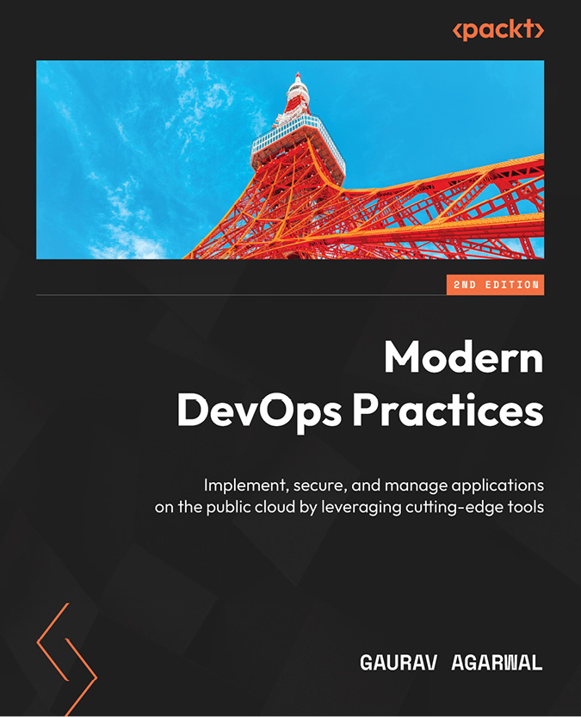](https://packt.link/1805121820)

****Modern DevOps Practices****

Gaurav Agarwal

ISBN: 978-1-80512-182-4

* Explore modern DevOps practices with Git and GitOps
* Master container fundamentals with Docker and Kubernetes
* Become well versed in AWS ECS, Google Cloud Run, and Knative
* Discover how to efficiently build and manage secure Docker images
* Understand continuous integration with Jenkins on Kubernetes and GitHub Actions
* Get to grips with using Argo CD for continuous deployment and delivery
* Manage immutable infrastructure on the cloud with Packer, Terraform, and Ansible
* Operate container applications in production using Istio and learn about AI in DevOps

[](https://packt.link/1803248009)

****Observability with Grafana****

Rob Chapman, Peter Holmes

ISBN: 978-1-80324-800-4

* Understand fundamentals of observability, logs, metrics, and distributed traces
* Find out how to instrument an application using Grafana and OpenTelemetry
* Collect data and monitor cloud, Linux, and Kubernetes platforms
* Build queries and visualizations using LogQL, PromQL, and TraceQL
* Manage incidents and alerts using AI-powered incident management
* Deploy and monitor CI/CD pipelines to automatically validate the desired results
* Take control of observability costs with powerful in-built features
* Architect and manage an observability platform using Grafana

# Packt is searching for authors like you

If you’re interested in becoming an author for Packt, please visit [authors.packtpub.com](http://authors.packtpub.com/) and apply today. We have worked with thousands of developers and tech professionals, just like you, to help them share their insight with the global tech community. You can make a general application, apply for a specific hot topic that we are recruiting an author for, or submit your own idea.

# Share Your Thoughts

Now you’ve finished *Mastering DevOps on Microsoft Power Platform*, we’d love to hear your thoughts! If you purchased the book from Amazon, please [click here to go straight to the Amazon review page](https://packt.link/r/1835880851)for this book and share your feedback or leave a review on the site that you purchased it from.

Your review is important to us and the tech community and will help us make sure we’re delivering excellent quality content.

# Download a free PDF copy of this book

Thanks for purchasing this book!

Do you like to read on the go but are unable to carry your print books everywhere?

Is your eBook purchase not compatible with the device of your choice?

Don’t worry, now with every Packt book you get a DRM-free PDF version of that book at no cost.

Read anywhere, any place, on any device. Search, copy, and paste code from your favorite technical books directly into your application.

The perks don’t stop there, you can get exclusive access to discounts, newsletters, and great free content in your inbox daily

Follow these simple steps to get the benefits:

1. Scan the QR code or visit the link below



<https://packt.link/free-ebook/978-1-83588-084-5>

1. Submit your proof of purchase
2. That’s it! We’ll send your free PDF and other benefits to your email directly

Search for books, courses, events, and more

## Contents

1. [Mastering DevOps on Microsoft Power Platform](https://learning.oreilly.com/library/view/mastering-devops-on/9781835880845/B22208_FM.xhtml" \l "_idParaDest-1)
2. [Contributors](https://learning.oreilly.com/library/view/mastering-devops-on/9781835880845/Section0002.xhtml" \l "_idParaDest-2)
3. [About the authors](https://learning.oreilly.com/library/view/mastering-devops-on/9781835880845/Section0002.xhtml" \l "_idParaDest-3)
4. [About the reviewers](https://learning.oreilly.com/library/view/mastering-devops-on/9781835880845/Section0003.xhtml" \l "_idParaDest-4)
5. [Preface](https://learning.oreilly.com/library/view/mastering-devops-on/9781835880845/B22208_Preface_eBook.xhtml" \l "_idParaDest-5)
   1. [Who this book is for](https://learning.oreilly.com/library/view/mastering-devops-on/9781835880845/B22208_Preface_eBook.xhtml" \l "_idParaDest-6)
   2. [What this book covers](https://learning.oreilly.com/library/view/mastering-devops-on/9781835880845/B22208_Preface_eBook.xhtml" \l "_idParaDest-7)
   3. [To get the most out of this book](https://learning.oreilly.com/library/view/mastering-devops-on/9781835880845/B22208_Preface_eBook.xhtml" \l "_idParaDest-8)
      1. [Download the example code files](https://learning.oreilly.com/library/view/mastering-devops-on/9781835880845/B22208_Preface_eBook.xhtml" \l "_idParaDest-9)
   4. [Conventions used](https://learning.oreilly.com/library/view/mastering-devops-on/9781835880845/B22208_Preface_eBook.xhtml" \l "_idParaDest-10)
   5. [Get in touch](https://learning.oreilly.com/library/view/mastering-devops-on/9781835880845/B22208_Preface_eBook.xhtml" \l "_idParaDest-11)
   6. [Share Your Thoughts](https://learning.oreilly.com/library/view/mastering-devops-on/9781835880845/B22208_Preface_eBook.xhtml" \l "_idParaDest-12)
   7. [Download a free PDF copy of this book](https://learning.oreilly.com/library/view/mastering-devops-on/9781835880845/B22208_Preface_eBook.xhtml" \l "_idParaDest-13)
6. [Part 1:Understanding DevOps on Microsoft Power Platform](https://learning.oreilly.com/library/view/mastering-devops-on/9781835880845/B22208_Part1.xhtml" \l "_idParaDest-14)
7. [Chapter 1: Mastering DevOps and ALM for Efficient Software Development](https://learning.oreilly.com/library/view/mastering-devops-on/9781835880845/B22208_01.xhtml" \l "_idParaDest-16)
   1. [SDLC – what it is all about](https://learning.oreilly.com/library/view/mastering-devops-on/9781835880845/B22208_01.xhtml" \l "_idParaDest-17)
      1. [Phases](https://learning.oreilly.com/library/view/mastering-devops-on/9781835880845/B22208_01.xhtml" \l "_idParaDest-18)
      2. [Methodologies](https://learning.oreilly.com/library/view/mastering-devops-on/9781835880845/B22208_01.xhtml" \l "_idParaDest-19)
   2. [Agile, Scrum, and Lean](https://learning.oreilly.com/library/view/mastering-devops-on/9781835880845/B22208_01.xhtml" \l "_idParaDest-20)
      1. [The Agile manifesto](https://learning.oreilly.com/library/view/mastering-devops-on/9781835880845/B22208_01.xhtml" \l "_idParaDest-21)
      2. [Lean management](https://learning.oreilly.com/library/view/mastering-devops-on/9781835880845/B22208_01.xhtml" \l "_idParaDest-22)
      3. [Scrum](https://learning.oreilly.com/library/view/mastering-devops-on/9781835880845/B22208_01.xhtml" \l "_idParaDest-23)
   3. [What is ALM?](https://learning.oreilly.com/library/view/mastering-devops-on/9781835880845/B22208_01.xhtml" \l "_idParaDest-24)
   4. [CI and CD](https://learning.oreilly.com/library/view/mastering-devops-on/9781835880845/B22208_01.xhtml" \l "_idParaDest-25)
   5. [DevOps-enabled architecture patterns](https://learning.oreilly.com/library/view/mastering-devops-on/9781835880845/B22208_01.xhtml" \l "_idParaDest-26)
   6. [Summary](https://learning.oreilly.com/library/view/mastering-devops-on/9781835880845/B22208_01.xhtml" \l "_idParaDest-27)
   7. [Further reading](https://learning.oreilly.com/library/view/mastering-devops-on/9781835880845/B22208_01.xhtml" \l "_idParaDest-28)
8. [Chapter 2: Getting Started with Microsoft Power Platform](https://learning.oreilly.com/library/view/mastering-devops-on/9781835880845/B22208_02.xhtml" \l "_idParaDest-30)
   1. [Technical requirements](https://learning.oreilly.com/library/view/mastering-devops-on/9781835880845/B22208_02.xhtml" \l "_idParaDest-31)
   2. [The rise of low-code/no-code](https://learning.oreilly.com/library/view/mastering-devops-on/9781835880845/B22208_02.xhtml" \l "_idParaDest-32)
      1. [The current and the future state of LCNC development](https://learning.oreilly.com/library/view/mastering-devops-on/9781835880845/B22208_02.xhtml" \l "_idParaDest-33)
      2. [Understanding the benefits of LCNC](https://learning.oreilly.com/library/view/mastering-devops-on/9781835880845/B22208_02.xhtml" \l "_idParaDest-34)
   3. [Getting started with Microsoft Power Platform services](https://learning.oreilly.com/library/view/mastering-devops-on/9781835880845/B22208_02.xhtml" \l "_idParaDest-35)
      1. [What is Microsoft Power Platform?](https://learning.oreilly.com/library/view/mastering-devops-on/9781835880845/B22208_02.xhtml" \l "_idParaDest-36)
      2. [Setting up our first environment](https://learning.oreilly.com/library/view/mastering-devops-on/9781835880845/B22208_02.xhtml" \l "_idParaDest-37)
   4. [Power Platform administration](https://learning.oreilly.com/library/view/mastering-devops-on/9781835880845/B22208_02.xhtml" \l "_idParaDest-38)
      1. [The Power Platform admin center](https://learning.oreilly.com/library/view/mastering-devops-on/9781835880845/B22208_02.xhtml" \l "_idParaDest-39)
      2. [Power Platform management and automation for administrators, makers, and developers](https://learning.oreilly.com/library/view/mastering-devops-on/9781835880845/B22208_02.xhtml" \l "_idParaDest-40)
      3. [Admin and management connectors](https://learning.oreilly.com/library/view/mastering-devops-on/9781835880845/B22208_02.xhtml" \l "_idParaDest-41)
   5. [Governance, compliance, and data privacy](https://learning.oreilly.com/library/view/mastering-devops-on/9781835880845/B22208_02.xhtml" \l "_idParaDest-42)
      1. [Data residency](https://learning.oreilly.com/library/view/mastering-devops-on/9781835880845/B22208_02.xhtml" \l "_idParaDest-43)
      2. [Compliance offerings](https://learning.oreilly.com/library/view/mastering-devops-on/9781835880845/B22208_02.xhtml" \l "_idParaDest-44)
      3. [Data protection](https://learning.oreilly.com/library/view/mastering-devops-on/9781835880845/B22208_02.xhtml" \l "_idParaDest-45)
   6. [Starting to build real-world business solutions](https://learning.oreilly.com/library/view/mastering-devops-on/9781835880845/B22208_02.xhtml" \l "_idParaDest-46)
      1. [Creating solutions using templates in Power Platform](https://learning.oreilly.com/library/view/mastering-devops-on/9781835880845/B22208_02.xhtml" \l "_idParaDest-47)
      2. [Enterprise templates](https://learning.oreilly.com/library/view/mastering-devops-on/9781835880845/B22208_02.xhtml" \l "_idParaDest-48)
      3. [Power Platform patterns](https://learning.oreilly.com/library/view/mastering-devops-on/9781835880845/B22208_02.xhtml" \l "_idParaDest-49)
      4. [Other ways for building business solutions](https://learning.oreilly.com/library/view/mastering-devops-on/9781835880845/B22208_02.xhtml" \l "_idParaDest-50)
      5. [Customer stories](https://learning.oreilly.com/library/view/mastering-devops-on/9781835880845/B22208_02.xhtml" \l "_idParaDest-51)
   7. [Summary](https://learning.oreilly.com/library/view/mastering-devops-on/9781835880845/B22208_02.xhtml" \l "_idParaDest-52)
   8. [Further reading](https://learning.oreilly.com/library/view/mastering-devops-on/9781835880845/B22208_02.xhtml" \l "_idParaDest-53)
9. [Chapter 3: Exploring ALM and DevOps in Microsoft Power Platform](https://learning.oreilly.com/library/view/mastering-devops-on/9781835880845/B22208_03.xhtml" \l "_idParaDest-55)
   1. [Why implement ALM and DevOps in Power Platform?](https://learning.oreilly.com/library/view/mastering-devops-on/9781835880845/B22208_03.xhtml" \l "_idParaDest-56)
      1. [Plan and track](https://learning.oreilly.com/library/view/mastering-devops-on/9781835880845/B22208_03.xhtml" \l "_idParaDest-57)
      2. [Development](https://learning.oreilly.com/library/view/mastering-devops-on/9781835880845/B22208_03.xhtml" \l "_idParaDest-58)
      3. [Build and test](https://learning.oreilly.com/library/view/mastering-devops-on/9781835880845/B22208_03.xhtml" \l "_idParaDest-59)
      4. [Deploy](https://learning.oreilly.com/library/view/mastering-devops-on/9781835880845/B22208_03.xhtml" \l "_idParaDest-60)
      5. [Operate](https://learning.oreilly.com/library/view/mastering-devops-on/9781835880845/B22208_03.xhtml" \l "_idParaDest-61)
      6. [Monitor and learn](https://learning.oreilly.com/library/view/mastering-devops-on/9781835880845/B22208_03.xhtml" \l "_idParaDest-62)
      7. [ALM and DevOps tooling](https://learning.oreilly.com/library/view/mastering-devops-on/9781835880845/B22208_03.xhtml" \l "_idParaDest-63)
   2. [Application modernization with an LCNC approach](https://learning.oreilly.com/library/view/mastering-devops-on/9781835880845/B22208_03.xhtml" \l "_idParaDest-64)
      1. [Application modernization options](https://learning.oreilly.com/library/view/mastering-devops-on/9781835880845/B22208_03.xhtml" \l "_idParaDest-65)
   3. [Building Power Platform adoption journey](https://learning.oreilly.com/library/view/mastering-devops-on/9781835880845/B22208_03.xhtml" \l "_idParaDest-66)
      1. [The Power Platform adoption maturity model](https://learning.oreilly.com/library/view/mastering-devops-on/9781835880845/B22208_03.xhtml" \l "_idParaDest-67)
      2. [Ways to improve the maturity level](https://learning.oreilly.com/library/view/mastering-devops-on/9781835880845/B22208_03.xhtml" \l "_idParaDest-68)
   4. [Summary](https://learning.oreilly.com/library/view/mastering-devops-on/9781835880845/B22208_03.xhtml" \l "_idParaDest-69)
   5. [Further reading](https://learning.oreilly.com/library/view/mastering-devops-on/9781835880845/B22208_03.xhtml" \l "_idParaDest-70)
10. [Part 2:Implementing DevOps on Microsoft Power Platform](https://learning.oreilly.com/library/view/mastering-devops-on/9781835880845/B22208_Part2.xhtml" \l "_idParaDest-71)
11. [Chapter 4: Understanding Power Platform Environments and Solutions](https://learning.oreilly.com/library/view/mastering-devops-on/9781835880845/B22208_04.xhtml" \l "_idParaDest-73)
    1. [Technical requirements](https://learning.oreilly.com/library/view/mastering-devops-on/9781835880845/B22208_04.xhtml" \l "_idParaDest-74)
    2. [What comes to a solution?](https://learning.oreilly.com/library/view/mastering-devops-on/9781835880845/B22208_04.xhtml" \l "_idParaDest-75)
    3. [Versioning of solutions and packages](https://learning.oreilly.com/library/view/mastering-devops-on/9781835880845/B22208_04.xhtml" \l "_idParaDest-76)
    4. [What about data – Dataverse and data modeling aspects](https://learning.oreilly.com/library/view/mastering-devops-on/9781835880845/B22208_04.xhtml" \l "_idParaDest-77)
    5. [Environments, managed environments, and environment strategy](https://learning.oreilly.com/library/view/mastering-devops-on/9781835880845/B22208_04.xhtml" \l "_idParaDest-78)
       1. [Managed Environments](https://learning.oreilly.com/library/view/mastering-devops-on/9781835880845/B22208_04.xhtml" \l "_idParaDest-79)
       2. [Environment strategies](https://learning.oreilly.com/library/view/mastering-devops-on/9781835880845/B22208_04.xhtml" \l "_idParaDest-80)
    6. [Managed pipelines – Our first CI/CD](https://learning.oreilly.com/library/view/mastering-devops-on/9781835880845/B22208_04.xhtml" \l "_idParaDest-81)
       1. [Power Platform pipelines](https://learning.oreilly.com/library/view/mastering-devops-on/9781835880845/B22208_04.xhtml" \l "_idParaDest-82)
       2. [Step-by-step walkthrough – creating our first CI/CD pipeline](https://learning.oreilly.com/library/view/mastering-devops-on/9781835880845/B22208_04.xhtml" \l "_idParaDest-83)
    7. [Summary](https://learning.oreilly.com/library/view/mastering-devops-on/9781835880845/B22208_04.xhtml" \l "_idParaDest-84)
    8. [Further reading](https://learning.oreilly.com/library/view/mastering-devops-on/9781835880845/B22208_04.xhtml" \l "_idParaDest-85)
12. [Chapter 5: Streamlining Power Platform Development with DevOps Tooling](https://learning.oreilly.com/library/view/mastering-devops-on/9781835880845/B22208_05.xhtml" \l "_idParaDest-87)
    1. [Technical requirements](https://learning.oreilly.com/library/view/mastering-devops-on/9781835880845/B22208_05.xhtml" \l "_idParaDest-88)
    2. [Git – the single source of truth](https://learning.oreilly.com/library/view/mastering-devops-on/9781835880845/B22208_05.xhtml" \l "_idParaDest-89)
    3. [Power Platform CLI](https://learning.oreilly.com/library/view/mastering-devops-on/9781835880845/B22208_05.xhtml" \l "_idParaDest-90)
    4. [Power Platform build tools for Azure DevOps](https://learning.oreilly.com/library/view/mastering-devops-on/9781835880845/B22208_05.xhtml" \l "_idParaDest-91)
    5. [GitHub Actions for Power Platform](https://learning.oreilly.com/library/view/mastering-devops-on/9781835880845/B22208_05.xhtml" \l "_idParaDest-92)
    6. [Managed pipelines – source control integration with Git](https://learning.oreilly.com/library/view/mastering-devops-on/9781835880845/B22208_05.xhtml" \l "_idParaDest-93)
       1. [GitHub workflows](https://learning.oreilly.com/library/view/mastering-devops-on/9781835880845/B22208_05.xhtml" \l "_idParaDest-94)
       2. [Dataverse with Power Automate cloud flows](https://learning.oreilly.com/library/view/mastering-devops-on/9781835880845/B22208_05.xhtml" \l "_idParaDest-95)
    7. [Copilots in Power Platform pipeline development](https://learning.oreilly.com/library/view/mastering-devops-on/9781835880845/B22208_05.xhtml" \l "_idParaDest-96)
    8. [Summary](https://learning.oreilly.com/library/view/mastering-devops-on/9781835880845/B22208_05.xhtml" \l "_idParaDest-97)
    9. [Further reading](https://learning.oreilly.com/library/view/mastering-devops-on/9781835880845/B22208_05.xhtml" \l "_idParaDest-98)
13. [Chapter 6: A Deep Dive into Continuous Integration/Continuous Deployment (CI/CD) Pipelines](https://learning.oreilly.com/library/view/mastering-devops-on/9781835880845/B22208_06.xhtml" \l "_idParaDest-100)
    1. [Technical requirements](https://learning.oreilly.com/library/view/mastering-devops-on/9781835880845/B22208_06.xhtml" \l "_idParaDest-101)
    2. [When everything comes together](https://learning.oreilly.com/library/view/mastering-devops-on/9781835880845/B22208_06.xhtml" \l "_idParaDest-102)
       1. [Branches and environments](https://learning.oreilly.com/library/view/mastering-devops-on/9781835880845/B22208_06.xhtml" \l "_idParaDest-103)
       2. [The Power Platform catalog](https://learning.oreilly.com/library/view/mastering-devops-on/9781835880845/B22208_06.xhtml" \l "_idParaDest-104)
    3. [Azure pipeline templates and reusable GitHub workflows](https://learning.oreilly.com/library/view/mastering-devops-on/9781835880845/B22208_06.xhtml" \l "_idParaDest-105)
    4. [The ALM Accelerator for Power Platform](https://learning.oreilly.com/library/view/mastering-devops-on/9781835880845/B22208_06.xhtml" \l "_idParaDest-106)
    5. [Automated testing in DevOps and Power Platform pipelines](https://learning.oreilly.com/library/view/mastering-devops-on/9781835880845/B22208_06.xhtml" \l "_idParaDest-107)
    6. [Summary](https://learning.oreilly.com/library/view/mastering-devops-on/9781835880845/B22208_06.xhtml" \l "_idParaDest-108)
    7. [Further reading](https://learning.oreilly.com/library/view/mastering-devops-on/9781835880845/B22208_06.xhtml" \l "_idParaDest-109)
14. [Chapter 7: An Overview of DevSecOps in Power Platform](https://learning.oreilly.com/library/view/mastering-devops-on/9781835880845/B22208_07.xhtml" \l "_idParaDest-111)
    1. [Technical requirements](https://learning.oreilly.com/library/view/mastering-devops-on/9781835880845/B22208_07.xhtml" \l "_idParaDest-112)
    2. [What is DevSecOps?](https://learning.oreilly.com/library/view/mastering-devops-on/9781835880845/B22208_07.xhtml" \l "_idParaDest-113)
       1. [Setup](https://learning.oreilly.com/library/view/mastering-devops-on/9781835880845/B22208_07.xhtml" \l "_idParaDest-114)
       2. [Plan and Design](https://learning.oreilly.com/library/view/mastering-devops-on/9781835880845/B22208_07.xhtml" \l "_idParaDest-115)
       3. [Commit (CI)](https://learning.oreilly.com/library/view/mastering-devops-on/9781835880845/B22208_07.xhtml" \l "_idParaDest-116)
       4. [Deploy (CD)](https://learning.oreilly.com/library/view/mastering-devops-on/9781835880845/B22208_07.xhtml" \l "_idParaDest-117)
       5. [Operate and Monitor](https://learning.oreilly.com/library/view/mastering-devops-on/9781835880845/B22208_07.xhtml" \l "_idParaDest-118)
    3. [Security model of Power Platform](https://learning.oreilly.com/library/view/mastering-devops-on/9781835880845/B22208_07.xhtml" \l "_idParaDest-119)
    4. [Secret scanning and static code analysis tools](https://learning.oreilly.com/library/view/mastering-devops-on/9781835880845/B22208_07.xhtml" \l "_idParaDest-120)
    5. [Solution checker](https://learning.oreilly.com/library/view/mastering-devops-on/9781835880845/B22208_07.xhtml" \l "_idParaDest-121)
    6. [Spinning up DevSecOps projects at scale](https://learning.oreilly.com/library/view/mastering-devops-on/9781835880845/B22208_07.xhtml" \l "_idParaDest-122)
    7. [Security of DevOps processes](https://learning.oreilly.com/library/view/mastering-devops-on/9781835880845/B22208_07.xhtml" \l "_idParaDest-123)
    8. [Summary](https://learning.oreilly.com/library/view/mastering-devops-on/9781835880845/B22208_07.xhtml" \l "_idParaDest-124)
    9. [Further reading](https://learning.oreilly.com/library/view/mastering-devops-on/9781835880845/B22208_07.xhtml" \l "_idParaDest-125)
15. [Chapter 8: Demonstrating ALM and DevOps Implementation](https://learning.oreilly.com/library/view/mastering-devops-on/9781835880845/B22208_08.xhtml" \l "_idParaDest-127)
    1. [Technical requirements](https://learning.oreilly.com/library/view/mastering-devops-on/9781835880845/B22208_08.xhtml" \l "_idParaDest-128)
    2. [Exercise – repository management and branch strategies for the applications](https://learning.oreilly.com/library/view/mastering-devops-on/9781835880845/B22208_08.xhtml" \l "_idParaDest-129)
    3. [Exercise – building CD pipelines and a release train](https://learning.oreilly.com/library/view/mastering-devops-on/9781835880845/B22208_08.xhtml" \l "_idParaDest-130)
    4. [Exercise – backlog management in GitHub](https://learning.oreilly.com/library/view/mastering-devops-on/9781835880845/B22208_08.xhtml" \l "_idParaDest-131)
    5. [Exercise – testing solutions](https://learning.oreilly.com/library/view/mastering-devops-on/9781835880845/B22208_08.xhtml" \l "_idParaDest-132)
    6. [Exercise – monitoring the applications](https://learning.oreilly.com/library/view/mastering-devops-on/9781835880845/B22208_08.xhtml" \l "_idParaDest-133)
    7. [Exercise – introducing feature flags](https://learning.oreilly.com/library/view/mastering-devops-on/9781835880845/B22208_08.xhtml" \l "_idParaDest-134)
    8. [Summary](https://learning.oreilly.com/library/view/mastering-devops-on/9781835880845/B22208_08.xhtml" \l "_idParaDest-135)
    9. [Further reading](https://learning.oreilly.com/library/view/mastering-devops-on/9781835880845/B22208_08.xhtml" \l "_idParaDest-136)
16. [Part 3:Exploring DevOps Best Practices and the Road Ahead](https://learning.oreilly.com/library/view/mastering-devops-on/9781835880845/B22208_Part3.xhtml" \l "_idParaDest-137)
17. [Chapter 9: Implementing the Fusion Development Approach](https://learning.oreilly.com/library/view/mastering-devops-on/9781835880845/B22208_09.xhtml" \l "_idParaDest-139)
    1. [Technical requirements](https://learning.oreilly.com/library/view/mastering-devops-on/9781835880845/B22208_09.xhtml" \l "_idParaDest-140)
    2. [What is the fusion development approach?](https://learning.oreilly.com/library/view/mastering-devops-on/9781835880845/B22208_09.xhtml" \l "_idParaDest-141)
       1. [Common examples of the fusion development approach in Power Platform](https://learning.oreilly.com/library/view/mastering-devops-on/9781835880845/B22208_09.xhtml" \l "_idParaDest-142)
       2. [Empowering collaboration with open source development practices](https://learning.oreilly.com/library/view/mastering-devops-on/9781835880845/B22208_09.xhtml" \l "_idParaDest-143)
       3. [Building a catalog process](https://learning.oreilly.com/library/view/mastering-devops-on/9781835880845/B22208_09.xhtml" \l "_idParaDest-144)
       4. [Additional tools for developers using Visual Studio](https://learning.oreilly.com/library/view/mastering-devops-on/9781835880845/B22208_09.xhtml" \l "_idParaDest-145)
    3. [Microsoft Azure and Power Platform together](https://learning.oreilly.com/library/view/mastering-devops-on/9781835880845/B22208_09.xhtml" \l "_idParaDest-146)
       1. [Application hosting services](https://learning.oreilly.com/library/view/mastering-devops-on/9781835880845/B22208_09.xhtml" \l "_idParaDest-147)
       2. [Integration Services](https://learning.oreilly.com/library/view/mastering-devops-on/9781835880845/B22208_09.xhtml" \l "_idParaDest-148)
       3. [Data analytics](https://learning.oreilly.com/library/view/mastering-devops-on/9781835880845/B22208_09.xhtml" \l "_idParaDest-149)
       4. [AI services](https://learning.oreilly.com/library/view/mastering-devops-on/9781835880845/B22208_09.xhtml" \l "_idParaDest-150)
       5. [Data storage](https://learning.oreilly.com/library/view/mastering-devops-on/9781835880845/B22208_09.xhtml" \l "_idParaDest-151)
    4. [Example of an Azure and Power Platform integration scenario](https://learning.oreilly.com/library/view/mastering-devops-on/9781835880845/B22208_09.xhtml" \l "_idParaDest-152)
       1. [Creating a Web API and a Power Platform custom connector with Visual Studio 2022](https://learning.oreilly.com/library/view/mastering-devops-on/9781835880845/B22208_09.xhtml" \l "_idParaDest-153)
       2. [Creating a Power Platform custom connector with Azure APIM](https://learning.oreilly.com/library/view/mastering-devops-on/9781835880845/B22208_09.xhtml" \l "_idParaDest-154)
       3. [Applying ALM to custom connectors](https://learning.oreilly.com/library/view/mastering-devops-on/9781835880845/B22208_09.xhtml" \l "_idParaDest-155)
    5. [Summary](https://learning.oreilly.com/library/view/mastering-devops-on/9781835880845/B22208_09.xhtml" \l "_idParaDest-156)
    6. [Further reading](https://learning.oreilly.com/library/view/mastering-devops-on/9781835880845/B22208_09.xhtml" \l "_idParaDest-157)
18. [Chapter 10: Enabling Pro-Dev Extensibility in Power Platform](https://learning.oreilly.com/library/view/mastering-devops-on/9781835880845/B22208_10.xhtml" \l "_idParaDest-159)
    1. [Technical requirements](https://learning.oreilly.com/library/view/mastering-devops-on/9781835880845/B22208_10.xhtml" \l "_idParaDest-160)
    2. [Enabling the power of the integration – connectors](https://learning.oreilly.com/library/view/mastering-devops-on/9781835880845/B22208_10.xhtml" \l "_idParaDest-161)
       1. [Connectors](https://learning.oreilly.com/library/view/mastering-devops-on/9781835880845/B22208_10.xhtml" \l "_idParaDest-162)
       2. [Connection references](https://learning.oreilly.com/library/view/mastering-devops-on/9781835880845/B22208_10.xhtml" \l "_idParaDest-163)
       3. [Environment variables](https://learning.oreilly.com/library/view/mastering-devops-on/9781835880845/B22208_10.xhtml" \l "_idParaDest-164)
       4. [Example – Decoupling configuration from the application](https://learning.oreilly.com/library/view/mastering-devops-on/9781835880845/B22208_10.xhtml" \l "_idParaDest-165)
    3. [Overview of canvas components and component libraries](https://learning.oreilly.com/library/view/mastering-devops-on/9781835880845/B22208_10.xhtml" \l "_idParaDest-166)
       1. [Canvas components](https://learning.oreilly.com/library/view/mastering-devops-on/9781835880845/B22208_10.xhtml" \l "_idParaDest-167)
       2. [Component libraries](https://learning.oreilly.com/library/view/mastering-devops-on/9781835880845/B22208_10.xhtml" \l "_idParaDest-168)
       3. [Managing the life cycle of the component library](https://learning.oreilly.com/library/view/mastering-devops-on/9781835880845/B22208_10.xhtml" \l "_idParaDest-169)
    4. [Getting to know code components](https://learning.oreilly.com/library/view/mastering-devops-on/9781835880845/B22208_10.xhtml" \l "_idParaDest-170)
       1. [Code component composition](https://learning.oreilly.com/library/view/mastering-devops-on/9781835880845/B22208_10.xhtml" \l "_idParaDest-171)
       2. [Creating your code component](https://learning.oreilly.com/library/view/mastering-devops-on/9781835880845/B22208_10.xhtml" \l "_idParaDest-172)
       3. [ALM for code components](https://learning.oreilly.com/library/view/mastering-devops-on/9781835880845/B22208_10.xhtml" \l "_idParaDest-173)
    5. [ALM for Power Pages](https://learning.oreilly.com/library/view/mastering-devops-on/9781835880845/B22208_10.xhtml" \l "_idParaDest-174)
       1. [Use of the PAC CLI for Power Pages](https://learning.oreilly.com/library/view/mastering-devops-on/9781835880845/B22208_10.xhtml" \l "_idParaDest-175)
       2. [Using Power Platform Build Tools with Power Pages](https://learning.oreilly.com/library/view/mastering-devops-on/9781835880845/B22208_10.xhtml" \l "_idParaDest-176)
       3. [Using Power Platform pipelines with Power Pages](https://learning.oreilly.com/library/view/mastering-devops-on/9781835880845/B22208_10.xhtml" \l "_idParaDest-177)
    6. [Summary](https://learning.oreilly.com/library/view/mastering-devops-on/9781835880845/B22208_10.xhtml" \l "_idParaDest-178)
    7. [Further reading](https://learning.oreilly.com/library/view/mastering-devops-on/9781835880845/B22208_10.xhtml" \l "_idParaDest-179)
19. [Chapter 11: Managing the Environment Life Cycle with Design Best Practices](https://learning.oreilly.com/library/view/mastering-devops-on/9781835880845/B22208_11.xhtml" \l "_idParaDest-181)
    1. [Technical requirements](https://learning.oreilly.com/library/view/mastering-devops-on/9781835880845/B22208_11.xhtml" \l "_idParaDest-182)
    2. [Building on the design best practices](https://learning.oreilly.com/library/view/mastering-devops-on/9781835880845/B22208_11.xhtml" \l "_idParaDest-183)
       1. [Power Platform Well-Architected](https://learning.oreilly.com/library/view/mastering-devops-on/9781835880845/B22208_11.xhtml" \l "_idParaDest-184)
       2. [Power Platform landing zones](https://learning.oreilly.com/library/view/mastering-devops-on/9781835880845/B22208_11.xhtml" \l "_idParaDest-185)
    3. [Automating environment life cycle management](https://learning.oreilly.com/library/view/mastering-devops-on/9781835880845/B22208_11.xhtml" \l "_idParaDest-186)
       1. [Infrastructure as code (IaC) over ClickOps](https://learning.oreilly.com/library/view/mastering-devops-on/9781835880845/B22208_11.xhtml" \l "_idParaDest-187)
       2. [Power Platform management with Terraform](https://learning.oreilly.com/library/view/mastering-devops-on/9781835880845/B22208_11.xhtml" \l "_idParaDest-188)
       3. [Traditional automated environment management approaches](https://learning.oreilly.com/library/view/mastering-devops-on/9781835880845/B22208_11.xhtml" \l "_idParaDest-189)
       4. [DLP considerations when managing environments](https://learning.oreilly.com/library/view/mastering-devops-on/9781835880845/B22208_11.xhtml" \l "_idParaDest-190)
    4. [Power Platform CoE](https://learning.oreilly.com/library/view/mastering-devops-on/9781835880845/B22208_11.xhtml" \l "_idParaDest-191)
       1. [The CoE Starter Kit](https://learning.oreilly.com/library/view/mastering-devops-on/9781835880845/B22208_11.xhtml" \l "_idParaDest-192)
       2. [Example of environment management](https://learning.oreilly.com/library/view/mastering-devops-on/9781835880845/B22208_11.xhtml" \l "_idParaDest-193)
    5. [Summary](https://learning.oreilly.com/library/view/mastering-devops-on/9781835880845/B22208_11.xhtml" \l "_idParaDest-194)
    6. [Further reading](https://learning.oreilly.com/library/view/mastering-devops-on/9781835880845/B22208_11.xhtml" \l "_idParaDest-195)
20. [Chapter 12: Looking Ahead with Copilots, ChatOps, and AI-Infused Applications](https://learning.oreilly.com/library/view/mastering-devops-on/9781835880845/B22208_12.xhtml" \l "_idParaDest-197)
    1. [Technical requirements](https://learning.oreilly.com/library/view/mastering-devops-on/9781835880845/B22208_12.xhtml" \l "_idParaDest-198)
    2. [The era of AI and the rise of GPTs](https://learning.oreilly.com/library/view/mastering-devops-on/9781835880845/B22208_12.xhtml" \l "_idParaDest-199)
       1. [Introduction to AI](https://learning.oreilly.com/library/view/mastering-devops-on/9781835880845/B22208_12.xhtml" \l "_idParaDest-200)
       2. [GPTs](https://learning.oreilly.com/library/view/mastering-devops-on/9781835880845/B22208_12.xhtml" \l "_idParaDest-201)
       3. [Responsible AI](https://learning.oreilly.com/library/view/mastering-devops-on/9781835880845/B22208_12.xhtml" \l "_idParaDest-202)
    3. [Microsoft Copilots and Copilots in Power Platform](https://learning.oreilly.com/library/view/mastering-devops-on/9781835880845/B22208_12.xhtml" \l "_idParaDest-203)
       1. [Copilots in Power Platform](https://learning.oreilly.com/library/view/mastering-devops-on/9781835880845/B22208_12.xhtml" \l "_idParaDest-204)
    4. [Copilots’ usage from the perspective of a maker](https://learning.oreilly.com/library/view/mastering-devops-on/9781835880845/B22208_12.xhtml" \l "_idParaDest-205)
    5. [Extending business solutions with AI Builder and Azure OpenAI](https://learning.oreilly.com/library/view/mastering-devops-on/9781835880845/B22208_12.xhtml" \l "_idParaDest-206)
       1. [Introducing AI Builder](https://learning.oreilly.com/library/view/mastering-devops-on/9781835880845/B22208_12.xhtml" \l "_idParaDest-207)
       2. [Using AI models and AI prompts](https://learning.oreilly.com/library/view/mastering-devops-on/9781835880845/B22208_12.xhtml" \l "_idParaDest-208)
       3. [Introducing Azure OpenAI](https://learning.oreilly.com/library/view/mastering-devops-on/9781835880845/B22208_12.xhtml" \l "_idParaDest-209)
    6. [ChatOps and Copilot Studio](https://learning.oreilly.com/library/view/mastering-devops-on/9781835880845/B22208_12.xhtml" \l "_idParaDest-210)
       1. [A closer look at Copilot Studio](https://learning.oreilly.com/library/view/mastering-devops-on/9781835880845/B22208_12.xhtml" \l "_idParaDest-211)
       2. [What is ChatOps](https://learning.oreilly.com/library/view/mastering-devops-on/9781835880845/B22208_12.xhtml" \l "_idParaDest-212)
       3. [Integrating Microsoft Teams with GitHub and Azure DevOps](https://learning.oreilly.com/library/view/mastering-devops-on/9781835880845/B22208_12.xhtml" \l "_idParaDest-213)
       4. [Building ChatOps for Power Platform with Copilot Studio](https://learning.oreilly.com/library/view/mastering-devops-on/9781835880845/B22208_12.xhtml" \l "_idParaDest-214)
       5. [ALM for Copilot Studio](https://learning.oreilly.com/library/view/mastering-devops-on/9781835880845/B22208_12.xhtml" \l "_idParaDest-215)
    7. [Summary](https://learning.oreilly.com/library/view/mastering-devops-on/9781835880845/B22208_12.xhtml" \l "_idParaDest-216)
    8. [Further reading](https://learning.oreilly.com/library/view/mastering-devops-on/9781835880845/B22208_12.xhtml" \l "_idParaDest-217)
21. [Index](https://learning.oreilly.com/library/view/mastering-devops-on/9781835880845/B22208_Index.xhtml" \l "_idParaDest-218)
    1. [Why subscribe?](https://learning.oreilly.com/library/view/mastering-devops-on/9781835880845/B22208_BM_eBook.xhtml" \l "_idParaDest-219)
22. [Other Books You May Enjoy](https://learning.oreilly.com/library/view/mastering-devops-on/9781835880845/B22208_BM_eBook.xhtml" \l "_idParaDest-220)
    1. [Packt is searching for authors like you](https://learning.oreilly.com/library/view/mastering-devops-on/9781835880845/B22208_BM_eBook.xhtml" \l "_idParaDest-221)
    2. [Share Your Thoughts](https://learning.oreilly.com/library/view/mastering-devops-on/9781835880845/B22208_BM_eBook.xhtml" \l "_idParaDest-222)
    3. [Download a free PDF copy of this book](https://learning.oreilly.com/library/view/mastering-devops-on/9781835880845/B22208_BM_eBook.xhtml" \l "_idParaDest-223)

## Landmarks

1. [Cover](https://learning.oreilly.com/library/view/mastering-devops-on/9781835880845/cover.xhtml)
2. [Table of Contents](https://learning.oreilly.com/library/view/mastering-devops-on/9781835880845/B22208_TOC_ePub.xhtml" \l "_idContainer002)
3. [Index](https://learning.oreilly.com/library/view/mastering-devops-on/9781835880845/B22208_Index.xhtml" \l "_idContainer188)